**Case Report**

The Value of Ultrasonography in the Diagnosis of a Rare Congenital Dermoid Cyst of the Anterior Fontanelle in an Infant

# Introduction

**Abstract**

A dermoid cyst is a benign lesion that may occur in different parts of the body. A dermoid cyst of the subgaleal space over the anterior fontanelle is rather uncommon. We present a case of congenital dermoid cyst of the anterior fontanelle in a 3-month-old male infant, underscoring the value of ultrasonography in the diagnosis and highlighting the classical clinical, sonographic, surgical, and pathological findings.

**Keywords:** *Anterior fontanelle, dermoid cyst, sonography*

**Abstrait**

Un kyste dermoïde est une lésion bénigne qui peut survenir dans différentes parties du corps. Un kyste dermoïde de l’espace sous-galéal au-dessus de la fontanelle antérieure est plutôt rare. Nous présentons un cas de kyste dermoïde congénital de la fontanelle antérieure chez un nourrisson de sexe masculin de 3 mois, soulignant l’intérêt de l’échographie dans le diagnostic et mettant en évidence les résultats cliniques, échographiques, chirurgicaux et pathologiques classiques.

**Mots-clés:** *Kyste dermoïde, fontanelle antérieure, échographie*

A dermoid cyst of the anterior fontanelle is a progressively enlarging benign soft-tissue swelling covered by intact overlying skin.[1] A dermoid cyst of the subgaleal space over the anterior fontanelle was first described among Africans in 1971 by Adeloye and Odeku and was referred to as “Adeloye-Odeku disease.” Similar cases, however, have been reported among other races.[2-5]

The lesion accounts for 0.1%–0.5% of all cranial tumours.[1] Although computed tomography (CT) scan and magnetic resonance imaging (MRI) are the modalities of choice for evaluation and pre-surgical planning,[1] ultrasonography is a reliable tool in the evaluation and pre-surgical planning, particularly in a low-income setting such as Nigeria where patients find it difficult paying out of pocket for CT and MRI.

We report a case of a subgaleal dermoid cyst of the anterior fontanelle in a 3-month-old male infant to highlight the usefulness of ultrasonography in surgical management.

This is an open access journal, and articles are distributed under the terms of the Creative Commons Attribution-NonCommercial- ShareAlike 4.0 License, which allows others to remix, tweak, and build upon the work non-commercially, as long as appropriate credit is given and the new creations are licensed under the identical terms.

**For reprints contact:** [reprints@medknow.com](mailto:reprints@medknow.com)

# Case Presentation

A 3-month-old male infant was referred to the paediatric surgical outpatient clinic from the hospital’s general outpatient department in April 2019 because of scalp swelling over the anterior fontanelle noticed from birth. The swelling, which was painless, had progressively increased in size. He was the product of an uncomplicated pregnancy and spontaneous vaginal delivery at a government primary health care centre. There was no known birth injury. The neonatal period was uneventful, and he achieved normal developmental milestones for his age.

There had not been any history of seizure or alteration in level of consciousness.

General examination revealed a healthy- looking, 6.4-kg, male infant who was not pale and was anicteric and afebrile. He had an approximately 4 × 4 cm dome-shaped swelling in the anterior fontanelle region [Figure 1]. The swelling was soft, non-tender, fluctuant, not pulsatile, and not attached to the overlying skin or underlying structures, and it trans- illuminated brilliantly.

Systemic examination, including that of the central nervous system, was essentially

**How to cite this article:** Adenigba PT, Lawal TA, Elemile PO, Onakpoma F, Adekanmi AJ. The value of ultrasonography in the diagnosis of a rare congenital dermoid cyst of the anterior fontanelle in an infant. J West Afr Coll Surg 2019;9:21-5.

**Peter T. Adenigba1, Taiwo A. Lawal2,3, Peter O. Elemile2, Francis Onakpoma4, Ademola J. Adekanmi1,5**

*1Department of Radiology, 2Department of Surgery, University College Hospital, University of Ibadan, 3Department of Surgery, College of Medicine, University of Ibadan, 4Department of Pathology, University College Hospital, University of Ibadan, 5Department of Radiology, College of Medicine, University of Ibadan, Ibadan, Nigeria*

**Received:** 14-Aug-2021 **Accepted:** 25-Oct-2021 **Published:** 05-Feb-2022

***Address for correspondence:*** *Dr. Ademola Joseph Adekanmi, Department of Radiology, College of Medicine, University of Ibadan, Ibadan, Nigeria.*

*E-mail: kanmiademola@gmail. com*

|  |
| --- |
| **Access this article online** |
| **Website:**  [www.jwacs-jcoac.org](http://www.jwacs-jcoac.org/) |
| **DOI:** 10.4103/jwas.jwas_34_21 |
| **Quick Response Code:** |

© 2022 Journal of the West African College of Surgeons | Published by Wolters Kluwer ‑ Medknow 21

normal. Laboratory investigation revealed a normal haematocrit of 41%.

# Imaging Findings

Lateral-view plain skull radiograph showed a well-defined, dome-shaped, homogeneous, soft-tissue dense opacity overlying the anterior fontanelle with intact skin and a normal underlying skull bone [Figure 2].

Transfontanelle ultrasound scan of the scalp swelling and the brain was performed in sagittal and coronal planes with LOGIQ S8 XDCLEAR GE Ultrasound scanner (SN: 503160SU2, Gyeonggi-do, Korea) using both the high-frequency (12.0 MHz) linear array transducer and a small curvilinear sector probe. B-mode scan of the mass revealed a well-defined, thin- walled, oval-shaped, complex mass with an anechoic cystic component and echogenic strands within, which did not show internal vascularity on colour Doppler interrogation. It measured

3.41 × 1.49 × 3.16 cm in the anteroposterior, craniocaudal, and transverse dimensions, respectively, and overlying the meninges but not communicating with the brain [Figure 3]. An ultrasound diagnosis of the anterior fontanelle dermoid cyst was made.

# Surgical Management and Pathological Evaluation

Total excision of the cystic mass was performed under general anaesthesia. A well-defined cystic mass was seen in the

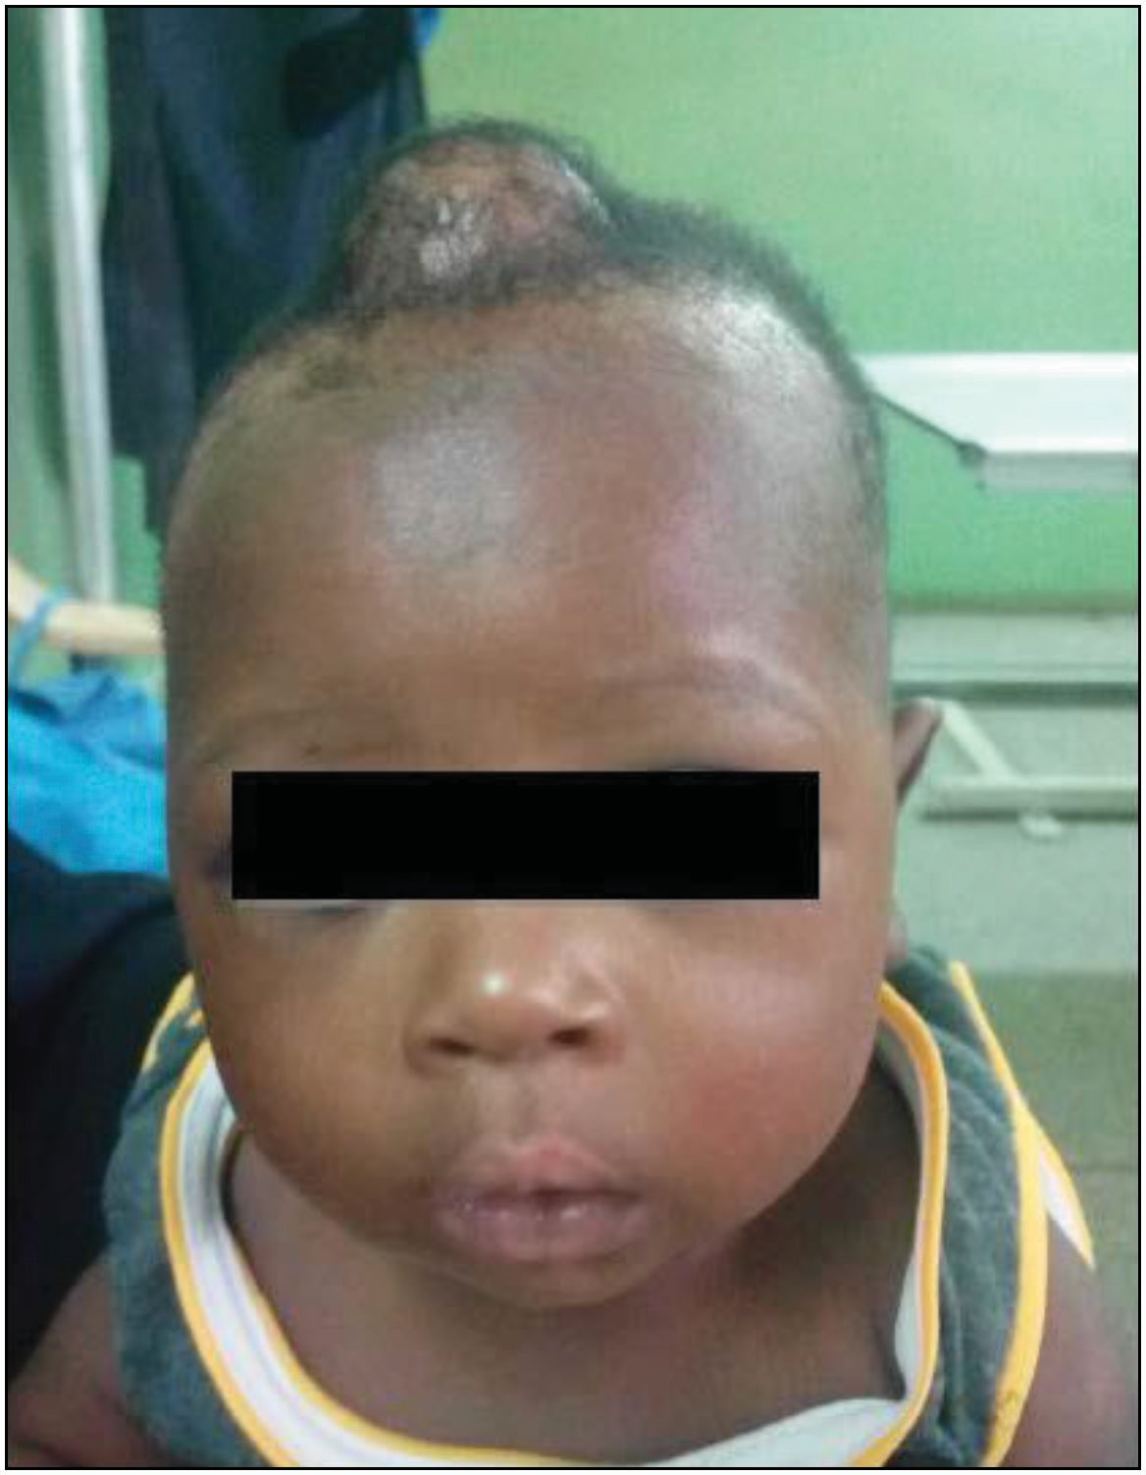

**Figure 1: Photograph of the male patient demonstrating mass over the anterior fontanelle**

subgaleal location following an elliptical incision over the swelling [Figure 4].

The resected lesion was a 3.5 × 3.0 × 3.0 cm nodular cystic mass, which weighed 17 g with a shiny external surface and congested vascular channels. It had a smooth inner wall and contained sebum and hair strands.

Microscopic sections of the cyst showed a keratinous cyst lined by stratified squamous epithelium, which contained keratin flakes [Figure 5a]. The cyst wall was fibrocollagenous and contained skin adnexal appendages such as hair follicles, sweat glands, and sebaceous glands [Figure 5b]. There was moderate focal infiltration of the stroma by chronic inflammatory cells, mainly lymphocytes.

The post-operative period was uneventful, and he was discharged home on the same day. He had his wound reviewed on day 3 post-op and was followed up in the outpatient clinic over 3 months with no observation of the swelling’s recurrence.

# Discussion

Dermoid cysts occur in various parts of the body and may be subcutaneous, subgaleal, intracranial, ovarian, testicular, or intraspinal in locations.[6-9] This is a case of a dermoid cyst in the subgaleal space over the anterior fontanelle.

There are three pathological types of dermoid cysts viz: the congenital dermoid cyst—teratoma type, occurring in the ovaries and testes; acquired dermoid cyst—from traumatic implantation of cells into deeper tissues (implantation dermoid cyst could follow surgery or lumbar puncture procedure); and the congenital inclusion dermoid cyst (CIDC)—from the inclusion of ectodermal cells as the

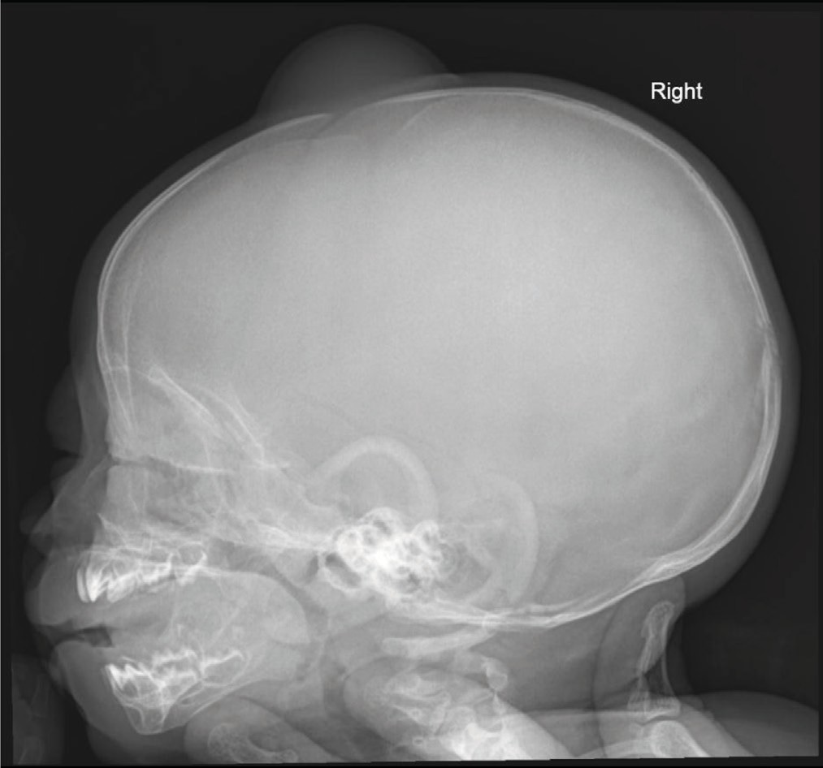

**Figure 2: Lateral skull radiograph shows hemispherical soft-tissue opacity over the anterior fontanelle**

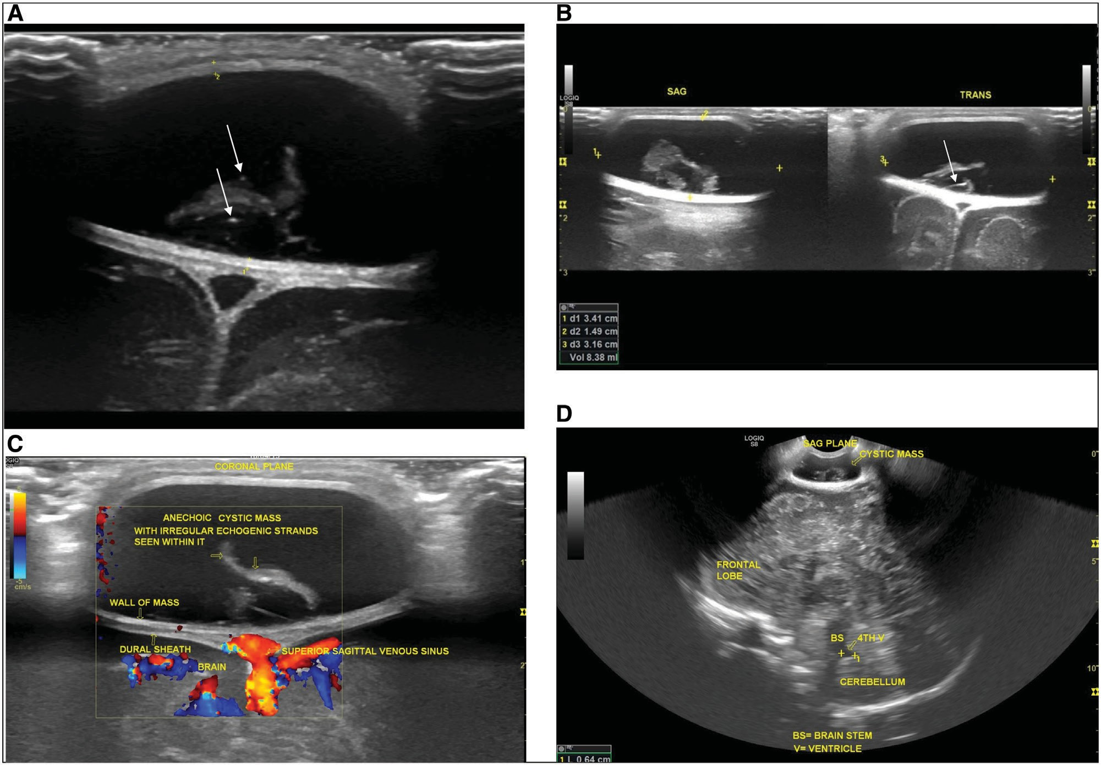

**Figure 3: (a) Coronal B-mode ultrasound (US) in the anterior fontanelle shows an oval-shaped, anechoic cystic mass overlying the dural meninges but did not communicate with the brain. (a, b) The mass showed multiple irregular echogenic structures, which was proved to be sebum on the pathological specimen, and hyperechoic lines and dot in different orientations (white arrows in a and b; *dot-dash sign*) represent hair. (c) Colour Doppler interrogation showed absent flow within the mass. (d) Midline sagittal transfontanelle US demonstrated a sonographically normal brain**

neural groove closes between the third and fifth weeks of embryogenesis.[7,9-12]

Dermoid cysts of the anterior fontanelle are categorised under congenital inclusion cysts, although such superficially located inclusions, unlike their deeply situated counterparts, develop later in embryogenesis.[7]

The subgaleal swelling in the index case was noticed at birth in keeping with a CIDC. Reports in the literature describe these lesions as solitary, soft, fluctuant, non-tender cystic swelling over the anterior fontanelle usually present at birth or soon after,[6,7] which were the characteristics found in this reported case. Additionally, in this case, there was brilliant trans-illumination indicating a fluid-containing cystic mass. The masses are of variable sizes, but the index case was less than 4 × 4 cm in orthogonal planes. The size is said to be dependent in most cases based on the patient’s age at the time of diagnosis.[13]

Radiological imaging plays an important role in the diagnosis, differentiation from other conditions, and pre- and post-surgical excision management of cases. A plain skull radiograph was obtained in the index case, and it showed a soft-tissue mass over an open anterior fontanelle. Another finding that could

be seen in older patients is smooth indentation over the outer skull table due to the pressure effect.[6]

Advancement in technology has made cross-sectional imaging modalities such as CT, MRI, and ultrasonography critical imaging tools to evaluate anterior fontanelle dermoid cyst.[1,10]

CT and MRI are considered the best imaging modalities for confirming the extracranial site of the lesion.[13] Contrast- enhanced cranial CT shows the cyst as a well-demarcated, non- enhancing hypodense lesion located on the dural meninges with no communication with the superior sagittal sinus. Bone window cranial CT images may reveal smooth scalloping of the skull bone’s outer table with the occasional finding of a focal breach in the inner table beneath the lesion.[1,3,5,10] After spontaneous closure of the anterior fontanelle, a 3D volume- rendered CT image of the cranium shows remodelling and depression of the skull bone at the bregma.[1,3,10] Cranial MRI also shows T1W hypointense and T2W hyperintense lesion without restricted diffusion on diffusion weighted imaging.[3,10] The dura is continuous beneath the lesion,[3,5] whereas MR venogram also demonstrates the cyst’s proximity to the superior sagittal sinus.

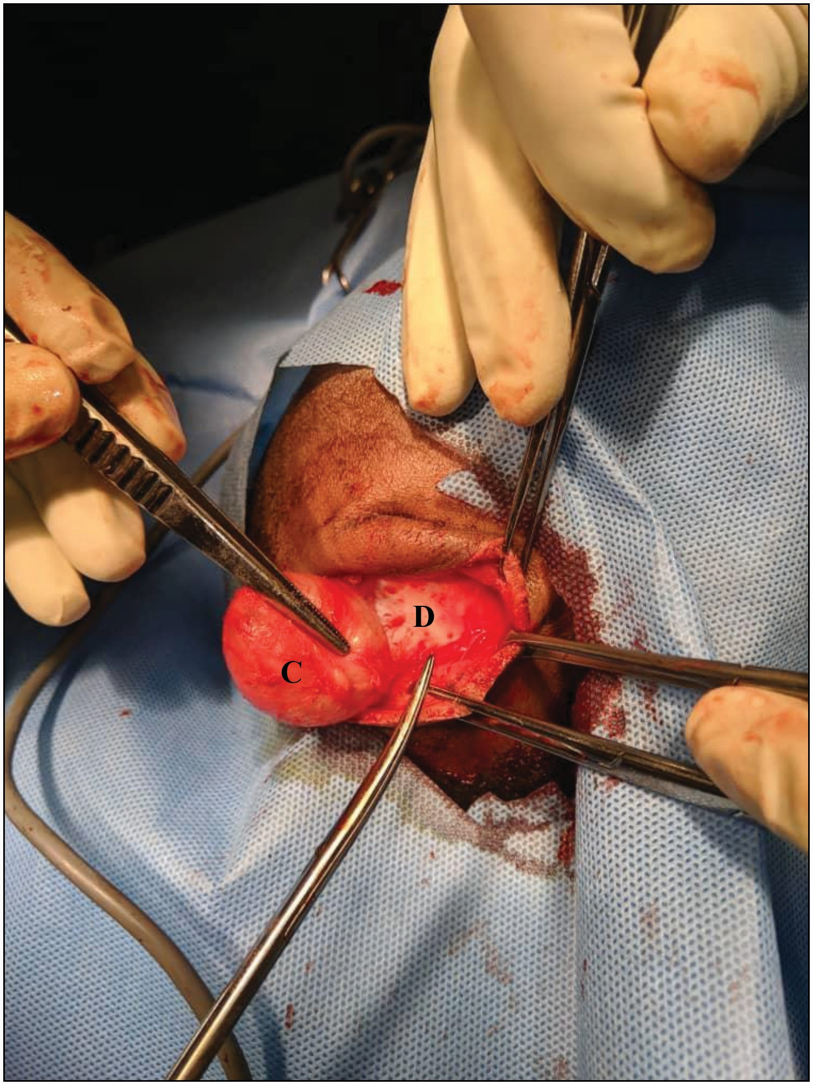

**Figure 4: The picture shows intraoperative removal of the cyst (C). The dural meninges (D) is demonstrated clearly**

However, CT exposes infants and children to the risk of ionising radiation, whereas MRI is not readily available in low resource countries, and even where available, high cost is a deterrent as most people pay out of pocket. CT and MRI were not done in this case due to the reasons mentioned above.

Ultrasonography has emerged as a very reliable, reproducible, accurate, readily available, cheap, and ionising radiation-free imaging modality for the evaluation of extracranial soft-tissue masses as well as intracranial evaluation in neonates and infants.[14,15] The primary imaging modality, in this case, was ultrasound. This included the B-mode and Doppler imaging of the superficial mass and transfontanelle imaging to assess intracranial extension. On B-mode ultrasound, the lesion was a less than 4 × 4cm, superficial, well-defined anechoic cystic mass located between the scalp and the echogenic dura over the anterior fontanelle region in agreement with the description of the previous authors.[2] The index case also showed hyperechoic lines and dots in different orientations within the imaging plane, giving the “dot and dash” sign or “dermoid mesh” sign, representing hair within the cyst. This sign has been mentioned in other dermoid cysts.[16] The “dots”depict echoes from hairs perpendicular to the scan plane, and the “dashes”echoes from hairs parallel to the scan plane.[16] Colour Doppler ultrasound of the mass showed neither colour nor sign of vascularity, whereas the transfontanelle ultrasound did not demonstrate the intracranial extension of this mass.

**Figure 5: (a) Histological section of the cyst shows a benign cyst filled with keratin flakes (arrows) and lined by stratified squamous epithelium (arrowheads) with associated underlying mature skin adnexal structures, H&E ×40. (b) Histological section of the cyst shows associated adnexal skin structures, hair follicle (arrow), and sebaceous glands (arrowheads), H&E ×100**

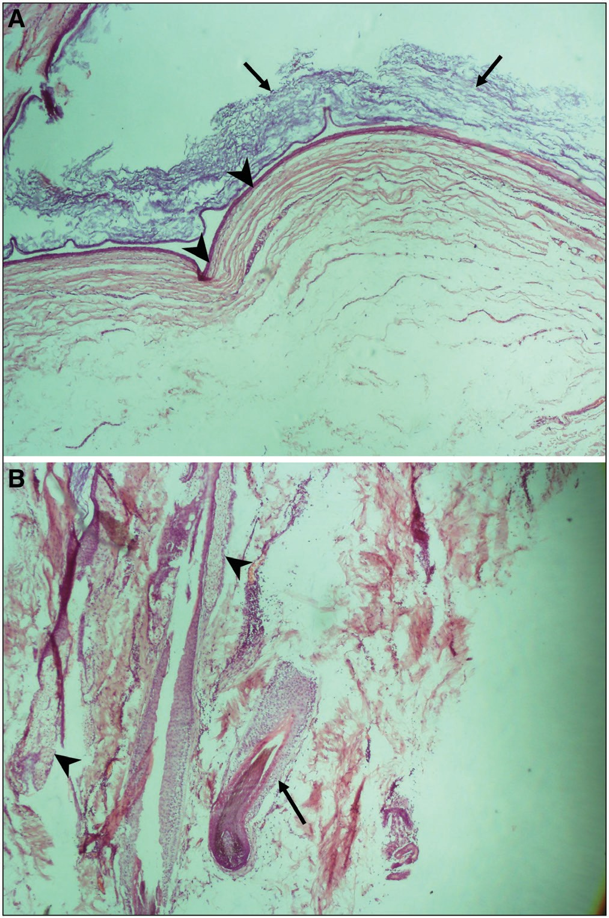The following differential diagnoses: epidermoid cyst, encephalocele, meningocele, cephalohaematoma, sebaceous cyst, pilonidal cyst, and sinus pericrania should be excluded in patients with similar clinical features as in the index patient.[1,6,10] An epidermoid cyst may closely resemble a dermoid cyst on imaging. However, on histological examination, both cysts have walls of connective tissue stroma lined with stratified keratinised squamous epithelium, but only dermoid cysts have dermal appendages.[6,7]

The sonographic imaging of swellings over the anterior fontanelle will help the surgeon know the nature of the mass and its relationship to intracranial structures, thereby facilitating treatment. In our index case, complete surgical excision of the cyst was done successfully without CT or MRI.

# Conclusion

Our case report underscores the importance of ultrasonography in diagnosing a congenital dermoid cyst over the anterior

fontanelle as the imaging findings correlated well with the intraoperative and histological findings. Additionally, in particular, radiation burdening CT scans should be restricted in infants and children.

## Declaration of patient consent

The authors certify that they have obtained all appropriate patient consent forms. In the form the patient(s) has/have given his/her/their consent for his/her/their images and other clinical information to be reported in the journal. The patients understand that their names and initials will not be published and due efforts will be made to conceal their identity, but anonymity cannot be guaranteed.

## Financial support and sponsorship

Nil.

## Conflicts of interest

There are no conflicts of interest.

# References

1. Agrawal A, Santhi V, Reddy VU. Subgaleal dermoid cyst of the anterior fontanelle in a child. Egypt J Radiol Nucl Med 2015;46:1171-4.
2. Tan EC, Takagi T. Congenital inclusion cysts over the anterior fontanel in Japanese children: A study of five cases. Childs Nerv Syst 1993;9:81-3.
3. Chaudhari AB, Rosenthal AD, Lipper S. Congenital inclusion cysts of the subgaleal space. Surg Neurol 1984;21:61-6.
4. Al-Gahtany M, Binitie O. Adeloye-Odeku disease in Aseer region of Saudi Arabia. J West Afr Coll Surg 2011;1:113-20.
5. Dadlani R, Ghosal N, Hegde AS. Bregmatic dermoid cyst in a patent anterior fontanelle. J Neurosci Rural Pract 2013;4:105-7.
6. Adeloye A, Odeku EL. Congenital subgaleal cysts over the anterior fontanelle in Nigerians. Arch Dis Child 1971;46:95-8.
7. Chaudhari AB, Ladapo F, Mordi VP, Choudhury KJ, Naseem A, Obe JA. Congenital inclusion cyst of the subgaleal space. J Neurosurg 1982;56:540-4.
8. Yan J, Li Y, Chen Q, Ye X, Li J. Rare orbital cystic lesions in children. J Craniomaxillofac Surg 2015;43:238-43.
9. De Maio PN, Mikulis DJ, Kiehl TR, Guha A. AIRP best cases in radiologic-pathologic correlation: Spinal conus dermoid cyst with lipid dissemination. Radiographics 2012;32:1215-21.
10. Adachi K, Ishii N, Takahashi H, Teramoto A. Congenital dermoid cyst at the anterior fontanelle: Neuroimaging before and after fontanelle closure. J Nippon Med Sch 2012;79:291-5.
11. Russel DS, Rubinstein LJ. Tumors and tumor-like lesions of maldevelopment origin. In: Bigner DD, McLendon RE, Bruner JM, editors. Pathology of Tumors of the Nervous System. 6th ed. New York, NY: Oxford University Press; 1998. p. 327-32.
12. Hidalgo J, Redett RJ 3rd, Soares BP, Cohen AR. Meet in the middle: A technique for resecting nasocranial dermoids-technical note and review of the literature. Childs Nerv Syst 2020;36:477-84.
13. de Aquino HB, de Miranda CC, de Britto Filho CA, Carelli EF, Borges G. Congenital dermoid inclusion cyst over the anterior fontanel: Report of three cases. Arq Neuropsiquiatr 2003;61:448-52.
14. Toprak H, Kiliç E, Serter A, Kocakoç E, Ozgocmen S. Ultrasound and Doppler US in evaluation of superficial soft-tissue lesions. J Clin Imaging Sci 2014;4:12.
15. Diwakar RK, Khurana O. Cranial sonography in preterm infants with short review of literature. J Pediatr Neurosci 2018;13:141-9.
16. Sahin H, Abdullazade S, Sanci M. Mature cystic teratoma of the ovary: A cutting edge overview on imaging features. Insights Imaging 2017;8:227-41.