**UPPER LUMBAR DISC PROLAPSE**

**Badejo OA1,2, Okunlola AI1, *Shokunbi MT1,2**

1Department of Neurological Surgery, University College Hospital Ibadan,

Nigeria

2Division of Neurological Surgery, Department of Surgery, College of Medicine, University of Ibadan, Nigeria

*Corresponding author:

Prof. M. T. Shokunbi

Department of Surgery, College of Medicine, University of Ibadan, Ibadan, Nigeria

Email: temitayoshokunbi@yahoo.com

**ABSTRACT**

Upper lumbar disc prolapse (ULDP) is a rare and a unique clinical entity which has a potentially devastating clinical outcome.It may manifest with low back or anterior thigh pain, polyradiculopathies (from spinal cord or cauda equina compression) and/or degenerative kyphoscoliosis. Its diagnosis is often difficult and may be missed because of the lack of specific root signs. Magnetic resonance imaging is the diagnostic modality of choice. Anterior, posterior and endoscopic approaches have been explored in the treatment of this pathology. However, the treatment outcome for ULDP has been found to be poorer compared to that of similar herniations at lower spinal levels. We report this case to draw attention to the need for a high index of suspicion to make the correct diagnosis.

**Keywords:** Upper Lumbar Disc Prolapse, Degenerative Kyphoscoliosis, Polyradiculopathies

**INTRODUCTION**

Disc prolapse of the upper lumbar spine constitutes a separate clinical entity compared to those below this region of the bony spine1-3. It is uncommon and has been associated with poorer prognosis compared to similar pathology in the lower lumbar spine1-4. We report a case of a patient with L2/L3 central disc prolapse.

**CASE REPORT**

A57-year-old man presented with a three-week history of sudden onset of severe low back pain radiating to the anterior surface of his left thigh. There was no limb weakness, numbness or sphincteric dysfunction. He had no previous history of trauma or spine surgery. The neurological deficits were in his lower limbs: weak left hip flexion (grade 4+); hyporreflexia of the knee jerks, arreflexia of the ankle jerks and absent plantar response bilaterally. Curiously, there was no sensory abnormality. He had a lumbosacral kyphoscoliotic deformity with convexity to the left and apex at the level of the L2/L3 intervertebral disc (IVD). Straight leg raising (SLR) was limited to 30o on the right and 20o on the left. Other examination findings were normal. A diagnosis of degenerative lumbar spine disease was made.

Magnetic resonance imaging (MRI) showed a reversed lumbar lordosis with kyphotic deformity and wedging of L2 vertebral body, multilevel disc desiccation at L2/L3, L3/L4, L4/L5, a large central intervertebral disc (IVD) prolapse at **L2/L3** with bilateral exit foramina narrowing (worse on the left) and disc bulges at T12/L1, L1/L2, L3/L4, L4/L5 and L5/S1 levels. (**Figures 1a and 2a**). He had partial L2 and L3 laminectomies alongside an L2/L3 discectomy. There was post-operative neurologic deterioration. Power was grade 4 in the muscle groups across the left hip and knee and also in the extensor hallucis longus on the left and grade 5 in other muscle groups. He also had L3, L4 hypoesthesia and arreflexia of the left knee and ankle jerk reflexes. There was complete resolution of pain and partial correction of the kyphoscoliosis and he was able to ambulate without support at the time of discharge from hospital two weeks post-operatively. Repeat MRI five months later showed decompression of the central spinal canal at L2/3 and obliteration of the left exit foramina at this level (**Figure 1b and 2b)**. At nine months after surgery, he had regained full power in all his muscle groups, the previously noted sensory abnormalities had resolved and the pre-operative spinal deformity noticeably improved .

**DISCUSSION**

We have described a middle-aged man with a large central L2/3 disc prolapse presenting with severe radicular low back pain, motor deficits, reflex abnormalities and acute kyphoscoliosis. A single level laminectomy and discectomy ameliorated the patient’s symptoms.

Lumbar disc prolapse (LDP) is infrequent in the upper lumbar spine, possibly because of the limited range of motion in this region2,4-6. ULDPs (involving L1/L2, L2/L3 +/- T12/L1 or L3/L4 intervertebral discs) account for less than 5% of all disc prolapses and are seen between the ages of 50 and 60 years3,7,8. Specifically, prolapse of L1/L2 and L2/L3 IVDs occur in 1 to 2% of all LDPs3,9. Conditions like pre-existing spine abnormalities, previous spine fusions/ surgeries, segmental instability and trauma have been associated with a predisposition to ULDP5,10. Our patient had no previous spine pathology which could have predisposed him to developing an L2-L3 disc prolapse, but fitted into the demography for this condition.

Clinical features of ULDP are ill-defined and can be atypical6,11,12. These include low back pain, neurogenic claudication, radicular pain or numbness along the region of distribution of the affected nerve roots (usually the anterior thigh) and limb weakness2,3,6,10,11. A single disc prolapse may cause polyradiculopathies because of the risk of compression of the conus medullaris and multiple nerve roots1,3,4,6,8,10. Autonomic dysfunction has been reported to be more common in ULDP than in lower LDP3,6,10. Paraparesis/ paraplegia are rare and when present, have been associated with achondroplasia7. Atrophy of the psoas and or quadriceps muscles could occur, and painful SLR may be present in about 50% of the patients7,11. A positive femoral stretch test is useful in diagnosis in 84-95% of cases11,13. Degenerative kyphosis and wedge-shaped vertebrae have been associated with ULDP as seen in the index patient12,14. Atypical presentations as an acute abdomen and as a lower abdominal swelling have been documented in previous reports15,16. Our patient had polyradiculopathies evidenced by the motor deficit (L2), reflex abnormalities (L3,L4, S1,S2) and radicular back pain (L2,L3). He had no sphincteric dysfunction despite the severity of the back of pain and presence of spinal deformity.

Diagnosis of upper LDP is sometimes difficult due to the paucity of specific root signs and misdiagnosis is not uncommon2,6,7. MRI is the investigating modality of choice, and was sufficient in confirming the diagnosis in our patient. Neuroimaging is essential for anatomical localization, surgical planning and ruling out other differential diagnoses2. A case of spinal glioblastoma multiforme mimicking an upper LDP has been reported in the literature17.

Anterior, posterior and endoscopic approaches have been explored in the treatment of this condition2. Possible posterior approaches described in the literature include unilateral laminectomy, bilateral laminectomy, and microdiscectomy1,2. Others include modified translaminar osseous channel-assisted percutaneous endoscopy, transdural approach (for calcified central ULDP), transforaminal approach via microendoscopy-assisted lumbar discectomy, and keyhole laminotomy8,18-20. An epiduroscopic laser neural decompression has been employed in the treatment of this condition21. Laminectomy and discectomy were effective and safe surgical options in our patient. He experienced a dramatic relief of his excruciating back pain as early as recovery from anaesthesia and had a significant reversal of his kyphosis within a week of surgery without any form of complex corrective spinal procedure. The long-term outcome of the associated spinal deformity remains to be seen in the index case (still being followed-up at our out-patient clinic.)

Prognosis is poorer in ULDP compared to lower LDP, and previous authors have documented post-operative neurologic deterioration as observed in our patient,who improved progressively over time back to his pre-morbid neurologic status and has maintained functional independence2,3.

**CONCLUSION**

Our patient’s clinical presentation and neuroimaging findings were in keeping with the diagnosis. Surgical treatment of his upper lumbar disc prolapse successfully ameliorated most of his symptoms. His spine deformity improved following surgical intervention. Despite the poorer prognosis associated with ULDP compared to lower ones, careful selection of surgical approach based on clinical and radiological characteristics can help achieve good surgical outcome4,10.

**Consent**

A written informed consent was obtained from the patient for use of his neuroimaging and for publication of this case report.

**REFERENCES**

1. Sanderson SP, Houten J, Errico T, Forshaw D, Bauman J, Cooper PR. The unique characteristics of "upper" lumbar disc herniations. Neurosurgery. 2004;55:385-9.
2. Kim DS, Lee JK, Jang JW, Ko BS, Lee JH, Kim SH. Clinical Features and Treatments of Upper Lumbar Disc Herniations. J Korean Neurosurg Soc. 2010;48:119-24.
3. Karaaslan B, Aslan A, Börcek AÖ, Kaymaz M. Clinical and surgical outcomes of upper lumbar disc herniations: a retrospective study. Turk J Med Sci. 2017;47:1157-1160
4. Awwal MA, Ahsan MK, Sakeb N. Outcome of symptomatic upper lumbar disc herniation. Mymensingh Med J. 2014;23:742-51
5. Hsu K, Zucherman J, Shea W, Kaiser J, White A, Schofferman J et al. High lumbar disc degeneration. Incidence and etiology. Spine. 1990;15:679-82.
6. Fontanesi G, Tartaglia I, Cavazzuti A, Giancecchi F. Prolapsed intervertebral disc at the upper lumbar level. Diagnostic difficulties. A report on 12 cases. Ital J Orthop Traumatol. 1987;13:501-7.
7. Vloeberghs M, Noterman J, Levivier M, Baleriaux D, Brotchi J. A patient with two upper lumbar disc herniations. Acta Orthop Belg. 1992;58:339-42
8. Zhijun X, Wenbo L, Jun A, Jianpu Q, Fang C, Zhiyuan Y et al. “A Modified Translaminar Osseous Channel-Assisted Percutaneous Endoscopic Lumbar Discectomy for Highly Migrated and Sequestrated Disc Herniations of the Upper Lumbar: Clinical Outcomes, Surgical Indications, and Technical Considerations.” BioMed Research International. 2017; 347:1-7. Article ID 3069575. https://doi.org/10.1155/2017/3069575
9. Bosacco SJ, Berman AT, Raisis LW, Zamarin RI. High lumbar disk herniations. Case reports. Orthopedics. 1989;12: 275-8
10. Lee DS, Park KS, Park MS. The Comparative Analysis of Clinical Characteristics and Surgical Results between the Upper and Lower disc herniations. J Korean Neurosurg Soc. 2013;54:379-83
11. Kido T, Okuyama K, Chiba M, Sasaki H, Seki N, Kamo K et al. Clinical diagnosis of upper lumbar disc herniation: pain and/or numbness distribution are more useful for appropriate level diagnosis. J Orthop Sci. 2016;21:419-24
12. Xu JX, Yang SD, Wang BL, Yang DL, Ding WY, Shen Y. Correlative analyses of isolated upper lumbar disc herniation and adjacent wedge-shaped vertebra. Int J Clin Exp Med 2015;8:1150-5
13. Estridge MN, Rouhe SA, Johnson NG. The femoral stretching test. A valuable sign in diagnosing upper lumbar disc herniations. J Neurosurg. 1982;57: 813-7
14. Iwasaki M, Akino M, Hida K, Yano S, Aoyama T, Saito H et al. Clinical and radiographic characteristics of upper lumbar disc herniation: ten-year microsurgical experience. Neurol Med Chir (Tokyo). 2011;51: 423-6
15. Khalatbari MR, Yahyavi ST, Borghei-Razavi H, Ghalaenovi H. Upper Lumbar Disc Herniation Presenting as Acute Abdomen. Acta Medica Iranica. 2009;47: 427-9
16. Bartolomei L, Carbonin C, Cagnin G, Toso V. Unilateral swelling of the lower abdominal wall. Unusual clinical manifestation of an upper lumbar disc herniation. Acta Neurochir. 1992;117(1-2):78-9
17. Choi WC, Lee JH, Lee SH. Spinal cord glioblastoma multiforme masquerading as high lumbar disc herniation. Surg Neurol. 2009;71:234-7
18. Choi JW, Lee JK, Moon KS, Hur H, Kim YS, Kim SH. Transdural approach for calcified central disc herniations of the upper lumbar spine. Technical note. J Neurosurg Spine. 2007;7:370-4
19. Takagi Y, Yamada H, Ebara H, Hayashi H, Kidani S, Toyooka K et al. Recurrent upper lumbar disc herniation treated via the transforaminal approach using microendoscopy-assisted lumbar discectomy: a case report. J Med Case Rep. 2018;12:110
20. Son S, Lee SG, Kim WK, Ahn Y. Key-hole Laminotomy (Translaminar Microsurgical Approach) for Upper Lumbar Herniated Disc. J Minim Invasive Spine Surg Tech. 2016:1:27-31
21. Jo D, Finch PM, Oh J. Epiduroscopic Laser Neural Decompression for Removal of L2–3 Disc Herniation in a Patient with Symptoms Suggestive of L5 Nerve Root Involvement. Pain Med. 2016;17:1386–8. doi: 10.1093/pm/pnv118

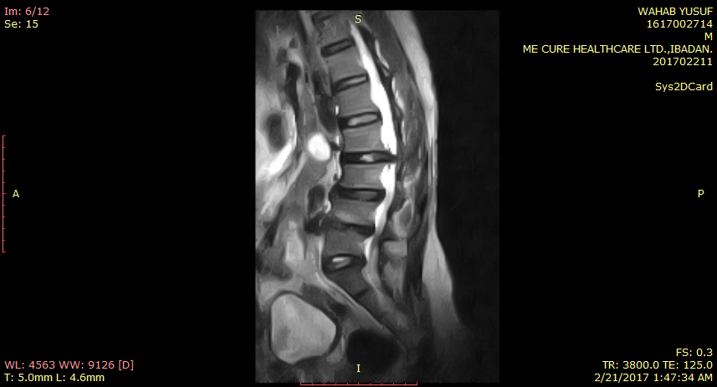

**1a**

**146o**

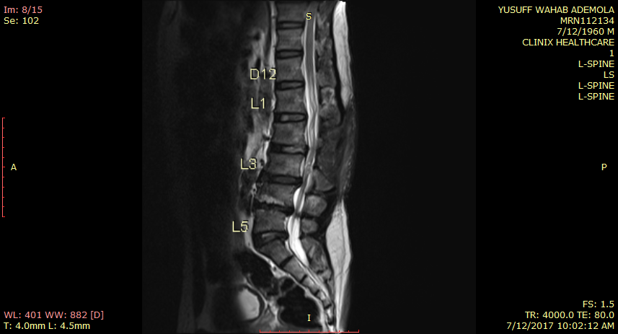

**1b**

**164o**

**L2**

**Figure 1: Sagittal T2-weighted MRI of the lumbosacral spine.**

1a: Pre-operative image showing a lumbar spine kyphotic deformity (grey lines), a large L2/L3 intervertebral disc prolapse (black arrow), multiple disc herniations from two levels above down to three levels below the reference point (white arrows) and a wedge-shaped vertebral transformation of L2 (green lines) adjacent to the disc prolapse. Adjacent wedge-shaped vertebra has been associated with ULDP.

1b: Neuroimaging five months after surgery. Note the post-laminectomy changes (absence of the spinous process of L2 and upper half of the L3 spinous process) and improvement in the degree of the lumbar kyphosis (grey lines). The white arrow indicates the remnant of the L3 spinous process. The herniated L2/L3 IVD in the pre-operative imaging has been eliminated (red arrow).

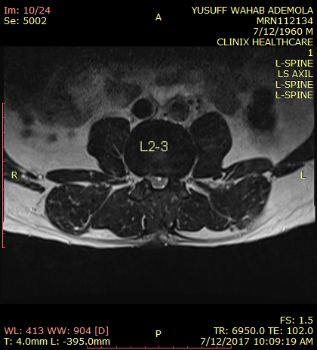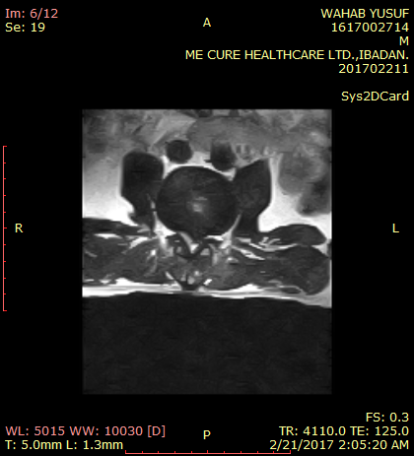

L2-3

**2b**

**2a**

**Figure 2: Pre-operative axial slice of the T2-weighted MRI of the lumbar spine at L2/L3 IVD level.**

2a: Pre-operative image showing a central disc herniation (red arrow head) with compromise of the spinal canal (black arrow).

2b: Axial T2-weighted image five months after surgery. Note the decompressed spinal canal (red arrow head) and the obliteration of the nerve root exit foramen, on the left, red arrow (compare with the right, white arrow).