**Case Report**

Unusual Hypopharyngeal Foreign Body (Meat Bolus) in a Cardiovascular Disease Patient

**Shuaib Kayode Aremu**

**Abstract**

A 50-year old post-cardiovascular disease trader was rushed to our hospital’s accident and emergency unit because of sudden onset noisy breathing associated with difficulty with breathing which had progressed for two days. Clinical examination revealed a patient in severe respiratory distress. We performed an urgent fibreoptic endoscopy to remove a meat bolus. It was found impacted in the hypopharynx with near-complete occlusion of the laryngeal inlet. He remained asymptomatic after the procedure and was subsequently transferred to the neurology unit for further management.

**Keywords:** *Foreign body, hypopharynx, meat bolus*

*ENT Department, College of Medicine and Health Science, Afe-Babalola University,*

*Ado-Ekiti, Ekiti State, Nigeria*

# Introduction

Foreign body ingestion and food bolus impaction are encountered commonly in clinical practice and are common endoscopic emergencies.[1] The majority of foreign body ingestions (75%) occur in the pediatric age group but frequently occur among the adult population (25%) also.[2,3] Impaction commonly occurs in the esophagus but can also be found in the airway depending on the nature of the substance ingested, the age of the patient, and the presence of a neurologic disorder.[4]

# Case Presentation

A 50-year old post-cardiovascular disease trader was rushed to the Accident and Emergency (AandE) unit of our hospital on account of sudden onset noisy breathing associated with difficulty with breathing which started two days before presentation. The complaints were heralded by the history of the patient trying to swallow a meat bolus during breakfast. There

distress, having grunting breathing. No neck swelling or neck mass was noted.

The patient was optimized and he subsequently had an emergency fiberoptic endoscopy done which revealed the meat bolus in the hypopharynx extending into the laryngeal inlet causing near- total occlusion [Figure 1]. The meat bolus was then removed with a Polypectomy snare. It measured about 6 cm x 5 cm x 2 cm in dimension [Figure 2]. There was an immediate dramatic improvement in his clinical symptoms after the removal of the meat bolus. A post removal endoscopy [Figure 3] revealed the epiglottis to be markedly oedematous but the laryngeal inlet was patent. The procedure was well-tolerated and no complications were recorded. He was subsequently transferred to the Neurology/ Stroke unit for further management and neuro- rehabilitation.

# Discussion

Upper aerodigestive tract foreign bodies often

**Received:** 09-Dec-2021 **Accepted:** 22-Mar-2022 **Published:** 08-Jun-2022

was associated hoarseness and choking feeling

present as surgical emergencies- particularly

but no cough and no vomiting.

He was a known systemic arterial hypertensive patient with poor drug compliance and had a left hemispheric ischaemic stroke a year earlier with a significant residual neurologic deficit (right-sided hemiparesis) despite physiotherapy.

On presentation in AandE he was conscious, extremely breathless, and in severe respiratory

given the possibility of a compromised airway.[5] Presentation depends on many factors such as age, size, type of the foreign body ingested, duration of ingestion, and underlying pathological conditions.[6,7] The clinical features depend on the site of impaction of the foreign body. In the airway, patients may present with choking, gagging, coughing, hoarseness of voice, breathlessness, stridor, chest tightness, wheezing, or cyanosis.[8] The

***Address for correspondence:***

*Dr. Shuaib Kayode Aremu, ENT Department, College of Medicine and Health Science, Afe-Babalola University*

*Ado-Ekiti, Nigeria.*

*E-mail:* [*aremusk@abuad.edu.ng*](mailto:aremusk@abuad.edu.ng)

predominant clinical features can indicate

|  |
| --- |
| **Access this article online** |
| **Website:**  [www.jwacs-jcoac.org](http://www.jwacs-jcoac.org/) |
| **DOI:** 10.4103/jwas.jwas_53_21 |
| **Quick Response Code:** |

This is an open access journal, and articles are distributed under the terms of the Creative Commons Attribution-NonCommercial- ShareAlike 4.0 License, which allows others to remix, tweak, and build upon the work non-commercially, as long as appropriate credit is given and the new creations are licensed under the identical terms.

**For reprints contact:** [reprints@medknow.com](mailto:reprints@medknow.com)

the section of the airway that is affected. For

**How to cite this article:** Aremu SK. Unusual hypopharyngeal foreign body (meat bolus) in a cardiovascular disease patient. J West Afr Coll Surg 2020;10:41-3.

© 2022 Journal of the West African College of Surgeons | Published by Wolters Kluwer ‑ Medknow 41

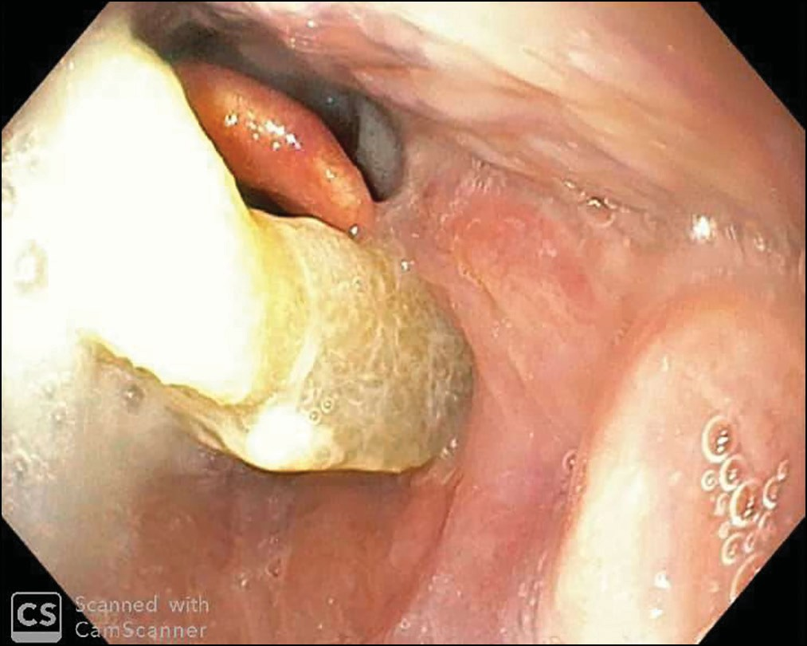

**Figure 1: Endoscopic image of a foreign body (meat bolus) in the hypopharynx causing significant laryngeal inlet obstruction**

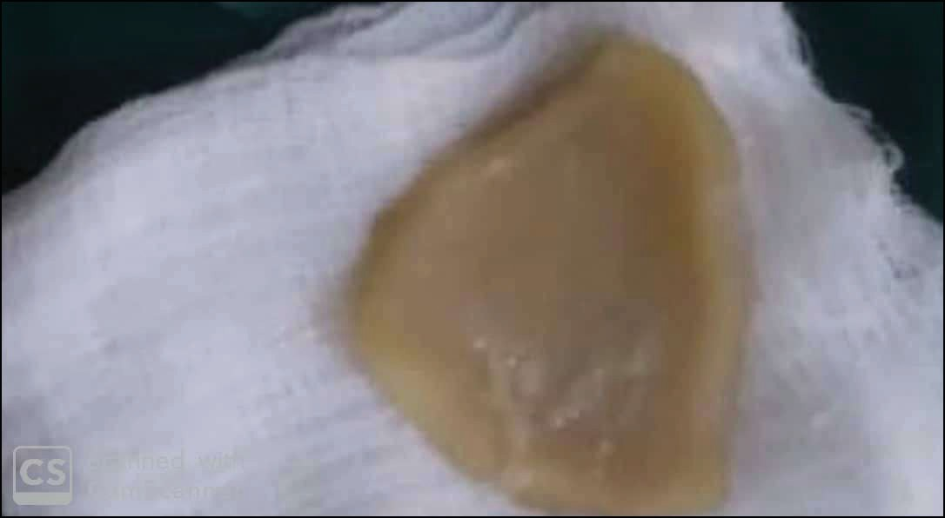

**Figure 2: The foreign body (meat bolus) specimen**

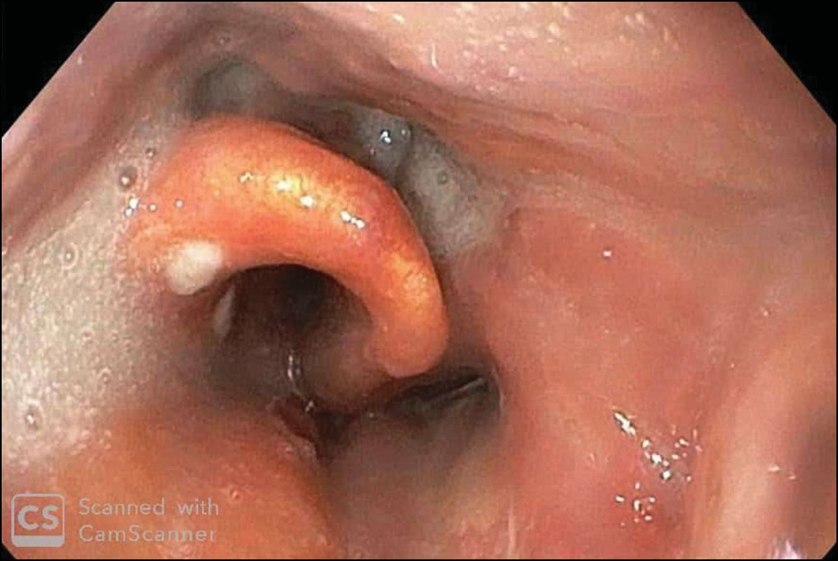

**Figure 3: Endoscopic image of the upper airway after removal the foreign body (meat bolus) reveals edematous epiglottis**

laryngotracheal foreign bodies, they include dyspnea, cough, and stridor, whereas those of bronchial foreign bodies include cough, decreased air entry, wheezing, and dyspnea.[8]

Airway impacted foreign bodies require urgent endoscopic removal because it can become rapidly life-threatening

with high morbidity and mortality. Foreign body aspiration accounts for 0.16–0.33% of adult bronchoscopic procedures.[9] The majority of oesophageal foreign bodies (80%–90%) pass spontaneously but 10%-20% of cases will require endoscopic removal, while less than 1% will need surgery for foreign body extraction or to treat complications.[10] In such a patient, it is important to preempt a possible failure of the fiberoptic oesophagoscopy to remove the foreign body. For this reason, there should be adequate preparation for an emergency tracheostomy to release the air because of the possibility of total airway occlusion during the oesophagoscopy. This will save the life of the patient first and the foreign body can be removed once the patient is stabilized through rigid oesophagoscopy.

# Conclusion

Accidental oesophageal foreign body ingestion is still a major problem among the elderly. The commonest foreign object recorded in studies was denture. However, this case report presented an unusual foreign body which is a meat bolus in a patient with an underlying risk factor, cardiovascular disease with left hemispheric stroke.

## Ethical approval and consent to participate

Ethical approval was obtained from the ethical committee of our institution.

**Availability of supporting data** All necessary data was obtained. **Authors’ contributions**

The sole author is Shuaib Kayode Aremu.

## Acknowledgements

I acknowledge all the staff members of A/E of our institution.

## Declaration of patient consent

The authors certify that they have obtained all appropriate patient consent forms. In the form the patient(s) has/have given his/her/their consent for his/her/their images and other clinical information to be reported in the journal. The patients understand that their names and initials will not be published and due efforts will be made to conceal their identity, but anonymity cannot be guaranteed.

## Financial support and sponsorship

Nil.

## Conflicts of interest

There are no conflicts of interest.

# References

1. Salih AM, Alfaki M, Alam-Elhuda DM. Airway foreign bodies: A critical review for a common pediatric emergency. World J Emerg Med 2016;7:5-12.

42 Journal of the West African College of Surgeons | Volume 10 | Issue 4 | October-December 2020

1. Baharloo F, Veyckemans F, Francis C, Biettlot MP, Rodenstein DO. Tracheobronchial foreign bodies: Presentation and management in children and adults. Chest 1999;115:1357-62.
2. Hsu Wc, Sheen Ts, Lin Cd, Tan Ct, Yeh Th, Lee Sy. Clinical experiences of removing foreign bodies in the airway and esophagus with a rigid endoscope: A series of 3217 cases from 1970 to 1996. Otolaryngol Head Neck Surg 2000;122: 450-4.
3. Pulcherio JOB, Magalhães EJC, Oliveira Velasco CMM, Resende LO, Ferreira AC, Gambassi BB, *et al*. Methods for esophageal foreign body removal among pediatric patients: 10 years? experience at a referral hospital. Curr Pediatr Res 2016;20:132-6.
4. Grochowski JJ, Hynes B. A toddler with a pharyngeal foreign body. Can Fam Physician 2008;54:1695-6.
5. Higo R, Matsumoto Y, Ichimura K, Kaga K. Foreign bodies in the aerodigestive tract in pediatric patients. Auris Nasus Larynx 2003;30:397-401.
6. Benjamin SB. Esophageal foreign bodies and food impactions. Gastroenterol Hepatol (N Y) 2008;4:546-8.
7. Blazer S, Naveh Y, Friedman A. Foreign body in the airway. A review of 200 cases. Am J Dis Child 1980;134:68-71.
8. Sehgal IS, Dhooria S, Ram B, Singh N, Aggarwal AN, Gupta D, *et al*. Foreign body inhalation in the adult population: Experience of 25,998 bronchoscopies and systematic review of the literature. Respir Care 2015;60:1438-48.
9. Athanassiadi K, Gerazounis M, Metaxas E, Kalantzi N. Management of esophageal foreign bodies: A retrospective review of 400 cases. Eur J Cardiothorac Surg 2002;21:653-6.



Journal of the West African College of Surgeons | Volume 10 | Issue 4 | October-December 2020 43