[Downloaded free from http://www.jwacs-jcoac.com on Friday, February 3, 2023, IP: 2.28.143.76]

**Original Article**

**Bland–Altman Plot: Agreement Between Ultrasound-measured Placenta Thickness and Other Biometric Parameters in the Determination of Gestational Age**



**Abstract**

**Purpose:** The aim of this article is to evaluate the agreement of placenta thickness (PT) with other foetal biometric parameters in the determination of gestational age (GA) in normal singleton foetuses. **Materials and Methods:** The study was a cross-sectional descriptive study conducted among 406 consecutively recruited pregnant women with singleton foetuses at 15–40 weeks of gestation at the National Hospital, Abuja, Nigeria from October to December 2019. Biparietal diameter (BPD), femur length (FL), head circumference (HC), abdominal circumference (AC), and PT were measured using standard measurement protocols. Bland and Altman (BA) plots were used to compare PT and other foetal biometric parameters. The significant statistical level was determined at a critical value of *P* < 0.05. **Results:** The mean age of study participants was 31.8±4.8 years. The BA plot of PT and HC demonstrated a normal distribution; the mean difference was around zero (3.968) and 95% of the measurements fell within 2SD of the mean. The BA plot of HC and AC measurements also showed that the 95% limits of agreement for differences fell within 10% of the mean of the measurements (-4.236 to 15.987 with a mean difference of 5.876), indicating good agreement between the two pairs of variables. However, BA plots between PT and BPD as well as PT and FL showed no agreement. **Conclusion:** This study indicates that there is good agreement or comparability between PT and HC measurements as well as between PT and AC measurements. Hence, either HC or AC measurements may be interchangeable with PT measurements in the ultrasound determination of GA. However, PT measurements did not agree well with BPD and FL measurements, respectively.

**Keywords:** *Altman, Bland, gestational age, placenta, plot, thickness*

**Omolara Adepate Olaleye, Olubunmi O. Olatunji, Kamaldeen O. Jimoh,**

**Abiola O. Olaleye1**

*Department of Radiology, National Hospital, Abuja, 1Department of Community Health, Obafemi Awolowo University Teaching Hospitals Complex, Ile Ife, Nigeria*

**Introduction**

Accurate dating is critically important for the management of pregnancy from the first trimester to delivery, especially in premature labour and post-dates pregnancies.[1] Although a few days of inaccuracy was acceptable in the past, recent studies have shown that inaccuracy of a few days may adversely affect pregnancy management such as the performance of maternal serum screening tests and the management of post-date pregnancies.[2,3] The current body of knowledge shows that sonographically derived dates are the most accurate method of gestational age (GA) determination for clinical use.

Different formulae including ultrasound-measured foetal biometric parameters such as biparietal diameter (BPD), head circumference (HC), abdominal

This is an open access journal, and articles are distributed under the terms ofthe Creative CommonsAttribution-NonCommercial-ShareAlike 4.0 License, which allows others to remix, tweak, and build upon the work non-commercially, as long as appropriate credit is given and the new creations are licensed under the identical terms.

**For reprints contact:** reprints@medknow.com

circumference (AC), and femur length (FL) are being used to estimate GA.[4] In recent times, several formulae have been developed, predicting GA using BPD, HC, AC, and FL at certain periods during pregnancy.[5,6]

Placenta thickness (PT) is often considered a good estimate of GA, comparable with other foetal biometric parameters (BPD, HC, AC, and FL).[7,8] While linear relationships between PT and other biometric parameters have been described in literature,[8] the extent to which PT can be used in place of other established parameters (BPD, HC, AC, and FL) in the determination of GA has not been fully explored in literature. Studies have shown that two quantitative measurements may be used interchangeably if both measurements agree.[9-14]

The authors often aim to determine the agreement between two parametric measures to determine whether they may

**How to cite this article:** Olaleye OA, Olatunji OO, Jimoh KO, Olaleye AO. Bland–Altman plot:Agreement between ultrasound-measured placenta thickness and other biometric parameters in the determination of gestational age. J West Afr Coll Surg 2022;12:46-51.

**Received:** 02-Aug-2022 **Accepted:** 17-Aug-2022 **Published:** 23-Nov-2022

***Address for correspondence:*** *Dr. Abiola O. Olaleye, Department of Community Health, Obafemi Awolowo University Teaching Hospitals Complex, Ile Ife, Nigeria.*

*E-mail: kayodeolaleye2012@ gmail.com*

**Access this article online**

**Website:**

www.jwacs-jcoac.com

**DOI:** 10.4103/jwas.jwas_165_22

**Quick Response Code:**

46 © 2022 Journal of the West African College of Surgeons | Published by Wolters Kluwer ‑ Medknow

[Downloaded free from http://www.jwacs-jcoac.com on Friday, February 3, 2023, IP: 2.28.143.76]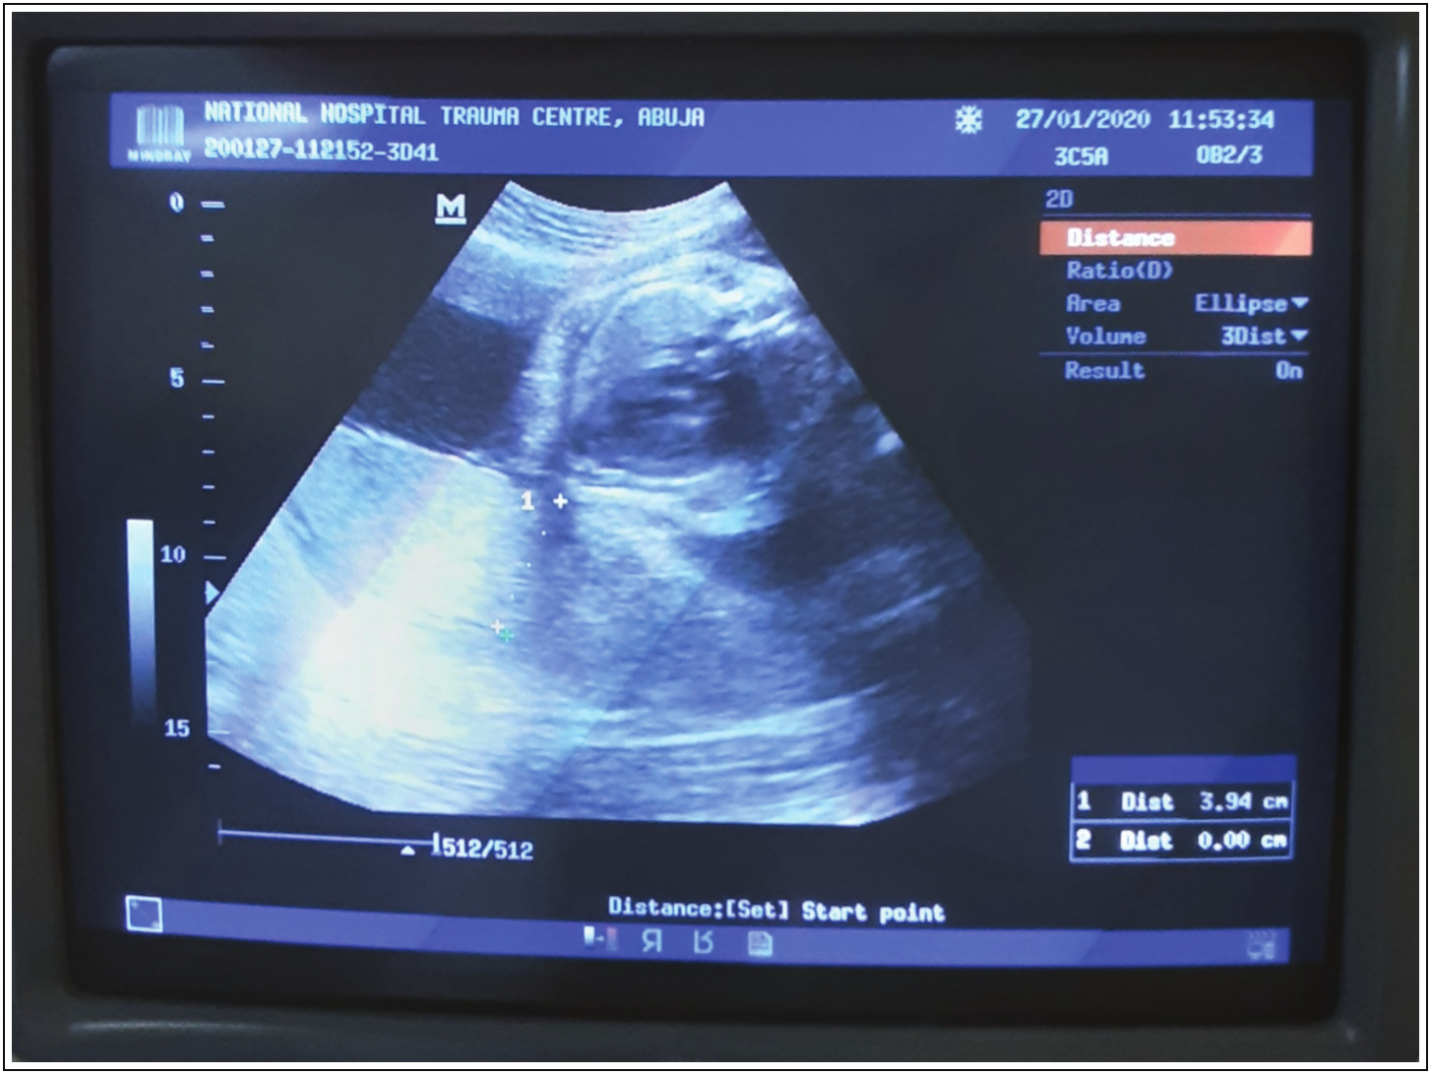

Olaleye, *et al.*: Bland–Altman plot

be used interchangeably especially in situations in which the use of established measures is either not possible or not suitable. It is important that such studies are conducted with the appropriate statistical methods suitable for testing agreement between two sets of quantitative data.[15] One of the methods used to assess the relationship between the measurement of PT and other established foetal biometric parameters in the estimation of GA is the product–moment correlation coefficient.[8,16] While correlation test can determine linear association between two quantitative variables, it does not provide a useful answer to the agreement between two quantitative methods of measurement.[9] Bland and Altman (BA) analysis has been reported as a suitable method for evaluating the extent of agreement between two quantitative measurement methods.[10,11,17] While BA analysis has been used in a previous study in the determination of estimated foetal weight using foetal biometric parameters,[18] there is paucity of literature on its use in the determination of GA. Therefore, this study aims to evaluate the agreement of PT with other biometric parameters (including BPD, HC, AC, and FL) in the determination of GA.

**Materials and Methods**

This cross-sectional study was conducted at the Department of Radiology, National Hospital, Abuja (NHA), Nigeria. Pregnant women with singleton pregnancy who were between 15 and 40 weeks’ GA were recruited into the study. The inclusion criteria were as follows: (i) singleton pregnancies, 15–40 weeks; (ii) history of regular menstruation; (iii) pregnant women sure of the last menstrual period (LMP), confirmed by early obstetric ultrasound scan; and (iv) women who gave consent for inclusion in the study. Pregnant women excluded from the study were as follows: (a) those with gestational diabetes, hypertension in pregnancy, anaemia, uterine masses, absence of an early obstetric ultrasound scan, rhesus isoimmunization, and women who do not give consent and (b) women whose foetus had suspected intrauterine growth restriction, hydrops fetalis, congenital malformations, multiple pregnancies, amniotic fluid conditions, renal pathology, gross foetal hydronephrosis, and foetal structural abnormality. Women who have placenta previa, poor visualization of the placenta, and other placental anomalies were also excluded. Pregnant women who had these conditions were excluded from this study to ensure comparability with previous studies.[7,8]

Using the formula for calculating the sample mean,[19] a minimum sample size was determined for this study, in which *Z* is the standard normal variate; *σ* is the standard deviation of the mean placental thickness; and *E* is the desired error margin. This study used *Z* = 1.96 (for 95% confidence interval); *E* = 0.5; *σ* the standard deviation of placental thickness derived from a previous study = 4.9.[20] Entering these values into the equation,

*n* =  (1.96*4.9) 2 ,  

 

0 5

.





*n* = 369. The study employed a sample size of 406 after accounting for the anticipated 10% non-response.

Using a trans-abdominal Phillips Ultrasound Scanner HD II XE (The Netherlands, 2012) with a 3–5 MHz curvilinear array probe, foetal biometric parameters including the BPD, FL, HC, AC, and PT were measured using standard protocols.[21] PT (in millimetres) was measured at the mid-portion of the placenta, at the level of umbilical cord insertion [Figure 1]. All measurements were made on still images captured with the freeze facility of the US scanner with the on-screen electronic caliper of the US unit. For each foetal biometric parameter, three best measurements and the mean of the measurements were taken and recorded for each participant.

GA estimation was done in two ways: by data and by ultrasound. Estimation of GA (by date) was based on a reliable recollection of the first day of the LMP and validated by a previous first trimester US scan. With participants’ LMP, Naegele’s rule was used to calculate the GA by date (in weeks).[22] Estimation of GA (by ultrasound) was done through theHadlockformula-basedalgorithmof the scanner.

**Statistical analysis**

Pearson’s correlation analysis as well as a correlation matrix was computed to determine linear relationships among BPD, AC, HC, FL, PT, and GA. To appraise the agreement between PT and other foetal biometric parameters, BA analysis, an evaluation of the difference between two quantitative measurements via a graphical method, was used. The respective differences between PT and BPD, HC, FL, and AC measurements were calculated. Similarly, the respective means of PT and BPD, HC, FL, and AC measurements were also calculated. The respective limits of

**Figure 1: US image showing a placenta that is relatively homogeneous in echotexture**

Journal of the West African College of Surgeons | Volume 12 | Issue 4 | October‑December 2022 47

[Downloaded free from http://www.jwacs-jcoac.com on Friday, February 3, 2023, IP: 2.28.143.76]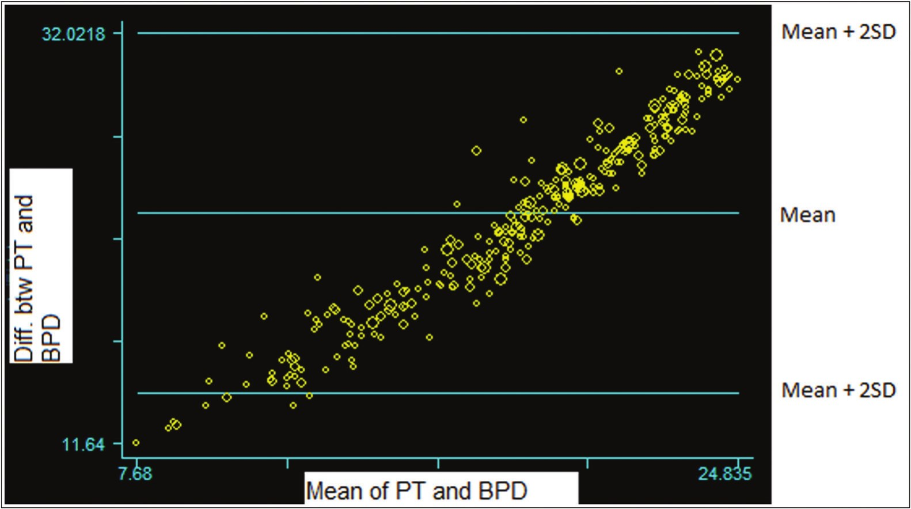

Olaleye, *et al.*: Bland–Altman plot

agreement for BPD, HC, FL, and AC were then calculated using the formula: mean of difference of two measurements ± (1.96 × Standard deviation of difference).[12] A scatter plot (BA Plot) was then constructed with the difference between paired quantitative measurements on the *y*-axis and the mean of the same pair of measurements on the *x*-axis.[9,11,23]

Ethical clearance for the study was obtained from the Research Ethics Committee of the National Hospital, Abuja, Nigeria. Informed consent was also obtained from the selected participants.

**Results**

There were 406 participants in the study with age ranging from 22 to 49 years, and the mean (±SD) age was 31.8±4.8 years. The mean (±SD) values of the participants’ weight and height were 81.7±14.7 kg and 1.6±0.1 m, respectively. Almost 3 out of 10 (27.3%) participants were primigravida, 29.1% primiparous, 40.6% multiparous, and 3.0% grand multiparous women.

The mean measurements of PT, BPD, HC, AC, and FL at 15 weeks were 16.8, 23.6, 8.7, 7.8, and 14.8 mm, respectively. In contrast, the mean PT, BPD, HC, AC, and FL at 40 weeks were 37.9, 91.3, 33.2, 34.0, and 75.2 mm, respectively.

A strong positive correlation between BPD and PT (*r*=0.831, *P* = 0.00) was observed. Comparing the BPD and PT measurements, the BA’s limits of agreement was from 14.193 to 32.022. The mean difference was 23.107 (95% CI: 22.672–23.542), and a statistically significant difference in variability between the PT and BPD measurements (*P* = 0.000) was found, indicating significant variance between the two measurements [Figure 2].

A strong positive correlation was found between PT and HC (*r*=0.813, *P* = 0.00). The BA plot conducted to test

agreement of PT and HC measurements demonstrated normal distributions; the mean difference was around zero (3.968) and 95% of the measurements fell within 2SD of the mean. Furthermore, the difference in variability between the two measurements (PT and HC) was non-significant (*P* = 0.403), indicating good agreement/comparability between the PT and HC measurements [Figure 3].

A strong positive correlation exists between PT and AC (*r*=0.771, *P* = 0.00). The BA plots for PT and AC measurements demonstrated normal distributions, and 95% of the measurements fell within 2SD of the mean. The difference in variability between the two measurements (PT and AC) was non-significant (*P*= 0.950). Furthermore, the 95% limits of agreement for differences between the PT and AC measurements fell within 10% of the mean of the measurements (-4.236 to 15.987 with a mean difference of 5.876), indicating good agreement/comparability between the two measurements [Figure 4].

The correlation between PT and FL was strongly positive (*r*=0.836, *P* = 0.00). BA’s limits of agreement for PT and FL measurements were from 13.182 to 38.156 with a mean difference of 25.669 [Figure 5]. There was a statistically significant difference in variability between the two measurements (*P* = 0.00), indicating a significant variance between PT and FL measurements.

BA discussed the interpretation of BA plots in previous studies (references). If the data points in a specific BA plot are very close to the zero line, it signifies a good level of agreement between the two methods under investigation. A weak agreement between the two measurement methods is implied if the data points are far from the zero line. Furthermore, if the constructed limits of agreement are within clinical acceptable differences, the two methods may be said to be interchangeable.

**Figure 2: Bland and Altman plot for PT and BPD**

48 Journal of the West African College of Surgeons | Volume 12 | Issue 4 | October‑December 2022

[Downloaded free from http://www.jwacs-jcoac.com on Friday, February 3, 2023, IP: 2.28.143.76]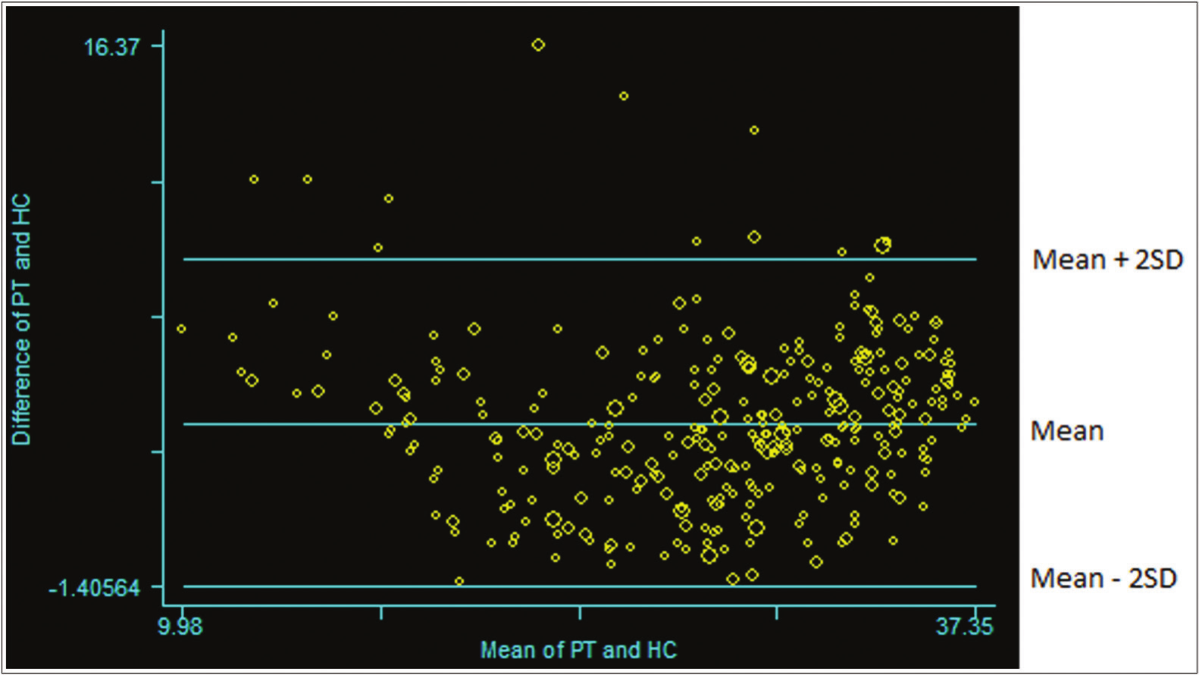

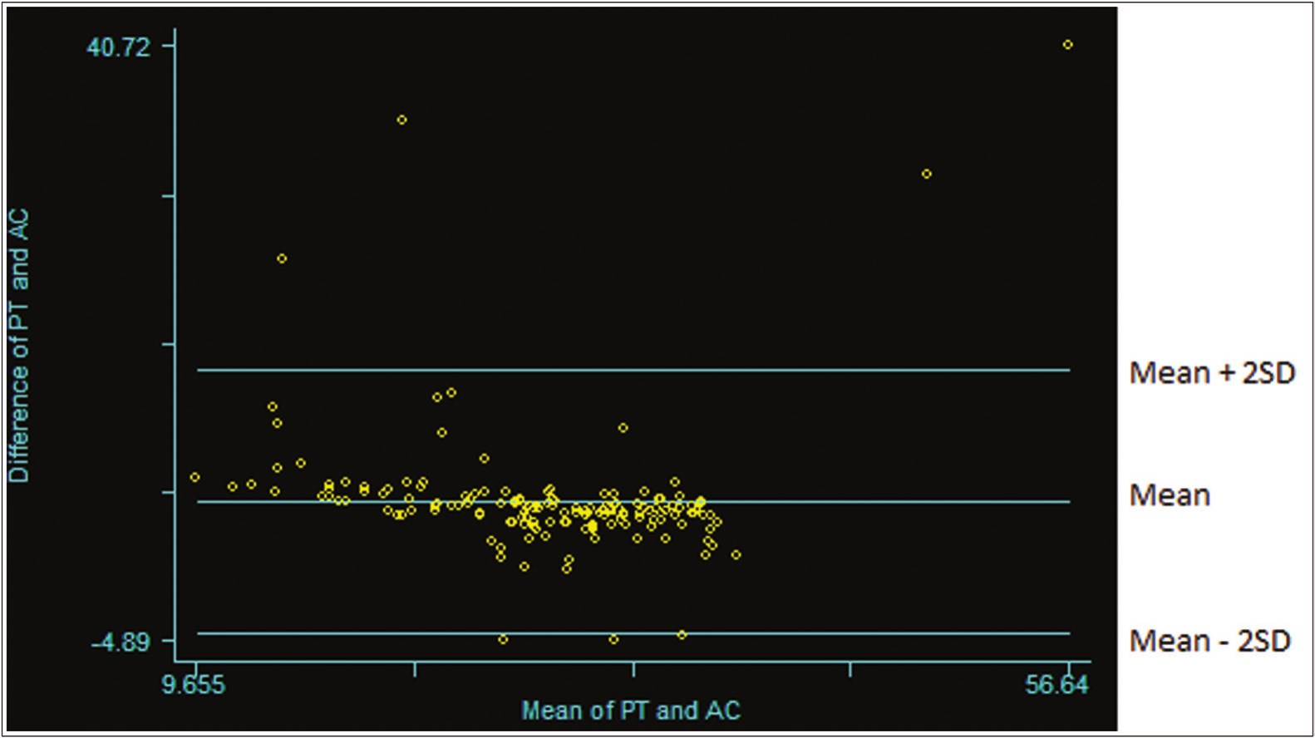

Olaleye, *et al.*: Bland–Altman plot

**Figure 3: Bland and Altman plot for PT and HC**

**Figure 4: Bland and Altman plot for PT and AC**

Of the four foetal biometric parameters compared with PT in the study, only HC and AC measurements are in agreement with PT measurements. This implies that PT measurement may be a potential biometric parameter that may be used.

**Discussion**

This study evaluated the agreement of PT with other biometric parameters (BPD, HC, AC, and FL) in the determination of GA. The study found that all foetal biometric parameters had a strong positive correlation with PT. However, only HC and AC agreed with PT using the BA plots as a measure of agreement.

As the foetus grows, placenta size increases, enabling it to perform to its vital functions. It is therefore expected that

the thickness of the placenta will be linearly related to the GA. Our study showed that PT is strongly positively correlated with BPD, HC, and AC, respectively. This finding is in keeping with the study conducted by Ohagwu *et al.*,[24] which showed that there was a statistically significant positive correlation between PT and BPD, on the one hand, and between PT and AC, on the other hand.

Studies have shown that correlation depends on the range and distribution of two variables.[10,12,17] Furthermore, the correlation test usually shows that as a variable increases the second variable being compared also increases if the correlation is positive, or decreases if there is negative correlation between them. However, correlation is unable to provide a useful answer to the agreement between two quantitative methods of measurement.

Journal of the West African College of Surgeons | Volume 12 | Issue 4 | October‑December 2022 49

[Downloaded free from http://www.jwacs-jcoac.com on Friday, February 3, 2023, IP: 2.28.143.76]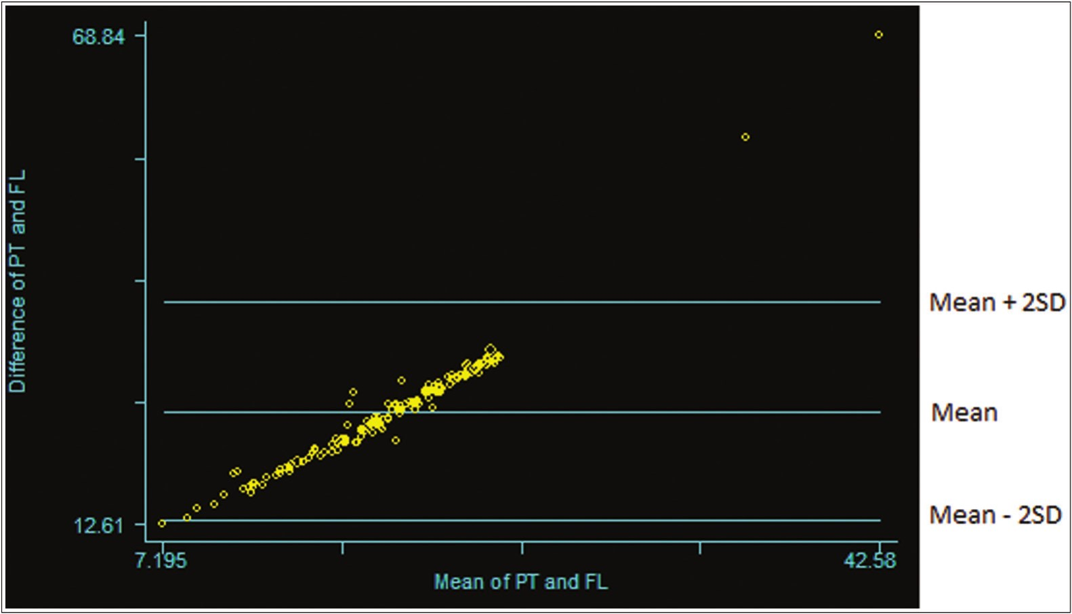

Olaleye, *et al.*: Bland–Altman plot

**Figure 5: Bland and Altman plot for PT and FL**

Majority of the studies conducted on PT and GA assessments only used correlation tests.[24,25] To the best of our knowledge, our study is the first one that considered a test of agreement in addition to correlation in the study of relationship between PT and other foetal biometric parameters.

Our study has a limited number of participants. A large (multicentre) study is recommended to enable a more rigorous evaluation of the limits of agreement of PT and other biometric parameters with a view to determining whether PT can be used in place of any of the other foetal biometric parameters (BPD, HC, AC, FL) in estimating GA in singleton pregnancies.

**Conclusion**

This study showed that comparing two quantitative measurement methods using the limits of agreement approach is fundamentally simple and useful. While PT showed a strong positive linear relationship with other foetal biometric parameters, only HC and AC agree significantly with PT in the estimation of GA of singleton foetuses.

**Acknowledgements**

The authors would like to thank all persons who made this research work a reality. We would like to thank the patients who provided consent to be enrolled in this study. Special thanks to the staff of the Department of Obstetrics and Gynaecology, National Hospital, Abuja, Nigeria. We would like to thank consultants and residents of the Department of Radiology, National Hospital, Abuja, Nigeria for their invaluable contributions during the design, implementation of the project, and writing of this study. The first author would like to express her gratitude to her supervisors, Dr OOO and Dr KOJ, for their extraordinary efforts and guidance which made this project a reality.

**Ethical statements**

This study was performed in keeping with the principles of the Declaration of Helsinki. Approval was granted by the Research Ethics Committee of the National Hospital, Abuja, Nigeria (NHA/EC/050/2019). Informed consent was obtained from all individual patients who participated in the study. The authors affirm that research participants provided informed consent for publication of the images in the manuscript.

**Authors’ contributions**

All authors contributed to the study conception and design. Material preparation, data collection, and analysis were performed by OAO, OOO, KOJ, and AOO. The first draft of the manuscript was written by OAO and all authors commented on previous versions of the manuscript. All authors read and approved the final manuscript.

**Financial support and sponsorship**

Nil.

**Conflicts of interest**

The authors have no relevant financial or non-financial interests to disclose.

**References**

1. Kalish RB, Chervenak FA. Sonographic determination of gestational age. Ultrasound Rev Obstet Gynecol 2005; 5:254-8.

2. Caughey AB, Nicholson JM, Washington AE. First- vs second-trimester ultrasound: The effect on pregnancy dating and perinatal outcomes. Am J Obstet Gynecol 2008;198:703.e1-5; discussion 703.e5-6.

3. Caughey AB, Snegovskikh VV, Norwitz ER. Postterm pregnancy: How can we improve outcomes? Obstet Gynecol

Surv 2008;63:715-24.

50 Journal of the West African College of Surgeons | Volume 12 | Issue 4 | October‑December 2022

[Downloaded free from http://www.jwacs-jcoac.com on Friday, February 3, 2023, IP: 2.28.143.76]

Olaleye, *et al.*: Bland–Altman plot

4. Hadlock FP, Deter RL, Harrist RB, Park SK. Estimating fetal age: Computer-assisted analysis of multiple fetal growth parameters. Radiology 1984;152:497-501.

5. Verburg BO, Steegers EA, De Ridder M, Snijders RJ, Smith E, Hofman A, *et al*. New charts for ultrasound dating of pregnancy and assessment of fetal growth: Longitudinal data from a population-based cohort study. Ultrasound Obstet Gynecol 2008;31:388-96.

6. Loughna P, Chitty L, Evans T, Chudleigh T. Fetal size and dating: Charts recommended for clinical obstetric practice. Ultrasound 2009;17:160-6.

7. Njeze NR, Ogbochukwu JO, Chinawa JM. Correlation of ultrasound placental diameter and thickness with gestational age. Pak J Med Sci 2020;36:1058-62.

8. Agwuna KK, Eze CU, Ukoha PO, Umeh UA. Relationship between sonographic placental thickness and gestational age in normal singleton fetuses in Enugu, Southeast Nigeria. Ann Med Health Sci Res 2016;6:335-40.

9. Giavarina D. Understanding Bland–Altman analysis. Biochem Med (Zagreb) 2015;25:141-51.

10. Chhapola V, Kanwal SK, Brar R. Reporting standards for Bland–Altman agreement analysis in laboratory research: A cross-sectional survey of current practice. Ann Clin Biochem 2015;52:382-6.

11. Doğan NÖ. Bland–Altman analysis: A paradigm to understand correlation and agreement. Turk J Emerg Med 2018;18:139-41.

12. Sedgwick P. Limits of agreement (Bland–Altman method). Br Med J 2013;346:f1630.

13. Bland JM, Altman DG. Statistical methods for assessing agreement between two methods of clinical measurement. Lancet 1986;1:307-10.

14. Bland JM, Altman DG. Agreed statistics: Measurement method

comparison. Anesthesiology 2012;116:182-5.

15. McAlinden C, Khadka J, Pesudovs K. Statistical methods for conducting agreement (comparison of clinical tests) and precision (repeatability or reproducibility) studies in optometry and ophthalmology. Ophthalmic Physiol Opt 2011;31:330-8.

16. Azagidi AS, Ibitoye BO, Makinde ON, Idowu BM, Aderibigbe AS. Fetal gestational age determination using ultrasound placental thickness. J Med Ultrasound 2020;28:17-23.

17. Gerke O. Reporting standards for a Bland–Altman agreement analysis: A review of methodological reviews. Diagnostics (Basel) 2020;10:334.

18. Burd I, Srinivas S, Paré E, Dharan V, Wang E. Is sonographic assessment of fetal weight influenced by formula selection? J Ultrasound Med 2009;28:1019-24.

19. Charan J, Biswas T. How to calculate sample size for different study designs in medical research? Indian J Psychol Med 2013;35:121-6.

20. HabibFA. Prediction of low birth weight infants from ultrasound measurement of placental diameter and placental thickness. Ann Saudi Med 2002;22:312-4.

21. Necas M. The clinical ultrasound report: Guideline for sonographers. Australas J Ultrasound Med 2018;21:9-23.

22. Loytved CA, Fleming V. Naegele’s rule revisited. Sex Reprod Healthc 2016;8:100-1.

23. Bland JM, Altman DG. Measuring agreement in method comparison studies. Stat Methods Med Res 1999;8:135-60.

24. Ohagwu CC, Abu PO, Ezeokeke UO, Ugwu AC. Relationship between placental thickness and growth parameters in normal Nigerian foetuses. Afr J Biotechnol 2009;8. Available from: https://www.ajol.info/index.php/ajb/article/view/59751.

25. Karthikeyan T, Subramaniam RK, Johnson W, Prabhu K. Placental thickness and its correlation to gestational age and foetal growth parameters—A cross sectional ultrasonographic

study. J Clin Diagn Res 2012;6:1732-5.

Journal of the West African College of Surgeons | Volume 12 | Issue 4 | October‑December 2022 51