**Original Article**

Treatment of Haemorrhoidal Disease by Laser Haemorrhoidoplasty at Dakar Preliminary Study of 21 Patients

**Balla Diop1,2,**

**Abstract**

**Background:** Surgical treatment of haemorrhoidal disease by laser haemorrhoidoplasty is a minimally invasive procedure that facilitates the postoperative course. Due to less aggression on the anoderm and the anal canal mucosa, it causes less significant postoperative pain and low morbidity compared with conventional excision according to the Milligan–Morgan or Fergusson procedure. We report, through a preliminary study, our data on laser haemorrhoidoplasty and discuss the indications and results. **Materials and Methods:** This is a descriptive prospective study carried out on 21 patients operated on for haemorrhoidal disease by laser haemorrhoidoplasty with or without mucopexy. **Results:** The series was composed of 17 men and 4 women with a male/female ratio of 4.25:1. The average age was 39.6 years with a range of 27–62 years. The symptomatology was rectal bleeding in 16 cases (76%) and anal swelling in 18 cases (85.7%). These include grade 2 haemorrhoids in 2 cases (9.5%), grade 3 in 12 cases (57%), and grade 4 in 7 cases (33%). It was associated with an anal fissure in four cases (19%) and an anal fistula in three cases (14.2%). Mucopexy and laser coagulation were performed therapeutically in 13 cases (61.9%) and laser coagulation without mucopexy was performed in 8 cases (38%). The energy delivered was on average 1488 or 496 J per pile. It was associated with skin tag excision in 18 cases (85.7%), fissurectomy, sphincterotomy, anoplasty in 4 cases (19.2%), and fistulectomy for low anal fistula in 2 cases (9.5%). Piles retraction was judged sufficient in 17 patients (81%). The postoperative course was simple with no notable complaints in 16 patients (76%). Complications consisted of minimal bleeding in six cases (28%), significant bleeding in two cases with readmission, residual skin tag in six cases (28.5%), and subcutaneous fistula in two cases (9.5%). No recurrence of the symptoms of the haemorrhoidal disease was noted. **Conclusion:** Laser haemorrhoidoplasty is a minimally invasive alternative for the treatment of haemorrhoidal disease, especially for grade 2 and 3 haemorrhoids without major prolapse. Postoperative pain is minimal, and the risk of stenosis or incontinence is almost non-existent.

**Keywords:** *Anus, good outcome, haemorrhoids, laser haemorrhoidoplasty, proctology*

## Pape Abdoulaye Ba1,2, Ahmet Diouf2,

**Baba NDiaye, Adamson Phiri2, Cheikna Sylla2**

*Department of Surgery, Ouakam Military Hospital, BP 24175 Dakar, Senegal, 1Department*

*of General Surgery Regional Hospital Center of Thiès, Senegal, 2UFR Sciences de la Sante/Iba Der Thiam University of Thiès, Senegal*

# Introduction

Haemorrhoids are normal vascular structures of the anal canal which participate in fine anal continence.[1] Their dilatation under the effect of multiple factors can generate symptoms dominated by rectal bleeding, anal discomfort, anus pruritus, or anal swelling. They become a concern in 4% of the patients and require

the pathogenesis of the haemorrhoidal disease, which considers arterial flow (overflow) as one of the causes of haemorrhoids packets’ dilatation.[2] It is therefore the object of new treatments proposed such as arterial ligation guided or not by Doppler, radiofrequency, or laser haemorrhoidoplasty. The laser associated or not with mucopexy coagulates the vessels and favours a progressive retraction of the

**Received:** 19-Apr-2022 **Accepted:** 04-May-2022 **Published:** 29-Jul-2022

medical or instrumental treatment, which

haemorrhoidal packets. It better keeps intact

have a suspensive effect on haemorrhoidal symptoms with high degree of recurrence. Conventional surgical treatment by the Milligan–Morgan or Fergusson procedure allows for definitive treatment. However, it is a source of acute postoperative pain and significant morbidity that improvements to the procedure or alternative treatment aim to substantially reduce. They are based more on

This is an open access journal, and articles are distributed under the terms of the Creative Commons Attribution-NonCommercial- ShareAlike 4.0 License, which allows others to remix, tweak, and build upon the work non-commercially, as long as appropriate credit is given and the new creations are licensed under the identical terms.

**For reprints contact:** [reprints@medknow.com](mailto:reprints@medknow.com)

the anoderm, the mucous membrane of the anal canal, and thus constitutes a minimal invasive treatment. A long-lasting beneficial effect on the symptoms and a sufficient retraction are reported in the literature.

In 2007, Karahaliloglu,[3] shared the first series of 106 cases of grades 1 and 2 treated with 980 diode laser and noted less pain. However, he reported a postoperative bleeding rate of 0.6% and a re-intervention rate of 54% due

**How to cite this article:** Diop B, Ba PA, Diouf A, NDiaye B, Phiri A, Sylla C. Treatment of haemorrhoidal disease by laser haemorrhoidoplasty at Dakar preliminary study of 21 patients. J West Afr Coll Surg 2021;11:33-7.

***Address for correspondence:***

*Prof. Balla Diop,*

*Department of Surgery, Ouakam Military Hospital, BP 24175 Dakar, Senegal.*

*E-mail:* [*dballa33@yahoo.fr*](mailto:dballa33@yahoo.fr)

|  |
| --- |
| **Access this article online** |
| **Website:**  [www.jwacs-jcoac.org](http://www.jwacs-jcoac.org/) |
| **DOI:** 10.4103/jwas.jwas_97_22 |
| **Quick Response Code:** |

© 2022 Journal of the West African College of Surgeons | Published by Wolters Kluwer ‑ Medknow 33

to insufficient application of the laser on the packets.[3] Since then, several other series have reported efficacy between 70% and 100%, and post-operative morbidity reduction compared with to conventional treatment by removal of haemorrhoidal prolapse.[1,4-8] The most frequently reported complications are early or delayed bleeding, persistent skin tags, and thrombosis. Our aim is to report our data on laser plastic surgery for haemorrhoids (LHP) through a preliminary study and to discuss the indications as well as the short- and medium-term results.

# Materials and Methods

We conducted a prospective descriptive study of 21 patients with haemorrhoidal disease. The study was carried out over a 12-month period, from January 2021 to December 2021, which included patients who underwent surgical treatment by laser haemorrhoidoplasty for haemorrhoidal disease, regardless of the stage: first-, second-, third-, or fourth-degree haemorrhoids.

Informed consent was obtained after providing information about the procedure. Indications were based on symptoms and the Goligher classification. The surgical treatment was performed in a 24-h hospitalization, under spinal anaesthesia or anaesthesia in a sling without prior bowel preparation or colonic evacuation. The procedure used a diode laser generator (Leonardo 1470 from Biolitec), set between 12 and 15 W in pulsed mode and which delivers laser energy through a radial fibre [Figure 1]. It also used a windowed proctoscope and ice cubes. In principle, a mucopexy is associated in case of important mucosal prolapse, followed by intermittent laser application [Figure 2]. Postoperative care included treatment with a stage 1 or 2 analgesic, a non-steroidal anti-inflammatory, metronidazole, a laxative, a twice-daily application of

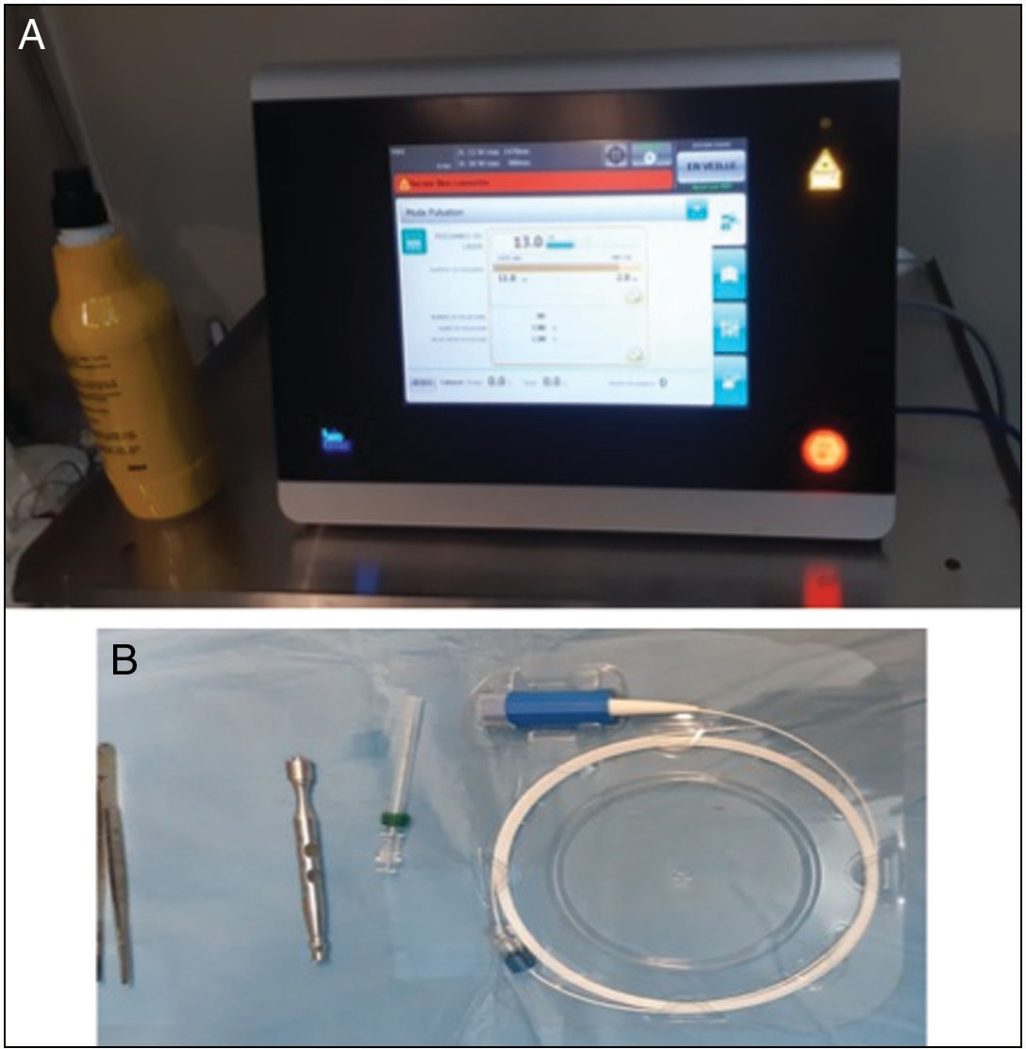

**Figure 1: Laser generator (a) and radial fibre (b)**

antiseptic. Follow-up was performed weekly until healing and then every 2 months. Parameters studied included age, sex, personal and family history, previous treatment symptoms, grade of haemorrhoidal disease that qualifies for surgical treatment. Intraoperative data and short- and medium-term results were also evaluated.

# Results

Twenty-one patients met the inclusion criteria. They were composed of 17 men and 4 women with a male/female ratio of 4.25:1. The mean age was 39.6 ± 11.22 years with a range of 27–62 years. The commonest symptoms were dominated by rectal discharge in 16 cases (76%), anal swelling in 18 cases (85.7%), and constipation in 21 cases (100%). The proctoscopic examination confirmed the haemorrhoidal disease. It was grade

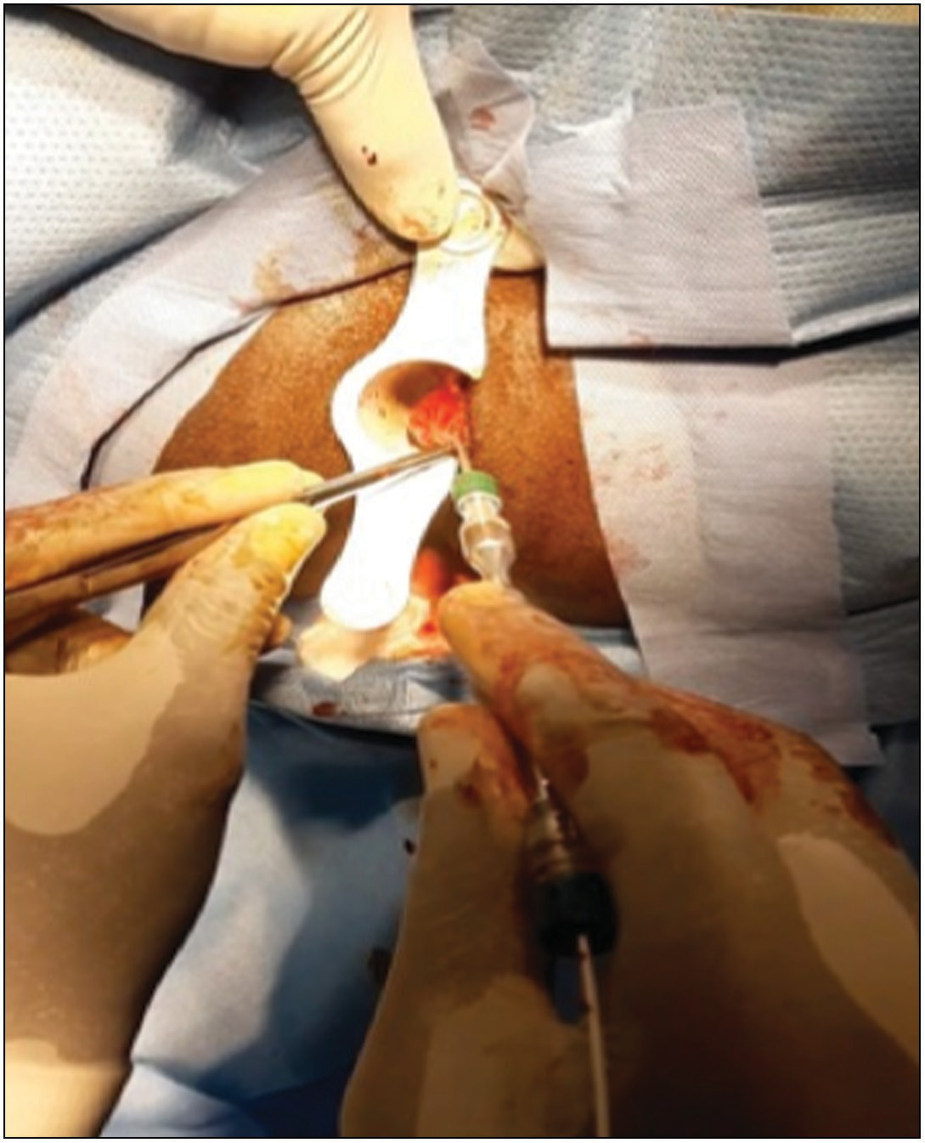

**Figure 2: Laser application in a pile**

### Table 1: Preoperative characteristics

|  |  |  |
| --- | --- | --- |
| **Preoperative characteristics** | **Number** | **Percentage** |
| Anal swelling | 18 | 87.5 |
| Bleeding | 16 | 76 |
| Classification (Goligher) |  |  |
| Grade 1 | 0 | 0 |
| Grade 2 | 2 | 9.5 |
| Grade 3 | 12 | 57 |
| Grade 4 | 7 | 33 |

Associated pathology

Anal fissure 4 19

Anal fistula 2 9.5

34 Journal of the West African College of Surgeons | Volume 11 | Issue 4 | October‑December 2021

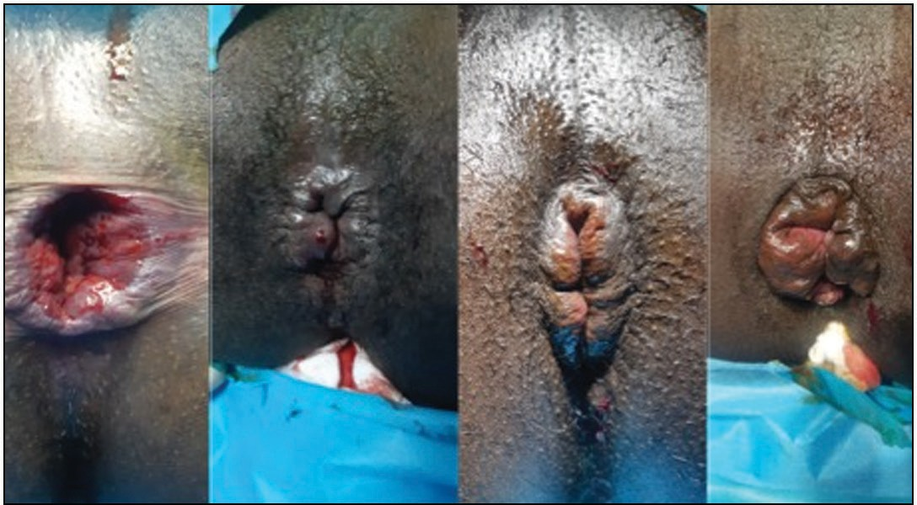

**Figure 3: Gradual stage of the haemorrhoidal disease**

### Table 2: Preoperative characteristics and morbidity

**Number Percentage**

Periop characteristics

Mucopexy + LHP 13 61.9

LHP without mucopexy 8 38

Mariscus excision 18 85.7

Hypertrophic polyp excision 3 14.2

Fibroid excision 1 4.7

the population.[9,10] It was found in 4.4% of the population in the United States in 1990 and more recently estimated at 14.4% in South Korea and 38.9% in Australia.[9,10] It is present in almost half of the subjects over 50 years of age.[11]

It becomes a concern in about 4% of cases due to symptoms or complications. In the tropics, haemorrhoidal disease has a particular profile due to self-medication, the traditional treatment used by most patients. Taboos, fears of painful surgery, and developed beliefs are the main causes of the delay in management and the frequency of advanced grade haemorrhoids in surgical settings.[12]

Depending on the stage, the treatment of haemorrhoidal disease can be medical, instrumental, and/or surgical. The indications depend more on the symptoms that the treatment aims to improve significantly with the minimum of complications and sequelae. The surgical procedures used are numerous with their own advantages and disadvantages. The conventional treatment by excision according to Milligan– Morgan carries out an ablation of the haemorrhoidal prolapse leaving the cutaneous–mucosal bridges. It is the most common procedure for its effectiveness, simplicity, and the fact that

Fissurectomy + sphincterotomy +

anoplasty

4 19.2

it requires little equipment. However, it is the cause of acute postoperative pain (VAS between 3 and 10 from the 1st to

Fistulectomy 2 9.2

Morbidity and treatment

|  |  |  |
| --- | --- | --- |
| Rehospitalization for bleeding  (pile stage 4) | 2 | 9.2 |
| Acide tranexamic (Exacyl) | 1 | 4.7 |
| Acide tranexamic (Exacyl) +  transfusion | 1 | 4.7 |
| Subcutaneous fistula (MH grade 4) | 2 | 9.2 |
| Fistulectomy | 1 | 4.7 |
| Skin tag | 6 | 28.5 |
| Local anaesthesia excision | 2 | 9.2 |

2 haemorrhoids in 2 cases (9.5%), grade 3 in 12 cases (57%),

and grade 4 in 7 cases (33%) [Figure 3]. It was associated with an anal fissure in four cases (19%) and anal fistula in three cases (14.2%). Table 1 summarizes the clinical data.

The postoperative course was simple with no notable complaints in 16 patients (76%) [Figure 4]. The exact evaluation of the pain by the visual-analogue scale (VAS) was not performed.

The complications consisted of bleeding in 8 cases (38%), of which 6 cases (28%) were minor bleeding that resolved. Two cases (9.5%) required re-admission.

Residual skin tags were noted in 6 cases (28.5%), 2 of which required excision under local anaesthesia. A subcutaneous fistula was noted in 2 cases (9.5%), 1 of which required a fistulotomy. No recurrence symptoms were recorded during the follow-up. The intraoperative and morbidity data are summarized in Table 2.

# Discussion

Haemorrhoidal disease remains a common condition with an estimated prevalence of between 2.9% and 27.9% or 50% of

the 6th week), urinary retention (20.1%), reflex constipation, bleeding (2.4–6%), and a long healing time of 4–6 weeks. In the medium- and long-term, there is a reported risk of anal incontinence (0.4%) and anal stenosis (1%), among others.[4,12-14]

Less-invasive methods have recently been developed to overcome these disadvantages and to facilitate the postoperative period. The most commonly used are Doppler-guided arterial ligation, radiofrequency, and laser haemorrhoidoplasty. A substantial gain in pain relief and few postoperative complications have been reported.

Laser haemorrhoidoplasty, like the endovenous laser, acts by thermal effect and leads to a sealing of the vessel walls and thus to an ablation of the vascular structures of the haemorrhoidal cushions. Its less aggressiveness on the anoderm and the anal canal results in less morbidity.

Thus, in terms of postoperative pain, the comparative study between laser haemorrhoidoplasty and the Milligan–Morgan procedure by Alsisy *et al.*[4] reported pain scores (VAS) of 2 and 6, respectively. The study by Poskus *et al.*[8] reported pain scores of 3.1 and 5, respectively. Postoperative analgesia was significantly less important.[4,7,8] In the Alsisy *et al.*’s[4] series, it was limited to analgesia on demand and in the Poskus *et al.*’s[8] series to anti-inflammatory drugs.

Postoperative bleeding is a complication noted in several series.[1,5,15] It is mostly minimal without any notable repercussion as noted in four (19%) patients in our series. Recurrent bleeding was noted in 2 (9.5%) of our patients with the need for re-hospitalization. Jahanshahi[15] and Naderan *et al.*[5] report a readmission and haemostasis rate of 0.6% and

Journal of the West African College of Surgeons | Volume 11 | Issue 4 | October‑December 2021 35

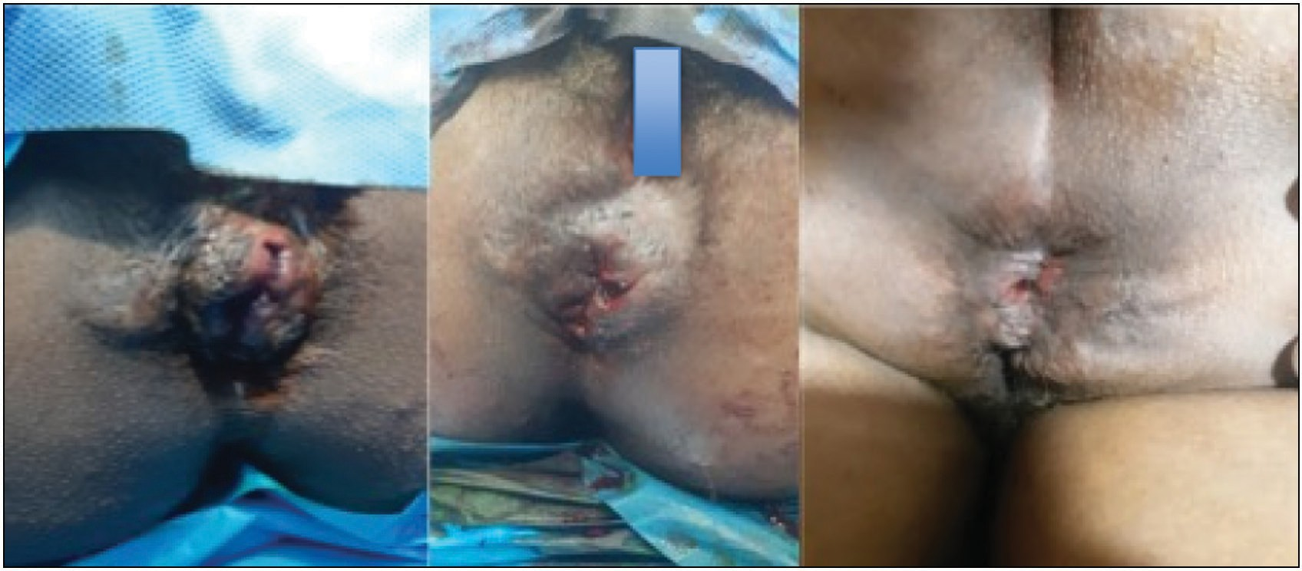

**Figure 4: Preoperative result and day 1 postoperative result**

10%, respectively. In our series, long mucopexy and grade 4 haemorrhoids were a source of complications (bleeding, insufficient retraction, thrombosis, marisque, fistula).

Thrombosis is a frequent complication of intrahaemorrhoidal instrumental or surgical procedures. It is partly related to the loss of venous drainage.[5] It is noted in 6.7–10% of the cases.[4,5]

A residual skin tag was noted in 28.5% of the cases in our series, whereas it was 33.3% in the study by Plapler *et al*.[16] Intraoperative skin excision or “lifting” prevents their occurrence but increases the size of the wound, even though it is superficial.

Postoperative care in this preliminary study required analgesia, antibiotic prophylaxis, anti-inflammatory medication, and twice-daily touching.

Studies comparing laser haemorrhoidoplasty with the Milligan–Morgan procedure conclude, among other things, similar efficacy, control of symptoms, and prolapse if the latter is small, shorter operative time, short hospitalization or outpatient in some series, faster recovery, and rapid resumption of activities.[4-6,16,17]

Data on recurrence still vary, though Poskus *et al.*[8] and Karahaliloglu[3] reported a recurrence rate of 10% and 11.3%, respectively, whereas Alsisy *et al*.[4] and Jahanshahi *et al*.[15] report a rate of 0. Within a follow-up period of 12 months, there were no recurrence. Long-term follow-up is nevertheless necessary. The limitations of this study were the small number of patients in this study and the cost of setting up the equipment the laser haemorrhoidectomy.

# Conclusion

This study has shown that laser haemorrhoidoplasty is a minimally invasive surgical treatment of haemorrhoidal disease with little distortion of the anal canal and has good outcome with few complications, especially for first-, second-, and third-degree haemorrhoids. Advanced forms such as grade 4 haemorrhoids and haemorrhoidal prolapse expose to

complications under laser and remain as indications for removal by conventional surgery according to Milligan and Morgan.

### Declaration of patient consent

The authors certify that they have obtained all appropriate patient consent forms. In the form the patient(s) has/have given his/her/their consent for his/her/their images and other clinical information to be reported in the journal. The patients understand that their names and initials will not be published and due efforts will be made to conceal their identity, but anonymity cannot be guaranteed.

### Financial support and sponsorship

Nil.

### Conflicts of interest

There are no conflicts of interest.

# References

1. Halit M, Zaim G, Ranko L, Hilmi I, Argjira J-S. Laser haemorrhoidoplasty procedure vs open surgical haemorrhoidectomy: A trial comparing 2 treatments for haemorrhoids of third and fourth degree. Acta Inform Med 2014;22:365-7.
2. Aigner F, Bodner G, Gruber H, Conrad F, Fritsch H, Margreiter R, *et al*. The vascular nature of hemorrhoids. J Gastrointest Surg 2006;10:1044-50.
3. Karahaliloglu A. First results after laser obliteration of first and second-degree hemorrhoids. Coloproctology 2007;29:327-36.
4. Alsisy A, Alkhateep YM, Salem IA. Comparative study between intrahemorrhoidal diode laser treatment and Milligan Morgan hemorrhoidectomy. Menoufia Med J 2019;32:560-5.
5. Naderan M, Shoar S, Nazari M, Elsayed A, Mahmoodzadeh H, Khorgami Z. A randomized controlled trial comparing laser intra- hemorrhoidal coagulation and Milligan–Morgan hemorrhoidectomy. J Invest Surg 2016;30:325-31.
6. De Nardi P, Tamburini AM, Gazzetta PG, Lemma M, Pascariello A, Asteria CR. Hemorrhoid laser procedure for second- and third-degree hemorrhoids: Results from a multicenter prospective study. Tech Coloproctol 2016;20:455-9.
7. Wesam NY, Doaa OR, Waleed AA, Walid AE. Comparison between laser hemorrhoidoplasty procedure and conventional open surgical hemorrhoidectomy. Egypt J Hosp Med 2022;86:112-6.

36 Journal of the West African College of Surgeons | Volume 11 | Issue 4 | October‑December 2021

1. Poskus T, Danys D, Makunaite G, Mainelis A, Mikalauskas S, Poskus E, *et al*. Results of the double-blind randomized controlled trial comparing laser hemorrhoidoplasty with sutured mucopexy and excisional hemorrhoidectomy. Int J Colorectal Dis 2020;35:481-90.
2. Johanson JF, Sonnenberg A. The prevalence of hemorrhoids and chronic constipation. An epidemiologic study. Gastroenterology 1990;98:380-6.
3. Kaidar-Person O, Person B, Wexner SD. Hemorrhoidal disease: A comprehensive review. J Am Coll Surg 2007;204:102-17.
4. Poon GP, Chu KW, Lau WY, Lee JM, Yeung C, Fan ST, *et al*. Conventional vs. triple rubber band ligation for hemorrhoids. A prospective, randomized trial. Dis Colon Rectum 1986;29:836-8.
5. Diop B, Ba PA, Diouf A, NDiaye B, Sarre SM, Sylla C. Prise en charge de la maladie hémorroidaire en milieu chirurgical à propos d’une série de 258 observations. Rev Afr Chir 2021;15:5-10.
6. Bleday R, Pena JP, Rothenberger DA, Goldberg SM, Buls JG. Symptomatic hemorrhoids: Current incidence and complications of operative therapy. Dis Colon Rectum 1992;35:477-81.
7. Sardinha TC, Corman ML. Hemorrhoids. Surg Clin North Am 2002;82:1153-67, vi.
8. Jahanshahi A, Mashhadizadeh E, Sarmast MH. Diode laser for treatment of symptomatic hemorrhoid: A short term clinical result of a mini invasive treatment, and one year follow up. Pol Przegl Chir 2012;84:329-32.
9. Plapler H, Hage R, Duarte J, Lopes N, Masson I, Cazarini C, *et al*. A new method for hemorrhoid surgery: Intrahemorrhoidal diode laser, does it work? Photomed Laser Surg 2009;27:819-23.
10. Longchamp G, Liot E, Meyer J, Toso C, Buchs NC, Ris F. Non-excisional laser therapies for hemorrhoidal disease: A systematic review of the literature. Lasers Med Sci 2021;36: 485-96.



Journal of the West African College of Surgeons | Volume 11 | Issue 4 | October‑December 2021 37