**PNEUMATIC REDUCTION OF INTUSSUSCEPTION IN CHILDREN: EXPERIENCE AND ANALYSIS OF OUTCOME AT JUTH, JOS, A TERTIARY HEALTH CENTRE IN NORTH CENTRAL NIGERIA**

**Dung ED*, Shitta AH, Alayande BT, Patrick TM, Kagoro B, Odunze N, Rikin C, Chirdan LB.**

Division of Paediatric Surgery, Department of Surgery, Jos University Teaching Hospital, Jos Nigeria

\***Corresponding Author:** Dr Dido E Dung E-mail:[didodung@yahoo.com](mailto:didodung@yahoo.com)

**Source of support:** Nil

**Conflict of Interest:** Nil

**ABSTRACT**

**Context:** Intussusception is a common childhood abdominal surgical emergency worldwide resulting in considerable morbidity and mortality if not promptly treated. Ultrasound-guided pneumatic reduction has been proven to be the most reliable and successful non-operative management option with the least complication rate.

**Aims:** To evaluate our local experience with the ultrasound-confirmed pneumatic reduction of childhood intussusception and to determine factors that predict successful outcome.

**Settings and Design:** A retrospective study of children less than 2 years oldwho presented to our facility with uncomplicated idiopathic intussusceptions between June, 2012 and June, 2017.

**Materials and Methods:** The clinical diagnosis was confirmed by abdominal ultrasonography. Pneumatic reduction with a locally assembled equipment was performed on selected and resuscitated patients; abdominal ultrasound scan was then performed to confirm successful reduction. The procedure was considered to have failed if unsuccessful after the third attempt. Laparotomy was performed on patients with failed procedure.

**Statistical analysis used:** Statistical Package for Social Sciences version 24 was used for data analysis. Categorical variables were compared using Fisher exact test (with odds ratios and 95% confidence intervals where appropriate) and numeric variables compared using the student t-test. Statistical significance was set at p< 0.05.

**Results:** Twenty five out of 36 children with intussusception were selected for the procedure with M:F ratio 1.8:1 and a mean age of 7.08 (SD4.18) months. Only 9 (36%) presented early (ie within 24 hours). While non-bilious vomiting was the commonest symptom, blood-stained finger on rectal examination was the commonest sign in the patients. The overall success rate was 60% (15 patients). Early presentation accounted for only 5 (33%) of successful procedures. The presence of an abdominal mass was associated with increased likelihood of success (OR 9.75,[95% CI [1.38-68.78], p=0.022), while the presence of a rectal mass was associated with a reduced likelihood of success (OR 0.16 95%CI [0.026-0.917], p=0.042 ). Age, sex, and duration of symptoms before presentation did not influence outcome. Early presentation was however significantly associated with success at first attempt, compared to late presentation, in those with successful outcomes. Recurrence was observed in one (6.7%) of the successful cases. The mean duration of hospital stay in those that had successful outcome, 3.4(SD1.0) days was significantly shorter than that for those who had laparotomy for failed reduction, 8.0(SD3.1) days (p<0.001). There was no bowel perforation and no mortality recorded.

**Conclusions:** The successful pneumatic reduction rate was 60%. The major predictors of success in this study were the presence of abdominal mass and the absence of intussusception apex in the rectum. Early presentation was significantly associated with success at first attempt, compared to late presentation, in those with successful outcomes. There was no bowel perforation or mortality. Ultrasound-confirmed pneumatic reduction of intussusception is a simple, easy, safe and effective non-operative management of uncomplicated intussusception in well selected children in our environment.

**Key Words:** Intussusception, Pneumatic reduction, Ultrasound-confirmed, Success rate

**Introduction:**

Intussusception is a common childhood problem worldwide.1 This is the most common abdominal emergency in infants and toddlers resulting in considerable morbidity and mortality if not promptly treated.2,3,4 Intussusception is an acquired clinical condition in which a segment of the intestine invaginates or telescopes into the adjoining segment with consequent resultant intestinal obstruction.5 Most episodes occur in otherwise well-nourished children. The classical paediatric triad of abdominal pain, red currant jelly stool and a palpable abdominal mass is encountered in only 25-50% of cases.6,7 Ultrasonography is currently the most reliable and accurate method used to diagnose intussusception.5,8

There has been a shift from operative to non-operative management of intussusception in children. The current non-operative management methods are the hydrostatic and the pneumatic methods.5,9,10 The benefits and advantages are enormous. These include early hospital discharge, overall reduction in morbidity and mortality, the absence of abdominal scars and economic benefits to both the hospital and the caregivers of these children. This sort of management is rarely practiced in our sub-region due to lack of expertise and facility.11 Air has inherent compressibility that enables it to sweep and dissect between the intussusceptum and the intussuscepiens leading to rapid reduction of the intussusception. Ultrasound-guided pneumatic reduction is the most reliable approach compared to the hydrostatic saline and barium method.This is based on the high success and low complication rates; however, there are still cases of recurrence and failed treatment. There are numerous advantages of pneumatic over barium and saline hydrostatic reduction of childhood intussusception. It is a cheap, easy and quick procedure to perform with reported higher success rates and absence of radiation exposure compared to barium saline hydrostatic reduction. Early detection of perforation, minimal peritoneal soilage and less soilage of the procedure room make it better than saline hydrostatic reduction.3,5,12 With the high morbidity and financial burden from operative management of intussusception on the poor populace in our sub-region, the pneumatic reduction method will play a major role in the management of childhood intussusception.11

The aim of this study was to highlight our local experience with the ultrasound-confirmed pneumatic reduction of childhood intussusception using our locally assembled instrument, and to determine and evaluate factors that predict success of the procedure.

**Subjects and Methods:**

This was a 5 year retrospective case study of 25 children admitted into our facility diagnosed with idiopathic intussusception from June 2012 to June 2017. The diagnosis was confirmed by abdominal ultrasound finding of an abdominal mass with the presence of pseudo-kidney and target signs. The inclusion criteria for this study were all children within ages between 0-24 months diagnosed withidiopathic intussusception and were further confirmed by abdominal ultrasound. The exclusion criteria included age above 24 months, the presence of bilious vomiting, abdominal distension, prolapsing rectal intussusception, critically ill patients such as those having peritonitis or shock, the presence of co-morbid states and an obvious pathologic lead point on abdominal ultrasound.

The equipment used was a locally assembled appropriate sized Tri-way Foley’s urethral catheter (18-26 Fr) connected to a portable sphygmomanometer through the smaller channel. The inflation bulb was connected to the larger channel of the catheter. The patients that qualified for the procedure were adequately resuscitated with intravenous fluids. Appropriate sized nasogastric tube and urethral catheter were passed. Intravenous broad-spectrum antibiotics were administered (Ceftriaxone 50 mg/kg in 2 divided doses per day and Metronidazole 7.5mg/kg per dose 8 hourly) during the period of admission and converted to oral Augmentin (25 mg/kg in 2 divided doses) and metronidazole (7.5mg/kg per dose 8 hourly) at discharge to complete a period of one week treatment. Necessary blood investigations were done and the patient booked for emergency laparotomyin case of failure of the procedure. The caregivers were counselled and informed consent obtained. The procedures were carried out in a procedure room close to the theatre. The patients were positioned in the left lateral decubitus position on the procedure table. The free end of the nasogastric tube was inserted into a kidney dish containing saline kept at the same level with the patient (Figure 1).The assembled Tri-way Foley’s catheter was lubricated with K-Y jelly and gently introduced per-rectum one third to half-way the length of the catheter (Figure 2). The balloon was inflated with 30-50 mls of normal saline. The gluteal folds were firmly held together by an assistant with gloved hands and gauze to avoid air leakage (Figure 3). Sedation was avoided because it could mask signs of shock. Also, the increase in intra-abdominal pressure during crying is believed to aid in the effectiveness of the procedure. The air was gradually introduced into the rectum by the inflation bulb; the rectal pressure was maintained between 80-120 mmHg and sustained for 3-5 minutes. The success of reduction was demonstrated clinically by a sudden drop in the pressure, the presence of air bubbles in the saline-filled kidney dish and a gush of stool after deflation of the catheter balloon. This signified bowel continuity with retrograde flow of air and antegrade flow of stool respectively. An abdominal ultrasound scan was then performed, using a portable ultrasound scan equipment, to confirm complete disappearance of the intussusception. If not successful, the procedure was repeated after the patient had rested for5 minutes. A maximum of 3 attempts at reduction were made. Failed cases and those with perforation were taken to the theatre for emergency laparotomy. The successful cases were taken into the ward for monitoring. The nasogastric tube was removed after 24 hours, oral feeding commenced and the patients were discharged home after 48-72 hours. Patients with recurrence after successful reduction had the procedure repeated. A maximum of 3 repeat procedures wereallowed.

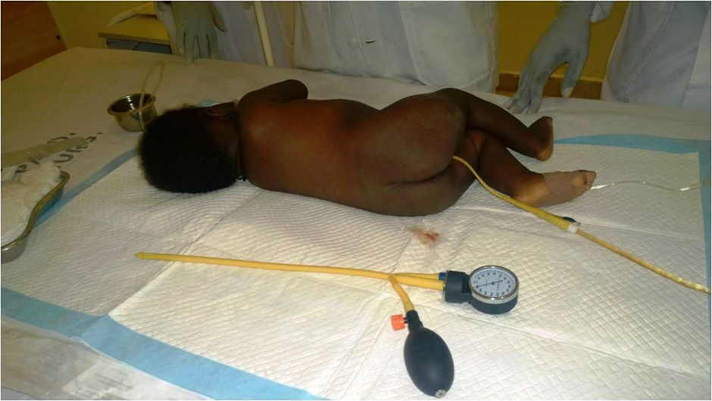

**Fig 1: The patient’s position**

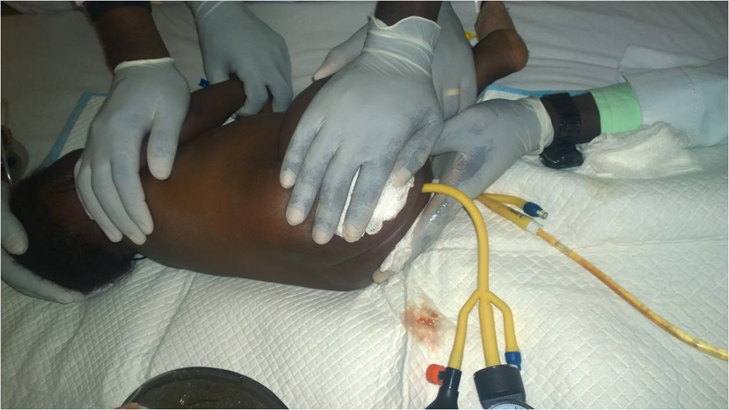

**Fig. 2: The procedure**The cases were retrospectively studied after ethical clearance had been obtained. Data were extracted from case notes, discharge summaries and operation notes. Statistical analysis was performed using the Statistical Package for Social Sciences (IBM SPSS statistic version 24). Fisher exact test (with odds ratios and 95% confidence limits where appropriate) and the student t-test were used for comparison of categorical and continuous variables respectively. Statistical significance was set at p< 0.05.

**Results:**

A total of 36 patients were managed for intussusception during the study period. Twenty five (69.4%) were selected for the pneumatic reduction of intussusception based on the criteria described in the methodology. There were 16 (64%) males and 9 (36%) females (M:F= 1.8:1) aged between 2 months and 19 months with **a** mean age of 7.08(S.D4.18)months (Table 1).

**Table 1: Age and Sex Distribution**

|  |  |  |  |
| --- | --- | --- | --- |
| **Age (months)** | **Sex** | |  |
|  | M | F | Total |
| <6 | 5 | 5 | 10 |
| ≥6 | 11 | 4 | 15 |
| Total | 16 (64%) | 9 (36%) | 25 (100%) |

**Mean=7.08** (**S.D=4.18)** **months**, **range= 2-19 months**

**Table 2 : Duration of symptoms before presentation**

|  |  |
| --- | --- |
| Duration of symptoms (hrs) No (%). | |
| ≤ 24 | 9 (36%) |
| 25-48 | 5 (20%) |
| 49-72 | 4(16%) |
| > 72 | 7 (28%) |
| Total | 25 (100%) |
|  |  |

**Mean 74.88(SD75.67) hours**

Table 2 shows the duration of symptoms before presentation to our facility. This ranged between 10 to 336 hours with a mean of 74.88(SD75.67) hours.Nine (36%) patients presented early**,** defined as within 24 hours of onset of symptoms; 16 (64%) presented late (i.e more than 24 hours after onset of symptoms). The symptoms and signs in this study are shown in Table 3. Non-bilious vomiting, diarrhoea and abdominal pain were the predominant symptoms, occurring in21 (84%), 13 (52%) and 10 (40%) patients respectively. Cough was seen in 3 (12%) of the patients. A palpable abdominal mass was demonstrated in 17 (68%) and a rectal mass in 11 (44%) of the patients. Blood stained stool on rectal examination was present in all the patients. The clinical triad of abdominal pain, abdominal mass and bloody stool on rectal examination in this study was observed in only 4 (16%) of the patients.

**Table 3: Symptoms and Signs**

|  |  |  |  |  |  |
| --- | --- | --- | --- | --- | --- |
| **Clinical presentation** |  | **No.** | | **Percentage** | |
|  | Abdominal pain | 10 | | 40% | |
| Symptoms | Vomiting | 21 | | 84% | |
|  | Diarrhoea | 13 | | 52% | |
|  | Cough | 3 | | 12% | |
|  | Pyrexia | 6 | | 24% | |
| Signs | Abdominal distension | 2 | | 8% | |
|  | Abdominal mass | 17 | | 68% | |
|  | Rectal mass | 11 | | 44% | |
|  | Dehydration | 24 | | 96% | |
|  | Tachycardia | 24 | | 96% | |
|  | Blood stained stool on rectal examination | 25 | | 100% | |
| The clinical triad of abdominal pain, abdominal mass and bloody stool | | | 4 | 16% |

Ultrasound-confirmed pneumatic reduction was successful in 15(60%). In 5 (33.3%) of the 15 patients the procedure was successful after one attempt, in 6 (40.0%) it was successful after two attempts and in 4 (26.7%) it was successful after three attempts. The median number of attempts was two.

Table 4 shows factors affecting the success of reduction.

**Table 4 : Factors Affecting Successful Procedure**

|  |
| --- |
| **Factor Outcome** |
| **Successful Unsuccessful Total OR# p-value**  **(95%CI@)** |

**Age**

(Months)

<6 7(70%) 3(30%) 10(100%) 2.04

≥6 8(53.3%) 7(46.7%) 15(100%) (0.38-11.07) 0.341*

**Sex**

M 9(56.3%) 7(43.7%) 16(100%) 0.64

F 6(66.7%) 3(33.3%) 9(100%) (0.11-3.53) 0.47*

|  |
| --- |
| **Duration of**  **symptoms**  ≤24hrs 5(55.6%) 4(44.4%) 9(100%) 0.75  >24 hrs 10(62.5%) 6(37.5%) 16(100%) (0.14-3.94) 0.53*  **Presence of**  **Abdominal Mass**  Yes 13(76.5%) 4(23.5%) 17(100%) 9.75  No 2(25.0%) 6(75.0%) 8(100%) (1.38-68.78) 0.022*  **Presence of**  **Rectal Mass**  Yes 4(36.4%) 7(63.6%) 11(100%) 0.16  No 11(78.6%) 3(21.4%) 14(100%) (0.026-0.917) 0.042* |
| #Odds Ratio @Confidence Interval *Fisher Exact Test  Successful reduction was achieved in 7 (70%) of patients less than 6 months and in 8 (53.3%) of those aged 6 months or older. However, the difference was not statistically significant (p=0.341). There was no significant difference in the proportions of successful reductions between male and female patients (p=0.47). Neither was there any significant difference in outcomes between those who presented early (within 24 hours of onset of symptoms) and those who presented late (after 24 hours) (p=0.53). Patients who had an abdominal mass were almost ten times more likely to have had a successful outcome than those without an abdominal mass (OR 9.75; 95%CI [1.38-68.78], p=0.022). On the other hand, patients with a rectal mass were 84% less likely to have had a successful outcome compared to those without a rectal mass (OR 0.16; 95%CI [0.026-0.917], p=0.042 ). |
|  | | |

**Table 5 : Factors Affecting Number of Times Procedure was carried out in Successful Cases**

|  |
| --- |
| **Factor**  **Number of times procedure carried out** |
| **Once More than once Total p-value** |

**Age**

(Months)

<6 2(28.6%) 5(71.4%) 7(100%)

≥6 3(37.5%) 5(62.5) 8(100%) 0.57

**Sex**

M 3(33.3%) 6(66.7%) 9(100%)

F 2(33.3%) 4(66.7%) 6(100%) 0.706

|  |
| --- |
| **Duration of**  **symptoms**  ≤24hrs 5(100%) 0(0%) 5(100%)  >24 hrs 0(0%) 10(100%) 10(100%) <0.001  **Presence of**  **Abdominal Mass**  Yes 4((30.8%) 9(69.2%) 13(100%)  No 1(50%) 1(50%) 2(100%) 0.571  **Presence of**  **Rectal Mass**  Yes 2((50) 2(50%) 4(100%)  No 3(27.3%) 8(72.7%) 11(100%) 0.560 |

Table 5 shows factors that affect the number of attempts at reduction before success in those in whom the procedure was successful. Age, sex, presence of abdominal or rectal masses were not significantly associated with the number of attempts at reduction before success was achieved. However, those who presented early were significantly more likely than those who presented late to have had successful outcome after one attempt. The duration of hospital stay in those that had successful outcome rangedbetween two to five days with a mean stay of 3.4(SD1.0)days. The hospital stay for those who had laparotomy for failed reduction ranged between one and eleven days with a mean of 8.0(SD3.1) days. The single patient discharged home the next day after laparotomy was a child of medical doctors who had a right sided abdominal mass and an obvious pathologic lymph node that was excised. The difference in the duration of hospital stay was statistically significant (p<0.001).

Recurrence was seen within four days in one (6.7%) of *the* patients that had successful reduction. He was a six-monthold male infant who presented 13 hours following onset of symptoms. He was worked up and had laparotomy. Intraoperative findings of ileo-colic intussusception with enlarged Peyers patches were noted. He had successful manual reduction of the intussusception and excision of the enlarged Peyers patches. Four (26.7%) patients who had successful reduction of intussusception were lost to follow-up. The ten (40%) patients with failed outcome had laparotomy. All were ileo-colic intussusceptions. Manual reduction with or without removal of pathologic lead points was successful in six;limitedright hemicolectomy was performed in the remaining four as a result of pathologic lead points and bowel tear. No mortality was recorded in the study.

**Discussion:**

Childhood intussusception still remains a common paediatric problem worldwide with considerable morbidity and mortality if not promptly treated.1,2,3 Globally, there has been a dynamic change in the management of childhood intussusception with a shift from the usual operative to the non-operative methods.5,9,11 Ultrasound-guided pneumatic reduction method for the management of childhood intussusception has been the most outstanding method compared to other known methods because of the highsuccess and the complication rates.5,6,12

The male dominance (M:F=1.8:1) observed in this study is similar to findings from other studies.4,10,13 The mean age of 7.08 months correlates with studies in Ghana and Ireland.10,13 Other studies showed contrasting results with higher mean ages.8,14,15 In our study, the mean duration of symptoms before presentation was 74.9 hours (i.e> 24hrs). Lower average of 18.5 hours (<24 hours)16 and higher values up to 145.9 hours have been reported in other studies.17 Only few (36%) patients presented early(≤24hrs).This is comparable to the results of some studies10,16,18 while others demonstrated sharply contrasting higher proportions ranging from 57.8% to 83.3%.8,9,19 The majority of patients in this study presenting late (>24hrs) is in keeping with results from previous studies especially in developing nations. This can be attributed to ignorance, poverty and poor access to tertiary health care. A study in Nigeria has shown that many patients present early to primary health care facilities; however, they eventually present late to specialists.20 This was as a result of misdiagnosis or delay by health care providers in the primary health facilities and even in the tertiary facilities.

In our study, 60% of the patients with intussusception had successful pneumatic reduction. Other studies have reported success rates ranging between 50-75%.10,11

The success of pneumatic reduction of 60% reported in our study was slightly lower than the 67% reported in Ghana.4,11 Some studies have shown success rates of 89% and above[9][21] while others have demonstrated lower values of 53.5%.22 The outcome was successful in only 56% of those that presented early. This is in contrast to higher values in other studies.2,11 Successful outcome was also demonstrated in 62.5% of those that presented late in this study. Higher success rates in those that presented late have been shown by other studies.9,15 ~~.~~ Successful outcome in first attempt of reduction was demonstrated in 33.3% of the patients in our study. Higher success rates in the first attempt at reduction of up to 78.9% have been shown in other studies.5,10,16

Age less than 3 months or greater than 2 years is said to be associated with increased likelihood of pathologic lead points and decreased likelihood of success.15 Our study did not demonstrate age to be associated with outcome. This is similar to the findings by Mensah et al in Ghana but different from the findings of Fallon et al.[4][23]; the latter found that age less than one year was a significant predictor of operative treatment for intussusception. Our study also did not show age to significantly affect the number of attempts for successful reduction.

Previous studies have not shown sex to be either associated with outcome or with the number of attempts before successful reduction 2,4,9 . Our study also demonstrates similar finding. Long duration of symptoms and late presentation being associated with reduced success rate of pneumatic reduction of intussusception has been the norm globally including the study by Mensah et al in Ghana.24,25,26 Our study suprisingly showed that the duration of symptoms was not associated with the outcome, although early presentation was associated with fewer number of attempts before successful reduction of intussusception. Tareen et al also found that the duration of symptoms did not influence the outcome of pneumatic reduction.9 The presence of palpable abdominal mass is a clinical finding for the diagnosis of intussusception. Most studies did not relate the presence of abdominal mass with the outcome. Our study showed that palpable abdominal mass is associated with successful outcome. The study by Joda et al demonstrated that the presence of a palpable right-sided or epigastric mass was associated with increased chance of successful procedure while a left-sided mass or a palpable mass in the rectum was associated with a reduced chance of success.10 They also found that a right-sided or epigastric mass was associated with greater chances of success at first attempt than left-sided or rectal mass. The present study did not find any association between the presence of abdominal mass and the number of times the procedure was carried out before success was achieved. The presence of a palpable rectal mass is a sign of advanced disease. Our study showed that the presence of a rectal mass was associated with failure of pneumatic reduction of intussusception. It was, however, not significantly associated with the number of attempts before reduction was successful.

Recurrence was observed in 6.7% in this study. Higher values of 35.2%16 and lower values of 4.5%10 have been reported in other studies. The mean duration of hospital stay for those that had successful reduction of 3.4 days is longer than the 12 hours to 2.3 days reported in other studies.811 The significantly shorter hospital stay in those who had successful reduction would have meant lower hospital costs and perhaps less disruption of family life. This gives it advantage over the operative management of intussusception.

The remaining 10(40%) patients, in whom the procedure failed, had laparotomy. Laparotomy has been reported to be much lower, up to 23% in other studies.27 All the pathologies were ileo-colic intussusception. Manual reduction was successful in majority of the patients; a lower success rate of only 21% has been reported in other studies.17 Limited right hemicolectomy was performed on the rest of the patients with failed operative procedure.

The main limitation of this study, apart from it being retrospective, is the rather small number of patients involved. A future larger study would clarify the findings in this study.

**Conclusion**:

The successful pneumatic reduction rate was 60%. The major predictors of success in this study were the presence of abdominal mass and the absence of intussusception apex in the rectum. Early presentation was significantly associated with success at first attempt, compared to late presentation, in those with successful outcomes. There was no bowel perforation or mortality. Ultrasound-confirmed pneumatic reduction of intussusception is a simple, easy, safe and effective non-operative management of uncomplicated intussusception in well selected children in our environment.

**REFERENCES**

1. Rahman GA, Mungadi IA. Childhood intussusception in Ilorin, Nigeria. Sahel Med J

1999;2:86-8

2. Tang P, Law EK, Chu WC. Pneumatic reduction of paediatric intussusception: Clinical experience and factors affecting outcome. Hong Kong J Radiol 2016;19:200-7

3. Khorana J, Singhavejsakul J, Ukarapol N, Laohapensang M, Wakhanrittee J, Patumanond J. Enema reduction of intussusception: the success rate of hydrostatic and pneumatic reduction. Ther Clin Risk Manag 2015;11:1837-42

4. Mensah YB, Glover-Addy H, Etwire V, Twum MB, Asiamah S, Appeadu-Mensah W *et al*. Pneumatic reduction of intussusception in children at Korle Bu Teaching Hospital: An initial experience. Afr J Paediatr Surg 2011;8:176-81

5. Omar BH, Syed NF, Mujtaba I. Ultrasound guided pneumatic reduction of intussusception in children - a case series. Int J Recent Sci Res 2015;6:4204-7

6. Ozcan R, Huseynov M, Emre S, Tutuncu C, Vehin HE, Dervisoglu S *et al*. A review of intussusception cases involving failed pneumatic reduction and re-intussusception. Ulus Travma Acil Cerrahi Derg 2016;22:256-64

7. Ongom PA, Opio CK,Kijjambu SC. Presentation, aetiology and treatment of adult intussusception in a tertiary Sub-Saharan Hospital: a 10-year retrospective study. BMC Gastroenterol 2014;14:86

8. Al-Mefih W, AbuQuraa A, Khaswneh G, Al-Ibrahim A, Abdullah B, Al-Omary N. Pneumatic reduction of pediatric intussusception: Experience at Queen Rania Al-Abdullah Hospital for children. J R Soc Med 2016;23:13-19

9. Tareen F, Ryan S, Avanzini S, Pena V, Mc Laughlin D, Puri P*.* Does the length of the history influence the outcome of pneumatic intussusception in children? Paediatr Surg Int 2011;27:587-89

10. Joda AE, Salih WM, Shakarly NH. Ultrasound guided pneumatic reduction of intussusception: A clinical experience from Baghdad. Am J Paediatr 2017;3:76-82

11. Abatanga FA, Amoah M, Adeyinka AO, Nimako B, Yankey KP*.* Pneumatic reduction of intussusception in children at the KomfoAnokye Hospital, Kumasi, Ghana. East Afr Med J 2008;85:550-5

12. Singh AP, Tanger R, Mathur V, Gupta AK. Pneumatic reduction of intussusception in children. Saudi Surg J 2017;5:21-5

13. Hazra NK, Karki OB, Verma M, Rijal D, De A, Nath B. Intussusception in children: A short-term analysis in a tertiary care hospital. Am J Public Health Res 2015;3:53-6

14. Ogundoyin OO, Olulana DI, Lawal TA. Childhood intussusception: A prospective study of management trend in a developing country. Afr J Paediatr Surg 2015;12:217-20

15. Kiran KM, Shiva KT, Naveen KM, Pavan BM, Ashok C, Kottur S. Study of factors influencing pneumatic reduction of intussusception in children in Tumkur, South India. Int J Sci Stud 2014;2:30-32

16. Kritsaneepiaboon S, Sangkhathat S, Kaungurn S. Pneumatic reduction of intussusception: factors affecting outcome in Thailand. Asian Biomed 2011;5:235-41

17. Pandey A, Singh S, Wakhlu A, Rawat J. Delayed presentation of intussusception in children-a surgical audit. Ann Paediatr Surg 2011;7:130-2

18. Kella N, Rathi PK, Soomro BA, Qureshi MA. Childhood intussusception: delayed presentation and surgical outcome. J Liaquat Uni Med Health Sci 2009;8:46-9

19. Abraham MK, Joy MG, Menon SS, Bindu S, Ramakrishnan P. A simple and safe technique for pneumatic reduction of intussusception. Asian J Surg 2006;29:170-2

20. Bode CO. Presentation and management outcome of childhood intussusception in Lagos: A prospective study. Afr J Paediatr Surg 2008;5:24-8

21. Ramachandran P, Gupta A, Vincent P, Sridharan S. Air enema for intussusception: Is predicting the outcome important? Paediatr Surg Int 2008;24:311-3

22. Alehossein M, Babaheidarian P, Salamati P. Comparison of different modalities for reducing childhood intussusception. Iran J Radiol 2011;8:83-7

23. Fallon SC, Lopez ME, Zhang W, Brandt ML, Wesson DE et al. Risk factors for surgery in pediatric intussusception in the era of pneumatic reduction. J Pediatr Surg 2013;48:1032-6

24. McDermott VG, Taylor T, Mackenzie S, Henry GM. Pneumatic reduction of intussusception: Clinical experience and factors affecting outcome. Clin Radiol 1994;49:30-4

25. Li JE, Yang LJ, Wang J, Sheng M, Guo WL. Predictors of successful air enema reduction of intussusception in infants younger than 4 months. J Pediatr Gastroenterol Nutr 2014;58:786-8

26. Sandler A, Ein S, Connolly B, Daneman A, Filler RM. Unsuccessful air-enema reduction of intussusception: is a second attempt worthwhile? Pediatr Surg Int 1999;15:214-16

27. Henry MC, Breuer CK, Tashijian DB. The appendix sign: a radiographic marker for irreducible intussusception. J Pediatr Surg 2006;41:487-9