**Original Article**

**Prognostic Factors in the Management of Empyema Thoracis in Northern Nigeria**



**Abstract**

**Background:** Empyema thoracis portrays pleural effusion with demonstrable actively multiplying bacteria. It is a significant cause of morbidity, and commonly complicates parapneumonic effusions. It is important to identify those factors that can be used to prognosticate the outcome of its management in our locality so that those that are modifiable could be applied to improve management outcomes. **Materials and Methods:** A prospective cohort study of patients managed for empyema thoracis at the Ahmadu Bello University Teaching Hospital (ABUTH), Zaria, Nigeria from February 2017 to January 2018 was conducted. Eighty-three patients were enrolled for this study and recruitment into the study included all consecutive patients being managed for empyema thoracis in ABUTH, Zaria during the study period. Data collected included age, gender, aetiology, microbial isolates, BMI, initial and total empyema volumes, and duration before hospital presentation. The patients were subsequently managed and observed, and the outcome of management (duration of drainage and hospital stay, percentage of lung expansion, and need for decortication) was noted. **Results:** Patients in the paediatric age group correlated positively with an earlier presentation to the hospital. The duration before presentation correlated positively with the stage of the disease. The duration before presentation and the total empyema volume indexed to body surface area could prognosticate all four outcome parameters assessed. The age and stage of the disease prognosticated the lung expansion and the need for decortication. The initial empyema volume indexed to body surface area prognosticated the length of hospital stay. The presence of complications was a determinant of the need for decortication. Adolescents and adults had 2.1 times increased probability of requiring a decortication for successful management. **Conclusion:** The age, stage of the disease, duration before presentation, initial empyema volume indexed to body surface area, and total empyema volume indexed to body surface area can be used to prognosticate the outcome of empyema thoracis. With the onset of complication comes a higher chance of requiring decortication. Children are less likely to require decortication for satisfactory management of empyema thoracis.

**Keywords:** *Decortication, empyema thoracis, parapneumonic effusion, tube thoracostomy*

**Ikechukwuka Ifeanyichukwu Alioke1,**

**Ibrahim Zira Delia2, Sunday Adoga Edaigbini3, Anietimfon Umoh Etiuma2**

*1Division of Cardiothoracic Surgery, Federal Medical Centre, Abuja, Nigeria, 2Division of Cardiothoracic Surgery, Ahmadu Bello University Teaching Hospital, Zaria, Nigeria, 3Division*

*of Cardiothoracic Surgery, University of Calabar Teaching Hospital, Calabar, Nigeria*

**Introduction**

“Empyema” is a Greek word that means “pus in the pleural cavity”. It is defined as a purulent pleural effusion or any pleural effusion with actively multiplying bacteria.[1-4]

Recently, the incidence of empyema thoracis is on the increase,[5,6] with a mortality ranging from 4.2 to 24%,[6-9] but could be as high as 25 to 75% in the elderly and debilitated.[10] From the review of literature, empyema thoracis appears to have a higher incidence in the developing parts of the world, likely due to poor health-seeking behaviour, poverty, and malnutrition. Since the disease constitutes a significant consumer of chest surgeons’ man-hours in the clinical setting

This is an open access journal, and articles are distributed under the terms ofthe Creative CommonsAttribution-NonCommercial-ShareAlike 4.0 License, which allows others to remix, tweak, and build upon the work non-commercially, as long as appropriate credit is given and the new creations are licensed under the identical terms.

**For reprints contact:** reprints@medknow.com

in our sub-region, it becomes imperative for the attending clinician to identify early, the likely prognostic factors that predict the outcome of management; alter the modifiable factors if any, and plan for the best line of management to minimize morbidity and mortality. This study attempts to identify the factors that can be used to prognosticate the outcome of management of empyema thoracis in our sub-region.

**Materials and Methods**

This comprised all patients with empyema thoracis admitted to Ahmadu Bello University Teaching Hospital (ABUTH), Zaria, Kaduna State, Nigeria within the twelve-month study period spanning February 2017 to January 2018. All

**How to cite this article:** Alioke II, Delia IZ, Edaigbini SA, Etiuma AU. Prognostic factors in the management of empyema thoracis in Northern Nigeria. J West Afr Coll Surg 2022;12:75-81.

**Received:** 25-Jul-2022 **Accepted:** 29-Aug-2022 **Published:** 23-Nov-2022

***Address for correspondence:***

*Mr. Ikechukwuka Ifeanyichukwu Alioke,*

*Division of Cardiothoracic Surgery, Federal Medical Centre, Abuja, Nigeria.*

*E-mail: aliokeinchrist@yahoo. com*

**Access this article online**

**Website:**

www.jwacs-jcoac.com

**DOI:** 10.4103/jwas.jwas_157_22

**Quick Response Code:**

© 2022 Journal of the West African College of Surgeons | Published by Wolters Kluwer ‑ Medknow 75

Alioke, *et al.*: Prognostic factors in the management of empyema thoracis in Northern Nigeria

consecutive patients with empyema thoracis diagnosed as per the definition above who consented to the study were enrolled. The exclusion criteria included patients with bilateral empyema thoracis, recurrent empyema thoracis, and patients who had tube thoracostomy elsewhere before referral to our facility. Eighty-three patients who satisfied the inclusion and exclusion criteria were enrolled. Ethical approval for the study was obtained.

On admission, each patient had pleural fluid aspirated for physical examination, microscopy, culture, and sensitivity. Chest tubes were inserted under strict asepsis and local anaesthesia in the 7th intercostal space, mid-axillary line, with the patient in the Fowler’s position. Empirical broad-spectrum antibiotics were commenced and subsequently changed based on the sensitivity pattern of the pleural aspirate. Chest physiotherapy using an incentive spirometer was instituted. The initial empyema volume was the volume of empyema drained from the time of tube thoracostomy till when continous free flow of empyema fluid had ceased, while the total empyema volume was the total volume of empyema drained from insertion to removal of the chest tube. These two volumes were indexed to the body surface area in an attempt to standardize the volumes across all age groups. They were designated the initial empyema volume indexed to the body surface area (IEV/BSA) and the total empyema volume indexed to the body surface area (TEV/BSA). Patients were considered treated for empyema thoracis when there was a resolution of symptoms and signs, at least 75% lung expansion compared to the contralateral lung (measurements were taken from the hilum to the periphery of the lungs on a postero-anterior chest X-ray), and the measured lung expansion must be sufficient; enough to obliterate any previous empyema cavity. Any patient that didn’t meet the above definition of

treatment was scheduled for pleural decortication. Clinical data for the study were recorded in a structured proforma and analyzed using simple linear regression analysis, Chi-square and Spearman’s correlation.

**Results**

This study enrolled 83 patients that satisfied the inclusion and exclusion criteria.

Figure 1 represents the age distribution of the patients, the majority of which were males with M:F of 3.15:1

Figure 2 represents the duration before presentation, and was noted to assume a normal distribution curve but skewed to the right, with the majority of patients presenting between 29 days and 3 months. Patients in the paediatric age group presented earlier (Spearman’s correlation coefficient of 0.304, p-value = 0.005).

Also, the duration before presentation correlated positively with the stage of the disease (Spearman’s correlation coefficient of 0.665, p-value < 0.001).

Figure 3 represents the initial empyema volume indexed to the body surface area of patients (IEV/BSA). The majority had IEV/BSA between 201 to 400 mls/m2.

Figure 4 represents the total empyema volume indexed to the body surface area of patients (TEV/BSA). The majority had TEV/BSA between 501 to 1000 mls/m2.

The most common complication was tube site infection (21.7% n=18). Others include cosmetic deformity (6%, n=5) and bronchopleural fistulae(occurring in 3 patients [3.6%] with tuberculous empyema).

During the study, there were 3 mortalities (3.6%) two of which died from sepsis, and the third from acute respiratory

**Figure 1: Age distribution**

76 Journal of the West African College of Surgeons | Volume 12 | Issue 4 | October‑December 2022

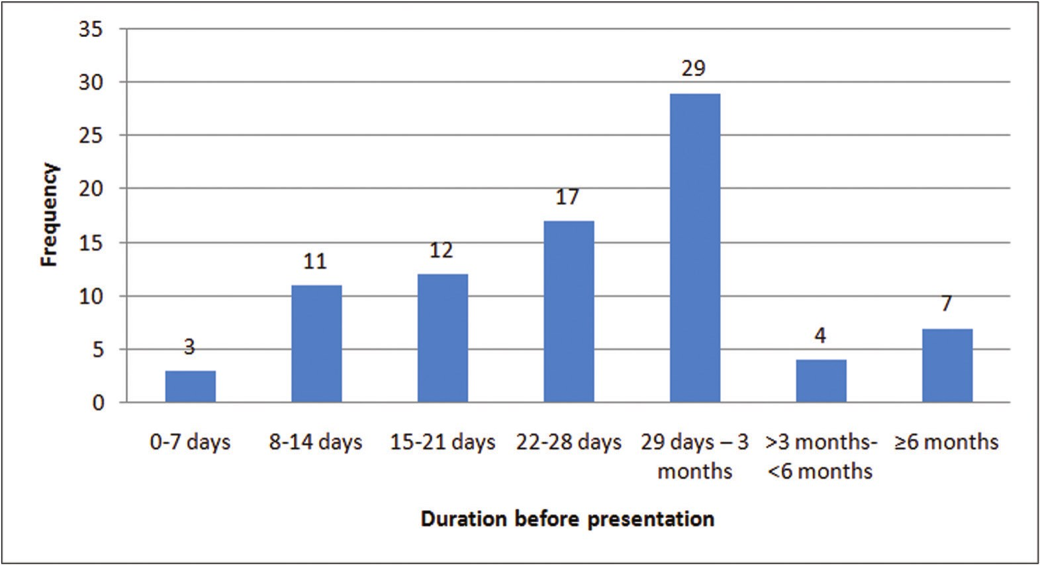

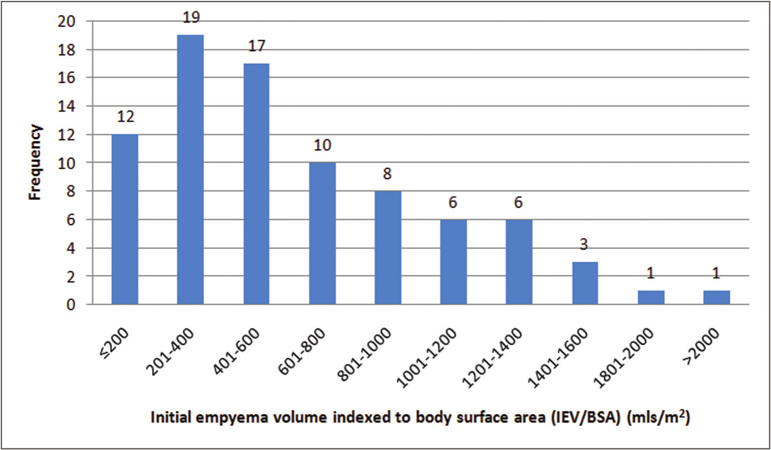

Alioke, *et al.*: Prognostic factors in the management of empyema thoracis in Northern Nigeria

**Figure 2: Duration before the presentation of patients**

**Figure 3: Initial empyema volume indexed to body surface area of patients (IEV/BSA)**

distress syndrome. Of the 80 patients that survived, 29 (36.3%) required decortication to achieve acceptable lung expansion (those with lung expansion ≤ 74% which was considered unacceptable lung expansion in this study), while 51 (63.7%) were managed by closed tube thoracostomy as the definitive treatment strategy. In those who required decortication, rib resection was required for a successful thoracotomy.

Tables 1 to 4 represent the prognostic significance of various analyzed factors on the duration of drainage, percentage of lung expansion, length of hospital stay, and the need for decortication.

Adolescents and adults had 2.1 times increased probability of requiring decortication following empyema thoracis than children.

Presence of complications positively correlated with the need for decortication with a χ2 value of 0.032.

**Discussion**

Empyema thoracis commonly results from bacterial pneumonia with subsequent parapneumonic effusion.[10-13] Twenty to sixty percent of patients admitted to the hospital for bacterial pneumonia subsequently develop parapneumonic effusions, out of which 5 to 10% progress to empyema.[10,12,14]

The age-old principle of managing empyema thoracis involves evacuation of pleural collection, obliteration of the pleural space, and treatment of the underlying disease process. This is achieved by a combination of treatment options that are largely stage-dependent. These

Journal of the West African College of Surgeons | Volume 12 | Issue 4 | October‑December 2022 77

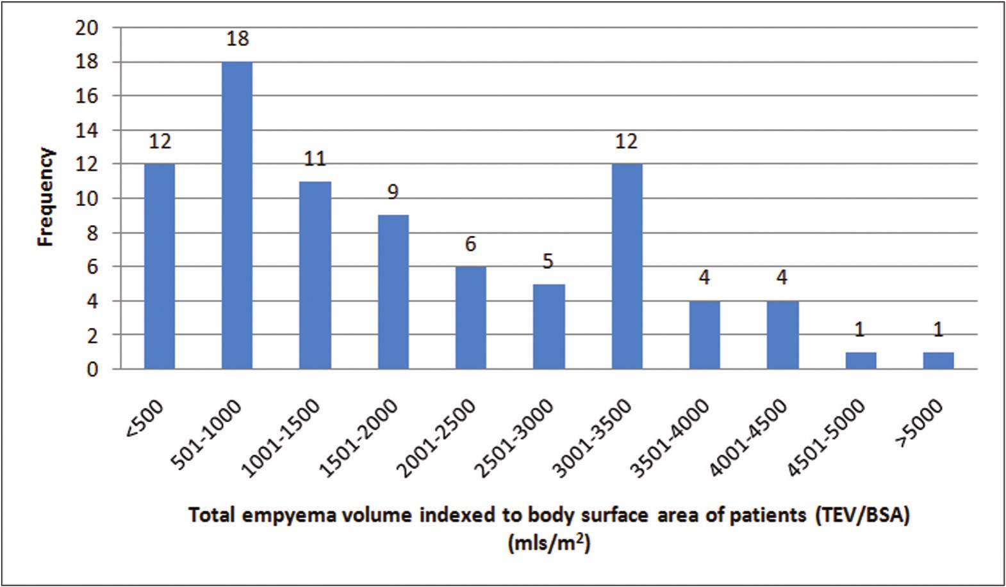

Alioke, *et al.*: Prognostic factors in the management of empyema thoracis in Northern Nigeria

**Figure 4: Total empyema volume indexed to body surface area of patients (TEV/BSA)**

**Table 1: Determinants of duration of drainage**

**Variables** **Univariate Analysis** **Multivariate Analysis**



**β** **SE Age** 0.051 0.179 **Gender** -0.177 7.777

**95%CI** ***p*** **β** **SE** **95%CI** ***p*** -0.274, -0.438 0.649

-28.076, 2.871 0.109

**Duration before presentation Stage**

**Number of organisms BMI**

**Initial empyema volume indexed to BSA (IEV/BSA)**

0.246 0.034 0.168 7.217 0.074 4.424 0.012 6.818 0.111 0.089

0.010, 0.145 0.025* 0.201 0.033 -0.003, 0.130 0.042* -3.322, 25.398 0.130

-5.851, 11.753 0.507 -12.829, 14.304 0.914 -0.087, 0.266 0.317

**Total empyema volume** 0.308 0.027 0.025, 0.133 0.005* 0.275 0.027 0.017, 0.124 0.011* **indexed to BSA (TEV/BSA)**

* Statistically significant at a *p*-value of <0.05, SE – Standard Error, CI – Confidence Interval, BMI – Body Mass Index, BSA – Body Surface Area, IEV – Initial Empyema Volume, TEV – Total Empyema Volume

**Table 2: Determinants of percentage lung expansion**

**Variables** **Univariate Analysis** **Multivariate Analysis**

**Age Gender**

**Duration before presentation Stage**

**Number of organisms BMI**

**Initial empyema volume indexed to BSA (IEV/BSA) Total empyema volume indexed to BSA (TEV/BSA)**

**β** **SE** -0.268 0.108

0.047 5.045 -0.448 0.020 -0.346 4.375 -0.115 2.758 0.031 4.331 -0.216 0.056

-0.390 0.017

**95% CI**

-0.481, -0.051 -7.941, 12.148 -0.126, -0.048 -22.959, -5.540

-8.309, 2.672 -7.447, 9.797 -0.221, 0.002

-0.096, -0.029

***p*** 0.016* 0.678

<0.001* 0.002* 0.310 0.787 0.055

<0.001*

**β** **SE** -0.094 0.106

-0.349 0.019 -0.168 4.364

-0.261 0.016

**95%CI** ***p***

-0.303, 0.117 0.381

-0.106, -0.030 0.001* -15.622, 1.764 0.117

-0.074, -0.010 0.011*

* Statistically significant at a *p*-value of <0.05, SE – Standard Error, CI – Confidence Interval, BMI – Body Mass Index, BSA – Body Surface Area, IEV – Initial Empyema Volume, TEV – Total Empyema Volume

78 Journal of the West African College of Surgeons | Volume 12 | Issue 4 | October‑December 2022

Alioke, *et al.*: Prognostic factors in the management of empyema thoracis in Northern Nigeria

**Table 3: Determinants of length of hospital stay**

**Variables** **Univariate Analysis** **Multivariate Analysis**

**Age Gender**

**Duration before presentation Stage**

**Number of organisms BMI**

**β** **SE** 0.188 0.118

-0.172 5.312 0.398 0.022 0.219 4.858 0.188 2.911 -0.105 4.601

**95%CI**

-0.036, 0.432 -18.784, 2.368 0.040, 0.126

-0.039, 19.303 -0.865, 10.727

-13.442, 4.877

***p*** 0.096 0.126

<0.001* 0.051 0.094

0.355

**β** **SE**

0.314 0.017

**95%CI**

0.031, 0.100

***p***

<0.001*

**Initial empyema volume** 0.319 0.058 0.057, 0.288 0.004* -0.259 0.061 -0.262, -0.018 0.025* **indexed to BSA (IEV/BSA)**

**Total empyema volume** 0.618 0.015 0.076, 0.136 <0.001* 0.738 0.019 0.088, 0.165 <0.001* **indexed to BSA (TEV/BSA)**

* Statistically significant at a *p*-value of <0.05, SE – Standard Error, CI – Confidence Interval, BMI – Body Mass Index, BSA – Body Surface Area, IEV – Initial Empyema Volume, TEV – Total Empyema Volume

**Table 4: Determinants of need for decortication**

**Variables** **Univariate Analysis** **Multivariate Analysis**

**β Age** 0.283 **Gender** -0.054

**SE** **95%CI** 0.003 0.002, 0.013

0.128 -0.316, 0.193

***p*** **β** **SE** 0.011* 0.129 0.003 0.633

**95%CI** ***p***

-0.002, 0.009 0.253

**Duration before presentation Stage**

**Number of organisms BMI**



**Initial empyema volume indexed to BSA (IEV/BSA)**

0.384 0.001 0.409 0.108 0.100 0.070 0.069 0.109 0.078 0.001

0.001, 0.003 0.212, 0.641 -0.077, 0.201 -0.151, 0.285 -0.002, 0.004

<0.001* 0.292 0.001 <0.001* 0.267 0.116

0.378 0.544 0.489

0.000, 0.002 0.006* 0.047, 0.509 0.019*

**Total empyema volume** 0.230 <0.001 0.000, 0.002 0.040* 0.083 <0.001 -0.001, 0.001 0.435 **indexed to BSA (TEV/BSA)**

* Statistically significant at a *p*-value of <0.05, SE – Standard Error, CI – Confidence Interval, BMI – Body Mass Index, BSA – Body Surface Area, IEV – Initial Empyema Volume, TEV – Total Empyema Volume

options include long-term antibiotics, needle thoracentesis, tube thoracostomy, video-assisted thoracoscopic surgery (VATS), open decortication, open drainage, and muscle transposition.[10,12]

As a prognostic factor, it was noted that children were 2.1 times less likely to require a decortication for successful management of empyema thoracis. From the simple linear regression presented above, being a child better predicted a better lung expansion following tube drainage. This was corroborated in an earlier study by Hassan and Mabogunje who had managed all their paediatric patients with empyema thoracis using pleural drainage with no report of any child requiring decortication in Zaria.[15] Satish and colleagues had earlier documented that children had better resorption of the thickened pleura associated with chronic empyema thoracis.[16] Perhaps the levels of matrix metalloproteinases and other enzymes involved in the degradation of extracellular matrix and tissue remodelling may be higher in children than in adults with empyema thoracis. Since children with the disease presented earlier than adults (Spearman’s correlation coefficient of 0.304, p-value = 0.005), they could have had less pleural fibrosis, thus encouraging a better lung expansion than adults.

Thus, the chances of requiring decortication for successful management are less for children than for adults.

Empyema was noted to predominantly affect males (M:F 3.15:1, n= 83). This did not significantly affect the outcome and corroborated with Elemraid’s report that found gender in children to be insignificant as a determinant of children who developed empyema thoracis from community-acquired pneumonia.[17] Edaigbini et al also earlier reported M:F of 2.7:1 in Zaria,[3] as well as Thomas et alwho also had M:F of 1.9:1in their study at Lagos.[18] Other authors also found a male preponderance for the disease.[1,19] However, in a retrospective analysis by Tsai et. al, they reported a statistically-significant reduction in mortality in the males compared to the females with empyema thoracis.[16]

Duration before presentation was found to prognosticate the duration of drainage, lung expansion, length of hospital stay, and the need for decortication. It was noted that most patients with empyema thoracis presented late (28 days to 3 months). Similarly, the stage of the disease was found to be a predictor of lung expansion (with a negative correlation) and the need for decortication (with a positive correlation). Duration before presentation correlated positively with the

Journal of the West African College of Surgeons | Volume 12 | Issue 4 | October‑December 2022 79

Alioke, *et al.*: Prognostic factors in the management of empyema thoracis in Northern Nigeria

stage of the disease (Spearman’s correlation coefficient of 0.665, p-value < 0.001). Due to late presentation, 76% of our patients presented with stage 3 of the disease and were largely from the adult population. As alluded to earlier, children were noted to significantly present earlier than adults. The reason for this late presentation by adults was not assessed in this study. Perhaps, the initial course of the illness is less dramatic in adults, with higher chances of symptoms being masked by the ingestion of over-the-counter medication. Also, the cost of healthcare especially when patients pay out of pocket could be another contributing factor. Thirdly, alternative medical practice has gained ground in most of our communities and forms the first line of care for ailments. The hospital becomes relevant only when this remedy fails. Thus, with a delay in presentation, more pleural fibrosis and lung entrapment ensue (the higher the stage of the disease). Previous research has documented a favourable outcome in the management of earlier stages of empyema thoracis as opposed to the later stages.[16]

Fifty patients (60.2%) had no complications related to the management of empyema. The most common complication encountered was tube site infection (n=18, 21.7%). This was because tube thoracostomy for empyema thoracis was a dirty procedure with gross contamination of the surgical site, and consequent surgical (tube) site infection. Other complications included cosmetic deformity of the chest wall, bronchopleural fistula (which occurred in 3 patients with tuberculous empyema), atelectasis, pneumothorax, and subcutaneous emphysema. Three (3.6%) mortalities were recorded, two of which had sepsis, and the third developed acute respiratory distress syndrome. Most researchers have recorded mortality rates between 3.2% and 8.4%.[7,9,18,20-23] In our study, the presence of complications such as tube site infection and bronchopleural fistula was associated with a higher incidence of decortication for successful management (Chi-square *p-value* of 0.032). This is because of the associated pneumothorax that limits the effectiveness of chest physiotherapy and persistently keeps the ipsilateral lung in a perpetual state of variable degree of collapse, thus permitting fibrinous exudates to become organized into a fibrous peel in the collapsed state. There is also soilage by atmospheric air, thus prolonging the duration of infection. Another reason could be that the bronchopleural fistula is associated with an underlying disease of the lung parenchyma which limits lung compliance and causes persistent atelectasis.

The IEV/BSA only prognosticated the length of hospital stay. The more the initial volume drained, the longer the hospital stay. This may be due to a more profound initial lung collapse, and the more the time required for chest physiotherapy to improve the lung expansion and shorten hospital stay. The TEV/BSA was a significant factor as a predictor of the duration of drainage, the percentage of

lung expansion, the need for decortication and the length of hospital stay. One significant drawback with the use of this parameter is that it can only be assessed in retrospect (after drainage and management of the disease). Studies documented in the literature haven’t studied IEV/BSA and TEV/BSA as prognostic factors in this disease.

The gender and BMI did not significantly influence the duration of drainage, the percentage of lung expansion, length of hospital stay, or the need for decortication. Although Nwiloh and colleagues had found a very low serum albumin level to be associated with increased mortality, we didn’t find any relationship between BMI and any of the outcome parameters. Perhaps, a normal BMI does not necessarily translate to an adequate nutritional status. Since there are conflicting reports on the use of BMI as a nutritional assessment tool,[24,25] biochemical parameters probably remain the better marker for adequacy of nutrition.

Similarly, the number of infecting organisms isolated was not a predictor of any of our 4 outcome parameters. Although empyema thoracis is usually a polymicrobial disease[26] with different sensitivity patterns for each of the organisms isolated, our inability (institutional factors) to carry out anaerobic culture may have impacted negatively on the ‘negative predictive value’ of the number of infective organisms.

**Conclusion**

The age, stage of the disease, duration before presentation, the initial empyema volume indexed to the body surface area (IEV/BSA), and the total empyema volume indexed to the body surface area (TEV/BSA) can be used to prognosticate the outcome of empyema thoracis. With the onset of complication comes a higher chance of requiring decortication. Children are less likely to require decortication for satisfactory management of empyema thoracis.

**Limitations**

A larger sample size and longer duration of study would have aided in a better determination of statistical significance.

**What is already known on this topic**

The pathophysiology and management of empyema thoracis.

**What this study adds**

Factors that can be used to prognosticate the outcome of management of empyema thoracis.

**Financial support and sponsorship**

Nil.

**Conflicts of Interests**

None declared.

80 Journal of the West African College of Surgeons | Volume 12 | Issue 4 | October‑December 2022

Alioke, *et al.*: Prognostic factors in the management of empyema thoracis in Northern Nigeria

**Authors’ Contributions**

1) Ikechukwuka Ifeanyichukwu Alioke – Conceptualization, manuscript writing

2) Sunday Adoga Edaigbini - Conceptualization, manuscript editing

3) Anietimfon Umoh Etiuma - Conceptualization, manuscript editing

4) Ibrahim Zira Delia – Manuscript editing

**References**

1. Cunanan AG. Pleural effusion and empyema in children: A Philippine experience. Respirology 2014;19(Supplement 3):196.

2. Ahmed O, Zangan S. Emergent management of empyema. Semin Intervent Radiol 2012;29:226-30.

3. Edaigbini S, Delia I, Aminu M, Anumenechi N, Audu S. Empyema thoracis in zaria; A preliminary report. Nigerian Journal of Surgery 2011;17:82-6.

4. Akgül AG, Örki A, Örki T, Yüksel M, Arman B. Approach to empyema necessitatis. World J Surg 2011;35:981-4.

5. Ahmed AH, Yacoub TE. Intrapleural therapy in management of complicated parapneumonic effusions and empyema. Clin Pharmacol 2010;2:213-21.

6. Ahmed AE, Yacoub TE. Empyema thoracis. Clin Med Insights Circ Respir Pulm Med 2010;4:1-8.

7. Adeyemo AO, Adeyujigbe O, Taiwo OO. Pleural empyema in infants and children: Analysis of 298 cases. J Natl Med Assoc 1984;76:799-805.

8. Ahmed RA, Marrie TJ, Huang JQ. Thoracic empyema in patients with community-acquired pneumonia. Am J Med 2006;119:87-83.

9. Asindi AA, Efem SE, Asuquo ME. Clinical and bacteriological study on childhood empyema in south eastern nigeria. East Afr Med J 1992;69:78-82.

10. Sellke F, Swanson S, del Nido P. Benign pleural disease: Empyema thoracis. In: Sabiston & Spencer Surgery of the Chest. 7th ed. Philadelphia, PA: Saunders; 2005.

11. Baue AE, Geha AS, Hammond GL, Laks H, Naunheim KS. Benign and malignant diseases of the pleura. In: Glenn’s Thoracic and Cardiovascular Surgery. 6th ed. Stamford, CT: Appleton & Lange; 1996.

12. Shields TW, LoCicero J, Reed CE, Feins RH. General Thoracic Surgery. 7th ed. Philadelphia, PA: Lippincott Williams & Wilkins;

2009.

13. Larry RK, Irving LK, Thomas LS. Mastery of Cardiothoracic Surgery. 2nd ed. Philadelphia, PA: Lippincott Williams & Wilkins; 2007.

14. Bar I, Stav D, Fink G, Peer A, Lazarovitch T, Papiashvilli M. Thoracic empyema in high-risk patients: Conservative management or surgery? Asian Cardiovasc Thorac Ann 2010;18:337-43.

15. Hassan I, Mabogunje O. Paediatric empyema thoracis in zaria, nigeria. Ann Trop Paediatr 1992;12:265-71.

16. Satish B, Bunker M, Seddon P. Management of thoracic empyema in childhood: Does the pleural thickening matter? Arch Dis Child 2003;88:918-21.

17. Elemraid MA, Thomas MF, BlainAP, Rushton SP, Spencer DA, Gennery AR, *et al*. North East of England Pediatric Respiratory Infection Study Group Newcastle upon Tyne, UK. Risk factors for the development of pleural empyema in children. Pediatr Pulmonol 2015;50:721-6.

18. Thomas MO, Ogunleye EO. Chronic Empyema: Aetiopathology and Management Challenges in the Developing World. Surg Sci 2011;02:446-50.

19. Ekpe EE, Akpan MU. Poorly treated broncho-pneumonia with progression to empyema thoracis in Nigerian children. TAF Prev Med Bull. 2010;9:181-6.

20. Hassan I, Mabogunje O. Adult empyema in Zaria, Nigeria. East Afr Med J 1992;69:97-100.

21. Alfageme I, Muñoz F, Peña N, Umbría S. Empyema of the thorax in adults. Etiology, microbiologic findings, and management. Chest 1993;103:839-43.

22. Ozol D, Oktem S, Erdinc E. Complicated parapneumonic effusion and empyema thoracis: Microbiologic and therapeutic aspects. Respir Med 2006;100:286-91.

23. Odelowo EO, Adedoyin MA, Andy JJ, Olamijulo SK. Empyema thoracis in Nigerians: Experience with a policy of conservative operative management. Int Surg 1989;74:247-52.

24. Wagner D, Adunka C, Kniepeiss D, Jakoby E, Schaffellner S, Kandlbauer M, *et al.* Serum albumin, subjective global assessment, body mass index and the bioimpedance analysis in the assessment of malnutrition in patients up to 15 years after liver transplantation. Clin Transplant 2011;25:E396-400.

25. Madhuvanthi M, Lathadevi GV. Serum proteins alteration in association with body mass index in human volunteers. J Clin Diagn Res 2016;10:CC05-7.

26. Chen W, Lin YC, Liang SJ, Tu CY, Chen HJ, Hang LW, *et al.* Hospital-acquired thoracic empyema in adults: A 5-year study.

South Med J 2009;102:909-14.

Journal of the West African College of Surgeons | Volume 12 | Issue 4 | October‑December 2022 81