**Original Article**

Predicting Major Complications Following Laparotomy for Gastrointestinal Conditions Using Surgical Apgar Score: A Prospective Analysis in a Nigerian Population

## Saminu Muhammad1, Abdurrahman Abba Sheshe2,

**Abstract**

**Background:** Surgical Apgar score (SAS) is one of the risk assessment tools used in predicting postoperative complications. It is a simple and inexpensive tool composed of three intra-operative variables; lowest heart rate, lowest mean arterial blood pressure, and estimated blood loss, which are scored with a total of 10 points, based on which patients are risk stratified for developing post-operative complications. SAS was found to have good predictive accuracy for post-operative morbidity and mortality.

The main objective of this study was to determine the efficacy of SAS in predicting major complications following laparotomy for gastrointestinal conditions. **Materials and Methods:** The study was a prospective observational study, conducted in Aminu Kano Teaching Hospital, Kano, Nigeria. Eighty-three adult patients, who required laparotomy for gastrointestinal conditions were recruited. Data was collected using proforma, and patients were followed up for 30 days. The intra- operative parameters for SAS were scored, and according to the scores, patients were risk stratified for developing post-operative complications. The data were analyzed; sensitivity, specificity, and accuracy of the SAS were determined. **Results:** A total of 83 patients were recruited in the study. About half (44.6%) of the patients developed major post-operative complications and a mortality rate of 7.2%. Most of the patients that died had low SAS. The sensitivity, specificity, accuracy, and AUC of SAS found were: 83.8%. 47.8%, 63.9% and 0.74 (95% CI; 0.63–0.84, *P* < 0.001) respectively. **Conclusion:** This study revealed that SAS is efficacious in predicting major complications following laparotomy for gastrointestinal conditions.

**Keywords:** *Efficacy, major complication and laparotomy, prediction, surgical apgar score*

**Habila Ulea Naaya2, Ibrahim Eneye Suleiman2,**

## Usman Mohammed Bello2

*1Department of Surgery, Aminu Kano Teaching Hospital Kano, 2Department of Surgery, Bayero University Kano/Aminu Kano Teaching Hospital Kano, Nigeria*

# Introduction

Various risk assessment tools have been developed for predicting morbidity and mortality following surgical operations. This is due to many complications associated with surgical operation especially when conducted in an emergency setting.[1] Mortality rate recorded following emergency laparotomy in an international study ranged from 13% to 18% within 30days and rose up to 25% within 2years.[2] In a regional study conducted in Kenya, Dullo *et al*[3] found a morbidity rate of up to 40.8% and a mortality rate of 7.9% following laparotomy. However, Ugochukwu *et al*[4] reported a mortality rate of 18.6% following laparotomy for typhoid ileal perforation in south-eastern Nigeria.

Postoperative complications negatively affect the socioeconomic status of the affected

This is an open access journal, and articles are distributed under the terms of the Creative Commons Attribution-NonCommercial- ShareAlike 4.0 License, which allows others to remix, tweak, and build upon the work non-commercially, as long as appropriate credit is given and the new creations are licensed under the identical terms.

**For reprints contact:** [reprints@medknow.com](mailto:reprints@medknow.com)

patients as well as the nation at large; due to loss of man-hours because of increased hospital stay, and due to high cost of care. As a way of minimizing complications related to surgical procedures, clinicians have devised tools to predict post-operative complications,[3,5-7] and stratify patients based on the risk of developing the complications, so that some measures are taken to prevent their occurrence. More so, patients could be triaged for efficient utilization of health resources. These tools include Acute Physiological and Chronic Health Evaluation (APACHE) score, Physiological and Operative Severity Score for the enumeration of Mortality (POSSUM), American Society of Anesthesiologists (ASA) classification, Estimation of PhysiologicAbility and Surgical Stress (E-PASS), Simplified Acute Physiologic Score (SAPS II), Mortality Probability Model (MPM II), etc.

**How to cite this article:** Muhammad S, Sheshe AA, Naaya HU, Suleiman IE, Bello UM. Predicting major complications following laparotomy for gastrointestinal conditions using surgical Apgar score: A prospective analysis in a Nigerian population. J West Afr Coll Surg 2022;12:24-9.

**Received:** 04-Apr-2022 **Accepted:** 14-Jul-2022 **Published:** 06-Oct-2022

***Address for correspondence:*** *Dr Usman Mohammed Bello, Department of Surgery, Bayero University Kano/Aminu Kano Teaching Hospital Kano, Nigeria.*

*E-mail:* [*belloum01@yahoo.co.uk*](mailto:belloum01@yahoo.co.uk)

|  |
| --- |
| **Access this article online** |
| **Website:**  [www.jwacs-jcoac.com](http://www.jwacs-jcoac.com/) |
| **DOI:** 10.4103/jwas.jwas_92_22 |
| **Quick Response Code:** |

24 © 2022 Journal of the West African College of Surgeons | Published by Wolters Kluwer ‑ Medknow

Muhammad, *et al.*: Predicting major complications following laparotomy for gastrointestinal conditions using surgical Apgar score

Clinicians require simple risk assessment tools that are composed of limited and readily obtainable variables in most clinical settings. Such a risk assessment tool as the Apgar score in obstetrics; it has these qualities and has been widely accepted by obstetricians for routine clinical use.[8] The growing desire and need for a simple and acceptable tool for routine use by clinicians (surgeons) as enjoyed by the Apgar score led Gawande and his colleagues in 2007 to develop Surgical Apgar score (SAS) in Boston United States.[5,9] This scoring system is very simple, inexpensive, and derived from readily obtainable variables.

SAS was developed from a retrospective cohort study on 303 patients who underwent open colectomy at Brigham and Women’s Hospital, Boston, United State.[5] This 10-point risk assessment tool comprises three intra-operative variables, i.e. lowest heart rate, lowest mean arterial blood pressure, and estimated blood loss.[5] These variables are graded; the lowest heart rate from 0 to 4, the lowest mean arterial pressure, and the estimated blood loss is graded from 0 to 3 each as depicted in Appendix Table 1.[5] The total points to be scored are 10-points. Based on the scores, patients are stratified according to their risk for developing post-operative complications: High-risk group (0–4 SAS), moderate risk (5–7 SAS), and Low risk (8–10 SAS).[1] There was a significant association between SAS scores and the development of post-operative complications.[5]

SAS was validated for use in many surgical specialties including general surgery, vascular surgery, neurosurgery, urology, orthopedics etc..[5,9] Similarly it was validated in a large international multicenter prospective study conducted on 5,909 patients who underwent non cardiac surgical operations.[9] It has been used for predicting postoperative complications in many surgical operations and has shown hope in evaluating interventions to halt poor post-operative outcomes.[3,6,7]Regenbogen *et al.* in a retrospective study conducted on patients who underwent general and vascular surgical procedures, found that SAS can be used to identify patients at high or low risk for developing post-operative complications or death.[6] SAS was also found useful in predicting morbidity and mortality especially the low surgical Apgar score following laparotomy.[10] In a similar study conducted in Kenya, Dullo et al[3] reported that surgical Apgar score could be used in risk stratification of patients for developing major post- operative complications following laparotomy.[3]

The SAS has been found to be efficacious in predicting postoperative complications including mortality.[3,10] It was found to have good predictive accuracy for morbidity following laparotomy in the Kenyan study.[3] Chitra et al10 in their study on patients who underwent laparotomy found that surgical Apgar score has high sensitivity (94.87%) and low specificity (26.83%) in predicting post- operative complications.[10] The positive and negative predictive values of 55.2% and 84.6% respectively, and the accuracy of 60.0% were recorded in the same study.[10] In another study conducted on patients who had emergency

abdominal surgery in the Caribbean.[11] They found 73.0% sensitivity and40.0% specificity of SAS in predicting major complications.[11] They also found that SAS has moderate accuracy in predicting postoperative complications, with an AUC of 0.71 (95% CI, 0.68–0.73; *P* < 0.001).[11]

# Materials and Methods

This study was an observational prospective study conducted in Aminu Kano Teaching Hospital, Kano between 1st June 2018 and 31st May 2019; the hospital is a tertiary health care centre in Northwestern Nigeria. Eighty three adult patients who had met the indication for laparotomy for gastrointestinal conditions and consented were enrolled. Ethical approval to conduct the study was obtained from the hospital research and ethics committee.

Bio-demographic data and clinical characteristics of the patients were collected using a proforma. The intra- operatives parameters used to arrive at SAS; lowest Heart rate, lowest MAP and Estimated Blood Loss were all documented. The SAS was calculated for all the patients as in Appendix Table 1.[5] Based on the score patents were risk stratified for developing postoperative complications; High- risk group (0–4 SAS), moderate risk (5–7 SAS) and Low risk (8–10 SAS).[1] The patients were followed up for 30 days and postoperative complications and deaths documented.

The data was analyzed using Statistical package for social sciences (SPSS) (Version 22, Armonk, NY IBM Corp.).[12] The quantitative variables-age was summarized using mean, standard deviation and range, while qualitative variables such as sex, type of surgery, complications, etc., were summarized using frequencies, percentages, and or proportions. ROC curved was generated from the SPSS analysis of the SAS and postoperative outcomes, the cutoff point was determined, and AUC obtained.

|  |  |
| --- | --- |
| **patients** | |
| **Diagnoses** | **Number of patients (%)** |
| Peritonitis | 23 (27.7) |
| Ruptured appendix | 15 (18.1) |
| Perforated peptic ulcer diseases | 4 (4.8) |
| Typhoid ileal perforation | 4 (4.8) |
| Intestinal obstruction Colorectal tumour | 17 (20.5)  8 (9.6) |
| Adhesive | 4 (4.8) |
| Inguinal hernia | 2 (2.4) |
| Others | 3 (3.6) |
| Abdominal trauma | 12 (14.5) |
| Obstructive jaundice | 5 (6.0) |
| Gastric cancer | 4 (4.8) |
| Gastric outlet obstruction | 3 (3.6) |
| Enterocutenous fistula | 3 (3.6) |
| Hepatic tumour | 2 (2.4) |
| Gastric GIST | 2 (2.4) |
| Retroperitoneal tumour | 2 (2.4) |
| Others 10 (12.0) | |

### Table 1: A table displaying the common diagnoses of the

Sensitivity, specificity, positive predictive value (PPV), negative predictive value (NPV), and accuracy of the Surgical Apgar score were obtained using 2-2 contingency table.

# Results

A total of 83 patients were studied, and their ages ranged between 18 years and 86 years. Their mean age was

40.2 years and the standard deviation of 17.6 years. The age distribution has been summarized and graphically displayed in form of a histogram shown in Figure 1.

Most of the patients were male, with male to female ratio of 1.5:1 as summarized and displayed in form of a pie chart in Figure 2.

The emergency presentation was the main mode of admission as shown in the doughnut chart in Figure 3.

Peritonitis was the most common surgical condition that required laparotomy, and ruptured appendix was the most frequent cause of the peritonitis in the patients studied as depicted in Table 1.

Many of the patients studied had major post-operative complications, and wound infection was the most common post-operative complication as shown in Table 2.

A total of 6 patients died within 30day post-operative periods out of the 83 patients recruited in the study. This gives a 30day post-operative mortality rate of 7.2% rate in this study. The Major complications and mortality in all the risk groups are displayed in Table 3.

Using the SPSS software the SAS and post-operative outcomes in terms of major post-operative complications were entered to produce a ROC curve. It gives a relationship between sensitivity and 1-specificity, and it has shown that SAS is a good test for predicting major post-operative complications.

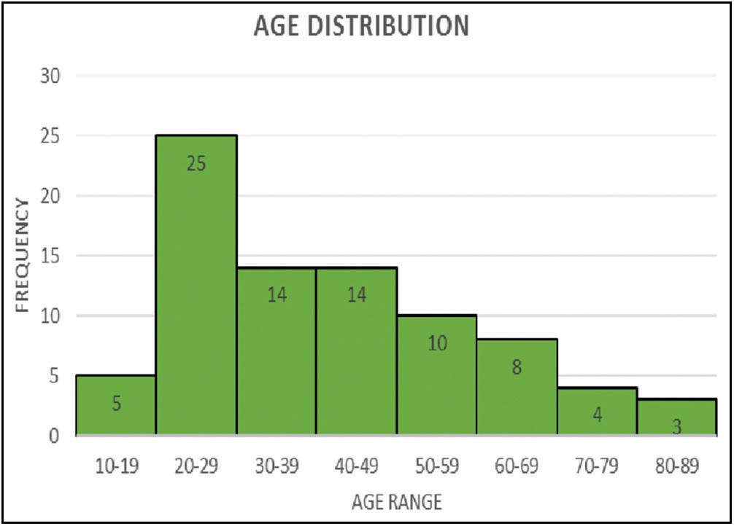

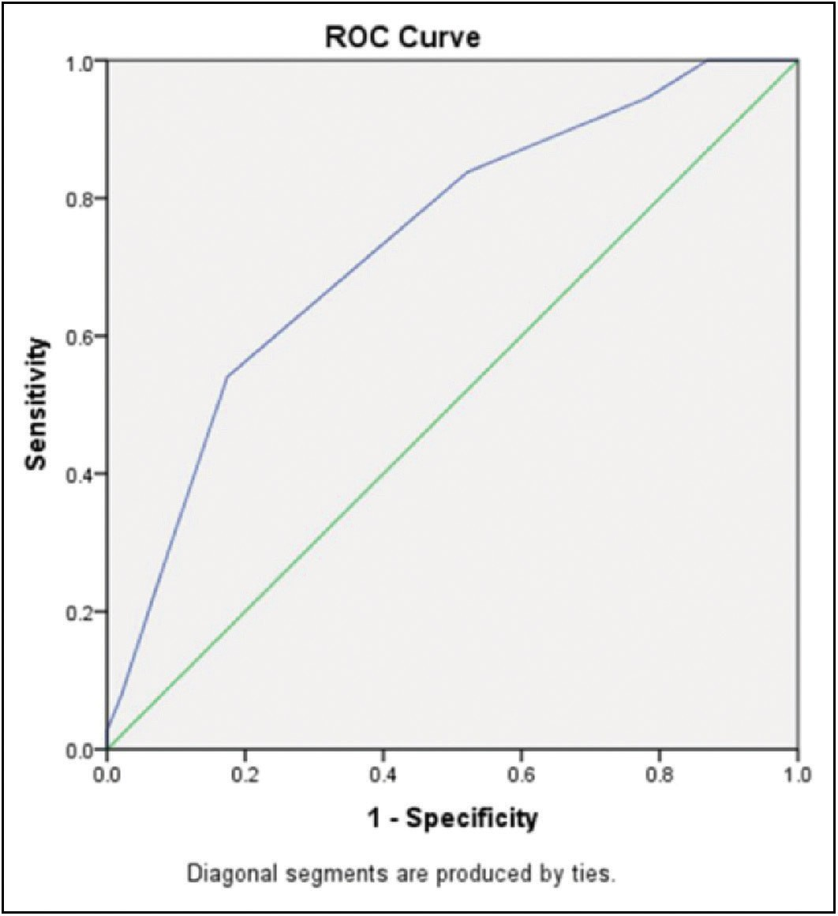**Figure 1: A histogram displaying the age distribution of the 83 patients Figure 3: Showing a receiver operating characteristics curve (ROC curve)**

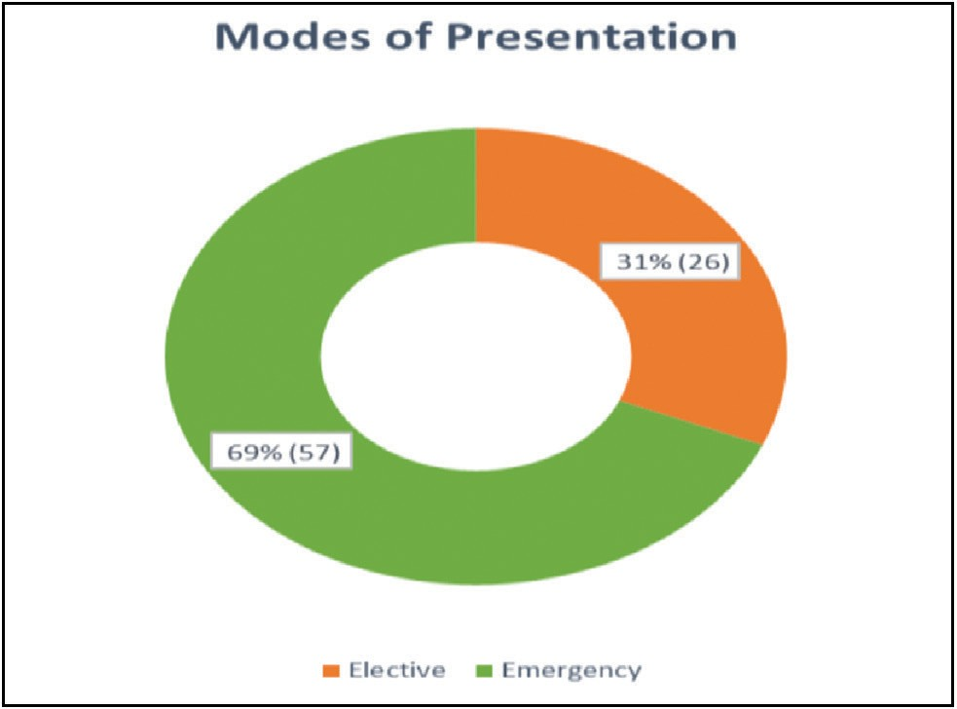

**Figure 2: A doughnut chart showing the mode of presentations of the**

|  |  |  |  |  |
| --- | --- | --- | --- | --- |
| **Surgical**  **Apgar score** | **Risk**  **group** | **Counts**  **(%)** | **Major**  **complications (%)** | **Deaths**  **(%)** |
| 0–4 | High risk | 28 (33.7) | 20 (71.4) | 4 (14.3) |
| 5–7 | Moderate | 49 (59.0) | 17 (34.7) | 2 (4.1) |
| 8–10 | Low | 6 (7.2) | 0 (0.0) | 0 (0.0) |

### Table 2: A table showing 30day major post-operative complications in the patients

|  |  |
| --- | --- |
| **30days postoperative complications** | **Number of patients (%)** |
| Wound infections | 19 (22.9) |
| Wound dehiscence | 6 (7.2) |
| Enterocutaneous fistulae | 3 (3.6) |
| Severe anaemia | 2 (2.4) |
| Others | 7 (8.4) |

**Table 3: A table showing 30day post-operative major complication rate in the risk groups**

**patients studied**

### Table 4: A table showing the area under the curve

for 48hours or longer, pneumonia, pulmonary embolism,

**Area under the curve**

***P*-value Lower bound 95% CI**

**Upper bound 9% CI**

stroke, wound disruption, deep or organ space surgical site infection, sepsis, systemic inflammatory response syndrome

0.736 <0.001 0.629 0.844

The area under the curve was automatically calculated by the software, and it depicts the accuracy of the test. The area under the curve was 0.74 (95% CI; 0.63–0.84, P-value<0.0001) from the test result in Table 4.

The cutoff point of 6 determined from the ROC curve was used in the formation of the 2-2 contingency table below.

Therefore,

Sensitivity= 31/37 × 100 =83.8%

Specificity= 22/46 × 100 =47.8%

Positive predictive Value =31/55 × 100 = 56.4% Negative predictive value = 22/28 × 100 =78.6% Accuracy = (31 + 22)/83 × 100 =63.9%

# Discussion

This study was done to determine the efficacy of SAS in predicting major post-operative complications following laparotomy for gastrointestinal conditions.The patients studied were between the ages of 18 to 86 years with a mean age of 40.2 years; this showed that majority of the patients who had laparotomy within the period of the study were young adults. In a similar local study conducted by Ugochukwuet al,[4] the mean age of 25.0years was reported.

Peritonitis from ruptured appendicitis was the most common indication for laparotomy in this study, 18.1% of the patients studied had ruptured appendicitis. The second most common indications were penetrating abdominal trauma; 14.5% of the patients had laparotomy due to abdominal trauma as depicted in [Table 1]. A close picture of these findings was reported in a local study conducted in Ibadan by Oyandipo and colleagues.[13] They found that ruptured appendicitis was the most common indication for laparotomy also; accounting for 27.5% of their patients and it was again followed by penetrating abdominal trauma which accounted for 16.2% of the patients studied.[13] However, in the Kenyan study penetrating abdominal trauma was the most common indication for laparotomy; 18.4% of the patients studied had penetrating abdominal injuies.[3]

The definition of major post-operative complications in this study was adapted from the American College of Surgeons National Surgical Quality Improvement Programme (ACS- NSQIP) definition. They defined major post-operative complications as any of the following: “Acute renal failure, bleeding requiring ≥ 4 unit red cell transfusions within 72hours after an operation, cardiac arrest requiring cardiopulmonary resuscitation, coma for 24hours or longer, deep venousthrombosis and septic shock. Others include myocardial infarction, unplanned intubations, ventilator use

and vascular graft failure”.[5,9] In this study the rate of 30day

major post-operative complications was 44.6% and that of 30day mortality was 7.2%. A similar finding was reported in the Kenyan study; the rate of 40.8% and 7.9% of major post-operative complication and mortality respectively was recorded.[3]Ayandipo *et al.* reported lower mortality and post- operative complication rate in their local study in Ibadan Southwestern Nigeria. They recorded a 9.2% and 2.4% post-operative complication rate and mortality respectively.[13] Moreover, the study design was retrospective; there might be missing data and other biases in data reporting and recording.

It was observed in this study that major post-operative complication rate was more common in the high-risk group; the rate of major post-operative complications in this group was found to be 71.4% and 30day mortality of 14.3%. However, in the moderate-risk group, the rate of post-operative major complications was 34.7% and 4.1% mortality rate; while in the low-risk group there was no major complication or mortality recorded, refer to Table 3. The analysis also revealed statistically significant association between SAS and postoperative complications (*P* < 0.002). These findings conformed to what obtained in most literature. In the study conducted by Ngarambe et al, the mortality of up to 50.0% and post-operative complication rate of 64.0% in the high-risk group were reported, while only 3.0% and 11.0% mortality and major post-operative complication rate were reported respectively in mild risk group.[7] And no mortality or morbidity was documented also in the low-risk group.[7]In the Kenyan study, the rate of post-operative complication was 58.3%, 35.6%, and 16.6% for high risk, moderate, and low-risk group respectively.[3] The same picture was obtained in a study done in Pakistan by Balaga and his colleague; it was found that the rate of major post-operative complications in the high-risk group was 66.6% and the mortality rate was 33.3%, while that of the low-risk group was 8.3% and 0% recpectively.[14]

This study aimed at determining the efficacy of SAS in predicting post-operative morbidity and mortality. And the study revealed a sensitivity of SAS of 83.8%, this showed that SAS has high sensitivity in predicting major post-operative complications following laparotomy for gastrointestinal conditions. This conforms to what was reported in a similar study conducted in south India by Chitra and his collegues[10]; they found a sensitivity of 94.9%. However, both studies recorded a low specificity; in this current study specificity of 47.8% was obtained while in theirs was 26.8%.[10] In another study done by Singh et al,[11] although the study was conducted only on patients who had emergency abdominal surgery in the Caribbean. They found 73.0% sensitivity and 40.0% specificity of SAS in predicting major complications.[11]The positive predictive and negative predictive values of SAS in predicting major post-operative complications in our study were 56.4% and

### Table 5: A 2-2 contingency table for risk groups and major

**post-operative complications**

**Postoperative Postoperative Total complication (yes) complication (no)**

High risk (SAS<6) 31 24 55

Low risk (SAS≥6) 6 22 28

Total 37 46 83

78.6% respectively. In the Indian study by Chitraet al,[10] they found similar figures to this study with positive and negative predictive values of 55.2% and 84.6% respectively. This showed that SAS in this study has fair positive and good negative predictive values and the findings conformed to what is obtained in the literature.

The accuracy of SAS in this study as deduced from the 2-2 contingency table was 63.9%, Table 5.This finding is similar to what was reported in the study conducted by Chitra and his colleagues in a teaching hospital setting in India.[10] They recorded SAS accuracy of 60.0% in predicting laparotomy as well. However in the study performed by Singh et al, they did not use calculated accuracy from the 2-2 contingency table, they rather used the AUC.[11] In this current study the AUC of 0.74 (95% CI, 0.63–0.84; *P* < 0.001) was obtained, depicting 74.0% accuracy. And this was closely conformed to what Singh and colleagues found in their study, they found an AUC of 0.71 (95% CI, 0.68–0.73; *P* < 0.001).[11] From the findings of this study, SAS has a moderate accuracy in terms of predicting major post-operative complication following laparotomy for gastrointestinal conditions. The definition and interpretation of the accuracy from the AUC were adapted from the study by Fisher et al.[15] The AUC of 0.9 depicts high accuracy, AUC of 0.7–0.9 depicts moderate accuracy, and AUC of 0.5–0.7 depicts low accuracy.[15]Even though the study by Singh et al[11] was retrospective while this was prospective, they both revealed similar findings with strong statistical significance. This strongly depicts that SAS has moderate accuracy and is efficacious in predicting major post-operative complications and death.

# Conclusion

This study revealed that SAS has moderate accuracy in predicting major complications following laparotomy for gastrointestinal conditions. It is, therefore, an efficacious tool for predicting major complications following laparotomy for gastrointestinal conditions.

### Financial support and sponsorship

Nil.

### Conflicts of interest

There are no conflicts of interest.

### Authors contribution

Saminu Muhammad

Formulated the research question, administer questionnaire, wrote introduction

Abdurrahman Abba Sheshe

Reviewed the article, participated in writing the discussion

Habila Ulea Naaya

Thoroughly review the article and help with statistics

Ibrahim Eneye Suleiman

Reviewed the article and help with Data analysis

Usman Mohammed Bello

Participated in operating the patients, article review and writing the Discussion

# References

1. Santoshsingh SR, Sathyakrishna BR. Surgical Apgar score - A simple prognostic tool in surgery. Int J Sci Study 2016;4:1-5.
2. Oliver CM, Walker E, Giannaris S, Grocott MP, Moonesinghe SR. Risk assessment tools validated for patients undergoing emergency laparotomy: A systematic review. Br J Anaesth 2015;115:849-60.
3. Dullo M, Swo O, Eo N. Surgical apgar score predicts post- laparatomy complications. Ann Afri Surg 2013;10:24-9.
4. Ugochukwu AI, Amu OC, Nzegwu MA. Ileal perforation due to typhoid fever e Review of operative management and outcome in an urban centre in Nigeria. IJSU 2013;11:218-22.
5. Gawande AA, Kwaan MR, Regenbogen SE, Lipsitz SA, Zinner MJ. An apgar score for surgery. J Am Coll Surg 2007;204:201-8.
6. Regenbogen SE, Ehrenfeld JM, Lipsitz SR, Greenberg CC, Hutter MM, Gawande AA. Utility of the surgical apgar score: Validation in 4119 patients. Arch Surg 2009;144:30-6; discussion 37.
7. Ngarambe C, Smart BJ, Nagarajan N, Rickard J. Validation of the surgical apgar score after laparotomy at a tertiary referral hospital in rwanda. World J Surg 2017;41:1734-42.
8. Brian M, Donald DM, Kenneth JL. The continuing value of the Apgar score for the assessment of Newborn Infants. N Engl J Med 2001;344:467-71.
9. Haddow JB, Adwan H, Clark SE, Tayeh S, Antonowicz SS, Jayia P, *et al*.; London Surgical Research Group. Use of the surgical apgar score to guide postoperative care. Ann R Coll Surg Engl 2014;96:352-8.
10. Chitra S, Saravanan K, Ashoka CD, Gourab K. Utility of surgical APGAR score in predicting morbidity and mortality in patients undergoing laparotomy. J Curr trend Clin Med Lab Biochem 2015;3:23-30.
11. Singh K, Hariharan S. Detecting major complications and death after emergency abdominal surgery using the surgical apgar score: A retrospective analysis in a caribbean setting. Turk J Anaesthesiol Reanim 2019;47:128-33.
12. IBM Corp. Released 2011. IBM SPSS Statistics for Windows, Version 20.0. Amonk, NY: IBM Corp.
13. Ayandipo OO, Afuwape OO, Irabor DO, Abdurrazzaaq AI, Nwafulume NA. Outcome Of Laparotomy For Peritonitis In 302 Consecutive Patients In Ibadan, Nigeria. Ann Ib Postgrad Med 2016;14:30-4.
14. Balaga S, Banoth SN, Bejjamshetty N. Surgical Apgar score: Efficacy in predicting surgical outcome. IJSR 2017;6: 370-1.
15. Fischer JE, Bachmann LM, Jaeschke R. A readers’ guide to the interpretation of diagnostic test properties: Clinical example of sepsis. Intensive Care Med 2003;29:1043-51.



### Appendix Table 1: Displaying scoring of points of the SAS parameters

|  |  |  |  |  |  |
| --- | --- | --- | --- | --- | --- |
| **0 Point 1 Point 2 Points** | | | | **3 Points** | **4 Points** |
| Estimated blood loss (mL) | >1000 | 601–1000 | 101-600 | ≤100 |  |
| Lowest MAP (mmHg) | <45 | 45–54 | 55-69 | ≥70 |  |
| Lowest heart rate (beats/min) | >85 | 76–85 | 66-75 | 56–65 | ≤55 |
| Adapted from Gawande *et al*.[5] |  |  |  |  |  |