**Case Report**

**Post-dated Breech Pregnancy in a Non-obviously Communicating Rudimentary Horn of a Bicornuate Uterus Requiring Hemi-hysterectomy**

**Abstract**

Developmental anomalies of the Müllerian duct systems such as the bicornuate uterus are rare globally and hardly do term pregnancies occur in conjunction with these abnormalities. The occurrence of post-dated pregnancy is rarely associated with a bicornuate uterus. We present a 35-year-old un-booked multigravida with post-date pregnancy complicated by breech and intrauterine foetal death (IUFD) in a rudimentary uterine horn. She had caesarean delivery complicated by intractable postpartum haemorrhage (PPH). This together with the risks of poor uterine involution in the postpartum and obstetric outcome in the event that another pregnancy occurs in the same horn subsequently warranted a caesarean hemi-hysterectomy of the rudimentary uterine horn. Uterine bicornuate is an uncommon genital tract anomaly and a rare cause of post-date pregnancy. Postpartum bleeding warranting caesarean hemi-hysterectomy should be anticipated as the pregnant horn may not be responsive to conventional oxytocics.

**Keywords:** *Breech, caesarean hemi-hysterectomy, post-date pregnancy, rudimentary horn*

**Muhammad Baffah Aminu,**

**Iffat Sania1, Munni Khairunnaesa1**

*Department of Obstetrics & Gynaecology, Abubakar Tafawa Balewa University,*

*Bauchi, Nigeria, 1Department of Obstetrics & Gynaecology, Sadar Hospital, Cox’s Bazaar, Bangladesh*

**Introduction**

The partial or total failure in the development of the Müllerian duct system in utero results in anomalies of the female genital especially involving the uterus and tubes.[1,2] One of these abnormalities is the bicornuate uterus with a non-functional horn. This uncommon condition accounts for approximately 1:100000 pregnancies[3] with more than two-thirds occurring in isolation (noncommunicating).

The occurrence of term pregnancy in the rudimentary horn of a bicornuate uterus is rare because the reproductive outcome in women with this condition is usually not encouraging[4-6] with a reported incidence of approximately 1:140000 pregnancies.[7] Quite a few viable pregnancies have been shown to occur in a rudimentary horn with the majority being previable ending in miscarriages.[4] The occurrence of post-dated breech pregnancies in rudimentary horns is not common and thus the reason for this case report. In our literature search, we only came across one publication.[8] The management options for pregnancies in the rudimentary horn, therefore, had been evacuation and or laparotomy. This article

This is an open access journal, and articles are distributed under the terms ofthe Creative CommonsAttribution-NonCommercial-ShareAlike 4.0 License, which allows others to remix, tweak, and build upon the work non-commercially, as long as appropriate credit is given and the new creations are licensed under the identical terms.

**For reprints contact:** reprints@medknow.com

presents the occurrence of post-dated breech pregnancy with intrauterine foetal death (IUFD) in a non communicating horn requiring caesarean hemi-hysterectomy. It is aimed at raising awareness on the occurrence of this condition and its consideration as a cause of postpartum haemorrhage (PPH).

**Case Report**

We describe the case of a 35-year-old unbooked Gravida 3 Para 2+0, 1 alive patient at 41 weeks of gestation noted to have absent foetal movement for one month and regressing pregnancy symptoms. She had no history of bleeding per vaginum, liquor drainage or continuous abdominal pain. Her gynaecological history was not eventful. A physical examination done at presentation did not show any abnormality.

Abdominal examination showed a gravid uterus with fundal height of 34cm, there was a singleton foetus in longitudinal lie, breech presentation, foetal heart tone was not present. The surface of the gravid uterus was smooth except in the left iliac region where there was a firm to hard discontinuity (a bulge) measuring 8×6cm which can be gotten above but not below. Cervical assessment revealed a Bishop score of 4/13. Obstetrical ultrasound at presentation to

**How to cite this article:** Aminu MB, Sania I, Khairunnaessa M. Post-dated breech pregnancy in a non-obviously communicating rudimentary horn of a bicornuate uterus requiring hemi-hysterectomy. J West Afr Coll Surg 2023;13:111-3.

**Received:** 15-Sep-2022 **Accepted:** 14-Oct-2022 **Published:** 18-Jan-2023

***Address for correspondence:*** *Dr. Muhammad Baffah Aminu, Department of Obstetrics and Gynaecology, Abubakar Tafawa Balewa University, Bauchi, Nigeria.*

*E-mail: mbaminu@atbu,edu.ng*

**Access this article online**

**Website:**

www.jwacs-jcoac.com

**DOI:** 10.4103/jwas.jwas_194_22

**Quick Response Code:**

© 2023 Journal of the West African College of Surgeons | Published by Wolters Kluwer ‑ Medknow 111

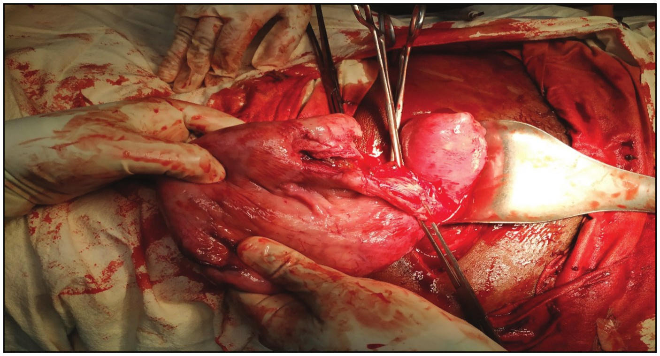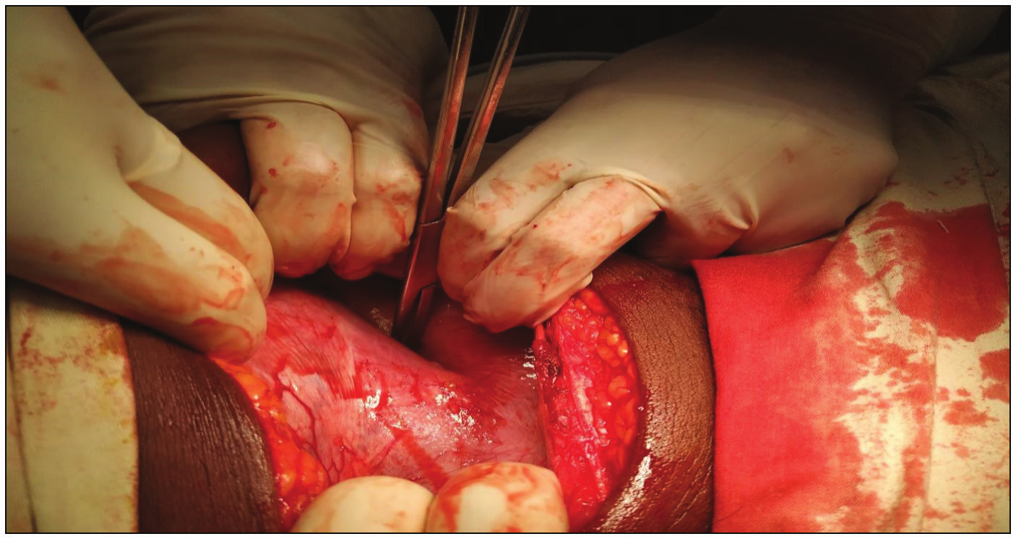Aminu, *et al.*: Post-dated breech pregnancy in a noncommunicating rudimentary horn

**Figure 1: Gravid uterus with a formed lower segment on the right horn of the uterus, clear bifurcation as pointed with forceps**

**Figure 2: Probing showed the right cervical canal was later noted to be connected to the main cervix via a small opening midway into the cervix**

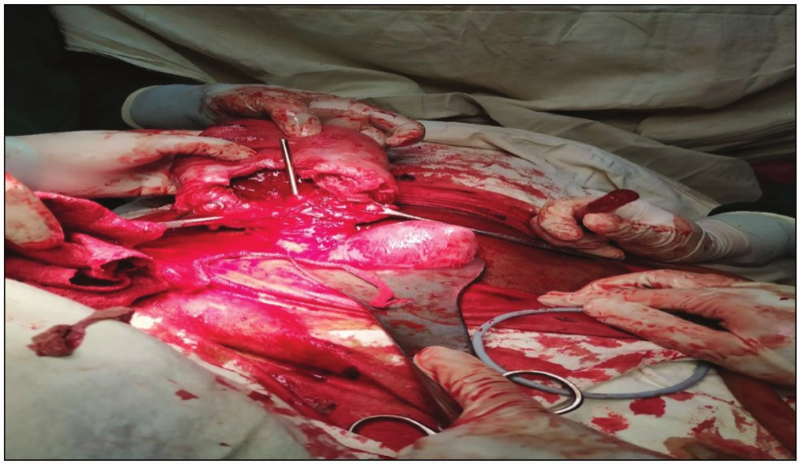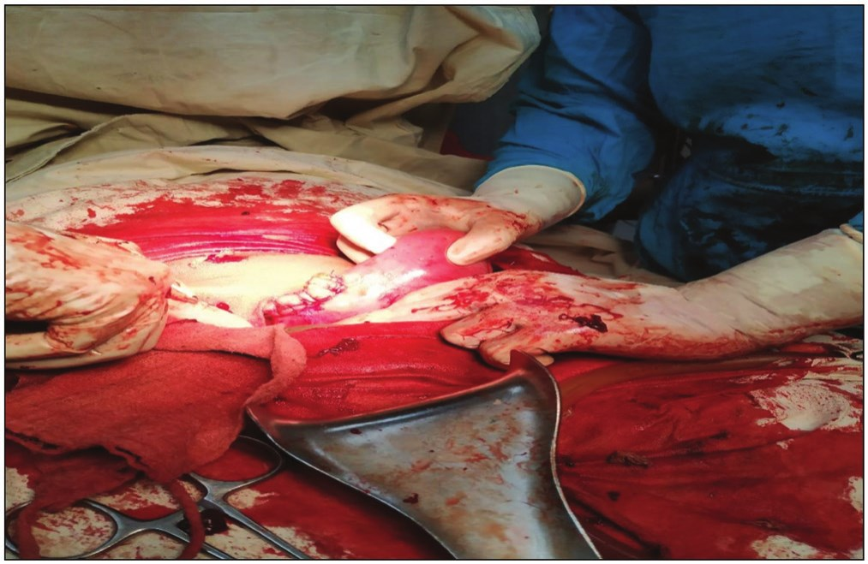

the labour and delivery suite revealed a singleton foetus in breech presentation, the foetal heart tone was absent and there was collapsed head, lungs and subcutaneous oedema. The uterus appeared double with a left empty uterus having a well defined margin and normal endometrial plate (bicornuate uterus). Attempts at cervical ripening and induction of labour were unsuccessful and she was then delivered via emergency caesarean section with findings of well-developed tubes and ovaries bilaterally. Gravid uterus on the right bicornuate horn [Figure 1] with no obvious internal cervical opening. The anatomic orientation of the cervix on the rudimentary horn was not clear but a gentle probing showed a cervical canal connected to the main cervix midway into the cervix [Figure 2]. The left arm of the uterus was well developed and continuous with the cervix. A macerated stillborn male child in right sacro-anterior position weighing 2.3kg was delivered. The placenta was fundal. The baby had no obvious congenital abnormality. Attempts were made to prevent haemorrhage but she developed primary PPH due to atony [Figure 3] and had 60 international units (IU) of oxytocin and 0.5mg of intramyometrial ergometrine given, but to no avail, thus warranting caesarean hemi-hysterectomy of the rudimentary horn [Figure 4]. The left uterus, fallopian tube and ovary were all normal. She did well subsequently and was discharged home after 5 days.

**Figure 3: Atonic right pregnant horn**

**Figure 4: Caesarean hemi-hysterectomy of the pregnant rudimentary horn and the normal uterus on the left**

**Discussion**

Pregnancies in the rudimentary horn of the uterus could present with varied symptoms sometimes confusing the attending physician, occasionally, they can be mistaken for cornual or tubal ectopic gestation. In some cases, they may also present with signs and symptoms of preterm delivery, breech presentation,[9] abnormal placental location (praevia), ectopic pregnancy and growth restriction.[2] In most cases, there is usually an observed discontinuity between the cervical Os and the uterine horn harbouring the conceptus as seen in the case under review or there could be abnormal uterine contour during palpation of the gravid uterus.[10]

The occurrence of breech and post-dated pregnancy in a rudimentary uterus is not an unusual association since there are documented shreds of evidence of breech presentation resulting in post-date pregnancy. Aside from the symptom of pregnancy, women with this abnormal pregnancy may have recurrent pregnancy loss and dysmenorrhoea requiring ultrasound scan which is helpful during or outside pregnancy, However, magnetic resonance imaging (MRI) where available have been shown to be a greater tool for accurate diagnosis especially outside pregnancy.[7,11] The majority of patients could present with abdominal pain requiring surgical removal

112 Journal of the West African College of Surgeons | Volume 13 | Issue 1 | January‑March 2023

[Downloaded free from http://www.jwacs-jcoac.com on Tuesday, February 7, 2023, IP: 2.28.143.76]

Aminu, *et al.*: Post-dated breech pregnancy in a noncommunicating rudimentary horn

of the horn in order to avoid complications during childbirth as was done in this case report.

The occurrence of term pregnancy in a rudimentary uterus has been reported but not with breech and postdates. To date, only one case of post-date pregnancy in a rudimentary uterus has been reported.[8] Hence, this case report is unique. However, cases of ectopic and molar pregnancies have been shown to occur in the rudimentary horn of an abnormal uterus.[1]

One of the most common options of care for these patients is laparotomy and excision of the tube, and the rudimentary horn containing the pregnancy. There have been reported cases of laparoscopic resection of the rudimentary horn outside pregnancy followed by a second look hysterolaparoscopy with successful conception.[12] The role of laparoscopic hemi-hysterectomy in term pregnancy is yet to be confirmed, thus warranting the choice of laparotomy for the index case due to the size of the uterus and the advanced gestational age. The laparoscopic approach is therefore contraindicated in this case.

**Conclusion**

Pregnancy in a rudimentary uterine horn can lead to postdatism. Obstetricians should obtain double consent when performing caesarean section for such pregnancies as caesarean hemi-hysterectomy may sometimes be required.

**Declaration of patient consent**

Theauthors certify that they have obtained all appropriate patient consent forms. In the form the patient(s) has/have given his/her/their consent for his/her/their images and other clinical information to be reported in the journal. The patients understand that their names and initials will not be published and due efforts will be made to conceal their identity, but anonymity cannot be guaranteed.

**Financial support and sponsorship**

Not applicable.

**Conflicts of interest**

There are no conflicts of interest.

**References**

1. Krishnamoorthy K, Gerkowicz S, Verma U. Viable intrauterine pregnancy and coexisting molar pregnancy in a bicornuate uterus: A rare presentation. J Clin Imaging Sci 2016;6:26.

2. Kumar A, Deepika N. Ruptured non-communicating rudimentary horn of unicornuate uterus at 14 weeks of pregnancy: A case report. Global J Med Public Health 2013;2.

3. Nahum GG. Rudimentary uterine horn pregnancy. The 20th-century worldwide experience of 588 cases. J Reprod Med 2002;47:151-63.

4. Heinonen PK, Saarikoski S, Pystynen P. Reproductive performance of women with uterine anomalies. An evaluation of 182 cases. Acta Obstet Gynecol Scand 1982;61:157-62.

5. Tazinya AA, Feteh VF, Ngu RC, Bechem NN, Halle-Ekane GE. Term pregnancy in a bicornuate uterus: Complications, diagnostic and therapeutic challenges in a low resource setting (Douala, Cameroon). Int J Med Pharm Case Rep 2018;11:1-4.

6. Pannu D, Bharti R, Anand HP, Sharma M. Term live secondary abdominal pregnancy: A case report. Malays J Med Sci 2016;23:96-9.

7. Rath TS, Tripathy SR, Rout S, Mishra J. The unchartered waters of obstetrics-rupture of non-communicating rudimentary horn pregnancy (Rnhp) in a Bicornuate Uterus. Gynecol Obstet (Sunnyvale) 2016;6:2161-0932.

8. Feteh VF, Dimala CA, Njim T, Fuka B. Post term pregnancy in a non-communicating rudimentary horn of a unicornuate uterus. BMC Res Notes 2016;9:209.

9. Vaz SA, Dotters-Katz SK, Kuller JA. Diagnosis and management of congenital uterine anomalies in pregnancy. Obstet Gynecol Surv 2017;72:194-201.

10. Tsafrir A, Rojansky N, Sela HY, Gomori JM, Nadjari M. Rudimentary horn pregnancy: First-trimester prerupture sonographic diagnosis and confirmation by magnetic resonance imaging. J Ultrasound Med 2005;24:219-23.

11. Marcal L, Nothaft MA, Coelho F, Volpato R, Iyer R. Mullerian duct anomalies: Mr imaging. Abdom Imaging 2011;36:756-64.

12. Alborzi S, Asefjah H, Amini M, Vafaei H, Madadi G, Chubak N, *et al*. Laparoscopic metroplasty in bicornuate and didelphic uteri:

Feasibility and outcome. Arch Gynecol Obstet 2015;291:1167-71.

Journal of the West African College of Surgeons | Volume 13 | Issue 1 | January‑March 2023 113