EXPERIENCE WITH Ponseti Protocol and Achilles Tenotomy in THE MANAGEMENT OF Clubfoot at the Lagos STATE UNIVERSITY TEACHING HOSPITAL, lagos, Nigeria
EXPÉRIMENTATION DU PROTOCOLE PONSETI ET DE LA TÉNOTOMIE D’ACHILLES DANS LA GESTION DU PIED-BOT AU SEIN DU CENTRE HOSPITALIER UNIVERSITAIRE DE L’ÉTAT DE LAGOS, NIGÉRIA

*Adewole OA¹, Williams OM², Shoga MO¹, Kayode MO¹, Giwa SO³
¹Department of ORTHOPAEDIC Surgery, Lagos State University Teaching Hospital, Ikeja, Nigeria. E-mail: L.adewole@yahoo.com
²Paediatric Surgery unit, Department of Surgery, Lagos State University Teaching Hospital Ikeja, Nigeria
³Orthopaedic Unit, Department of Surgery, COLLEGE OF MEDICINE University of LagoS, lagos, NIGERIA
*Correspondence
No grant support
no conflict of interest

ABSTRACT
Background: Achilles tenotomy is very frequently performed to correct persistent equinus deformity in Ponseti clubfoot management worldwide.
Aim: To review the frequency of Achilles tenotomy and outcome of treatment of idiopathic clubfoot using the Ponseti method.
Setting: Lagos State University Teaching Hospital, Lagos, Nigeria.
Design of the study: Prospective observational study

Methodology: All the patients with idiopathic clubfoot treated using the Ponseti protocol in the clubfoot clinic between June 2013 and October 2015 were recruited. The data obtained included biographic data, Pirani score at presentation, number of casts until initial correction, number of feet that had Achilles tenotomy and complications. They were recorded in the International Clubfoot Registry (ICR) hosted by the Centre for Bioinformatics and Computational Biology at the University of Iowa, USA and were analysed using the ICR software.
Results: Of the 124 patients in this study, 77 (62.1%) had bilateral foot deformities (154 feet) and 47 patients (37.9%) had unilateral clubfoot making a total of 201 clubfeet. Their ages at presentation ranged from 1 week to 6 years. Forty (32.3%) patients were aged less than 1 month, 58(46.8%) aged between 1 and 6 months, 12 (9.7%) aged between 6 and 12 months and while 14 (11.3%) aged 12 months and above. There were 77 males and 47 females with a male/female ratio of 1.6:1. The initial Pirani score was 4 and above in 140 feet with a mean of 4.3. Correction was achieved after a mean of 5.2 casts and tenotomy was performed in 45 (23.1%) feet before foot abduction brace application..
Conclusion: This study has shown that congenital idiopathic clubfeet can be managed with good outcome using the Ponseti protocol with a reduced frequency of Achilles tenotomy.
Key words: Clubfoot, Ponseti protocol, Achilles tenotomy, Nigeria.

RÉSUMÉ
Contexte : La ténotomie d’Achilles est très souvent faite pour amender la déformation tenace de l’équin dans la gestion de pied bot Ponseti dans le monde.
Objectif : Pour réviser la fréquence de la ténotomie d’Achilles et la suite du traitement du pied bot idiopathique par le biais de la méthode Ponseti.
Lieu : Centre hospitalier universitaire de l’état de Lagos, Nigéria.
Conception de l'étude: Étude observationnelle prospective
Méthodologie : Tous les patients ayant de pied bot idiopathique traités suivant le protocole Ponseti dans la clinique pied bot entre juin 2013 et octobre 2015 ont été recrutes. . Les données réalisées comprenaient des données biographiques, le score Pirani à la présentation, le nombre de plâtres jusqu'à la première rectification, le nombre de pieds ayant eu une ténotomie d'Achille et des complexités. Ils ont été enregistrés dans le Bureau international d’enregistrement Clubfoot ; (International Clubfoot Registry (ICR) hébergé par le Centre de bio-informatiques et de biologie computationnelle à l'Université d'Iowa, aux États-Unis et ont été analysés en utilisant le logiciel ICR.
Résultat : Parmi les 124 patients de cette étude, 77 (62,1%) avaient des déformations bilatérales du pied (154 pieds) et 47 patients (37,9%) avaient un pied bot unilatéral ce qui atteint un total de 201 pieds bots. Leur âge au moment de la présentation variait de 1 semaine à 6 ans. Quarante (32,3%) patients étaient âgés de moins de 1 mois, 58 (46,8%) âgés de 1 à 6 mois, 12 (9,7%) âgés de 6 à 12 mois et 14 (11,3%) âgés de 12 mois et plus. Il y avait 77 hommes et 47 femmes avec une proportion de 1,6 :1 hommes / femmes. Le premier score Pirani était de 4 et plus en 140 pieds avec une moyenne de 4,3. La correction a été obtenue après une moyenne de 5,2 plâtres et une ténotomie a été effectuée dans 45 pieds (23,1%) avant l'application de l'orthèse d'abduction du pied.
Conclusion : Cette étude a montré que les pieds bots idiopathiques congénitaux peuvent être effectivement gérés par le biais du protocole Ponseti avec une fréquence réduite de la ténotomie d'Achille.
Mots clés: Pied bot, Protocole Ponseti, Ténotomie d'Achille, Nigéria.

INTRODUCTION
The Ponseti method of non-operative management of congenital clubfoot is widely acknowledged as the gold standard worldwide, reducing the need for extensive surgery¹. Studies have yielded good results on long-term follow-up and even non-medically qualified personnel have been trained to practice this method in resource-challenged communities^{1,2}. In Nigeria, the method has become quite popular and early results have been comparable with others³.
The Ponseti method entails weekly serial manipulation and casting according to a specific protocol followed by heel cord tenotomy when necessary. Thereafter, the lower limb is placed in a long leg cast in 90 degrees flexion and 70 degrees abduction for three weeks. As soon as correction is achieved, a foot abduction brace is worn 23 hours a day for 3 months and at nap and night time for 3-4 years⁴ .
Achilles tenotomy is usually performed if there is a persistent equinus after the lateral head of the talus is reduced onto the navicular. Some authors found that the degree of equinus and the rigidity of the foot are predictors of the need for tenotomy. They also found out that the feet that corrected after tenotomy were equally well corrected as those who did not require tenotomy⁵. A significantly higher Pirani score has been reported in feet requiring tenotomy, the hind foot score being a better predictor of tenotomy than the midfoot score⁶. In the study quoted, 92% of the feet with Pirani score of 4 or more required at least 4 casts before correction. Anaesthetic protocols for tenotomy differ, some are performed under local anaesthesia, others under general anaesthesia or sedation^{5,7,8}. Most practitioners use surgical blades for percutaneous tenotomy but a modification using a large gauge hypodermic needle has been described⁹.
Complications of Achilles tenotomy reported in the literature include bleeding from damage to the peroneal artery and lesser saphenous vein and a pseudoaneurysm ^{7,10}. One author reported injury of the posterior tibial artery and nerve which required exploration, ligation of the posterior tibial artery and primary repair of the posterior tibial nerve¹¹. The observations regarding the vascular anomalies in the lower limbs of patients with idiopathic clubfoot^{12,13,14} has led some authors to routinely perform doppler ultrasound studies before performing percutaneous tenotomy⁷. A mini-open technique has also been described to reduce the complication rate as compared with the percutaneous technique. Ankle dorsiflexion following the percutaneous procedure usually improves by 10-15 degrees only but the mini-open technique improves it up to 30 degrees¹⁵. Sometimes, tenotomies need to be performed more than once on account of recurrence but ultrasonographic studies have shown that tendon healing is not complete after tenotomy until about 12 weeks and as such, there is a need to wait for a minimum of 12 weeks before a repeat tenotomy is performed¹⁶.
Reports vary regarding the number of feet that undergo tenotomy before correction, but most studies report between 70% and 90%^{1,4,17}. In a previous publication ³, the procedure was performed on only 26.6% of the feet, and this was attributed to the fear of complications since general anaesthesia was not readily available and the children often had to be physically restrained even after administering local anaesthesia. In spite of the relatively low tenotomy rate in this series, correction was achieved within the average time reported by other authors.
This study is a review of our experience with tenotomy in Ponseti management of idiopathic club feet. We reviewed our technique, complications and the number of casts applied until correction was achieved.

PATIENTS & METHODS
All the patients who visited the clubfoot clinic with idiopathic clubfoot from June 2013 to October 2015 were recruited in the study. Patients who defaulted before initial correction was achieved and those with syndromic and neurological clubfoot were excluded. All the patients were treated according to the Ponseti protocol after obtaining informed consent and permission was obtained from the parents to take photographs. Approval was given by the hospital research and ethics committee to carry out this study. No x-rays were performed on any of the patients.
After correction of the cavus and heel varus, ensuring that the head of talus was covered, heel cord tenotomy was performed for patients who had persistent equinus (Pirani rigid equinus score of 1 or 0.5) by the authors under local anaesthesia. Local infiltration of 0.2-0.3 mls of 1% lignocaine was given using a 1-ml syringe around the Achilles tendon about 1cm proximal to its insertion into the calcaneus. All the tenotomies were performed using a size 18 G hypodermic needle, introduced from the medial side of the tendon. The procedures were performed in the clubfoot clinic with sterile materials. A long leg cast with the knee flexed to 90 degrees was applied with the feet in 70 degrees of abduction for three weeks, and a Steenbeck foot abduction brace was applied immediately after cast removal. The patients were followed up at 3-month intervals specifically to check for signs of relapse for a minimum of one year.
The patients’ visits were recorded in the international clubfoot registry (ICR) hosted by The Center for Bioinformatics and Computational Biology at the University of Iowa, USA. Biographic data, Pirani score at presentation, number of casts until initial correction, number of tenotomies, complications and relapse were recorded and analysed using the ICR software.

RESULTS
A total number of 124 patients with idiopathic clubfeet were recruited into this study, 77 (62.1%) of them had bilateral foot deformities making a total of 201clubfeet. Their ages at presentation ranged from 1 week to 6 years. Forty (32.3) patients were aged less than 1 month, 58(46.8%) aged between 1 and 6 months, 12 (9.7%) aged between 6 and 12 months while 14 (11.3%) aged 12 months and above as shown in Fig. 1. There were 77 males and 47 females with a male/female ratio of 1.6:1 (Fig 2). The initial Pirani score was 4 and above in 140 feet and the mean Pirani score was 4.3. (Fig 3).
Initial correction was achieved after a mean of 5.2 casts before abduction brace application. Of the total number of idiopathic clubfeet, 45 (23.1%) had tenotomy before the final three-week cast (Fig 4). No patient had a repeat tenotomy.
The feet that had tenotomy had a mean of 5.9 casts. The mean cast per foot for patients who did not have tenotomy was 4.9. One patient had bleeding after tenotomy due to a suspected peroneal artery injury. Relapse was observed in 11 (5.6%) feet after at least one year of follow-up.

DISCUSSION
The main findings of this study were the severe deformities the patients presented with and the low tenotomy rate. Treatment outcome was good and the mean number of casts applied before correction was within usual limits. The age and sex range of the patients with clubfoot seen in our series is similar to our previous series, but some of our patients still present at walking age (14.9%). The mean Pirani score of 4.3 indicates that our patients generally have rather severe deformities. These findings are similar to our previous findings^{3,18}.
It is known that tenotomies when performed, reduce the number of casts applied before correction. However, the average number of casts in this study was 5.2 which fell well into the range of the findings of other authors ^{11,19}. With a tenotomy rate of 23.1%, lower than the rate of other series,^{1,4,17} further studies would be needed to determine the place of tonotomy in the management of clubfoot. However, amongst the cases that eventually had tenotomy, more casts were applied with the average being 5.9. This indicated that tenotomies should be done when absolutely indicated. Furthermore, the clubfeet seen in this study did not appear to be less severe than in other series^{10, 19}.
The limitations of this study included the small sample size and the short follow-up period following treatment.
Conclusion: This study has shown that congenital idiopathic clubfeet can be managed with good outcome using the Ponseti protocol with a reduced frequency of Achilles tenotomy.

REFERENCES
- Cooper DM, Dietz FR. Treatment of idiopathic clubfoot. A thirty-year follow-up note. JBJS. 1995 Oct 1;77(10):1477-89.
- Tindall AJ, Steinlechner CW, Lavy CB, Mannion S, Mkandawire N. Results of manipulation of idiopathic clubfoot deformity in Malawi by orthopaedic clinical officers using the Ponseti method: a realistic alternative for the developing world?. Journal of Pediatric Orthopaedics. 2005 Sep 1;25(5):627-9.
- Adewole OA, Williams OM, Kayode MO, Shoga MO, Giwa SO. Early Experience with Ponseti Club Foot Management in Lagos, Nigeria. East and Central African Journal of Surgery. 2014;19(2):72-7.
- Ponseti IV. Congenital clubfoot-Fundamentals of treatment. Oxford/New York; Oxford University Press, 1996.
- Scher DM, Feldman DS, van Bosse HJ, Sala DA, Lehman WB. Predicting the need for tenotomy in the Ponseti method for correction of clubfeet. Journal of Pediatric Orthopaedics. 2004 Jul 1;24(4):349-52.
- Dyer PJ, Davis N. The role of the Pirani scoring system in the management of club foot by the Ponseti method. Bone & Joint Journal. 2006 Aug 1;88(8):108
- Dobbs MB, Gordon JE, Walton T, Schoenecker PL. Bleeding complications following percutaneous tendoachilles tenotomy in the treatment of clubfoot deformity. Journal of Pediatric Orthopaedics. 2004 Jul 1;24(4):353-7.
- Bor N, Katz Y, Vofsi O, Herzenberg JE, Zuckerberg AL. Sedation protocols for Ponseti clubfoot Achilles tenotomy. Journal of children's orthopaedics. 2007 Nov 3;1(6):333-5.
- Minkowitz B, Finkelstein BI, Bleicher M. Percutaneous tendo-Achilles lengthening with a large-gauge needle: a modification of the Ponseti technique for correction of idiopathic clubfoot. The Journal of foot and ankle surgery. 2004 Aug 31;43(4):263-5.
- Burghardt RD, Herzenberg JE, Ranade A. Pseudoaneurysm after Ponseti percutaneous Achilles tenotomy: a case report. Journal of Pediatric Orthopaedics. 2008 Apr 1;28(3):366-9.
- Changulani M, Garg NK, Rajagopal TS, Bass A, Nayagam SN, Sampath J, Bruce CE. Treatment of idiopathic club foot using the Ponseti method. Bone & Joint Journal. 2006 Oct 1;88(10):1385-7.
- Ben-menachem Y, Butler JE. Arteriography of the foot in congenital deformities. JBJS. 1974 Dec 1;56(8):1625-30.
- Dobbs MB, Gordon JE, Schoenecker PL. Absent posterior tibial artery associated with idiopathic clubfoot. JBJS Case Connector. 2004 Mar 1(3):599-602.
- Greider TD, Siff SJ, Gerson P, Donovan MM. Arteriography in club foot. JBJS. 1982 Jul 1;64(6):837-40.
- Dogan A, Kalender AM, Seramet E, Uslu M, Sebik A. Mini-open technique for the achilles tenotomy in correction of idiopathic clubfoot: a report of 25 cases. Journal of the American Podiatric Medical Association. 2008 Sep;98(5):414-7.
- Mangat KS, Kanwar R, Johnson K, Korah G, Prem H. Ultrasonographic phases in gap healing following Ponseti-type Achilles tenotomy. JBJS. 2010 Jun 1;92(6):1462-7.
- Laaveg SJ, Ponseti IV. Long-term results of treatment of congenital club foot. The Journal of bone and joint surgery. American volume. 1980 Jan;62(1):23-31.
- Adewole OA, Giwa SO, Kayode MO, Shoga MO, Balogun RA. Congenital club foot in a teaching hospital in Lagos, Nigeria. African journal of medicine and medical sciences. 2009 Jun;38(2):203-6.
- Abdelgawad AA, Lehman WB, Van Bosse HJ, Scher DM, Sala DA. Treatment of idiopathic clubfoot using the Ponseti method: minimum 2-year follow-up. Journal of Pediatric Orthopaedics B. 2007 Mar 1;16(2):98-105.

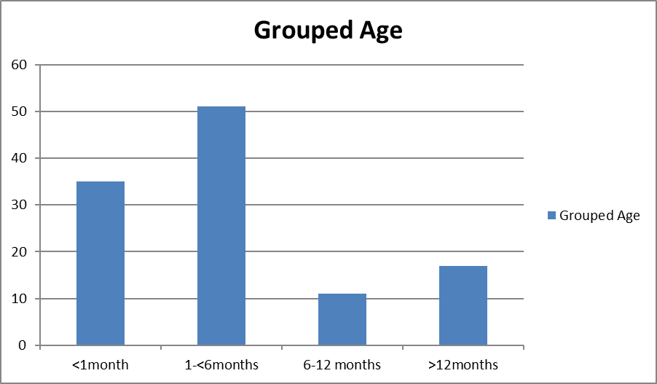
Fig. 1: Grouped Age

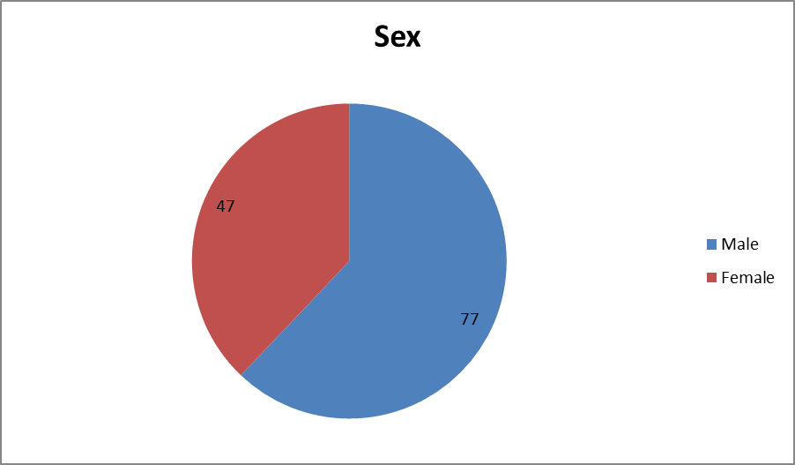
Fig. 2: Sex Distribution

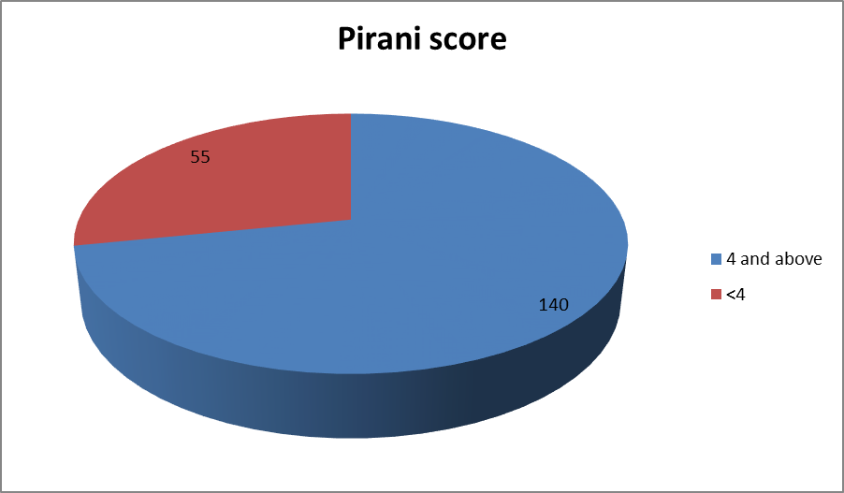
Fig. 3: Pirani Score at Presentation

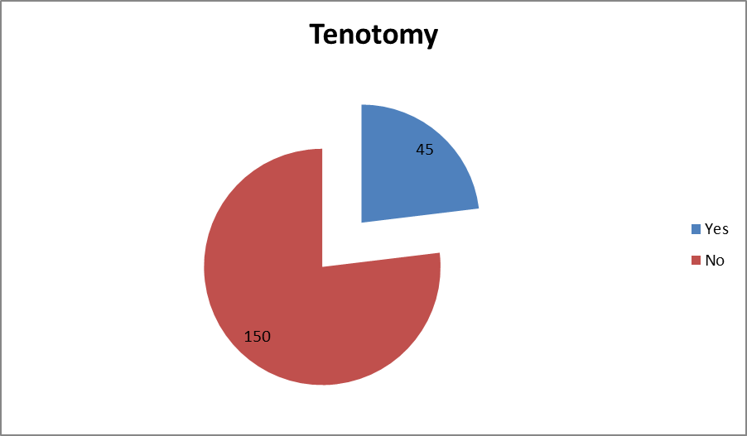
Fig. 4: Tenotomy Distribution

INTRODUCTION
La méthode de Ponseti de gestion non-opératoire du pied bot congénital est reconnue en grande partie comme l'étalon-or dans le monde entier, en réduisant le besoin d'une chirurgie extensive¹. Des études ont donné de bons résultats sur le suivi à long terme et même du personnel non médicalement qualifié a été formé pour mettre en pratique cette méthode dans les communautés ayant des problèmes de ressources^{1,2}. Au Nigéria, la méthode est devenue très populaire et les résultats préalables ont été comparables aux autres³.
La méthode de Ponseti consiste en une manipulation et un moulage en série hebdomadaires selon un protocole spécifique suivi d'une ténotomie du talon quand il est nécessaire. Par la suite, le membre inférieur est placé dans une jambe longue coulée en flexion à 90 degrés et en abduction à 70 degrés pour une période de trois semaines. Aussitôt que la correction est réalisée, un appareil orthopédique d'abduction du pied est porté 23 heures par jour pendant 3 mois et pendant la sieste et la nuit, il est porté de 3-4 ans⁴.
La ténotomie d'Achille est habituellement mise en pratique s'il existe un équin persistant après que la tête latérale du talus ait été réduite sur le naviculaire. Certains auteurs ont constaté que le degré d'équin et le raideur du pied sont des indicateurs du besoin de ténotomie. Ils ont aussi découvert que les pieds redressés après la ténotomie étaient aussi bien redressés que ceux qui ne nécessitaient pas de ténotomie⁵. Un score Pirani significativement plus élevé a été rapporté dans les pieds exigeant une ténotomie, le score du pied arrière étant un meilleur indicateur de la ténotomie que celui de la partie centrale du pied⁶. Dans l'étude citée, 92% des pieds avec un score Pirani de 4 ou plus ont nécessité au moins 4 plâtres avant qu’ils ne soient redressés. Les protocoles anesthésiques pour la ténotomie se différencient, certains sont réalisés sous l’anesthésie locale, alors que les autres sont réalisés sous l’anesthésie générale ou sédation^{5,7,8}. La plupart des praticiens utilisent des lames chirurgicales pour la ténotomie percutanée, mais une modification utilisant une aiguille hypodermique à large calibre a été décrite⁹.

Les complications de la ténotomie d'Achille rapportées dans la littérature comportent des saignements causé par des lésions de l'artère péronière et de la veine saphène inférieure et un pseudo-anévrysme^{7,10}. Un auteur a rapporté une lésion de l'artère tibiale postérieure et du nerf qui exigeaient une exploration, une ligature de l'artère tibiale postérieure et une réparation primaire du nerf tibial postérieur¹¹. Les observations a propos des anomalies vasculaires dans les membres inférieurs des patients ayant un pied bot idiopathique^{12,13,14} ont conduit certains auteurs à réaliser des échographies Doppler avant d'effectuer une ténotomie percutanée⁷. Une technique mini-ouverte a également été décrite pour réduire le taux de complication par rapport à la technique percutanée. La recourbure de la cheville suivant la procédure percutanée ne s'améliore généralement que de 10 à 15 degrés, mais la technique de mini-ouverture la rend améliorée jusqu'à 30 degrés¹⁵. Parfois, les ténotomies doivent être répétées plus d'une fois en raison de la récidive, mais des études échographiques ont montré que la guérison des tendons n'est pas complète après la ténotomie jusqu'à environ 12 semaines et que, par conséquent, il faut attendre au moins 12 semaines avant qu’une autre ténotomie ne soit réalisée¹⁶.

Les rapports sont en variation quant au nombre de pieds qui subissent une ténotomie préalable au redressement, mais la plupart des études rapportent entre 70% et 90%^{1,4,17}. Dans une publication précédente³, la procédure était mise en pratique sur seulement 26,6% des pieds, ce qui était dû à la crainte de complications car l'anesthésie générale n'était pas facilement disponible et les enfants devaient souvent être retenus physiquement même après l'anesthésie locale. Malgré le taux de ténotomie relativement faible dans cette série, la correction a été réalisée dans le temps moyen rapporté par d'autres auteurs.
Cette étude est une revue de notre expérimentation de la ténotomie dans la gestion des pieds-bots idiopathiques Ponseti. Nous avons revu notre technique, les complications et le nombre de moulages appliqués jusqu'à la réalisation d’une correction.

PATIENTS ET MÉTHODES
Tous les patients ayant du pied bot idiopathique qui ont visité la clinique du pied bot de juin 2013 à octobre 2015 ont été recrutés dans l'étude. Les patients qui ont fait défaut avant que la correction préalable ne soient concrétisées et ceux ont un pied bot syndromique et neurologique ont été écartés. Tous les patients ont été traités conformément au protocole Ponseti après être accordés un consentement éclairé et les parents ont obtenu l'autorisation de prendre des photos. Le comité de recherche et d'éthique de l'hôpital a donné son agrément pour concrétiser cette étude. Aucune radiographie n'a été effectuée sur des patients.
Après correction de la deformation d’orteil et celle du talon, en s'assurant que la tête du talus était couverte, une ténotomie du talon a été réalisée chez les patients ayant un équin tenace (score équin rigide Pirani de 1 ou 0,5) sous anesthésie locale. Une infiltration locale de 0,2 à 0,3 ml de lidocaïne à 1% a été administrée en utilisant une seringue de 1 ml autour du tendon d'Achille à environ 1 cm proximal de son insertion dans le calcanéum. Toutes les ténotomies ont été réalisées à l'aide d'une aiguille hypodermique de taille 18 G, introduite du côté médial du tendon. Les procédures ont été effectuées dans la clinique du pied bot avec des matériaux stériles. Une longue jambe coulée avec le genou fléchi à 90 degrés a été appliquée avec les pieds à 70 degrés d'abduction pendant trois semaines, et une orthèse d'abduction de Steenbeck a été appliquée immédiatement après l'enlèvement du plâtre. Les patients ont été suivis à des intervalles de 3 mois spécifiquement pour vérifier les signes de récidive pendant au moins un an.
Les visites des patients ont été enregistrées dans le registre international des pieds bots (International Clubfoot Registry (ICR) hébergé par le Centre de bio-informatique et de biologie computationnelle de l'Université de l'Iowa, États-Unis. Les données biographiques, le score Pirani au cours de la présentation, le nombre de plâtres jusqu'à la première correction, le nombre de ténotomies, les complications et les récidives ont été enregistrés et analysés en utilisant le logiciel ICR.

RÉSULTATS
Une somme de 124 patients ayant du pied bot idiopathique ont été recrutés dans cette étude, 77 (62,1%) d'entre eux avaient des déformations bilatérales du pied, ce qui résulte à un total de 201 pied bot. Leur âge lors de la présentation variait de 1 semaine à 6 ans. Quarante (32,3) patients étaient âgés de moins de 1 mois, 58 (46,8%) âgés de 1 à 6 mois, 12 (9,7%) âgés de 6 à 12 mois et 14 (11,3%) âgés de 12 mois et plus, comme démontré sur le tableau / la graphique 1. Il y avait 77 hommes et 47 femmes avec une proportion hommes / femmes de 1,6: 1 (Tableau 2). Le score préalable de Pirani était de 4 et plus à 140 pieds et le score moyen de Pirani était de 4,3. (Tableau 3).

La première correction a été obtenue après une moyenne de 5,2 plâtres avant l'application de orthèse d'abduction. Parmi la somme de pieds bots idiopathiques, 45 (23,1%) ont eu une ténotomie avant le coulage ultime de trois semaines (Tableau / Graphique 4). Aucun patient n'a eu une reprise de la ténotomie.

Les pieds qui ont subi une ténotomie avaient une moyenne de 5,9 de coulage. Le coulage moyen par pied pour les patients qui n'ont pas eu de ténotomie était de 4,9. Un patient avait des saignements après la ténotomie en raison d'une lésion présumée de l'artère péronière. Une rechute a été remarquée dans 11 (5,6%) pieds après au moins un an de suivi.

DISCUSSION
Les découvertes principales de cette étude ont été les déformations lourdes chez des patients et le faible taux de ténotomie. La suite du traitement était bonne et le taux moyen de coulages appliqués avant redressement était dans les confins courants. La portée de l'âge et du genre des patients avec un pied bot observés dans notre série sont semblables à ceux de nos séries préalables, mais certains de nos patients en présentent toujours à l'âge de la marche (14,9%). Le score moyen de Pirani de 4,3 montre que nos patients ont généralement des déformations assez sévères. Ces résultats sont similaires à nos résultats précédents^{3,18}.
Il est évident que lorsqu’on fait les ténotomies, cela abaisse le nombre de coulages appliqués avant la correction. Pourtant, le nombre moyen de coulages dans cette étude était de 5,2, ce qui tombait bien dans la gamme des résultats d'autres auteurs^{11,19}. Un taux de ténotomie étant de 23,1% et inférieur au taux des autres séries^{1,4,17}, d'autres études s’avéraient utile pour déterminer la place de la ténotomie dans la gestion du pied bot. Cependant, parmi les cas qui ont finalement eu une ténotomie, plus de coulages ont été appliquées avec une moyenne de 5,9. Ceci a montré que les ténotomies devraient être faites dès elles sont absolument indiquées. Ensuite, les pieds bots qui se sont montrés dans cette étude ne semblaient pas moins graves que dans les autres séries^{10, 19}.
Les limites de cette étude comptaient la petite taille de l'échantillon et la courte période de suivi suivant le traitement.
Conclusion: Cette étude a démontré que les pieds bots idiopathiques congénitaux peuvent être gérés avec de bons résultats à l’aide du protocole Ponseti avec une fréquence réduite de la ténotomie d'Achille.

RÉFÉRENCES
1. Cooper DM, Dietz FR. Traitement du pied bot idiopathique. Une note de suivi de trente ans. JBJS. 1995 1er octobre; 77 (10): 1477-89.
2. Tindall AJ, CW Steinlechner, CB Lavy, Mannion S, Mkandawire N. Résultats de la manipulation de la déformation du pied bot idiopathique au Malawi par des cliniciens orthopédiques par le biais de la méthode Ponseti: une alternative réaliste pour le monde en voie de développement ?. Journal de l'orthopédie pédiatrique. 2005 1er septembre; 25 (5): 627-9.
3. Adewole OA, Williams OM, Kayode MO, Shoga MO, Giwa SO. Expérience préalable avec la Direction du Pied bot Ponseti (Ponseti Club Foot Management) à Lagos, au Nigéria. Journal de chirurgie de l'Afrique de l'Est et du Centre. 2014; 19 (2): 72-7.
4. Ponseti IV. Pied bot congénital - Fondamentaux de traitement. Oxford / New York; Oxford University Press, 1996.
5. Scher DM, Feldman DS, van Bosse HJ, Sala DA, Lehman WB. Prédire le besoin de ténotomie dans la méthode Ponseti pour la correction des pieds bots. Journal de l'orthopédie pédiatrique. 2004 juil. 1; 24 (4): 349-52.
6. Dyer PJ, Davis N. Le rôle du système de notation Pirani dans la gestion du pied bot par la méthode Ponseti. Bone & Joint Journal. 2006 1er août; 88 (8): 108
7. Dobbs MB, Gordon JE, Walton T, Schoenecker PL. Complications hémorragiques suite à la ténotomie de la tendoachille percutanée dans le traitement de la difformité du pied bot. Journal de l'orthopédie pédiatrique. 2004 juil. 1; 24 (4): 353-7.
8. Bor N, Katz Y, Vofsi O, JE Herzenberg, Zuckerberg AL. Protocoles de sédation pour le pied bot Ponseti ténotomie Achilles. Journal de l'orthopédie des enfants. 2007 3 novembre; 1 (6): 333-5.
9. Minkowitz B, BI Finkelstein, Bleicher M. Allongement tendineux-Achille percutané avec une aiguille de grand calibre: une modification de la technique Ponseti pour le redressement du pied bot idiopathique. Le Journal de la chirurgie du pied et de la cheville. 2004 31 août; 43 (4): 263-5.
10. Burghardt RD, JE Herzenberg, Ranade A. Pseudo anévrisme après ténotomie Achille percutanée Ponseti : un rapport de cas. Journal de l'orthopédie pédiatrique. 2008 1er avril; 28 (3): 366-9.
11. Changulani M, Garg NK, TS Rajagopal, Bass A, SN Nayagam, Sampath J, Bruce CE. Traitement du pied bot idiopathique par la méthode Ponseti. Bone & Joint Journal. 2006 1er octobre; 88 (10): 1385-7.
12. Ben-menachem Y, Butler JE. Artériographie du pied en malformations congénitales. JBJS. 1974 1er décembre; 56 (8): 1625-30.
13. Dobbs MB, Gordon JE, Schoenecker PL. Artère tibiale postérieure absente associée à un pied bot idiopathique. JBJS Case Connecteur. 2004 mars 1 (3): 599-602.
14. Greider TD, Siff SJ, Gerson P, Donovan MM. Artériographie en pied bot. JBJS. 1982 juil. 1; 64 (6): 837-40.
15. Dogan A, Kalender AM, Seramet E, M Uslu, Sebik A. Technique mini-ouverte pour la ténotomie d'Achille dans la correction du pied bot idiopathique: un rapport de 25 cas. Journal de l'Association médicale podiatrique américaine (American Podiatric Medical Association). 2008 septembre; 98 (5): 414-7.
16. Mangat KS, R Kanwar, Johnson K, Korah G, Prem H. Phases ultrasonographiques dans la guérison de trou après la ténotomie d'Achille de type Ponseti. JBJS. 2010 1er juin; 92 (6): 1462-7.
17. Laaveg SJ, Ponseti IV. Résultats à long terme du traitement du pied bot congénital. Le Journal de la chirurgie osseuse et articulaire. Volume américain. 1980 Jan; 62 (1): 23-31.
18. Adewole OA, Giwa SO, Kayode MO, Shoga MO, Balogun RA. Pied bot congénital dans un centre hospitalier à Lagos, au Nigéria. Revue africaine de médecine et de sciences médicales. 2009 juin; 38 (2): 203-6.
19. Abdelgawad AA, Lehman WB, Van Bosse HJ, Scher DM, Sala DA. Traitement du pied bot idiopathique conformément à la méthode Ponseti: suivi minimum de 2 ans. Journal des Orthopédiques Pédiatrique (Journal of Pediatric Orthopaedics) B. 2007 Mars 1; 16 (2): 98-105.

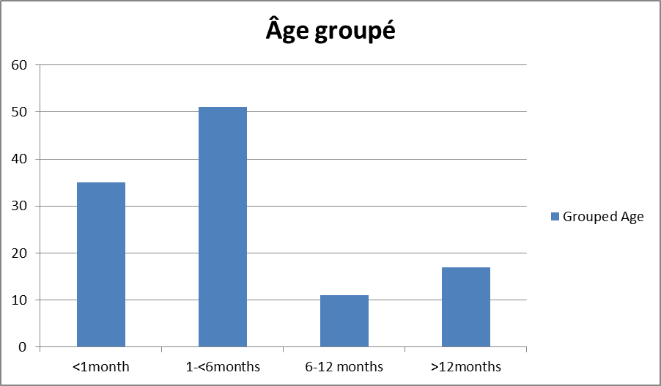
Graphique 1 : Âge groupé / Âge classé

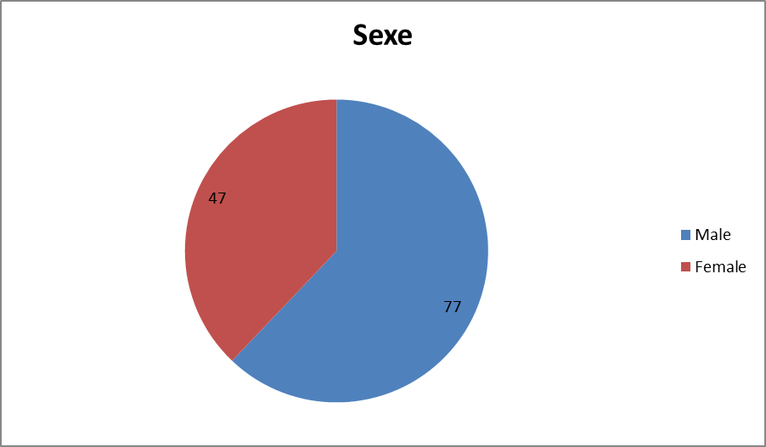
Graphique 2: Répartition de sexe

Graphique 3 : Score Pirani à la presentation

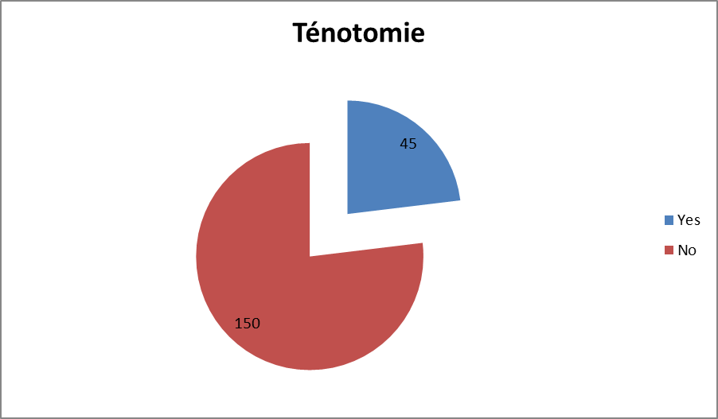
Graphique 4 : Répartition de tétonomie

