**Original Article**

Pit Pattern Analysis of Colorectal Polyps using Storz Professional Image Enhancement System (SPIES) Endoscopy: A Pilot Study

**Emeka Ray-Offor1,2, Fatimah Biade Abdulkareem3,4, Nze J. Jebbin1**

**Abstract**

**Background:** Endoscopic management of colorectal polyps includes detection, characterization, and therapeutic strategies. Pit pattern analysis is a useful tool when differentiating neoplastic and non-neoplastic colorectal polyps. **Aim:** To correlate pit pattern characterization of colorectal polyps using SPIES endoscopy and the histopathology. **Materials and Methods:** Total colonoscopy was performed on 189 patients by same endoscopist from January 2020 to September 2021 using Image 1 Connect (TC200), Image 1 H3-Link (TC300) and video-colonoscope (Karl Storz, Tuttlingen, Germany). Identified polyps were classified using Paris classification for mucosal lesions and the pit pattern according to Kudo’s modified criteria using SPIES endoscopy. All lesions were diagnosed by histopathological examination. Kappa index (*κ*) was used to evaluate the agreement of SPIES endoscopy Kudo’s pit classification with the histopathological diagnosis. The sensitivity, specificity, positive predictive value (PPV), and negative predictive value (NPV) were independently determined. **Result:** Thirty-four polyps were detected in twenty-nine patients with twenty-one (61.8%, 21/34) polyps histologically confirmed as neoplastic. SPIES endoscopy characterized seventeen (50%, 17/34) of the polyps as neoplastic, four (1.8%, 4/34) as non-neoplastic (false negative) and four (1.8%, 4/34) as false positives. The sensitivity and specificity of SPIES endoscopy were 81.0% and 69.2% respectively and same values for PPV and NPV. The diagnosis of neoplastic polyps by SPIES endoscopy was in moderate agreement with histopathological diagnosis (*κ* = 0.502) **Conclusion:** SPIES endoscopy is a useful, rapid, and non-invasive tool in the endoscopic assessment of colorectal polyps.

**Keywords:** *Colon and rectum, colonoscopy, polyps*

*1Department of Surgery, University of Port Harcourt, Choba, Rivers State, 2Digestive Disease Unit, Oak Endoscopy Centre, Port Harcourt, Rivers State, 3Department of Anatomic and Molecular Pathology, College of Medicine, University of Lagos, 4The Specialist Laboratories, Lagos, Lagos State, Nigeria*

# Introduction

There is an established adenoma-carcinoma sequence in the incidence of colorectal cancer with a validated correlation between size and neoplastic risk of polyps.[1] The endoscopic management of colorectal polyps includes detection, characterization, and therapeutic strategies. The therapeutic strategies for abnormal mucosal growth include snare polypectomy, cold/hot forceps biopsy, endoscopic mucosal resection, and

strategy advocated by gastroenterology experts has the related benefit of reduced time, cost of procedure and work burden on pathologists for histopathology.[3,4] Additionally, a positive diagnosis could be made for small polyps not retrieved or unsuitable for histological anaysis.[5]

Conventional chromoendoscopy requires the application of dye agents (e.g., indigo carmine, crystal violet, or methylene blue) onto mucosal surface to outline contours for

**Received:** 19-Apr-2022 **Accepted:** 22-May-2022 **Published:** 27-Aug-2022

submucosal dissection. Pit pattern analysis

a discriminating inspection.[6] Newer image

is a useful tool to differentiate neoplastic from non-neoplastic colorectal mucosal lesions. A detailed characterization of small mucosal polyps (<10 mm) is critical to advocating a ‘diagnose and leave’ for non- neoplastic lesions or a ‘resect and discard’ strategy.[2] The former is for clearly non-neoplastic lesions, and latter for clearly neoplastic lesions with a low likelihood of harboring advanced pathology. This

|  |
| --- |
| **Access this article online** |
| **Website:**  [www.jwacs-jcoac.org](http://www.jwacs-jcoac.org/) |
| **DOI:** 10.4103/jwas.jwas_96_22 |
| **Quick Response Code:** |

enhancement technologies are capable of macroscopic real- time assessment of histopathology during colonoscopy (*in vivo* optical biopsy), to enhance diagnostic precision and guide subsequent therapeutic strategies. Virtual chromoendoscopy is a quick and noninvasive live imaging method to enhance mucosal appearance and detection of gastrointestinal polyps. SPIES endoscopy comprises standard assessment

***Address for correspondence:*** *Dr. Emeka Ray-Offor, Department of Surgery, University of Port Harcourt, Choba, Rivers State, Nigeria. E-mail: emeka.ray-offor@ uniport.edu.ng*

in white light performed with a red, green,

This is an open access journal, and articles are distributed under the terms of the Creative Commons Attribution-NonCommercial- ShareAlike 4.0 License, which allows others to remix, tweak, and build upon the work non-commercially, as long as appropriate credit is given and the new creations are licensed under the identical terms.

**How to cite this article:** Ray-Offor E, Abdulkareem FB, Jebbin NJ. Pit pattern analysis of colorectal polyps using Storz professional image enhancement system (SPIES) endoscopy: A pilot study. J West Afr Coll Surg 2022;12:17-22.

**For reprints contact:** [reprints@medknow.com](mailto:reprints@medknow.com)

© 2022 Journal of the West African College of Surgeons | Published by Wolters Kluwer ‑ Medknow 17

and blue (RGB) camera followed by digital reprocessing in five modes to obtain modified images.[7-9] Chroma modality uses local contrast of present colour differences to enhance the sharpness of the image.[7-9] The Clara mode uses a local brightness adaption in the image to achieve a clearer visibility of darker regions within the image.[7-9] Together in the Clara/Chroma mode is designed to offer a clearer and sharper image of the original white light image obtained. The Spectra A and B modalities change the effective spectral response in the imaging system, so that a better color contrast can be observed.[7-9]

An extensive search of world literature shows preliminary data on the usefulness of SPIES endoscopy in the bladder, ureter, and upper airway for detection of suspicious areas.[10-12] However, there is a paucity of literature on the utilization of this technology in the colon and rectum. In colorectal studies, pit pattern diagnosis is useful to differentiate between neoplasia and non-neoplasia, diagnose the degree of histological atypia in a tumor, diagnose the invasion depths of early carcinomas, detect minute residual tumors after endoscopic resection, estimate the degree of histological inflammation in ulcerative colitis, and diagnose dysplasia-/colitis-associated carcinomas in ulcerative colitis.[6] This study aims to correlate Kudo’s pit pattern classification of colorectal polyp using SPIES endoscopy and the histopathology of same resected polyp.

# Materials and Methods

This prospective, blinded study was conducted in an open access/referral ambulatory Endoscopy facility in Port Harcourt, Rivers State, Nigeria between January 2020 to September 2021. An Ethical approval for the study was obtained from the study centre. Signed informed consent was obtained from all participating patients according to Helsinki declaration. Included in the study were consecutive adult out-patients (≥18 years) who were undergoing colonoscopy for symptoms related to colorectal pathology and asymptomatic individuals for screening and surveillance of colorectal cancer, that had at least one polyp. The exclusion criteria included: cases of colonoscopy performed without SPIES endoscopy; poor bowel preparation with less than 10% mucosal inspection; resected polyp that could not be retrieved for pathologic assessment; and cases where polyps could not be resected due to nearness to haemorrhoidal pillar or on anticoagulation.

Total colonoscopy was performed prospectively on consecutive patients using colonoscopes with - Image 1 Connect (TC200), Image 1 H3-Link (TC300) and 13925 PKS video-colonoscope (Karl Storz, Tuttlingen, Germany) designed for 8x magnification and high-definition optical images.[8] The caecum was identified either by the appendix orifice, tri-radiate caecal fold, ileocaecal valve, and terminal ileal or neoterminal-ileal intubation with small bowel biopsy in patients with a previous right hemicolectomy.

All patients were given the same bowel preparation guidelines based on low residue diet for 2 days preceding day of procedure and an oral ingestion of liquid propulsive agents (i.e., sodium picosulphate magnesium citrate 2 sachet taken in divided doses evening before and morning of procedure, not more than 3 hours to colonoscopy procedure). The quality of bowel preparation was graded using the Aronchick’s bowel preparation scale.[13] All colonoscopies were performed by an experienced endoscopist (ERO) having >10-year experience with a withdrawal phase lasting at least 6 minutes. Copious lavage for mucosal inspection was done in suboptimal conditions.

Each polyp was routinely evaluated in real time, initially with white light (WLE), and followed immediately with SPIES reassessment. All polyps detected during the procedure were documented for size, location, and morphology (i.e., pedunculated, sessile etc.) using the Paris classification for superficial mucosal lesions.[14] The open jaw of the biopsy forceps was used in the assessment of the polyp size. A complete video recording of each procedure was obtained. Relevant images of polyps, caecum or terminal ileum and any abnormal finding were captured and stored as high-definition JPEG files. Histology was predicted for all polyps *in vivo* using SPIES based on the surface mucosal and vascular patterns identified. Chroma modality enhances contrast while Clara modality increases sharpness. In combination, they provide a clearer and sharper image of WLE [Figure 1]. The Spectra A and B modalities provide better color contrast. The surface pit pattern was classified according to Kudo’s pit pattern criteria using SPIES endoscopy with its 5 modalities. This Kudo’s classification has I -round pit (normal pit), II - asteroid pit; IIIS - tubular of round pit (smaller than the normal pit), IIIL tubular of round pit (larger than the normal pit), IV dendritic or gyrus-like pit, and V -amorphous, nonstructured pit.[15]

After polyp evaluation using SPIES, all polyps were removed. A visual estimation of a polyp loosely (i.e., about a 1 mm margin from each cup) within the jaw of the regular forceps biopsy equates to a diameter of 5mm or less-diminutive polyp. Polyps with a diameter of ≤5 mm were resected using cold biopsy forceps without diathermy; polyps measuring >5 mm were resected using endoscopic loop, without diathermy; and the larger lesions were removed by endoscopic loop, with diathermy, or endoscopic mucosal resection.

Resected specimens were sent for histopathology, stained with hematoxylin and eosin (HE) and reviewed by an expert gastrointestinal pathologist with >15 years of gastrointestinal pathology experience (FBA). The pathologist was blinded to the endoscopic findings.

The outcome of interest in the study was the diagnostic performance of SPIES (sensitivity, specificity, positive and negative predictive values) for adenoma diagnosis in resected polyps.

18 Journal of the West African College of Surgeons | Volume 12 | Issue 2 | April‑June 2022

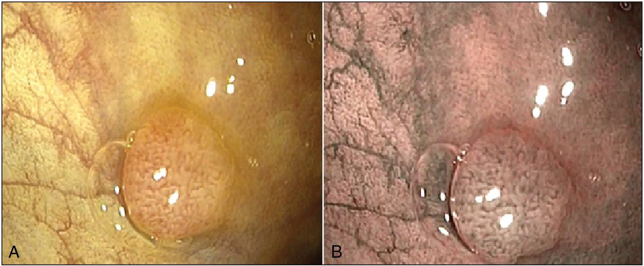

**Figure 1: Semi-pedunculated colon polyp (Paris 0-1sp; Kudo’s pit type IIIL) (a) Image of polyp using white light endoscopy-WLE (b) Same polyp in SPIES Spectra A mode**

A quantitative analysis of age of patients was reported as mean ± standard deviation and qualitative data characterized in simple percentages. The sensitivity, specificity, accuracy, NPV and PPV of SPIES diagnosis of adenoma were calculated using histopathology as the reference standard. Kappa index (*κ*) was used to evaluate the agreement of SPIES endoscopy Kudos Pit classification with the histopathological diagnosis.

# Results

Total colonoscopy was performed prospectively on 189 patients using high definition colonoscopes without zoom magnification. There were 34 polyps detected in 29 patients. The age of patients in cases that polyps were detected ranged from 32 to 80 years (mean 61.1 ± 12.4 years) with a gender distribution of 17 males (58.6%) and 12 females (41.4%).

An adequate bowel preparation (Aronchick’s Excellent/ Good grades) was recorded in 21 (72.4%) patients and a fair bowel preparation grade was recorded in eight patients necessitating lavage with ≥95% mucosal inspection. A 100% caecal intubation was achieved. The polyps were detected predominantly in the left colon 22(64.7%)-ten in the rectum, seven in the sigmoid colon, five in the descending colon. Also, transverse colon recorded eight polyps, ascending colon, four.

A sessile morphology was predominant in detected polyps-64.7% (22/34)- [Table 1]. Polyps were histologically confirmed as neoplastic in 21(61.8%, 21/34) of these patients- [Table 2]. SPIES endoscopy characterized 17 (50%, 17/34) of the polyps as neoplastic (Kudo’s type IIIs, IIIL, and IV), four (1.8%, 4/34) as non-neoplastic (false negative) and four (1.8%, 4/34) as false positives- [Table 3]. The sensitivity and specificity of SPIES endoscopy were 81.0% and 69.2% respectively and same values for PPV and NPV. The diagnosis of neoplastic polyps by SPIES endoscopy was in moderate agreement with histopathological diagnosis (*κ* = 0.502).

**Table 1: Characteristics of detected polyps Polyp characteristics Frequency Percentage** Paris classification

|  |  |  |
| --- | --- | --- |
| 0-1s | 22 | 64.7 |
| 0-1p | 9 | 26.5 |
| 0-1sp | 2 | 5.9 |
| 0-11a/c | 1 | 2.9 |
| Total | 34 | 100 |
| Kudo’s pit type |  |  |
| I | 13 | 38.2 |
| II | 0 | 0.0 |
| IIIs | 12 | 35.3 |
| IIIL | 5 | 14.7 |
| IV | 4 | 11.8 |
| V | 0 | 0.0 |
| Total | 34 | 100 |
| Polyp size |  |  |
| ≤5mm | 21 | 61.8 |
| 5-10mm | 11 | 32.3 |
| ≥10mm | 2 | 5.9 |

Total 34 100

# Discussion

The traditional use of WLE has been revolutionized by several image-enhancing, user-friendly technologies to aid accurate real-time histopathology (optical biopsy). These technologies enhance contrast of mucosal surface and vascular structures, at the click of a button, improving detection of tumors. The three major endoscope manufacturers (Olympus Medical Systems, Pentax Medica, and Fujinon Endoscopy) have introduced proprietary technologies to achieve this, with Narrow Band Imaging (NBI), i-SCAN and Fujinon Intelligent Color Enhancement (FICE), respectively. The sensitivity and specificity of SPIES endoscopy in this pilot study was 81.0% and 69.2%. This is comparable to the most widely studied image enhancement technology- NBI (Olympus, Japan). NBI has shown a sensitivity ranging from 83% to 97% and a specificity from 64% to 100% across the studies for the diagnosis of adenoma.[16]

Journal of the West African College of Surgeons | Volume 12 | Issue 2 | April‑June 2022 19

A common feature in image enhancement technologies is the filtering of the standard images in white light to achieve superior contrast by reducing the amount of red light in the image and of narrowing the bandwidth of blue and green light.[17] The SPIES system developed by Karl Storz (Germany) is a new imaging technology using innovative modes of illumination technique, based on brightness, enhanced contrast, and spectrum separation. The red, deep parts of the visible spectrum are filtered, and the remaining colors are more pronounced in the Spectra A mode designed to give a similar image to that obtained using NBI –[Figure 1].[7] On the other hand, Spectra B is obtained by adding 15% of red color to Spectra A.[7-9] For

the Clara mode, there is an adaptation of the image filters increasing local luminosity to highlight the darker regions from the endoscopic images.[7-9] A fourth mode, Chroma, intensifies the structures highlighted on the image displayed on the screen using a more pronounced contrast of the colors.[7-9] A combination of the last 2 effects is expected in the Clara + Chroma mode- [Figure 2].

Approximately one third of polyps (61.8%) detected in this study were diminutive (≤5 mm) and summarily 94.2% polyps were <10 mm in size. There is documented use of regular biopsy forceps of open -jaw diameter of 7 mm for removal of diminutive polyps similar to this study however a randomized controlled trial documents this to be inferior to jumbo

forceps for single bite complete polyp removal.[18] There was

**Table 2: Histopathology of resected polyps Histopathology Frequency Percentage** Adenoma 21 61.8

|  |  |  |
| --- | --- | --- |
| *Tubulo-villous adenoma with low*  *grade dysplasia* | *11* | *32.4* |
| *Tubular adenoma with low grade*  *dysplasia* | *10* | *29.4* |
| Inflammatory polyp | 10 | 29.4 |
| Hyperplastic polyp | 1 | 2.94 |
| Adipose tissue | 1 | 2.94 |
| Not available | 1 | 2.94 |
| Carcinoma | 0 | 0.0 |
| Total | 34 | 100 |

no restriction to single bite in this study, but completeness was ensured by a second bite if adjudged incomplete by endoscopist with histopathology of all resected tissue. From extensive colonoscopy series pooled from screening for colorectal cancer, over 90% of polyps were documented as small (6–9 mm) or diminutive (≤5 mm), with the latter forming the majority.[19] This is notable since cancer risk or advanced features (villous elements or high-grade dysplasia) is especially low in diminutive polyps. Hence, an accurate optical characterisation of small polyps (<10 mm) can allow non-neoplastic polyps to be left in-situ and surveillance intervals to be determined without histopathology. A polyp detection rate of 15.3% (29/189), and an exceptionally high

adenoma detection rate were recorded. However, an earlier

## Table 3: Correlation of endoscopic and histopathologic diagnosis of neoplastic lesions

study on polyp detection with WLE from the centre with a larger sample size (496) yielded a PDR of 22.4%, and

**SPIES**

**Neoplastic**

**Non-neoplastic**

**Correlation *κ***

an adenoma detection rate of 7.9% with a 95.3% caecal

**diagnosis (Endoscopy)** Neoplastic (Kudo’s type IIIs, IIIL,

IV, V)

Non neoplastic (Kudo’s type

**(Histopathology) (Histopathology)**

17 4 0.502

4 9

intubation rate.[20] This disparity in adenoma detection rate is likely to be predominantly related to sample size.

Seventeen out of 21 polyps were correctly characterized using SPIES as neoplastic (Kudos IIIS, IIIL and IV). On the other hand, 9 out of 13 polyps were correctly designated as non-neoplastic polyps (Kudo’s pit type I andII)- [Figure 3]. Kudo *et al.* described a classification for colorectal neoplasia. The type I and II pit patterns are characteristic of non-

I, II)

neoplastic lesions, such as normal mucosa or hyperplastic

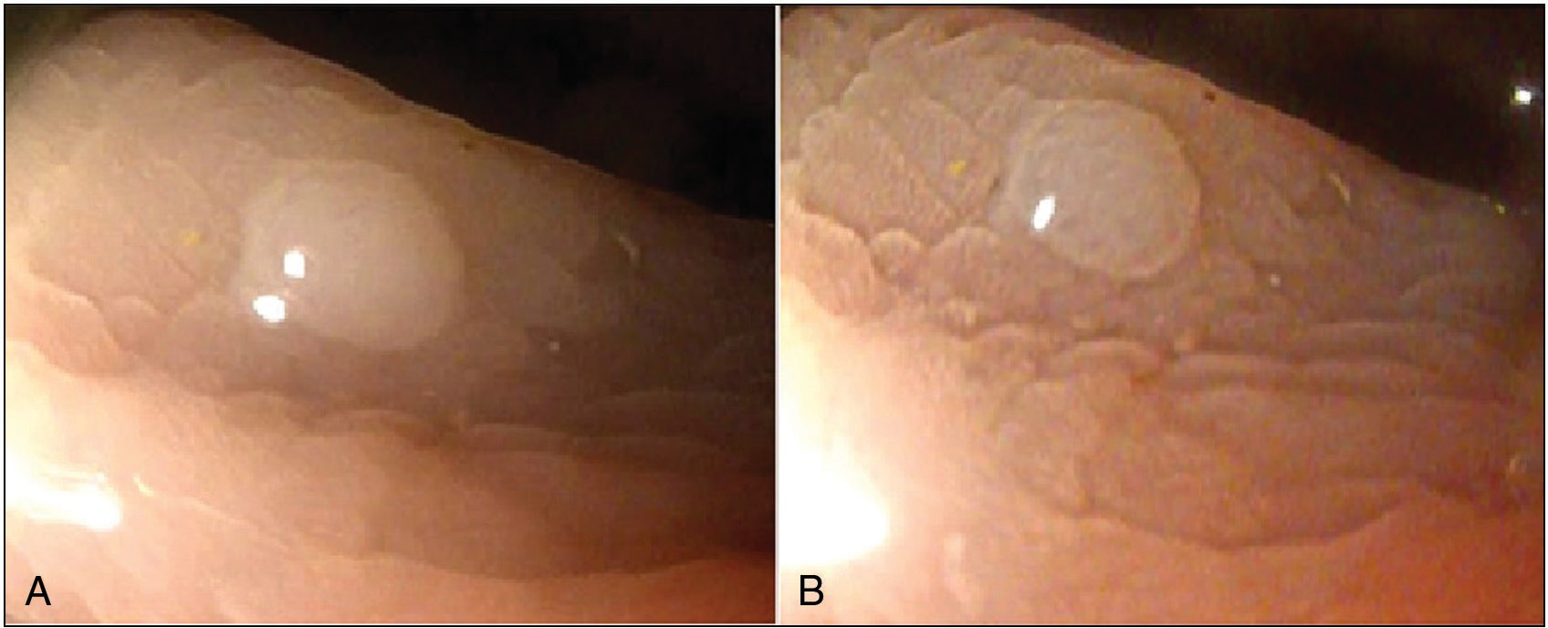

**Figure 2: Sessile colon polyp (Paris 0-1s Kudo’s pit type I) (a) Image of polyp using white light endoscopy WLE (b) Same polyp in SPIES Clara + Chroma mode**

20 Journal of the West African College of Surgeons | Volume 12 | Issue 2 | April‑June 2022

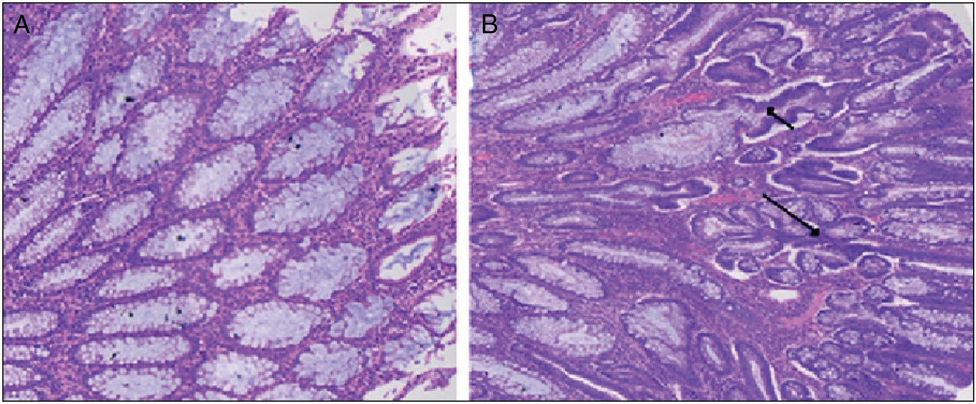

**Figure 3: Photomicrograph Inflammatory polyp vs Adenomatous polyp H & E stain x 20 A. Inflammatory polyp (showing uniform crypts, basally placed single layer of epithelial cells, intact goblet cells, and loose inflamed lamina propria) B. Adenomatous polyp with low grade dysplasia (showing multilayering of epithelial lining (black arrows), hyperchromatic nuclei and goblet cell depletion)**

polyps. However, most lesions showing pattern types of IIIS, IIIL, or IV, are intramucosal neoplastic lesions (e.g., adenoma or intramucosal carcinoma). Lesions with a type V pattern are suggestive of deep invasive carcinoma.[15] No case of malignant polyp or sessile serrated polyp was recorded. In a large sized study population from same centre (496 patients), 2 cases of serrated polyp/adenoma and 1 malignant polyp were recorded. Thus, a low detection rate of serrated polyp (0.4%) and malignant polyp (0.2%) in our locality. The former rate is like documented incidence of dysplastic serrated polyps (0.3–0.5%) which are thought to be precursors of cancer via an alternative pathway.[21]

In the absence of a government-sponsored screening program for colonoscopy and a limited utilization of colonoscopy by practicing doctors in our locality, an average of 125 colonoscopies/year are performed. The completion time of study for an appropriately sized large sample size is likely to span at least 4 years. However, further large-sized prospective study is needed for a statistically significant recommendation of ‘diagnose and leave’ or resect and discard strategy in our environment. The current practice to remove all detected polyps and subject them to histopathology remains standard.

# Conclusions

SPIES endoscopy is a useful, rapid, and non-invasive tool in the endoscopic assessment of colorectal polyps.

## Acknowledgement

We wish to acknowledge Dr. Treasure Onyeukwu for her assistance in gathering data.

## Financial support and sponsorship

Nil external support.

## Conflicts of interest

Dr E. Ray-Offor, Prof FB Abdulkareem and Prof NJ Jebbin have no conflicts of interest to declare.

## Criteria for authorship

1. Ray-Offor E- Concept, design, data acquisition, statistical analysis, literature search and manuscript write up.
2. Abdulkareem FB- Data acquisition, manuscript editing and review.
3. Jebbin NJ- Manuscript editing and review

Final version was read and approved by all authors

**References**

1. Gschwantler M, Kriwanek S, Langner E, Göritzer B, Schrutka- Kölbl C, Brownstone E, *et al*. High-grade dysplasia and invasive carcinoma in colorectal adenomas: A multivariate analysis of the impact of adenoma and patient characteristics. Eur J Gastroenterol Hepatol 2002;14:183-8.
2. Rex DK, Kahi C, O’Brien M, Levin TR, Pohl H, Rastogi A, *et al*. The american society for gastrointestinal endoscopy PIVI (preservation and incorporation of valuable endoscopic innovations) on real-time endoscopic assessment of the histology of diminutive colorectal polyps. Gastrointest Endosc 2011;73:419-22.
3. Ignjatovic A, East JE, Suzuki N, Vance M, Guenther T, Saunders BP. Optical diagnosis of small colorectal polyps at routine colonoscopy (detect inspect characterise resect and discard; DISCARD trial): A prospective cohort study. Lancet Oncol 2009;10:1171-8.
4. Hassan C, Repici A, Zullo A, Sharma P. New paradigms for colonoscopic management of diminutive colorectal polyps: Predict, resect, and discard or do not resect? Clin Endosc 2013;46:130-7.
5. Kessler WR, Imperiale TF, Klein RW, Wielage RC, Rex DK. A quantitative assessment of the risks and cost savings of forgoing histologic examination of diminutive polyps. Endoscopy 2011;43:683-91.
6. Tanaka S, Oka S, Hirata M. Pit pattern diagnosis for colorectal neoplasia using narrow band imaging magnification. Digest Endosc 2006; 18:S52-56.
7. Bus MTJ, Martijn de Bruin D, Faber DJ, Kamphuis GM, Zondervan PJ, Pilar Laguna Pes M, *et al*. Optical diagnostics for upper urinary tract urothelial cancer: Technology, thresholds, and clinical applications. J Endourol 2015;29: 113-23.

Journal of the West African College of Surgeons | Volume 12 | Issue 2 | April‑June 2022 21

1. Karl Storz systems for gastroenterology. Available from. [https://www](http://www.karlstorz.com/cps/rde/xbcr/karlstorz_assets/).kar[lstorz.com/cps/rde/xbcr/karlstorz_assets/](http://www.karlstorz.com/cps/rde/xbcr/karlstorz_assets/) ASSETS/3347684.pdf. [Last accessed on 21 May 2022].
2. Emiliani E, Talso M, Baghdadi M, Barreiro A, Orosa A, Serviàn P, *et al*. Evaluation of the spies TM modalities image quality. Int Braz J Urol 2017;43:476-80.
3. Kamphuis GM, de Bruin DM, Fallert J, Gultekin MH, de Reijke TM, Laguna pes MP, *et al*. Storz professional image enhancement system: A new technique to improve endoscopic bladder imaging. J Cancer Sci Ther 2016;8:071-077.
4. Staníková L, Walderová R, Jančatová D, Formánek M, Zeleník K, Komínek P. Comparison of narrow band imaging and the storz professional image enhancement system for detection of laryngeal and hypopharyngeal pathologies. Eur Arch Otorhinolaryngol 2018;275:1819-25.
5. Li M, Huang Z, Wang Y, Sun Y, Li C, Qu J, *et al*. Storz professional image enhancement system (SPIES) endoscopy in the detection of sinonasal inverted papilloma: A pilot study. Acta Otolaryngol 2021;141:513-8.
6. Aronchick CA, Lipshutz WH, Wright SH, Dufrayne F, Bergman G. A novel tableted purgative for colonoscopic preparation: Efficacy and safety comparisons with colyte and fleet phospho-soda. Gastrointest Endosc 2000;52:346-52.
7. Endoscopic Classification Review Group. Update on the Paris classification of superficial neoplastic lesions in the digestive tract. Endoscopy 2005;37:570-78.
8. Kudo S, Rubio CA, Teixeira CR, Kashida H, Kogure E. Pit pattern in colorectal neoplasia: Endoscopic magnifying view. Endoscopy 2001;33:367-73.
9. van den Broek FJ, Reitsma JB, Curvers WL, Fockens P, Dekker E. Systematic review of narrow-band imaging for the detection and differentiation of neoplastic and nonneoplastic lesions in the colon (with videos). Gastrointest Endosc 2009;69:124-35.
10. Kamiński MF, Hassan C, Bisschops R, Pohl J, Pellisé M, Dekker E, *et al*. Advanced imaging for detection and differentiation of colorectal neoplasia: European society of gastrointestinal endoscopy (ESGE) guideline. Endoscopy 2014;46:435-49.
11. Draganov PV, Chang MN, Alkhasawneh A, Dixon LR, Lieb J, Moshiree B, *et al*. Randomized, controlled trial of standard, large-capacity versus jumbo biopsy forceps for polypectomy of small, sessile, colorectal polyps. Gastrointest Endosc 2012;75:118- 26.
12. Lieberman D, Moravec M, Holub J, Michaels L, Eisen G. Polyp size and advanced histology in patients undergoing colonoscopy screening: Implications for CT colonography. Gastroenterology 2008;135:1100-5.
13. Ray-Offor E, Jebbin NJ. Neoplastic and non-neoplastic colorectal polyps in Port Harcourt, Nigeria: A single centre review of 496 colonoscopies. West Afr J Med 2020;37:385-90.
14. Gupta N, Bansal A, Rao D, Early DS, Jonnalagadda S, Wani SB, *et al*. Prevalence of advanced histological features in diminutive and small colon polyps. Gastrointest Endosc 2012;75:1022-30.

22 Journal of the West African College of Surgeons | Volume 12 | Issue 2 | April‑June 2022