**Case Report**

Penile Fracture with Complete Urethral Rupture and Urine Extravasation: A Case Report

**Baje Salihu Makama, Liman Haruna, Yusuf Stephen, Umar Aminu**

**Abstract**

Penile fracture is a rare traumatic injury of an erect phallus involving mainly the tissues responsible for penile erection, corpora cavernosa, and penile sheath, which occur commonly, but not solely during vigorous sexual intercourse. Here, we present a 34-year-old man who presented with a 5-h history of snapping sound heard during sexual intercourse with subsequent loss of tumescence, swelling of the phallus, and assumption of abnormal contour, scrotal swelling, and lower anterior abdominal swelling. On examination, the patient was in severe painful distress with swelling around the external genitalia and lower abdomen and dorsolateral penile angulation with marked tenderness. The diagnosis of penile fracture was made; intraoperatively, there was a complete rupture of both corpora cavernosa and corpus spongiosum, complete disruption of the urethra, and buck’s fascia tear causing haematoma and urine extravasation into the scrotum and anterior abdominal wall. The patient had haematoma evacuation, corpora repair, and urethroplasty done, did well, and has been on follow-up for 2 years with good erectile and voiding functions.

**Keywords:** *Corporal repair, penile fracture, scrotal swelling, urethroplasty*

*Department of Surgery, Abubakar Tafawa Balewa University Teaching Hospital, Bauchi, Bauchi State, Nigeria*

# Introduction

Penile fracture is a urology surgical emergency, which is rare or significantly under reported. It is mainly seen in young males of the age range 16–30 years and occurs in an erected penis usually during the sexual intercourse or penile manipulation.[1] The typical clinical manifestations are trauma to the penis, an audible clicking sound, posterection detumescence, and swelling.[1,2] Cases of urethral injury associated with penile fractures, also called as tritubular penile fracture, are rare.[3,4] We report a case of a complete urethral rupture occurring with penile fracture.

lower abdominal swelling. The patient also noticed complete inability to pass urine. On examination, the patient was in severe painful distress with swelling around the external genitalia, lower abdomen, and dorsolateral penile angulation; there is obvious oedema of the phallus and scrotum, which appeared tensed and shiny. There is tenderness on palpation more marked around the root of the phallus [Figure 1]. All other examination were normal aside the area of pathology.

The patient was taken to the theatre for immediate penile exploration, which was done via a circumferential subcoronal

**Received:** 18-Jan-2022 **Accepted:** 20-Apr-2022 **Published:** 12-Jul-2022

degloving incision of the penile skin, an

# Case Report

A 34-year-old man who presented with a 5-h history of severe pain, swelling, and abnormal contouring of the phallus sustained when he had “trauma” during the sexual intercourse and later developed lower abdominal and scrotal swelling. He heard a cracking sound and a sharp pain when he thrust during the act of coitus followed by rapid detumescence of the phallus and subsequent penile, scrotal, and

accumulated haematoma at the penile root about 8 cm was seen, which we evacuated, a complete rupture of both corpora cavernosa and corpus spongiosum was seen, and there was also a complete disruption/ discontinuity of the urethra at the level of the injury with buck’s fascia tear revealed after clearing of the haematoma. There was urine extravasation into the scrotum and anterior abdominal wall with oedema of the tissues [Figures 2 and 3].

***Address for correspondence:*** *Dr. Baje Salihu Makama, Urology Unit, Department of Surgery, Abubakar Tafawa Balewa University Teaching Hospital, Bauchi, Bauchi State, Nigeria.*

*E-mail: bajemakama50.bm@ gmail.com*

We did a minimal debridement of the

|  |
| --- |
| **Access this article online** |
| **Website:**  [www.jwacs-jcoac.org](http://www.jwacs-jcoac.org/) |
| **DOI:** 10.4103/jwas.jwas_18_22 |
| **Quick Response Code:** |

This is an open access journal, and articles are distributed under the terms of the Creative Commons Attribution-NonCommercial- ShareAlike 4.0 License, which allows others to remix, tweak, and build upon the work non-commercially, as long as appropriate credit is given and the new creations are licensed under the identical terms.

**For reprints contact:** [reprints@medknow.com](mailto:reprints@medknow.com)

corpora tissue at the site of injury/rupture

**How to cite this article:** Makama BS, Haruna L, Stephen Y, Aminu U. Penile fracture with complete urethral rupture and urine extravasation: A case report. J West Afr Coll Surg 2021;11:31-4.

© 2022 Journal of the West African College of Surgeons | Published by Wolters Kluwer ‑ Medknow 31

and repaired the tissue with interrupted absorbable polyglactin (vicryl) 2/0 suture [Figures 4 and 5]. We spatulate both the proximal and distal ends of the urethra at the point of rupture with a vertical 0.5 cm slit and did a tension-free repair of the urethra over an indwelling size 16 F Foley’s urethral catheter with a single-layer polyglactin (vicryl) 3/0 suture, suturing the posterior urethra before inserting the urethral catheter and then suturing the ventral urethra over it [Figure 6]. The penile skin was closed with an interrupted suturing technique using nonabsorbable monofilament polyamide 4/0 suture material. Postoperatively, the patient was given intravenous ceftriaxone 1 g 12 hourly, paracetamol 300 mg

8 hourly, and nefopam 10 mg 12 hourly.

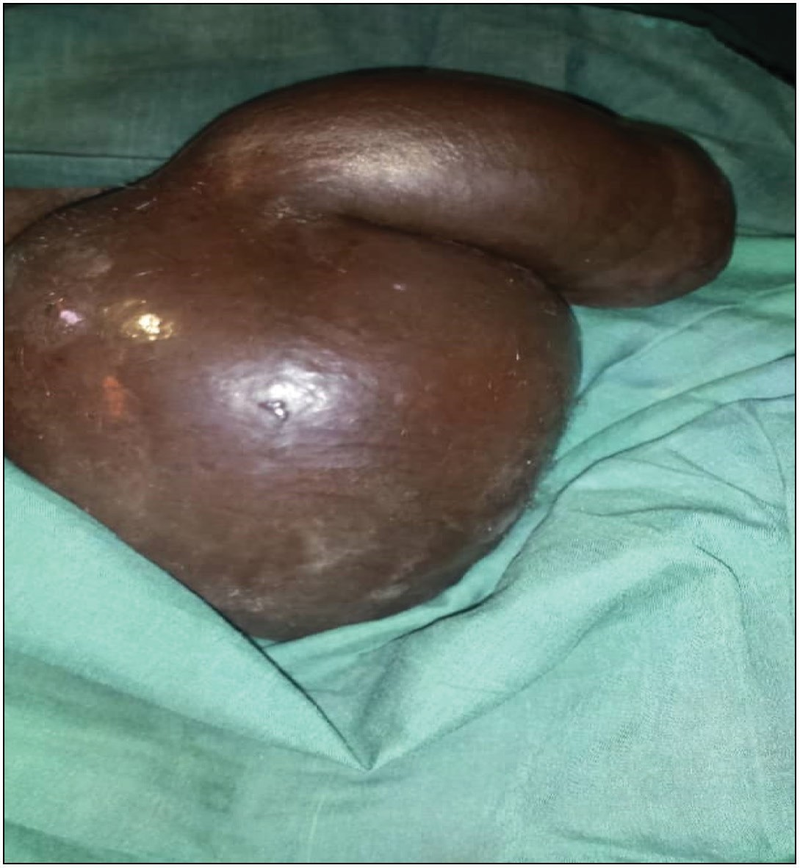

**Figure 1: Eggplant deformity of the phallus**

The patient did well and was discharged on postoperative day 5. Indwelling urethral catheter was removed exactly 3 weeks after the surgery at a regular clinic follow-up visit. He has maintained normal voiding and erectile function ever since and is now 2 years postprocedure.

We affirmed that all the procedures performed in the study are in accordance with ethical standard of the institution and research committee and with the 1964 Helsinki declaration (as revised in October 2013). Written informed consent was obtained from the patient for this study and for the use of the clinical intraoperative pictures and any other accompanying images.

# Discussion

Penile fracture is the traumatic rupture of tunica albuginea and corpora cavernosa,[5] which occur in an erect penis and usually associated with blunt trauma sustained during the sexual intercourse or penile manipulation and/or mastubation[6]; other causes include mechanical trauma that causes forceful bending of the penis, direct blow to an erect penis, or even rolling over in bed unto an erect penis. Symptoms include cracking sound heard during vigorous thrust at coitus and acute sharp pain of the erected penis followed closely by rapid detumescence. Signs include deformity and contouring of the penile shaft, eggplant deformity, darkening of the penile skin/ ecchymosis, swelling, and tenderness on palpation[7] in penile fracture; there is a rupture of the tunica albuginea, partial or complete rupture of the tunica cavernosa and spongiosum, and rarely the urethra might be involved.[7,8] The tunica albuginea thins out in an erected penis, making it vulnerable. Jack *et al.* have observed that the strain of buckling the engorged corpora can generate pressure above 1500 mmHg, hence exceeding the limit of tensile strength

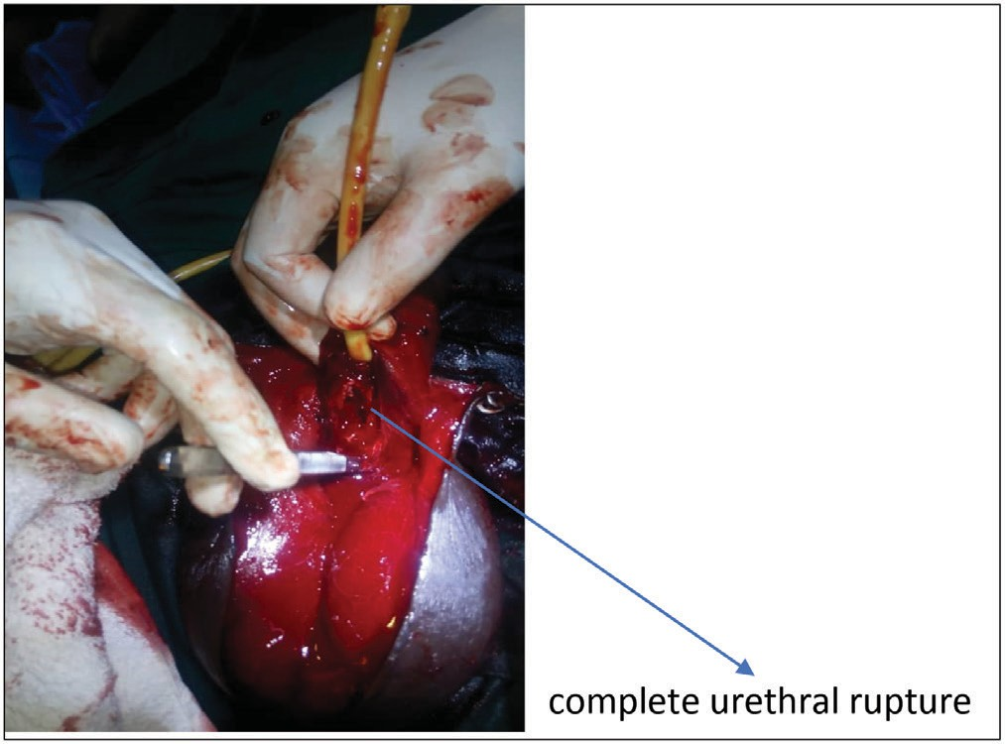

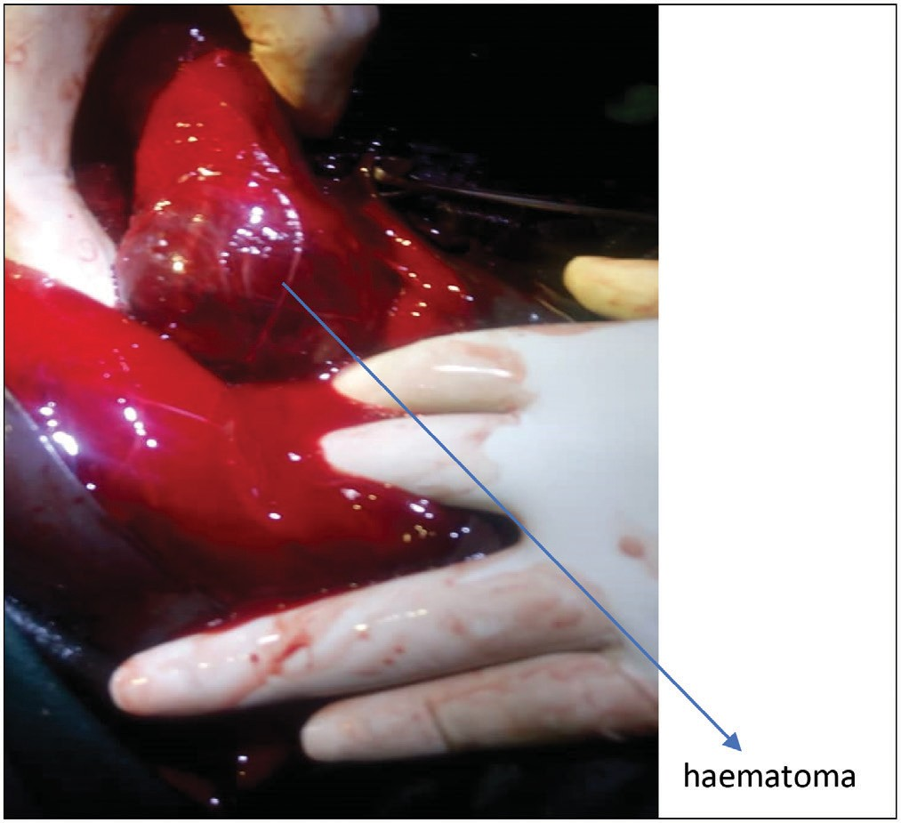**Figure 2: Complete rupture of the urethra Figure 3: Haematoma collection at the site of penile fracture**

32 Journal of the West African College of Surgeons | Volume 11 | Issue 2 | April‑June 2021

of the tunica, which has thinned out and thus vulnerable to rupture.[9]

Penile fracture is a relatively uncommon urologic emergency whose rarity might not also be unrelated to the under reportage of the condition aided by the sensitive nature of the common precipitating factors.[10,11] Penile fracture occurring with urethral injuries is rare, known as tritubular penile fractures.[12] Those with complete urethral rupture are even rarer as it is more likely to find partial/incomplete urethral tear and other less extensive urethral injuries with penile fracture.[13]

Patients with accompanying urethral injuries present with other associated symptoms such as painful micturition,

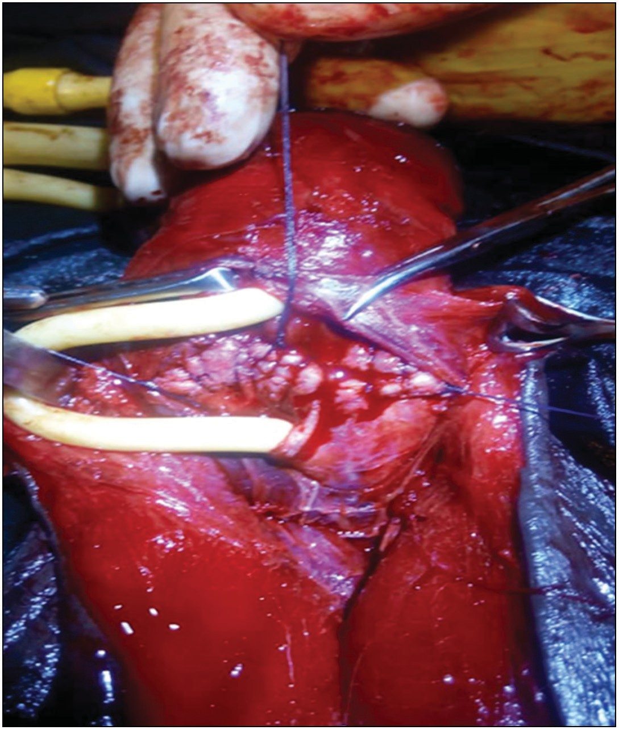

**Figure 4: The corpora rent after it was repaired**

difficulty in passing urine, or complete inability to pass urine and acute urinary retention.[13] Penile fracture has been noticed to be more common among young adults, usually the age range between 15 and 38years; the individuals in this age range are more adventurous; they often have aggressive sexual behaviours and are more likely to use sex-enhancing drugs and experiment different sexual positions[13]; penile fracture has also been noticed more with the woman on top sex position.[14]

In this case, our patient, a 34-years-old, falls within the common age range. He had a complete inability to pass urine with subsequent swelling of the scrotum and suprapubic region of the abdomen likely because of extravasation of urine following a complete urethral rupture. He also had other classical symptoms of penile fractures, which help support the diagnosis; there was a history of cracking sound, pain, and rapid detumescence during the sexual intercourse. Clinical diagnosis of penile fracture was made, and he was urgently prepared for surgical intervention to prevent the unfavourable outcomes seen with delay in surgical intervention or conservative management earlier advocated[15-17]; many patients are reluctant to present because of the tendency to cover private issues. There is also poor awareness of penile fracture by the public, all of which can lead to delay presentation; however, our patients presented in a good time, about 5 h after the incident and he had immediate surgery and repair of both penile muscles and the urethra. Immediate repair of corporal tissue and urethra is being advocated for penile fracture as

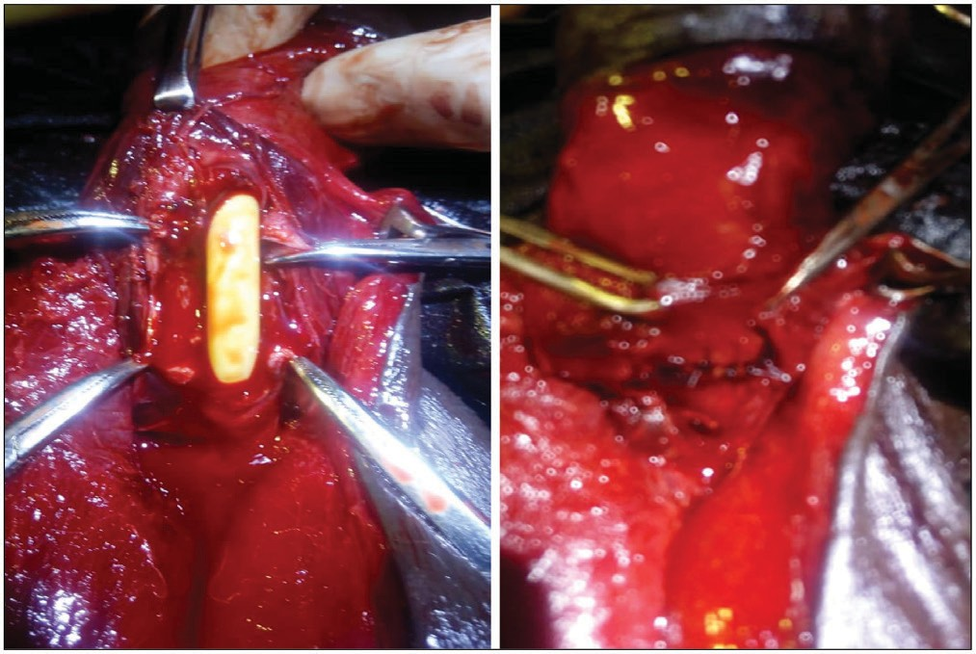

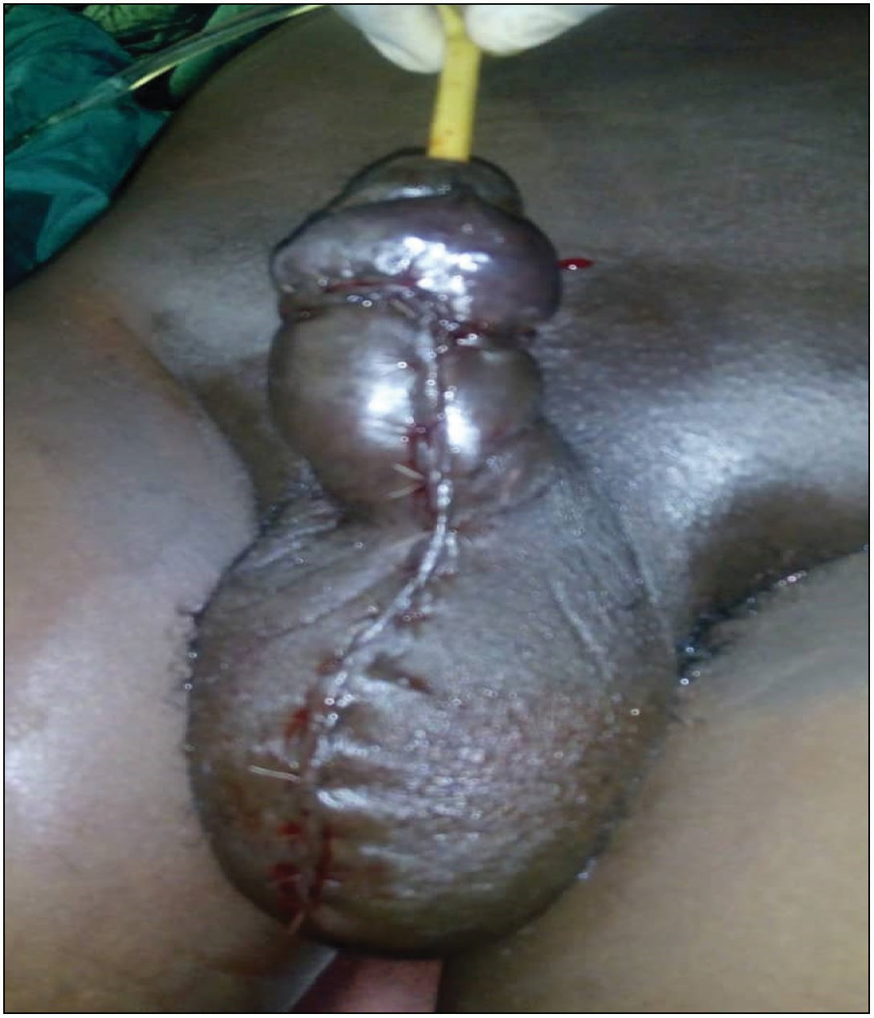**Figure 5: Urethral disruption demonstrated with Foley catheter *in situ* and**

**after the urethra was repaired Figure 6: The phallus after the surgery with urethral catheter *in situ***

Journal of the West African College of Surgeons | Volume 11 | Issue 2 | April‑June 2021 33

this insures normal erectile and voiding functions without complications.[18,19] The patient did well postoperatively, with good voiding and erectile functions for up to 2 years after surgery, consistent with previous reports of cases of penile fracture that had immediate repair[19,20]; our case is a further prove that immediate surgical repair of corporal tissues and urethra is the best treatment option for tritubular penile fracture.

# Conclusion

Penile fracture is a urological emergency that may involve a complete rupture of the urethra. Early presentation and prompt intervention are keys to a good outcome and total recovery including the preservation of erectile function.

## Declaration of patient consent

The authors certify that they have obtained all appropriate patient consent forms. In the form the patient(s) has/have given his/her/their consent for his/her/their images and other clinical information to be reported in the journal. The patients understand that their names and initials will not be published and due efforts will be made to conceal their identity, but anonymity cannot be guaranteed.

## Financial support and sponsorship

Nil.

## Conflicts of interest

There are no conflicts of interest.

# References

1. Moslemi MK. Evaluation of epidemiology, concomitant urethral disruption, and seasonal variation of penile fracture: A report of 86 cases. Can Urol Assoc J 2013;7:E572-5.
2. Kamdar C, Mooppan UM, Kim H, Gulmi FA. Penile fracture: Preoperative evaluation and surgical technique for optimal patient outcome. BJU Int 2008;102:1640-4; discussion 1644.
3. Jagodic K, Erklavec M, Bizjak I, Poteko S, Korosec Jagodic H. A case of penile fracture with complete urethral disruption during sexual intercourse: A case report. J Med Case Rep 2007;1:14.
4. Kasaraneni P, Mylarappa P, Gowda RD, Puvvada S, Kasaraneni D. Penile fracture with urethral injury: Our experience in a tertiary care hospital. Arch Ital Urol Androl

2019;90:283-7.

1. Ateyah A, Mostafa T, Nasser TA, Shaeer O, Hadi AA, Al- Gabbar MA. Penile fracture: Surgical repair and late effects on erectile function. J Sex Med 2008;5:1496-502.
2. Eke N. Fracture of the penis. Br J Surg 2002;89:555-65.
3. Derouiche A, Belhaj K, Hentati H, Hafsia G, Slama MR, Chebil M. Management of penile fractures complicated by urethral rupture. Int J Impot Res 2008;20:111-4.
4. Barros R, Ribeiro JGA, da Silva HAM, de Sá FR, Fosse AM Jr, Favorito LA. Urethral injury in penile fracture: A narrative review. Int Braz J Urol 2020;46:152-7.
5. Jack GS, Garraway I, Reznichek R, Rajfer J. Current treatment options for penile fractures. Rev Urol 2004;6:114-20.
6. Anastasiou I, Anastasiou A, Katafigious I, Tsavdaris DE, Constantinides C, Isolated corpus spongiosum injury after sexual intercourse. Archivio Italiano di Urologia e Andrologia 2018;90:295-6.
7. Nicolaisen GS, Melamud A, Williams RD, McAninch JW. Rupture of the corpus cavernosum: Surgical management. J Urol 1983;130:917-9.
8. Nymark J, Kristensen JK. Fracture of the penis with urethral rupture. J Urol 1983;129:147-8.
9. Tang Z, Yang L, Wei Q, Wang F, Liu LR, Tan P, *et al*. Management and outcomes of penile fracture: A retrospective analysis of 62 cases with long-term assessment. Asian J Androl 2018;20:412-3.
10. Barros R, Schulze L, Ornellas AA, Koifman L, Favorito LA. Relationship between sexual position and severity of penile fracture. Int J Impot Res 2017;29:207-9.
11. Amer T, Wilson R, Chlosta P, Albuheissi S, Qazi H, Fraser M. Penile fracture: A meta-analysis. Urol Int 2016;96:315-29.
12. Mazaris EM, Livadas K, Chalikopoulos D, Bisas A, Deliveliotis C, Skolarikos A. Penile fractures: Immediate surgical approach with a midline ventral incision. BJU Int 2009;104:520-3.
13. Wong NC, Dason S, Bansal RK, Davies TO, Braga LH. Can it wait? A systemic review of immediate vs. delayed surgical repair of penile fractures. Can Urol Assoc J 2017;11:53-60.
14. Nale D, Bojanić N, Nikić P. Penile fracture: A rare case of simultaneous rupture of the one corpus cavernosum and complete urethral rupture. Vojnosanit Pregl 2015;72:60-2.
15. Barros R, Guimarães M, Nascimento C Jr, Araújo LR, Koifman L, Favorito LA. Penile refracture: A preliminary report. Int Braz J Urol 2018;44:800-4.
16. Raheem AA, El-Tatawy H, Eissa A, Elbahnasy AH, Elbendary M. Urinary and sexual functions after surgical treatment of penile fracture concomitant with complete urethral disruption. Arch

Ital Urol Androl 2014;86:15-9.

34 Journal of the West African College of Surgeons | Volume 11 | Issue 2 | April‑June 2021