**Case Report**

Parotid Gland Mucoepidermoid Carcinoma in a Three-year Old: A Case Report

**Rumbidzai Chiware, Dipuo Masege**

**Abstract**

Salivary glands consist of parotid, submandibular, sublingual and other minor salivary glands. Tumors affecting these glands present a diagnostic and therapeutic challenge for the pathologist and the surgeon respectively. They are not uncommon in adults but rare in children, with an annual incidence of 0.08 per 100 000. When present, older children are affected. Mucoepidermoid carcinoma (MEC) is the most common cancer presenting in children with a predilection for the parotid gland. This case report describes presentation of this rare tumor in a three-year old girl with a brief review of the literature.

**Keywords:** *Children, malignant, mucoepidermoid carcinoma, parotid gland, salivary gland*

*Department of Otorhinolaryngology, Head and Neck Surgery, Chris Hani Baragwanath Academic Hospital, University of the*

*Witwatersrand, Johannesburg, South Africa*

# Case Report

A three-year old female patient presented to the ENT department at Chris Hani Baragwanath Academic Hospital (CHBAH) with a six-month history of progressively enlarging, intermittently painful mass at the angle of the jaw. No facial weakness was reported. There was no history of trauma, no history of tuberculosis and no positive family history of note. There was no exposure to radiation and environmental pollutants.

Clinical examination showed a well- child with normal vital signs. Head and neck examination showed a right sided firm, non-tender mobile parotid mass of approximately 3 cm in diameter with normal overlying skin. The mass was confined to the parotid space with no intraoral extension and no lymph nodes were palpable. Facial nerve was intact. Initial assessment was that of a slow growing benign mass, possibly infective or granulomatous, to exclude tuberculosis being common in our setting.

Contrasted Computed Tomography (CT) scan showed a contained, enhancing, irregular parotid gland lesion [Figure 1], fine needle aspiration and cytology (FNAC) of the mass was inconclusive. Blood tests, including human immunodeficiency virus

(HIV) and Epstein Barr Virus (EBV) were normal. Chest X-ray was normal.

The child underwent superficial parotidectomy via a modified Blair incision, with facial nerve preservation [Figure 2]. The procedure was done under general anaesthesia with facial nerve intraoperative monitoring. Perioperative intravenous Augmentin antibiotic was given and continued for 48 hours until the drain was removed. The child was discharged 3 days following the procedure with no facial nerve paresis. The specimen was sent for histopathological evaluation, which showed intermediate grade MEC with uninvolved surgical margins. The tumour was stage III (pT3 pN0 M0). The child was not given postoperative chemotherapy or radiation in view of negative surgical margins and the intermediate nature, versus high grade, of the lesion No recurrence has been observed in 15 months since the procedure. Regular reviews will be continued on a long-term basis.

# Discussion

Salivary gland malignancies amount to less than 10% of all head and neck cancers in children.[1-4] The incidence is low in all age groups at 0.4 to 2.6 cases per 100 000

in adults and 0.08 per 100 000 in children annually.[2,5] Parotid masses are most likely

**Received:** 02-Jun-2022 **Accepted:** 02-Jul-2022 **Published:** 06-Oct-2022

***Address for correspondence:***

*Dr. Dipuo Masege, Division of Ear, Nose and Throat Surgery, Room 7,*

*Friends of Bara Building, Chris Hani Baragwanath Academic Hospital and University of*

*the Witwatersrand Soweto, Johannesburg, South Africa. E-mail: dipuo.masege@wits. ac.za*

to be malignant in children as compared

|  |
| --- |
| **Access this article online** |
| **Website:**  [www.jwacs-jcoac.com](http://www.jwacs-jcoac.com/) |
| **DOI:** 10.4103/jwas.jwas_130_22 |
| **Quick Response Code:** |

This is an open access journal, and articles are distributed under the terms of the Creative Commons Attribution-NonCommercial- ShareAlike 4.0 License, which allows others to remix, tweak, and build upon the work non-commercially, as long as appropriate credit is given and the new creations are licensed under the identical terms.

**For reprints contact:** [reprints@medknow.com](mailto:reprints@medknow.com)

to adults[3] at a rate of 50% in children and

**How to cite this article:** Chiware R, Masege

D. Parotid gland mucoepidermoid carcinoma in a three-year old: A case report. J West Afr Coll Surg 2022;12:120-3.

120 © 2022 Journal of the West African College of Surgeons | Published by Wolters Kluwer ‑ Medknow

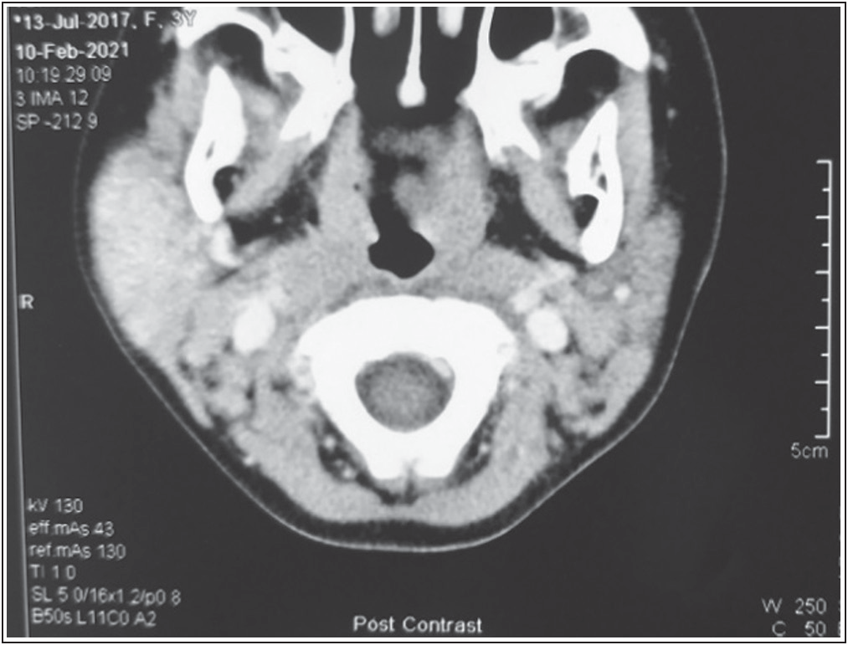

**Figure 1: Axial CT of parotid mass**

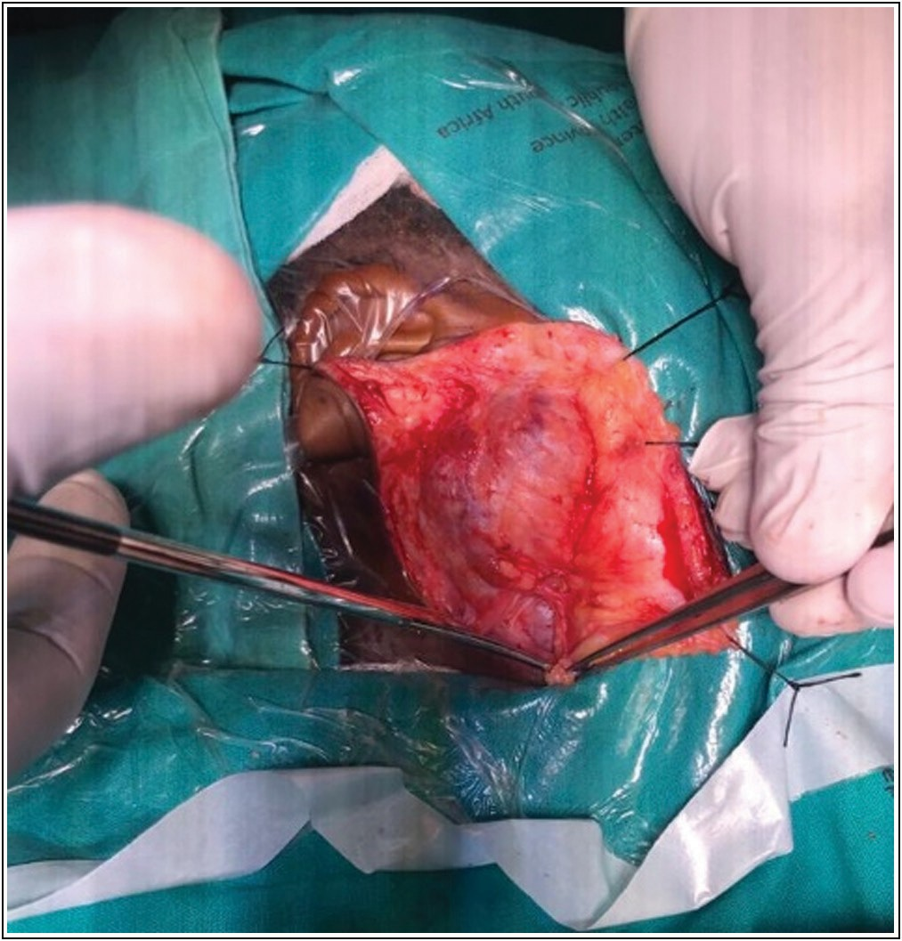

**Figure 2: Exposure of the parotid lesion via a modified Blair incision**

15–32% in adults,[3,6] of which MEC is the most common type.[7,8]

MEC, which is mostly low grade in children, usually presents at an average age of 13.5years and has a female predilection.[3] In children under the age of 10 years, it is usually high grade with poor prognosis.[3,4] Our patient is a 3 year old female patient, in keeping with findings in the literature but with an intermediate grade tumour which is against findings of generally high grade malignancy in children under the age of 10 years.[3,4]

MEC presents as a painless mass with 1–2 years’ average duration.[4] Additional symptoms may include pain, facial weakness, sleep disordered breathing, voice changes and

**Figure 3: Superficial lobe of the parotid gland removed with exposure of the facial nerve and its branches**

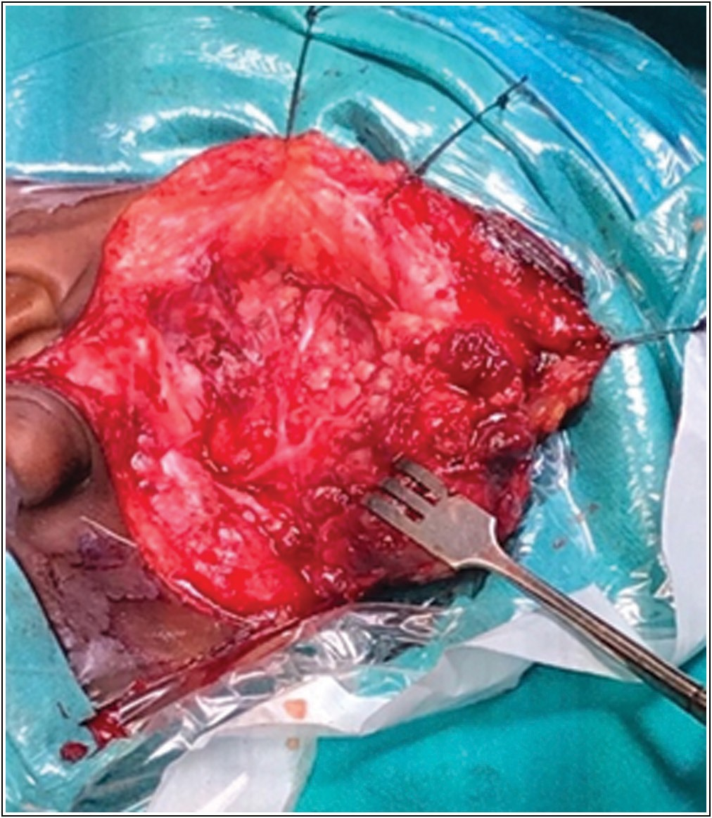hearing loss.[2] Our patient had a shorter duration of symptoms of 6 months with episodic pain. There was no other associated symptom complex.

The aetiology of MEC is unknown, but genetics and prior exposure to ionizing radiation may play a role.[3,4] Other risk factors include Epstein Barr Virus(EBV), cytomegalovirus (CMV) infections and environmental pollutants such as asbestos, nickel, silica, rubber and woodworking material.[4] Our patient was not directly exposed to any of these, though she lives in an area close to a platinum mine.

On examination signs of malignancy, including facial nerve paralysis, may be found in up to 4% of cases.[2,9] This typically shows a firm, variable fixation non-tender mass ranging in size from 1-3 cm.[3] Our patient did not exhibit any signs of malignancy. Facial nerve was intact and the overlying skin was intact. The mass was not tender.

The differential diagnosis of parotid MEC may be congenital or acquired. Branchial cleft cysts or other cysts should be considered for the former and acute parotitis, pleomorphic adenomas, hemangiomas or lymphoepithelial cysts in HIV infection in the latter. Less common malignancies include acinic cell and adenoid cystic carcinomas.[9,10]

Diagnostic workup includes full blood count, renal and liver function, imaging and tissue sampling. Serological testing for HIV, CMV and EBV should also be done.[6]

Imaging studies include radiographs, which may reveal lung metastases when present. Ultrasound is a quick non-invasive

Journal of the West African College of Surgeons | Volume 12 | Issue 3 | July‑September 2022 121

test with no exposure to ionizing radiation or requiring sedation. It is helpful in distinguishing cystic from solid masses.[9] Ultrasound can also help guide FNAC biopsy.[2]

CT and magnetic resonance imaging (MRI) allow for comprehensive assessment of parotid masses, including involvement of the deep lobe or surrounding structures.[6,9] MRI is better at soft tissue characterization and important in delineating tumour margins.[9] Facial nerve and perineural invasion are also better visualised with MRI.[6,9] CT is useful for identification of osseous involvement.[9] Positron emission tomography (PET) CT is of more use when looking for metastatic disease.[10]

FNA is an invasive test for diagnosis of parotid tumours. FNA is a highly reliable test. However, young children may not be able to tolerate it when awake, which can limit its usefulness. This may have been the case in our patient. Biopsy carries risks such as tumour seeding and facial nerve injury.[2] FNAC in our patient was inconclusive. Core biopsy however, through a planned incision in a safe region may be an option in a few selected cases such as those suspected to have lymphoma or unequivocal FNA.[2] The accuracy of FNA in differentiating between benign and malignant masses is only 79%, and even when malignancy is confirmed immunohistochemistry and grading cannot be determined through cytology.[2] The diagnosis of MEC on our patient was made post-operatively with histopathological analysis of the surgical specimen.

The management of choice for parotid MEC in children is parotidectomy, either superficial or total depending on site of lesion, with facial nerve preservation.[2,4,7,8] Surgery usually carries good outcomes for children.[4] Indications for facial nerve resection is preoperative paralysis or intraoperative invasion by tumour.[6] Following resection, primary anastomoses or transpositional grafting is indicated.[9] Therapeutic neck dissection is indicated for patients with clinical and/or radiological evidence of cervical metastases.[4] Our patient did not have any lymph nodes.

Other treatment options for parotid MEC include radiation and chemotherapy. Outcomes for these modalities are uncertain due to the rarity of these cancers in children and their use is controversial.[4] Radiation in children is given with caution in a select few due to the potential effects of retardation in craniofacial development, osteoradionecrosis, mucositis, salivary gland hypofunction, xerostomia and future development of other head and neck malignancies.[2] Intensity-modulated radiation is a good option for children as it avoids exposure to normal tissues while focusing only on involved areas.[8] Indications for radiation include advanced irresectable cases, cases with positive margins, high-grade disease, perineural and/or lymphovascular invasion and extraglandular extension, which our patient did not have.[4]

Chemotherapy is considered in patients with recurrent disease or palliative cases.[4,8] Our patient was managed surgically with a superficial parotidectomy and the facial nerve was preserved. Histopathological analysis revealed an intermediate grade MEC with clear margins.

Features used for MEC grading are nuclear atypia, presence of cystic versus solid components, perineural and or lymphovascular invasion, necrosis and mitotic activity.[4,9] The grading systems used such as Healy, Armed Forces Institute of Pathology and Brandwein stratify tumours into low, intermediate or high grade.[9] Low grade MEC has more cystic components as opposed to high grade MEC which are more solid. The histology in our patient showed predominantly solid growth pattern with 20% cystic component.

In major salivary gland malignancies, the adult TNM staging is used.[5,9] The importance is determination of the ultimate prognosis of paediatric MEC. High grade disease significantly lowers survival.[9] Low and intermediate grade carcinomas both carry a good prognosis.[9] Our patient was classified as having stage III mucoepidermoid carcinoma (pT3N0M0) according to the TNM classification, but an intermediate grade according to AFIP grading. Intermediate No recurrence has been observed to date and long-term follow up will be continued.

# Conclusion

Salivary gland malignancies are rare in children with an incidence of less than 5%, and when it occurs affects children older than the age of 10. MEC is the most common malignant type usually affecting the parotid gland. The prognosis of MEC in children is usually good due to the low or intermediate grading commonly found in this age group. Primary surgery is usually sufficient, and recurrence is rare.

## Financial support and sponsorship

Nil.

## Conflicts of interest

There are no conflicts of interest.

## Author contribution

Drs Masege and Chiware conceptualized the idea

Dr Chiware conducted the initial literature search and Dr Masege did a supplementary literature review and revision of the manuscript

Dr Masege did the final approval of the version to be submitted

## Ethics

Ethics Committee approval was obtained from the University of the Witwatersrand Human Research Ethics Committee (M210889)

122 Journal of the West African College of Surgeons | Volume 12 | Issue 3 | July‑September 2022

# References

1. Yoshida EJ, García J, Eisele DW, Chen AM. Salivary gland malignancies in children. Int J Pediatr Otorhinolaryngol 2014;78:174-8.
2. Bateman N, Lawrence R. Salivary Glands. In Watkinson JC, Clarke RW, editors. Scott-Brown’s Otorhinolaryngology Head & Neck Surgery. 8th ed. Vol 2. Boca Raton: Taylor & Francis Group; 2018. p. 443-9.
3. Carlson ER, Schlieve T. Salivary gland malignancies. Oral Maxillofac Surg Clin North Am 2019;31:125-44.
4. Peraza A, Gómez R, Beltran J, Amarista FJ. Mucoepidermoid carcinoma. An update and review of the literature. J Stomatol Oral Maxillofac Surg 2020;121:713-20.
5. Vander Poorten V, Bradley PJ. Malignant tumors of the salivary glands. In Watkinson JC, Clarke RW, editors. Scott-Brown’s Otorhinolaryngology Head & Neck Surgery.

8th ed. Vol 3. Boca Raton: Taylor & Francis Group; 2018. p. 131-51.

1. Daniel SJ, Kanaan AA. Salivary gland disease in children. In: Flint P, Haughey B, Lund V, *et al*. editors. Cummings Otolaryngology Head & Neck Surgery. 6th ed. Philadelphia: Mosby; 2010. p. 3103-18.
2. Radomski S, Dermody S, Harley EH Jr. Clinical characteristics and outcomes of major salivary gland malignancies in children. Laryngoscope 2018;128:1126-32.
3. Lennon P, Silvera VM, Perez-Atayde A, Cunningham MJ, Rahbar R. Disorders and tumors of the salivary glands in children. Otolaryngol Clin North Am 2015;48:153-73.
4. Young A, Okuyemi OT. Malignant Salivary Gland Tumors. In: StatPearls. Treasure Island (FL): StatPearls Publishing; 2020. Available from: [https://www.ncbi.nlm.nih.go](http://www.ncbi.nlm.nih.gov/books/)v/books/ NBK563022/. [Last accessed on 2022 Jul 21].
5. Ord RA, Carlson ER. Pediatric salivary gland malignancies. Oral Maxillofac Surg Clin North Am 2016;28:83-9.



Journal of the West African College of Surgeons | Volume 12 | Issue 3 | July‑September 2022 123