**Original Article**

Comparison of Flexible Nasopharyngoscopy with Plain Radiograph in the Assessment of Children with Adenoid Hypertrophy

# Introduction

**Abstract**

**Background:** Obstructive adenoid hypertrophy is one of the commonest disorder seen in paediatric otorhinolaryngology clinics. It has a wide range of complications that can lead to cardiopulmonary and developmental problems; hence, early diagnosis and treatment are paramount in preventing the complications. Several modalities for the assessment of adenoid hypertrophy have been described in the literature, of which plain radiograph and flexible nasopharyngoscopy are the most popular. In this study, traditional method of evaluating adenoid hypertrophy (plain radiograph) has been compared with newer flexible nasopharyngoscopy. **Materials and Methods:** This is a cross-sectional study of randomly selected children with clinical diagnosis of obstructive adenoid disease. All eligible participants underwent clinical examinations, flexible nasopharyngoscopy and postnasal space X-ray. The findings were compared using the chi-square test and Pearson’s correlation test. **Results:** The age of the participants ranged between 2 and 10 years with mean of 4.5 ± 2.5 years. There were 79 (56.4%) males and 61 (43.6%) females. The adenoid hypertrophy observed using flexible nasopharyngoscopy among the participants ranged between 20 and 90% with mean of 67.4 ± 15.4%. The adenoid enlargement measured using adenoidal–nasopharyngeal ratio on plain radiograph ranged between 0.40 and 0.96 with mean of 0.7 ± 0.09. The Pearson’s correlation test revealed strong correlation between flexible nasopharyngoscopy and plain radiograph (*r* = 0.858, *P* = .000), and there was statistically significant association between the two methods (*χ*2 = 148.8, *P* = .000). **Conclusion:** There was a strong correlation between flexible nasopharyngoscopy and plain radiograph of the postnasal space in the assessment of obstructive adenoid disease in children.

**Keywords:** *Adenoid hypertrophy, comparison, flexible nasopharyngoscopy, postnasal space X-ray*

Obstructive adenoid hypertrophy is one of the commonest childhood disorders encountered in otorhinolaryngology practice worldwide. It is responsible for a high number of medical visits to hospitals, and it is one of the main reasons given for parent absence at work places.[1,2] In Nigeria, obstructive adenoid hypertrophy was also found to be one of the common disorders seen in paediatric otorhinolaryngology clinics.[3] The prevalence varies across the regions: 18.55% was reported in Port Harcourt,[3] 9.2% was recorded in Ibadan,[4] 7.7% was seen among primary school children in Ile-Ife,[5] and the least prevalence of 4.9% was reported among hospitalised patients in Sokoto.[6]

Adenoid hypertrophy is the commonest cause of nasopharyngeal airway obstruction in children.[7] It has a wide range of complications that can lead to cardiopulmonary and developmental problems such as obstructive

This is an open access journal, and articles are distributed under the terms of the Creative Commons Attribution-NonCommercial- ShareAlike 4.0 License, which allows others to remix, tweak, and build upon the work non-commercially, as long as appropriate credit is given and the new creations are licensed under the identical terms.

**For reprints contact:** [reprints@medknow.com](mailto:reprints@medknow.com)

sleep apnoea syndrome, pulmonary hypertension, cardiac failure, and eventually failure to thrive.[8-10] Therefore, early diagnosis and treatment are paramount before the complications set in.

Several modalities for the assessment of adenoid hypertrophy have been described in the literature, of which plain radiograph and flexible nasopharyngoscopy are the most popular, but there is no conclusive agreement on the best and universally applicable method of assessment.[11] Flexible nasopharyngoscopy is currently recommended by some authors; it was found to be an accurate, reliable, and safe diagnostic procedure, and it also provides a definitive assessment of the status of both the nasal cavity and nasopharynx.[12,13] However, it has drawbacks as well; it is prone to subjectivity as it relies on professional opinion and judgment, and some workers reported poor inter-rater reliability and low inter-observer agreement. It is also expensive and not universally available, especially in sub-Saharan Africa.[14-16]

**How to cite this article:** Adamu A, Jibril YN, Hasheem MG, Abdullahi H, Salisu AD, Nwaorgu OG. Comparison of flexible nasopharyngoscopy with plain radiograph in the assessment of children with adenoid hypertrophy. J West Afr Coll Surg 2020;10:6-10.

## Auwal Adamu1, Yasir Nuhu Jibril2, Muhammad Ghazali Hasheem3,

**Hamisu Abdullahi3, Abubakar Danjuma Salisu3, Onyekwere**

**George B. Nwaorgu4**

*1Department of Otorhinolaryngology Head & Neck Surgery, Abubakar Tafawa Balewa University/ Abubakar Tafawa Balewa University Teaching Hospital, Bauchi, 2Department of Otorhinolaryngology, Aminu Kano Teaching Hospital, Kano, 3Department of Otorhinolaryngology, Aminu*

*Kano Teaching Hospital/Bayero University, Kano, 4Department of Otorhinolaryngology, University College Hospital Ibadan/College of Medicine, University of Ibadan, Nigeria*

**Received:** 07-Jan-2022 **Accepted:** 27-Feb-2022 **Published:** 08-Jun-2022

***Address for correspondence:*** *Dr. Auwal Adamu, Department of Otorhinolaryngology Head &*

*Neck Surgery, Abubakar Tafawa Balewa University/Abubakar Tafawa Balewa University Teaching Hospital, Bauchi, Nigeria.*

*E-mail: auwal.adamu@npmcn. edu.ng*

|  |
| --- |
| **Access this article online** |
| **Website:**  [www.jwacs-jcoac.org](http://www.jwacs-jcoac.org/) |
| **DOI:** 10.4103/jwas.jwas_37_22 |
| **Quick Response Code:** |

6 © 2022 Journal of the West African College of Surgeons | Published by Wolters Kluwer ‑ Medknow

On the other hand, plain radiograph is the most widely used investigative method for the assessment of adenoid hypertrophy. It is an objective method of assessment, especially when cephalometric measurements (like adenoidal–nasopharyngeal ratio [ANR]) are employed for interpretation. It is readily available, cheap, and easy to interpret. However, it has been criticised by some researchers due to its low accuracy and precision, inter-observer error, inability to compel a child to assume standard position during the procedure, and exposure to radiation.[17] Although radiation exposure to children from radiological imaging has been an area of debate,[18] some authors have reported that children are particularly more sensitive to radiation exposure and children exposed to radiation have two- to three-fold increased risk of developing cancer than adults.[18,19] Similarly, another report also indicated that even low-dose radiation can predispose children to cancer later in life.[20] Despite these shortcomings, plain radiographs are still used in many developing countries, where facilities for the newer assessment methods are not available. Therefore, this study aims to determine the degree of agreement between the traditional plain radiograph and a newer flexible nasopharyngoscopy in the assessment of adenoid hypertrophy in our environment.

# Materials and Methods

The study was a hospital-based cross-sectional study conducted at the ENT clinic of Aminu Kano Teaching Hospital between October 2018 and December 2019. Ethical approval was obtained from the institution’s research and ethics committees with reference number NHREC/21/08/2008/AKTH/EC/2398. Informed consent was obtained from the parent of each study participant. The participant included in the study were children with clinical diagnosis of obstructive adenoid disease who presented during the study period. Children excluded from the study were those with nasal mass, craniofacial anomaly, and bleeding disorder; uncooperative patients; or those who had adenoidectomy previously. Simple random sampling technique (by balloting) was used to recruit the participants. A structured questionnaire was used to collect relevant clinical information using the interviewer-administered method.

Flexible nasopharyngoscopy was performed under the aseptic technique; the participant was made to sit comfortably on a chair supported by the parent/caregiver or restrained on the caregiver’s lap depending on the age of the child. Nasal examination was carried out with a bright headlamp. For patients found with nasal discharge, cleaning and suctioning were carried out using an appropriate size flexible suction catheter. Patients with gross nasal mass were excluded from the study. Xylocaine spray 10% (10 mg/metered dose) was applied into both nasal cavities (1–2 metered dose) to anaesthetise the nasal mucosa, to ease the procedure, and to reduce discomfort. Additionally, xylometazoline nasal spray 0.05% (two to three drops) was applied into the nose for a participant with engorged inferior turbinate. Five minutes was given for xylocaine and/ or xylometazoline to take effect. A flexible nasopharyngoscope

(Model No: 68E3566M, diameter: 2.7 mm; Medtronic Xomed, Florida) was used for the procedure. The scope was disinfected and lubricated before introduction into the nose. Defogging of the flexible nasopharyngoscope was done by wiping the tip of the scope with a piece of cotton wool soaked in Savlon. The tip of the scope was passed into the most spacious nasal cavity along the floor of the nasal cavity to examine the choanae, the nasopharynx, and Eustachian tube openings. The nasopharynx was examined in upright and clear endoscopic view, and the finding was recorded as a percentage of obstruction of the choanae. The result was further grouped according to endoscopic grading described by Yazici *et al.*[21] (grade 1: adenoid hypertrophy obstructing <50% of choanae, grade 2: adenoid hypertrophy obstructing 50–75% of choanae, and grade 3: adenoid hypertrophy obstructing 76–100% of choanae).

A digital plain radiograph of the postnasal space (lateral view) was done at the radiology department of the institution. It was taken in an erect posture, with the head of the patient fixed in a true lateral direction. The Fujioka *et al.*[22] method of ANR was used for grading of the adenoid hypertrophy on plain radiograph. The ANR was further grouped into mild obstruction (ANR = 0.50–0.62), moderate obstruction (ANR = 0.63–0.75), and severe obstruction (ANR ≥ 0.76). The measurements of ANR on plain radiograph were made several days after the flexible nasopharyngoscopic examination, and the authors were blinded to the findings of the endoscopy.

The data obtained were analysed using Statistical Product and Service Solutions version 20.0 for Windows (IBM Inc., Chicago, Illinois). Data were summarised as quantitative and qualitative variables. Quantitative variables were expressed as mean and standard deviation (SD). Qualitative variables were expressed as frequencies and percentages. The chi-square test was used to compare the association between the qualitative variables, whereas the Pearson’s correlation test was used to compare the relationship between the quantitative variables. The level of statistical significance was set at *P* value ≤ .05, 95% confidence interval.

# Results

The age of the participants ranged between 2 and 10 years, with mean ± SD = 4.5 ± 2.5 years. There were 79 (56.4%) males and 61 (43.6%) females with male to female ratio of 1:08. The adenoid obstruction observed using flexible nasopharyngoscopy among the participants ranged between 20 and 90%, with mean ± SD = 67.4 ± 15.4%. Table 1 shows the distribution of the grades of adenoid obstruction observed using flexible nasopharyngoscopy. Figure 1 shows endoscopic picture of grade 1 and grade 3 adenoid obstruction.

The adenoid enlargement measured using ANR on plain radiograph ranged between 0.40 and 0.96, with mean ± SD = 0.7 ± 0.09. Table 2 shows the distribution of the degree of adenoid obstruction measured using the ANR method. Figure 2 shows X-ray postnasal space of mild and severe adenoid enlargement.

Journal of the West African College of Surgeons | Volume 10 | Issue 4 | October-December 2020 7

The findings of flexible nasopharyngoscopy and plain radiograph in the patients with obstructive adenoid disease were compared. The Pearson’s correlation test revealed positive correlation between flexible nasopharyngoscopy

### Table 1: Flexible nasopharyngoscopy grading

|  |  |  |
| --- | --- | --- |
| **Endoscopic grading** | **Frequency** | **Percentage** |
| Grade 1 | 25 | 17.9 |
| Grade 2 | 77 | 55.0 |
| Grade 3 | 38 | 27.1 |
| **Total** | **140** | **100** |

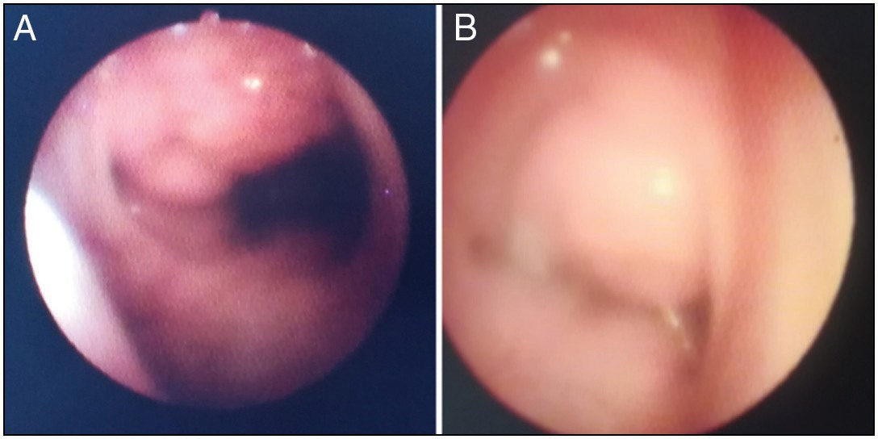

**Figure 1: Endoscopic picture of grade 1 (A) and grade 3 (B) adenoid obstruction**

### Table 2: Plain radiograph grading

|  |  |  |
| --- | --- | --- |
| **X-ray grading** | **Frequency** | **Percentage** |
| Mild obstruction | 29 | 20.7 |
| Moderate obstruction | 77 | 55.0 |
| Severe obstruction | 34 | 24.3 |
| **Total** | **140** | **100** |

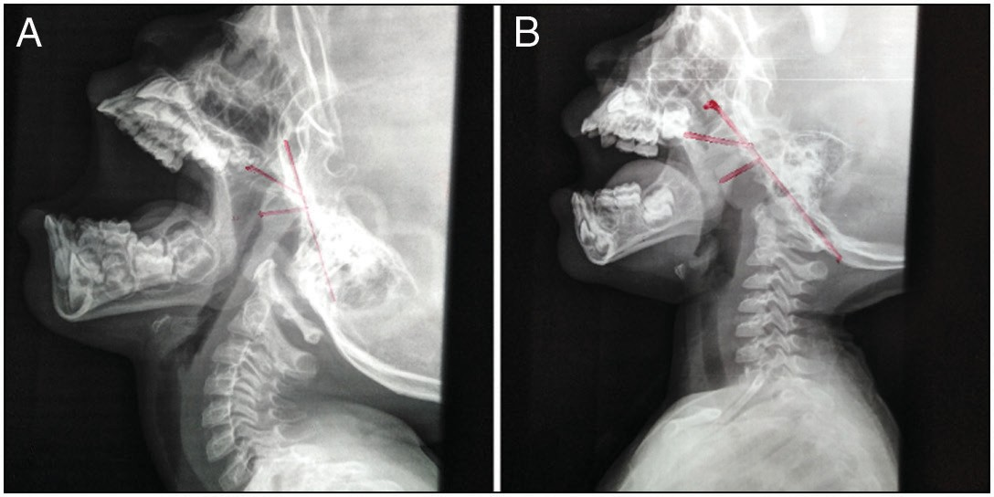

**Figure 2: X-ray postnasal space of mild (A) and severe (B) adenoid enlargement**

and plain radiograph, and there was statistically significant correlation between the two investigation methods (*r* = 0.858, *P* = .000). Table 3 shows chi-square comparison between flexible nasopharyngoscopy and plain radiograph, and there was statistically significant association between the endoscopic and X-ray grading (*χ*2 = 148.8, *P* = .000).

# Discussion

Flexible nasopharyngoscopy is nowadays an established method used in otolaryngology practice. The introduction of flexible nasopharyngoscopy made it possible to examine the nasal cavities, pharynx, and larynx in children with ease and permit accurate diagnosis to be made. The procedure is well tolerated in the paediatric age group and some authors considered it as the method of choice for the evaluation of the nasopharynx in children.[23-25] In this research, the flexible endoscopic grading and plain radiograph grading in the patients with obstructive adenoid disease were compared, and the findings showed a statistically significant association (***χ*2 =** 148.8, *P* = .000). This is similar to the findings of other studies that reported a statistically significant association between the flexible endoscopy and plain radiograph for both small and large adenoids.[13,26] Additionally, the Pearson’s correlation test revealed a strong positive correlation between flexible nasopharyngoscopy and plain radiograph in patients with obstructive adenoid disease studied (*r* = 0.858, *P* = .000). This is similar to the findings of Kindermann *et al.*[13] and Souki *et al.*[27] who reported a statistically significant agreement with correlation coefficient of *r* = 0.83 (*P* < .001) and *r* = 0.67 (*P* < .05), respectively. In contrast, Mlynarek *et al.*[28] reported a weak correlation of *r* = 0.312 (*P* = .082), whereas Wormald *et al.*[29] reported poor correlation with no statistically significant agreement between the two methods (*r* = 0.11, *P* > .5). These variations may be due to differences in the study protocol, age group, or sample size selected in their studies.

This study found severe adenoid obstruction (endoscopic grade

3) in 27.1% of the patients. This is lower than the findings obtained in a study in Texas, USA, where severe obstruction was seen in 59% of the patients.[30] The higher prevalence of severe obstruction in their study may be due to the nature of the participants they studied. The authors selected only children with obstructive sleep apnoea, and this group of patients are expected to have more severe form of adenoid obstruction. Endoscopic grade 2 adenoid hypertrophy was seen in 55% of the participants of this study; this is similar to the findings of Satish *et al.*[31] who reported that 50% of their patients had

### Table 3: Comparison of flexible nasopharyngoscopy and plain radiograph

|  |  |  |  |  |  |  |
| --- | --- | --- | --- | --- | --- | --- |
| **Endoscopic grading** |  | **X-ray grading** |  | **Total** | **Chi-square** | ***P* value** |
|  | **Mild** | **Moderate** | **Severe** |  |  |  |
| Grade 1 | 23 (92.0%) | 2 (8.0%) | 0 (0.0%) | 25 (100%) |  |  |
| Grade 2 | 6 (7.8%) | 64 (83.1%) | 7 (9.1%) | 77 (100%) | 148.8 | 0.000* |
| Grade 3 | 0 (0.0%) | 11 (28.9%) | 27 (71.1%) | 38 (100%) |  |  |
| **Total** | **29 (100%)** | **77 (100%)** | **34 (100%)** | **140 (100%)** |  |  |

*Statistically significant association

8 Journal of the West African College of Surgeons | Volume 10 | Issue 4 | October-December 2020

endoscopic grade 2 adenoid obstruction. The similarities of the findings may be attributed to similar endoscopic grading system with our study. In this study, grade 1 adenoid obstruction was observed in 17.9% of the patients; this is contrary to the findings of Isaac *et al.*[32] in Canada and Ameli *et al.*[33] in Italy where they reported higher proportion of endoscopic grade 1 adenoid enlargement (46% and 36.1%, respectively). The higher percentage of grade 1 adenoid hypertrophy in their studies may be due to the selection of older children (mean age of 10.3 and 6.7 years, respectively) compared to our study (mean age of 4.5 years). The older children tend to have milder form of obstructive adenoid disease.[24,34] This is because older children have wider nasopharyngeal airway space, and the adenoid enlargement was reported to start regressing after the age of 4.5 years.[22]

In summary, this study further supports the existing evidence of a strong correlation between flexible nasopharyngoscopy and plain radiograph in the diagnosis of obstructive adenoid disease. It is therefore recommended that flexible nasopharyngoscopy should be favoured (in centres where available) in the assessment of obstructive adenoid disease, as it gives the same result as an X-ray and at the same time avoids exposure to radiation. The strength of this study lies in the comparison of the two diagnostic methods in randomly selected patients. The patients underwent standard endoscopic and X-ray procedures, and the findings were interpreted based on standard measurements. However, one of the limitation encountered was difficulty in performing the procedure on an uncooperative child. This was minimised by explaining the procedure to an older child and by the application of topical anaesthetic spray to the nose, which reduced discomfort and improved cooperation. There is a need to carry out further studies on this topic, probably comparison of these two procedures in the assessment of pre- and post- operative nasopharyngeal airway space.

# Conclusion

This study found that flexible nasopharyngoscopy correlated very well with ANR measurements on plain radiograph of the postnasal space. Therefore, flexible nasopharyngoscopy is recommended for the assessment of obstructive adenoid disease as it avoids exposure to radiation.

### Financial support and sponsorship

Nil.

### Conflicts of interest

There are no conflicts of interest.

# References

1. Szalmás A, Papp Z, Csomor P, Kónya J, Sziklai I, Szekanecz Z, *et al*. Microbiological profile of adenoid hypertrophy correlates to clinical diagnosis in children. Biomed Res Int 2013; 2013:629607.
2. Marseglia GL, Caimmi D, Pagella F, Matti E, Labó E, Licari A, *et al*. Adenoids during childhood: The facts. Int J Immunopathol Pharmacol 2011;24:1-5.
3. Ibekwe MU, Mbalaso OC. Pattern of paediatric ear, nose and throat diseases in Port Harcourt, South-South, Nigeria. The Nigerian Health Journal 2015;15:48-52.
4. Fasunla AJ, Samdi M, Nwaorgu OG. An audit of ear, nose and throat diseases in a tertiary health institution in South-western Nigeria. Pan Afr Med J 2013;14:1.
5. Eziyi JA, Amusa YB, Nwawolo C. The prevalence of nasal diseases in Nigerian school children. J Med Med Sci 2014;5:71-7.
6. Amutta SB, Abdullahi M, Aliyu D, Manya C, Yikawe SS, Solomon JH. Pattern of otorhinolaryngeal, head and neck diseases in the in-patient unit of a tertiary health institution in Sokoto, North Western Nigeria. Bo Med J 2015;12:102-07.
7. Shirley WP, Woolley AL, Wiatrak BJ. Pharyngitis and adenotonsillar disease. In: Flint PW, Haughey BH, Lund VJ, Niparko JK, Richardson MA, Robbins KT, *et al*., editors. Cummings Otolaryngology Head & Neck Surgery. 5th ed. Philadelphia: Mosby Elsevier; 2010. p. 2881-9.
8. Li AM, Hui S, Wong E, Cheung A, Fok TF. Obstructive sleep apnoea in children with adenotonsillar hypertrophy: Prospective study. Hong Kong Med J 2001;7:236-40.
9. Arminio G, Neto LM, Stamm AEC. Pulmonary hypertension in patients with adenotonsillar hypertrophy. Rev Bras Otorrinolaringol 2003;69:819-23.
10. Duman D, Naiboglu B, Esen HS, Toros SZ, Demirtunc R. Impaired right ventricular function in adenotonsillar hypertrophy. Int J Cardiovasc Imaging 2008;24:261-7.
11. Feres MF, Hermann JS, Pignatari SS. Cephalometric evaluation of adenoids: An analysis of current methods and a proposal of a new assessment tool. Am J Orthod Dentofacial Orthop 2012;142:671-8.
12. Lourenço EA, de Carvalho Lopes K, Pontes A Jr, Oliveira MH, Umemura A, Vargas AL. Comparison between radiological and nasopharyngolaryngoscopic assessment of adenoid tissue volume in mouth breathing children. Braz J Otorhinolaryngol 2005;71:23-7.
13. Kindermann CA, Roithmann R, Lubianca Neto JF. Sensitivity and specificity of nasal flexible fiberoptic endoscopy in the diagnosis of adenoid hypertrophy in children. Int J Pediatr Otorhinolaryngol 2008;72:63-7.
14. Major MP, Flores-Mir C, Major PW. Assessment of lateral cephalometric diagnosis of adenoid hypertrophy and posterior upper airway obstruction: A systematic review. Am J Orthod Dentofacial Orthop 2006;130:700-8.
15. Filho DI, Raveli DB, Raveli RB, de Castro Monteiro Loffredo L, Gandin LG Jr. A comparison of nasopharyngeal endoscopy and lateral cephalometric radiography in the diagnosis of nasopharyngeal airway obstruction. Am J Orthod Dentofacial Orthop 2001;120:348-52.
16. Bitar MA, Rahi A, Khalifeh M, Madanat LM. A suggested clinical score to predict the severity of adenoid obstruction in children. Eur Arch Otorhinolaryngol 2006;263:924-8.
17. Araujo-Neto SA, Queiroz SM, Baracat ECE, Pereira IMR. Radiographic evaluation of adenoid size in children: Methods of measurement and parameters of normality. Radiol Bras 2004; 37:6.
18. Marcu LG, Chau M, Bezak E. How much is too much? Systematic review of cumulative doses from radiological imaging and the risk of cancer in children and young adults. Crit Rev Oncol Hematol 2021;160:103292.
19. Burger IM, Murphy KJ, Jordan LC, Tamargo RJ, Gailloud P. Safety of cerebral digital subtraction angiography in children: Complication rate analysis in 241 consecutive diagnostic angiograms. Stroke 2006;37:2535-9.
20. Robbins E. Radiation risks from imaging studies in children with cancer. Pediatr Blood Cancer 2008;51:453-7.

Journal of the West African College of Surgeons | Volume 10 | Issue 4 | October-December 2020 9

1. Yazici H, Soy FK, Kulduk E, Doğan S, Dündar R, Sakarya EU, *et al*. Comparison of nasal mucociliary clearance in adenoid hypertrophy with or without otitis media with effusion. Int J Pediatr Otorhinolaryngol 2014;78:1143-6.
2. Fujioka M, Young LW, Girdany BR. Radiographic evaluation of adenoidal size in children: Adenoidal–nasopharyngeal ratio. Am J Roentgenol 1979;133:401-4.
3. Brambilla I, Pusateri A, Pagella F, Caimmi D, Caimmi S, Licari A, *et al*. Adenoids in children: Advances in immunology, diagnosis, and surgery. Clin Anat 2014;27:346-52.
4. Cassano P, Gelardi M, Cassano M, Fiorella ML, Fiorella R. Adenoid tissue rhinopharyngeal obstruction grading based on fiberendoscopic findings: A novel approach to therapeutic management. Int J Pediatr Otorhinolaryngol 2003;67:1303-9.
5. Chien CY, Chen AM, Hwang CF, Su CY. The clinical significance of adenoid-choanae area ratio in children with adenoid hypertrophy. Int J Pediatr Otorhinolaryngol 2005;69:235-9.
6. Wang DY, Bernheim N, Kaufman L, Clement P. Assessment of adenoid size in children by fibreoptic examination. Clin Otolaryngol Allied Sci 1997;22:172-7.
7. Souki MQ, Souki BQ, Franco LP, Becker HM, Araújo EA. Reliability of subjective, linear, ratio and area cephalometric measurements in assessing adenoid hypertrophy among different age groups. Angle Orthod 2012;82:1001-7.
8. Mlynarek A, Tewfik MA, Hagr A, Manoukian JJ, Schloss MD, Tewfik TL, *et al*. Lateral neck radiography versus direct video rhinoscopy in assessing adenoid size. J Otolaryngol 2004;33: 360-5.
9. Wormald PJ, Prescott CAJ. Adenoids: Comparison of radiological assessment methods with clinical and endoscopic findings. J Laryngol Otol 1992;106:342-4.
10. Ulualp SO, Szmuk P. Drug-induced sleep endoscopy for upper airway evaluation in children with obstructive sleep apnea. Laryngoscope 2013;123:292-7.
11. Satish HS, Sarojamma AN, Kumar A. A study on role of adenoidectomy in otitis media with effusion. IOSR Journal of Dental and Medical Sciences 2013;4:20-4.
12. Isaac A, Major M, Witmans M, Alrajhi Y, Flores-Mir C, Major P, *et al*. Correlations between acoustic rhinometry, subjective symptoms, and endoscopic findings in symptomatic children with nasal obstruction. JAMA Otolaryngol Head Neck Surg 2015;141: 550-5.
13. Ameli F, Brocchetti F, Tosca MA, Signori A, Ciprandi G. Adenoidal hypertrophy and allergic rhinitis: Is there an inverse relationship? Am J Rhinol Allergy 2013;27:e5-10.
14. Tall H, Bah FY, Nasser T, Sambou A, Diallo BK. Ear, nose and throat disorders in pediatric patients at a rural hospital in Senegal. Int J Pediatr Otorhinolaryngol 2017;96:1-3.

10 Journal of the West African College of Surgeons | Volume 10 | Issue 4 | October-December 2020