**Case Report**

Multiple Skipped Craniospinal Arteriovenous Malformations Complicated with Hydrocephalus and Syringomyelia

# Introduction

**Abstract**

Arteriovenous malformations (AVMs) can occur within the intracranial or spinal region. When AVMs occur within the central nervous system, they are usually solitary. Central nervous system AVMs are known to be more common within the intracranial compartment when compared with the spinal region. AVMs within the intracranial compartment can be complicated with hydrocephalus, whereas AVM within the spinal cord may be associated with syringomyelia, just like a posterior fossa AVM. The co-existence of cranial and spinal AVMs has only been reported in very few cases in the literature. We report a case of multiple and skipped cerebral and juvenile spinal AVM associated with hydrocephalus and cervicothoracic syringomyelia in a 26-year-old female.

**Keywords:** *Arteriovenous malformations, hydrocephalus, syringomyelia*

Central nervous system arteriovenous malformations (AVMs) are not common entities. When central nervous system AVM occurs, the spinal cord variety is known to be rarer than its intracranial counterpart and some are still underdiagnosed, especially in challenged facility environments.[1,2] The concomitant occurrence of spinal and cranial AVM in the same patient is very rare with very few cases reported (less than five) in the literature, one being an autopsy case.[3] Spinal AVM can rarely lead to syringomyelia, whereas its intracranial variant can lead to hydrocephalus in addition to syringomyelia. We report a case of multiple and skipped cerebral and juvenile spinal AVM associated with hydrocephalus and cervicothoracic syringomyelia in a 26-year-old female.

# Case Report

The patient is a 26-year-old right-handed female. She presented in September 2017 with a 3-year history of headaches and quadriparesis which had worsened significantly 2 months prior to presentation. Her headaches were worse on lying down and were associated with posterior neck and upper back pains. The weakness was of gradual onset, initially involving the lower extremities before extending to her upper limbs. There was

associated numbness of all her finger tips, bilateral blurred vision, nausea, and tinnitus but no hearing impairment. She had two episodes of generalized tonic-clonic seizures a few days to presentation. There was no history of vomiting, swelling in any part of the body, chronic cough, or symptoms suggestive of bleeding dyscrasias. On examination, she was conscious, asthenic, afebrile, not pale, and anicteric. Her vital signs were within normal limits. There were no facial or retinal nevi, café-au-lait spots, axillary or inguinal freckling, iris hamartomas, cutaneous or mucous haemangiomas, subcutaneous nodules, arteriovenous fistula or varicose veins of any of the limbs, hemihypertrophy of the extremities, or spinal deformity. Her Glasgow coma scale score was 15. She had bitemporal haemianopia [Figure 1] with bilateral blurring of disc margins, nuchal rigidity, positive Romberg’s sign, and difficulty to tandem walk. Motor examination revealed muscle atrophy in all her limbs with power grade of 4/5. There was significant spasticity in all her extremities with exaggerated muscle stretch reflexes, clonus, and extensor plantar reflexes. Cranial computerized tomographic (CT) scan and magnetic resonance imaging (MRI) with contrast revealed a brilliant contrast- enhancing hypodense vascular mass 31.7 mm

×18.5 mm × 16.2 mm in the inferior aspect of the fourth ventricle extending through the

## Olufemi Emmanuel Idowu1,2,

**Julius Mautin Vitowanu2**

*1Division of Neurological Surgery, Department of Surgery, Faculty of Clinical Sciences, College of Medicine, Lagos State University, Ikeja, Lagos, 2Division of Neurological Surgery, Department of Surgery, Lagos State University Teaching Hospital (LASUTH), Ikeja, Lagos, Nigeria*

**Received:** 09-Dec-2021 **Accepted:** 22-Mar-2022 **Published:** 08-Jun-2022

***Address for correspondence:*** *Dr. Julius Mautin Vitowanu, Neurosurgery Division, Department of Surgery, Lagos State University Teaching Hospital, Ikeja, Lagos, Nigeria. E-mail:* [*mautin80@gmail.com*](mailto:mautin80@gmail.com)

foramen magnum into the spinal canal; similar

|  |
| --- |
| **Access this article online** |
| **Website:**  [www.jwacs-jcoac.org](http://www.jwacs-jcoac.org/) |
| **DOI:** 10.4103/jwas.jwas_52_21 |
| **Quick Response Code:** |

This is an open access journal, and articles are distributed under the terms of the Creative Commons Attribution-NonCommercial- ShareAlike 4.0 License, which allows others to remix, tweak, and build upon the work non-commercially, as long as appropriate credit is given and the new creations are licensed under the identical terms.

**For reprints contact:** [reprints@medknow.com](mailto:reprints@medknow.com)

vascular lesion was seen in the left cerebellar

**How to cite this article:** Idowu OE, Vitowanu JM. Multiple skipped craniospinal arteriovenous malformations complicated with hydrocephalus and syringomyelia. J West Afr Coll Surg 2020;10:36-40.

36 © 2022 Journal of the West African College of Surgeons | Published by Wolters Kluwer ‑ Medknow

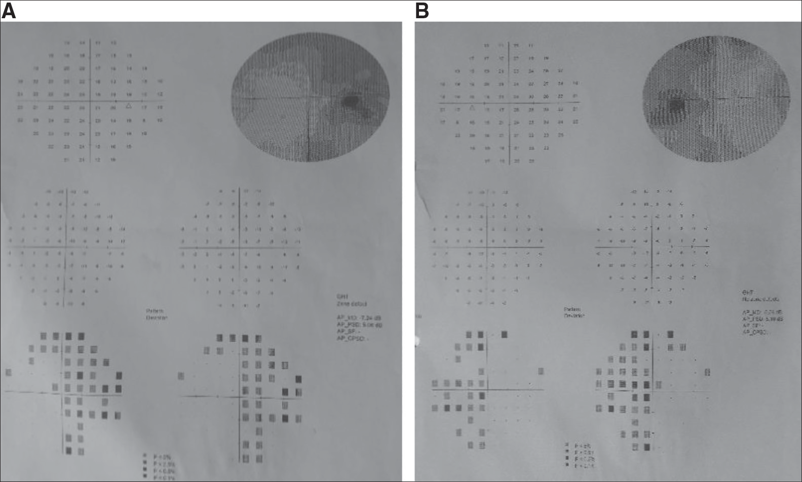

**Figure 1: Pre-operative automated perimetric visual field assessment of the right (a) and left eye (b)**

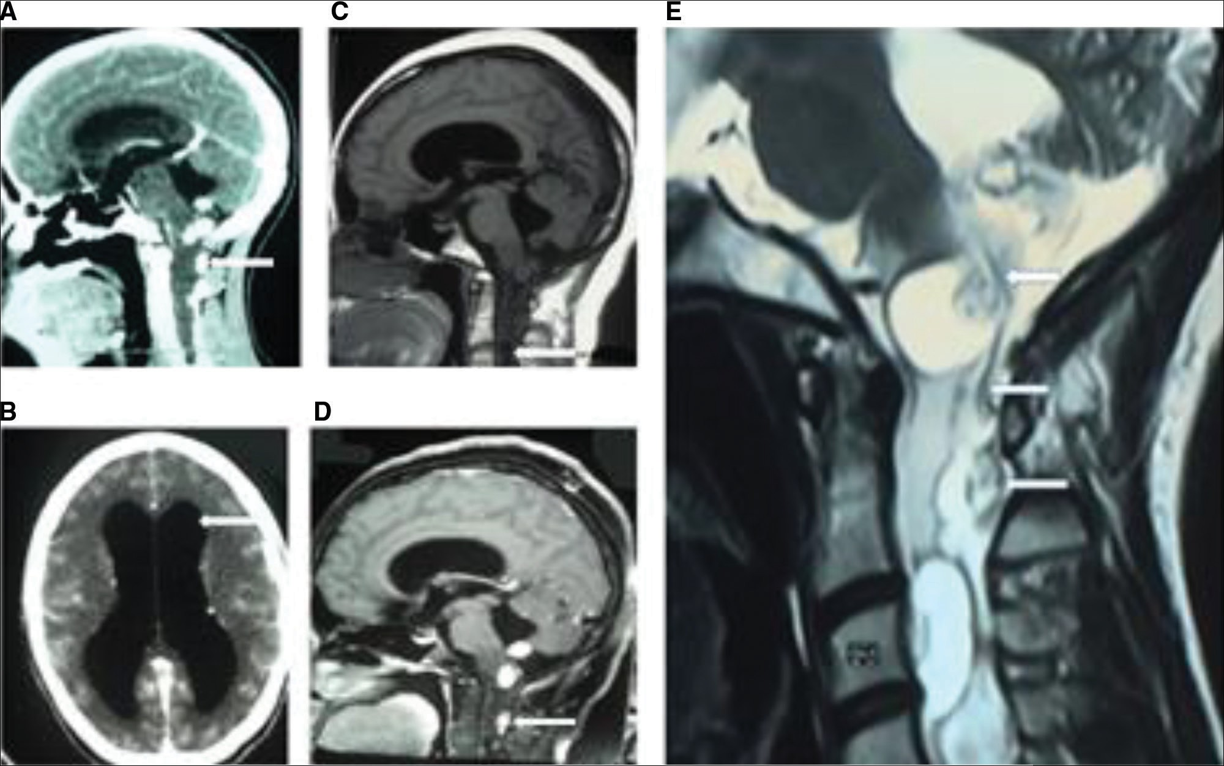

**Figure 2: Cranial computerized tomographic images showing AVM (A) with hydrocephalus (B); cranial sagittal T1-weighted with and without contrast (C,D) and sagittal T2-weighted spinal MR image showing numerous dilated vessels as flow voids (white arrow) and extensive syrinx (E)**

hemisphere measuring 6.2 mm × 6.2 mm × 6.0 mm. Her ventricles were dilated and effacement of sulci and gyri was present [Figure 2]. Spinal 1.5 T MRI showed multiple and skipped Anson and Spetzler type III AVM (Juvenile) at 2nd and 3rd cervical and 3rd, 4th, and 6th thoracic levels, with a long segment dilatation of the central canal from the 3rd cervical

to the 4th thoracic spinal region of the cord, in keeping with a syrinx [Figure 2]. Her abdominal ultrasound was normal with no hepatic haemangioma. A diagnosis of multiple and skipped craniospinal AVM associated with cervicothoracic syrinx and hydrocephalus was made. Other differential diagnoses are posterior cranial fossa tumour with drop metastasis and

Journal of the West African College of Surgeons | Volume 10 | Issue 4 | October‑December 2020 37

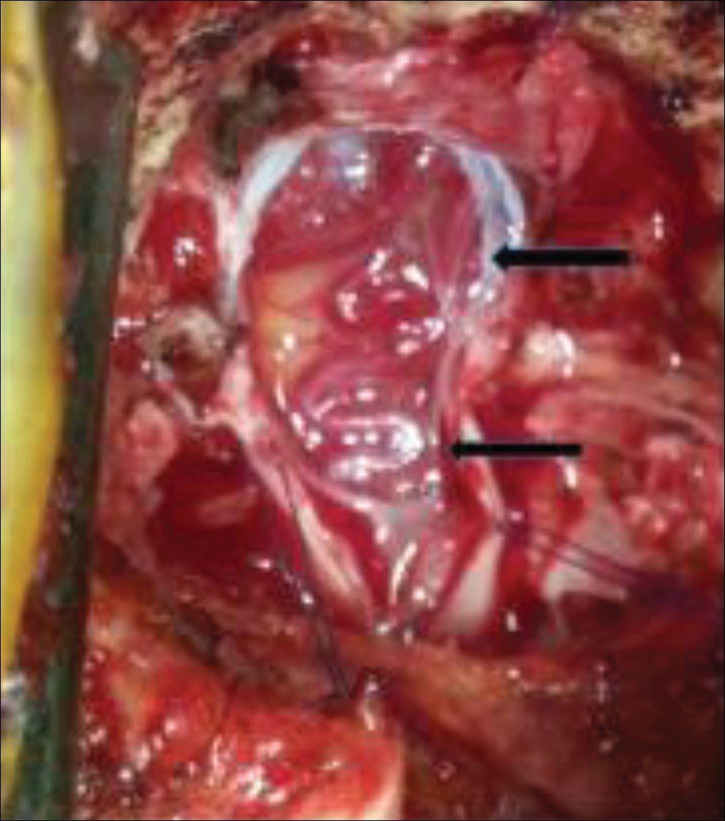

**Figure 3: Intra-operative findings of arteriovenous malformation (black arrows)**

Chiari I malformation. The need for further evaluation with superselective spinal angiography and subsequent embolization at another centre was discussed with the patient. While awaiting further evaluation and definitive treatment, she had worsening motor deficit with inability to walk and increasing frequency of seizures. Due to non-availability of facilities for embolization, patient’s deteriorating clinical condition, and lack of funds to go and have an urgent treatment in a country with available facility for embolization, she had midline suboccipital craniectomy, C1 laminectomy, partial resection of AVM, augmentation duroplasty, and right frontal ventriculoperitoneal shunt placement at the same time. Intra-operative findings were that of multiple posterior fossa AVM [Figure 3]. Her post-operative period was uneventful, and she improved with resolution of headaches and improvement of her vision while motor functions remained the same. She was referred for definitive treatment of the AVM abroad. The patient could not go for definitive treatment due to lack of funds. She represented in December 2021 with features of disease progression (difficulty swallowing, drooling, respiratory distress difficulty articulating words, and worsening spastic paraparesis). She died before any investigation could be done.

# Discussion

Different syndromic conditions have been noted with multiple cerebral AVMs. Bonnet–Dechaume–Blanc syndrome (also known as Wyburn–Mason syndrome), a rare congenital AVM of the brain, retina, or facial nevi, and Rendu–Osler–Weber (hereditary haemorrhagic telangiectasia) are syndromic forms of AVM that have been reported.[4] Rendu–Osler–

Weber disease is a rare autosomal dominant genetic disorder that leads to abnormal blood vessel formation in the skin, mucous membranes, lungs, liver, and brain. The coexistence of Klippel–Trenaunay–Weber syndrome with spinal AVM has been documented.[5-7] This is manifested by a triad of hemihypertrophy of the extremities, cutaneous haemangiomas, and arteriovenous fistula or varicose veins of the involved limbs.

Coexistence of cranial and spinal AVM is very rare with only a few cases being reported in the literature. Shallwani *et al.*[3] reported two cases of single concurrent intracranial and a spinal AVM. Hasegawa *et al.* reported a case of multiple cerebral AVM associated with spinal AVM. Mizutani *et al.*[8] described a case of multiple AVMs located in the cerebellum, posterior fossa, spinal cord, dura, and scalp with associated port-wine stain and supratentorial venous anomaly. Another case report by Moss *et al.*[9] was that of intracerebral and spinal vascular malformation in a patient without hereditary haemorrhagic telangiectasia. The case we are reporting is that of a multiple intracranial AVM coexisting with multiple intraspinal AVM [Figure 2]. The details of all the craniospinal AVMs[9-15] are listed in Table 1, along with our case. Our patient had AVM within the posterior fossa, the spinal cord tissue, and at the extensive extramedullary region with multiple feeders over several vertebral levels.

In the case presented, these malformations can be symptomatic as a result of mass effect by venous congestion, “steal phenomenon” with ischaemia, or haemorrhage. Their evolution is marked by acute or progressive neurological deficit and can sometimes lead to non-specific neurological symptoms, which can delay proper diagnosis. Without proper treatment, they can typically lead to severe spinal cord symptoms and myelopathy. Reports concerning AVM as a cause of syringomyelia are uncommon. Our patient had an extensive syrinx in association with her multiple AVMs. There is no consensus yet on the pathophysiology of syrinx from AVM. The hypothesis includes repeated AVM haemorrhages with cord destruction and exudation of fluid into the cord resulting from chronic venous congestion and breakdown of the blood– spinal cord barrier caused by AVM shunting. Multiple feeders over several vertebral levels are common with juvenile spinal AVM. In spinal AVM, the type of shunting is difficult to determine by the MRI but well analyzed by superselective arteriography. Srivatanakul *et al.*[17] reported four cases of syringomyelia-associated spinal cord AVM, which were all managed with embolization. Syringomyelia resolved after embolization in three of the cases. The lack of facility for superselective arteriography and endovascular therapy (the “gold standard” for managing this lesion) limited our therapeutic options. However, the patient experienced some clinical improvement with decompression and cerebrospinal fluid diversion while awaiting continuation of treatment at an outside facility, with facilities for embolization of the AVM. Posterior fossa decompression, partial resection, and embolization of multiple skipped craniospinal AVM have not been described. Surgery for III juvenile malformations

38 Journal of the West African College of Surgeons | Volume 10 | Issue 4 | October‑December 2020

### Table 1: Craniospinal arteriovenous malformations: Contrast of cases in the literature

**Author(s) Gender Age (years)**

**Clinical features Intracranial AVM Spinal AVM**

Krayenbühl *et al*.[13] Male 55 Lower limb weakness Cerebellum T2-L2

Hash *et al.*[11] Male 24 Back pain Right tentorium T9-T10, glomus Hoffman *et al.*[12] Male 1.3 Headaches and lower limb weakness Right tentorium T2-T10, glomus Parkinson and West[14] Male 47 Headaches and neck pain Left temporal T11-L1

Moss *et al*.[9] Female 50 Autopsy, right lower limb pain, and

paraesthesia

Right caudate, frontal, and pontomedullary junction

T6-T7

Mizutani *et al*.[8] Female 7 Altered sensorium Cerebellum C1-C2 Tsurushima *et al*.[16] Female 3 Altered sensorium and paraparesis Left temporal L2, glomus

Hasegawa *et al*.[10] Male 22 Headaches Left occipital, right temporal, right frontal

L1, juvenile

Wang *et al.*[15] Female 31 Left upper limb radiculopathy Right occipital C1-C2

Shallwani *et al*.[3] Female Female

12 10 Headaches and jerky lower limbs movements Headaches and quadriparesis

Left mesial temporal Left parietal

T8-T9, glomus C2, dural

Idowu and Vitowanu (present study)

Female 26 Headaches, quadriparesis, and altered

sensorium

Fourth ventricle, left cerebellar hemisphere

C2-T6, juvenile

is not always optimal due to its complexity and diversity. Careful assessment of AVM angioarchitecture is crucial for its successful management. Selective catheterization of the anterior and/or posterior vessels feeding the AVM is followed by embolization with particles (e.g., polyvinyl alcohol, tris- acryl gelatin microspheres) or liquid (e.g., ethyl vinyl alcohol copolymer—Onyx glue) embolic material. Coils are not used in these lesions because they require relatively rigid microcatheters that cannot be safely navigated through the spinal arteries.

# Conclusion

Multiple and skipped craniospinal AVM with concomitant hydrocephalus and syringomyelia is rare with limited management options and more challenges in resource- limited health centres. Superselective arteriography and embolization is the main stay of treatment in multiple and skipped craniospinal AVMs. Faced with non-availability of facilities for embolization, patient’s deteriorating clinical status, and the lack of funds to have urgent treatment in a centre with appropriate facility for embolization, suboccipital decompressive craniectomy, duroplasty, and right frontal ventriculoperitoneal shunt can be used to stop or delay disease progression prior to definitive treatment.

### Authors’ contribution

OEI conceived the idea. OEI and JMV defined the intellectual content, performed the literature search, collated data, wrote, edited, reviewed the manuscript, and approved the final version of the manuscript.

### Declaration of patient consent

The authors certify that they have obtained all appropriate patient consent forms. In the form the patient (s) has/have given his/her/their consent for his/her/their images and other clinical information to be reported in the journal. The patients understand that their names and initials will not be published

and due efforts will be made to conceal their identity, but anonymity cannot be guaranteed.

### Financial support and sponsorship

This research did not receive any specific grant from funding agencies in the public, commercial, or not-for-profit sectors.

### Conflicts of interest

The authors report no conflict of interest.

### Ethical approval

The study has been conducted in line with the institutional ethical guidelines (LREC/06/10/1502).

# References

1. Onda K, Yoshida Y, Watanabe K, Arai H, Okada H, Terada T. High cervical arteriovenous fistulas fed by dural and spinal arteries and draining into a single medullary vein: Report of 3 cases. J Neurosurg Spine 2014;20:256-64.
2. Veznedaroglu E, Nelson PK, Jabbour PM, Rosenwasser RH. Endovascular treatment of spinal cord arteriovenous malformations. Neurosurgery 2006;59:S202-9; discussion S3–13.
3. Shallwani H, Tahir MZ, Bari ME, Tanveer-Ul-Haq. Concurrent intracranial and spinal arteriovenous malformations: Report of two pediatric cases and literature review. Surg Neurol Int 2012;3:51.
4. Willinsky RA, Lasjaunias P, Terbrugge K, Burrows P. Multiple cerebral arteriovenous malformations (AVMs). Review of our experience from 203 patients with cerebral vascular lesions. Neuroradiology 1990;32:207-10.
5. Kojima Y, Kuwana N, Sato M, Ikeda Y. Klippel–Trenaunay–Weber syndrome with spinal arteriovenous malformation—Case report. Neurol Med Chir (Tokyo) 1989;29:235-40.
6. Rohany M, Shaibani A, Arafat O, Walker MT, Russell EJ, Batjer HH, *et al*. Spinal arteriovenous malformations associated with Klippel– Trenaunay–Weber syndrome: A literature search and report of two cases. Am J Neuroradiol 2007;28:584-9.
7. Tan EC, Takagi T, Nagai H. Spinal arteriovenous malformations in Klippel–Trénaunay–Weber syndrome: Case report. No Shinkei Geka 1990;18:877-81.

Journal of the West African College of Surgeons | Volume 10 | Issue 4 | October‑December 2020 39

1. Mizutani T, Tanaka H, Aruga T. Multiple arteriovenous malformations located in the cerebellum, posterior fossa, spinal cord, dura, and scalp with associated port-wine stain and supratentorial venous anomaly. Neurosurgery 1992;31:137-40; discussion 140–1.
2. Moss JG, Sellar RJ, Hadley DM. Intracerebral and spinal vascular malformation in a patient without hereditary haemorrhagic telangiectasia. Neuroradiology 1989;31:280-1.
3. Hasegawa S, Hamada JI, Morioka M, Kai Y, Takaki S, Ushio Y. Multiple cerebral arteriovenous malformations (AVMs) associated with spinal AVM. Acta Neurochir (Wien) 1999;141:315-9.
4. Hash CJ, Grossman CB, Shenkin HA. Concurrent intracranial and spinal cord arteriovenous malformations. Case report. J Neurosurg 1975;43:104-7.
5. Hoffman HJ, Mohr G, Kusunoki T. Multiple arteriovenous malformations of spinal cord and brain in a child. Case report. Childs Brain 1976;2:317-24.
6. Krayenbühl H, Yaşargil MG, McClintock HG. Treatment of spinal cord vascular malformations by surgical excision. J Neurosurg 1969;30:427-35.
7. Parkinson D, West M. Spontaneous subarachnoid hemorrhage first from an intracranial and then from a spinal arteriovenous malformation. Case report. J Neurosurg 1977;47:965-8.
8. Wang Y, Zhang H, Ling F. Coexistence of a single cerebral arteriovenous malformation and spinal arteriovenous malformation. Neurol India 2009;57:785-8.
9. Tsurushima H, Meguro K, Matsumura A, Narushima K, Nakada Y, Nose T. Multiple arteriovenous malformations of spinal cord and brain in a child. Pediatr Neurosurg 1995;23: 166-70.
10. Srivatanakul K, Songsaeng D, Ozanne A, Toulgoat F, Lasjaunias P. Spinal arteriovenous malformation associated with syringomyelia. J Neurosurg Spine 2009;10:436-42.



40 Journal of the West African College of Surgeons | Volume 10 | Issue 4 | October‑December 2020