MODIC CHANGES IN ADULTS WITH CHRONIC LOW BACK PAIN IN NORTH CENTRAL NIGERIA

*OYINLOYE OI, BAMIDELE JO, ¹POPOOLA GO

Department Of Radiology, University of Ilorin Teaching Hospital, Ilorin, Nigeria. Email: oyinbuk2001@yahoo.com
¹Department of Epidemiology and Community Medicine, University Of Ilorin

*Correspondence

No grant support
No conflict of interest

Abstract
Background: Modic changes in the endplates of the vertebral bodies have been associated with low back pain. There is however paucity of information on the pattern of Modic changes in the lumbosacral spine in Nigerians with low back pain.
Aim: To determine the prevalence of Modic changes in patients with chronic low back pain in our environment.
Design of study: Cross-sectional longitudinal study
Settings: University of Ilorin Teaching Hospital, Ilorin, Nigeria.
Methodology: A total of 147 consecutive adults who had MRI of the lumbosacral spine for chronic low back pain were examined for the presence of Modic changes.
Result: 35(23.8%) individuals had Modic changes present out of I47 patients with low back pain evaluated.
Out of the 735 lumbar vertebral endplates evaluated, 90(12.2%) had Modic changes present.
Among the endplates with Modic changes, 36(40%) were type I, been the most common in our sample, while 27(30%) were type II and type III each.

Conclusion
This study has shown that Modic changes occurred more frequently at the end plates of lower lumbar vertebrae(L4/L5, and L5/S1) and Type I was the most common while Type II and III had equal prevalence; the changes occurred more frequently with increasing age suggesting these changes are degenerative in nature.

Key words. Modic changes, Low back pain, MRI, Nigeria.
INTRODUCTION
Degenerative vertebral disc disease such as herniated vertebral discs is one of the major reasons for low back pain worldwide, extension of these degenerative changes to the vertebral endplate has been shown to be important in the development of low back pain¹.
MRI has remained the gold standard for definitive diagnosis of low back pain and spinal disorders since its introduction into clinical practice in the 1980’s. MRI provides high resolution, multiaxial and multiplanar images of tissues with no known biohazard effects². Although plain radiograph is readily available, affordable and portable, it has low sensitivity for disc and spinal cord pathology and also has a high rate of false-positive findings¹ .
In 1988, Modic and co-workers⁴ described and validated an MRI-detected vertebral pathology later known as Modic changes which is defined as signal variations of the vertebral endplate and the adjacent subchondral vertebral marrow^{3,4..}
According to Modic, Type I changes appear hypointense on T1-weighted imaging (T1WI) and hyperintense on T2-weighted imaging (T2WI) reflecting increased vascularity or oedema within the subchondral bone marrow. Type II Modic changes appear hyperintense on T1WI and isointense or hyperintense on T2WI consistent with fatty degeneration of the bone marrow or endplate necrosis. Type III Modic changes appear as hypointense on both T1WI and T2WI and represents subchondral bone sclerosis^{4..}
Evidence shows that Modic changes is strongly linked with disc degeneration ^{5, 6} and previous studies have focused mainly on their clinical significance, pathogenesis, as well as their relationship with low back pain^{6–8}.
The aim of this study is to evaluate the distribution and prevalence of the different types of Modic change in the lumbosacral spine of adults with low back pain in our environment.
Patients and Methods
This is a cross sectional study with the study population selected from consecutive 147 adult patients with low back pain (n =147) who had had spine MRI at the University of Ilorin Teaching Hospital between January 2013 and May 2015. The inclusion criteria were chronic nonspecific low back pain of at least three months duration and patients who are 18 years old and above. All the patients included in the study gave a written informed consent prior to the MRI study, and each patient underwent a structured interview before MR examination of the lumbar spine. The exclusion criteria included specific back disease such as fracture, neoplasia, infectious, or rheumatic spine disease; spinal stenosis; congenital spinal anomaly; minor spine operation such as herniated disc surgery within the past six months and major spine operation, such as fusion or disc prosthesis at any time.
The study was approved by the ethical committee of the University of Ilorin Teaching Hospital, Ilorin, Nigeria.

Imaging methods
The MRI studies were performed with an open low field 0.2 T MR unit (Magnetom Open Viva, Siemens AG, Erlangen, Germany) using surface coils. The imaging parameters of T1- and T2-weighted spin-echo sequences were conventional according to the established spine imaging protocols of the hospital. T1- and T2-weighted sagittal and axial T1-weighted sequences were obtained using TR/TE times of 650/22 milliseconds and T2-weighted images using 2600/90. The acquisition matrix was 192×256 for T1 and 256×256 for T2, with a field of view of 260 mm (pixel size 1.02 mm). The slice thickness and inter-slice gap were 4mm and 0.4mm for sagittal images and 3 mm and 0.3 mm for axial slices.
Image Evaluation
The MRI scans of the patients were reviewed from the electronic images on the computer system of the MRI machine.
Each MRI lumbosacral image was assessed for the presence and type of Modic changes in the lumbar spine.
All the evaluations were performed according to a set of protocol by two radiologists familiar with spinal imaging. Sagittal T1W images were first reviewed and then correlated with the sagittal and axial T2W images.
Modic MRI classification was used as follows : areas of low signal extending from the vertebral endplates on T1 and high signal on T2-weighted images (type 1), areas of high signal on both T1 and T2-weighted images (type 2), and areas of low signal on both T1 and T2-weighted images classified as type 3 was used ⁹.
In order to differentiate Modic changes from artefacts and signal variations resulting from other vertebral marrow abnormalities, only signal changes of vertebral bone marrow that extend from the endplate and involving two or more adjacent sagittal slices were classified as Modic changes.

Number of endplates with Modic changes
The evaluation included the adjacent endplates to the intervertebral disc of the lumbosacral region (inferior endplate of L1 through superior endplate of S1). The number of endplates with Modic changes(MCs), regardless of the type of MCs was counted for each subject and the specific types and the location of MCs, such as disc level were recorded.

Statistical Analysis
Descriptive statistics were used to depict the prevalence of Modic changes(MCs) and the distribution of MCs in the lumbar region. χ² tests were used to compare the presence of MCs between the upper (L1/2, L2/3 and L3/4 discs) and lower lumbar regions (L4/5 and L5/S1 discs). Linear and logistic regressions were used to examine the association between MCs and age. All the demographic data of the patients were analysed using SPSS version 21.0.

Results
Descriptive Statistics
The baseline study population consisted of 147 chronic LBP patients (65.3% males and 34.7% females). A total number of 35(23.8%) patients had Modic changes. The main descriptive statistics for the age and sex distribution of the 147 patients were determined as seen in Table 1. The mean age of the patients was 53.6±14 years with a range of 22 - 81years. While 92(62.6%) were less than 60 years, and 55(37.4%) patients were older than 60 years with males constituting 96(65.3%) and females 51(34.4%) with a male/female ratio of 1.9:1.
The relationship between Modic changes and gender distribution showe 63 (70%) males had Modic changes compared to 27 (30%) females.

Prevalence of Modic changes
A total of 35(23.8%) patients out of the 147 patients in this study with low back pain had Modic changes in their vertebrae. Out of the 735 lumbar vertebral endplates of the 147 patients evaluated, 90(12.2%) had Modic changes while the remaining 645(87.8%) had no Modic changes (Table 2).
There was a significant relationship between the disc level and the presence of Modic changes. (P<0.05); the presence of Modic change was highest at L4/L5 (21.1%) and lowest at L1/L2 (
3.4%) Among the endplates with MCs, 36(40%) were Type 1, while 27 (30%) were type 2 and another 27(30%) type 3 as shown in Table 3.

Distribution of Modic changes in the lumbar region
The distribution of modic changes(MCs) by lumbar disc level is presented in Fig. 1. Type 1(Fig.2 ) was the most common form of MCs at L2/L3, L3/L4, and L4/L5 lumbar disc levels.

Relationship between MCs and age
The distribution of Modic changes in relation to age is shown in Tables 3 and 4 with 64 (71.1%) patients with Modic changes older than 60 years (Table 3). The presence of MCs in the lumbar region was statistically associated with advancing age (p<0.001) especially at the lower disc levels i.e L3/L4, L4/L5, L5/S1(Table 4). When the association between specific types of Modic changes and age was examined, more patients with advanced age had Modic changes.
.

Discussion
This study has shown a prevalence of Modic changes(MCs) in 23.8% of the 147 patients with chronic low back pain. The prevalence rate of MCs vary widely in most studies ranging from 1% in adolescent in a Danish population to 100% in a selected adult patient ¹⁰. In a systematic review of prevalence of MRI evidence of Modic changes, the median prevalence rate in relation to individuals and lumbar levels was 36% and 13% respectively¹¹.
The lower prevalence rate, especially amongst individuals with low back pain could be attributed to the fact that our patients were evaluated with low-field (0.2 T) MR scanner which has been shown to report lower prevalence of MC when compared to high-field (1.5 T) MR scanners.¹² Modic 1 dominated in low-field scanners, while Modic 2 was more prevalent in high-field scanners. Differences in the prevalence of findings across studies could also be explained by the kind of subjects that were recruited, sample size and potential genetic differences across different groups^{13,-15}.
Type 1 MC was predominant affecting 40% of the vertebral bodies studied with MRI which differed from observations among adult patients and working populations in previous reports in Northern Europe and North America which reported type II as the commonest in their patients with low back pain¹³. However, in Northern Europe, Type I was the most common finding among the general population thought to be because Type I could regress to normal bone marrow or convert to Type II ¹³. Reports of patients with chronic low back pain and Modic Type I changes have been associated with increased serum levels of C-reactive protein and increased expression of tumour necrosis factor alpha(TNFα) in vertebral endplates ¹⁶. Modic Type I reflects on-going inflammation and considered to be the earliest and most active stage in the evolution of end plate changes ⁴.
In accordance with earlier observations that MCs are uncommon in children ,¹⁷ and young adults ¹³, but common in middle-aged adults^{14,15} , the current study confirmed an association between advancing age and the presence of Modic changes. Older age was associated with a greater number of end plates affected with the highest frequency of 71.1% occurring in patients older than 60yrs, suggesting ageing or associated factors may play an essential role in the pathogenesis of Modic changes. Our study found no significant sex differences in patients with MCs which is in agreement with the vast majority of previous studies showing no significant differences in prevalence rates of MCs between men and women^{18,19}.
In this study, MCs were found to affect both the cranial and caudal endplates of a disc with the same type of MCs affecting both adjacent endplates. Based on this phenomenon, Modic changes were regarded by some authors as a manifestation of disc degeneration, particularly in severely degenerated discs ^{20,-22}. A study of chronic low back pain patients by Kerttula et al²³ indicated that both increasing and decreasing Modic changes were associated with an accelerated process of adjacent disc degeneration. Furthermore, recent longitudinal findings suggest that local disc conditions such as disc degeneration, bulging and herniation, determine the occurrence of new Modic Changes²⁴. Although mixed Modic changes have been described, they were not encountered in this study. Mixed Modic implies the presence of different types of Modic changes within the end plates, such as mixed Types I–II and Types II–III ²⁵.

This study also showed that MCs were commonest in the lower lumbar vertebrae (L4/L5 and L5/S1) as observed by Huang et al²⁶ who analysed 31 similar studies. The similarities between lumbar degeneration and MC, such as both being more common in the lower lumbar region and associated with age, as well as the close relationship between them, indicated that disc degeneration and MCs shared a common causal pathway^{10,26}.
End plates played an important role in disc nutrient transport ²⁷, so end plate damage followed by calcification could reduce the transport and accelerate the process of disc degeneration. End plate damage also decompressed the adjacent disc^{26, 27} which had been shown to cause disc degeneration in animal models²⁵. Either mechanism could explain why MCs were associated with increased age and disc degeneration in this study.
The limitations of this study include the cross-sectional nature which could only assess associations rather than cause and effect. Furthermore , the patients were evaluated with low-field (0.2 T) MR scanner which had been shown to be associated with lower prevalence of MC when compared to high-field (1.5 T) MR scanners¹².
Conclusion: This study has shown that Modic changes occurred more frequently at the end plates of lower lumbar vertebrae(L4/L5, and L5/S1) and Type I was the most common while Type II and III had equal prevalence; the changes occurred more frequently with increasing age suggesting these changes are degenerative in nature.

REFERENCES
- Bell, GR, Ross JS. Diagnosis of Nerve Root Compression. Myelography,
Computed Tomography and MRI. The Orthopedic clinics of North America. 1992;23:405-419.
- Jarvik, JJ, Hollingworth W, Heagerty P, Haynor DR, Deyo RA. The longitudinal Assessment of Imaging and Disability of the Back (LAIDBack) Study: Baseline data. Spine. 2001;26:1158-1166.
- de Roos A, Kressel H, Spritzer C, Dalinka M. MR imaging of marrow changes adjacent to end plates in degenerative lumbar disk disease. AJR Am J Roentgenol. 1987;149:531–534.
- Modic MT, Steinberg PM, Ross JS, Masaryk TJ, Carter JR. Degenerative disk disease: assessment of changes in vertebral body marrow with MR imaging. Radiology. 1988;166:193–199.
- Albert HB, Manniche C. Modic changes following lumbar disc herniation. Eur Spine J. 2007;16:977–982.
- Kjaer P, Korsholm L, Bendix T, Sorensen JS, Leboeuf-Yde C. Modic changes and their associations with clinical findings. Eur Spine J. 2006;15:1312–1319.
- Weishaupt D, Zanetti M, Hodler J, Min K, Fuchs B, Pfirrmann CW, et al. Painful Lumbar Disk Derangement: Relevance of Endplate Abnormalities at MR Imaging. Radiology. 2001;218:420–427.
- Thompson KJ, Dagher AP, Eckel TS, Clark M, Reinig JW. Modic changes on MR images as studied with provocative diskography: clinical relevance–a retrospective study of 2457 disks. Radiology. 2009;250:849–855.
- Modic MT, Steinberg PM, Ross JS, Masaryk TJ, Carter JR. Degenerative disk disease: assessment of changes in vertebral body marrow with MR imaging. Radiology. 1988 :166;:193–199.
- Jensen TS, Sorensen JS, Kjaer P. Intra- and interobserver reproducibility of vertebral endplate signal (modic) changes in the lumbar spine: the Nordic Modic Consensus Group classification. Acta Radiol. 2007;48:748–754.
- Jensen TS, Karppinen J, Sorensen JS, Niinimaki J, Leboeuf-Yde C. Vertebral endplate signal changes (Modic change): a systematic literature review of prevalence and association with non-specific low back pain. Eur Spine J. 2008;17:1407–1422.

- Bendix T, Sorensen JS, Henriksson GA, Bolstad JE, Narvestad EK, Jensen TS, Lumbar Modic changes – A comparison between findings at low- and High-field MRI. Spine 2012; 37:1756-176.
- Arana E, Kovacs FM, Royuela A, et al. Modic changes and associated features in Southern European chronic low back pain patients. Spine journal 2011;11:402-411.

- Takatalo J, Karppinen J, Niinimaki J, Taimela S, Nayha S, Jarvelin MR, et al. Prevalence of degenerative imaging findings in lumbar magnetic resonance imaging among young adults. Spine 2009;34:1716–1721.
- Kuisma M, Karppinen J, Niinimaki J, Ojala R, Haapea M, Heliovaara M, et al. Modic changes in endplates of lumbar vertebral bodies: prevalence and association with low back and sciatic pain among middle-aged male workers. Spine. 2007;32:1116–1122.
- Ohtori S, Inoue G, Ito T, Koshi T, Ozawa T,Doya H, et al. Tumor necrosis factor-immunoreactive cells and PGP 9.5 immunoreactive nerve ﬁbers in vertebral endplates of patients with discogenic low back Pain and Modic type 1 or type 2 changes on MRI.Spine (Phila Pa 1976) 2006; 31: 1026–31.
- Kjaer P, Leboeuf-Yde C, Sorensen JS, Bendix T. An epidemiologic study of MRI and low back pain in 13-year-old children. Spine 2005;30:798–806.
- Zhang YH, Zhao CQ, Jiang LS, Chen XD, Dai LY. Modic changes: a systematic review of the literature. Eur Spine J. 2008;17:1289–1299.
- Kjaer P, Leboeuf-Yde C, Korsholm L, Sorensen JS, Bendix T. Magnetic resonance imaging and low back pain in adults: a diagnostic imaging study of 40-year-old men and women. Spine. 2005;30:1173–1180.

- Jensen RK, Leboeuf-Yde C, Wedderkopp N, Serensen JS, Jensen TS, Manniche C. Is the development of Modic changes associated with clinical symptoms? A 14-month cohort study with MRI. Eur Spine J. 2012; 21:2271-9
- Albert HB, Manniche C. Modic changes following lumbar disc herniation. Eur Spine J.2007;16:977–82.
- Kjaer P, Korsholm L, Bendix T, Sorensen JS, Leboeuf-Yde C. Modic changes and their associations with clinical findings. Eur Spine J. 2006;15:1312–1319.
- Kerttula L, Luoma K, Vehmas T, Gronblad M, Kaapa E, Modic type 1 change may predict rapid progressive, deforming disc degeneration: A prospective 1-year follow-up study. Eur Spine J. 2012;21:1135-1142.
- Jensen TS, Kjaer P, Korsholm L, Bendix T, Sorensen JS, Manniche C, et al. Predictors of new vertebral endplate signal (Modic) changes in the general population. Eur Spine J. 2010;19:129–135.
- Wang Y, Videman T, Niemelainen R, Battie MC. Quantitative Measures of Modic
changes in Lumbar Spine Magnetic Resonance Imaging: Intra- and Inter-rater Reliability. Spine 2011;36:1236–1243.
- Huang ZY, Xu HC, Lei T. Li QL, Wu AM and Ni WF. Location of Modic changes in the lumbar spine: a meta-analysis. Eur Spine J. 2016; 25: 3746–3759.
- Sheng-yun L, Letu S, Jian C, hui L, Zhi S, et al. Comparison of Modic Changes in the Lumbar and Cervical Spine, in 3167 Patients with and without Spinal Pain. PLoS ONE 2014; 9(12): e114993.

Table 1: Age distribution of the patients
Variable | Frequency | Percent
Age group (years)
20 – 40 | 30 | 20.4
40 – 60 | 62 | 42.2
> 60 | 55 | 37.4

Table 2: Prevalence of Modic changes in the vertebra
 | Modic change in Vertebra
Disc space | Yes | No | Total | χ² | p value
Disc space | n (%) | n (%) | n (%)
L1/ L2 | 5 (5.6) | 142 (22.0) | 147 (20.0) | 26.336 | < 0.001*
L2/ L3 | 13 (14.4) | 134 (20.8) | 147 (20.0)
L3/ L4 | 16 (17.8) | 131 (20.3) | 147 (20.0)
L4/ L5 | 31 (34.4) | 116 (18.0) | 147 (20.0)
L5/ S1 | 25 (27.8) | 122 (18.9) | 147 (20.0)
Total | 90 (100.0) | 645 (100.0) | 735 (100.0)
χ²: Chi square; *: p value < 0.05 (i.e. statistically significant)

Table 3: Relationship between pattern of Modic changes and Age group
 | Age group (years)
Modic change | 20 – 40 | 40 – 60 | > 60 | Total | χ² | p value
Modic change | n (%) | n (%) | n (%) | n (%)
Modic 1 | 0 (0.0) | 7 (29.2) | 29 (45.3) | 36 (40.0) | 2.690 | 0.611^{Y}
Modic 2 | 2 (100.0) | 8 (33.3) | 17 (26.6) | 27 (30.0)
Modic 3 | 0 (0.0) | 9 (37.5) | 18 (28.1) | 27 (30.0)
Total | 2 (100.0) | 24 (100.0) | 64 (100.0) | 90 (100.0)
χ²: Chi square; ^{Y}: Yates corrected chi square

Table 4: Modic changes at different vertebral levels versus age groups
 | Age group (years)
Modic change in Vertebra | 20 – 40 | 40 – 60 | > 60 | Total | χ² | p value
Modic change in Vertebra | n (%) | n (%) | n (%) | n (%)
L1/ L2
Yes | 0 (0.0) | 1 (1.6) | 4 (7.3) | 5 (3.4) | 1.926 | 0.382 ^{Y}
No | 30 (100.0) | 61 (98.4) | 51 (92.7) | 142 (96.6)
L2/ L3
Yes | 0 (0.0) | 3 (4.8) | 10 (18.2) | 13 (8.8) | 7.551 | 0.023 ^{Y}*
No | 30 (100.0) | 59 (95.2) | 45 (81.8) | 134 (91.2)
L3/ L4
Yes | 0 (0.0) | 3 (4.8) | 13 (23.6) | 16 (10.9) | 15.221 | < 0.001*
No | 30 (100.0) | 59 (95.2) | 42 (76.4) | 131 (89.1)
L4/ L5
Yes | 1 (3.3) | 9 (14.5) | 21 (38.2) | 31 (21.1) | 16.949 | < 0.001*
No | 29 (96.7) | 53 (85.5) | 34 (61.8) | 116 (78.9)
L5/ S1
Yes | 1 (3.3) | 8 (12.9) | 16 (29.1) | 25 (17.0) | 10.404 | 0.006*
No | 29 (96.7) | 54 (87.1) | 39 (70.9) | 122 (83.0)
χ²: Chi square; *: p value < 0.05 (i.e. statistically significant); ^{Y}: Yates corrected chi square

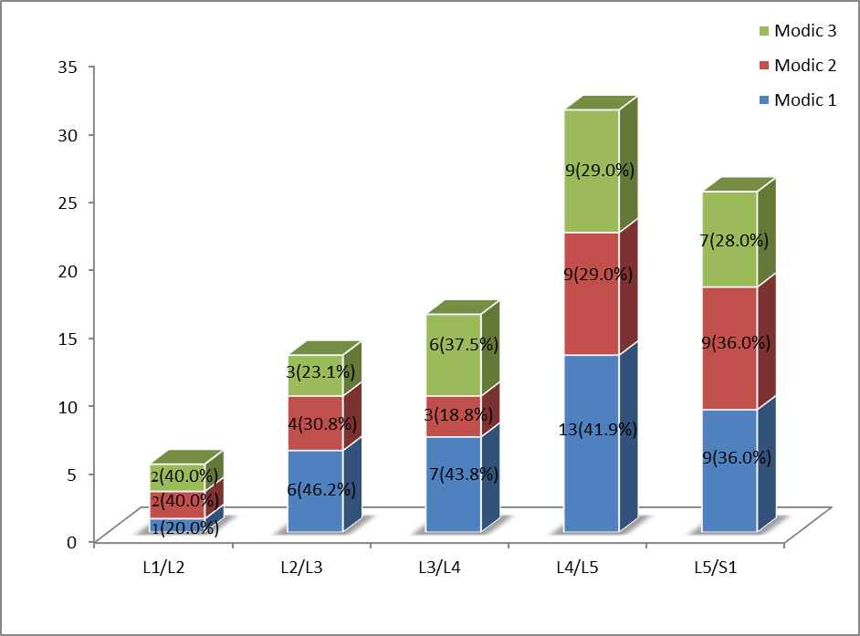

Fig. 1: The distribution of specific type of Modic changes by lumbar disc level.
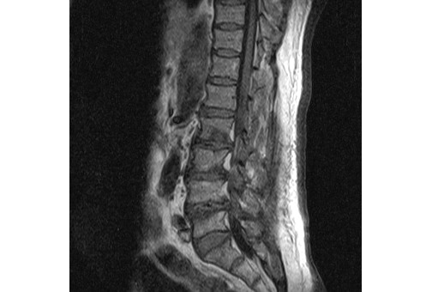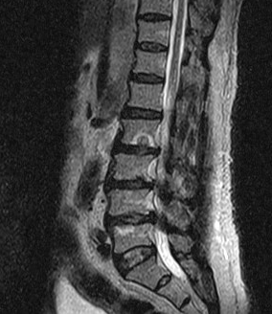
Fig. 2: T1W and T2W sagittal MRI images showing Modic type I( low signal intensity on T1W and high signal intensity on T2W) at the superior endplate of L5.Note also a schmorl node at the inferior endplate of L2 , with surrounding rim of modic 1 change.

