MINIMAL INVASIVE SURGICAL APPROACH IN THEMANAGEMENT OF COMMINUTED CROWN-ROOT FRACTURE– A CASE REPORT
APPROCHE CHIRURGICALE INVASIVE MINIMALE DANS LA GESTION DE LA FRACTURE DE LA COURONNE COURANTE - UN RAPPORT DE CAS

Yadav M¹, Kaushik M², Sharma R³, Chowdhry P⁴

¹Department of Conservative Dentistry and Endodontics, Army College of Dental Sciences, Jai Jawahar Nagar, Chennapur, Secunderabad, Telangana, India. E-mail:monayadav91@gmail.com
² Department of Conservative Dentistry and Endodontics, Army College of Dental Sciences
³Department of Conservative Dentistry and Endodontics, Army College of Dental Sciences
⁴Department of Conservative Dentistry and Endodontics, Army College of Dental Sciences
*Correspondence
No grant support
No conflict of interest

ABSTRACT

Comminuted root fractures have a questionable prognosis and present with limited treatment options. In the following case, a comminuted crown root fracture in relation to maxillary left central incisor was managed with a minimally invasive surgical approach. The procedure involved repairing the multiple fracture lines in the root with Biodentine following the endodontic therapy and root resection. The patient was found to be asymptomatic at the end of a follow up period of ten months.

Key words: CBCT, Comminuted root fracture, Trauma, Biodentine.

RESUME
Les fractures radiculaires comminutives ont un pronostic discutable et présentent des options de traitement limitées. Dans le cas suivant, une fracture de la couronne de racine comminutive par rapport à l'incisive centrale gauche maxillaire a été prise en charge par une approche chirurgicale minimalement invasive. La procédure consistait à réparer les lignes de fracture multiples dans la racine avec Bio-dentine après la thérapie endodontique et la résection radiculaire. Le malade s'est révélé asymptomatique à la fin d'une période de suivi de dix mois.
Mots clés: CBCT, Fracture radiculaire comminutive, Traumatisme, Bio-dentine.

INTRODUCTION
Traumatic injuries to a tooth are commonly encountered, among young adults. Clinical presentation of dental trauma can be varied, from a simple enamel infraction to complete ex-articulation or avulsion of a tooth. Root fracture can be defined as a fracture involving the cementum, dentin and pulp^{1.}Amongst the dental traumatic injuries in the permanent dentition, root fractures have an incidence of 0.5 to 7% and commonly occur in the age group of 11-20 years²⁻⁴. They occur mainly in the maxillary centrals (68%) and maxillary laterals (27%) due to frontal impact, a few 5% in mandibular incisors⁵. Depending on the number of fracture lines, it can be either single or multiple (comminuted).

Root fracture cases are of interest to clinicians and are also considered challenging, as their management may involve an interdisciplinary/multidisciplinary treatment approach. Initial management of a root fracture depends on position of the fracture line, length of the remaining root segment and the presence or absence of a coronal segment¹.

Several treatment modalities such as:
- Disinfection and obturation of the coronal segment only,
- Surgical removal of the apical segment,
- Removal of the coronal segment and orthodontic /surgical extrusion of the apical segment
- Stabilization of the coronal segment with endodontic implants, have been proposed for the management of root fractures⁶.
Crown root fractures involving the pulp are defined as complicated fractures. Based on the number of fracture lines, comminuted root fractures are ones having multiple fracture lines. These have serious complications with poor prognosis. Hence, in case of a confirmed diagnosis, treatment of comminuted root fractures is extraction⁷.The following case report describes the management of a comminuted root fracture in relation to maxillary left central incisor using a minimally invasive surgical approach. It involved resection of the fractured apical segment followed by retrograde root end filling and sealing of the remaining fracture lines using biodentine. To the best of authors’ knowledge we have not located reports on the management of a comminuted root fracture surgically using biodentine.

CASE REPORT
A 33-year-old male patient reported to the Department of Conservative Dentistry & Endodontics, Army College of Dental Sciences, Secunderabad, India with the chief complaint of pain in upper front tooth region of one-week duration.
The patient’s dental history disclosed that he had suffered a dental trauma due to accidental fall 6 months back, which resulted in broken crown with respect to upper left central incisor. The partially separated fractured crown fragments had been reattached to each other using a tooth colored filling material at a dental clinic 2 days post trauma. The patient remained asymptomatic for a period of about two weeks and so did not undergo any further treatment. He thereafter developed pain and mild intro-oral swelling in relation to the same tooth and this led to his consult at this institute. Medical and family histories were non-contributory.
Intraoral examination revealed a discolored crown with respect to 21 which was tender to percussion and showed Grade I mobility. Soft tissue evaluation showed a tender intraoral swelling with vestibular obliteration and a sinus opening with purulent discharge at the mid root region of tooth #21[Fig. 1]. Periodontal probing showed normal intact gingiva but the affected tooth showed no response to thermal and electric pulp tests. The adjacent teeth responded within normal limits to testing.
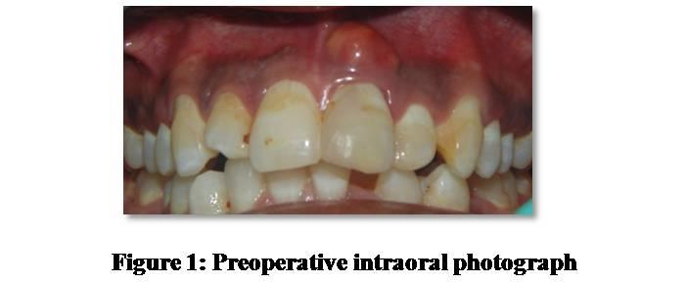
Radiographic examination revealed the fracture lines that extended subgingivally. A series of angled radiographs were taken which showed two oblique fracture lines, one from mesio-incisal part of crown extending subgingivally on the disto-cervical surface of the root while the second fracture line ran obliquely in the mid root region of tooth #21. A diagnostic radiograph was taken after inserting a gutta-percha cone (# 25; 2%, Dentsply, Tulsa Dental Specialties, United States) into the sinus tract to confirm its origin [Fig. 2].

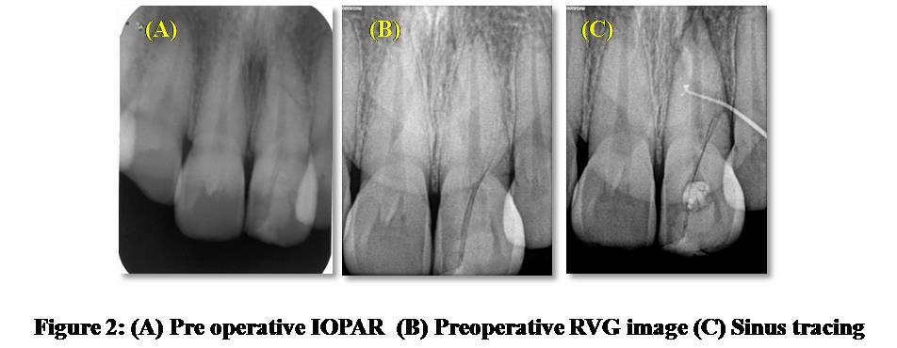

A CBCT scan [Fig. 3] revealed multiple fracture lines passing obliquely through the root with loss of labial cortical bone with respect to tooth #21. A diagnosis of complicated crown root fracture was made and both an immediate as well as definitive treatment plan was formulated. As the prognosis of this tooth was questionable, extraction followed by replacement of tooth was advised to the patient. However, the patient desired retention of his fractured tooth for as long as it remained functional. Hence, root canal therapy, followed by surgical repair of the fracture externally for tooth # 21was planned after obtaining a written informed consent.

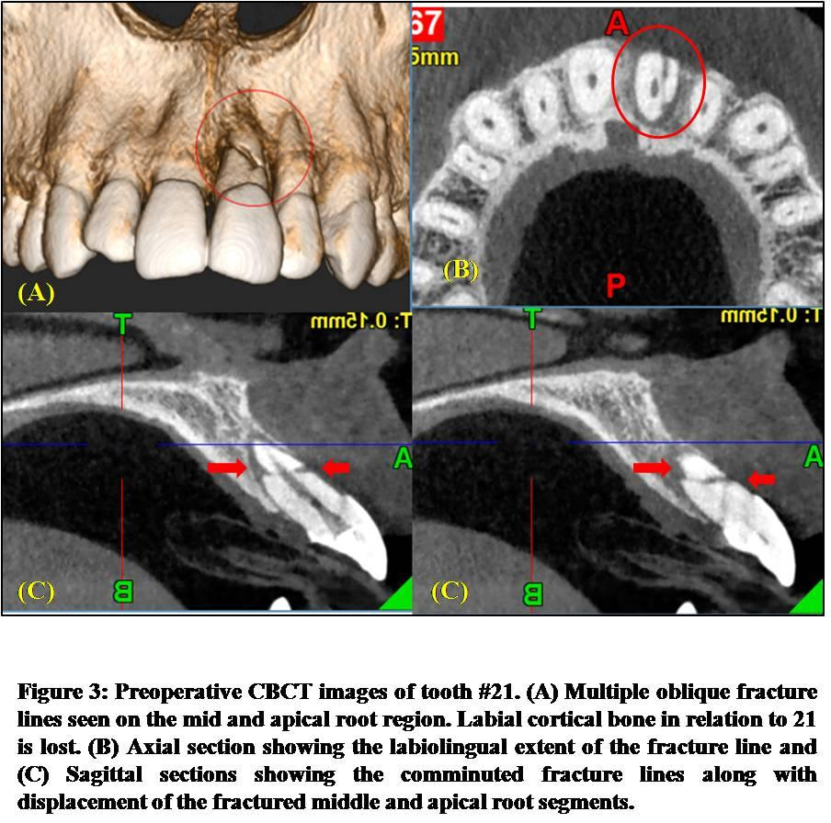

Immediate treatment: Root canal therapy
The goal of this phase was to provide immediate relief from pain and to reassure the patient. Access was gained to the root apex. The working length of the root canal [WL=27 mm] was determined radiographically through radiovisiography (RVG). Cleaning and shaping of the canal was performed using hand-held K files (MANI, INC. Utsunomiya, Tochigi, Japan) and Protaper Universal rotary files(Dentsply Tulsa Dental; Tulsa, Oklahoma) upto #25 (F2) tip size and 6% taper. The root canal was irrigated with 5.2% sodium hypochlorite and normal saline between each instrument change. The canal was finally flushed with normal saline and dried with absorbent paper points. An intracanal medicament comprising of a paste of calcium hydroxide powder mixed with saline (Deepashree products, Ratnagiri, India) was placed in the canal for 1 week.
After 1 week, the swelling subsided and the tooth was asymptomatic. Obturation was done using Gutta Percha (Dentsply, France, SAS) coated with MTA Fillapexsealer (Angelus, Londrina, Parana). Finally, the access cavity was sealed with glass ionomer cement (Ketac Molar Easymix, 3M ESPE AG, Seefeld, Germany) [Fig. 4 (A-C) show the working length, master cone and obturation radiographs, respectively].Written consent was obtained from the patient to use the radiographs in the present case report.

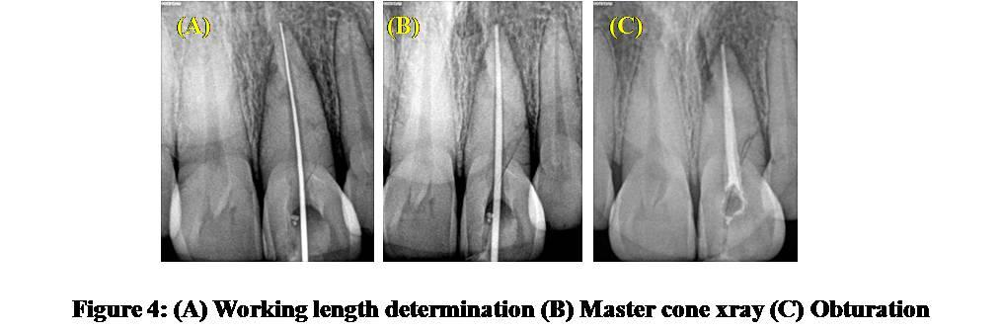

Definitive treatment: Surgery
After 1 week of the obturation, the definitive surgery was planned. The procedure was performed under local anesthesia with 2% lignocaine containing 1:80,000 adrenaline. A crevicular incision was from the mesial aspect of the maxillary right lateral incisor till the mesial aspect of the maxillary left canine. A mesial releasing incision extending into the vestibule was taken to raise a triangular flap. Sub-periosteal reflection was done. The apical 4mmof the root was resected to include the oblique apical fracture line. Retrograde cavity was prepared using micromotor handpiece and filled with biodentine (Septodont) as a retrograde restorative material.
The gaps between the fractures lines in the mid and cervical root region were gently curetted and irrigated with betadine. The fractured defects were sealed with Biodentine. To compensate for the loss of labial cortical plate over tooth #21, a thin layer of Biodentine was applied and stabilized by a platelet rich fibrin membrane (PRF) placed over it. The gingival flap was repositioned and sutured[Fig. 5].
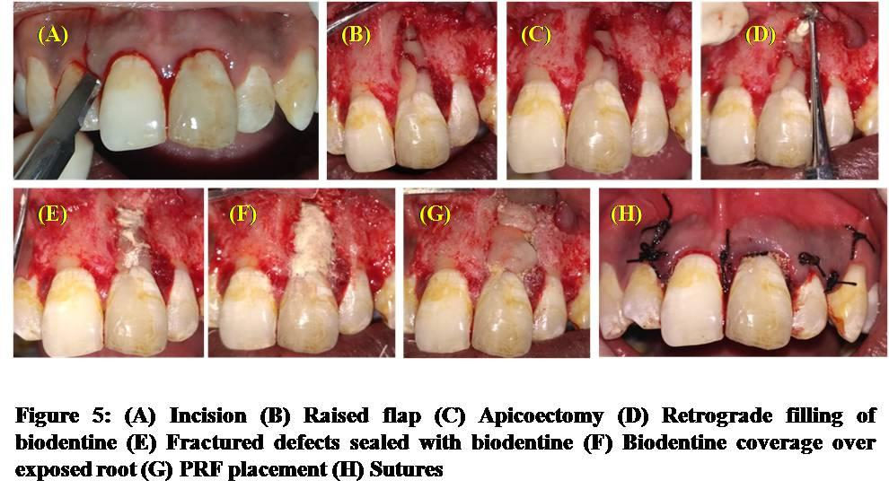

Post operatively the patient was placed on Novamox-CV625 mg b.d.s (CIPLA, India), Metrogyl 400mg t.d.s (JB CHEMICALS, India), Acecloren 400 mg t.d.s (Indoco REMEDIES LTD, India) for five days and 0.2%Hexidinemoutwash (ICPA, India) twice a day for 7 days. After 7 days, the patient was recalled for suture removal. Periodic evaluation was done after 2 months, 6 months and 10 months [Fig. 6]. Figure 7 shows the CBCT scan of the tooth #21 at the 10th month evaluation. Clinically the patient was asymptomatic. Radiographically, periapical healing was evident. Figure 8 shows the clinical comparison of the pre-operative and post- operative status of the patient.
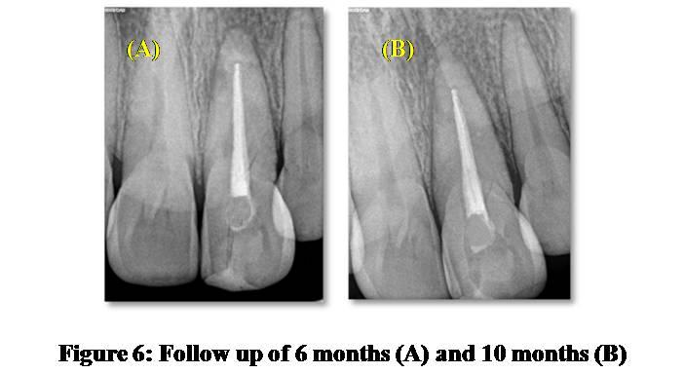
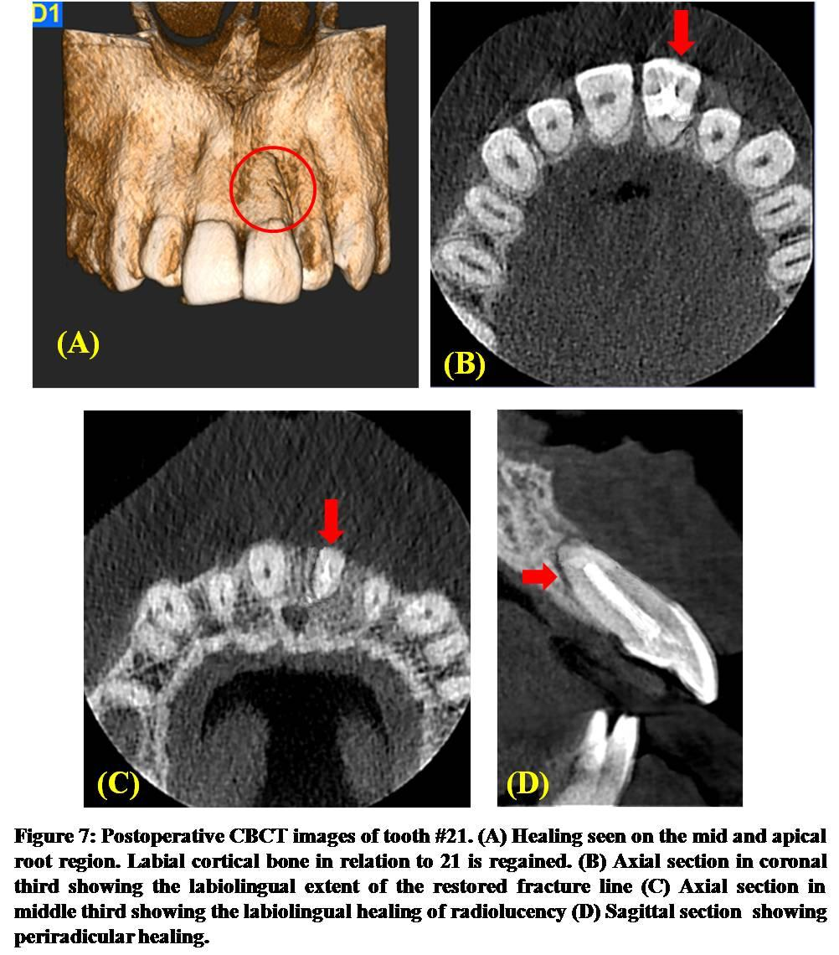

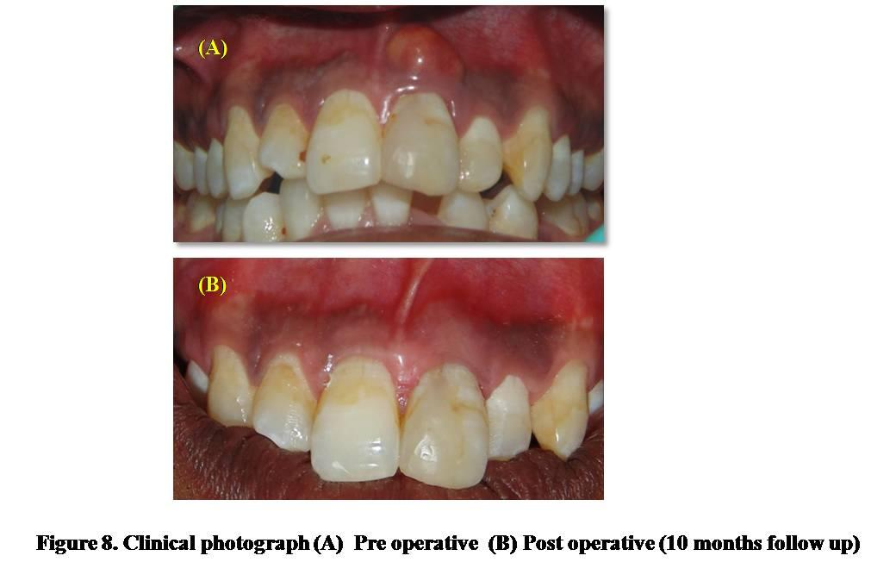

DISCUSSION
Management of complicated crown-root fractures remains a challenge. So far treatment options for comminuted root fractures were limited. It is a complication, which leads to extraction in nearly every case⁶. Hence, in the present case, extraction of tooth #21 and replacement by implant, fixed partial (FPD) or removable denture was discussed with the patient. However, all the suggested treatment options, for replacement of tooth #21were neither affordable (implant, FPD) for the patient nor favored because of aesthetic reasons. Thus, an alternative treatment plan to restore the functionality of the tooth for as long as possible was suggested to the patient who gave informed written consent.
Conventional dental radiography served as an aid in assessing the status of the pulp and periodontium but gave little or no information on the direction and extent of the fracture. Depending on the extension of the fracture line towards the root and its relationship with the periodontium (below alveolar crest) the treatment is going to vary. For example, if a fracture is limited to the crown surface, it can be restored, however, if it extends below the alveolar crest, the prognosis is generally poor. Making a proper treatment decision in such cases was a challenge for the endodontist as there were limited noninvasive tools to assess the length of the fractures below the soft tissues and alveolar crest.
Newer methods of analysis, such as Cone Beam Computed Tomography (CBCT), are currently being studied in order to help identify root fractures in a nondestructive fashion⁷ . The joint position statement by the American Association of Endodontists (AAE) and American Academy of Oral and Maxillofacial Radiology (AAOMR) regarding the use of CBCT in Endodontics states that “the patient’s history and clinical examination must justify the use of CBCT by demonstrating that the benefits to the patient outweigh the potential risks”⁸ .

In this case, we used the multi-slice view of CBCT to detect the fracture in various planes and to determine their apical extent and proximity to the pulp thereby predicting the prognosis. The volume of data acquired in a single scan not only allows visualizing a tooth from coronal, sagittal, or axial view, but also gave a provision to reslice the volume at any slice thickness. This volume of data could be manipulated repeatedly to gather large amount of information about the tooth and its periapical tissues.

In the present case report, the tooth #21 was obturated using MTA Fillapex sealer (Angelus, Londrina, Parana) as it is a mineral trioxide aggregate-based, salicylate resin root canal sealer which is designed to provide a high flow rate. It contains 13% MTAand salicylate resin for their biocompatibility and antimicrobial properties. It also showed calcium ion release, inducing rapid tissue regeneration in sites of bone lesion and microbial activity⁹.
In the present case, an apical root resection of 4mm was done to include the apical most fracture line from the apex in the resected segment of the tooth. The tooth had a working length of 27mm, and so, the crown- root ratio was maintained post apicoectomy. The prepared retrograde cavity was restored with biodentine while the remaining fracture lines on the mid and cervical root region were also sealed using the same material.
Biodentine, which is a bioactive cement mainly consisting of tri- and dicalcium-silicate, was used as the preferred choice of material in the current case, as it develops a hydroxyapatite-like surface in the presence of body fluids containing calcium or phosphate. This surface is biocompatible and displays good conditions for cell attachment and proliferation of the PDL⁸. A thin layer of biodentine was coated on the labial surface of the root of tooth #21, as it shows significantly higher levels of calcium and silicon ion release¹⁰⁻¹¹. The silicon in its composition played an important role in its bioactivity- It increased bone calcification^{12,13}stimulated bone growth¹⁴⁻¹⁶and has a positive effect on the mineralization of dentine^{17,18}.

Limitation: it is difficult to extrapolate the results of a single case with a follow up period of 10 months to a more general conclusion. Thus, more number of such cases should be monitored over a longer period to prescribe a general recommendation.
In conclusion, the management of the present case involved a novel approach of endodontic therapy, followed by surgical exposure of the site and filling the fracture gaps with biodentine as a treatment option for teeth with comminuted root fracture.

REFERENCES
- Andreasen FM, Andreasen JO, Cvek M. Root fractures. In: Textbook and Color Atlas of Traumatic Injuries to Teeth. Andreasen FM, Andreasen JO, eds. Copenhagen: Blackwell Publishing Ltd. 2007, pp 337– 371.

- Majorana A, Pasini S, Bardellini E, Keller E. Clinical and epidemiological study of traumatic root fractures. Dent Traumatol. 2002; 18:77– 80.

- Clark SJ, Eleazer P. Management of a horizontal root fracture after previous root canal therapy. Oral Surg Oral Med Oral Pathol Oral Radiol Endod. 2000; 89: 220-223.

- Yates JA. Root fractures in permanent teeth: a clinical review. Int Endod J. 1992; 25: 150-157.

- Çalişkan MK, Pehlivan Y. Prognosis of root-fractured permanent incisors. Endodontics and Dental Traumatology. 1996;12(3):129–136.

- Mora MA, Mol A, Tyndall DA, Rivera EM. In vitro assessment of local computed tomography for the detection of longitudinal tooth fractures. Oral Surgery, Oral Medicine, Oral Pathology, Oral Radiology and Endodontology. 2007;103(6): 825–829.

- Malhotra N, Kundabala M, Acharaya S. A review of root fractures: diagnosis, treatment and prognosis. Dent Update. 2011;38:615–628.8.

- AAE and AAOMR joint position statement. Use of cone-beam-computed tomography in endodontics. Pennsylvania Dental Journal. 2011;78(1):37–39
9. Vitti RP, Prati C, Silva EJ, Sinhoreti MA, Zanchi CH, de Souza E Silva MG, Ogliari FA, Piva E et al. Physical Properties of MTA Fillapex Sealer. J Endod 2013;39(7):915-918
- Van Lunduyt K, Taddei P, Modena E, van Meerbeek B, Prati C. Environmental scanning electron microscopy connected with energy dispersive X-ray analysis and Raman techniques to study ProRoot mineral trioxide aggregate and calcium silicate cements in wet conditions and in real time. J Endod. 2010; 36:851–857.

- Han L, Okiji T. Uptake of calcium and silicon released from calcium silicate-based endodontic materials into root canal dentine. IntEndod J. 2011; 44:1081–1087.

- Han L, Okiji T. Bioactivity evaluation of three calcium silicate-based endodontic materials. IntEndod J. 2013; 46:808–814.

- Carlisle EM. Silicon: a possible factor in bone calcification. Science. 1970; 167:279–280.

- Carlisle EM. Silicon as a trace nutrient. Sci Total Environ. 1988; 73:95–106.

- Patel N, Best SM, Bonfield W, Gibson IR, Hing KA, Damien E, Revell PA. A comparative study on the in vivo behavior of hydroxyapatite and silicon substituted hydroxyapatite granules. J Mater Sci Mater Med. 2002; 13:1199–1206.

- Porter AE, Best SM, Bonfield W. Ultrastructural comparison of hydroxyapatite and silicon-substituted hydroxyapatite for biomedical applications. J Biomed Mater Res A. 2004;68:133–141.

- Porter AE, Bothelo CM, Lopes MA, Santos JD, Best SM, Bonfield W. Ultrastructural comparison of dissolution and apatite precipitation on hydroxyapatite and silicon-substituted hydroxyapatite in vitro and in vivo. J Biomed Mater Res A. 2004; 69:670–679.

- Saito T, Toyooka H, Ito S, Crenshaw MA. In vitro study of remineralization of dentin: effects of ions on mineral induction by decalcified dentin matrix. Caries Res. 2003; 37:445–449.

INTRODUCTION
Des lésions traumatiques à une dent sont fréquemment rencontrées chez les jeunes adultes. La présentation clinique du traumatisme dentaire peut être variée, d'une simple infraction d'émail à l'ex-articulation complète ou à l'avulsion d'une dent. La fracture radiculaire peut être définie comme une fracture impliquant le cémenteux, la dentine et la pulpe¹. Parmi les lésions traumatiques dentaires de la denture permanente, les fractures radiculaires ont une incidence de 0,5 à 7% et surviennent généralement chez le groupe d’âge de 11-20 ans²⁻⁴. Ils surviennent principalement dans les maxillaires centraux (68%) et les maxillaires latéraux (27%) en cas d'impact frontal, quelques 5% dans les incisives mandibulaires⁵. Selon le nombre de lignes de fracture, il peut être unique ou multiple (fragmenté).
Les cas de fracture radiculaire intéressent les cliniciens et sont également considérés comme difficiles, car leur prise en charge peut impliquer une approche de traitement interdisciplinaire / multidisciplinaire. La prise en charge initiale d'une fracture radiculaire dépend de la position de la ligne de fracture, de la longueur du segment racinaire restant et de la présence ou de l'absence d'un segment coronal¹.
Plusieurs modalités de traitement telles que:
• Désinfection et obturation du segment coronal seulement,
• L'ablation chirurgicale du segment apical,
• Enlèvement du segment coronal et extrusion orthodontique/chirurgicale du segment apical,
• La stabilisation du segment coronal par des implants endodontiques a été proposée pour la prise en charge des fractures radiculaires⁶.
Les fractures de la racine de la couronne impliquant la pulpe sont définies comme des fractures compliquées. Selon le nombre de lignes de fracture, les fractures radiculaires comminutives sont celles qui ont plusieurs lignes de fracture. Ceux-ci ont des complications sérieuses avec un mauvais pronostic. Ainsi, en cas de diagnostic confirmé, le traitement des fractures radiculaires comminutives est une extraction. Le rapport de cas suivant décrit la prise en charge d'une fracture radiculaire comminutive par rapport à l'incisive centrale gauche maxillaire par voie chirurgicale minimalement invasive. Il s'agissait d'une résection du segment apical fracturé suivie d'un rem- plissage de l'extrémité radiculaire rétrograde et d'un scellement des lignes de fracture restantes à l'aide de la bio-dentine. À la connaissance des auteurs, nous n'avons pas trouvé de rapports sur la prise en charge chirurgicale d'une fracture radiculaire comminutive utilisant la bio-dentine.

RAPPORT DE CAS
Un homme de 33 ans s’est rendu au Département de la Dentisterie Conservatrice et d'endodontie du Collège Militaire des Sciences Dentaires de l'armée, à Secunderabad, en Inde, avec une plainte dont le principal problème est une douleur dans la région dentaire de la partie supérieure du front pendant une semaine.
Les antécédents dentaires du malade ont révélé qu'il avait subi un traumatisme dentaire en raison d'une chute accidentelle d’il y avait 6 mois déjà, ce qui a entraîné une fracture de la couronne par rapport à l'incisive centrale supérieure gauche. Les fragments de couronne fracturés partiellement séparés ont été rattachés l'un à l'autre à l'aide d'un matériau de remplissage de couleur dentaire dans une clinique dentaire deux jours après le traumatisme. Le malade est resté asymptomatique pendant une période d'environ deux semaines et n'a donc subi aucun autre traitement. Par la suite, il a développé une douleur et un léger gonflement intro-oral par rapport à la même dent, ce qui a conduit à sa consultation dans cet institut. Les antécédents médicaux et familiaux étaient non contributifs.
L'examen intra-buccal a révélé une couronne décolorée par rapport à 21 qui était sensible aux percussions et présentait une mobilité de grade I. L'évaluation des tissus mous a montré un gonflement tendre intra-buccal avec oblitération vestibulaire et une ouverture sinusale avec une décharge purulente au niveau de la racine médiane de la dent n ° 21 [Fig. 1]. Le sondage parodontal a montré une gencive normale intacte, mais la dent affectée n'a montré aucune réponse aux tests de pâte thermique et électrique. Les dents adjacentes ont répondu dans les limites normales aux tests.
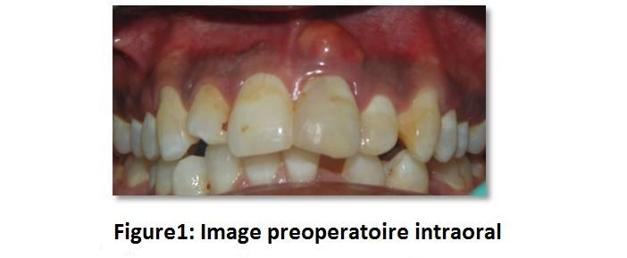
L'examen radiographique a révélé les lignes de fracture qui s'étendaient sous la gencive. Une série de radiographies inclinées ont montré deux lignes de fractures obliques, une de la partie mésio-incisale de la couronne s'étendant sous la gencive sur la surface disto-cervicale de la racine tandis que la seconde fracture était oblique dans la région médiane de la dent n ° 21. Une radiographie diagnostique a été prise après l'insertion d'un cône de gutta-percha (n ° 25, 2%, Dentsply, Tulsa Dental Specialties, États-Unis) dans le tractus sinusal pour confirmer son origine [Fig. 2].
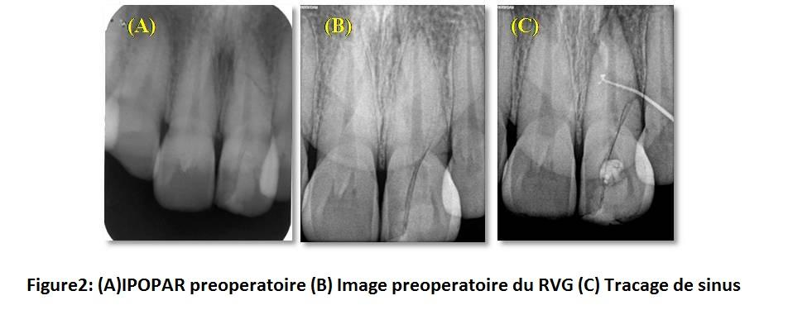
Un scannage CBCT [Fig. 3] a révélé de multiples lignes de fracture passant obliquement à travers la racine avec une perte d'os cortical labial par rapport à la dent # 21. Un diagnostic de fracture radiculaire compliquée a été posé et un plan de traitement immédiat et définitif a été formulé. Comme le pronostic de cette dent était discutable, l'extraction suivie du remplacement de la dent était conseillée au malade. Cependant, le malade a souhaité conserver sa dent fracturée aussi longtemps qu'elle resterait fonctionnelle. Par conséquent, une thérapie canalaire, suivie d'une réparation chirurgicale de la fracture externe pour la dent # 21, a été planifiée après l'obtention d'un consentement bien éclairé écrit.
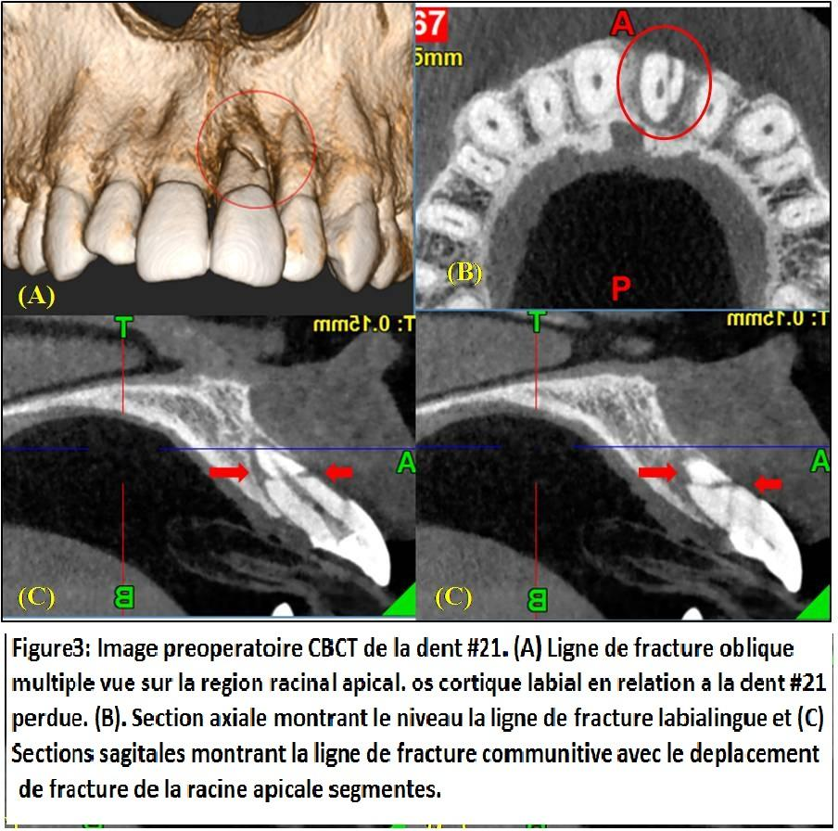
Traitement immédiat: traitement du canal radiculaire
Le but de cette phase était de soulager immédiatement la douleur et de rassurer le malade. L'accès a été gagné à l'apex de la racine. La longueur de travail du canal radiculaire [LT = 27 mm] a été déterminée radio-graphiquement par radio-visio-graphie (RVG). Le nettoyage et la mise en forme du canal ont été effectués à l'aide d’outils K portatifs (MANI, INC., Utsunomiya, Tochigi, Japon) et d’outils rotatifs Protaper Universal (Dentsply Tulsa Dental, Tulsa, Oklahoma) jusqu'à la pointe N ° 25 (F2) et taille tipe de 6% effiler. Le canal radiculaire a été irrigué avec de l'hypochlorite de sodium à 5,2% et du sérum physiologique normal entre chaque changement d'instrument. Le canal a finalement été rincé avec une solution saline normale et séché avec des pointes de papier absorbant. Un médicament intra-canalaire comprenant une pâte de poudre d'hydroxyde de calcium mélangée à une solution saline (produits Deepashree, Ratnagiri, Inde) a été placé dans le canal pendant 1 semaine.
Après 1 semaine, le gonflement a diminué et la dent était asymptomatique. L'obturation a été réalisée à l'aide de Gutta Percha (Dentsply, France, SAS) enduit de MTA Fillapexsealer (Angelus, Londrina, Parana). Finalement, la cavité d'accès a été scellée avec du ciment ionomère de verre (Ketac Molar Easymix, 3M ESPE AG, Seefeld, Allemagne) [Fig. 4 (A-C) montrent la longueur de travail, cône de maître et les radiographies d'obturation, respectivement]. Le consentement écrit d'utiliser les radiographies dans le présent rapport de cas a été obtenu du malade.
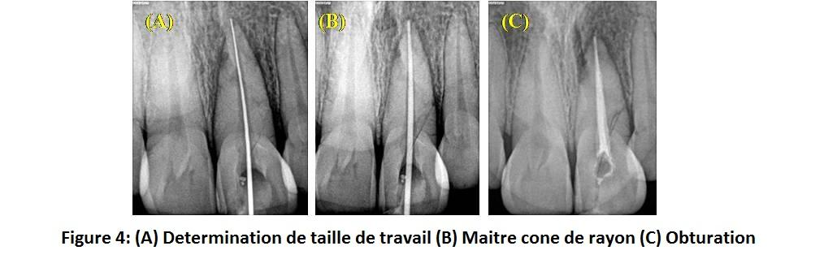
Traitement définitif: La chirurgie
Après 1 semaine de l'obturation, la chirurgie définitive a été planifiée. La procédure a été réalisée sous anesthésie locale avec de la lignocaïne à 2% contenant 1: 80 000 adrénaline. Une incision creviculaire était de la face mésiale de l'incisive latérale droite maxillaire jusqu'à l'aspect mésial de la canine maxillaire gauche. Une incision libératrice mésiale s'étendant dans le vestibule a été prise pour élever un volet triangulaire. Une réflexion sous-périostée a été faite. La racine de 4 mm de la racine a été réséquée pour inclure la ligne de fracture apicale oblique. La cavité rétrograde a été préparée en utilisant une pièce à main micromoteur et remplie de bio-dentine (Septodont) en tant que matériau de restauration rétrograde.
Les espaces entre les lignes de fractures dans la région des racines médiane et cervicale ont été doucement curetés et irrigués avec de la bétadine. Les défauts fracturés ont été scellés avec Bio-dentine. Pour compenser la perte de la plaque corticale labiale sur la dent n ° 21, une fine couche de Bio-dentine a été appliquée et stabilisée par une membrane de fibrine riche en plaquettes (PRF) placée au-dessus. Le lambeau gingival a été repositionné et suturé [Fig. 5].
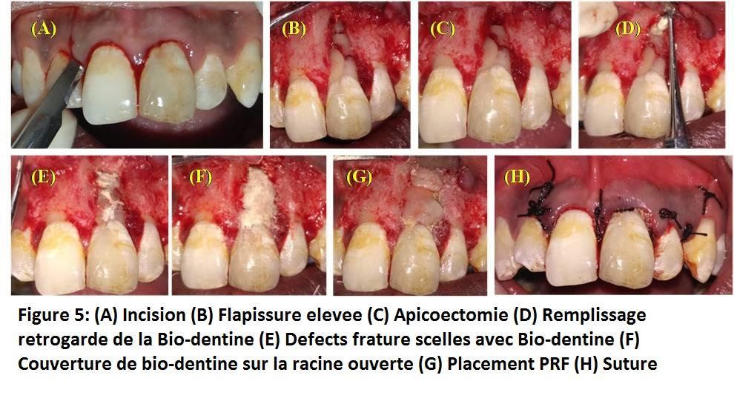
Après l'opération, le malade a été placé sur Novamox-CV625 mg bds (CIPLA, Inde), Metrogyl 400mg tds (JB CHEMICALS, Inde), Acecloren 400 mg tds (Indoco REMEDIES LTD, Inde) pendant cinq jours et 0,2% Hexidinemoutwash (ICPA, Inde ) deux fois par jour pendant 7 jours. Après 7 jours, le malade a été rappelé pour l'enlèvement de la suture. L'évaluation périodique a été faite après 2 mois, 6 mois et 10 mois [Fig. 6]. La figure 7 montre le scannage CBCT de la dent n° 21 lors de l'évaluation du 10ème mois. Cliniquement, le malade était asymptomatique. Radio-graphiquement, la guérison péri-apicale était évidente. La figure 8 montre la comparaison clinique de l'état préopératoire et postopératoire du malade.
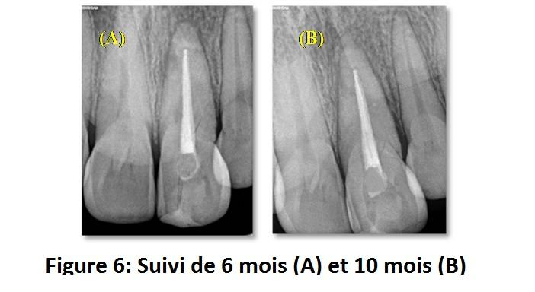
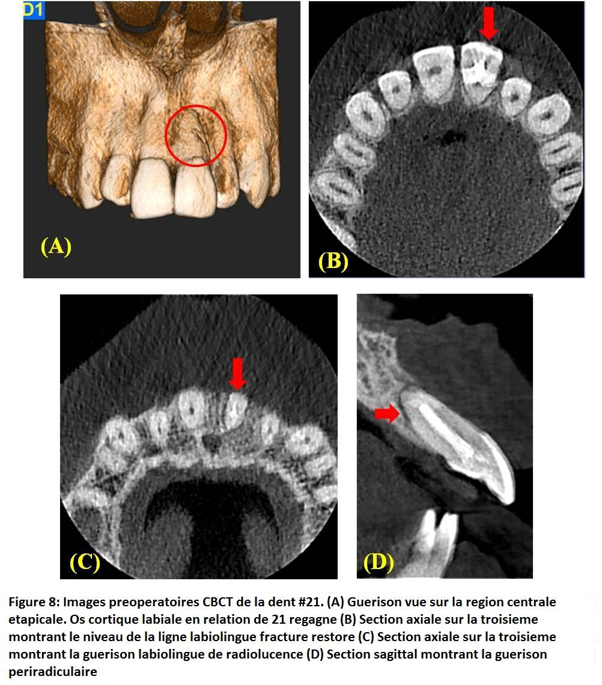
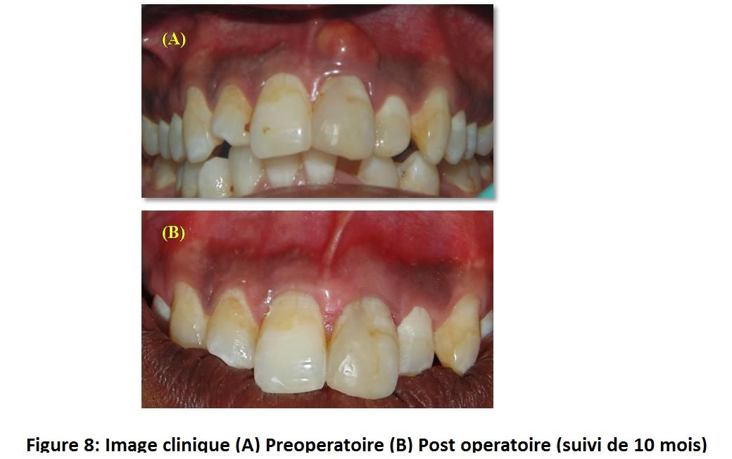
DISCUSSION
La prise en charge des fractures compliquées de la couronne et de la racine reste un défi. Jusqu'à présent, les options de traitement pour les fractures radiculaires comminutives étaient limitées. C'est une complication qui conduit à l'extraction dans presque tous les cas⁶. Par conséquent, dans le cas présent, l'extraction de la dent n° 21 et le remplacement par implant, par prothèse partielle fixe (FPD) ou par prothèse amovible ont été discutés avec le malade. Cependant, toutes les options de traitement suggérées, pour le remplacement de la dent n° 21, n'étaient ni abordables (implant, FPD) pour le malade, ni favorisées pour des raisons esthétiques. Ainsi, un plan de traitement alternatif pour restaurer la fonctionnalité de la dent aussi longtemps que possible a été suggéré au malade qui a donné un consentement écrit éclairé.
La radiographie dentaire conventionnelle a servi à évaluer l'état de la pulpe et du parodonte, mais n'a donné que peu ou pas d'information sur la direction et l'étendue de la fracture. Selon l'extension de la ligne de fracture vers la racine et sa relation avec le parodonte (sous la crête alvéolaire), le traitement va varier. Par exemple, si une fracture est limitée à la surface de la couronne, elle peut être rétablie, mais si elle se prolonge sous la crête alvéolaire, le pronostic est généralement mauvais. Prendre une décision de traitement appropriée dans de tels cas était un défi pour l'endodontiste car il y avait des outils non invasifs limités pour évaluer la longueur des fractures sous les tissus mous et la crête alvéolaire.
Des méthodes d'analyse plus récentes, telles que la tomographie par faisceau conique (CBCT), sont actuellement à l'étude afin d'aider à identifier les fractures radiculaires de manière non destructive⁷. La déclaration conjointe de l'American Association of Endodontists (AAE) et de l'American Academy of Oral et Maxillofacial Radiology (AAOMR) concernant l'utilisation de CBCT en endodontie stipule que «l'histoire du malade et l'examen clinique doivent justifier l'utilisation de CBCT en démontrant que les avantages pour le malade l'emportent sur les risques potentiels "⁸.
Dans ce cas, nous avons utilisé la vue en coupe multiple de CBCT pour détecter la fracture dans divers plans et pour déterminer leur étendue apicale et la proximité de la pulpe, prédisant ainsi le pronostic. Le volume de données acquises au cours d'un seul balayage permet non seulement de visualiser une dent à partir d'une vue coronale, sagittale ou axiale, mais également de prévoir de pondérer le volume à n'importe quelle épaisseur de coupe. Ce volume de données pourrait être manipulé à plusieurs reprises pour recueillir une grande quantité d'informations sur la dent et ses tissus péri-apicaux.
Dans le présent rapport de cas, la dent n° 21 a été obturée à l'aide d'un scellant MTA Fillapex (Angelus, Londrina, Parana) car il s'agit d'un scellant à base de résine salicylate à base d'agrégats minéraux et de tri salicylate. Il contient 13% de résine MTA et de salicylate pour leur biocompatibilité et leurs propriétés antimicrobiennes. Il a également montré une libération d'ions calcium, induisant une régénération tissulaire rapide dans les sites de lésion osseuse et l'activité microbienne⁹.
Dans le cas présent, une résection de la racine apicale de 4 mm a été faite pour inclure la ligne la plus apicale de la fracture de l'apex dans le segment réséqué de la dent. La dent avait une longueur de travail de 27 mm et, par conséquent, le rapport couronnes-racines était maintenu après l'apicectomie. La cavité rétrograde préparée a été restaurée avec la bio-dentine tandis que les lignes de fracture restantes sur la région des racines du milieu et cervicale ont été également scellées en utilisant le même matériau. La bio-dentine, qui est un ciment bioactif composé principalement de tri- et di-calcium-silicate, a été choisie comme matériau préféré dans le présent cas, car il développe une surface de type hydrox-apatite en présence de fluides corporels contenant du calcium ou du phosphate. Cette surface est biocompatible et présente de bonnes conditions pour l'attachement cellulaire et la prolifération du PDL⁸. Une fine couche de bio-dentine a été appliquée sur la surface labiale de la racine de la dent n° 21, car elle montre des niveaux significativement plus élevés de libération de calcium et d'ions de silicium¹⁰⁻¹¹. Le silicium dans sa composition a joué un rôle important dans sa bio-activité. Il a augmenté la calcification osseuse^{12,13} stimulé la croissance osseuse¹⁴⁻¹⁶ et a un effet positif sur la minéralisation de la dentine^{17,18}.
Limitation: il est difficile d'extrapoler les résultats d'un seul cas avec une période de suivi de 10 mois à une conclusion plus générale. Ainsi, un plus grand nombre de ces cas devrait être surveillé sur une plus longue période pour prescrire une recommandation générale.
En conclusion, la gestion de la présente affaire impliquait une nouvelle approche de la thérapie endodontique, suivie par une exposition chirurgicale du site et le remplissage des espaces de fracture avec de la bio-dentine comme option de traitement pour les dents avec une fracture radiculaire comminutive.
REFERENCES
1. Andreasen FM, Andreasen JO. Fractures de Cvek M. Root. Dans: Manuel et atlas des blessures traumatiques aux dents. Andreasen FM, Andreasen JO, éd. Copenhague: Blackwell Publishing Ltd. 2007, p. 337-371.
2. Majorana A, Pasini S, Bardellini E, Keller E. Étude clinique et épidémiologique des fractures radiculaires traumatiques. Dent Traumatol. 2002; 18: 77-80.
3. Clark SJ, Eleazer P. Prise en charge d'une fracture radiculaire horizontale après un traitement canalaire antérieur. Oral Surg Oral Med Oral Pathol Oral Radiol Endod. 2000; 89: 220-223.
4. Yates JA. Fractures radiculaires dans les dents permanentes: une revue clinique. Int Endod J. 1992; 25: 150-157.
5. Çalişkan MK, Pehlivan Y. Pronostic des incisives permanentes fracturées. Endodontie et traumatologie dentaire. 1996; 12 (3): 129-136.
6. Mora MA, Mol A, Tyndall DA, Rivera EM. Évaluation in vitro de la tomodensitométrie locale pour la détection des fractures longitudinales des dents. Chirurgie buccale, médecine buccale, pathologie buccale, radiologie buccale et endodontie. 2007; 103 (6): 825-829.
7. Malhotra N, M Kundabala, Acharaya S. Un examen des fractures radiculaires: le diagnostic, le traitement et le pronostic. Dent mise à jour. 2011; 38: 615-628.8.
8. Déclaration de position commune AAE et AAOMR. Utilisation de la tomographie à faisceau conique en endodontie. Pennsylvanie Dental Journal. 2011; 78 (1): 37-39.
9. Vitti RP, Prati C, Silva EJ, Sinhoreti MA, Zanchi CH, Souza E Silva MG, Ogliari FA, Piva E et al. Propriétés physiques du MTA Fillapex Sealer. J Endod 2013; 39 (7): 915-918.
10. Van Lunduyt K, Taddei P, Modène E, van Meerbeek B, Prati C. microscopie électronique à balayage d'environnement reliée à l'analyse de rayons X dispersive d'énergie et Raman pour étudier l'agrégat de trioxyde de dioxyde minéral ProRoot et les ciments de silicate de calcium dans des conditions humides et réelles temps. J Endod. 2010; 36: 851-857.
11. Han L, Okiji T. Absorption de calcium et de silicium libérés à partir de matériaux endodontiques à base de silicate de calcium dans la dentine canalaire. IntEndod J. 2011; 44: 1081-1087.
12. Han L, Okiji T. Évaluation de la bioactivité de trois matériaux endodontiques à base de silicate de calcium. IntEndod J. 2013; 46: 808-814.
13. Carlisle EM. Silicium: un facteur possible dans la calcification osseuse. Science. 1970; 167: 279-280.
14. Carlisle EM. Le silicium comme oligo-élément Sci Total Environ. 1988; 73: 95-106.
15. Patel N, Meilleur SM, Bonfield W, IR Gibson, Hing KA, Damien E, Revell PA. Une étude comparative sur le comportement in vivo de l'hydrox-apatite et des granules d'hydrox-apatite substitués au silicium. J Mater Sci Mater Med. 2002; 13: 1199-1206.
16. Porter AE, Meilleur SM, Bonfield W. Comparaison ultra-structurale de l'hydrox-apatite et de l'hydrox-apatite substituée au silicium pour des applications biomédicales. J Biomed Mater Res A. 2004; 68: 133-141.
17. Porter AE, Bothelo CM, Lopes MA, Santos JD, Best SM, Bonfield W. Comparaison ultra-structurale de la dissolution et de la précipitation d'apatite sur hydrox-apatite et hydrox-apatite substituée au silicium in vitro et in vivo. J Biomed Mater Res A. 2004; 69: 670-679.
18. Saito T, Toyooka H, ​​Ito S, Crenshaw MA. Etude in vitro de la reminéralisassions de la dentine: effets des ions sur l'induction minérale par la matrice dentinaire décalcifiée. Caries Res. 2003; 37: 445-449.

