MANAGEMENT OF PROSTATE CANCER IN ACCRA, GHANA
LA GESTION DE CANCER DE LA PROSTATE A ACCRA, AU GHANA
*Yeboah ED¹, Hsing AW^{2,4}, Mante S³, Mensah JE¹, Kyei MY¹, Yarney J¹, Vanderpuye V¹, Beecham K¹, Tettey Y¹, Biritwum RB¹, Adjei AA¹, Gyasi R¹, Asante K¹, Ampadu KN¹, Klufio GO¹, Gepi-Attee S¹, Owoo C¹, Kwami D¹, Ahiaku⁵, Pandra R⁶, Cook MB²,
¹University of Ghana Medical School(UGMS), Korle Bu Teaching Hospital(KBTH), Accra, Ghana now University of Ghana School of Medicine and Dentistry(UGSMD), Accra, Ghana. Email: kofiyebuk@gmail.com

- ²Division of Cancer Epidemiology and Genetics, National Cancer Institute(NCI),National Institute of Health(NIH), Bethesda, Maryland, USA.
- ³37 Military Hospital, Accra, Ghana
- ⁴Stanford University – Stanford Cancer Institute, CA, USA.
- ⁵Visiting Surgeon from UK
- ⁶Visiting Surgeon, Indian Forces Hospital.

*Correspondence

No conflict of interest.
SOURCES OF GRANT: The Ghana Study was part of Ghana Prostate Health Study (GPHS) and Case Expansion Studies 2002 – 2013 supported by National Cancer Institute/National Institute of Health (NCI/NIH) Bethesda, the University of Ghana School of Medicine and Dentistry, the Korle Bu Teaching Hospital and Government of Ghana through the Ministry of Health (MOH) Ghana.

ABSTRACT
Introduction: Africans living with prostate cancer in Africa face problems of early diagnosis and appropriate treatment.
Aim: To study the clinical incidence of prostate cancer, risk factors, TNM stage, their management and outcomes.
Methods: A prospective study of Prostate Cancer cases managed at Korle Bu Teaching Hospital and hospitals in Accra, diagnosed by history, abnormal PSA/DRE, physical examination and histologically confirmed by biopsy from 2004 to 2013 was carried out. The cases were TNM staged and managed by approved protocol.
Results: There were 669 cases with a mean age 70±0.045SE years, median Gleason Score of 7, organ confined Prostate Cancer(PC) in 415(62%), locally advanced in 167(25%) and metastatic Prostate Cancer in 87(13%) cases. The cases were followed for median of 10 months to ≥ 84 months. Organ confined cases were managed by: Radical Prostatectomy (RP) 92 (13.8%) with a mortality of 0.3%; brachytherapy 70 (10.5%) with a mortality of 0.1% and External Beam Radiotherapy (EBRT) 155 (23%) with a mortality 0.7%. In all, 98 men constituting (14.1%) cases with a mean age of 75+0.25SE years, life expectancy <10 years were treated by hormonal therapy with a mortality of 1.7%. Twenty cases who were for active surveillance (GS6), PSA <10ng/ml, life expectancy <10 years later all opted for EBRT. Locally advanced cases 25% all had neoadjuvant hormonal therapy then Brachytherapy in 3 (0.4%) mortality 0.15% and EBRT in 64 (9.5%), mortality 0.59%. Hormonal therapy was given in 100 (15%) locally advanced cases, mortality 5%. Metastatic prostate cancer cases (13%) were managed by hormonal therapy, mortality 6%.
Conclusions: Improved facilities and dedicated skilled teams led to a significant rise in proportion of organ confined Prostate Cancer from 15.3% to 62% curable by Radical Prostatectomy, brachytherapy or EBRT with longer disease free survival.

Key words: Prostate cancer, Gleason score, Stage, Management, Radical prostatectomy, Radiation therapy, Hormonal therapy.

ABSTRAIT
Introduction: Les africains vivant avec le cancer de la prostate en Afrique ont connu les problèmes de diagnostic précoce et le traitement approprié .
But : Pour étudier l’incidence de cancer de la prostate, des facteurs de risque , l'étape de TNM , la gestion et les résultats .
Méthode: Une étude prospective de gestion des cas de Cancer de la Prostate à l'hôpital d’enseignement de Korle Bu et hôpital à Accra, diagnostiqué par histoire , le PSA/DRE anormale, examen physique et histologiquement confirmé par biopsie de 2004 à 2013 a été réalisée. Ce sont les cas de TNM et la gestion approuvé par protocol.
Résultats: Il y avaient 669 cas avec la moyenne âge de 70±0.045SE ans , la médian de score Gleason de 7, organe confinée de cancer de la prostate (CP) en 415(62%), localement avancé en 167(25%) et le cancer de la prostrate métastatique en 87(13%) des cas. Les cas étaient suivi pour un médian pendant 10 mois ≥ 84 mois. Des cas des Organes confinée étaient gérée par : La Prostatectomie radicale (RP) 92 (13.8%) avec la mortalité de 0.3%;brachytherapie 70 (10.5%) avec une mortalité de 0.1% et la radiothérapie externe (EBRT) 155 (23%) avec une mortalité de 0.7%. En tous , 98 hommes qui constituent (14.1%) cas avec une moyenne de 75+0.25SE ans , durée de vie <10 ans étaient traité avec la thérapie hormonale de mortalité 1.7%. Vingt cas qui sont pour surveilance active (GS6), PSA <10ng/ml,durée de vie<10 ans plutard ont choisit EBRT.Des cas localement avancé sont 25% ils ont tous eu la thérapie hormonale neoadjuvant que la Brachytherapie en 3 (0.4%) mortalité 0.15% et EBRT en 64 (9.5%), mortalité 0.59%. Thérapie hormonale à été donné en 100 (15%)des cas localement avancé , mortalité 5%. Les cas de cancer de la prostate métastatique prostate (13%)était géré par la thérapie hormonal, mortalité 6%.
Conclusions: Des facilités amélioré et des équipes compétent et engager à mené à l’augmentation significative et proportion d’organ confinée .Le cancer prostate de 15.3% to 62% qui peut se guérit par la prostatectomie radicale, brachytherapie ou EBRT avec une période plus longue de survie .

Mots clés : Cancer de la prostrate, Gleason score, étape, Gestion, Prostatectomie radicale thérapie radicale, Thérapie hormonale .

INTRODUCTION

Prostate Cancer (PC) is the commonest Cancer in living men and has high incidence in the African Caribbean’s, African Americans, Caucasians but low in Asiatics and Chinese. PC prevalence in Africans and Ghanaians has been under reported. The worldwide incidence of PC is variable. It is the 15th commonest cancer constituting 11.7% and of new cases, 19% in developed countries and 5% in developing countries. It is next to Liver cancer in Western men^{1,2, 3,4,5,6,7,8,9}. In Africa, epidemiology studies have found low PSA testing, late presentation and low percentage of organ confined disease (T1 – T2) but high percentage of locally advanced 30% and metastatic PC in 55% of cases^{1,10,11} making disease control difficult. Recent reports indicate high prevalence in Caribbean’s and Ghanaians^{12,13}.
The risk factors reported for PC include familial, sporadic, presence of testis, ageing, ethnicity, race (highest African American > Caucasian American > Asian Americans), high activity of oncogenes, 5-DHT, 5 alpha reductase but decreased activity of anti-oncogenes. Others are hormonal imbalance, decreased cell death and genetics/GWAS have incriminated HPC1, HPC2, p53, 17q21, 8q24, BRAC1, BRAC2. Other risk factors are red meat and fatty diet, early sex activity, Viruses – HPV, HSV, chronic inflammation, prostatitis and high Basal Metabolic Index (BMI) ^{10,11,12 14,15,16,17,18,19.}
OBJECTIVES
The study was to identify and establish the clinical incidence of prostate cancer, risk factors, TNM stage, their management and outcomes.
ETHICAL APPROVAL: The project was approved by the IRBs, College of Health Sciences/NCI/Ministry of Health Ghana.
SPONSORSHIP: The study was sponsored by NCI/NIH, University of Ghana Medical School and Korle Bu Teaching Hospital.

PATIENTS & METHODS
A prospective study of cases of prostate cancer(PC) suspected by abnormal PSA (TPSA >4ng/ml, abnormal PSA velocity >0.75ng/ml year, PSAD >0.15ng/ml, short PSA doubling time) or abnormal DRE was carried out. Prostate Cancer was histologically confirmed by TRUS guided/trucut biopsy, digitally guided biopsy or with TURP/open simple prostatectomy specimens. Histological diagnosis was by pathologists at Korle Bu Teaching Hospital(KBTH), Accra, Ghana and some validated by John Hopkins pathologists in Baltimore, USA. The centers involved in this study were Korle Bu Teaching Hospital, 37 Military Hospital, Nyaho Medical Centre, SSNIT Hospital and Ridge Hospital, all in Accra.
The subjects underwent detailed history, physical examination including DRE, anthropometric measurements and PSA determination. Other investigations included IPSS, EFI, prostatitis index, screening for STD’s and genetic/genome wide studies. Informed consent was obtained from all the subjects.
The staging procedures included X-ray’s (Chest, KUB, Skeletal Survey), abdomino-pelvic ultra sonographic scan(USG), CT Scan/MRI and radioactive bone scan and staged by TNM staging. Fig 1
Only cases with histologically proven prostate cancer (PC) were included in the study and patients with inadequate data were excluded from the study.
MANAGEMENT PROTOCOLS (as in Table 1)
(A)ORGANNCONFINED 1. EARLY PC Life expectancy >15 years, 1. T1-T2 N0M0 GS≤7. - These were managed by (a) Radical Prostatectomy (RP) (b) Brachytherapy or (c) External Beam Radiotherapy (EBRT)
2. EARLY T1 – T2 G>7 was managed by neoadjuvant Androgen Deprivation Therapy(ADT) then RP, Brachytherapy or EBRT
(B)LOCALLY ADVANCED T3 T4 N0M0 GS ≤7 – Neoadjuvant hormonal therapy, brachytherapy, EBRT or hormonal therapy.
(C)METASTATIC disease treated by hormonal therapy.
(D)HORMONE REFRACTORY Cases managed by Stilboestrol, chemotherapy e.g. Ketoconazole.
(E)ACTIVE SURVEILLANCE for organ confined PSA < 10ng/ml T1-T2 N0M0 GS6 (no G4 or 5) Life expectancy <10 years.

Post Treatment Follow up
Post RP or radiation therapy we follow patients every 3 months for 1 year, then every 12 months. DRE, TPSA PSDT, PSA Velocity and PSA doubling time are estimated at the follow-up visits. If changes suggest biochemical failure, then salvage post-surgery radiotherapy is given or hormonal treatment if post RP radiotherapy rejected or contraindicated.
For patients on active surveillance, the follow up protocol was every 3 months for 1 year then every 6 months. At each visit, DRE, TPSA, PSA Velocity, PSA doubling time are performed and if any indicate progression then we treat by RP or radiotherapy with or without hormonal therapy
- PATIENTS WITH BONY METASTASES – Symptomatic patients were given bisphosphonates orally or infusions for 1 year. Hormone therapy was given to metastatic cases who were not castrated (confirmed by serum testosterone levels) but EBRT 8GY – 30GY was given to relieve spinal cord compression, relief of pain and obstructive symptoms. Bone metastases with hypocalcemia was managed by infusions of Zolendronic acid.
- PATIENTS WITH IMMINENT CORD COMPRESSION – these were treated by a course of dexamethasone + Bilateral Total Orchiectomy (BTO) or hormonal therapy (Stilbestrol, ADT Ketoconazole).
- HORMONE REFRACTORY CASES(HRPC)/CASTRATE RESISTANT (CRPC)
These cases were given palliative hormonal chemotherapy: - Stilbestrol or ketoconazole or docetaxel 75mg/m² given 3 weekly with prednisolone or abiraterone. A few cases were given oral cyclophosphamide plus prednisone. These were guided by affordability issues.
- PATIENTS WITH COMORBIDITIES such as obesity, diabetes mellitus (DM), congestive cardiac failure (CCF), severe hypertension (HPTN), Ischaemic heart disease (IHD), chronic kidney disease (CKD), chronic liver failure (CLF), chronic anemia and elderly had their conditions managed by conventional methods to prevent untoward morbidity or mortality influenced by affordability issues.
- PATIENTS WITH URINARY OBSTRUCTIVE SYMPTOMS– Those with moderate to severe symptoms (cases with IPSS ≥ 8, QOL ≥ 3) high Post Void Residua(PVR)l urine and decreased Peak Flow Rate(PFR) were given alpha adrenergic blockers ± finasteride. Cases with severe bleeding, severe symptoms, refractory recurrent retention, calculi, diverticuli are treated by TUIP/ TURP, bladder neck resection or radical prostatectomy if localized T₁– T₂ N0M0 disease

The data obtained including demographic, clinical features, relevant investigations, management offered and outcome were analyzed using Statistical Package for Social Science (SPSS) version 20.
Data results were expressed as percentages and means ± standard deviations. A p-value of less than 0.05 was considered significant.

RESULTS
A total of 697 cases were recruited out of which 669(96%) had completed medical records abstractions with adequate data. The remaining 22 without adequate data were excluded from the study. The median age was 70±0.48SE years with a range of 41 – 94 years (Fig 2a) while the median PSA was 52.5ng/ml with a range of 2.5 – 9,900ng/ml (Fig 2b).
Hospital logbooks cases were obtained from Korle Bu Teaching Hospital (KBTH) in 401 (60%) cases, 37 Military in 54 (8%) cases, Nyaho Medical Center in 210 (31%), 4 (0.6%) from SSNIT and Ridge hospitals in Accra, Ghana. Their ethnicity are as follows: Akan 320 (48%), Ga- Adangbe 160 (24%), Ewes 80 (12%), Northern 34 (5%), non-Ghanaian 4, not stated 71 (10.6%); their social status include: retired 46.1%, middle income 20.5%, high income 11.4%, low income 9%, while Christians made up 54%, moslem 7%, other 39%. Biopsy types included TRUS-guided biopsies in 63.5%, digitally guided biopsies in 21.7% (Fig 2c)

Stages and Gleason scores(GS) (Fig 2d)
The 669 cases were staged thus: localized disease T1 – T2 N0 M0 in 415 (62%) cases, locally advanced disease T3-T4 N0M0 in 167(25%), metastatic disease in 87 (13%) cases while the Gleason Scores(GS)-High risk GS ≥7 was 67.7% whereas low and intermediate risk GS ≤ 6 was 32.3% (Table 3)

1. ORGAN CONFINED (LOCALISED) T1-2 N0M0 415 (62%), Median GS <7, presentation PSA ≥ 4ng/ml 95.6%, PSA ≤ 4, 4.4%, LUTS (LUTO/IRRITATIVE) 25%, retention of urine (ROU) 10%, medical management of obstructive symptoms with alpha blocker ± finasteride in 23%. The co-morbidities were hypertension (HPTN) 21%, diabetes mellitus (DM) 4%, HPTN & DM 3.3%, anemia with Hb <12gm/dl in 3.3% and renal impairment with creatinine >120umol/L in 10% cases.

Management PC n = 415 (62%)
(a)Radical Prostatectomy (RP) - localized disease T1 – T2 M0 number was 92/669 (13.8%) Fig 3
mean age 61.8 years ± 0.88SE with a range of 51 – 72 years. Radical (Open) Prostatectomy cases 85 (12.7%), radical retropubic open prostatectomy 81 (12%), perineal radical prostatectomy 4 (0.6%), laparoscopic RP 7 (1%). Mean pre-operative PSA 17.9 ng/ml ± 2.58SE (range 4 – 100ng/ml) versus mean post-operative PSA 0.43 ± 0.26SE (range 0.01 – 12ng/ml) p< 0.0001 in 12.8%, median GS ≤ 7, median follow up 10 months (range 10 months – 84 months+), lost to follow up 6 (0.9%).
RP specimen organ confined disease was 76 (11.4%), BPH 3 (0.4%) and positive margins 13 (2%). Cases with positive margins were treated by hormones/EBRT. Biochemical failure(BF) were 18(2.7%) and were treated by EBRT + Androgen Deprivation Therapy (ADT)
Post-operative complications were erectile dysfunction (EDYS) 10 (1.5%), bladder neck stenosis 10 (1.5%), overactive bladder (OAB) 6 (0.9%), UTI 12 (1.8%), and deaths 2 (0.3%) from pulmonary embolism/myocardial infarction (PE/MI). Deep vein thrombosis (DVT) 5 (0.7%) treated by anticoagulants, urinary Incontinence temporary 6 (0.7%) treated by oxybutynin, detrusitol and pelvic exercises.

(b) Brachytherapy for n = 70 (10.5%). I¹²⁵ seeds deliver dose 160GY. Mean age 60.8 ± 0.587SE (Range 51 – 76 years) Table 4, Fig 4. Lost to follow up 9 (1.3%), and one death 1/669 (0.1%). Pre-treatment versus post-treatment PSA n = 61 (9.1%) PSA 13.34ng/ml ± 0.08SE versus mean post PSA 0.166ng/ml ± 0.03SE p<0.0001 . Mean pre-treatment PSA Stage T₁ (n = 20) 13.32ng/ml ± 0.24SE versus post mean PSA 0.134ng/ml ±0.06 SE p<0.0001. Mean pre-treatment PSA T2 (n41) 13.38ng/ml ± 0.34SE versus post 0.234ng/ml ± SE 0.05 p<0.0001 in 9.1%. Fig. 4.
Follow up median 12 months (10 – 72 months), 9 (1.3%) defaulted, complications were, BF 3 (0.4%) with PSA 6.41, 20 and 40ng/ml, median time to failure 23 months. Treatment of BF was by hormone therapy Zoladex/BTO + EBRT 40 – 50GY. Radiation cystitis 6 (0.9%) treated by tranexamic acid, tamsulosin oxybutynin/ detrusitol, prednisolone Ciprofloxacin, EDYS 6 (0.9%), treated with Tardanafil/sildenifil citrate, DVT 1 (0.1%) treated by anticoagulants, death 1 (0.1%) from PE.

(c)EBRT for n= 155(23%). Table 5, 6 Fig 5
Cobalt 60, 70 – 74GY 2D/3D, 20 of 155 were on surveillance and recruited later, mean age 61.75 ± 0.2462SE. Outcomes mean pre-treatment PSA (n = 137) PSA 16.513 ±0.80SE versus post treatment PSA 0.33 ± 0.11 p<0.0001. T₁ cases mean pre-treatment versus post-treatment PSA 13.35ng/ml ± 0.86SE versus 0.232ng/ml ± 0.011SE p< 0.0001 and for T₂ pre-treatment 17.2ng/ml ± 0.95SE versus post 0.35ng/ml ± 0.013SE and p<0.0001 in 52/669 (7.7%)
Median follow up 10 months (7 months – 8⁺ years), lost to follow up 18 (2.7%), BF 18 (2.7%), 3% treated by hormone/chemotherapy, mortality 5 (0.7%) (3 from massive haematuria, radiation cystitis, 2 – DVT and PE)

(d)LOCALISED DISEASE WITH PROGRESSION AND HAD HORMONAL THERAPY n=98 (14.6%) (T1-T2 N0M0)
High risk G ≥7, mean age 75 ± 0.25SE (Range 68 – 94yrs) of these 6 (0.1%) have had simple prostatectomy for BPH. Comobidities included HPTN 4.2%, Ischaemic heart disease (IHD)1.6%, DM 3.7%, Obesity 2.2%, CCF 1.5%. Methods LHRH analogue/ chemotherapy 30 + 18*(4.5% + 2.7%), Stilboestrol 2.5mg + aspirin 30 (4.5%), BTO 20 (3%) ± bicalutamide/ flutamide. BF noncompliant with LHRH agonists 18* were treated by BTO 18 (2.7%) (Total BTO 38 5.7%), T₁ 24 (3.6%), T₂ 74 (11%). Mean pretreatment PSA 24ng/ml ±0.84SE (range 3.8 – 90.8ng/ml) versus post mean treatment nadir PSA 0.34ng/ml ± 0.01SE (range 0.2ng/ml – 50ng/ml) p< 0.002. in 66/669(9.8%). Median follow up 10 months (range 12 months – 7 years), mortality 9 (1.3%), CVA 2 (0.3%), DVT and PE 1 (0.5%), castrate resistance PC (CRPC) 6 (0.9%), Lost to follow up T₁ 18 (2.7%), T₂ 14 (2.1%).

2.LOCALLY ADVANCED T₃₋₄ M0 N0 DISEASE n=167(25%) (T₃ 100, T₄ 67)
Mean age 70± 0.535SE, Median GS > 7, mean pre-treatment PSA 48.5ng/ml ± 0.96SE (range 7.1 – 2793ng/ml) versus post-treatment mean PSA 0.6ng/ml ± 0.34SE (range 0.2 – 50ng/ml). Of these 4 (0.6%) had had previous simple prostatectomy for BPH.
Presentation – LUTS/LUTO 40 (6%), acute retention of urine (AROU) 7 (9%), chronic retention of urine (CROU) 3 (0.4%), obstructive uraemia 4 (0.6%), hematuria 10 (1.5%), EDYS 5 (7.5%), Pain back/perineal/supra- pubic 17 (2.5%).
Management – Neoadjuvant hormonal ± TAB LHRH analogue 87 (13%) ± TAB /Stilboestrol 20 (3%) ± TAB BTO 60 (9%) followed by (a)brachytherapy 3 (0.4%), (b) EBRT 64 (9.6%)
a) Locally Advanced Management treated by Brachytherapy
T₃ 3 (0.4%), pre-treatment median PSA was 14.3ng/ml (range 9.4 – 17.3ng/ml) and post treatment median PSA was 0.11ng/ml (range 0.11 – 0.12ng/ml). Complications were 1 death 0.15% from progression of disease (Fig 6a).

b) Locally Advanced treated by EBRT (Fig 6b).
n = 64 (9.5%), Lost to follow up 7 (1%), pre-treatment mean PSA T₃ 57 (8.5%) 32.4ng/ml ± 0.85SE, T₄ 7 median PSA 64.6ng/ml versus post-treatment mean PSA T₃ 0.4ng/ml ± 0.12SE p< 0.0001, post T₄ median PSA 0.45ng/ml (Fig 6b). Lost to follow up 7. Complications were 21 (3%): - BF 5 (0.7%) (T₃ 1 T₄ 4), radiation cystitis 7 (1%), proctocolitis 4 (0.6%), rectal bleeding 5 (0.7%), Deaths 4 hematuria- 1 (0.15%), disease progression 3 0.4%.

(c)Locally Advanced PC managed by hormonal therapy
Number of cases were 100 (15%), of these 4 (0.6%) had had previous simple prostatectomy for BPH, T₃ 40 (5.9%), T₄ 60 (9%). Mean pre-treatment PSA was T₃ (40) 34.1ng/ml ± 0.78 and T₄ 60 pre-treatment mean PSA 41.05 ng/ml ± 0.81SE versus mean post treatment PSA T3 was 0.4ng/ml ± 0.11SE p< 0.002 and T4 0.48ng/ml ± 0.11SE p< 0.002 in 13%
Management Methods were LHRH ± TAB (ADT bicalutamide /flutamide) 47 – 7%, Stilboestrol ± aspirin 6 – 0.8% and BTO 47 – 7%. 50 (7.5%) of cases with LUTO/LUTS AROU/CROU were treated by alpha blockers ± finasteride 43 – 5%, TUIP/TURP Bladder neck resection 17 – 2.5%. Complications were HRPC/CRPC 31 – 4.6%, hot flashes 36 – 5%, EDYS 98 – 15%. The median follow up was 12 months (rang 1 year – 7 years), lost to follow up 9 – 1.34% (T₃ 3 and T₄ 6), hospital mortality 34 – 5% due to urosepsis 16 – 2.4%, bedsores and sepsis 5 – 0.7%, PE 3 – 0.4%, obstructive uraemia 6 – 0.9%, and anemia from hematuria 4 – 0.6%.

(3) Metastatic Disease
T₁₋₄ N₁₋₃ M1 n 87 13%, mean age 70 ± 0.587SE, median GS ≤7 (r4 – 10), mean pre-treatment PSA 98ng/ml ± 1.344 (r7 – 9,900ng/ml), mean post-treatment PSA 0.46ng/ml ± 0.138 (r0.04 – 86ng/ml). Presentation: LUTS/LUTO 31 – 4.6%, AROU 8 – 1%, uremia CROU 5 – 0.7%, metastatic – skeletal: pelvis 40 – 6%, spine 8 – 1%, pelvis/spine 15 – 2.2%, pelvic/groin lymph nodes (PLN) positive 15 – 2.2%, hematuria 9 – 1.3%, paraplegia 9 –1.3%, pulmonary secondary’s 4 – 0.6%, cerebral secondary’s 3 – 0.4%, lymphedema penis & scrotum 3 – 0.4%, lymphedema legs 4 – 0.6%, pain skeletal /waist 58 – 8.6%, anemia 18 – 2.7%, headaches 3 – 0.4%. Treatment was by hormonal/ chemotherapy and conventional methods for complications.
Management AROU/CROU – Catherization, α-blockers ± finasteride 13 (1.9%), TURP 8 (1.2%), LHRH analogue ± TAB 20 (3%), Stilboestrol TAB 15 (2.2%), BTO 52 (7.8%).
Complications Hot flashes 26 (3.9%), EBRT used for localized vertebra bone secondaries to relieve compression in 6 cases 0.9%, BF 30 – 4.4% managed as HRPC/CRPC - 4.5% by stilboestrol, ketoconazole/prednisolone, docetaxel, cyclophosphamide and prednisolone. Hospital mortality 40 – 6%, urosepsis 14 – 2%, obstructive uropathy/uremia 10 – 1.5%, anemia hematuria 6 – 0.9%, bedsores sepsis 5 – 0.7%, DVT PE 5 – 0.7%, Lost to follow up 8 – 1.2%.

SUMMARY OF FINDINGS Table 6
Summary of Management of 669 cases
- Stages at Presentation. Stages found were T1 T2 M0 -62%, T3T4 M0 -25%, metastatic PC-13%.
- Risk Factors established in our Study are males with testes, advanced age and high BMI. Genome wide studies have shown chromosome 10p14 associated with PC in Ghana, aggressive PC GS ≥7 (67.7%) high PSA >52ng/ml associated with SNPS 5q31.3 and low grade GS ≤6 (32.3%) PSA <52ng/ml associated with SNPs Xq28 & 6q21. These findings have been published elsewhere and will be discussed.
- The comorbidities were hypertension (HPTN) 25%, DM 5.4%, HPTN/DM 5.1%, anemia 3.3%, CKD 11.1%. Lost to follow up 71 (10.6%) Table 6.
- Initially, there were significant falls in PSA in most groups in the immediate post treatment period.
- Management of PC in Ghana has improved since 2004 from study of 669 cases with long disease free survival with improved urological practices with 62% presenting as organ confined allowing curative treatment such as: radical prostatectomy 92 (14%), mortality 2 (0.3%), brachytherapy 73 (11%), mortality 2 (0.3%), EBRT 155 T₁-T₂, (23%), mortality 5 (0.7%), Active surveillance (3%) 20 cases (T₁ 8 & T₂ 12), later opted for EBRT, so analyzed with EBRT.

The locally advanced 167, (25%) cases were managed by neoadjuvant hormonal/chemotherapy followed by EBRT and brachytherapy 67 (10%), hormonal chemotherapy 100 (15%). The metastatic cases 13% were managed by hormonal ± chemotherapy. Hormonal therapy long/short term for localized disease (98) and locally advanced (167) and metastatic disease (87) that is in 52.6% cases using LHRH analogues BTO, stilboestrol + aspirin ± TAB.

DISCUSSION
More and more of prostate cancers (PC) in the Western hemisphere are diagnosed at an earlier stage because of rising numbers of PSA testing. Cooperberg¹⁴ showed proportion of low risk tumor rose from 29.8% in 1989 to 45.3% in 2001 and the proportion of locally advanced disease fell from 19.2% to 4.4% and the metastatic cases declined from 14.1% to 3.3% in USA. Reports from USA and Jamaica indicate that late stage of presentation is associated with low income Whites, African Americans and Jamaicans³.
This trend has also been observed in communities with PSA screening which caused stage down migration of radical prostatectomy specimens. ^{14, 15} Our study has shown stage down migration T₁ – T₂ 62%, locally advanced 25%, metastatic 13% versus T₁ – T₂ 15.35%, locally advanced 32.3%, metastatic 52.5% in our retrospective study¹³ statistically significant p<0.0001. In our population study T₁-T₂ 82%, locally advanced 12% and metastatic 6%. This is in line with Western trends.

T1 – 2 N0M0 ORGAN CONFINED 415 (62%)
- RADICAL PROSTATECTOMY n 92 (13.8%) (Fig 3, Table 6)
Our survival of 98% for RP is comparable to results from other centers ^{20,21,22,23,24,25,26.} There were initial significant falls in pre-versus post-operative PSA p<000.1 in 86/92(93.4%). We have had limited experience with laparoscopic RP 7 (1%) cases which is purported to have low incidence of mortality, erectile dysfunction or complications^{27,28} but no experience with robotic RP which is reported to give better results with morbidity and mortality than open and laparoscopic RP^{27,28}. Unlike Weldon, Isenlin, Ruenes and Gueye who have done several cases of radical perineal prostatectomy^{23,29,30}, we have had only 4 (0.6%) cases of perineal RP which did well. Kyei has reported his experiences with RP at KBTH in Accra which did well²². The biochemical failure of 13 (2%) in 92 cases were due to positive margins and were managed successfully by EBRT /hormonal therapy ^{31,32.}
- BRACHYTHERAPY FOR ORGAN CONFINED PC (T₁ – T₂ N0M0) n = 70 (Table 4, Fig 4, Table 6)
The therapeutic value of brachytherapy is generally comparable to RP ^{33,34,35}. Brachytherapy has good outcomes with 8year PSA relapse free survival of low risk PC 88%, intermediate risk PC 81% and the initial high risk PC 65%. Randomized control study has established that RP and brachytherapy have comparable 5-year biochemical recurrence rates but brachytherapy has favorable side effect profile of potency than radical prostatectomy^{33,34,36.} Our study has confirmed these observations as 70 (10.5%) of our patients who had brachytherapy with a median follow up of 12 months (range 10 – 84 months) had significantly low PSA nadir values recorded in post treatment PSA with only 0.4% BF which responded to hormonal therapy and one (0.1%) death from PE as a result of DVT.

- EBRT FOR EARLY DISEASE T₁₋₂ N0M0 n 155(23.1%) (Table 5, 6, Fig 5)
Current literature supports the role of EBRT in management of localized PC as comparable to RP even though it has been claimed that surgery offered better results than EBRT^{21,22,33,37,38,39.} Our results have been encouraging since large numbers of cases 155 (23.1%) were treated in one center; the national radiotherapy center (NRC) KBTH compared to 92 (13.8%) RP at KBTH and 37 Military Hospital. There were significant falls in post treatment PSA. The national radiotherapy center (NRC) at KBTH is capable of offering services to patients from all parts of Ghana. There is another radiotherapy center at Komfo Anokye Teaching Hospital but they have not published their experiences with PC. The 3 (0.4%) deaths from bleeding due to radiation cystitis have not occurred since the introduction of conformal techniques. The efficacy of radiation therapy has been reported by ASTRO (American Society of Radiation Oncology) and AUA (American Urological Association) Joint guidelines on PC therapy^{31,32,35,36,37,38,40.}

LOCALISED DISEASE PC WITH PROGRESSION n 98 (14.4%) – MANAGED BY HORMONAL THERAPY
The efficacy of hormonal/chemotherapy for advanced PC has been established^{41,42,43.} Biochemical failure, castrate resistant PC occurred in 6 (0.9%) who also had CVA 2%, DVT/pulmonary embolism 2% and CCF 2%. Even though hormonal therapy is not recommended as therapy for early PC and those with life expectancy more than 10 years, these cases survived longer in the face of comorbidities. Our cases of >72 years and short life expectancy were 98 (14.4%), some elderly frail and others with serious comorbidities such as DM 3.7%, obesity 2.2% were managed by hormonal therapy when they progressed. There was significant fall in pre-treatment nadir values in PSA p< 0.002. The survival was from 36 months to 7 years which shows this is good option for these groups of patients^{41,42,44,45.46,47.} The complications of DVT 2%, CRPC 0.9% could be expected from this form of therapy, even though soluble aspirin seems to reduce incidence of DVT.

LOCALLY ADVANCED PC T₃ T₄ NxM0 n = 167 (25%)
- Sixty-seven (10%) locally advanced cases were managed by neoadjuvant hormonal and radiation therapy Figs. 6abc
Neoadjuvant hormonal therapy in 67 followed by radiation EBRT 9.6% and brachytherapy 0.4%. There were significant falls in post radiation nadir PSA in the EBRT group p< 0.0001. The survival rate in this group of cases was impressive. Promising results from several phase III trials for combining radiotherapy (brachytherapy or EBRT) with total androgen blockage (TAB) lie in the synergistic effects of both treatments^{32,44,48.} Reports from radiation therapy oncology group(RTOG) suggest that patients with GS 7 or higher also have improved survival rate when treated by TAB and radiotherapy^{31,44,48,49.} This holds promise for our patients with locally advanced PC who can benefit from TAB plus radiotherapy ^{37,38,44,47,48,49,50.}

- LOCALLY ADVANCED PC – managed by hormonal therapy only n 100 (15%)
One hundred cases (15%) were managed by hormonal therapy alone. The initial fall in pre-treatment PSA was significant p<0.002. The complications encountered were erectile dysfunction >12%, gynaecomastia 3%, hot flashes/flushes 9%, HRPC/CRPC 4.5%. Five percent (5%) died in hospital from progression of disease by PE, obstructive uropathy, urosepsis, bed sores and sepsis and anemia as have been previously reported^{41,42,43,47.}

METASTATIC DISEASE n = 87 (13%) median GS7, median prior PSA 98ng/ml. The median post treatment falls in PSA are impressive but were not subjected to statistical analysis because of non-comparable variables. These were managed by hormonal therapy and comorbidities managed by conventional methods. As expected, hospital mortality was high in these from urosepsis, obstructive uraemia and progression to hormone refractory PC or castrate resistance PC (HRPC/CRPC). Unfortunately, most of our cases could not afford docetacel, abiraterone and other efficacious therapies for CRPC.
Androgen deprivation is established as effective against advanced and metastatic PC but unfortunately with time almost all PC will become androgen refractory (HRPC/CRPC)^{41, 42,43,45,46,47,51.} The current forms of androgen deprivation function by either lowering the circulating androgens or blocking the binding of androgen to the androgen receptors^{39,40,41,42.} But almost all androgen refractory PC remain sensitive to androgen and therefore ADT should be continued in CRPC disease, unfortunately the alternate drugs such as docetacel, carbazitazel, denossumab, bevacizumb, abiraterone and ipilimumab are very expensive and are not affordable by most of our cases or not available in Ghana. However, with limited experience stilboestrol and prednisolone have been effective in some of our cases with CRPC/HRPC cases^{50.} The side effects of hormonal therapy include erectile dysfunction, hot flashes, sweating, gynecomastia and breast tenderness, pains from tumour flare, weight gain, memory problems, mood swings, depression, osteoporosis and risk of early heart attack. Intermittent androgen deprivation may slow down progression to CRPC with fewer side effects and is being used in some of our patients ^{42,45.}
Cytotoxic drugs used for our CRPC were docetaxel and carbazitaxel which have been shown to be effective and improve overall survival for limited period in CRPC but are expensive and not affordable by most of our patients.
Bone pain in metastatic cases can be ameliorated by zolendonic acid and denosumad.
Novel approaches for HRPC/CRPC include immunotherapy by use of sipuleucel-T in men with asymptomatic CRPC. Abiraterone is effective with patients progressing after docetaxel but these are very expensive for our patients and effective for limited periods^{45.}

RISK FACTORS IN PC
The risk factors reported in PC include familial 10%, sporadic 80 – 90%, presence of testes, ageing hormones, genetic factors and race. PC prevalence is highest in Caribbean Africans, African Americans, Caucasian American and least in Asians^{2,10,11,16,17,25,52,53.} Others are increased activity of oncogenes, decreased activity of antioncogenes, increased dihydrotestosterone levels and increased activity of 5 alpha reductase, hormonal imbalance, and decreased cell death, raised BMI, early sex and Genetic /GWAS studies have incriminated HPC1, HPC2, p53, 17q21, 8q24, BRAC1 & BRAC2. Vaguely incriminated are HPV, HSV, chronic inflammation, high red meat and fatty diet.
Our genome wide studies are continuing, to date we found the following risk factors from the Ghana study. African race PC has high prevalence of 6.3 – 7% in Ghana. Our GWAS have also incriminated chromosome 10p14 with PC, aggressiveness and high PSA >52.5ng/ml GS>7 with 5q31.3. Low grade PSA <52.5ng/ml GS<7 with chromosomes Xq28 and 6q21^{53,54,55.}
The weakness of this study included lack of follow up in some patients, high cost of treatment and the lack of insurance cover for treatment of prostate cancer. Also, complications of the curative methods RP, brachytherapy and EBRT which should be avoided.

CONCLUSION:
Improved facilities and dedicated skilled teams led to a significant rise in proportion of organ confined Prostate Cancer from 15.3% to 62% curable by Radical Prostatectomy, brachytherapy or EBRT with longer disease free survival. Since it has been established that both the quality of life and cancer free survival for organ confined PC disease can be achieved by the above treatment modalities, physicians and urologists should be able to pick organ confined cancer by PSA testing and DRE so that patients can be diagnosed at an early stage and receive curative treatments to achieve long cancer free survival and better quality of life.

ACKNOWLEDGEMENTS
We acknowledge the help of Medical doctors, residents, nurses, health professionals and paramedical staff, staff of pathology and medical illustration and abstractors. We also acknowledge Mrs. Evelyn Tay for coordination of the project and Ms. Victoria Okyne for coordination and secretarial services. We are also grateful to the CEO’S of Korle Bu, 37 Military Hospital, Nyaho Medical Center, SSNIT Hospital, Ministry of Health, Ghana health Service and IRB’s of NCI/NIH, CHS University of Ghana, Noguchi Memorial Institute of Medical Research and MOH for giving permission for the study which has achieved most of the objectives we set ourselves.

Table 1
Stage (TNM) | Grade  (Gleason score) | Treatment Protocols offered for Prostate Cancer in Ghana
Early  (T1 and T2 N0 M0) | GS ≤7 | External beam radiotherapy EBRT 2D/3D 70 – 74GY  Brachytherapy 160 GY – I seeds  Radical Prostatectomy (RP) (Open retropubic or perineal/ Laparoscopic)
Active Surveillance  T1 – T2 N0M0 | Low Risk GS ≤6 (No GS 4 no GS 5) | Life expectancy <10 yrs. PSA <10ng/ml Follow up every 3 months for 1st year and every 6 months subsequently. Check TPSA, PSA velocity, DRE at each visit. If progression by TPSA, ↑PSA velocity >0.75ng/ml/yr., repeat biopsy and appropriate Rx by radiation or hormonal therapy
Early  (T1 and T2a N0 M0) | GS 7- 10 | Neoadjuvant ADT/Radical Prostatectomy /Brachytherapy  External beam radiotherapy 2D or 3D conformal + neoadjuvant or adjuvant hormonal therapy with antiandrogens or Luteinizing Hormone Releasing Hormone(LHRH) analogues ± Total Androgen Blockade(TAB)
Late LOCALLY ADVANCED  (any T3 and T4) N0 M0 | GS ≤7 | Neoadjuvant hormonal therapy with antiandrogens ± TAB or  Bilateral orchidectomy/Hormonal therapy TAB and EBRT/ Brachytherapy
Late  (any T3 and T4) M1 | High Risk  GS 7 – 10 | Bilateral orchidectomy Hormone therapy LHRH analogues ± TAB ADT ↑supportive therapy
Hormone Refractory |  | Stilboestrol, Cyclophosphamide, antiandrogen withdrawal, docetacel, prednisolone

Table 2: Prostate cancer incidence vs PSA level
PSA (ng/ml) | Number | Percentage  %
0 – 4 | 9 | 1.5
4.1 - 10 | 56 | 8
10.1 – 20 | 125 | 18.6
> 20 | 460 | 68.7
Initial PSA not stated | 19 | 2.8

Table 3: Gleason Scores of the patients
Gleason Score | N | %
G≤ 4 | 29 | 4.4 | Low Risk
G5  G6 | 40  147 | 6  21.9 |  | Moderate  Risk
G7  G8  G9  G10 | 225  110  96  22 | 33.7  16.4  14.3  3.3 |  | High Risk  67.7%

Table 4: Brachytherapy for 70 cases with T₁ T₂ No Mo
T Stage | T1 | T2
PRE-Rx n | 23 | 47
G2 – 6  7  8 – 10 | 10  1  1 | 15  9  3
Mean  Pre-Rx PSA ng/ml | 13.32 ± 0.24SE  (6.1 – 38.07) | 13.38 ± 0.34SE  (2.5 – 69)
Post Follow up  (10 – 72 mths)  Mean 12 mths | 20 | 41
POST Rx PSA  ng/ml mean  range | 0.134 ± 0.06SE  (0.01 – 7.9) | 0.234 ± 0.056SE  (0.01 – 57.3)
pre vs post PSA | P< 0.0001 | P< 0.0001
Biochemical Failure (BF) | 1 | 2 Rx EBRT/ Hormone therapy

Table 5: External Beam Radiotherapy (EBRT) in 155 cases (T₁T₂ N0M0)
T Stage |  | T1 | T2
N |  | 24 | 131
Pre-treatment PSA Mean ng/ml |  | 13.35 ± 0.8SE | 17.2 ± 0.925SE
Range |  | 3.8 – 22.5 | 2.7 – 93.8
No follow up Median 10 months range7 months – 8 years |  | 21 | 116
Mean post treatment PSA ng/ml |  | 0.23 ± 0.11SE | 0.35 ± 0.13SE
Range |  | 0.01 – 3.56 | 0.01 – 14.54
Pre vs post PSA |  | P< 0.0001 | P< 0.0001
Biochemical Failure (BF) |  | 3 | 15

Table 6: MANAGEMENT offered for various stages of prostate cancer
STAGE |  |  |  |  | Modality Treatment |  |  |  |  |  |  |  |  |  |  |  | TNM |  |  |  |  | Stage |  |  |  |  |  |  |  |  |  |  |  |  | Lost to  follow up
 |  |  |  |  |  |  |  |  |  |  |  |  |  | N |  |  |  |  | T1 |  |  | T2 |  |  |  | T3 |  |  | T4 |  |  | T ₁₋₄ N ₁₋₃ M1
Organ confined T1-T2 N0M0 n=415 |  |  | Radical Prostatectomy RRP 81 PRP 4  Laparoscopic 7  Brachytherapy  EBRT  Hormonal/ Chemotherapy |  |  |  |  |  |  |  |  |  |  |  |  | 92  70  155  98 |  |  |  |  | 17  23  24  24 | 75  47  131  74 |  |  |  |  |  |  |  |  |  |  |  |  |  | 6  9  18  14
Locally advanced T3-T4 M0  n=167 |  | Androgen Deprivation Neoadjuvant  Brachytherapy  EBRT  Hormonal therapy |  |  |  |  |  |  |  |  |  |  | 167  3  64  100 |  |  |  |  |  |  | - |  |  |  | - 3  57 7  40 60 |  |  |  |  |  |  |  |  | 16  -  (7)  (9)
Advanced metastatic T1-4 N1-3 M1  n=87 |  | Hormonal androgen deprivation therapy |  |  |  |  |  |  |  |  |  |  |  |  | 87 |  |  |  |  |  |  |  |  |  |  |  |  |  |  |  | 87 8
 |  |  |  | Total |  |  |  |  |  |  | 669 |  |  |  |  |  |  |  |  | 88 |  | 327 |  |  | 100 67 87 |  |  |  |  |  |  |  |  | 71
RRP (Radical Retropubic Prostatectomy), PRP (Perineal Radical Prostatectomy)
Lost to follow up (71/669) 10.6%, Mortality in 8 years in advanced and metastatic cases were 91/669 (13.6%) due to bleeding 2(0.3%), obstructive uropathy 20(3%), urosepsis 20 (3%), paraplegia 31(4.6%) and sepsis 18 (2.7%).
Fig. 1
T stages of Prostate Cancer
T2 palpable tumour confined to the gland
T1 Non palpable tumour

Palpable tumour beyond gland
T4 Tumour fixed to adjacent structures

Fig 2a Age Ranges of the patients
AGE DISTRIBUTION (r41 – 94), Median Age 70
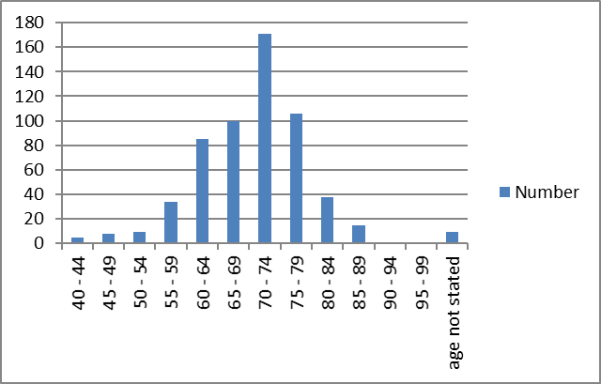

Fig 2b Initial PSA levels of the patient
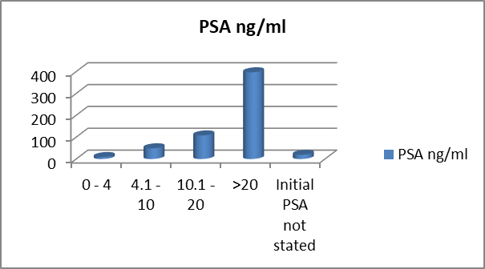 Median PSA 52.5ng/ml
Range (2.5 – 9,900)

(Fig 2c) Biopsy methods used
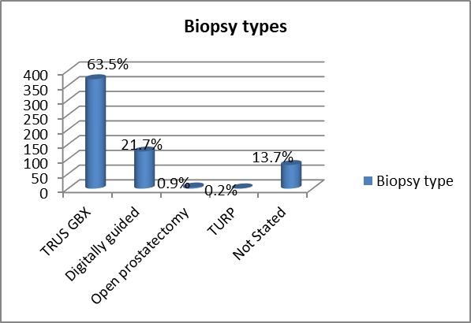

Fig. 2d: TNM Stage

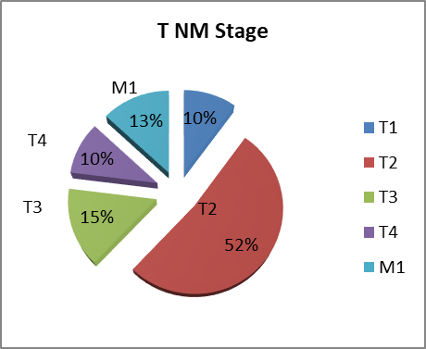

Fig 3 RADICAL PROSTATECTOMY n = 86 T1T2 N0M0 PC PRE VS POST TREATMENT PSA
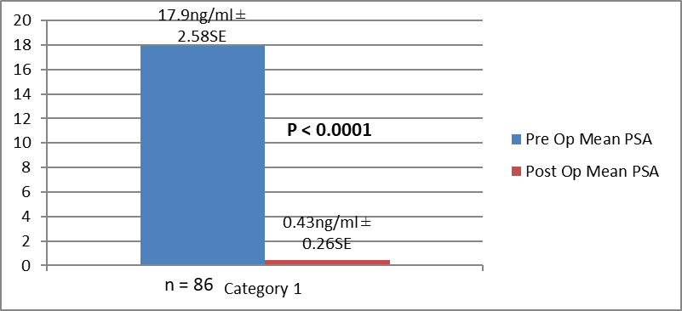

Fig 4 BRACHYTHERAPY 61 cases T1 T2 N0M0 of PC
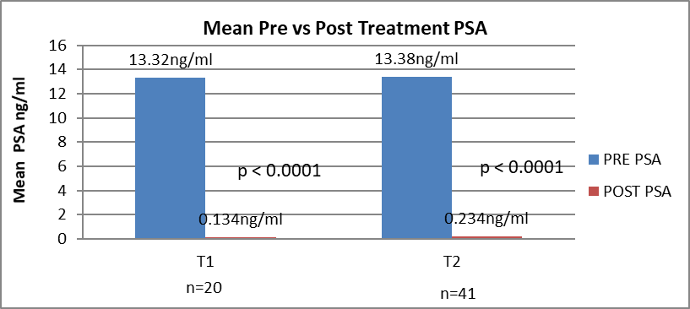

Fig 5 EBRT for 137 cases T1 T2 N0M0 of PC PRE VS POST Treatment PSA
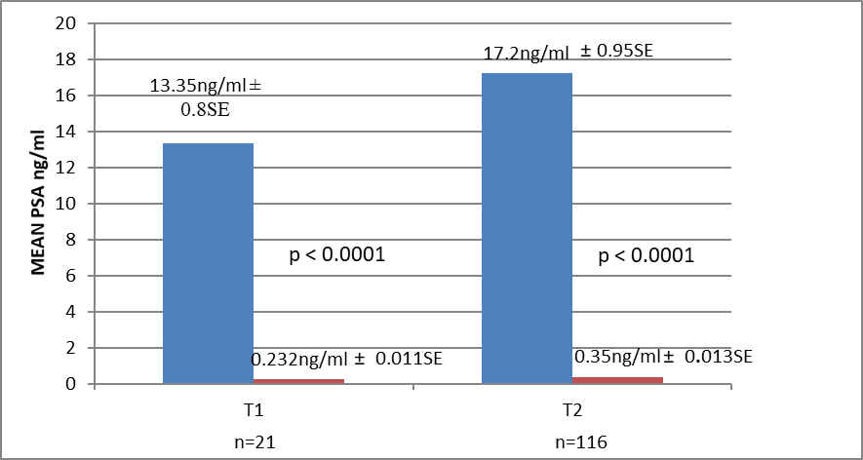

Fig. 6a: LOCALLY ADVANCED PC Rx BRACHYTHERAPY PRE & POST Rx
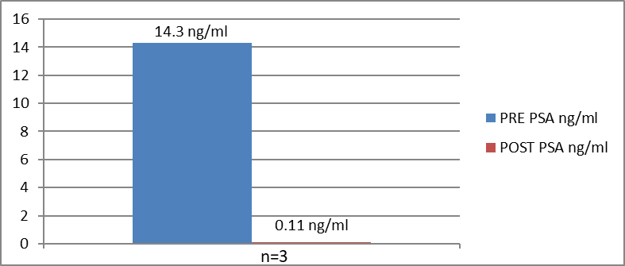
(median)

Fig. 6b: PRE VS POST TREATMENT PSA LOCALLY ADVANCED PC T3 T4 N0M0 TREATED BY EBRT
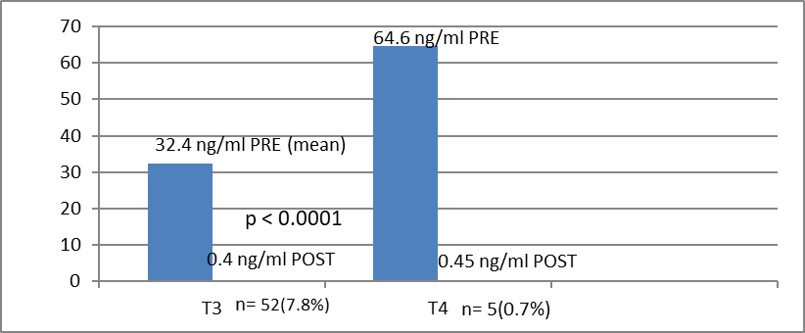
(median)

References
- Crawford ED. Epidemiology of prostate cancer. Urology. 2003,62:3 – 12.
- Hsing AW. International Trends and Patterns of cancer incidence and mortality. Int J Cancer. 2000:85; 60 – 7.
- Glover Jr FE, Coffey DS, Douglas LL, Cadogan M, Russell H, Tulloch T, Baker TD, Wan RS, Walsh P. The Epidemiology of prostate cancer in Jamaica. J Urol. 1998;159(6):1984 –1987.
- Center MM, Jeme A, Lorte-Tievlent J, Ward E, Ferlay J, Brawley O, Bray F. International variables in PC incidence and mortality rates. Eur Urol. 2012; 61:1079–1092.
- Haas GP, Delongchamps N, Brawley OW, Wang CY, de la Roza G. The worldwide epidemiology of Prostate Cancer: perspectives from autopsy studies. Can J Urol. 2008; 15:3866–3871.
- Parkin D, Whelan SL, Ferlay J, Hambi-Cherif M, Silas F, Thomas JO, Wablington H. Prostate Cancer in Africa Epidemiology and Prevention. IARC Press Lyon France 2002.
- Parkin DM, Ferlay J, Curado MP, Bray F, Edwards B, Shin HR, Forman D Fifty years of cancer incidences. International Journal of Cancer Issue 12 127: 2918 – 2927.
- Chu LW, Richey J, Devesa SS, Quraishi SM, Zhang H, Hsing AW. Prostate cancer incidence rates in Africa. Prostate cancer 2011: 947870.
- Gronberg H. PC Epidemiology. The Lancet Vol. 361 no. 9360:859 – 864.
- Hsing AW. Hormones and prostate cancer, what’s next? Epidemiol/Rev 2000; 23: 42 – 58.
- Rebbeck TR, Devesa SS, Chang BL, Cheng I Bunker CH, Cooney K, Gueyes SM, Yeboah ED, Hsing AW, Zeigler-Johnson CM. Global patterns of PC incidence, aggressiveness and mortality in men of African Descent. Prostate Cancer. 2013; 10560857:1 – 12.
- Bunker CH, Patrick AL, Konety BR, Onir R, Brufsky AM, Vivas CA, Beach MJ et al High prevalence of screening-detected prostate cancer among Afro-Caribbeans: The Tobago prostate cancer survey – Cancer Epidemiology Biomarkers and prevention. 2002; 8:726 – 729.
- Hsing AW, Yeboah ED, Biritwum R, Tettey Y, DeMarzo AM, Adjei AA, Netto G, Yu K, et al (2014) “High prevalence of screen detected PC in West African Men Implications for Racial Disparity in Prostate Cancer” J Urology. 2014; 192(3):730 – 735.
- Cooperberg MR, Dubeck DP, Meng MY, Mehtan SS, Farall P.The changing face of Prostate Cancer: Trends in clinical presentation and primary management. J Clinic Onco 2004; 22 (11) :2141 – 2149.
- Cooperberg MR, Mevi JW, Carrol P et al (2005). The changing face of low risk PC. Trends in clinical presentation and primary management. J Clinic Onco. 2005; 23(11): 8146 – 8151.
- Ritchey J, Biritwum RB, Yeboah ED, Tettey Y, Adjei A, Chokkallinghan A, Quaraishi S, Hsing AW. Body size and other epidemiologic characteristics in West African men implications for Racial Disparity in Prostate Cancer. American Journal of Epidemiology (AJE).2008; 01354p.
- Mutetwa B, Taioli E, Ahong-Rogers. Prostate cancer characteristics and survival in males of African Ancestry according to place of birth. Data from Brooklyn – New York, Guyana, Tobago and Trinidad. Prostate. 2010; 70(10):1102 – 1109.
- Gann PH. Risk factors in PC. Rev Urol. 2002; 4 (5):3 – 10.
- Laponite J, Chinde LI, Higgins JP, de Rijin MJ, Bair E, Montgomery K, Ferrari M, Egevad L, et al. Gene expression profiling identifies clinically relevant subtypes of Prostate Cancer. Proceedings National Academy of Sciences USA. 2008;1 (3):811 – 816.
- Walsh PC. Radical prostatectomy for localised prostate cancer provides durable cancer control with excellent quality of life. A structured debate. J of Urol. 2000;163(6):1802 – 1807.
- Walsh PC, De Weere TL, Eisenberger MA, Clinical practice localised prostate cancer. N Eng J Med. 2007; 357: 2696 – 705.
- Kyei MY, Mensah JE, Gepi-Atee S, Kwami D, Ampadu K, Asante K, Klufio GO, Yeboah ED. Outcomes after Radical Prostatectomy in Ghanaians; a surgeons early experience. ISRN Urol. 2013: Art. ID832496 p1 – 15.
- Weldon VE, Tavel FR, Neuwitt H. Continence, potency and morbidity after radical perineal prostatectomy. J Urol. 1997; 158: 1470 – 5.
- Link RE, Su LM, Sullivan W. Health related quality of life before and after laparoscopy. J Urol. 2005;173:175-9.
- Morrison BF, Conrad K, Strachan G, Miller R, Aiken W, Mayhew. Radical Prostatectomy outcomes at University hospital of West Indies 2000 – 2007. West Indian Medical Journal. 60(1):68 – 72.
- Catalona WJ, Carvalhal GF, Mager DE, Smith DM. Potency continence and complication rates in 1,870 consecutive radical retropubic prostatectomies” Journal of Urol. 1999;162(2):433 – 438.
- Patel VE, Palmer KI et al. Robotic Assisted laparoscopic RP perioperative outcomes of 1500 cases. J Endo Urol. 2008; 22: 2209 – 305.
- Stolzenberg JU, Rabenat R, Do M, Kallidonis P, Liatsikos EN et al. Endoscopic extraperitoneal RP University of Leipsig experience of 2000 cases. J Endourol. 2008; 22(10): 2319 – 25.
- Isenlin CE, Robertson JE, Paulson DF. Radical perineal prostatectomy oncological outcome during a 20 year period. J Urology. 1999; 161:163-8.
- Fiecarra VI, Nonara G, Artibani W, Cestari A, Galfano A, Graefen M, Guazzoni G. Retropubic laparocopic and robot assisted Radical Prostatectomy. A systemic review and cumulative analysis of comparative studies. Eur Urol. 2009; 55:1037-63.
- MulCathy N. AUA and ASTRO issue Joint Guidelines for post-surgery Radiotherapy Medscape Medical news 2013.
- Aral IA. External Beam radiotherapy in Prostate Cancer. MEDSCAPE Medical News.2014; p1 – 13.
- Dong SP. Current Status of brachytherapy for prostate cancer. Korean J Urology. 2012; 53 (II): 743 – 749.
- Mensah JE, Yarney J, Vanderpuiye V, Akpakli E, Tagoe S, Sasu E. Prostate Brachytherapy in Ghana. Our initial experience. Journal of Contemporary Brachytherapy. 2016;8(5):289 – 385.
- Keyes M, Norris J, Mckenzie MD. Results of men treated in provisional brachytherapy program are among the best in the world. BC MJ. 2010;52(2):76 – 83.
- D’Amico AVI, Moul JW, Carrol PR, Sun L, Chen LD et al. Surrogate endpoint for prostate cancer specific mortality after radical prostatectomy or radiation therapy. J Natl Cancer Institute. 2003; 85:136 – 138.
- Paulson DF. Ramdomised series of treatment with surgery vs radiation for prostate adenocarcinoma. NCI Monogr. 1988; 137 – 13.
- Zeleftsky MI, Fuks Z, Hunt M, Manon YY, Ling CC. High dose intensity modulated radiation therapy for PC early toxicity, and biochemical outcome in 772 patients. Int J Radiation Oncology Biol Physics. 2002;53(5): 1111-16.
- Bagshaw MA, Cox RS, Ramback JE. Radiation therapy for localized Prostate Cancer justification by long term follow up. UROL Clinics North Am. 1990; 17(4): 787 – 802.
- Schroder FH, Roacha M, Scandino P. Clinical decision making management of Prostate cancer. New Eng J Med. 2008; 3592: 2602-9.
- Huggins C, Stevens RE, Hodges V. Studies on PC II The effects of castration on advanced PC. Archives of Surgery. 1941; 43: 209 – 223.
- Nanniki M, Ueno S, Kitagawa Y, Fukagai T, Akaza H. Effectiveness and adverse effects of hormonal therapy for prostate cancer. Japanese experience perspective. Asian Journal of Androl. 2012; 14(3):451 – 457.
- Prostate Cancer Trialists’ Collaborative Group. Maximum androgen blockade in advanced prostate cancer an overview of randomized trials. Lancet 2000; 255: 1491 – 1498.
- Bolla M, Warde P, Collete L, Blank L, Dubois JB, Mirimane H, Storme G, et al. Long term results with immediate androgen suppression and EBRT in patients with locally advanced PC (an EORTIC Study) a phase III randomized trial. Lancet. 2002; 360:103 – 108.
- D’Lorenzo G, Buosherba C, Autorino R, Placido SD, and Scenberg CN. Castration resistant prostate cancer current and emerging treatment strategies, Drugs. 2010;70(6):963 – 1000.
- Andriole GL, Levin DL, Crawford ED, Gelmann EP, Pinsky PF, Chia D, Kramer BS, et al. Prostate cancer screening in prostate, lungs, colorectal and ovarian (PLCO) cancer screening Trial: Findings from initial screening round of randomized Trial. Journal National Cancer Institute. 2005;97(6): 433 – 8.
- Shroder FH, Huggosson J, Rovbal MJ, Teuvo LJ, Tammela TLJ, Gatto S, et al. Screening and prostate cancer mortality in randomized European Study. N Eng J Med. 2009;360(13):1320 – 8.
- Grimm P, Billet I, Botswick D, Dicker AP, Frank S, Immerzeel J, Kupelian P, et al. Comparative analysis of PSA free survival outcomes of patients with low, intermediate and high risk Prostate Cancer treated by radical therapy. Results from PC results Study Gp. BJU.2012; 109(22)22 – 29.
- D’Amico AV, Chen MH, Renshaw AA, Loffredo RN, Kantoff PW, et al. Androgen suppression and radiation vs radiation alone for locally advanced PC. JAMA.2012;299(3):289 – 295.
- Pollack A, Zagare FK, Starkswell et al. PC response to radiation dose response. Results of MD Anderson phase III randomized trial. Int J Radiology Oncology. 2002; 53:1097 – 103.
- Philips AA, Jacobson JS, Magai C, Consedius N, Horowicz-Mhler NC, Negut I. Cancer incidence and mortality in the Caribbean. Cancer Investigation. 2007; 5(6): 476-483.
- Yeboah ED, Mensah JE, Klufio GO, Mante SD. Ketoconazole and bisphosphats in advanced hormone refractory prostate cancer in Ghanaians. BJU Int.2002;90(2) 304.
- Powell IJ, Heilbrun L, Littrup PL, Franklin A, Parzuchowski J, Gelfend D, Sakr W. Outcome of African American men screened for prostate cancer: the Detroit Education and Early Detection (DEED) study. J Urol. 1997; 159(1): 146-149.
- Haiman CA, Chen GK, Blot WJ, Strom SS, Berndt SK, Inzes RA, Yeboah ED, Tettey Y, Adjei AA, Biritwum R. Genome wide Association study of PC in Men of African Ancestry identifies, a susceptibility locus at 17q21” Nature Genet. 2011; 43(6):570 – 573.
- Cook MB, Wang Z, Yeboah ED, Tettey Y, Biritwum RB, Adjei AA, Tay E, Truelove et al. Genome wide association study of Prostate Cancer in West African Men. Human Genetics. 2014;13 133(5):509 – 521.

INTRODUCTION

Le cancer de la prostate (PC)est le cancer le plus commune parmi les hommes vivant et il a une incidence élevé chez les Africains Caraïbes, Afro-Americains, Caucasiens mais faible parmi les Asiatiques et les Chinois. La prévalence du CP chez les Africains et Ghaneens n'était pas bien rapporté . L ’ incidence mondiale de CP est variable. C’est le 15ème cancer qui constitue 11.7% et des cas nouveaux , 19% dans les pays développés et 5% dans les pays en voie de développement . Il est le prochain après le cancer de foire chez les hommes de l’ouest ^{1,2, 3,4,5,6,7,8,9}. En Afrique, l’étude épidémiologie à constaté le test faible de PSA , la présentation et le pourcentage faible d’organe confinée (T1 – T2) mais la pourcentage élevé de métastatique PC avancé localement 30% dans les cas de 55% ^{1,10,11} ce qui rend le contrôle de maladie difficile .Des rapports récent indiquent la haut prévalence chez les Caraïbe et Ghaneens^{12,13}.
Les facteurs de risque rapporté de PC inclut familiale , sporadique, présence de testicule , vieillissement ,ethnicite, race (le plus élevé Afro-Americain > Les Caucasiens Americains > Asie Americains),des activités oncogènes élevé 5-DHT, 5 alpha réductase mais activités diminuer des anti-oncogenes. D’autres sont des hormonales déséquilibrée, la réduction de morte cellules et génétique /le GWAS a incriminé les HPC1, HPC2, p53, 17q21, 8q24, BRAC1, BRAC2. D’autres facteurs de risque sont des viande rouge , la régime de grasse, des activités précoce sexuel, les viruses – HPV, HSV, l’inflammation chronique, prostatite et t l’indice métabolique basal (BMI) ^{10,11,12 14,15,16,17,18,19.}
OBJECTIFS
L’objectifs de cette étude c’est pour identifier et établir l’incidence clinicale de cancer de la prostrate, des facteurs de risque , l'étape de TNM, leur gestions et résultats.
LE CONSENTEMENT ETHICAL: LE projet a été approuvé par le IRBs, le collège de science de la santé /NCI/de ministere de la santé du Ghana.
LA BOURSE : l’étude à été sponsorisé par NCI/NIH, Université Médical de Ghana et l’hôpital d’enseignement Korle Bu .

PATIENTS ET MÉTHODE
Une étude de cas de cancer de la prostrate (PC) soupçonné l ’ anormale de PSA (TPSA >4ng/ml,de vélocité anomalie PSA >0.75ng/ml année, PSAD >0.15ng/ml, court PSA doublant du temps )ou le DRE anormale réalisé . Le cancer de la prostate était histologiqement confirmé par le guidé TRUS/ la biopsie digitalement guidé ou avec TURP/les simple spécimen prostatectomie. Le diagnostic histologique des pathologistes de l’hôpital d’enseignement à KorleBu (KBTH), Accra, Ghana et d’autres validé par la pathologiste à Baltimore, aux états unis .Les centres qui ont participé comprennent ; hôpital d’enseignement Korle Bu , 37 Hopital Militaire, Centre Médical Nyaho ,Hôpital SSNIT et Hôpital Ridge , Tout à Accra.
Les sujets ont suivi l'histoire détaillé , examen physique ce qui inclus DRE, la mesure anthropometi et la détermination PSA.D’autres enquêtes inclus le IPSS, EFI, l’index prostatitis ,la despitage pour le STD et génétique/l’immense étude de Genome .Des consentement à été obtenu de tout les sujets.
Les procédures de mis en scène inclus X-ray (poitrine ,KUB,enquête squelettique ), abdomino-pelvien, balayage ultrasonographique(USG), CT Scan/MRI et balayage radioactive d’os mis en scène par TNM . Fig 1
Seul les cas histologiquement confirmé avec le cancer de la prostate (PC) étaient inclut dans l’étude et les patients avec des données Insufficient ont été exclus de cette étude.
LES PROTOCOL DE GESTION(Comme citée dans le Tableau 1)
(A)ORGANE CONFINEE 1. PRECOCE CP .D'urée de vie >15 ans 1. T1-T2 N0M0 GS≤7. - Ceux ci ont été contrôlé par(a)La Prostatectomie Radicale (RP) (b) Brachytherapie ou (c)La radiotherapie externe (EBRT)
2.PRECOCE T1 – T2 G>7 était contrôlé par le neoadjuvant Androgen Deprivation Thérapie(ADT) et puis RP, Brachytherapie ou EBRT
(B) LOCALEMENT AVANCE T3 T4 N0M0 GS ≤7 – La thérapie hormonale Neoadjuvant , brachytherapie, EBRT ou la thérapie hormonale .
(C)La maladie traite par la thérapie hormonale MESTASTETIQUE
(D)HORMONE REFRACTAIRE: Des Cas géré par Stilboestrol, chimiothérapie e.g. Ketoconazole.
(E)LA SURVEIĹANCE ACTIVE pour l’organ confinée PSA < 10ng/ml T1-T2 N0M0 GS6 (no G4 or 5)durée de vie <10 .

La suivi Post traitement
Le Post RP ou la thérapie de radiation, nous suivons des patients pour chaque 3 mois pendant 1 ans, et puis chaque 12 mois. La vélocité DRE, TPSA PSDT, PSA et le doublage de temps de PSA est estimé lors de visite de suivi. Si les changements suggèrent l'échec biochimie , la radiothérapie postopératoire est donnée ou le traitement hormonal ,si le post RP radiothérapie est rejeté ou contredite .
Pour la surveillance,le protocol de suivie était pour 3 mois pour un ans et puis chaque 6 mois. A chaque visite de suivi, le DRE,le TPSA, le PSA Vélocité, Le PSA doublant de temps est réalisé et s’il indique que la progression est traité par RP ou radiothérapie avec ou sans la thérapie hormonale .
- PATIENTS AVEC DES OS METASTATIQUE –les patients symptomatique étaient donné bisphosphonates oralement pour un ans .La thérapie hormonale était donné au cas où Ils n’ont pas étaient castrate (confirmé par l'étape du sérum testostérone ) mais le EBRT 8GY – 30GY a été donné pour diminuer la compression de moelle épinière , soulagement de la douleur et des symptomes obstructive symptoms. Des os métastases avec l’hypocalcemie a été contrôlé par l’nfusions d’acide Zolendronic .
- PATIENTS AVEC LA CORDE DE COMPRESSSION IMMINENT–ceux ci ont été traité par un cours de dexamethasone + Bilatéral orchiectomie (BTO) ou la thérapie(Stilbestrol, ADT Ketoconazole).
- LES CAS D’HORMONE REFRACTAIRE (HRPC)/RESISTANT CASTRATE(CRPC)
Ces cas étaient donné la chimiotherapie palliative hormonale: - .Stilbestrol ou ketoconazole ou docetaxel 75mg/m² donné 3 semaines avec prednisolone ou abiraterone. Quelques cas ont été donné cyclophosphamide oral et plus de prednisone. Ceux ci ont été guidé par des problèmes abordable .
- PATIENTS AVEC DES COMORBIDITIES ainsi que l’obésité, le diabète sucré (DM), le cardiaque congestive, (CCF), l’hypertention sévère (HPTN), la maladie cardiaque isenemique (IHD), la maladie rénal chronique(CKD) l’insuffisance hépatique chronique(CLF), l’ anémie chronique, et la condition des vieux a été contrôlé avec des méthodes conventionelle pour éviter la morbidité facheux ou la mortalité influencé par les problèmes abordable .
- PATIENTS AVEC DES SYMPTOMES OBSTRUCTIF
Ceux qui ont des symptômes sévère modéré (les cas avec IPSS ≥ 8, QOL ≥ 3) résultats négatif élevé(PVR)urine , diminution du débit maximal .(PFR)ont été donné les bloqeurs alpha adrenergique ± finasteride.Les cas avec des saignements sévère, des symptômes sévère , des rétention recurrent refractoire, calculi, diverticuli traiter par TUIP/ TURP, la resection du col de la vessie ou la prostatectomie si c’est localisé T₁– T₂ N0M0 maladie

Les données obtenues comprennent les démographiques, les caractères clinicale , des enquêtes pertinentes, la gestion offert ,les résultats ont été analysé en utilisant .Ensemble Statistique pour les sciences sociales(SPSS) version 20.
Les résultats des données ont été exprimé comme des pourcentages et moyens de dérivé standard . Un p-valeur moins de 0.05 était considéré important .

RESULTATS
Un total de 697 cas étaient recruté au quel 669(96%)ont complété l’abstraction de l’enregistrement médical avec des données adéquate. Les restes 22 sujets qui n’ont pas des données adéquat ont été exclus de cette étude .La moyenne âge était 70±0.48SE ans avec un gamme 41 – 94 ans (Fig 2a) alors que le médian PSA était 52.5ng/ml avec un gamme de 2.5 – 9,900ng/ml (Fig 2b).
Le journal de bord de l’hôpital des cas ont été obtenus de l’hôpital d’enseignement Korle Bu (KBTH) dans 401 (60%) cas , 37 Militaires dans 54 (8%) cas, Centre Médical Nyaho dans 210 (31%), 4 (0.6%) de SSNIT et l'hôpital Ridge à Accra, au Ghana. Leurs ethnicites sont ainsi : Akan 320 (48%), Ga- Adangbe 160 (24%), Ewes 80 (12%), le nord 34 (5%), les non-idigene 4, 71 ne sont pas cité (10.6%); leur état social ce qui inclus : les retraités 46.1%, revenu moyen 20.5%, revenu élevé 11.4%, faible revenu 9%, les chrétiens ont composé 54%,les musulmans 7%, et d’autres 39%. Les types de biopsies comprennent les biopsies de TRUS-guide dans 63.5%, les biopsies guidé par voie numérique dans 21.7% (Fig 2c)

Etapes et Gleason scores(GS) (Fig 2d)
Les 669 cas étaient présenté ainsi :maladie localisé T1 – T2 N0 M0 en 415 (62%) cas de maladie avancé localement T3-T4 N0M0 chez 167(25%), maladie métastatique dans 87 (13%) cas , bien que les scores de Gleason (GS)-risque élevé GS ≥7 était67.7% alors que des risques et immédiat étaient GS ≤ 6 était 32.3% (Tableau 3)

1. ORGAN CONFINEE(LOCALISE) T1-2 N0M0 415 (62%), Médian GS <7, présentation PSA ≥ 4ng/ml 95.6%, PSA ≤ 4, 4.4%, LUTS (LUTO/IRRITATIVE) 25%, rétention d’urine (ROU) 10%, la gestion médicale du symptômes obstructive avec alpha bloqeur ± finasteride dans 23%. La co-morbidités étaient hypertension (HPTN) 21%, diabètes sucré(DM) 4%, HPTN & DM 3.3%, anémie avec Hb <12gm/dl in 3.3% et insuffisance rénale avec créatinine >120umol/L en cas de 10% .

La gestion PC n = 415 (62%)
(a)Prostatectomie Radicale (RP) - maladie localisé T1 – T2 M0 nombre était 92/669 (13.8%) Fig 3
moyenne âge étaient 61.8 years ± 0.88SE avec un gamme de 51 – 72 ans .Des cas prostatectomie (Ouvert ) Prostatectomie cas 85 (12.7%)la prostatectomie radicale de retropubique ouverte, 81 (12%), périnéale prostatectomie radicale 4 (0.6%), laparoscopique RP 7 (1%). La moyen opératoire PSA 17.9 ng/ml ± 2.58SE (range 4 – 100ng/ml) contre la moyenne post opératoire PSA 0.43 ± 0.26SE (range 0.01 – 12ng/ml) p< 0.0001 in 12.8%, médian GS ≤ 7, la suivi médical10 mois (un gamme de 10 mois – 84 mois +), perdu de suivre 6 (0.9%).
RP la maladie spécimen organ confinée était 76 (11.4%), BPH 3 (0.4%) et les marginales positive 13 (2%).Les cas avec des marginales positive étaient traité avec hormones/EBRT. L ’ échec Biochimie (BF) était18(2.7%) et ont été traité par EBRT +dépravation thérapie androgen Androgen (ADT)
Les complications postopératoire était la dysfonction érectile (EDYS) 10 (1.5%), sténoses du col de la vessie 10 (1.5%), vessie hyperactive (OAB) 6 (0.9%), UTI 12 (1.8%), et deux morts (0.3%) de l’embloie pulmonaire /myocardial infarction (PE/MI). Thrombose veineuse profonde (DVT) 5 (0.7%) traité par des anticoagulants, l’inconsistence urinaire temporaire 6 (0.7%)traité par l’oxybutynin, detrusitol et des exercices pelvienne

(b) Brachytherapie pour n = 70 (10.5%). I¹²⁵ les graines administrent une dose de 160GY. Moyen age 60.8 ± 0.587SE (Range 51 – 76 ans) Tableau 4, Fig 4 perte de suivre 9 (1.3%), et un mort 1/669 (0.1%).Le pré traitement contre le post traitement PSA n = 61 (9.1%) PSA 13.34ng/ml ± 0.08SE contre la post moyenne PSA 0.166ng/ml ± 0.03SE p<0.0001 . La moyenne pré traitement l'étape PSA T₁ (n = 20) 13.32ng/ml ± 0.24SE contre le post moyenPSA 0.134ng/ml ±0.06 SE p<0.0001.Le pré traitement moyen PSA T2 (n41) 13.38ng/ml ± 0.34SE contre le post 0.234ng/ml ± SE 0.05 p<0.0001 in 9.1%. Fig. 4.
Suivi médian 12 mois (10 – 72 mois ), 9 (1.3%) défaut, des complications étaient BF 3 (0.4%) avec PSA 6.41, 20 et 40ng/ml, le temps de médian à l’echec de 23 mois .Le traitement BF était par la thérapie hormonale Zoladex/BTO + EBRT 40 – 50GY. Radiation cystites 6 (0.9%)traitement par l’acide tranexamique , tamsulosine oxybutynine/ detrusitol, prednisolone Ciprofloxacin, EDYS 6 (0.9%), traité avec le Tardanafil/sildenifil nitrate, DVT 1 (0.1%) traité par anticoagulants, la mort 1 (0.1%) de PE.

(c)EBRT pour n= 155(23%). Tableau 5, 6 Fig 5
Cobalt 60, 70 – 74GY 2D/3D, 20 de 155 ont été en surveillance recruté après , moyenne âge de 61.75 ± 0.2462SE. Les résultats de moyen de pré traitement PSA (n = 137) PSA 16.513 ±0.80SE contre le post traitement PSA 0.33 ± 0.11 p<0.0001. T₁ cas de moyen de pré traitement PSA 13.35ng/ml ± 0.86SE contre 0.232ng/ml ± 0.011SE p< 0.0001 et pour T₂ pre-traitement 17.2ng/ml ± 0.95SE contre le post 0.35ng/ml ± 0.013SE et p<0.0001 dans 52/669 (7.7%)
Suivi de médian de10 mois (7 mois – 8⁺ ans ),perte de suivi 18 (2.7%), BF 18 (2.7%), 3% traité par hormone/chimiothérapie, mortalité 5 (0.7%) (3 de la laurie massive haematuria, la radiation cystites, 2 – DVT and PE)

(d)LA MALADIE LOCALISEE AVEC PROGRESSION ET A EU LA THERAPIE HORMONALE n=98 (14.6%) (T1-T2 N0M0)
Haute risque G ≥7, moyen age 75 ± 0.25SE (Range 68 – dans ) ces cas 6 (0.1%)ont eu des prostatectomies simples pour BPH. Les comobidities comprennent HPTN 4.2%, maladie cardiaque isenemique (IHD)1.6%, DM 3.7%, Obésité2.2%, CCF 1.5%. Méthode LHRH analogue/ chimiothérapie 30 + 18*(4.5% + 2.7%), Stilboestrol 2.5mg + aspirin 30 (4.5%), BTO 20 (3%) ± bicalutamide/ flutamide. BF non conforme avec LHRH agoniste 18* étaient traité par BTO 18 (2.7%) (Total BTO 38 5.7%), T₁ 24 (3.6%), T₂ 74 (11%). Le moyen de pré traitement PSA 24ng/ml ±0.84SE (gamme 3.8 – 90.8ng/ml) contre le post moyen traitement de nadir PSA 0.34ng/ml ± 0.01SE (gamme 0.2ng/ml – 50ng/ml) p< 0.002. en 66/669(9.8%). Suivi Médian de 10 mois (gamme 12 mois – 7 ans), mortalité 9 (1.3%), CVA 2 (0.3%), DVT et PE 1 (0.5%), la résistance castrer PC (CRPC) 6 (0.9%),perte de suivi T₁ 18 (2.7%), T₂ 14 (2.1%).

2 . LOCALEMENT AVANCE T₃₋₄ M0 AUCUNE MALADIE n=167(25%) (T₃ 100, T₄ 67)
Moyen âge Mean 70± 0.535SE, Médian GS > 7,le pré traitement moyen PSA 48.5ng/ml ± 0.96SE (gamme 7.1 – 2793ng/ml) contre post-traitement moyen PSA 0.6ng/ml ± 0.34SE (range 0.2 – 50ng/ml). De ces 4 (0.6%) ont eu au paravant la simple prostatectomie pour BPH.
Présentation – LUTS/LUTO 40 (6%), retention aigu d’urine (AROU) 7 (9%),rétention d’urine (CROU) 3 (0.4%), uremie obstructive 4 (0.6%), hématurie 10 (1.5%), EDYS 5 (7.5%),/douleur de dos /perineal/supra- pubic 17 (2.5%).
Management – Neoadjuvant hormonal ± TAB LHRH analogue 87 (13%) ± TAB /Stilboestrol 20 (3%) ± TAB BTO 60 (9%) suivi par (a)brachytherapie 3 (0.4%), (b) EBRT 64 (9.6%)
a)La gestion avancé traité par Brachytherapie
T₃ 3 (0.4%), pré traitement médian PSA était 14.3ng/ml (range 9.4 – 17.3ng/ml) et le post traitement post médian PSA était 0.11ng/ml (range 0.11 – 0.12ng/ml). Les complications étaient 1 mort 0.15% de la progression de maladie (Fig 6a).

b)Locale avancé traité par BEBRT (Fig 6b).
n = 64 (9.5%),perte de suivi 7 (1%), le moyen du pre-traitement PSA T₃ 57 (8.5%) 32.4ng/ml ± 0.85SE, T₄ 7 médian PSA 64.6ng/ml contre le moyen post traitement SA T₃ 0.4ng/ml ± 0.12SE p< 0.0001, post T₄ médian PSA 0.45ng/ml (Fig 6b). Perte de suivi 7. Les complications étaient 21 (3%): - BF 5 (0.7%) (T₃ 1 T₄ 4), la radiation cystites 7 (1%), proctocolitis 4 (0.6%),saignement rectal 5 (0.7%), les morts 4 hématurie- 1 (0.15%),la progression de maladie 3 0.4%.

(c)Localement Avancé PC gérer par la thérapie hormonale
Le nombre de cas étaient 100 (15%),au quel 4 (0.6%) ont eu une simple prostatectomie pour BPH, T₃ 40 (5.9%), T₄ 60 (9%). Le pre-traitement PSA était T₃ (40) 34.1ng/ml ± 0.78 et T₄ 60 le pre-traitement moyen PSA 41.05 ng/ml ± 0.81SE contre le moyen de post traitement PSA T3 était 0.4ng/ml ± 0.11SE p< 0.002 et T4 0.48ng/ml ± 0.11SE p< 0.002 dans 13%
La gestion des méthodes étaient LHRH ± TAB (ADT bicalutamide /flutamide) 47 – 7%, Stilboestrol ± aspirine 6 – 0.8% et BTO 47 – 7%. 50 (7.5%) de cas avec LUTO/LUTS AROU/CROU ont été traité par bloqeurs ± finasteride 43 – 5%, TUIP/TURP la resection du col de la vessie 17 – 2.5%.Les complications étaient HRPC/CRPC 31 – 4.6%, les bouffés de chaleurs 36 – 5%, EDYS 98 – 15%.La suivi de médian était 12 mois (rang 1 ans – 7 ans ),perte de suivi 9 – 1.34% (T₃ 3 and T₄ 6),mortalité hôpital 34 – 5% par la raison d’ urosepsis 16 – 2.4%, escarres et état septique 5 – 0.7%, PE 3 – 0.4%, obstructive uremie 6 – 0.9%,et uremie de hématurie 4 – 0.6%.

(3) Maladie Métastatique
T₁₋₄ N₁₋₃ M1 n 87 13%,moyen age 70 ± 0.587SE, médian GS ≤7 (r4 – 10),moyen pre-traitement PSA 98ng/ml ± 1.344 (r7 – 9,900ng/ml), moyen post-traitement PSA 0.46ng/ml ± 0.138 (r0.04 – 86ng/ml). Présentation: LUTS/LUTO 31 – 4.6%, AROU 8 – 1%, uremia CROU 5 – 0.7%, métastatique – squelette de: pelvienne 40 – 6%, colonne vertébrale 8 – 1%, pelvienne/colonne vertébrale 15 – 2.2%,pelvien/les ganglions lymphatique de Groin (PLN) positive 15 – 2.2%, hématurie 9 – 1.3%, paraplégie 9 –1.3%, pulmonaire secondaire’s 4 – 0.6%, cérébral secondaire3 – 0.4%,lymphedema penis & scrotum 3 – 0.4%, lymphedema du pieds 4 – 0.6%, douleur squelette/ventre/taille 58 – 8.6%, anémie 18 – 2.7%, maux des têtes3 – 0.4%. Traitement par hormonal / chimiothérapie et des méthodes conventionelle pour les.
La gestion AROU/CROU – Catherization, α-bloqeurs ± finasteride 13 (1.9%), TURP 8 (1.2%), LHRH analogue ± TAB 20 (3%), Stilboestrol TAB 15 (2.2%), BTO 52 (7.8%).
Complications Les bouffées de chaleur 26 (3.9%), EBRT utilisé pour la localisation d’os vertèbre localisé secondarie pour soulager la compression dans 6 cas 0.9%, BF 30 – 4.4% gérer comme HRPC/CRPC - 4.5% par stilboestrol, ketoconazole/prednisolone, docetaxel, cyclophosphamide et prednisolone.Mortalite hôpital 40 – 6%,urosepsis 14 – 2%, obstructive uropathy/uremia 10 – 1.5%, 3 uremie hématurie 6 – 0.9%, escarres sepsis 5 – 0.7%, DVT PE 5 – 0.7%, suivi de 8 – 1.2%.

RESUME DE RECHERCHE Tableau 6
Résumé de la gestion de 669 cas.
- Etapes lors de presentation . Les etapes trouvé étaient T2 M0 -62%, T3T4 M0 -25%, métastatique PC-13%.
- Des facteurs de risque établi dans notre étude sont les mâles avec DES testicules , âgé avancé le haut BMI. L'étude immense de Génome a montré la chromosome 10p14 associé avec le PC au Ghana, le PC aggressive GS ≥7 (67.7%) le haut PSA >52ng/ml associé avec SNPS 5q31.3 et la grade faible GS ≤6 (32.3%) PSA <52ng/ml associé avec SNPs Xq28 & 6q21. Ces resultats ont été publiés quelques parts et seront discuté .
- Les comorbidities étaient l’hypertension (HPTN) 25%, DM 5.4%, HPTN/DM 5.1%, anémie 3.3%, CKD 11.1% perte de suivi71 (10.6%) Tableau 6.
- D’abbord ,il y a des chutes en PSA dans la plupart de groupe dans la période du traitement post immédiat .
- La gestion de CP au Ghana a amélioré depuis 2004 d'après l’étude de 669 cas avec un long suivi sans maladie avec la pratique urologique amélioré de 62% présentant comme l’ organ confinée permettant le traitement curatif comme : la prostatectomie radicale de 92 (14%), mortalité 2 (0.3%), brachytherapie 73 (11%), mortalité 2 (0.3%), EBRT 155 T₁-T₂, (23%), mortalité 5 (0.7%), Surveillance Active (3%) 20 cas (T₁ 8 & T₂ 12), a choisi plutard EBRT, ainsi analysé avec EBRT.

Les cas localement avancé 167, (25%) étaient contrôlé par le neoadjuvant hormonal/chimiothérapie suivi par EBRT et brachytherapie 67 (10%), chimiothérapie hormonale100 (15%). Les cas métastatique 13% étaient contrôlé par hormonal ± chimiotherapie. La thérapie hormonale de longue terme /de courte terme pour les maladies localisé (98)et localement avancé (167)et la maladie métastatique (87)qui sont dans les 52.6% des cas en utilisant le LHRH les analogues BTO,stilboestrol + aspirine ± TAB.

DISCUSSION
Plus de plus des cancers de la prostate (CP)dans l'hémisphère de l’ouest sont diagnostiqué très tôt par la raison de test PSA. Cooperberg¹⁴ a montré que la proportion de risque tumeur s'est élevé de 29.8% en 1989 à 45.3% en 2001;542 la proportion de la maladie avancé localement s’abaisse de 19.2% à 4.4% et les cas métastatique ont reduit de 14.1% à 3.3% aux états unis.Des rapports des Etats Unis et Jamaïque indiquent que la présentation tardive est associée aux blancs qui gagne peu d’argent , les Afro-Americains et les Jamaïquains³.
Cette façon à été observée dans les communautés qui ont la despitage PSA ce qui a causé L’echec de la migration radicale des spécimens prostatectomie . ^{14, 15} Notre étude a montré une étape d'échec de la migration T₁ – T₂ 62%, localement avancé 25%, métastatique 13% vis à vis T₁ – T₂ 15.35%, localement avancé 32.3%, métastatique 52.5% dans notre étude retrospective ¹³ Statistiquement significative p<0.0001. Dans notre étude de population T₁-T₂ 82%, localement avancé 12% et métastatique 6%. Cela était en accord avec le modele de l’ouest .

T1 – 2 N0M0 ORGAN CONFINED 415 (62%)
- RADICAL PROSTATECTOMY n 92 (13.8%) (Fig 3, Table 6)
Notre survivant de 98% pour le RP est comparable aux résultats d’autres centres ^{20,21,22,23,24,25,26.} Il y avait d'abbord des significative initial de chute dans les pre-versus post-operative PSA p<000.1 en 86/92(93.4%).Nous avons eu des expériences limité des cas de laparoscopique RP 7 (1%) qui est prétendu d’avoir un niveau bas de mortalité , dysfonction érectile ou des complications^{27,28} mais aucune expérience avec robotique RP ce qui est rapporté d’avoir des meilleures résultats avec la morbidité et mortalité que l'ouvert et laparoscopique RP^{27,28}. Contrairement à Weldon, Isenlin, Ruenes et Gueye qui ont réalisé plusieurs cas de périnéale radicale de prostatectomie ^{23,29,30}, nous avons eu seulement 4 (0.6%) cas de périnéale RP qui ont bien fait . Kyei a rapporté son expérience avec RP au KBTH à Accra qui était bien fait²². L ’ échec biochimie de 13 (2%) dans 92 cas était par la raison positive des marginales et était contrôlé avec succès par EBRT /thérapie hormonale ^{31,32.}
- BRACHYTHERAPY FOR ORGAN CONFINED PC (T₁ – T₂ N0M0) n = 70 (Tableau 4, Fig 4, Tableau 6)
La valeur thérapeutiques de brachytherapie est généralement comparable à RP ^{33,34,35}. Brachytherapie à des bon résultats avec 8ans de PSA survie sans chute de risque faible PC 88%, risque intermediat de PC 81% et la haute risque initial et l’initial de PC 65%.L’étude de contrôle randomisé à été établit que le RP et la brachytherapie ont le taux de 5ans de récurrence biochimie comparable mais brachytherapie a une un profile d’effet secondaire favorable profile de puissance que la prostatectomie radicale^{33,34,36.}
Notre étude a confirmé ces observations comme 70 (10.5%) de nos patients qui ont la brachytherapie avec un médian de suivi de12 mois (range 10 – 84 mois) ont le bas significative de PSA valeurs que nadir a enregistré du post traitement PSA avec seulement 0.4% de BF qui a répondu à la thérapie hormonale et un (0.1%) mort de PE par le résultat de DVT.

- EBRT FOR EARLY DISEASE T₁₋₂ N0M0 n 155(23.1%) (Table 5, 6, Fig 5)
La littérature présente soutient le rôle de EBRT dans la gestion de CP localisé en homme comparable au RP même qu’il est affirmé que la chirurgie à offert des meilleures résultats que le EBRT^{21,22,33,37,38,39.} Notre résultats étaient encourageant puisque une grande nombre de cas 155 (23.1%) étaient traité dans un centre; le centre national de la radiothérapie (NRC)au KBTH comparé au 92 (13.8%) RP au KBTH et 37 Military Hospital. Il y avait des chutes dans le post traitement PSA. Le centre radiothérapie (NRC) à KBTH est capable d'offrir des services aux patients partout au Ghana.Il y a un autre centre de radiothérapie à l’hopital d’enseignement Komfo Anokye mais ils n’ont pas encore publier leurs expériences avec le PC. Les 3 (0.4%) morts du saignement à cause de la cystites radiation n’a pas encore se produire depuis l’introduction de techniques qui conformes l’efficacité de la thérapie de radiation à été rapporté par ASTRO (Société Américaine de la radiation Oncologie) la société américain de la radiation oncologie et l’ AUA l’association urologique d’Amerique .Les guides sur la thérapie PC ^{31,32,35,36,37,38,40.}

MALADIE LOCALISEE DE CP AVEC PROGRESSION n 98 (14.4%) – GERER PAR LA THERAPIE HORMONALE
L’efficacité hormonale /chimiothérapie avancé pour le CP a été établi ^{41,42,43.} L ’ échec Biochemique ,la résistance castrer CP s’est produit en 6 (0.9%) qui ont aussi le CVA 2%, DVT/pulmonaire embolisme 2% et CCF 2%.Même que la thérapie hormonale n’est pas recommandé comme thérapie pour le CP précoce et ceux avec l'attente de vie plus que 10 ans,ces cas ont survit plus long face à aux comorbidities. Notre cas de >72 ans et la courte durée de vie était 98 (14.4%), quelques vieux faibles et d’autres avec des co-morbidités sérieux ainsi que le DM 3.7%, obésité 2.2% étaient contrôlé avec la thérapie hormonale lorsequ’ils sont progressé . Il y avait une baisse significative dans le pré traitement des valeurs de nadir en PSA p< 0.002. La survie était de 36 mois à 7 ans qui montre que c’est une bonne option pour ces groupes de patients ^{41,42,44,45.46,47.} Les complications de DVT 2%, CRPC 0.9% peut se voir de ce genre de thérapie, meme que l'aspirine soluble peut réduire l’incidence de DVT.

LOCALEMENT AVANCÉ PC T₃ T₄ NxM0 n = 167 (25%)
- Soixante sept (10%)de cas localement avancé étaient contrôler par neoadjuvant la thérapie hormonale et thérapie de radiation Figs. 6abc
La thérapie Neoadjuvant hormonal chez 67 étaient suivi par la radiation EBRT 9.6% et brachytherapie 0.4%.Il y avait des chutes significative dans la post radiation de nadir PSA dans le groupe EBRT p< 0.0001.Le taux survie dans ce groupe était impressionnant . Des résultats encourageant de plusieurs tenter de 3 ème étape pour la combination radiothérapie (brachytherapie ou EBRT)
avec la bloquage totale d’androgen (TAB) reste l’effet synergistique des deux traitements ^{32,44,48.} Les rapports de groupe de radiation de therapie oncologie (RTOG)suggère que les patients avec GS 7 ou plus ont aussi le taux de survie amélioré lorsqu’il est traité par le TAB et la radiothérapie ^{31,44,48,49.} Cela donne l’espoir à notre patients avec le PC localement avancé qui peut bénéficier de TAB plus la radiothérapie avancé ^{37,38,44,47,48,49,50.}

- LE PC LOCALEMENT AVANCE – contrôlé seulement par la thérapie managed by hormonale n 100 (15%)
Un centaine de ces cas a été (15%) contrôlé par la thérapie hormonale seulement .la chute initiale dans le pre-traitement de PSA était significative p<0.002. Les complications rencontré étaient la dysfonction érectile >12%, gynaecomastia 3%, des bouffées de chaleur/les bouffées 9%, HRPC/CRPC 4.5%. Cinq percent (5%) mort a l'hôpital par raison de progression de maladie par PE, obstructive uropathy urosepsis, ecarres et sepsis et anémie comme rapporté au paravant .^{41,42,43,47.}

LA MALADIE METASTATIQUE n = 87 (13%) MÉDIAN GS7, médian avant le PSA 98ng/ml. Le médian post traitement median tombe sur le PSA sont pas mpressive mais n’étaient pas sujet à l’analyse statistique à cause des variables incomparable .Ceux ci étaient contrôlé par la thérapie hormonale et comorbidities de méthode conventionnelle .Comme prévu , la mortalité hôpital était élevé dans ces cas à partir d’ urosepsis, l’uremie obstructive et la progression à la réfractaire hormonale CP ou castrer la résistance de CP (HRPC/CRPC). Malheureusement , la plupart de notre sujets ne sont pas capable de payer pour le docetacel, abiraterone et d’autres thérapies efficaces pour CRPC.
La dépravation Androgen est établi comme effective contre le CP avancé et métastatique CP mais malheureusement avec le temps presque tous les CP deviendront androgen réfractaire (HRPC/CRPC)^{41, 42,43,45,46,47,51.} La présente forme de la dépravation d’ androgen fonction par la réduction de la circulation d’ androgens ou bloquant la liason androgen au récepteurs d’ androgen^{39,40,41,42.} Mais près que tout les androgen refractaire CP reste sensitive à androgen et ainsi le ADT doit se continuer dans la maladie CRPC , malheureusement les comprimés alternative comme docetacel, carbazitazel, denossumab, bevacizumb, abiraterone et ipilimumab sont très cher et la majorité de notre sujets n’ont pas la capacité de l'acheter et aussi ce n’est pas disponible au Ghana. Neamoins , avec des experience le stilboestrol et le prednisolone sont efficace dans quelques cas de nos sujets avec CRPC/HRPC cas^{50. ....}L’effet secondaires de la thérapie hormonale comprennent la dysfontion érectile ,bouffées de chaleur, seurs, gynecomastia et la tendresse des seins, des douleurs de flambée de tumeur , prise de poids des problèmes avec la mémoire, sautés d'humeur, la dépression, osteoporosis et le risque précoce de crise cardiaque. La dépravation Intermittente androgen peut ralenti la progression de CRPC avec de moins d’effets secondaires et c’est utilisé pour quelques uns de notre cas ^{42,45.}
Des comprimés cytotoxic utilisé pour notre CRPC sont ;docetaxel et carbazitaxel qui était montré d’être efficace et améliorer la survie générale pour une période limité en CRPC mais sont cher et la majorité de notre patients ne peuvent pas les acheter .
La douleur d’os dans les cas métastatique peut être amélioré par l’acide zolendonique et denosumad.
Nouvel approaches pour le HRPC/CRPC inclus immunothérapie par l’usage de sipuleucel-T chez les hommes avec l’ asymptomatique CRPC. L’Abiraterone est efficace avec les patients progressant après docetaxel mais ils sont très cher pour notre patients et efficace pour une période limité ^{45.}

LES FACTEURS DE RISQUE EN CP
Les facteurs de risque rapporté en CP inclus familial 10%, sporadique 80 – 90%, présence de testicule , les hormones de vieillisements , les facteurs génétiques et race. La prévalence de CP est le plus élevé chez les Caraïbes Africains, Afro-Americains, Caucasien Americains et au moins chez les Asiatiques Asiens^{2,10,11,16,17,25,52,53.} D’autres sont les activités augmenté des oncogènes, l'activité diminuer des anti-oncogenes, le niveau élevé de hydrotestosterone et l'activité augmenté de 5 alpha reductase, l ’hormonale équilibrée , et la réduite de morte de cellules , le BMI élevé, activités sexuel précoce et génétique /l’étude de GWAS incriminé, HPC2, p53, 17q21, 8q24, BRAC1 & BRAC2. Vaguement incriminé sont HPV, HSV, l’inflammation chronique, viande rouge élevé high et la régime de graisse .
Notre étude génome immense continue toujours , jusqu'au jourd'hui nous avons trouvé les facteurs de risque suivante d'étude de Ghana .La race Africain CP a une haute as prévalence de 6.3 – 7% au Ghana. Notre GWAS a aussi incriminé la chromosome 10p14 avec le PC, l ’ agressivité et haute PSA >52.5ng/ml GS>7 avec 5q31.3. La grade bas de Low PSA <52.5ng/ml GS<7 avec les chromosomes Xq28 et 6q21^{53,54,55.}
La faiblesse de cette étude inclus la manque de suivi de quelque patients, le coût élevé de traitement et la manque d'assurance pour couvrir le traitement du cancer prostate . Et aussi les complications des méthodes curative RP, brachytherapie et EBRT qui doit être éviter .

CONCLUSION:
Des facilités amélioré et des équipes dédié ont mené à l’augmentation significative dans la proportion d’organ confinée de Cancer de la prostrate 15.3% à 62% curable par la Prostatectomie radicale,brachytherapie ou EBRT qui n’a plus de chance de survivre de maladie . Puise qu’il est établi que la qualité de vie et survie libre de cancer pour l’organe confinée CP maladie peut s’achever par la modalités de traitement ,physiciens et urologistes doivent sélectionner d’organe confinée de cancer par le test PSA et DRE pour que les patients soient diagnostiqué tôt et recevoir le traitement curative pour achever une vie libre de survie libre de cancer et une vie de bonne qualité .

RECONNAISSANE
Nous sommes reconnaissant vers les médecins,les résidents, les infirmières, les professionels de santé health et les personnels paramédicales , les personnels de pathologies et l’ illustration médical et abstracteurs. Nous sommes aussi reconnaissant vers Mme. Evelyn Tay pour la cordination du projets et Mlle. Victoria Okyne pour la cordination et des services secrétaire .Nous sommes aussi reconnaissant aux CEO de Korle Bu, 37 Military Hospital, Nyaho Medical Center, SSNIT Hospital, ministère de la santé , le services de la santé Ghana et l’IRB de NCI/NIH, l’université de Ghana CHS, l’Institut Noguchi Mémorial des recherches médical(Noguchi Memorial Institute of Medical Research ) et le MOH pour avoir donné la permissions pour cette étude qui a achevé près que tout les objectifs que nous avons établi avant de commencer.

Tableau 1
Étape (TNM) | Grade  (Gleason score) | Traitement du Protocol offert pour le Cancer de la Prostate au Ghana
Précoce  (T1 and T2 N0 M0) | GS ≤7 | La radiotherapie extene ternal EBRT 2D/3D 70 – 74GY  Brachytherapie en 160 GY – I semence. ..  Prostatectomie Radicale (RP) ( retropubic ouvert périnéale/ Laparoscopic)
Surveillance  Active  T1 – T2 N0M0 | Risque Faible ≤6 (No GS 4 no GS 5) | L’attente de longévité <10 ans. PSA <10ng/ml suivi trimestriel pendant la première année et chaque 6 mois consécutif.Verifier TPSA,la vélocité PSA , DRE pendant chaque visite . Si la progression par TPSA, ↑la vélocité PSA Vélocité>0.75ng/ml/ans., répète la biopsie et radiation appropriate Rx par la radiation ou thérapie hormonale
Précoce  (T1 and T2a N0 M0) | GS 7- 10 | Neoadjuvant ADT/ Prostatectomie Radicale /Brachytherapie  La radiothérapie externe 2D or 3D conformant + neoadjuvant ou adjuvant thérapie hormonale avec antiandrogens ou HormonLuteinizing , relâchement d’Hormone(LHRH) analogues ±Blockage Total d’Androgen (TAB)
Tardive  Localement avancé  AVANCE  ( T3 et T4) N0 M0 | GS ≤7 | Neoadjuvant thérapie hormonale avec antiandrogens ± TAB or  Orchidectomie bilatéral y/therapie hormonale TAB et EBRT/ Brachytherapie
Tardive  (any T3 and T4) M1 | Risque  Élevé  GS 7 – 10 | Orchidectomy Bilatéral thérapie hormone LHRH analogues ± TAB ADT ↑ .....supportive thérapie
Refractoire hormone |  | Stilboestrol, Cyclophosphamide, antiandrogen retrait docetacel, prednisolone

Table 2: L’incidence de cancer Prostate contre PSA level
PSA (ng/ml) | Nomber | Pourcentage  %
0 – 4 | 9 | 1.5
4.1 - 10 | 56 | 8
10.1 – 20 | 125 | 18.6
> 20 | 460 | 68.7
La PSA initiale pas cité | 19 | 2.8

Table 3: Les Scores Gleason Scores des patients
Gleason Score | N | %
G≤ 4 | 29 | 4.4 | Courte Risque
G5  G6 | 40  147 | 6  21.9 |  | Modérer  Risque
G7  G8  G9  G10 | 225  110  96  22 | 33.7  16.4  14.3  3.3 |  | Risque élevé  67.7%

Table 4: Brachytherapie pour 70 cas avec T₁ T₂ No Mo
Étape T | T1 | T2
PRE-Rx n | 23 | 47
G2 – 6  7  8 – 10 | 10  1  1 | 15  9  3
Moyen  Pre-Rx PSA ng/ml | 13.32 ± 0.24SE  (6.1 – 38.07) | 13.38 ± 0.34SE  (2.5 – 69)
Post Suivi  (10 – 72 mths)  Moyen 12 mois | 20 | 41
POST Rx PSA  ng/ml moyen  range | 0.134 ± 0.06SE  (0.01 – 7.9) | 0.234 ± 0.056SE  (0.01 – 57.3)
pre vs post PSA | P< 0.0001 | P< 0.0001
L ’ échec Biochemie(BF) | 1 | 2 Rx EBRT/ Thérapie Hormonale

Table 5: Radiothérapie Externe (EBRT) dans 155 cas (T₁T₂ N0M0)
T Stage |  | T1 | T2
N |  | 24 | 131
Pre-traitement PSA Moyen ng/ml |  | 13.35 ± 0.8SE | 17.2 ± 0.925SE
Gamme |  | 3.8 – 22.5 | 2.7 – 93.8
Aucun suivi de Médian 10 mois.. range7 mois – 8 ans |  | 21 | 116
Moyen post traitement PSA ng/ml |  | 0.23 ± 0.11SE | 0.35 ± 0.13SE
Gamme |  | 0.01 – 3.56 | 0.01 – 14.54
Pre vs post PSA |  | P< 0.0001 | P< 0.0001
L’echec biochimique (BE) |  | 3 | 15

Tableau 6: GESTION offert pour les étapes varie de cancer prostate
STAGE |  |  |  |  | Modalité Traitement |  |  |  |  |  |  |  |  |  |  |  | TNM |  |  |  |  | Étape |  |  |  |  |  |  |  |  |  |  |  |  | Perte de suivi
 |  |  |  |  |  |  |  |  |  |  |  |  |  | N |  |  |  |  | T1 |  |  | T2 |  |  |  | T3 |  |  | T4 |  |  | T ₁₋₄ N ₁₋₃ M1
Organ confinée T1-T2 N0M0 n=415 |  |  | Prostatectomie Radicale RRP 81 PRP 4  Laparoscopic 7  Brachytherapie  EBRT  Hormonale/ Chimiothérapie |  |  |  |  |  |  |  |  |  |  |  |  | 92  70  155  98 |  |  |  |  | 17  23  24  24 | 75  47  131  74 |  |  |  |  |  |  |  |  |  |  |  |  |  | 6  9  18  14
Localement avancé T3-T4 M0  n=167 |  | Androgen Deprivation Neoadjuvant  Brachytherapie  EBRT  Therapie Hormonale |  |  |  |  |  |  |  |  |  |  | 167  3  64  100 |  |  |  |  |  |  | - |  |  |  | - 3  57 7  40 60 |  |  |  |  |  |  |  |  | 16  -  (7)  (9)
métastatique avancé  T1-4 N1-3 M1  n=87 |  | Hormonal androgen deprivation thérapie |  |  |  |  |  |  |  |  |  |  |  |  | 87 |  |  |  |  |  |  |  |  |  |  |  |  |  |  |  | 87 8
 |  |  |  | Total |  |  |  |  |  |  | 669 |  |  |  |  |  |  |  |  | 88 |  | 327 |  |  | 100 67 87 |  |  |  |  |  |  |  |  | 71
RRP ( Prostatectomie radicale retropubic), PRP (Périnéale Prosectonomie Radicale)
Perte de suivi (71/669) 10.6%, Mortalité en 8 ans dans les cas avancé métastatiques étaient 91/669 (13.6%) par raison de saignement 2(0.3%), uropathy obstructive 20(3%), urosepsis 20 (3%), paraplégie 31(4.6%) et sepsis 18 (2.7%).
Fig. 1
T l'étape de Cancer Prostate
T2 Tumeur palpable confinée confinedthe gland
T1 Tumeur in palpable

Tumeur Palpable au dela de gland
T4 Tumeur fixé adjacent les structures

Fig 2a Taux d’age des patients
DISTRIBUTION D’ÂGE (r41 – 94), Médian Age 70
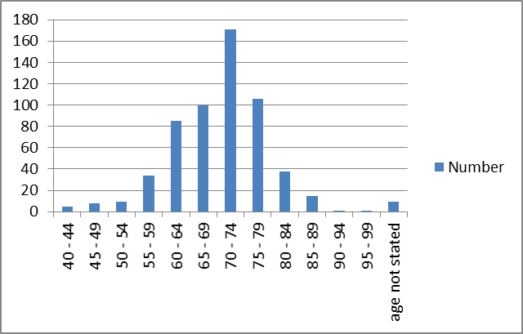

Fig 2b niveau de PSA initial de patient
Médian PSA 52.5ng/ml
Gamme (2.5 – 9,900)
Le PSA initial n’est pas cité.

(Fig 2c)Méthodes de biopsies utilisé
Les Types de Biopsies
TRUS GBX■ Prostatectomie ouverte ■ Pas cité .

Fig. 2d:Étape TNM

Fig 3 PROSTATECTOMIE RADICALE n = 86 T1T2 N0M0 PC PRE VS POST TRAITEMENT PSA
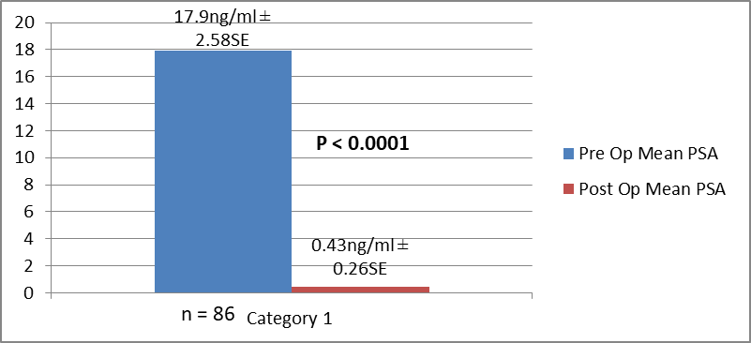
Catégorie 1
Fig 4 BRACHYTHERAPIE de 61 casT1 T2 N0M0 de PC
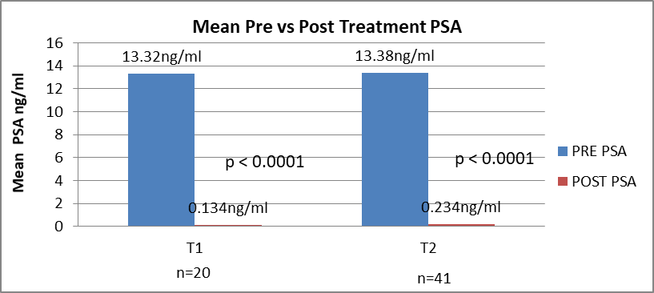
Moyen Pre contre le post traitement PSA

Fig 5 EBRT de 137 cas T1 T2 N0M0 de PC PRE CONTR POST Traitement PSA
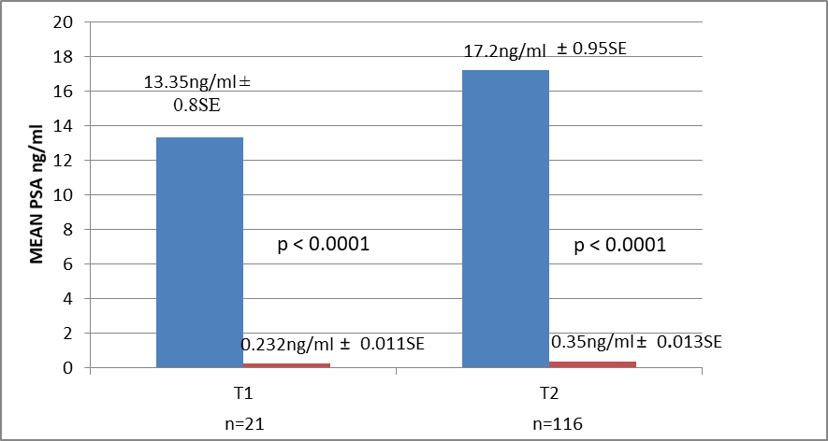

Fig. 6a: LOCALEMENT AVANCE CP Rx BRACHYTHERAPIE PRE & POST Rx
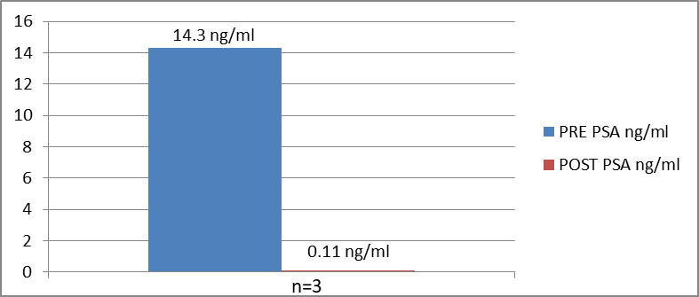
(median)

Fig. 6b: PRE CONTRE POST TRAITETMENT PSA LOCALEMENT AVANCE PC T3 T4 N0M0 TRAITE BY EBRT
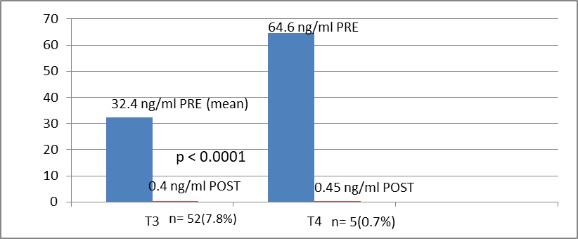
(median)

References
- Crawford ED. Épidémiologie de cancer prostate. Urology. 2003,62:3 – 12.
- Hsing AW.Des voies /façon de l’incidence de cancer et mortalité . Int J Cancer. 2000:85; 60 – 7.
- Glover Jr FE, Coffey DS, Douglas LL, Cadogan M, Russell H, Tulloch T, Baker TD, Wan RS, Walsh P. The Épidémiologie de cancer prostate en Jamaïque .J Urol. 1998;159(6):1984 –1987.
- Center MM, Jeme A, Lorte-Tievlent J, Ward E, Ferlay J, Brawley O, Bray F.Les variables International dans l’incidence PC et le taux la mortalité . Eur Urol. 2012; 61:1079–1092.
- Haas GP, Delongchamps N, Brawley OW, Wang CY, de la Roza G. Épidémiologie mondiale de cancer de la prostate :les perspectives des études d’autopsies . Can J Urol. 2008; 15:3866–3871.
- Parkin D, Whelan SL, Ferlay J, Hambi-Cherif M, Silas F, Thomas JO, Wablington H. Cancer prostate dans l ’ épidémiologie et la prévention. IARC Press Lyon France 2002.
- Parkin DM, Ferlay J, Curado MP, Bray F, Edwards B, Shin HR, Forman D Cinquante ans de l’incidences de . Journal International des problèmes du cancer 12 127: 2918 – 2927.
- Chu LW, Richey J, Devesa SS, Quraishi SM, Zhang H, Hsing AW. Le taux de l’ incidence de cancer prostate en Afrique . Cancer prostate cancer 2011: 947870.
- Gronberg H. PC Épidémiologie. Les Lancet Vol. 361 no. 9360:859 – 864.
- Hsing AW. Hormones et le cancer prostate ,et la suite? Epidemiol/Rev 2000; 23: 42 – 58.
- Rebbeck TR, Devesa SS, Chang BL, Cheng I Bunker CH, Cooney K, Gueyes SM, Yeboah ED, Hsing AW, Zeigler-Johnson CM.Les modèles globale de l’incidence de PC , l ’ agressivité et la mortalité chez les hommes de l ’ origine Africain .Cancer Prostate . 2013; 10560857:1 – 12.
- Bunker CH, Patrick AL, Konety BR, Onir R, Brufsky AM, Vivas CA, Beach MJ et al la haute prévalence de despitage détecté de cancer prostate chez les Afro - Caraïbe: le sondage de cancer de la prostrate deTobago– l’epidemologie de Cancer Biomarkers et la prévention. 2002; 8:726 – 729.
- Hsing AW, Yeboah ED, Biritwum R, Tettey Y, DeMarzo AM, Adjei AA, Netto G, Yu K, et al (2014) “La haute prévalence de PC détecté chez les hommes ouest africains , les Implications pour la disparité racial dans le cancer prostate” J Urology. 2014; 192(3):730 – 735.
- Cooperberg MR, Dubeck DP, Meng MY, Mehtan SS, Farall P.le changement des de visages de cancer de la prostate :les modèles de présentation clinique et gestion primaire . J Clinic Onco 2004; 22 (11) :2141 – 2149.
- Cooperberg MR, Mevi JW, Carrol P et al (2005)changement de risque faible CP,Changement de risque courte .les modèles de présentation clinicale et la gestion primaire . J Clinic Onco. 2005; 23(11): 8146 – 8151.
- Ritchey J, Biritwum RB, Yeboah ED, Tettey Y, Adjei A, Chokkallinghan A, Quaraishi S, Hsing AW. La taille du corps et d’autres caractéristiques epidemologique chez les hommes ouest africains , les implications pour la disparité raciale de cancer de la prostrate . Epidemologie Périodique d ’ Amérique(AJE).2008; 01354p.
- Mutetwa B, Taioli E, Ahong-Rogers. Le cancer de la prostate caractéristiques et survie et mâles l’Afrique African ancestre selon le lieu de naissance . Donnée de Brooklyn – New York, Guyana, Trinité et Tobago . Prostate. 2010; 70(10):1102 – 1109.
- Gann PH. Risque facteurs en CP. Rev Urol. 2002; 4 (5):3 – 10.
- Laponite J, Chinde LI, Higgins JP, de Rijin MJ, Bair E, Montgomery K, Ferrari M, Egevad L, et al.Le profil d'expression clinicale identifie les sous-type pertinent au cancer de la prostrate. Previsions academique national des sciences USA. 2008;1 (3):811 – 816.
- Walsh PC.Prostatectomie radicale le cancer prostate donne le contrôle cancer durable d’une qualité de vie excellente . Un débat structuré . J of Urol. 2000;163(6):1802 – 1807.
- Walsh PC, De Weere TL, Eisenberger MA, La pratique clinical localisé de cancer de la prostrate. N Eng J Med. 2007; 357: 2696 – 705.
- Kyei MY, Mensah JE, Gepi-Atee S, Kwami D, Ampadu K, Asante K, Klufio GO, Yeboah ED. Les résultats après la prostatectomie radicale Prostatectomie chez les Ghaneens; une expérience précoce de chirurgiens . ISRN Urol. 2013: Art. ID832496 p1 – 15.
- Weldon VE, Tavel FR, Neuwitt H. Continence, puissance et morbidité après la prostatectomie périnéale radicale. J Urol. 1997; 158: 1470 – 5.
- Link RE, Su LM, Sullivan W. Qualité de santé relié à la vie avant et après laparoscopy. J Urol. 2005;173:175-9.
- Morrison BF, Conrad K, Strachan G, Miller R, Aiken W, Mayhew. Les résultats de prostectomie radicale à l’ Université de l’ hôpital de l’inde ouest 2000 – 2007.Le journal médical de l’inde ouest . 60(1):68 – 72.
- Catalona WJ, Carvalhal GF, Mager DE, Smith DM. La contnence puissance et les taux de complications en 1,870 la consecutive prostatectomies radicale retropubic consécutive ” Journal de Urol. 1999;162(2):433 – 438.
- Patel VE, Palmer KI et al. Resultat de laparoscopique RP perioperative de 1500 cas. J Endo Urol. 2008; 22: 2209 – 305.
- Stolzenberg JU, Rabenat R, Do M, Kallidonis P, Liatsikos EN et al. Endoscopic extraperitoneal RP, expérience de 2000 cas de Université de Leipsig . J Endourol. 2008; 22(10): 2319 – 25.
- Isenlin CE, Robertson JE, Paulson DF. Résultat radical périnéale de prostatectomie oncologie pendant une période de 20 ans J Urology. 1999; 161:163-8.
- Fiecarra VI, Nonara G, Artibani W, Cestari A, Galfano A, Graefen M, Guazzoni G. Laparoscopic Retropubic et la prostatectomie radicale assistée robotic . Une revue systématique et l’analyse cumulative des études comparée. Eur Urol. 2009; 55:1037-63.
- MulCathy N. AUA et ASTRO problème de Joint Guide pour le post chirurgie radiothérapie . Medscape Medical news 2013.
- Aral IA. La thérapie de radiation externe en cancer prostrate MEDSCAPE Medical News.2014; p1 – 13.
- Dong SP.l’etat actuel de statut brachytherapie pour le cancer de la prostate. Korean J Urology. 2012; 53 (II): 743 – 749.
- Mensah JE, Yarney J, Vanderpuiye V, Akpakli E, Tagoe S, Sasu E. Prostate Brachytherapie prostate au Ghana.Notre expérience initiale . Journal de Brachytherapy contemporaine. 2016;8(5):289 – 385.
- Keyes M, Norris J, Mckenzie MD. Résultats des hommes traité avec la brachytherapie provisionnel sont parmi les meilleurs au monde. BC MJ. 2010;52(2):76 – 83.
- D’Amico AVI, Moul JW, Carrol PR, Sun L, Chen LD et al. Substitut de point final urrogate pour le cancer de la prostate de mortalite spécifique après la prostatectomie radicale ou thérapie de radiation. J Natl Cancer Institute. 2003; 85:136 – 138.
- Paulson DF. Les séries du traitement randomisé series avec chirurgie contre la radiation prostate adénocarcinome. NCI Monogr. 1988; 137 – 13.
- Zeleftsky MI, Fuks Z, Hunt M, Manon YY, Ling CC. L’intensite élevée en dose modulée pour la radiation thérapie de toxicité précoce de CP et les résultats de biochimie dans 772 patients. Int J Radiation Oncology Biol Physics. 2002;53(5): 1111-16.
- Bagshaw MA, Cox RS, Ramback JE.La thérapie de radiation pour la justification de cancer de la prostrate de suivi de long temps de suivi. UROL Clinics North Am. 1990; 17(4): 787 – 802.
- Schroder FH, Roacha M, Scandino P. La gestion de prise de decision clinicale de cancer de la Prostate . New Eng J Med. 2008; 3592: 2602-9.
- Huggins C, Stevens RE, Hodges V.Etudes sur PC II , concernant l’ effets de castrer de PC avancé . Archives de chirurgie . 1941; 43: 209 – 223.
- Nanniki M, Ueno S, Kitagawa Y, Fukagai T, Akaza H. L’efficacité et l’effet majeur de thérapie hormonale cancer de la prostate. Perspective d'expérience japonais .Asian Journal de Androl. 2012; 14(3):451 – 457.
- Prostate Cancer Trialists’ Collaborative Group. La bloquage maximum androgen dans le cancer de la prostate avancé .Un aperçu d’echantillon randomisé . Lancet 2000; 255: 1491 – 1498.
- Bolla M, Warde P, Collete L, Blank L, Dubois JB, Mirimane H, Storme G, et al. Résultats long terme avec la suppression androgen immédiat et EBRT chez les patients avec le CP localement avancé (une étude EORTIC )un essai randomisé de phase III . Lancet. 2002; 360:103 – 108.
- D’Lorenzo G, Buosherba C, Autorino R, Placido SD, and Scenberg CN.Castration résistant de cancer de la prostate actuel et des stratégies de traitement émergeant, Drogue. 2010;70(6):963 – 1000.
- Andriole GL, Levin DL, Crawford ED, Gelmann EP, Pinsky PF, Chia D, Kramer BS, et al. Depistage de cancer de la prostate en prostate,poumon ,colorectal et ovarien (PLCO) l’essai de depistage : Résultat de depistage intial de test randomisé .l’Institut Journal National de Cancer . 2005;97(6): 433 – 8.
- Shroder FH, Huggosson J, Rovbal MJ, Teuvo LJ, Tammela TLJ, Gatto S, et al. Depistage et balayage mortalité de cancer de la prostate dans l’étude randomisé européenne . N Eng J Med. 2009;360(13):1320 – 8.
- Grimm P, Billet I, Botswick D, Dicker AP, Frank S, Immerzeel J, Kupelian P, et al. L’analyse comparative des résultats de survie libres des patients avec un intermediat bas, et risque élevé de cancer de la prostate traité par la thérapie . Résultats de PC Gp. BJU.2012; 109(22)22 – 29.
- D’Amico AV, Chen MH, Renshaw AA, Loffredo RN, Kantoff PW, et al. La suppression androgen et radiation contre radiation seule pour le CP localement avancé CP. JAMA.2012;299(3):289 – 295.
- Pollack A, Zagare FK, Starkswell et al. PC réponse à la dose de radiation. Résultats de MD Anderson phase III randomisé . Int J Radiologie Oncologie 2002; 53:1097 – 103.
- Philips AA, Jacobson JS, Magai C, Consedius N, Horowicz-Mhler NC, Negut I. Lincidence de Cancer et mortalité Caraïbe. Enquête sur cancer2007; 5(6): 476-483.
- Yeboah ED, Mensah JE, Klufio GO, Mante SD. Ketoconazole et bisphosphats dans l’hormone réfractaire avancé de cancer prostate chez les Ghaneens. BJU Int.2002;90(2) 304.
- Powell IJ, Heilbrun L, Littrup PL, Franklin A, Parzuchowski J, Gelfend D, Sakr W. Résultat de depistage d’Afro- Americains pour le cancer prostate :L’education Detroit et détection précoce (DEED) étude. J Urol. 1997; 159(1): 146-149.
- Haiman CA, Chen GK, Blot WJ, Strom SS, Berndt SK, Inzes RA, Yeboah ED, Tettey Y, Adjei AA, Biritwum R. Etude immense de Genome PC in Men of African Ancestry identifies, a susceptibility locus at 17q21” Nature Genet. 2011; 43(6):570 – 573.
- Cook MB, Wang Z, Yeboah ED, Tettey Y, Biritwum RB, Adjei AA, Tay E, Truelove et al. L’etude immense d’association Génome sur le cancer de la prostate ches les hommes d’ Afrique de l’ouest . Génétique humaine. 2014;13 133(5):509 – 521.

