MARGINAL MICROLEAKAGE PROPERTIES OF ACTIVA BIOACTIVE RESTORATIVE AND NANOHYBRID COMPOSITE RESIN USING TWO DIFFERENT ADHESIVES IN NON CARIOUS CERVICAL LESIONS - AN IN VITRO STUDY
LES PROPRIETAIRES DE FUITE MARGINALES DE RESTAURATION ACTIVA BIOACTIVE ET RESIN COMPOSITE NANOHYBRIDE UTILISANT DEUX ADHESIVES DIFFERENTS DANS LA LESION CERVICALE NON CARIEUSE - UNE ÉTUDE VITRO

Kaushik M, *Yadav M

Department of Conservative Dentistry and Endodontics, Army College of Dental Sciences, Secunderabad, Telangana 500087, India. E-mail: monayadav91@gmail.com
*Correspondence

No grant support
No conflict of interest

Abstract
Background: In clinical practice, the restoration of non-carious cervical lesions is a challenge, because most of the time the cervical margin is located in cementum or dentin. This characteristic makes the cervical margin more susceptible to microleakage, causing cavosurface stains, postoperative sensitivity and also favours the incidence of carious lesions.
Aim: To compare and evaluate the microleakage in class V lesions restored with Activa Bioactive restorative and nanohybrid composite resin using two different bonding agents.
Methodology: In this study, 50 class V cavities were prepared in freshly extracted teeth. The samples were randomly divided into 5 groups (n=10), depending on the type of restorative material and bonding agent:
Group 1 - Activa Bioactive (Pulpdent, USA) + No bonding,
Group 2 - Activa Bioactive + Tetric N Bond (Ivoclar Vivadent, Colombia),
Group 3 - Activa Bioactive + G Bond (GC Corp., Tokyo, Japan),
Group 4 - Nanohybrid Composite (Ivoclar Vivadent, Colombia) + Tetric N Bond,
Group 5 - Nanohybrid Composite + G Bond.
The samples were restored with their respective material based on the group. After curing all the specimens were subjected to thermocycling and cyclic loading. Specimens were stained with 2% rhodamin b dye and evaluated for dye penetration.
Results: Results were obtained based on Kruskal Wallis and Mann Whitney U- test.
Conclusion: Within the limitations of this study, none of the materials were free from microleakage. All the materials showed more microleakage at gingival margins compared to occlusal margins. Among all the groups Activa Bioactive restorative when used in combination with Tetric N Bond showed the least microleakage.
Key word: Activa Bioactive, Non Carious Cervical Lesions, Microleakage.
Abstrait
Contexte: Dans la pratique clinicale, la restauration de lésions cervicale non-carieuse est un défi , parce que la plupart du temps la marge cervicale est localisé dans le cément ou la dentine. Ces caractéristiques fait que la marge cervicale soit plus susceptible à micro-fuite,qui cause les taches superficielle , sensitivite post-opératoire et aussi favoriser l’ incidence de lésions carieuses .
But: Pour comparer et évaluer la micro-fuite dans les lésions restaurés avec Activa BioACTIVE restauration et la composite résine de nanohybride de lésions classe V et composite nanohybride résine utilisant deux agents différent d’ agent de liaison .
Méthodologie: In Dans cette étude , 50 cavités classe V ont été préparé dans les dents nouvellement enlevé. Des échantillons étaient divisé aléatoirement en 5 groupes (n=10), selon le type de matériel de restauration et agent de liaison:
Groupe 1 - Activa Bioactive (Pulpdent, États Unis) + Aucune liaison ,
Groupe 2 - Activa Bioactive + le lien Tétrique N (Ivoclar Vivadent, Colombie),
Groupe 3 - Activa Bioactive + le lien G (GC Corp., Tokyo, Japon),
Groupe 4 - Composite Nanohybride (Ivoclar Vivadent, Colombie) + le lien Tétrique N ,
Group 5 - Composite Nanohybrid + le lien G .
Des échantillons étaient restauré avec leur matériel respective selon le groupe. Après le durcissement ,tout les spécimen étaient soumis à la thermocyclage et charge cyclique. Des spécimen étaient coloré avec 2% rhodamin b colorant et évalué pour la penetration de coloration .
Résultats: Les résultats étaient obtenu basé sur le test de Kruskal Wallis et Mann Whitney
Conclusion: Dans les limitations de cette étude , aucun des matériels étaient libre de micro- fuite. Tous les matériels ont montré plus de micro-fuite à la marge gingivale comparé à la marge occlusal . Parmi les groupes Activa BioACTIVE restauration lorse qu’il est utilisé en combinaison avec Tetric N Bond a montré le moins micro-fuite
Mots clés Key :Activa BioACTIVE, Non Carieuse Cervicale Lésions, Micro-fuite.

INTRODUCTION
Non carious cervical lesions (NCCLs) are the cynosure in clinical dentistry, especially among clinical practitioners because of their increasing prevalence¹. Restoring such lesions is technique sensitive and may lead to failure of cervical adhesive restorations due to a variety of factors like, poor isolation, cusp movement during occlusion or adhesion to different substrates (enamel and dentin/ cementum).
A variety of materials are available for restoring class V lesions, like Glass ionomer cement, resin modified GIC and composite resin. Out of these, the most popular restorative material is composite resin due to its esthetics and strength. However it has a drawback in the form of polymerization shrinkage, which is the main reason for marginal gap formations and subsequent marginal leakage².
Bioactive restorative materials are a relatively new concept in dentistry. They are reported to release more fluoride than glass ionomers. Additionally, they react to pH changes in the mouth by uptaking calcium, phosphate, and fluoride ions to maintain the chemical integrity of the tooth structure. Activa Bioactive restorative (Pulpdent, USA) is one such restorative material which comprises of a patented bioactive shock-absorbing rubberized ionic-resin (Embrace resin) matrix that contains a small amount of water. It contains no Bisphenol A, Bis-GMA or BPA derivatives³. This class of composites is delivered via a dual-barrel automix syringe and can be placed with or without a bonding agent. However, as per the manufacturer, it is advisable to use a bonding agent in cases of additional retention, like in class V lesions.
There is a constant ongoing research towards the development of an ideal restorative material as well as new adhesives to reduce the microleakage & enhance the bond strength. However, despite the advances in these materials, the marginal integrity, which is the most important feature of adhesive restorative materials, still remains a challenge. A substandard marginal integrity can lead to formation of gaps at the tooth- restorative interface resulting in microleakage, which poses serious clinical problems such as, secondary caries, marginal discoloration and hypersensitivity, all of which may result in failure of restorations⁴.
Thus the purpose of this in vitro study was to compare the Activa bioactive restorative (Pulpdent, USA) with the commonly used nanohybrid composite (Ivoclar Vivadent, Colombia) by varying the bonding agents in NCCLs. The null hypothesis states that there is no difference in the performance of the two materials.

MATERIALS AND METHODS

Fifty freshly extracted human premolar (both maxillary and mandibular) teeth free of caries, cracks, abrasions, attrition, and restorations were collected from the Department of Oral and Maxillofacial Surgery, Army College of Dental Sciences. Any extrinsic stains or calculus deposits on the teeth were cleaned and specimens were stored in isotonic saline until use.

Preparation of sample
Box-type Class V cavities of dimension, 2mm x3mm x2mm (2mm inciso- gingivally, 3mm mesio-distally & 2mm in depth), were prepared on the buccal surface of the premolars as shown figure 2, A. The dimensions of the prepared cavities were standardized using Vernier caliper. The prepared cavities were rinsed thoroughly with air/water spray.
Division of samples
The samples were randomly divided into 5 groups (n=10), depending on the type of restorative material and bonding agent as shown in figure 1.
Restoration of samples
Depending on the group, each group was bonded with different adhesives, Tetric N Bond (Ivoclar Vivadent, Colombia) and G Bond (GC Corp., Tokyo, Japan) as per manufacturer’s instructions except in group 1, where no bonding agent was applied. The cavities were restored with Activa Bioactive (Pulpdent, USA) and Nanohybrid Composite (Ivoclar Vivadent, Colombia), A2 shade, using incremental technique and light-cured for 20 sec. The restorations were finished and polished using Super- Snap Mini- Kit (Shofu Dental Corporation), after which the specimens were stored in 100% humidity for 24 hours.

Thermocycling and dye immersion
The samples were subjected to thermocycling in a water bath for 500 cycles between 5° and 55°C with a dwell time of 25 s followed by subjecting them to cyclic loading for 10,000 cycles. Following this, all the surfaces of the samples were triple coated with nail varnish, except a 1 mm cavosurface margin around the restoration and their apices were sealed with wax as shown in figure 2, B. All specimens were immersed in 2% rhodamine B dye solution for 24 hrs after which they were rinsed with water and air-dried.

Microleakage
The samples were longitudinally sectioned in a buccolingual direction using a diamond disc. The sectioned restorations were examined under a stereomicroscope at 30 X magnification as shown in figure 3. The depth of dye penetration was analyzed based on a scoring system suggested by Silveira de Araújo et al⁴.
Score 0 - No dye penetration
Score 1 – Penetration involving half the occlusal/gingival wall
Score 2 – Penetration involving more than half the occlusal/gingival wall
Score 3 – Penetration involving the axial wall
Score 0
Score 1
Score 2
Statistical analysis
The statistical analysis for microleakage was performed using the Kruskal Wallis test followed by the Mann Whitney U-tests with the Wilcoxon correction for pair-wise comparisons at a significance level of p < 0.05.

RESULTS
A total of 50 teeth were restored during this study with Activa Bioactive & Nanohybrid composite resin restorative material using two different adhesive systems. The tooth- resin interface at the restorative margins was assessed for microleakage. The microleakage in Activa Bioactive restorative at the enamel and dentin margins in comparison to Nanohybrid Composite resin with their respective bonding agents is shown in figure 4.

In figure 4,
Group 2 (Activa Bioactive + Tetric N Bond) depicts least microleakage as compared to group 5 (Nanohybrid Composite + G Bond), which has shown highest microleakage.
Microleakage in G Bond adhesive groups is greater than Tetric N Bond adhesive groups.
Maximum leakage was observed at dentin margins as compared to enamel margins.

The dye penetration was observed to be higher in dentin margins among all the groups as shown in Table 1. The Kruskal Wallis test compared dye leakage at enamel and dentin margins. However, statistically, for all the groups at the enamel and dentin margins p > 0.05.Thus, it can be concluded that although all the experimental groups showed dye leakage at the enamel and dentin margins, statistically, there was no significant difference in leakage at both the margins.
When pair-wise comparisons were made by the Mann Whitney U-test, Group 2 (Activa Bioactive + Tetric N Bond) showed lesser dye leakage than the rest of the groups along both the enamel and the dentin margins. However, this difference was not significant statistically.
The results for dye leakage are obtained in the ascending order as:
Activa Bioactive + Tetric N Bond < Composite + Tetric N Bond < Activa Bioactive +No bonding < Activa Bioactive + G Bond < Composite + G Bond.

DISCUSSION
There is a constant increase in aesthetic demand for a material that ensures near to perfect adhesion to the tooth surface in order to minimize microleakage and improve marginal integrity. Microleakage forms the basis for predicting the performance of any restorative material. Several methods are available for detecting microleakage. These include scanning electron microscopy, the use of dyes, chemical tracers, and radioactive tracers, neutron activation analysis, and fluid filtration⁵. A dye leakage method was used in this study as it is simple, reliable and well accepted.
Among the various dyes available, rhodamine b dye was selected for this study because it has greater diffusion on human dentin than methylene blue. It has a low molecular size of 1 nm, which is smaller than the diameter of a dentinal tubule and has the ability to penetrate through the smallest of gaps between the interface of the tooth and restoration⁶. The extent of dye penetration indicates the gaps between the interface of tooth and the restorative material which may lead to ingress of bacteria and their byproducts.
Class V cavities offer a good experiment for testing adaptation of material to the tooth substrate. The cervical lesions pose a restorative challenge due to the complex morphology, where the coronal margin is in enamel and cervical margin in dentin/ cementum. Thus, in the present study class V cavities were selected. The reasons for increased microleakage at the dentinal margin as compared to enamel margin may be^{7,8}:
The organic content of dentin substrate and outward movement of dentinal tubular fluids.
Incomplete removal of the smear layer for adequate demineralization and hybrid layer formation, by acidic primers.
The solvent carriers such as, water, alcohol, and acetone, in the adhesives may react differently with varying degrees of surface moisture present in the tubules.
Orientation of dentin tubule to the cervical wall (CEJ) – Dentinal tubules are oriented parallel to the cervical wall in class V cavities which are located at approximately 1 mm from the CEJ. The hybrid layer formation is absent in the dentinal margins, and is an important cause of leakage.
Due to the intake of food and fluids at varying temperatures, when the restorative materials are placed in the oral environment, they are constantly exposed to thermal variations which may affect their long term performance. Thus, to simulate temperature changes that take place in the oral environment, all the specimens for microleakage evaluation were subjected to thermocycling procedures at temperatures of 5°-55°±10°C, with a dwell time of 25 s, for 500 cycles⁹. The cyclic loading was performed as the occlusal stresses produced in the cervical region of a tooth during normal function and parafunction may increase microleakage and deteriorate the margins of class V restorations¹⁰.

The results of the present study found that Activa Bioactive restorative exhibited less microleakage in comparison to nano hybrid composite. This could be attributed to the ionic resin component which contains phosphate acid groups with antimicrobial properties that improve the interaction between the resin and the reactive glass fillers and enhance the interaction with tooth structure¹¹. The hydrogen ions break off from the phosphate groups through an ionization process that is dependent upon water & are replaced by calcium in the tooth structure. This ionic interaction binds the resin to the minerals in the tooth, forming a strong resin-hydroxyapatite complex and a positive seal against microleakage^{11,12}. However, when used in combination with a bonding agent, Tetric N Bond exhibited least microleakage values among all the groups.

Tetric N Bond is a fifth generation bonding agent which contains HEMA (2-hydroxy-ethyl-methacrylate) in significantly high quantities. HEMA has the characteristic of wetting the tooth surface in a positive way and has high penetration capacity into the etched dentin. It mixes the hydrophilic and hydrophobic components of the bonding agent into one solution and acts as a co-solvent by dissolving the various components into water providing a stronger bond. On the other hand, G Bond (GC Corp., Tokyo, Japan) in group 3 and 5, exhibited greater microleakage as compared to Tetric N Bond (group 2 and 4). The reason for this can be attributed to the absence of HEMA. In absence of HEMA, the collagen peptides forms intermolecular hydrogen bonds with the nearest neighboring collagen peptides causing the collapse of the collagen network leading to weaker bonds and higher microleakage^{13,14}.

The limitation of the study:
The present research work was carried out on a small sample size which could be the limitation of this study. Also this in vitro research was performed using standard method of themocycling with cyclic loading to simulate the intraoral environment for checking the microleakage at the tooth- restoration interface. However, further research by conducting in vivo studies could authenticate these results.

CONCLUSION: Based on the present study, Activa Bioactive restorative, in combination with a 5th generation bonding agent, Tetric N Bond, showed lesser microleakage in comparison to other groups. However, the difference was not significant statistically. Thus, it may be considered as a good restorative option for restoring cervical lesions.

ACKNOWLEDGEMENT
This study was supported by the Department of Prosthodontics, Army College of Dental Sciences, Secunderabad, India. The authors do not have any financial interest in the companies whose materials are included in this article

REFERENCES
1. Smith B and Robb N. The prevalence of toothwear in 1007 dental patients. Journal of Oral Rehabilitation. 1996;23 (4):232–239.
2.Gerdolle D, Mortier E, Droz D. Microleakage and Polymerization Shrinkage of Various Polymer Restorative Materials. Journal of Dentistry for Children. 2008;75(2):125-133.
3.The Future of Dentistry Now in Your Hands. PULPDENT publication XF- VWP REV: 05/2014. Watertown, MA: Pulpdent Corporation; 2014.
4.Franco EB, Gonzaga Lopes L, Lia Mondelli RF, da Silva e Souza MH Jr, Pereira Lauris JR. Effect of the cavity configuration factor on the marginal microleakage of esthetic restorative materials. Am J Dent. 2003;16(3):211-4.
5.Alani AH, Toh CG. Detection of microleakage around dental restorations: A review. Oper Dent 1997;22:173-85.
6.Bortoluzzi EA, Broon NJ, Bramante CM, Garcia RB, de Moraes IG, Bemardeineli N. Sealing ability of MTA and radiopaque portland cement with or without calcium chloride for root-end filling. J Endod. 2006;32:897-900.
7.Owens BM, Johnson WW. Effect of single step adhesives on the marginal permeability of class V resin restorations. Oper Dent. 2007;32:67–72.
8.Santini A, Ivanovic V, Ibbetson R, Milia E. Influence of cavity configuration on microleakage around class V restorations bonded with seven self etching adhesives. J Esthet Restor Dent. 2004;16:128–36.
9.Pazinatto FB, Campos BB, Costa LC, Atta MT. Effect of the number of thermocycles on microleakage of resin composite restorations. Pesqui Odontol Bras 2003;17:337-41.
10. Arisu H. D., Uçtasli M. B., Eligüzeloglu E., Ozcan S., Omürlü H. The effect of occlusal loading on the microleakage of class V restorations. Oper Dent. 2008;33(2):135–141. doi: 10.2341/07-49.
11.Naorungroj S, Wei HH, Arnold RR, Swift EJ Jr, Walter R. Antibacterial surface properties of fluoride-containing resin-based sealants. J Dent 2010;38(5):387-91.
12.Zmener O, Pameijer CH, Hernandez S. Resistance against bacterial leakage of four luting agents used for cementation of complete cast crowns. Am J Dent 2014;27(1):51-55.
13.Singla R, Bogra P and Singal B. Comparative evaluation of traditional and self-priming hydrophilic resin. J Conserv Dent 2012;15(3):233-6.
14.Nikhil V, Singh V, Chaudhry S. Comparative evaluation of bond strength of three contemporary self-etch adhesives: An ex vivo study. Contemp Clin Dent 2011;2:94-7.
A

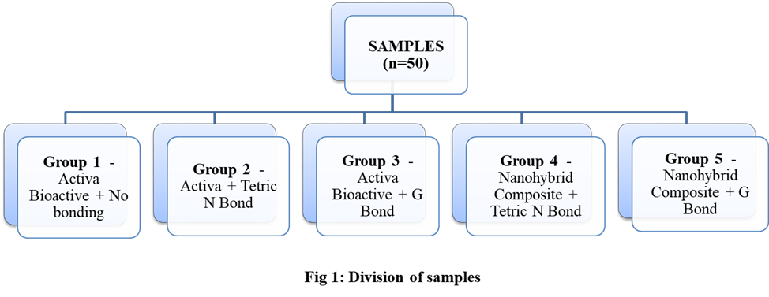
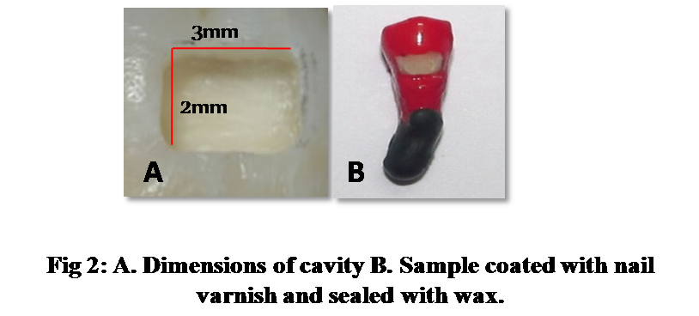

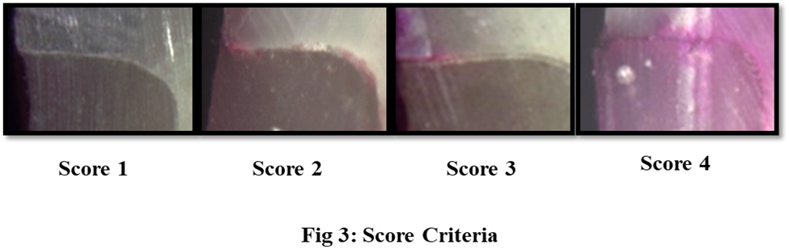

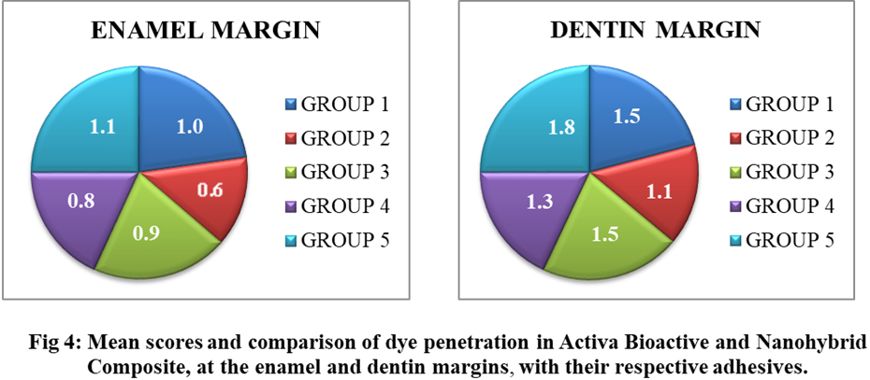

Groups Scoring 0 1 2 3 Total
Cavity margins
Activa Bioactive + No bonding Enamel 4 3 2 1 10
Dentin 3 2 2 3 10

Activa Bioactive + Tetric N Bond Enamel 5 4 1 0 10
Dentin 3 4 2 1 10

Activa Bioactive + G Bond Enamel 4 3 3 0 10
Dentin 1 5 2 2 10
Nanohybrid Composite + Tetric N Bond Enamel 4 4 2 0 10
Dentin 2 5 1 2 10

Nanohybrid Composite + G Bond Enamel 3 4 2 1 10
Dentin 0 4 4 2 10

Table 1: Distribution of dye penetration scores at the enamel and dentin margins in all the groups

INTRODUCTION
Les lésion Non carieuse cervicale (NCCLs)sont le summum dans la clinicale de dentistrie, particulièrement parmi les practiticiens clinical par la raison de leur prévalence augmenté ¹. Pour restaurer ce genre de lésions est une technique sensible et peut mener à l’echec de la restauration adhésive cervicale par la raison des facteurs varier comme, la pauvre isolation, le mouvement de cuspide lors d’occlusion ou adhésion aux différents substrats ( l ’ émail dentine/ cément).
Une variété des matériels sont disponibles pour la restauration de lésions classe V , comme verre ionomere ciment, résine modifié GIC et composite résine. Parmi eux, le matériel restaurative le plus populaire est la composite résine en raison de son esthétiques et force. Néanmoins il a un inconvénient à la forme de polymérisation de rétrécissement, ce qui est la raison principale pour la formation de l’ecart marginal et fuite subséquent marginal ².
Les matériels bioactive restaurations sont relativement un nouveau conception dans la dentistrie . Selon le rapport donné il libère plus de fluorure que le verre ionomere. En plus, il réagit au changement de pH dans la bouche par l ’ absorption de calcium, phosphate, et l’ion fluorure pour maintenir l'intégrité chimie de la structure de dent . La restoration Activa Bioactive (Pulpdent, États Unis) est l’un de matériel restauration qui consiste de breveté bioactive amortisseurs de résine ionique caoutchoutée (Embrasser la résine ) matrice qui contient peu d’eau. Il contient aucune Bisphenol A, Bis-GMA ou BPA derivatives ³. Cette classe de composites est délivré à travers un double cylindre seringue automix et peut être placé avec ou sans agent de liaison . Quoique , concernant le fabriquant, il est conseillé d'utiliser un agent liaison dans les cas additionnels de retention,comme les lesions de classe V .
Il y a une recherche régulier cours vers le développement d’un matériel de restauration idéal ainsi que des nouveaux adhésives pour réduire le micro-fuite et améliorer la force de liaison . Néanmoins , malgré les progrès dans ces matériels, l ’ intégrité marginale, ce qui est le plus important de caractéristique de matériel restative adhésive , reste encore un défi d’une intégrité marginale .Sous qualité peut mener à la formation des écarts dans l’interface de dent - restauration résultant en micro-fuite, ce qui crée des problèmes clinical sérieux comme, carie secondaire, décolorations de decolorisation marginale et l’hypersensitivite, tout ce qui peut résulter dans l’echec de restaurations⁴.
Donc son but dans cette étude vitro c’est de comparer la restauration Activa bioactive (Pulpdent, États Unis) avec la composite nanohybride utilisé régulièrement (Ivoclar Vivadent, Colombie) par des agents varier de liaison dans NCCLs. L ’ hypothèses de nul indique qu’il n y a aucune différence dans les performances des deux matériel .

MATERIELS ET MÉTHODE

Cinquante premolaire humain nouvellement enlevé (le maxillaire et mandibulaire) les dents libre de carie,fissure,abrasions, attrition, et restaurations ont été collecté du Département de Chirurgie Maxillofacial et Orale , Collège Militaire de sciences dentaires .N’importe qu'elle tache extrinsèque calcul déposé sur le dent était nettoyé et les spécimen étaient gardé dans le salin jusqu'à l’usage .

Préparation d'échantillon
Cavités type-boite de Classe V de dimension, 2mm x3mm x2mm (2mm inciso- gingivale, 3mm mesia-distal & 2mm en profondeur), était préparé sur la surface buccal des prémolaires comme montré dans la figure 2, A. Les dimensions des cavités préparé etait standardisé utilisant vernier . Les cavités étaient bien rincé soigneusement avec pulvérisateur de l’eau .
Division des échantillons
Les échantillons étaient divisé aléatoirement dans 5 groupes (n=10), selon le type de matériel restaurative et agent liaison comme montré dans la figure 1.
Restauration des échantillons
Selon le groupe, chaque groupe était lié avec des adhésives différentes, le lien Tétrique N (Ivoclar Vivadent, Colombie) et le lien G (GC Corp., Tokyo, Japon)selon les instructions de fabriquant excepté le groupe 1, là où aucun agent liaison était appliqué .Les cavités étaient restauré avec Activa Bioactive (Pulpdent, États Unis) et la composite Nanohybride (Ivoclar Vivadent, Colombie), A2 nuance , utilisant la technique incremental et polymeriser pendant 20 second . Les restaurations étaient fini et polir utilisant le Super- Snap Mini- Kit (Shofu Dental Corporation), et après les spécimens étaient gardé en 100% humidité pendant 24 heures.

Thermocyclage et colorisation d'immersion
Les échantillons étaient soumis à la thermocyclage dans l’eau de bain pour 500 cycles entre 5° et 55°C avec une durée de temporisation de 25 s suivi en les soumis à la charge cyclique de 10,000 cycles. Suite de cela , tout les surfaces des échantillons étaient triple revêtements avec le vernis à l’angle, excepté un1 mm la marge cavosurface autour de restauration et leurs apex étaient scellé avec le cire comme montré dans la figure 2, B. Tout les spécimens étaient s'immerger dans 2% rhodamine B de solution colorant pendant 24 h après qu’ils étaient rincé avec l’eau et séché à l’air.

Micro-fuite
Les échantillons étaient sectionné longitudinalement dans une direction buccolinguale utilisant un disque diamant . Les restaurations étaient examiné sous un stéréoscopique à un taux d'agrandissement de 30 X comme montré dans la figure 3. Le profondeur de la penetration de colorant était analysé basé sur un système de barème suggéré par Silveira de Araújo et al⁴.
La note 0 - Aucune penetration de colorant
Score 1 – Penetration qui inclut la moitié d’occlusal/le mur gingivale .
Score 2 – Penetration qui inclut plus que la moitié d’occlusal/mur gingivale
Score 3 – Penetration qui inclut le mur paroi axiale.
Score 0
Score 1
Score 2
Analyse Statistique
L’analyse statistique pour la micro-fuite était fait en utilisant le test Kruskal Wallis suivi par le test de Mann Whitney avec correction de Wilcoxon des comparaison par paire à une niveau significative de p < 0.05.

RESULTATS
Un total de 50 dents étaient restauré lors de cette étude avec Activa BioACTIVE et composite Nanohybride de résine restaurative material utilisant deux systèmes différents adhésives . L’interface de dent - résine à la marge restauration étaient évalué pour le micro-fuite. Le micro-fuite en Activa Bioactive restaurative à l’ émail et la marge dentine en comparaison à la résine composite Nanohybride avec leur agents de liaison respectivement est montré dans la figure 4.

Dans la figure 4,
Groupe 2 (Activa Bioactive + le lien Tétrique N ) montre le moins micro-fuite comme comparé au groupe 5 (Composite Nanohybride + le lien G ), qui a montré le plus élevé micro-fuite.
Micro-fuite dans la liason adhésif G des groupes est plus grand quel La liaison Tétrique N de groupes adhésives.
Le micro-fuite maximum était observé à la marge dentine comme comparé à la marge émail .

La penetration de coloration était observé d’être plus élevé dans la marge dentine parmi les groupes montré au Tableau 1. Le test Kruskal Wallis a comparé la fuite coloré à l’émail et la marge dentine . Néanmoins ,statistiquement, pour tout les groupes à la marges émail et la marge dentine p > 0.05.Donc, on peut fait une conclusion que même que tout les groupes expérimentals ont montré la fuite de coloration à l’émail et la marge dentine, statistiquement, il n y a aucune différence significative dans la fuite et les deux marges .
Quand la comparaison par paire étaient fait avec le test Mann Whitney , Groupe 2 (Activa Bioactive + le lien Tétrique N ) a montré de moins fuite que le reste du groupes au long d ’ émail et la marge dentine . Néanmoins, cette différence n'avait pas de différence significative statistiquement.
Les résultats pour la fuite de colorisation étaient obtenu dans une ordre croissant comme:
Activa Bioactive + le lien Tétrique N < Composite + le lien Tétrique N < Activa Bioactive +Aucune liaison < Activa Bioactive + le lien G < Composite + le lien G .

DISCUSSION
Il y a une régulière augmentation esthétique pour la demande d’ un matériel qui assure que la presque parfait adhésion à la surface de dent à fin de minimiser la micro- fuite et améliorer l’ intégrité marginale. La micro-fuite forme la base de prédire la performance de n’importe quel matériel restaurative . Plusieurs méthode sont disponibles pour détecter la micro-fuite . Ceux ci incluent la microscopique électronique à balayage,l’usage de colorations, traceurs chimiques , et traceur radioactive, l’ analyse d’activation neutron, la filtration de fluide ⁵. Une méthode de fuite a été utilisé dans cette étude comme il est simple, fiable et bien accepté.
Parmi les colorisations varier disponible, le colorant b rhodamine a été sélectionné pour cette étude parce qu’il avait un plus grand diffusion sur la dentine humain que le bleu de méthylène . Il a une taille bas moléculaire de 1 nm, ce qui est plus petit que la diamètre des tubules dentinaires et il a la capacité de pénétrer par les plus petits écarts entre l’interface de dent et restauation⁶. Ampleur de penetration de colorant indique les écarts entre l’interface de dent et le matériel restorative qui peut mener à l ’ infiltration de bactériémie et leurs sous-produit
Les cavités de la classe V offre une bonne expérience pour tester l’adaptation de matériel à la dent substrats. La lésion cervicale pose un défi restaurative en raison de morphologie complexe , là où la marge coronale est dans l ’ émail et la marge cervicale en dentine/ cément. Alors, dans l’étude présente les cavités de la classe V étaient sélectionné . Les raison pour le micro-fuite augmenté dans la marge dentinaire comme comparé à la marge émail peut être^{7,8}:
Le contenu organique de substrat de dentine et un mouvement vers l'extérieur de fluides tubulaires dentinaires.
L ’ enlèvement incomplète de la boue dentinaire pour déminéralisation adéquat et la formation de la boue hybride , par les amorces acides.
Les porteurs de solvant ainsi que ,l’eau, alcool, et acétone, dans les adhésives peuvent réagit différemment avec les degrés varier de surface humidité présent dans les tubules.
L’orientation de tubule dentinaires au mur cervicale (CEJ) – Les tubules dentinaires sont orientée parallèlement au mur cervicale dans la classe V des cavités qui sont localisé à approximativement 1 mm du CEJ. La formation de couche hybride est absent dans la marge dentinaires et c’est un important cause de fuite.
Par la raison de consommation de nourriture et les fluides au températures, quand les matériels restorative étaient placé dans environment oral , ils sont régulièrement exposés aux variations thermal qui peut affecté leurs performances long terme. Alors , pour simuler le changement température qui a eu lieu dans environnement oral ,tout les spécimen d ’ évaluation pour la fuite était soumis au procédures de thermocyclage à une température de 5°-55°±10°C, avec un temps durée de temporisation de 25 s, pour 500 cycles⁹. La charge cyclique a été fait comme le contraintes occlusales produit dans la région cervicale d’une dent pendant une fonction normale et parafonction peut augmenter le micro-fuite et détériorer les marges de restauration de classe V ¹⁰.

Les résultats de cette étude présente à trouvé que la restauration Activa Bioactive a exposé moins de micro-fuite en comparaison à la composite nano hybride . Cela peut être attribué au composant de résine ionique qui contient groupe phosphate acide avec les propriétés antimicrobiennes qui améliore l’ interaction entre la résine et la charge de verre réactive et améliore l’interaction avec la structure de dent ¹¹. L'hydrogène ions s’interrompe du groupe phosphate à travers un procès d’ionisation qui dépend sur l’eau et qui est remplacé par le calcium dans la structure de dent . Cette interaction ionique lie la résine aux minéraux de dent , qui forme un fort résine-hydroxyapatite complexe et un scelle positive contre le micro-fuite ^{11,12}. Néanmoins, quand il est utilisé en combinaison avec un agent de liaison , lien tétrique N a exposé moins de valeur fuite parmi tout les groupes.

Le lien Tétrique N est un cinquième génération d’agent liaison qui contient le HEMA (2-hydroxy-ethyl-methacrylate)dans une quantité élevé significative . HEMA a une caractéristique de mouiller la surface de dent dans une façon positive et a une capacité de penetration élevé dans la borde dentine. Il mélange les composants hydrophile et hydrophobe de l’agent de liason dans une solution et agit comme co-solvant en dissolvant des composants varier dans l’eau en donnant un fort lien . Dans l’autre côté ,un lien de G (GC Corp., Tokyo, Japon) dans les groupes 3 et 5, ont exposé plus de micro-fuite en comparaison au lien Tetric N (groupes 2 et 4). La raison pour cela peut être attribué à l’absence d’ HEMA. Dans l’absence de HEMA, la collagène peptides forment un lien intermoleculaire l'hydrogène avec la plus proche peptides collagène qui cause l’effondrement du réseau collagène qui mène à la faible lien et le micro-fuite élevé ^{13,14}.

Limitation de l’étude: La recherche présent à été fait avec des petits taille d'échantillon qui peut être la limitation de cette étude. Et dans la recherche vitro a été réalisée utilisant la méthode standard de thermocyclage avec la charge cyclique pour simuler l’environnement intraoral pour verifier le micro-fuite à la restauration de l’ interface de dent .Néanmoins, plus de recherche conduire dans l’étude vitro peut valider ces résultats .

CONCLUSION: Basé sur cette étude présente , la restaurationActiva Bioactive ,en combinaison avec with un 5eme génération agent liaison , le lien Tétrique N , a montré moins de micro-fuite en comparaison aux autres groupes. Néanmoins, la différence n’était pas significative statistiquement . Alors, cela peut être considéré comme une bonne option de restaurative pour restaurer les lésions cervicale.

RECONNAISANCE
Cette étude était soutenir par le Département de .Prosthodontie, Collège Militaire de Sciences dentaires Collège, Secunderabad, l’Inde. Les auteurs n’ont pas aucun intérêt financière dans les entreprises dont leurs matériaux étaient inclut dans les références de cette article.

References
1.Smith B, Robb N. La prévalence de dentrllerie dans les patients dentaire 1007 . Journal de Réhabilitation orale . 1996;23 (4):232–239.
2.Gerdolle D, Mortier E, Droz D.Micro-fuite et Polymérisation rétrécissement de matériel varier de polymer restauration . Journal Dentistrie pour les enfants. 2008;75(2):125-133.
3.Le futur de dentistrie dans vos mains maintenant. PULPDENT publication XF- VWP REV: 05/2014. Watertown, MA: Pulpdent Corporation; 2014.
4.Franco EB, Gonzaga Lopes L, Lia Mondelli RF, da Silva e Souza MH Jr, Pereira Lauris JR.L’effet du facteur de la configuration de cavité sur un micro-fuite marginale des matériaux de restauration esthétique . Am J Dent. 2003;16(3):211-4.
5.Alani AH, Toh CG. Détection de micro-fuite autour des restaurations dentaire : Une revue. Oper Dent 1997;22:173-85.
6.Bortoluzzi EA, Broon NJ, Bramante CM, Garcia RB, de Moraes IG, Bemardeineli N.sceller la capacité de MTA et radiopaque portland cement avec ou sans calcium chloride pour la remplissage de l'extrémité de la racine . J Endod. 2006;32:897-900.
7.Owens BM, Johnson WW. L’effet d’une seule étape adhésives sur la perméabilité marginale de classe V résine restaurations. Oper Dent. 2007;32:67–72.
8.Santini A, Ivanovic V, Ibbetson R, Milia E. L’ Influence de configuration de cavité sur la micro-fuite autour de classe V restaurations collé avec sept gravures automatique adhésives. J Esthet Restor Dent. 2004;16:128–36.
9.Pazinatto FB, Campos BB, Costa LC, Atta MT. L’Effet de nombres thermocycles sur micro-fuite de restauration de résine composite . Pesqui Odontol Bras 2003;17:337-41.
10.Arisu H. D., Uçtasli M. B., Eligüzeloglu E., Ozcan S., Omürlü H. L’effet du chargement occlusal sur le micro-fuite de restauration de classe V . Oper Dent. 2008;33(2):135–141. doi: 10.2341/07-49.
11.Naorungroj S, Wei HH, Arnold RR, Swift EJ Jr, Walter R. Antibacterien
surface de propriétaires de fluorure-qui contient scellent à base de résine . J Dent 2010;38(5):387-91.
12.Zmener O, Pameijer CH, Hernandez S. Résistance contre la fuite bactérienne pour quatre agents de lutage utilisé pour la cimentation de couronne complète. Am J Dent 2014;27(1):51-55.
13.Singla R, Bogra P and Singal B. Evaluation comparative traditionnelle et auto- amorçant de résine hydrophile . J Conserv Dent 2012;15(3):233-6.
14.Nikhil V, Singh V, Chaudhry S. Evaluation comparative de force de liaison de trois contemporaire d ’ adhésive automordancant : une étude vitro. Contemp Clin Dent 2011;2:94-7.
A

Fig 2: A. Les dimensions de cavité . B . Echantillon démaquillé de vernis à ongles et scellé avec le cire .
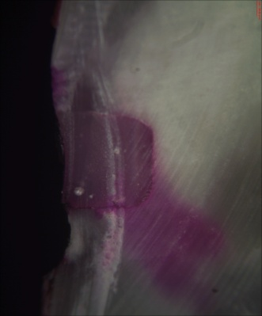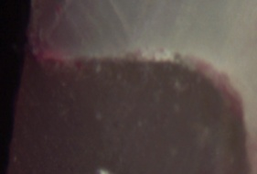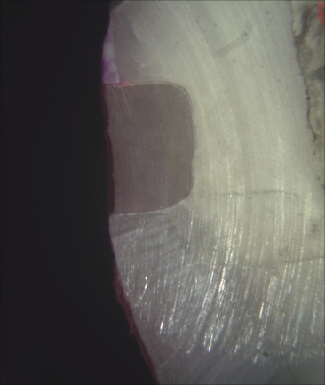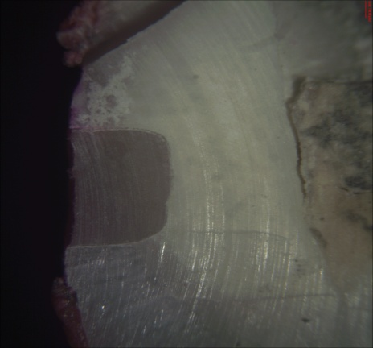

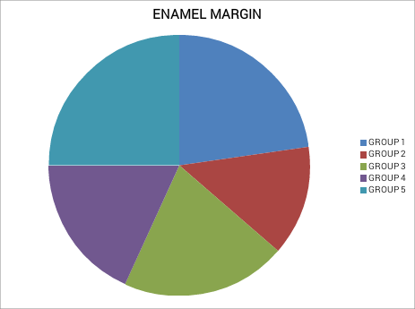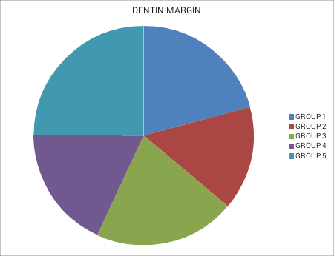
Marge émail Marge Dentine
Groupe 1 Groupe 1
Groupe 2 Groupe 2
Groupe 3 Groupe 3
Groupe 4 Groupe 4
Groupe 5 Groupe 5

Groupes Note 0 1 2 3 Total
Les marges cavité
Activa Bioactive + Aucune liaison Émail 4 3 2 1 10
Dentine 3 2 2 3 10

Activa Bioactive +le lien Tétrique Émail 5 4 1 0 10
Dentine 3 4 2 1 10

Activa Bioactive + le lien G Émail 4 3 3 0 10
Dentine 1 5 2 2 10
Nanohybride Composite + le lienTétrique N Émail 4 4 2 0 10
Dentine 2 5 1 2 10

Nanohybride Composite + le lien G Émail 3 4 2 1 10
Dentine 0 4 4 2 10

Tableau 1: La distribution de note penetration colorant à l’émail et les marges dentines dans tout les groupes.

