**Original Article**

Pattern of Mammography Utilization by Women Attending Asokoro District Hospital, Abuja, Nigeria

# Introduction

**Abstract**

**Introduction:** Mammography is a major tool for the screening and diagnosis of breast cancer globally. Poor funding and lack of good public health education for mammography in resource-limited countries limit access to mammographic services. In these settings, patients bear the cost of breast cancer screening from out-of-pocket expenses. The aim of this study was to interrogate the pattern of utilization of mammography by women of childbearing age, who attended Asokoro District Hospital (ADH) for Healthcare, with the view to increase uptake. **Materials and Methods:** This was a 4-year retrospective, cross-sectional study of 534 women who attended ADH from July 2015 to June 2019 for screening or diagnostic mammography. Data were extracted from completed questionnaire by women who had mammography during the period under review. The data were entered into Statistical Package for the Social Sciences version 27 by IBM for analysis. **Results:** The mean age of the women was 47.8 years ± 7.7 with a range of 30–82 years. Most of the women, 525 (94.9%), were referred for mammography by health workers; only nine (5.1%) had mammography on self-referral. In all, 71% of the women paid for their mammography from their pockets, whereas 28.1% made payments through the National Health Insurance Scheme (NHIS). A total of 100% of women who reported for mammography on self-referral paid for the services from their pockets. The association between the funding options and mode of referral was statistically significant, *P* = 0.049. **Conclusion:** This study showed that referral for mammography by health workers was responsible for not only most of the mammograms conducted but also all the women who utilized NHIS to pay for this service. Resources should therefore be directed towards creating awareness among health workers, especially with the present level of NHIS coverage in the population, in order to increase the uptake of screening mammography in the population.

**Keywords:** *Cancer, funding, pattern, screening, utilization mammography*

Breast cancer is the most common cancer among women in most parts of the world, accounting for about 24.2% of all female cancers[1] and the fifth cause of cancer death.[2] It is the second most common cancer in the world and the second most common cause of cancer deaths in resource-limited countries[3] such as Nigeria. In developed countries of the world, especially the United States and United Kingdom, breast cancer is of public health concern due to the high incidence of about 90–120/100,000, with one in every eight to nine women having a lifetime risk of developing breast cancer.[4] In these countries, legislation and programmes to fund early detection are in place, with early diagnosis and proper treatment curtailing morbidity and mortality from breast cancer.[2] Breast cancer also has the best prognosis of all cancers in

This is an open access journal, and articles are distributed under the terms of the Creative Commons Attribution-NonCommercial- ShareAlike 4.0 License, which allows others to remix, tweak, and build upon the work non-commercially, as long as appropriate credit is given and the new creations are licensed under the identical terms.

**For reprints contact:** [reprints@medknow.com](mailto:reprints@medknow.com)

these countries.[2] These factors, in addition to the biology of breast cancer in Western countries, make management of breast cancer a lot easier.[4-6] Unfortunately, breast cancers present differently in women of African descent, with a much younger age of onset, about 15–20 years earlier in black women,[4] compared to other races.

The incidence of breast cancer in African women and women of African descent is generally low.[4] The incident rate of 20– 22/100,000 and one in every 13 women having a lifetime risk of developing breast cancer is reported by some authors.[3-5] However, recent statistics in developing countries have shown increasing incidence of breast cancer primarily due to the changing lifestyle of women in favour of the Western pattern.[1] In Asia, some countries have recorded an increase in breast cancer incident rate of more than 100% in the last few decades due to changing lifestyle,

**How to cite this article:** Bassey OS, Aghahowa ME, Esomonu SN, Adeniji-Sofoluwe AT, Nnabuchi CV, Aluko-Olokun OA, *et al.* Pattern of mammography utilization by women attending Asokoro District Hospital, Abuja, Nigeria. J West Afr Coll Surg 2020;10:30-5.

## Oku S. Bassey1, Michael E. Aghahowa2,3, Sabastine N. Esomonu4, Adenike T. Adeniji- Sofoluwe5,

**Chidi V. Nnabuchi6,7, Oluseun A. Aluko- Olokun1,**

**Chidimma S. Awodu1**

*1Department of Radiology, Asokoro District Hospital, Abuja, 2Department of Surgery, Asokoro District Hospital, Abuja, 3Department of Surgery, Nile University of Nigeria, Abuja, 4Federal Capital Territory Primary Health Care Board, Abuja, 5Department of Radiology, University College Hospital, Ibadan, 6Department of Medicine, Asokoro District Hospital, Abuja, 7Department of Medicine, Nile University of Nigeria, Abuja, Nigeria*

**Received:** 03-Jan-2022 **Accepted:** 14-Feb-2022 **Published:** 04-May-2022

***Address for correspondence:*** *Dr. Oku Sunday Bassey, Department of Radiology,*

*Asokoro District Hospital, Abuja, Nigeria.*

*E-mail: Okuabasi2020@gmail. com*

|  |
| --- |
| **Access this article online** |
| **Website:**  [www.jwacs-jcoac.org](http://www.jwacs-jcoac.org/) |
| **DOI:** 10.4103/jwas.jwas_2_22 |
| **Quick Response Code:** |

30 © 2022 Journal of the West African College of Surgeons | Published by Wolters Kluwer ‑ Medknow

especially in reproductive behaviour.[1] This, in addition to socioeconomic dynamics and attributes of breast cancer in African women, presents a great challenge to all stakeholders in the fight against breast cancer, in the midst of the background of poor policies and funding, as well as lack of awareness, among others.

Breast cancer screening refers to the examination and testing of otherwise healthy women for breast cancer to achieve early diagnosis.[2] Different authors[2,3,7,8] have documented that early detection of breast cancer does not only reduce morbidity and mortality from breast cancer but also offer a variety of treatment options, as well as the reduce cost of treatment. Breast cancer awareness and screening provide the basis for the achievement of early detection and definitive diagnosis.[5] Mammography remains the gold standard for breast cancer screening.[9,10] However, other screening options include breast self-examination, clinical breast examination, breast ultrasound, digital breast tomosynthesis, magnetic resonance imaging, and genetic screening, among others.

Different economies adopt different funding policies to meet breast cancer screening needs for their target population. In countries where breast cancer is of public health concern, policies are in place to ensure that all women at the right age have access to screening and are encouraged to go for screening through unsolicited invitations and reminders by relevant agencies of government, to have their screening done[11-13] as it is the practice in the United Kingdom. In this situation, the screening program is fully funded by the government through the National Health Scheme. In the United States, the policy of self-referral through sufficient breast cancer awareness is in place. In this scenario, patients pay for screening through their personal health insurance policy. Until recently in Nigeria, citizens access health care mainly by paying from their pockets. However, it is thought that the advent of National Health Insurance Scheme (NHIS) has given citizens in the employ of government at the national and sub-national levels increased access to health care. Unfortunately, there are no provisions in the scheme that encourage or compel women of appropriate age to access breast cancer screening. The Nigeria National Cancer Control Plan[14] (2018–2022) has in place a lofty policy for early detection and management of cancers in the country. However, poor funding has made this policy implementation unattainable. In view of this, most patients attending breast cancer screening in Radiology Department of Asokoro District Hospital (ADH), Abuja, access mammography through out-of-pocket expenses as they do with their general health needs most of the time.

The aim of this study was to examine the pattern of utilization of mammography and the different funding options used by women who attended the Radiology Department of ADH for screening or diagnostic mammography. It is our belief that information obtained from this study will assist in policy change in Federal Capital Territory (FCT) as a subnational entity, to adopt the best approach or template to encourage uptake of breast cancer screening among the residents.

# Materials and Methods

This is a 4-year retrospective cross-sectional study of women who attended ADH from July 2015 to June 2019 for screening or diagnostic mammography. Ethical clearance was obtained from the ADH Ethics and Research Review Committee. ADH is a 120-bed hospital, one of the hospitals in the city centre of the FCT owned by the Federal Capital Territory Administration and managed by the Hospital Management Board. It is one of the few hospitals in the FCT that provide mammographic screening for the over 3.3 million residents of the FCT and the surrounding states of Nasarawa, Niger, Kaduna, Kogi, and Benue.

A whole group sampling of 534 was used; data were obtained from the records of patients who had screening or diagnostic mammography in the Radiology Department of ADH during the period under review. This provided data on the sociodemographic characteristics and the funding option adopted by participants for the study. The biodata/history and radiologists’ report were matched and confirmed to be the same participant before data were extracted for the study.

The data and radiologist’s report findings were entered into Statistical Package for the Social Sciences version 27 for analysis. The total number of women 40 years and above attending ADH for mammography was established. Funding option was compared with the mode of referral amongst the cohort, and this was compared with the outcome of the diagnostic or screening mammogram (final Breast Imaging Recording and Data Systems, BI-RADS categorization). Bivariate analysis using the Chi-square test was applied to test for differences between proportions and the level of statistical significance was determined by a p-value of <0.05. Frequency tables and cross-tabulations were generated.

# Results

A total of 534 women who had mammography done between July 2015 and June 2019 were studied at ADH, Abuja. The mean age of the women was 47.8 years ± 7.7 with a range of 30–82 years [Table 1]. Most of the women (50%) were within the 40–49 years age group, followed by those in the 50–59 years age group (32.7%).

Most of the women 354 (66.3%) had heterogeneous fibroglandular and homogeneously dense breast pattern. The homogeneously fatty and scanty fatty–fibroglandular breast pattern were seen in 135 (25.3%) of the women. The common presenting complaints were breast pain, lump, and nipple discharge, out of which pain was recorded the most (249). Most of the complaints were in the left breast 270 (50.6%), and both breasts were involved in 126 (23.6%) of the patients [Figure 1].

Among the women who presented with breast lump, 115 (71.9%) had final Bi-RADS category 4–6, whereas 45 (28.1%) had final Bi-RADS category 0–3. Most of the women, 525 (94.9%), were referred for mammography by health workers and 71% paid from their pockets [Table 2].

Journal of the West African College of Surgeons | Volume 10 | Issue 3 | July‑September 2020 31

The comparison between the final Bi-RADS category of those who were referred by health workers and those who self- referred was not statistically significant [Table 3]. Similarly, the comparison between the final Bi-RADS of those who paid for mammographic services from their pocket and those who accessed services through NHIS was not statistically significant [Table 4]. In all, 100% of women who reported for mammography on self-referral paid 8000 naira (about US$30) for the services from their pockets. A higher proportion of women who were referred by a health worker paid for mammography through health insurance than women who were self-referred, and the difference was statistically significant, *P* = 0.049 [Table 5].

A total of 459 participants had data on their body mass index (BMI) recorded. Most of the participants were overweight and obese (32% and 28.5%, respectively), and 25.5% had normal BMI. No participant was underweight [Figure 2]. The mean BMI of participants was 28.1 ± 5.3 standard deviation with a range of 22.1–40.6. There was no significant association between the BMI and final Bi-RADS or breast cancer risk [Table 6]. Most of the participants, 74%, had tertiary level of education. In all, 100% of self-referred participants had tertiary level education, but this was not statistically significant

### Table 1: Sociodemographic characteristics of patients

[Table 7]. Tertiary level of education had positive association with utilization of NHIS as funding option for mammography. However, there was no statistically significant association between the level of education and the final Bi-RADS score.

# Discussion

Poor funding, absence or dearth of modern equipment, as well as lack of well-trained personnel mitigate the access to health care services in developing countries.[1,3] However, access to health care services in general and breast cancer screening in particular is also limited by the level of education and awareness, as well as the funding options available to the

### Table 2: Bi-RADS for breast pattern, final Bi-RADS, and funding options for the period under review

**Variables Frequency (*N* = 534) Percent**

Bi-RADS for breast pattern

Low risk 135 25.3

High risk 354 66.3

Missing values 45 8.4

Final Bi-RADS

0–3 432 80.9

4–6 54 10.1

Missing values 48 9.0

Funding option

|  |  |  |  |  |  |
| --- | --- | --- | --- | --- | --- |
| **Variables** | **Frequency (*N* = 534)** | **Percent** | NHIS | 150 | 28.1 |
| Age groups (years) |  |  | Out of pocket | 384 | 71.9 |
| 30–39 | 117 | 11.3 | Referred by |  |  |
| 40–49 | 519 | 50 | Self | 9 | 1.7 |
| 0–54 | 339 | 32.7 | Health worker | 525 | 98.3 |
| 60–69 | 48 | 4.6 | Previous mammography |  |  |
| 70 and above | 15 | 1.4 | No | 507 | 94.9 |

SD: standard deviation

Mean age = 47.8 years ± 7.7 SD Median age = 46 years

Yes 27 5.1

BI-RADS: Breast Imaging Recording and Data Systems, NHIS: National Health Insurance Scheme

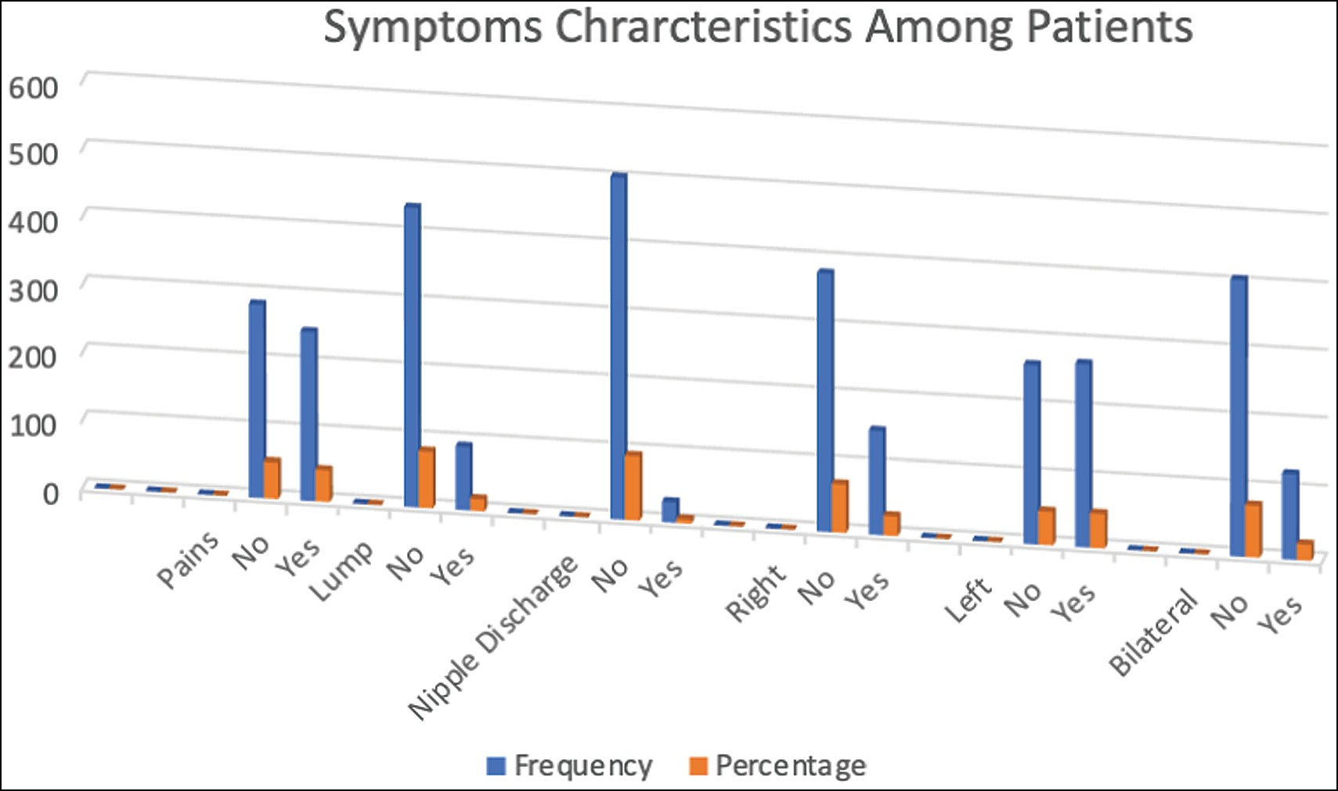

**Figure 1: Symptoms characteristics of the patients**

32 Journal of the West African College of Surgeons | Volume 10 | Issue 3 | July‑September 2020

Funding options

### Table 3: Association between funding options and final Bi-RADS

**Final Bi-RADS *χ*2 *P* value 0–3 (*N* = 432), *n* (%) 4–6 (*N* = 54), *n* (%)**

NHIS 111 (88.1) 15 (11.9) 0.108 0.742

Out of pocket 321 (89.2) 39 (10.8)

BI-RADS: Breast Imaging Recording and Data Systems,NHIS: National Health Insurance Scheme

Referred by

### Table 4: Association between referrals and final Bi-RADS

**Final Bi-RADS *χ*2 *P* value 0–3 (*N* = 432), *n* (%) 4–6 (*N* = 54), *n* (%)**

Self 9 (100) 0 (0.0) 1.146 0.284

Health workers 423 (88.7) 54 (11.3) BI-RADS: Breast Imaging Recording and Data Systems,

Referred by

### Table 5: Association between referrals and funding options

**Funding options *χ*2 *P* value NHIS (*N* = 432), *n* (%) Out of pocket (*N* = 54), *n* (%)**

Self 0 (0.0) 9 (100) 3.576 0.049

Health workers 150 (28.6) 375 (71.4) NHIS: National Health Insurance Scheme

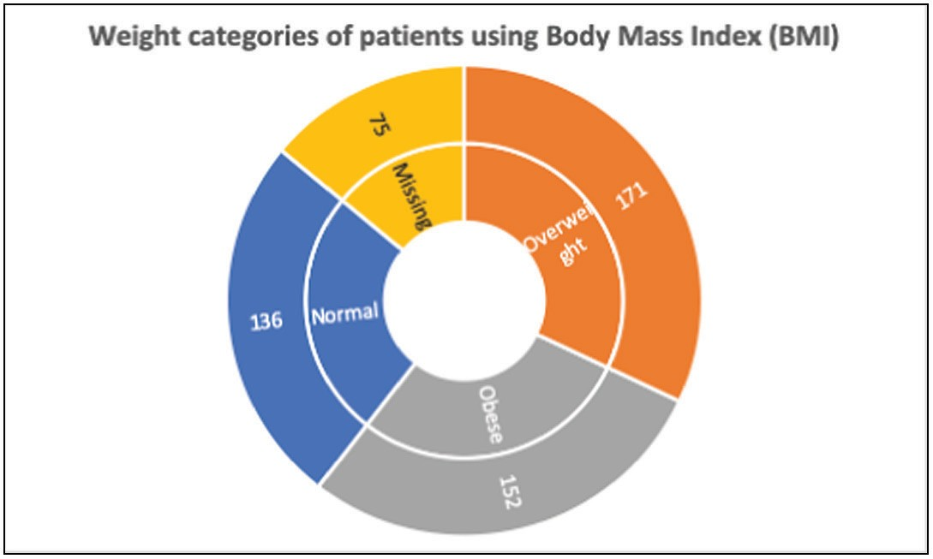

**Figure 2: Sunburst chart showing the distribution of the BMI of participant**

patients, where the equipment and personnel are available as shown in this study. The fact that most patients access services in our clime by paying from their pockets invariably leads to underutilization of available technology and skills in the presence of other competing needs for the patients.

In developed countries, organized breast cancer screening programmes are in place;[11-15] therefore, very few women self- refer for mammographic services. The organized screening programmes are based on identifying the target population or those eligible for breast cancer screening. National population census, health and cancer registers, social insurance/tax records, as well as population migration records are easily accessible to health authorities to implement organized screening programmes.[11] Usually, invitations are sent by mails; personal invitations or telephone calls are used to implement organized breast cancer screenings.[12] The target population

usually do not pay for this service from their pockets because organized population-based screening is usually a public health programme funded by the government.[11,12,15]

Self-referral for mammography or spontaneous mammography is generally reported to be associated with increased levels of breast cancer detection as well as poorer levels of cost- effectiveness and quality assurance in the management of breast cancer.[13] Over the years, there has been a shift from spontaneous mammography to organized mammographic breast cancer screening to meet the public health importance of breast cancer.[16,17] In this study, all women who self-referred had benign findings, whereas those who were referred by heath workers had 11.3% of cancer detection. This finding is at variance with that of da Costa Vieira *et al.*,[15] which shows increased cancer detection in women who self-referred. The result of this study shows that 100% of the women who self-referred paid for the services from their pockets and therefore had positive attitude towards their health in general and breast cancer screening.

In this study, most of the participants have tertiary level education, whereas 100% of the self-referred patients had tertiary education. All the self-referred participants had no clinical complain, and their screening mammogram was done as part of their general or routine medical examination, which further confirms their positive attitude towards their health. Most of the participants referred by health workers had either benign or suspicious findings, and all the cancers in this study were reported from participants who were referred by health workers. However, the data available did not show whether the participant referred by health workers went to the health worker on account of breast-related complain or general health care

Journal of the West African College of Surgeons | Volume 10 | Issue 3 | July‑September 2020 33

### Table 6: Association between BMI and final Bi-RADS

|  |  |  |  |  |
| --- | --- | --- | --- | --- |
|  | **Final Bi-RADS** |  | ***χ*2** | ***P* value** |
| **0–3 (*N* = 380), *n* (%)** | **4–6 (*N* = 45), *n* (%)** |  |  |
| BMI  Normal | 112 (29.5) | 17 (37.8) |  |  |
| Overweight | 142 (37.4) | 14 (31.1) | 1.394 | 0.498 |
| Obese | 126 (33.2) | 14 (31.1) |  |  |

BI-RADS: Breast Imaging Recording and Data Systems, BMI: body mass index

### Table 7: Relationship between the level of education and referral method by participant

|  |  |  |  |  |
| --- | --- | --- | --- | --- |
|  | | **Referred by** | ***χ*2** | ***P* value** |
| **Education** | **Self (*N* = 6), *n* (%)** | **Health workers (*N* = 254), *n* (%)** |  |  |
| Primary | 0 (0.0) | 26 (10.2) |  |  |
| Secondary | 0 (0.0) | 42 (16.5) | 2.175 | 0.337 |
| Tertiary | 6 (100) | 186 (73.2) |  |  |

services. No data are available on the effect of peer pressure on the participants in this study.

The level of awareness of breast cancer has been documented to be very poor in developing countries,[18] even among health workers.[19-21] Our study shows that most women who accessed both screening and diagnostic mammography in the period under review were referred by health workers. Thus, this supports the previous findings of positive relationship between the role of health workers and utilization of mammography in the population.[15,16] Different institutions, government, and non-profit organizations have invested a lot of resources in creating awareness in the populace with poor outcomes, as evidenced by very poor self-referral for women (1.7%) who accessed mammography in this study. The higher percentage of women who responded to referral by health workers in this study is in consonance with the study by da Costa Vieira *et al.*[15] Thus, the positive relationship between referral by health workers and the uptake of mammography shows good prospects for direct positive impact in the uptake of screening mammography with associated early detection of breast cancer and reduction in breast cancer mortality in the population, if resources are channelled in creating awareness among health workers.

This study also shows positive association between the level of education and mammographic screening as well as increase in the use of NHIS for funding screening mammogram. Three categories of enrolees, (i) FCT Health Insurance, (ii) National Health Insurance, and (iii) Private Insurance, are registered for health insurance services in our facility. They pay capitation of N500, N750, and N2500 naira, respectively; these amounts are equivalent to US$1, US$1.5, and US$5, respectively. Mammography is one of the services covered 100% by health insurance; therefore, at a very small fraction of the cost, enrolees are paying for mammography among other health services. This study shows positive relationship between the level of education and the utilization of health insurance to pay for mammography. This invariably makes mammography services more accessible to women with tertiary education

through the availability of health insurance. BMI and breast density are known to show positive correlation with risk of breast cancer or final Bi-RADS[22] category. However, there was no statistical significance between the two in this study probably due to the small sample size.

# Conclusion

Studies in developed countries on the evolution of breast cancer screening have shown positive correlation between organized breast cancer screening programmes and early detection of breast cancer in the population. This had led to a successful public health policy on breast cancer screening in these countries. In this study, referral for mammography by health workers was responsible for not only most of the mammogram but also the women who utilized NHIS to pay for this service, thereby saving the much-needed resources for other needs. Therefore, although the present level of public awareness with low uptake of mammography should be maintained, scarce resources should be redirected towards creating awareness among health workers, especially with the present level of NHIS coverage in the population in order to increase the utilization of screening mammography in the population.

### Limitation of the study

The main limitations of this study are the small sample size and incomplete data from the records of some of the participants.

### Acknowledgement

The authors wish to acknowledge all the imaging and supporting staff of Radiology Department, Asokoro District Hospital for their invaluable services that made this study successful.

### Financial support and sponsorship

Nil.

### Conflict of interest

The study was not sponsored by any organisation and the authors declare no conflicts of interest.

34 Journal of the West African College of Surgeons | Volume 10 | Issue 3 | July‑September 2020

# References

1. Anderson BO, Yip CH, Smith RA, Shyyan R, Sener SF, Eniu A, *et al*. Guideline implementation for breast healthcare in low-income and middle-income countries: Overview of the breast health global initiative global summit 2007. Cancer 2008;113:2221-43.
2. The International Agency for Research on Cancer. 2018. Available from: https://[www.who.int/cancer/PRGlobocanFinal.](http://www.who.int/cancer/PRGlobocanFinal) [Last accessed on 30 Nov 2021].
3. Yip CH, Smith RA, Anderson BO, Miller AB, Thomas DB, Ang ES, *et al*.; Breast Health Global Initiative Early Detection Panel. Guideline implementation for breast healthcare in low- and middle-income countries: Early detection resource allocation. Cancer 2008;113:2244-56.
4. Baquet CR, Mishra SI, Commiskey P, Ellison GL, DeShields M. Breast cancer epidemiology in blacks and whites: Disparities in incidence, mortality, survival rates and histology. J Natl Med Assoc 2008;100:480-8.
5. American Cancer Society. Available from: [https://www](http://www.cancer.org/).cancer[.org.](http://www.cancer.org/) Breast Cancer Facts & Figures 2019 – 2020. [Last accessed on 22 Oct 2021].
6. Danford DN. Disparities in breast cancer outcomes between Caucasian and African American women: A model for describing the relationship of biological and nonbiological factors. Breast Cancer Res 2013;15:208.
7. Humphrey LL, Helfand M, Chan BK, Woolf SH. Breast cancer screening: A summary of the evidence for the U.S. Preventive Services Task Force. Ann Intern Med 2002;137:347-60.
8. Onyebuchi CI. Re-thinking breast and cervical cancer preventive campaign in developing countries: The case for interventions at schools. BMC Public Health 2019;19:503.
9. Miller RG. Breast cancer screening: Can we talk? J Gen Intern Med 2001;16:206-7.
10. Breast Health Services, John Hopkins Medicine. 2020. Available from: [https://www.hopkinsmedicine.or](http://www.hopkinsmedicine.org/)g. [Last accessed on 30 Nov 2021].
11. Perry N, Broeders M, de Wolf C, Tӧrnberg S, Holland R, von Karsa. European guidelines for quality assurance in breast cancer screening and diagnosis. Ann Oncol 2008;19:614-22.
12. Olsson S, Andersson I, Karlberg I, Bjurstam N, Frodis E, Håkansson S. Implementation of service screening with mammography in Sweden: From pilot study to nationwide programme. J Med Screen 2000; 7:14-8.
13. Bucchi L, Falcini F, Baraldi GP, Bondi A, Bonsanto R, Bravetti P, *et al*. Integrating self-referral for mammography into organised screening: Results from an Italian experience. J Med Screen 2003;10:134-8.
14. Federal Ministry of Health, Nigeria. Available from: [https://www](http://www/). iccp-portal.org. Nigeria National Cancer Control Plan 2018 – 2020. [Last accessed on 02 Oct 2020].
15. da Costa Vieira RA, Biller G, Uemura G, Ruiz CA, Curado MP. Breast cancer screening in developing countries. Clinics (Sao Paulo) 2017;72:244-53.
16. de Koning HJ, van Oortmarssen GJ, van Ineveld BM, van der Maas PJ. Breast cancer screening: Its impact on clinical medicine. Br J Cancer 1990;61:292-7.
17. Forrest AP. Screening and breast cancer incidence. J Natl Cancer Inst 1990;82:1525-6.
18. Atoyebi OA, Atimomo CE, Adesanya AA, Beredugo BK, da Rocha- Afodu JT: An appraisal of 100 patients with breast cancer seen at the Lagos University Teaching Hospital. Nig Qt J Hosp Med 1997;7:104- 8.
19. Akhigbe AO, Omuemu VO. Knowledge, attitudes and practice of breast cancer screening among female health workers in a Nigerian urban city. BMC Cancer 2009;9:203.
20. Bassey OS, Adeniji-Sofoluwe AT, Adeoye AO, Monsuro OA, Akingbola TS, Osofundiya OO, *et al*. Mammographic breast pattern in postmenopausal women in Ibadan, South-West Nigeria. Br J Med Med Res 2016;17:1-10.
21. Shieh Y, Scott CG, Jensen MR, Norman AD, Bertrand KA, Pankratz VS, *et al*. Body mass index, mammographic density, and breast cancer risk by estrogen receptor subtype. Breast Cancer Res 2019;21:48.
22. Elmore JG, Carney PA, Abraham LA, Barlow WE, Egger JR, Fosse JS, *et al*. The association between obesity and screening mammography accuracy. Arch Intern Med 2004;164:1140-7.

Journal of the West African College of Surgeons | Volume 10 | Issue 3 | July‑September 2020 35