MAGNETIC RESONANCE IMAGING PATHOLOGICAL EVIDENCE IN PATIENTS WITH LOW BACK PAIN IN SOUTHWEST NIGERIA
PREUVE PATHOLOGIQUE D'IMAGERIE PAR RESONANCE MAGNETIQUE CHEZ DES MALADES SOUFFRANT DE DOULEUR AU DOS DU SUD-OUEST DU NIGERIA
*Adekanmi AJ, Atalabi OM, Bello TO¹, Ogunseyinde OA
Department of Radiology, College of Medicine University of Ibadan, Nigeria. E-mail: kanmiademola@gmail.com
¹Department of Radiology, Ladoke Akintola University of Technology Teaching Hospital, Osogbo, Nigeria.

*Correspondence
Grant support: None
Subvention: Aucun
Conflict of interest: None
Conflit d'intérêts: Aucun
ABSTRACT
Background: Low back pain, a condition that affects many individuals worldwide during their lifetime is receiving increasing attention due to the attendant chronic disability, absenteeism from work, loss of earning power, loss of quality of life and finances. Recently focus has been on the rising prevalence and search for steps to address low back pain risk factors now known to be modifiable. For the evaluation of low back pain, magnetic resonance imaging (MRI) has emerged as the imaging modality of choice.
Aim: To determine the prevalence and distribution of lumbosacral spine discs, osseous, ligamentum flavum and facet joint changes evaluated by MRI. And to further understand the lumbosacral spine biomechanics of MRI-related disco-osseous abnormalities among native African population with low back pain.
Study design: This was a retrospective study.
Setting: University College Hospital, Ibadan, Nigeria.
Methodology: The Lumbosacral spine T1W and T2W sagittal and axial images and post gadolinium contrast images generated using a low field MRI scanner and body surface coil, in patients with low back pain, were evaluated in line with pre-defined spinal changes.
Results: There were a total of one hundred and eight low back pain patients who had Magnetic resonance imaging between March 2015 and August 2016 in this study with a mean age of 49.9 years and a range of 8 to 77 years. There were 28(25.9%) patients aged 50 – 59 years; this age bracket had the highest number while those aged 20 years and below were 3.7%. In all, 80(74.1%) subjects had chronic low back pain. Abnormal Magnetic resonance findings were reported in 96.3%. Multiple disc affectation was seen in 75.3%; disc bulge (79.8%) was the commonest disc findings followed by dehydration in 74.0%. The L4/5 discs were commonly affected in disc dehydration in 59(76.6%) cases, anterior herniation in 22(61.1%) cases, ventrolateral herniations in 9(81.8%) cases, nerve root compression in 21(60%) cases, facet joint hypertrophy in 17/24(70.8%) cases and spinal canal stenosis in 32/47(68.1%) cases. Vertebral end plate changes occur mostly at L4 and L5 (74% at each level).
Conclusion: This study has shown that Magnetic Resonance Imaging changes in low back pain involved multiple discs and multilevel osseous pathologies, however, disc abnormalities are predominant. The L4-5, L5-S1 disc levels and L4 vertebra body were the most commonly affected sites among a native African population.
Key words: Low back pain, Spondylosis, Disc herniation, Osseous abnormalities, MRI.
RESUME
Contexte: La lombalgie, une condition qui affecte de nombreuses personnes dans le monde entier au cours de leur vie, fait l'objet d'une attention croissante en raison de l’invalidité chronique, de l’absentéisme au travail, de la perte de capacité de gain, de la qualité de vie et des finances. Récemment, l'accent a été mis sur la prévalence croissante et la recherche de mesures pour traiter les facteurs de risque de douleur dans le bas du dos qui sont maintenant modifiables. Pour l'évaluation de la douleur au bas du dos, l'imagerie par résonance magnétique (IRM) est devenue la modalité d'imagerie de choix.
But: Déterminer la prévalence et la distribution des disques de la colonne lombo-sacrale, des modifications de l'os osseux, du ligamentum flavum et de l'articulation de la facette évaluées par IRM. Et pour mieux comprendre la biomécanique de la colonne lombo-sacrée des anomalies disco-osseuses liées à l'IRM au sein de la population africaine autochtone souffrant de douleurs lombaires.
Conception de l'étude: Il s'agissait d'une étude rétrospective.
Lieu: University College Hospital, Ibadan, Nigéria.
Méthodologie: Les images axiales sagittales et axiales T1W et T2W de la colonne lombo-sacrale et les images de contraste post-gadolinium générées à l'aide d'un scanner IRM à champ faible et d'une bobine à la surface du corps, chez des malades souffrant de lombalgie, ont été évaluées en fonction des modifications prédéfinies de la colonne vertébrale.
Résultats: Au total, cent huit malades présentant une douleur au bas du dos ayant subi une imagerie par résonance magnétique entre mars 2015 et août 2016 ont participé à cette étude avec un âge moyen de 49,9 ans et une rangé de 8 à 77 ans. Il y avait 28 (25,9%) malades âgés de 50 à 59 ans; cette tranche d'âge avait le nombre le plus élevé, tandis que les personnes âgées de 20 ans et moins étaient de 3,7%. Au total, 80 (74,1%) sujets souffraient de lombalgie chronique. Des résultats anormaux de résonance magnétique ont été signalés dans 96,3% des cas. Une affectation multiple du disque a été observée dans 75,3% des cas. Le gonflement discal (79,8%) était la découverte de disque la plus fréquente suivie de la déshydratation chez 74,0%. Les disques L4/5 étaient fréquemment affectés par la déshydratation discale dans 59 cas (76,6%), une hernie antérieure dans 22 cas (61,1%), une hernie ventro-latérale dans 9 cas (81,8%), une compression des racines nerveuses dans 21 cas (60%), hypertrophie facettaire dans 17/24 (70,8%) des cas et sténose du canal rachidien dans 32/47 (68,1%) des cas. Les modifications de la plaque d'extrémité vertébrale se produisent principalement à L4 et à L5 (74% à chaque niveau).
Conclusion: Cette étude a montré que les modifications de l'imagerie par résonance magnétique dans la douleur au bas du dos impliquaient des disques multiples et des pathologies osseuses à plusieurs niveaux, cependant, les anomalies discales prédominaient. Les niveaux de disque L4-5, L5-S1 et le corps vertébral de L4 étaient les sites les plus fréquemment touchés parmi une population africaine autochtone.
Mots-clés: Lombalgie, Spondylose, Hernie discale, Anomalies osseuses, IRM.

INTRODUCTION
Low back pain, a condition that affects many individuals at some point in their lives¹ has become a serious public health problem often associated with disability and loss of earning potential^{2,3,4}. The 2010 Global Burden of Disease Study categorized low back pain as one of the top 10 diseases and injuries that account for the highest number of disability-adjusted life years worldwide⁵. The incidence of LBP is high as over 80% of people will have a complaint of LBP over a life time⁶ from which an estimated 5.0% to 10.0% of the cases will progress to chronic low back pain lasting three to six months or more⁷. This form of low back pain is responsible for high treatment costs, absenteeism from work, and individual suffering^{8,9,10}. Relapsed and multiple episode of low back pain years after initial presentation have been observed in cases of chronic low back pain⁷. In sub-Sahara Africa, chronic LBP has also been documented as the most common musculoskeletal problem encountered in the workplace with attendant loss of quality of life and finances¹¹. In the adult population, the point and the one-year prevalence was reported to be approximately 30% and 15% - 45% respectively in the Western countries¹².
The lifetime prevalence in African countries (28% - 74%) as reported by Louw et al¹³ in a systematic review was however comparable to the figures in Western countries (30% - 80%) ¹³, indicating that low back pain is also a serious problem among Africans.
Previous studies in Nigeria have reported a wide range of prevalence of low back pain of 38% to 73.5% in the literature^{14,15,16,17} in agreement with the reported figures in Western and African Countries¹³.
Although the aetiology of low back pain is broad, the vast majority of low back pain is mechanical in nature (musculoskeletal strains, nerve root compression, herniated disc, and degenerative disc and joints)¹⁸. Low back pain may also result from serious underlying conditions or non-mechanical conditions such as inflammatory conditions, infection, tumours or kidney stone¹⁸. In addition to these physical causes, psychological factors such as stress, depression, and/or anxiety can also present as low back pain^{19,20}. Although, the physical and psychosocial factors that come into play in the aetiology of low back pain are generally the same worldwide²¹. Differences in the extent of involvement of these factors, pattern of low back pain with respect to aetiology and population characteristics exist differ between countries and even within countries²¹. Recent studies suggest that many of the risk factors of low back pain are modifiable and can be addressed to a large extent by simple practical steps²².
It is of note that the diagnostic evaluation of patients with LBP can be very challenging and requires complex clinical decision-making especially in detecting the source of pain among the several structures potentially involved in chronic low back pain, a key factor in the management of these patients²³. Among other imaging modalities, magnetic resonance imaging (MRI) is preferred in the evaluation of low back pain²⁴.
Reports in sub-Sahara Africa have described some abnormalities or findings in low back pain, particularly the intervertebral disc changes on Magnetic resonance imaging^{24,25,26}. In this study we evaluated the prevalence and distribution of lumbosacral spine discs, vertebral body, lateral and central spinal canal, the facetal joint and ligamentum flavum changes among low back pain patients in South West Nigeria between March 2015 and August 2016.

Patients and Methods
Study Design: This was a retrospective study carried out over an 18 months period among patients that presented with low back pain who were referred for lumbosacral spine magnetic resonance imaging between March 2015 and August 2016. The hospital spinal MRI request cards and the lumbosacral spine MRI images of the patients were retrieved from the records department and from the picture archiving and communications system server respectively. Image acquisition was done by an open low field 0.36Tesla MINDRAY Medical-Magsense 360 MRI system, Software version; sencell 02.00.00.37666, Manufacture date 2012-09, China. The patients were scanned in supine position and body spine surface coil for imaging the lumbosacral spine, the images evaluated were localizer images, T1 and T2 W sagittal and selected T1 W and T2W axial images, as well as post contrast- gadolinium images. These images were evaluated and interpreted by two experienced radiologists with experience in spine magnetic resonance imaging while blinded to the patients’ demographic data and clinical presentations. Degree of agreement in a pilot of ten lumbosacral spine MRI images was 70-80% (Kappa).
Definition of intervertebral discs parameters was based on widely accepted earlier reports^{27,28,29}, the disc signal intensity classification into normal or dehydrated types was based on the Milette et al²⁷ criteria. Disc bulge and herniations were defined according to the work of Ract et al²⁸ and Fardon et al²⁹ as follows:-
Disc bulge were intervertebral discs with circumferentially symmetric extension or asymmetric extension more than 25% of the outer annulus beyond the perimeter of the adjacent vertebrae of the disc material but confined by the outermost annulus fibrosus fibres; disc protrusion were focal or asymmetric extension of the disc beyond the adjacent vertebral body or localized abnormalities of the disc margin that involve less than 25% of the disc circumference; disc extrusions were more extensive protrusions of the disc (through all layers of the annulus) beyond the interspace. The distance between the edges of the disc material beyond the disc space is greater than the distance between the edges of the base measured in the same plane. Sequestrated discs were extruded discs no longer in continuity with the parent disc material.
Osseous changes evaluated were:- Foraminal narrowing: foramen less than 4mm measured at the foramina segment of the radicular canal; Ligamentum flavum hypertrophy: widest diameter of ligamentum flavum on axial images greater than 5mm; Spinal canal stenosis: Antero-posterior diameter of the canal measured from the posterior margin of the intervertebral disc to the spinolaminar junction less than 11.5mm.
Facet arthropathy, vertebral body end plate changes according to Modic classification²⁷, vertebral body collapse, height reduction, and destruction were also evaluated and documented. Others were nerve root and spinal cord/cauda equina compression. Spondylolisthesis, and presence of congenital spinal anomalies or neoplasm.
Each patient was assigned a study number to protect patient’s identity. This study was approved by the joint University of Ibadan//University college hospital Institutional Review Committee.
The data obtained were analysed using Statistical Package for Social Sciences (SPSS) software (Version 22.0., IBM Corp. Released 2011, IBM SPSS Statistics for Windows, IBM Corp. Armonk, NY, USA) The data were presented using frequency tables and percentages, bar and pie charts as appropriate. Chi-square tests were used for statistical analysis of categorical variables. Test of association were carried out using Pearson correlations.

RESULTS
Study population
One hundred and eight patients who had MRI for low back pain during the study period were evaluated. About half (52.8%) of the patients were males while females were 51(47.2%) with a male/female ratio of 1.1:1. The mean age of the patients was 49.9 ± 15.4 years with a range of 8 - 77 years. Majority (25.9%) of the patients were within the 50 to 59 years age group, followed by patients within age group of 60 to 69 years (20.4%). The least number of patients with low back pain were those age 20 years and below (3.7%).
Clinical presentation
The commonest provisional diagnosis were lumbar spondylosis in 43(39.8%) cases, radiculopathy in 19(17.6%) and disc prolapse 9(8.3%). The least was pain in the lower limbs/sciatica in 2(1.9%) cases. Overall, lumbar spondylosis was the commonest provisional diagnosis as an entity or in association with other symptoms, accounting for 48/108(44.5%) of the study population (Table 1).
Clinical presentations were evaluated and compared based on age groups of the patients. Lumbar spondylosis was the commonest clinical presentation among patients in all age groups. Lumbar spondylosis was commonest among patients aged 60 years and above (46.9%). Disc prolapse (19.4%) was however more common among patients below 40 years of age. While Radiculopathy alone or in association with other symptoms were more common (31.1%) among patients aged 40 to 59 years. Radiculopathy was also seen in 21.9% among patients aged 60 years and above. Spinal tumours/spinal metastases expectedly were more common in those above 60 years of age, also shown in table 1.
Duration of Low back pain
In all, 23(21%) patients had acute low back pain (3 months and below) while the majority, 80(74.4%) patients had chronic low back pain of more than 3 months duration. Duration of low back pain was not stated in 5(4.6%) patients.
Magnetic Resonance Imaging findings
In this study, 96.3% (104/108) had abnormal MRI findings. Most 103(95.4%) patients had disc abnormalities while 23(21.7%) patients had vertebral pathologies; some of the pathologies are shown in images 1a and 1b.
Intervertebral disc pathologies
Disc bulge was seen in 83(79.8%) cases in this study, followed by disc dehydration in 77(74.0%) cases while disc migration was observed in one (1.0%) patient (Table 2). Multiple disc dehydration was observed in 81(75.3%) patients. Also, among patients with anterior disc herniation 81(77.9%) of the patients had multiple disc affected, while 18.2% (2/11) of patients had multiple ventrolateral disc herniation (Table 2).
Magnetic resonance disc pathologies in relationship with disc levels
Disc dehydration was observed in seventy seven patients and commoner at L4/L5 in 59(76.6%) patients, L5/S1 in 52(67.5%) and L1/L2 disc level in 15(19.5%) patients. Disc bulge occurred in eighty three patients; at the L3/L4 in 35(42.2%), at L5/S1 in 31(37.3%) and L4/L5 in 30(36.1%) patients. Disc protrusion occurred in a total of sixty-one patients; at equal frequency at the L4/L5 and L5/S1 in about 65.6% of patients, and in 2(3.3%) patients at L1/L2. Disc extrusion was observed in twenty-two patients; 15(68.2%) of the patients had disc extrusion at L5/S1, 11(50.0%) at L4/L5 while a patient each (4.5%) had extrusion at L1/L2 and L2/L3. Anterior disc herniation was recorded in thirty-six patients; at L4/L5 in 22(61.1%) patients, and the least was 1(2.8%) patient at L1/L2. In addition, ventrolateral disc herniation was also seen in eleven patients and more 9(81.8%) at L4-L5, as shown in Fig. 1.

Vertebral changes on magnetic resonance imaging
In this study, 57(52.5%) patients had normal vertebral curvature. Most common vertebral pathology was vertebral end plate changes in 37 (35.6%) cases as seen in Table 3.
Modic end plate changes were present in thirty-seven cases; 16( 44%) were class 3 end-plate changes, 14(37%) were class 3 changes while class 1 Modic end plate changes were seen in 7(19%) patients. Most (74%) vertebral end plate changes were at L5/S1, followed by L4/L5 (71.1%). Among the twenty patients with spondylolisthesis; 19(83%) were Grade 1, 3(13%) grade 2 and 1(4%) patient had grade 3. Spondylolisthesis (both antero and retrolisthesis), occurred mostly at the L5/S1 in 16(66.7%) of cases.
Most vertebral height changes (53.8%) occurred at L4 followed by L5 (50.0%) and L3 (15.4%). Also, vertebral destruction was observed in 9 cases; at L3 to L5 vertebrae and at a frequency of 22.2 %( 2/9) at each of these level, while L1 and L2 were destroyed in one patient at each level (Fig. 2).
Ligamentum flavum hypertophy, facet arthropathy, nerve root compression and spinal canal stenosis on MRI
Further analysis of abnormal spinal MRI results showed that among all patients with low back pain, as shown in figure 3, 34.6% had nerve root compression and 32.7% had ligamentum flavum hypertrophy. Nerve root compression was observed in about 60.0% at L4/L5 while about 2.9% of the patients had nerve root compression at L2/L3. Most ligamentum flavum hypertrophy (70.6%) occurred at L4/L5 followed by L5/S1 (38.2%) and L3/L4 (32.4%).
Concerning facet joint arthropathy, about 85.4% of facet arthropathy were bilateral, 12.2% occurred at the right side and 2.4% occurred at the left facet joint. Among cases with facet arthropathy, 70.8% occurred at L4/L5, 45.8% occurred at L3/L4 and 41.7% occurred at L5/S1. Other abnormalities observed were spinal canal stenosis. We recorded 39.5% of spinal canal stenosis at L4/L5, 25.9% at L5/S1 and 22.2% at L3/L4.

Gender and Age comparison of MRI changes

Table 4 showed that there were 36(70.6%) females who had disc narrowing compared to 27(47.4%) males with disc narrowing (p = 0.02); the other spinal pathologies did not show significant gender variations. Patients 60 years and above demonstrated statistically significant worsened degree of the following parameters compared with younger age group: disc dehydration, disk bulge, disk protrusion, anterior disk herniation and vertebral endplate changes, neural foramina stenosis, nerve root compression and facet arthrosis.
Other findings
Other findings from this study include a case each of; compression fracture of anterior aspect of the L5 body; fragmented hyperintense and expanded L3 vertebra; solitary hyperintense T12 vertebra and features of Tuberculosis of the spine in two patients.
DISCUSSION
The observed average age of 50 years in the low back pain population in this study, falls within the published data on low back pain most prevalent age range¹⁰ and the peak incidence age range of 49 – 59 years³⁰. The increasing trend generally observed with advancing age, also agrees with previous report ³⁰. We observed no significant gender predilection in agreement with previous studies ^{10, 27, 31}. Although there is no consensus on gender predilection in low back pain, most researchers reported no gender differences. The differences in female preponderance of low back pain documented by some authors ^{16, 32} compared to this study, may be due to the recognized variability of low back pain pattern from one place to another ³².
Lumbar spondylosis, a mechanical degenerative disease of the spine, and often the underlying cause of low back pain with advancing age^{33,34,35}, was observed mostly in those aged 40 years and above. The prevalence was higher in those above 60 years supporting the theory that degenerative spinal disease result from a combination of osteoporosis, vertebral compression fractures and spinal degenerative changes which are all associated with advancement in age³⁴. Our current study confirmed that age was a major factor associated with Lumbosacral spine degenerative disease.
The comparatively higher prevalence of disc prolapse/herniation at age 40 years and below is probably due to the youthful and active nature and consequent involvement in strenuous physical and sporting activities that involve lifting of heavy objects, and traumatic injuries from rotational, bending spinal motions^{36,37}.
Expectedly those aged 60 years and above were also observed to present with LBP because of primary or secondary bone malignancy. The prevalence of spinal malignancies increases exponentially with advancing age^{10, 34}.
Late hospital presentation is a common practice in our environment where self-medication and alternative medicine are rampant particularly among the non-educated people^{38,39}. These factors could account for the observed high proportion of patients that presented with chronic low back pain and had MRI at the hospital in this study.
MRI showed that degenerative disc changes were more common than osseous changes. And among the disc abnormalities, disc bulge and dehydration were most commonly observed. Our findings are in accordance with previous reports^{28, 40, 41}. Evaluation of the distribution of these pathologies showed that the lower vertebrae and discs were more commonly involved. The L4/5 discs particularly are the most common sites of disc dehydration, anterior and ventrolateral disc herniations, nerve root compression, and ligamentum flavum hypertrophy. Facet joint arthropathy, vertebral height reduction and spinal canal stenosis were also more prevalent at this level. Disc protrusion was however observed at equal frequency at L4/5 and L5/S1 in addition, the L4 and L5 vertebrae were commonly involved in vertebral end plate Modic changes. Disc extrusion and spondylolisthesis were rare but observed at the L5/S1 in agreement with previous report⁴².
The prevalence of degenerative disc disease on MRI, namely disc dehydration, narrowing and herniations has been reported to occur more at the L4/5 and closely followed by the L5/S1 levels by Teraguchi et al ⁴², corroborating our observation. The reasons for the distribution/prevalence of Lumbosacral spine degenerative disc changes at these levels, has been explained to be due to the spine alignment in the sagittal plane, the presence of lumbar lordosis and the hypothesis of compressive stress caused by posture on sagittal spine balance at the lower vertebral levels^{42,43}. These reports were consistent with our observation in this study. Also, facet joint arthropathy occur predominantly at L4/L5, in accordance with the findings of Teraguchi et al ⁴² that reported that the sagittal orientation of the articular processes at L4/5 makes them more unstable than at L5/S1 with increasing instability with ageing and becoming a common findings after 45–50 years of age²⁸. Similar reason may as well be responsible for the ligamentum flavum hypertrophy at this level. The high prevalence of spinal canal stenosis at L4/5 could be attributed to the high prevalence of central spinal canal stenosis at this level from accompanying posterior disc herniations. Though LBP showed no sex bias in this study, disc narrowing were significantly more prevalent among females as stated by previous authors^{41, 42}.
The high prevalence of Modic I type vertebral end plate changes observed agrees with the findings of other researchers. High prevalence of Modic 1 vertebral end plate changes with positive predictive value and specificity of 81 and 98% respectively for low back pain was documented by Thompson et al⁴⁴, while Weishaupt et al ⁴³⁻⁴⁵ reported that the severity and extent of Modic type 1 changes had a high predictive value for low back pain. Furthermore Hancock et al⁴⁴⁻⁴⁶, reported increased likelihood (estimated at 32 fold) of Modic type 1 changes to be present when there is low back pain is present in an individual⁴⁴⁻⁴⁶. These reports all documented an association between Modic I changes and occurrence of low back pain ^{45, 46}. We therefore concluded that the high Modic 1 changes prevalence is due to the fact that the population studied all had low back pain.
Furthermore we observed that spondylolisthesis was commoner at the L4/5 level in this study. Spondylolisthesis is reportedly caused by displacement of the superior vertebral body relative to the inferior vertebral body due to degenerative sagittalization of the articular facets⁴⁷. In addition, the L4/5 facet joint sagittal orientation makes it more prone to degenerative spondylolisthesis, which has been documented to occur most often at the L4 vertebrae⁴⁸. These factors we believed were responsible for our observation in this study.
Limitations of this study include the retrospective nature of the study. Patients with incomplete documentation and distorted image were not included. The low field MR scanner used in this study and the high cost of the MR examination would have reduced the sensitivity and excluded some patients.
CONCLUSION: This study has shown that Magnetic Resonance Imaging changes in low back pain involved multiple discs and multilevel osseous pathologies, however, disc abnormalities are predominant. The L4-5, L5-S1 disc levels and L4 vertebra body were the most commonly affected sites among a native African population.

REFERENCES
1. Anderson, GB. Epidemiological features of chronic low-back pain. Lancet. 1999; 354(9178): 581-5.
2. Balague F, Mannione FA, Pellise F, Cedraschi C. Non-specific low back pain. Lancet. 2002; 379 (9814):482-91.
3. Guo HR, Tanaka S, Halperin WE, Cameron LL. Back pain prevalence in US industry and estimates of lost workdays. Am J Public Health. 1999; 89(7): 1029-35.
4. Katz JN. Lumbar disc disorders and low-back pain: socioeconomic factors and consequences. J Bone Joint Surg Am. 2006; 88(suppl 2): 21-4.
5. AlMazroa MA, Memish ZA. Years lived with disability (YLDs) for 1160 sequelae of 289 diseases and injuries 1990-2010: a systematic analysis for the Global Burden of Disease Study 2010. Lancet. 2012; 380(9859), 2163-96. Erratum in: Lancet, 2013; 381(9867):628.
6. Rubin DI. Epidemiology and risk factors for spine pain. Neurol Clin, 2007; 25(2): 353-71.
7. Manchikanti L, Singh V, Falco FJ, Benyamin RM, Hirsch JA. Epidemiology of low back pain in adults. Neuromodulation. 2014; 17 (Suppl 2): 3-10.
8. Liao ZT, Pan YF, Huang JL, Huang F, Chi WJ, Zhang KX, et al. An epidemiological survey of low back pain and axial spondyloarthritis in a Chinese Han population. Scand J Rheumatol, 2009; 38(6):455-9.
9. Melloh M, Röder C, Elfering A, Theis JC, Müller U, Staub LP, et al. Differences across health care systems in outcome and cost-utility of surgical and conservative treatment of chronic low back pain: a study protocol. BMC Musculoskelet Disord. 2008; 9:81.
10. Guo H-R. Working hours spent on repeated activities and prevalence of back pain. Occup Environ Med. 20012; 59: 680-8.
11. Omokhodion FO, Sanya AO. Risk factors for low back pain among office workers in Ibadan, Southwest Nigeria. Occup Med. 2003; 53(4): 287–9.
12. Andersson GBJ. The Epidemiology of Spinal Disorders. In Frymoyer JW (ed.) The Adult Spine: Principles and Practice, 2nd ed. Philadelphia, Lippincott-Raven, 1997: 93–141.
13. Louw QA, Morris LD, Grimmer-Somers K. The prevalence of low back pain in Africa: A systematic review. BMC Musculoskelet Disord. 2007; 8: 105.
14. Omokhodion FO, Umar US, Ogunnowo BE. Prevalence of low back pain among staff in a rural hospital in Nigeria. Occup Med. 2000; 50(2): 107–10.
15. Rufa’i AA, Sa’idu IA, Ahmad RY, Elmi OS, Umar Aliyu SU, Jajere AM, et al. Prevalence and Risk Factors for Low Back Pain Among Professional Drivers in Kano, Nigeria, Archives of Environmental & Occupational Health. 2013; 70 (5): 251-5.
16. Fabunmi AA, Aba SO, Odunaiya NA. Prevalence of low back pain among peasant farmers in a rural community in South-West Nigeria. Afr J Med Sci. 2005); 34:259-62.
17. Ogunbode AM, Adebusoye LA, Alonge TO. Prevalence of low back pain and associated risk factors amongst adult patients presenting to a Nigerian family practice clinic, a hospital-based study. Afr J Prm Health Care Fam Med. 2013; 5(1):1-8.
18. National Institute of Neurological Disorder and Stroke. Low Back Pain Fact Sheet. https://www.ninds.nih.gov/Disorders/Patient-Caregiver-Education/Fact-Sheets/Low-Back-Pain-Fact-Sheet.
19. Besen E, Young AE, Shaw WS. Returning to work following low back pain: towards a model of individual psychosocial factors. J Occup Rehabil. 2015; 25(1): 25–37.
20. Deyo RA, Bryan M, Comstock BA, Turner JA, Heagerty P, Friedly J, et al. Trajectories of symptoms and function in older adults with low back disorders. Spine (Phila Pa 1976), 2015; 40(17):1352–62.
21. Omoke NI, Amaraegbulam PI. Low back pain as seen in orthopedic clinics of a Nigerian Teaching Hospital. Niger J Clin Pract. 2016; 19: 212-7.
22. Johnson OE, Edward E. Prevalence and Risk Factors of Low Back Pain among Workers in a Health Facility in South–South Nigeria. British Journal of Medicine & Medical Research. 2016; 11(8):1-8.
23. Allegri M, Montella S, Salici F, Valente A, Marchesini M, Compagnone C, et al. Mechanisms of low back pain: a guide for diagnosis and therapy F1000Research 2016, 5(F1000 Faculty Rev):1530 (doi: 10.12688/f1000research.8105.1)
24. Adekanmi AJ, Bello TO, Atalabi OM, Jimoh KO, Ogunseyinde OA. Magnetic resonance imaging of lumbosacral intervertebral discs in Nigerians with low back pain. West Afr J Radiol. 2017; 24: 61-7.
25. Adeyinka AO, Omidiji OA. Magnetic resonance imaging diagnoses in the lumbar spine of adults with low back pain in South West Nigeria. West Afr J Radiol. 2011; 18,:1-9.
26. Irurhe NK, Adekola OO, Quadri AR, Menkiti ID, Udenze IC, Awolola NA. The magnetic resonance scan findings in adult Nigerian with low back pain. World J Med Sci. 2012; 7: 204-9.
27. Ross JS, Modic MT. Current assessment of spinal degenerative disease with magnetic resonance imaging. Clin Ortho Rel Res. 1992; 279: 68-81.
28. Ract I, Meadeb JM, Mercy G, Cueff F, Husson JL, Guillin R. A review of the value of MRI signs in low back pain. Diagn Interv Imaging. 2015; 96: 239-49.

29. Fardon DF, Williams AL, Dohring EJ, Murtagh FR, Rothman SLG, Sze GK. Lumbar disc nomenclature: version 2.0: Recommendations of the combined task forces of the North American Spine Society, the American Society of Spine Radiology and the American Society of Neuroradiology. The Spine Journal. 2014); 14(11): 2525-45.
30. Wong AYL, Karppinen J, Samartzis D. Low back pain in older adults: risk factors, management options and future directions. Scoliosis Spinal Disord. 2017;12:14. eCollection 2017.
31. Deyo RA, Weinstein J. Primary health- Low back pain. N Engl J Med. 2001; 344: 362-70.
32. Wáng YXJ, Wáng J-Q, Káplár Z. Increased low back pain prevalence in females than in males after menopause age: evidences based on synthetic literature review. Quantitative Imaging in Medicine and Surgery. 2016; 6(2):199–206.
33. Ehrlich GE. Low back pain. Bulletin of the World Health Organization, 2003; 81: 671-6.
34. Dionne CE, Dunn KM, Croft PR. Does back pain prevalence really decrease with increasing age? A systematic review. Age Ageing. 2006; 35: 229–34.
35. Van Tulder MW, Scholten RJ, Koes BW. Nonsteroidal anti-inflammatory drugs for low back pain: a systematic review within the framework of the Cochrane Collaboration Back Review Group. Spine. 2000; 25: 2501-13.
36. Thompson P, Carr E. Content analysis of general practitioners requested lumbar spine x-ray report, British Journal of Radiology. 2007; 80: 866-71.
37. Prince MJ, Wu F, Guo Y, Gutierrez RLM, O’Donnell M, Sullivan R, et al. The burden of disease in older people and implications for health policy and practice. Lancet. 2015; 385: 549–62.
38. Zhao Y, Ma S. Observations on the Prevalence, Characteristics, and Effects of Self-Treatment. Frontiers in Public Health. 2016; 4:69.
39. El-Nimr NA, Wahdan IMH, Wahdan AMH, Kotb RE. Self-medication with drugs and complementary and alternative medicines in Alexandria, Egypt: prevalence, patterns and determinants. Eastern Mediterranean Health Journal. 2015; 21(4): 256-65.
40. Uduma FU, Ongolo P, Assam G, Fokam P, Motah M. Evaluation of pattern of magnetic resonance images of lumbosacral spine in Cameroon. A Pioneer study. Glob J Med Res. 2011; 11: 30-41.
41. Orege JA, Abuya JM, Elias GD. Common magnetic resonance imaging (MRI) patterns in patients with low back pain in Eldoret, Kenya. J Sci Innov Res. 2013; 2: 260-79.
42. Teraguchi M, Yoshimura N, Hashizume H, Muraki S, Yamada H, Minamide A, et al. Prevalence and distribution of intervertebral disc degeneration over the entire spine in a population-based cohort: the Wakayama Spine Study. Osteoarthritis and Cartilage. 2014; 22 (1): 104-10.
43. Murray KJ, Le Grande MR, de Mues AO, Azari MF. Characterisation of the correlation between standing lordosis and degenerative joint disease in the lower lumbar spine in women and men: a radiographic study. BMC Musculoskeletal Disorders (2017) 18:330-7.
44. Thompson KJ, Dagher AP, Eckel TS, Clark M, Reinig JW. Modic changes on MR images as studied with provocative diskography: clinical relevance–a retrospective study of 2457 disks. Radiology 2009; 250(3):849—55.
45. Weishaupt D, Zanetti M, Hodler J, Min K, Fuchs B, Pfirrmann CW, et al. Painful lumbar disk derangement: prevalence of endplate abnormalities at MR imaging. Radiology. 2001; 218 (2): 420-7.
46. Hancock MJ, Maher CG, Latimer J, Spindler MF, McCauley JH, Laslett M et al. Systematic review of tests to identify the disc, SIJ or facet joint as the source of low back pain Eur Spine J. 2007); 16 (10): 1539-50.
47. Grobler LJ, Robertson PA, Novotny JE, Pope MH. Etiology of spondylolisthesis. Assessment of the role played by lumbar facet joint morphology. Spine (Phila Pa, 1976). 1993; 18 (1):80-91
48. Jacobsen S, Sonne-Holm S, Rovsing H, Monrad H, Gebuhr P. Degenerative lumbar spondylolisthesis: an epidemiological perspective: the Copenhagen Osteoarthritis Study. Spine (Phila Pa 1976). 2007; 32(1): 120-5.

Table 1: Spinal MRI pathologies according to age groups

 | Age groups
Clinical Diagnosis | Below 40yrs (%) | 40-59yrs (%) | Above 60yrs (%) | Percentage total
Lumbar spondylosis | 12 (38.7) | 16 (35.5) | 15 (46.9) | 43 (39.8)
Spinal canal stenosis | 1 (3.2) | 3 (6.7) | 2 (6.2) | 6 (5.6)
Disc prolapse | 6 (19.4) | 3 (6.7) | 0 (0.0) | 9 (8.3)
Pain involving LL/sciatica | 0 (0.0) | 1 (2.2) | 1 (3.1) | 2 (1.9)
Spinal Tumours/ prostate/mets | 2 (6.5) | 2 (4.4) | 3 (9.4) | 7 (6.5)
LBP + Radiculopathy | 3 (9.6) | 9 (20) | 7 (21.9) | 19 (17.6)
lumbar Spondylosis + Radiculopathy | 0 (0.0) | 5 (11.1) | 0 (0.0) | 5 (4.6)
TB spine | 3 (9.6) | 0 (0.0) | 0 (0.0) | 3 (2.8)
Traumatic spinal injury | 2 (6.5) | 3 (6.7) | 1 (3.1) | 6 (5.6)
others | 2 (6.5) | 3 (6.7) | 3 (9.4) | 8 (7.4)
Total | 31 (28.7) | 45 (41.7) | 32 (29.6) | 108 (100)

Table 2: Distribution of disc changes

Disc abnormality | Frequency | Percentage
DISC dehydration  Single  Multiple | 19  58 | 24.7  75.3
DISC bulge  Single  Multiple | 47  36 | 56.6  43.4
DISC protrusion  Single  Multiple | 20  42 | 32.3  67.7
DISC extrusion  Single  Multiple | 14  8 | 63.6  36.4
DISC migration  Single  Multiple | 1  0 | 100
Anterior disc herniation  Single  Multiple | 23  13 | 63.9  36.1
Ventrolateral  Single  Multiple | 9  2 | 81.8  18.2

Table 3: Vertebral body MR changes in the study population

Vertebral changes | Frequency | Percent
Vertebral curvature (N=108)  Normal  Straightened  Reversal  Exaggerated  dorsal lordosis  Kyphosis | 57  34  10  5  2 | 52.5  31.7  8.9  5.0  2.0
Patients with abnormal MRI findings (N = 104)
Vertebral end plate changes | 37 | 35.6
Vertebral height changes | 25 | 24.0
Spondylolisthesis | 23 | 19.2
Vertebral destruction | 9 | 8.7
Other bony related abnormalities (N = 104)
Spinal canal Stenosis | 47 | 46.5
Facet arthropathy | 24 | 23.1

Table 4: Relationship between gender and MRI pathologies

MRI abnormalities | Sex |  | X² | p-Value
MRI abnormalities | Male  (n = 57) | Female  (n = 51) | X² | p-Value
Disc narrowing | 27 (47.4) | 36 (70.6) | 5.971 | 0.02
Disc dehydration | 42 (73.7) | 35 (68.6) | 0.336 | 0.56
Disc bulge | 41 (71.9) | 42 (82.4) | 1.644 | 0.200
Disc protrusion | 34 (59.6) | 28 (54.9) | 0.248 | 0.62
Disc extrusion | 11 (19.3) | 11 (21.6) | 0.086 | 0.77
Anterior disc herniation | 17 (29.8) | 19 (37.3) | 0.669 | 0.41
Ventrolateral | 6 (10.5) | 5 (9.8) | 0.015 | 0.90
Vertebral end plate changes | 16 (28.1) | 21 (41.2) | 2.053 | 0.15
Vertebral body changes | 15 (26.3) | 10 (19.6) | 0.681 | 0.41
Spondylolisthesis | 9 (15.8) | 11 (21.6) | 0.596 | 0.44
Foramina narrowing | 28 (49.1) | 31 (60.8) | 1.477 | 0.22
Ligamentum flavum hypertrophy | 15 (26.3) | 16 (31.4) | 0.336 | 0.36
Facet arthropathy | 11 (19.3) | 12 (23.5) | 0.288 | 0.59
Nerve root compression | 17 (29.8) | 19 (37.3) | 0.669 | 0.41
Abnormal Vertebral curvature | 25 (43.9) | 32 (62.7) | 3.852 | 0.05

Table 5: Associations between Age and MRI pathologies
Lumbosacral spine abnormalities on MRI | Age groups |  |  | X² | p-Value
Lumbosacral spine abnormalities on MRI | <40  (n= 31) | 40-59  (n= 45) | 60 and above  (n= 32) | X² | p-Value
Disc narrowing | 13 (41.9) | 27 (60.0) | 23 (71.9) | 5.895 | 0.052
Disc dehydration | 7 (22.6) | 38 (84.4) | 32 (100.0) | 52.634 | <0.001
Disc bulge | 21 (67.7) | 37 (82.2) | 25 (78.1) | 2.205 | 0.33
Disc protrusion | 8 (25.8) | 28 (62.2) | 26 (81.3) | 20.527 | <0.001
Disc extrusion | 4 (12.9) | 7 (15.6) | 11 (34.4) | 5.578 | 0.06
Anterior disc herniation | 3 (9.7) | 17 (37.8) | 16 (50.0) | 12.206 | 0.002
Vertebral end plate changes | 6 (19.4) | 15 (33.3) | 16 (50.0) | 6.595 | 0.04
Vertebral body changes | 2 (6.5) | 12 (26.7) | 11 (34.4) | 7.438 | 0.02
Spondylolisthesis | 2 (6.5) | 9 (20.0) | 9 (28.1) | 5.014 | 0.08
Spinal canal stenosis | 7 (22.6) | 23 (52.3) | 17 (56.7) | 8.892 | 0.01
Foramina narrowing | 6 (19.4) | 26 (57.8) | 27 (84.4) | 27.166 | <0.001
Ligamentum flavum hypertrophy | 2 (6.5) | 14 (31.1) | 15 (46.9) | 12.791 | 0.002
Facet arthropathy | 4 (12.9) | 7 (15.6) | 12 (37.5) | 7.200 | 0.03
Nerve root compression | 4 (12.9) | 13 (28.9) | 19 (59.4) | 15.988 | <0.001
Abnormal Vertebral curvature | 20 (64.5) | 20 (44.4) | 17 (53.1) | 2.969 | 0.23
Other findings | 21 (67.7) | 38 (84.4) | 31 (96.9) | 9.691 | 0.01

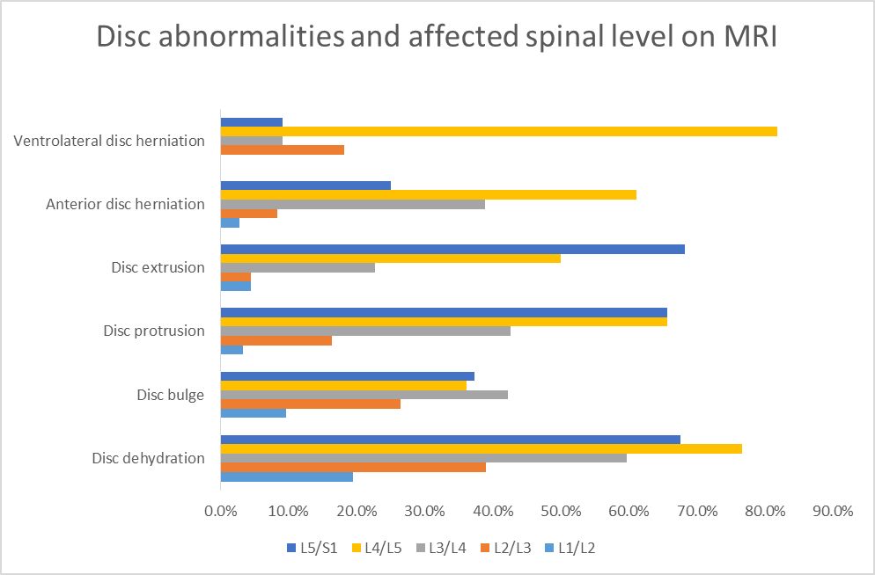

Fig. 1: intervertebral disc changes on MRI

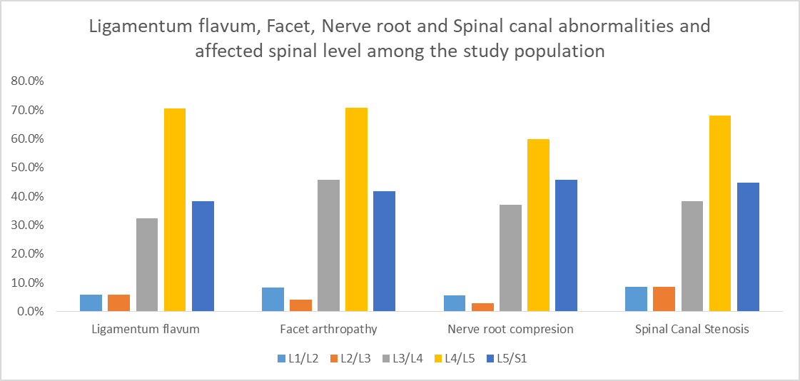
Fig. 2: Ligamentum flavum, Facet, Nerve root and Spinal canal abnormalities and affected spinal level

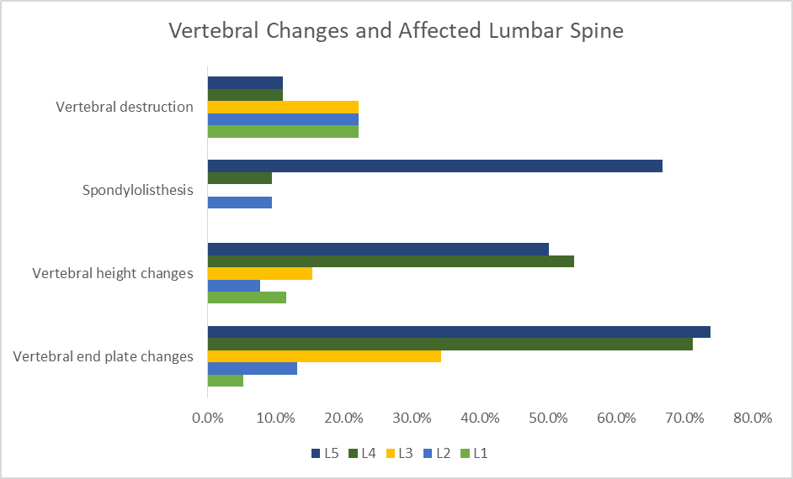Fig. 3: Lumbosacral vertebral changes abnormalities and the affected spinal level

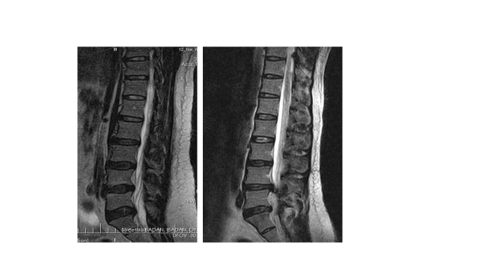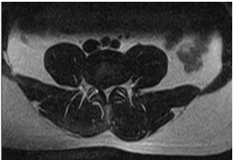
Images 1a and b; sagittal and axial T2W Lumbosacral MRI showing: multilevel disc dehydration from L3/4(blue asterisk) to L5/ and right paracentral disc protrusion (blue arrows) with spinal canal stenosis and right neural foraminal obliteration at L4/5.

INTRODUCTION
La lombalgie, une maladie qui affecte de nombreuses personnes à un moment de leur vie¹, est devenue un grave problème de santé publique souvent associée à une invalidité et à une perte de potentiel de gain^{2,3,4}. L'étude mondiale sur la charge de morbidité de 2010 a classé la lombalgie parmi les 10 principales maladies et traumatismes qui comptent le plus grand nombre d'années de vie corrigées de l'incapacité dans le monde⁵. L'incidence de la lombalgie est élevée, plus de 80% des personnes se plaignant de la lombalgie au cours de la vie⁶, de sorte qu'environ 5,0% à 10,0% des cas évolueront en lombalgie chronique durant trois à six mois ou plus⁷. Cette forme de douleur au bas du dos est responsable de coûts de traitement élevés, de l’absentéisme au travail et de la souffrance individuelle^{8,9,10}. Des rechutes et de multiples épisodes de lombalgie plusieurs années après la présentation initiale ont été observées dans les cas de lombalgie chronique⁷. En Afrique subsaharienne, la lombalgie chronique a également été documentée comme étant le problème musculo-squelettique le plus courant sur le lieu de travail, accompagné d'une perte de qualité de vie et de finances¹¹. Dans la population adulte, la prévalence ponctuelle et la prévalence sur un an seraient respectivement d’environ 30% et de 15% à 45% dans les pays occidentaux¹².
La prévalence au cours de la vie dans les pays africains (28% à 74%), rapportée par Louw et al¹³ dans une revue systématique, était toutefois comparable à celle des pays occidentaux (30% à 80%)¹³, ce qui indique que la lombalgie est aussi une maladie grave parmi les Africains.
Des études antérieures au Nigéria ont fait état d'une vaste gamme de prévalence de la lombalgie allant de 38% à 73,5% dans la littérature^{14,15,16,17}, en accord avec les chiffres publiés dans les pays occidentaux et africains¹³.
Bien que l'étiologie de la douleur au bas du dos soit large, la grande majorité des douleurs au bas du dos est de nature mécanique (tensions musculo-squelettiques, compression de la racine nerveuse, hernie discale, disque dégénératif et articulations)¹⁸. La lombalgie peut également être causée par des affections sous-jacentes graves ou des affections non mécaniques telles que des affections inflammatoires, des infections, des tumeurs ou des calculs rénaux¹⁸. Outre ces causes physiques, des facteurs psychologiques tels que le stress, la dépression et ou l'anxiété peuvent également se présenter sous la forme d'une douleur au bas du dos^{19,20}. Bien que les facteurs physiques et psychosociaux qui entrent en jeu dans l'étiologie de la douleur au bas du dos soient généralement les mêmes dans le monde entier²¹, les différences dans le degré d'implication de ces facteurs, le schéma de douleur au bas du dos en ce qui concerne l'étiologie et les caractéristiques de la population varient d'un pays à l'autre et même à l'intérieur d'un même pays²¹. Des études récentes suggèrent que bon nombre des facteurs de risque de la douleur au bas du dos sont modifiables et peuvent être résolus dans une large mesure par de simples étapes pratiques²².
Il est à noter que l'évaluation diagnostique des malades atteints de lombalgie peut être très difficile et nécessite une prise de décision clinique complexe, en particulier pour détecter la source de la douleur parmi les différentes structures potentiellement impliquées dans la lombalgie chronique, un facteur clé dans la gestion de ces malades²³. Parmi les autres modalités d'imagerie, l'imagerie par résonance magnétique (IRM) est préférée dans l'évaluation de la douleur au bas du dos²⁴.
Des rapports en Afrique subsaharienne ont décrit certaines anomalies ou constatations dans les douleurs au bas du dos, en particulier les modifications du disque intervertébral sur l'imagerie par résonance magnétique^{24,25,26}. Dans cette étude, nous avons évalué la prévalence et la distribution des disques de la colonne lombo-sacrale, du corps vertébral, du canal rachidien central et latéral, de l’articulation facétale et des changements du ligamentum chez les malades souffrant de lombalgie dans le sud-ouest du Nigeria entre mars 2015 et août 2016.
Malades et méthodes
Plan de l'étude: Il s'agissait d'une étude rétrospective menée sur une période de 18 mois auprès de malades présentant une douleur au bas du dos qui avaient été référés pour une imagerie par résonance magnétique de la colonne lombo-sacrale entre mars 2015 et août 2016. Les cartes de demande d'IRM pour la colonne vertébrale de l'hôpital et l'IRM lombo-sacrale des images des malades ont été récupérées du service des archives et du serveur du système d'archivage et de communication des images, respectivement. L’acquisition des images a été effectuée à l’aide d’un système IRM à champ faible et à champ faible 0,36 Teesla MINDRAY, version du logiciel; sencell 02.00.00.37666, Date de fabrication 2012-09, Chine. Les malades ont été scannés en décubitus dorsal et sur la bobine de la colonne vertébrale pour imager la colonne lombo-sacrale. Les images évaluées étaient des images avec localisateur, des images sagittales en T1 et T2 W et des images axiales choisies en T1 et en T2W ainsi que des images après contraste au gadolinium. Ces images ont été évaluées et interprétées par deux radiologistes expérimentés en imagerie par résonance magnétique de la colonne vertébrale, aveuglés par les données démographiques et les présentations cliniques des malades. Le degré d'accord dans un essai pilote de dix images IRM de la colonne lombo-sacrale était de 70 à 80% (Kappa).
La définition des paramètres des disques intervertébraux était basée sur des rapports antérieurs largement acceptés^{27,28,29}, la classification de l’intensité du signal discale en types normaux ou déshydratés était basée sur les critères de Milette et al²⁷. Le gonflement du disque et les hernies ont été définis conformément aux travaux de Ract et al²⁸ et de Fardon et al²⁹ comme suit: -
Le renflement du disque était un disque intervertébral avec une extension circonférentielle symétrique ou une extension asymétrique de plus de 25% de l'anneau externe au-delà du périmètre de la vertèbre adjacente du matériau du disque, mais confinée par les fibres de l'anneau fibreux le plus externe. La protrusion discale est une extension focale ou asymétrique du disque au-delà du corps vertébral adjacent ou des anomalies localisées de la marge discale qui touchent moins de 25% de la circonférence discale; les extrusions discales étaient des saillies plus étendues du disque (à travers toutes les couches de l'anneau) au-delà de l'inter-espace. La distance entre les bords du matériau du disque au-delà de l'espace du disque est supérieure à la distance entre les bords de la base mesurée dans le même plan. Les disques séquestrés sont des disques extrudés qui ne sont plus dans la continuité du matériau du disque parent.
Les modifications osseuses évaluées étaient les suivantes: - rétrécissement foraminé: foramen inférieur à 4 mm mesuré au niveau du segment foraminien du canal radiculaire; Hypertrophie du ligamentum flavum: diamètre le plus large du ligamentum flavum sur les images axiales supérieures à 5 mm; Sténose du canal rachidien: diamètre antéro-postérieur du canal, mesuré à partir du bord postérieur du disque intervertébral jusqu'à la jonction spino-laminaire inférieure à 11,5 mm.
L'arthropathie de la facette, les modifications de la plaque d'extrémité du corps vertébral selon la classification de Modic²⁷, l'effondrement du corps vertébral, la réduction de la hauteur et la destruction ont également été évalués et documentés. D'autres comprenaient la compression de la racine nerveuse et de la moelle épinière/cauda équin, spondylolisthésis, et présence d'anomalies de la colonne vertébrale congénitale ou néoplasme.
Un numéro d’étude a été attribué à chaque malade afin de protéger son identité. Cette étude a été approuvée par le comité d'examen institutionnel de l'hôpital universitaire d'Ibadan.
Les données obtenues ont été analysées à l'aide du logiciel SPSS (Statistical Package for Social Sciences) (version 22.0., IBM Corp., publié en 2011, IBM SPSS Statistics pour Windows, IBM Corp. Armonk, NY, États-Unis). Les données ont été présentées à l'aide de tableaux de fréquence et de pourcentages, bar et pie chartes selon le cas. Des tests du chi carré ont été utilisés pour l'analyse statistique de variables catégorielles. Les tests d'association ont été réalisés à l'aide de corrélations de Pearson.
RESULTATS
Population étudiée
Cent huit malades ayant eu une IRM pour lombalgie pendant la période de l'étude ont été évalués. Environ la moitié (52,8%) des patients étaient des hommes, contre 51 (47,2%) chez les femmes, avec un ratio hommes/femmes de 1,1: 1. L'âge moyen des malades était de 49,9 ± 15,4 ans avec une fourchette de 8 à 77 ans. La majorité des malades (25,9%) appartenaient au groupe d’âge de 50 à 59 ans, suivis des malades du groupe des 60 à 69 ans (20,4%). Le plus petit nombre de malades souffrant de douleurs lombaires étaient ceux âgés de 20 ans et moins (3,7%).
Présentation clinique
Les diagnostics provisoires les plus courants étaient la spondylose lombaire dans 43 cas (39,8%), la radiculopathie dans 19 cas (17,6%) et le prolapsus discal 9 (8,3%). Le moins important était la douleur aux membres inférieurs/sciatique dans 2 cas (1,9%). Globalement, la spondylose lombaire était le diagnostic provisoire le plus courant en tant qu’entité ou en association avec d’autres symptômes, représentant 48/108 (44,5%) de la population de l’étude (tableau 1).
Les présentations cliniques ont été évaluées et comparées en fonction des groupes d'âge des malades. La spondylose lombaire était la présentation clinique la plus fréquente chez les malades de tous les groupes d'âge. La spondylose lombaire était la plus fréquente chez les malades âgés de 60 ans et plus (46,9%). Le prolapsus discal (19,4%) était cependant plus fréquent chez les malades de moins de 40 ans. La radiculopathie, seule ou associée à d'autres symptômes, était plus fréquente (31,1%) chez les malades âgés de 40 à 59 ans. Une radiculopathie a également été observée chez 21,9% des malades âgés de 60 ans et plus. Les tumeurs à la colonne vertébrale / métastases à la colonne vertébrale étaient plus fréquentes chez les personnes de plus de 60 ans, également présentées dans le tableau 1.
Durée de la lombalgie
Au total, 23 (21%) des malades présentaient une douleur au bas du dos aiguë (3 mois et moins), tandis que la majorité des 80 malades (74,4%) avaient une douleur chronique au bas du dos d'une durée supérieure à 3 mois. La durée de la douleur au bas du dos n'a pas été précisée chez 5 (4,6%) des malades.
Résultats de l'imagerie par résonance magnétique
Dans cette étude, 96,3% (104/108) avaient des résultats anormaux en IRM. La plupart des malades (95,4%) présentaient des anomalies discales et 23 (21,7%) des pathologies vertébrales. Certaines des pathologies sont montrées dans les images 1a et 1b.
Pathologies du disque intervertébral
Un gonflement discal a été observé dans 83 cas (79,8%) dans cette étude, suivi d'une déshydratation discale dans 77 cas (74,0%), tandis qu'une migration discale a été observée chez un malade (1,0%) (tableau2). Une déshydratation discale multiple a été observée chez 81 malades (75,3%). En outre, parmi les malades présentant une hernie discale antérieure, 81 (77,9%) des malades étaient atteints de multiples disques, alors que 18,2% (2/11) des malades présentaient une hernie discale ventro-latérale multiple (Tableau 2).
Pathologies du disque à résonance magnétique en relation avec les niveaux du disque
Une déshydratation du disque a été observée chez 77 malades et plus commun à L4/L5 chez 59 malades (76,6%), L5/S1 chez 52 (67,5%) et au niveau du disque L1/L2 chez 15 malades (19,5%). Un bombement discal est survenu chez quatre-vingt-trois malades; au niveau L3/L4 chez 35 (42,2%), à L5/S1 chez 31 (37,3%) et L4/L5 chez 30 malades (36,1%). Une protrusion discale est survenue chez soixante et un malades au total; à fréquence égale à L4/L5 et à L5/S1 chez environ 65,6% des malades et chez 2 malades (3,3%) à L1/L2. L'extrusion discale a été observée chez vingt-deux malades; 15 (68,2%) des malades présentaient une extrusion discale à L5/S1, 11 (50,0%) à L4/L5, tandis qu'un malade (4,5%) présentait une extrusion à L1/L2 et L2/L3. Une hernie discale antérieure a été enregistrée chez 36 malades; à L4/L5 chez 22 malades (61,1%), et le moins important était un malade (2,8%) à L1/L2. En outre, une hernie discale ventro-latérale a également été observée chez onze malades et plus de 9 (81,8%) au stade L4-L5, comme le montre la Fig. 1.

Changements vertébraux en imagerie par résonance magnétique
Dans cette étude, 57 malades (52,5%) avaient une courbure vertébrale normale. La pathologie vertébrale la plus courante était les changements de plaque d'extrémité vertébrale dans 37 (35,6%) des cas, comme indiqué dans le tableau 3.
Des modifications des plaques d'extrémité de Modic étaient présentes dans trente-sept cas; 16 (44%) étaient des changements de plaque d'extrémité de classe 3, 14 (37%) étaient des changements de classe 3 alors que des changements de plaque d'extrémité de classe 1 Modic ont été observés chez 7 malades (19%). La plupart (74%) des modifications de la plaque d'extrémité vertébrale ont eu lieu à L5/S1, suivies de L4/L5 (71,1%). Parmi les vingt malades atteints de spondylolisthésis; 19 (83%) des malades de grade 1, 3 (13%) des malades de grade 2 et 1 (4%) avaient un grade 3. Les spondylolisthésis (antéro et rétrolisthésis) sont survenus principalement à la L5/S1 dans 16 (66,7%) des cas.
La plupart des changements de hauteur vertébrale (53,8%) se sont produits à L4, suivis de L5 (50,0%) et de L3 (15,4%). En outre, une destruction vertébrale a été observée dans 9 cas; aux vertèbres L3 à L5 et à une fréquence de 22,2% (2/9) à chacun de ces niveaux, tandis que les niveaux L1 et L2 ont été détruits chez un malade à chaque niveau (Fig. 2).
Hypertrophie de Ligamentum flavum, arthropathie des facettes, compression des racines nerveuses et sténose du canal rachidien en IRM
Une analyse plus poussée des résultats IRM rachidiens anormaux a montré que, parmi tous les malades souffrant de lombalgie, comme le montre la figure 3, 34,6% présentaient une compression de la racine nerveuse et 32,7% une hypertrophie du ligamentum. Une compression des racines nerveuses a été observée chez environ 60,0% à L4/L5, tandis qu'environ 2,9% des malades présentaient une compression des racines nerveuses à L2/L3. La plupart des hypertrophies du ligamentum flavum (70,6%) se sont produites à L4/L5, suivies de L5/S1 (38,2%) et de L3/L4 (32,4%).
En ce qui concerne l'arthropathie de la facette articulaire, environ 85,4% des arthropathies de la facette étaient bilatérales, 12,2% du côté droit et 2,4% de l'articulation de la facette gauche. Parmi les cas d'arthropathie des facettes, 70,8% des malades étaient atteints de L4/L5, 45,8% de L3/L4 et 41,7% de L5/S1. Une autre anomalie observée était la sténose du canal rachidien. Nous avons enregistré 39,5% des sténoses du canal rachidien à L4/L5, 25,9% à L5/S1 et 22,2% à L3/L4.
Comparaison entre le sexe et l'âge des modifications de l'IRM
Le tableau 4 montre que 36 femmes (70,6%) avaient un rétrécissement discal, contre 27 hommes (47,4%) présentant un rétrécissement discal (p = 0,02); les autres pathologies de la colonne vertébrale n'ont pas montré de variations significatives selon le sexe. Les malades de 60 ans et plus ont présenté une détérioration statistiquement significative des paramètres suivants par rapport au groupe d’âge plus jeune: déshydratation du disque, renflement du disque, saillie du disque, hernie discale antérieure et modifications du plateau vertébral, sténose foraminé neurale, compression de la racine nerveuse et arthrose facette.
Autres constatations
Les autres résultats de cette étude incluent un cas chacun; fracture par compression de la face antérieure du corps L5; hyper-intense fragmentée et vertèbre L3 élargie; vertèbre T12 hyper-intense solitaire et caractéristiques de la tuberculose de la colonne vertébrale chez deux patients.
DISCUSSION
L'âge moyen observé de 50 ans dans la population de douleurs lombaires dans cette étude se situe dans les données publiées sur la tranche d'âge la plus prévalent des douleurs lombaires¹⁰ et la tranche d'âge d'incidence maximale de 49 à 59 ans³⁰. La tendance à la hausse généralement observée avec l’âge, va également dans le sens du rapport précédent³⁰. Nous n’avons observé aucune prédilection significative liée au genre en accord avec les études précédentes^{10, 27, 31}. Bien qu’il n’existe pas de consensus sur la prédilection liée au genre dans les lombalgies, la plupart des chercheurs n’ont pas signalé de différences entre les sexes. Les différences de prépondérance de la douleur au bas du dos chez les femmes, documentées par certains auteurs^{16, 32} par rapport à cette étude, pourraient être dues à la variabilité reconnue du profil de la douleur au dos d'un endroit à un autre³².
La spondylose lombaire, une maladie dégénérative mécanique de la colonne vertébrale, et souvent la cause sous-jacente de la douleur au bas du dos avec l'âge^{33, 34, 35,} a été observée principalement chez les personnes âgées de 40 ans et plus. La prévalence était plus élevée chez les personnes de plus de 60 ans, ce qui conforte l'hypothèse selon laquelle une maladie rachidienne dégénérative résulte d'une combinaison d'ostéoporose, de fractures vertébrales par compression et de modifications dégénératives de la colonne vertébrale, toutes associées à un âge avancé³⁴. Notre étude actuelle a confirmé que l'âge était un facteur majeur associé à la maladie dégénérative de la colonne lombosacrée.
La prévalence comparativement plus élevée de prolapsus discal/hernie discale à 40 ans et moins est probablement due à la nature jeune et active et à la participation conséquente à des activités physiques et sportives pénibles impliquant la levée d'objets lourds et des lésions traumatiques résultant de mouvements de rotation et de flexion de la colonne vertébrale^{36, 37}
De manière attendue, les personnes âgées de 60 ans et plus présentaient également une lombalgie en raison d’une malignité osseuse primaire ou secondaire. La prévalence des tumeurs malignes de la colonne vertébrale augmente de façon exponentielle avec l’âge^{10, 34}.
La présentation tardive à l'hôpital est une pratique courante dans notre environnement, où l'automédication et la médecine douce sont monnaie courante, en particulier chez les personnes non instruites^{38,39}. Ces facteurs pourraient expliquer la forte proportion observée de malades présentant une lombalgie chronique et une IRM à l'hôpital dans cette étude.
L'IRM a montré que les modifications dégénératives du disque étaient plus courantes que les modifications osseuses. Et parmi les anomalies discales, le gonflement discal et la déshydratation ont été le plus souvent observés. Nos résultats sont conformes aux études précédentes^{28, 40, 41}. L'évaluation de la distribution de ces pathologies a montré que les vertèbres et les disques inférieurs étaient plus fréquemment impliqués. Les disques L4/5 sont en particulier les sites les plus courants de déshydratation discale, de hernie discale antérieure et ventrolatérale, de compression des racines nerveuses et d’hypertrophie du ligamentum flavum. Les arthropathies de l'articulation de la facette, la réduction de la hauteur vertébrale et la sténose du canal rachidien étaient également plus courantes à ce niveau. Une protrusion discale a toutefois été observée à fréquence égale à L4/5 et à L5/S1. De plus, les vertèbres L4 et L5 étaient généralement impliquées dans les modifications de Modic de la plaque terminale vertébrale. L'extrusion discale et les spondylolisthésis étaient rares mais observés au niveau L5/S1, conformément à une étude précédente⁴².
La prévalence de la discopathie dégénérative en IRM, à savoir la déshydratation discale, le rétrécissement et les hernies, a été signalée davantage au niveau L4/5 et suivie de près par les niveaux L5/S1 de Teraguchi et al⁴², corroborant ainsi notre observation. Les raisons de la distribution/prévalence des modifications discales dégénératives de la colonne lombosacrée à ces niveaux ont été expliquées comme étant dues à l'alignement de la colonne vertébrale dans le plan sagittal, à la présence de lordose lombaire et à l'hypothèse d'un stress compressif causé par la posture sur l'équilibre de la colonne sagittale aux niveaux vertébraux inférieurs^{42,43}. Ces rapports correspondaient à notre observation dans cette étude. En outre, les arthropathies de l'articulation facettaire se produisent principalement à L4/L5, conformément aux conclusions de Teraguchi et al⁴² qui ont indiqué que l'orientation sagittale des processus articulaires à L4/5 les rend plus instables qu'à L5/S1 avec une instabilité croissante avec le vieillissement et devenir une conclusion commune après 45 à 50 ans²⁸. Une raison similaire peut aussi bien être responsable de l'hypertrophie du ligamentum flavum à ce niveau. La prévalence élevée de la sténose du canal rachidien à L4/5 pourrait être attribuée à la prévalence élevée de la sténose du canal rachidien central à ce niveau par suite des hernies discales postérieures. Bien que la lombalgie ne montre aucun biais de sexe dans cette étude, le rétrécissement du disque était significativement plus prévalent chez les femmes, comme indiqué par les auteurs précédents^{41, 42}.
La forte prévalence des modifications de la plaque d'extrémité vertébrale de type Modic I est en accord avec les conclusions d'autres chercheurs. Thompson et al⁴⁴ ont documenté la prévalence élevée de modifications de la plaque d'extrémité vertébrale Modic 1 avec une valeur prédictive positive et une spécificité de 81% et 98% respectivement, tandis que Weishaupt et al ⁴³⁻⁴⁵ ont signalé que la gravité et l'étendue des modifications de Modic de type 1 avait une valeur prédictive élevée pour la douleur au bas du dos. En outre, Hancock et al⁴⁴⁻⁴⁶ ont signalé une probabilité accrue (estimée à 32 fois) de la présence de modifications de type Modic de type 1 lorsqu'une lombalgie est présente chez un individu⁴⁴⁻⁴⁶. Ces études ont toutes mis en évidence une association entre les modifications de Modic I et la survenue de douleurs lombaires^{45, 46}. Nous avons donc conclu que la prévalence élevée de modifications de Modic 1 était due au fait que la population étudiée avait toutes des douleurs lombaires.
De plus, nous avons observé que le spondylolisthésis était plus courant au niveau L4/5 dans cette étude. Le spondylolisthésis serait causé par le déplacement du corps vertébral supérieur par rapport au corps vertébral inférieur en raison d'une dégénération sagittale des facettes articulaires⁴⁷. En outre, l'orientation sagittale de l'articulation de la facette L4/5 le rend plus susceptible aux spondylolisthésis dégénératifs, qui ont été documentés pour se produire le plus souvent au niveau de la vertèbre L4⁴⁸. Nous croyons que ces facteurs étaient responsables de notre observation dans cette étude.
Les limites de cette étude incluent la nature rétrospective de l’étude. Les malades avec une documentation incomplète et une image déformée n'étaient pas inclus. Le scanner IRM à faible champ utilisé dans cette étude et le coût élevé de l'examen IRM auraient réduit la sensibilité et exclu certains malades.
CONCLUSION
Cette étude a montré que les modifications de l'imagerie par résonance magnétique dans la douleur au bas du dos impliquaient des disques multiples et des pathologies osseuses à plusieurs niveaux, cependant, les anomalies discales prédominaient. Les niveaux de disque L4-5, L5-S1 et le corps vertébral de L4 étaient les sites les plus fréquemment touchés parmi une population africaine autochtone.
LES REFERENCES
1. Anderson, GB. Caractéristiques épidémiologiques des douleurs lombaires chroniques.
Lancette. 1999; 354 (9178): 581-5.
2. Balague F, FA Mannione, F Pellise, Cedraschi C. Lombalgie non spécifique. Lancette. 2002; 379 (9814): 482-91.
3. Guo HR, Tanaka S, Halperin WE, Cameron LL. Prévalence des maux de dos dans l’industrie américaine et estimations du nombre de journées de travail perdues. Revue américaine de santé publique. 1999; 89 (7): 1029 à 1035.
4. Katz JN. Troubles du disque lombaire et lombalgie: facteurs et conséquences socio-économiques. J Chirurgie articulaire osseuse Am. 2006; 88 (suppl. 2): 21-4.
5. MA AlMazroa, Memish ZA. Années vécues avec une invalidité (YLD) pour 1160 séquelles de 289 maladies et traumatismes 1990-2010: une analyse systématique pour la Global Burden of Disease Study 2010. Lancet. 2012; 380 (9859), 2163-296. Erratum dans: Lancet, 2013; 381 (9867): 628.
6. Rubin DI. Épidémiologie et facteurs de risque de douleur à la colonne vertébrale. Neurol Clin, 2007; 25 (2): 353-71.
7. Manchikanti L, Singh V, Falco FJ, Benyamin RM, le juge Hirsch. Épidémiologie des douleurs lombaires chez les adultes. Neuromodulation. 2014; 17 (Suppl 2): ​​3-10.
8. Liao ZT, Pan YF, Huang JL, Huang F, Chi WJ, Zhang KX et al. Enquête épidémiologique sur les douleurs lombaires et les spondylarthropathies axiales dans une population chinoise Han. Scand J Rheumatol, 2009; 38 (6): 455-9.
9. Melloh M, Röder C, Elfering A, Theis JC, U Müller, Staub LP, et al. Protocole d’étude des différences entre les systèmes de soins de santé en termes de résultats et de rentabilité du traitement chirurgical et conservateur de la lombalgie chronique. BMC Musculoskelet Disord. 2008; 9h81.
10. Guo H-R. Heures de travail consacré à des activités répétées et à la prévalence des maux de dos. Occup Environ Med. 20012; 59: 680-8.
11. Omokhodion FO, Sanya AO. Facteurs de risque de lombalgie chez les employés de bureau à Ibadan, dans le sud-ouest du Nigéria. Occup Med. 2003; 53 (4): 287–9.
12. Andersson GBJ. L'épidémiologie des troubles de la colonne vertébrale. Dans Frymoyer JW (ed.) La colonne vertébrale des adultes: principes et pratique, 2e éd. Philadelphie, Lippincott-Raven, 1997: 93-141.
13. Louw QA, Morris LD, Grimmer-Somers K. La prévalence de la douleur au bas du dos en Afrique: une revue systématique. BMC Musculoskelet Disord. 2007; 8: 105.
14. Omokhodion FO, Umar US, Ogunnowo BE. Prévalence de la lombalgie chez le personnel d’un hôpital rural au Nigéria. Occup Med. 2000; 50 (2): 107-10.
15. Rufa’i AA, Sa’idu IA, Ahmad RY, Elmi OS, Umar Aliyu SU, Jajere AM, et al. Prévalence et facteurs de risque de lombalgie chez les conducteurs professionnels à Kano, Nigéria, Archives of Environmental & Occupational Health. 2013; 70 (5): 251-5.
16. Fabunmi AA, SO Aba, NA Odunaiya. Prévalence des douleurs lombaires chez les paysans d'une communauté rurale du sud-ouest du Nigéria. Afr J Med Sci. 2005); 34: 259-62.
17. Ogunbode AM, Adebusoye LA, Alonge TO. Prévalence de la douleur au bas du dos et des facteurs de risque associés chez les patients adultes se présentant dans une clinique de médecine familiale nigériane, une étude réalisée en milieu hospitalier. Afr J Prm Soins De Santé Fam Med. 2013; 5 (1): 1-8.
18. Institut national des troubles neurologiques et des accidents vasculaires cérébraux. Fiche de renseignements sur la douleur au bas du dos. https://www.ninds.nih.gov/Disorders/Patient-Caregiver-Education/Fact-Sheets/Low-Back-Pain-Fact-Sheet.
19. Besen E, jeune AE, Shaw WS. Retour au travail après une lombalgie: vers un modèle de facteurs psychosociaux individuels. J Occup Rehabil. 2015; 25 (1): 25–37.
20. Deyo RA, Bryan M, BA Comstock, JA Turner, P Heagerty, J Friedly et al. Trajectoires des symptômes et de la fonction chez les personnes âgées atteintes de lombalgies. La colonne vertébrale (Phila Pa 1976), 2015; 40 (17): 1352-162.
21. Omoke NI, Amaraegbulam PI. Douleur lombaire telle qu’observée dans les cliniques orthopédiques d’un hôpital universitaire nigérian. Niger J Clin Pract. 2016; 19: 212-7.
22. Johnson OE, Edward E. Facteurs de prévalence et de risque de lombalgie chez les travailleurs d'un établissement de santé du sud et du sud du Nigéria. Journal britannique de médecine et de recherche médicale. 2016; 11 (8): 1-8.
23. Allegri M, Montella S, F Salici, Valente A, Marchesini M, Compagnone C, et al. Mécanismes de la douleur au bas du dos: guide de diagnostic et de traitement F1000Research 2016, 5 (F1000 Faculty Rev): 1530 (doi: 10.12688 / f1000research.8105.1)
24. Adekanmi AJ, TO Bello, OM Atalabi, KO Jimoh, Ogunseyinde OA. Imagerie par résonance magnétique de disques intervertébraux lombo-sacrés chez des Nigérians souffrant de douleurs lombaires. West Afr J Radiol. 2017; 24: 61-7.
25. Adeyinka AO, Omidiji OA. Diagnostic par imagerie par résonance magnétique dans la colonne lombaire d'adultes souffrant de douleurs lombaires au sud-ouest du Nigéria. West Afr J Radiol. 2011; 18: 1-9.
26. Irurhe NK, Adekola OO, Quadri AR, Menkiti ID, Udenze IC, Awolola NA. Résultats de l’analyse par résonance magnétique chez un Nigérian adulte souffrant de douleurs lombaires. Monde J Med Sci. 2012; 7: 204-9.
27. Ross JS, Modic MT. Evaluation actuelle de la maladie dégénérative de la colonne vertébrale par imagerie par résonance magnétique. Clin Ortho Rel Res. 1992; 279: 68-81.
28. Ract I, Meadeb JM, Mercy G, Cueff F, Husson JL, Guillin R. Un examen de la valeur des signes IRM dans les douleurs au bas du dos. Diagnostic Interv Imaging. 2015; 96: 239-49.
29. Fardon DF, Williams AL, EJ Dohring, FR Murtagh, SLS Rothman, Sze GK. Nomenclature des disques lombaires: version 2.0: Recommandations des groupes de travail combinés de la North American Spine Society, de l’American Society of Spine Radiology et de l’American Society of Neuroradiology. Le journal de la colonne vertébrale. 2014); 14 (11): 2525-255.
30. Wong AYL, J Karppinen, Samartzis D. Douleurs lombaires chez les personnes âgées: facteurs de risque, options de gestion et orientations futures. Scoliose Spinal Disord. 2017; 12: 14. eCollection 2017.
31. Deyo RA, Weinstein J. Santé primaire - Lombalgie. N Engl J Med. 2001; 344: 362-70.
32. Wáng YXJ, Wáng J-Q, Káplár Z. Prévalence accrue de la lombalgie chez les femmes que chez les hommes après l'âge de la ménopause: preuves fondées sur une revue de littérature synthétique. Imagerie quantitative en médecine et chirurgie. 2016; 6 (2): 199-206.
33. Ehrlich GE. Douleur dans le bas du dos. Bulletin de l'Organisation mondiale de la Santé, 2003; 81: 671-6.
34. Dionne CE, KM Dunn, PR Croft. La prévalence des maux de dos diminue-t-elle vraiment avec l'âge? Une revue systématique. Vieillissement 2006; 35: 229–34.
35. Van Tulder MW, RJ Scholten, Koes BW. Anti-inflammatoires non stéroïdiens pour la douleur au bas du dos: une revue systématique dans le cadre du groupe de revue du dos de la Collaboration Cochrane. Colonne vertébrale. 2000; 25: 2501-13.
36. Thompson P, Carr E. L'analyse du contenu des médecins généralistes a demandé un rapport de radiographie de la colonne lombaire, British Journal of Radiology. 2007; 80: 866-71.
37. Prince MJ, Wu F, Guo Y, Gutierrez RLM, O’Donnell M, Sullivan R, et al. Fardeau de la maladie chez les personnes âgées et implications pour les politiques et les pratiques de santé. Lancette. 2015; 385: 549–62.
38. Zhao Y, Ma S. Observations sur la prévalence, les caractéristiques et les effets de l'autotraitement. Frontières en santé publique. 2016; 4:69.
39. NA El-Nimr, Wahdan IMH, Wahdan AMH, Kotb RE. Auto-médication avec des médicaments et des médecines complémentaires et alternatives à Alexandrie, en Égypte: prévalence, caractéristiques et déterminants. Journal de la santé de la Méditerranée orientale. 2015; 21 (4): 256 à 65.
40. Uduma FU, Ongolo P, Assam G, Fokam P, Motah M. Évaluation du motif d'images de résonance magnétique de la colonne lombo-sacrée au Cameroun. Une étude de pionnier. Glob J Med Res. 2011; 11: 30-41.
41. Orege JA, Abuya JM et Elias GD. Modèles communs d'imagerie par résonance magnétique (IRM) chez des patients souffrant de douleurs lombaires à Eldoret, au Kenya. J Sci Innov Res. 2013; 2: 260-79.
42. Teraguchi M, Yoshimura N, Hashizume H., Muraki S., Yamada H., Minamide A et al. Prévalence et distribution de la dégénérescence du disque intervertébral sur toute la colonne vertébrale dans une cohorte basée sur la population: l'étude Wakayama Spine. Arthrose et cartilage. 2014; 22 (1): 104-10.
43. Murray KJ, MR Le Grande, AO de Mues, Azari MF. Caractérisation de la corrélation entre la lordose debout et l'articulation dégénérative de la colonne lombaire inférieure chez les femmes et les hommes: étude radiographique. BMC Musculoskeletal Disorders (2017) 18: 330-7.
44. Thompson KJ, AP Dagher, Eckel TS, Clark M., Reinig JW. Changements modiques sur les images IRM étudiés avec la discographie provocante: pertinence clinique - une étude rétrospective de 2457 disques. Radiologie 2009; 250 (3): 849—55.
45. Weishaupt D, M Zanetti, J Hodler, Min K., Fuchs B, CW Pfirrmann et al. Dérangement douloureux du disque lombaire: prévalence d'anomalies de la plaque d'extrémité en IRM. Radiologie. 2001; 218 (2): 420-7.
46. ​​MJ Hancock, CG Maher, J. Latimer, MF Spindler, JH McCauley, Laslett M et al. Revue systématique des tests visant à identifier le disque, le SIJ ou l’articulation à facette comme source de la douleur au bas du dos (Eur Spine J. 2007); 16 (10): 1539-1550.
47. LJ Grobler, PA Robertson, JE Novotny, pape MH. Étiologie du spondylolisthésis. Evaluation du rôle joué par la morphologie articulaire de la facette lombaire. Spine (Phila Pa, 1976). 1993; 18 (1): 80-91
48. Jacobsen S, Sonne-Holm S, Rovsing H, Monrad H, Gebuhr P. Spondylolisthésis lombaire dégénératif: une perspective épidémiologique: l'étude de Copenhague sur l'arthrose. Colonne vertébrale (Phila Pa 1976). 2007; 32 (1): 120-5.

Tableau 1: Pathologies IRM rachidiennes en fonction de l'âge
Les groupes d'âge
Diagnostic clinique Moins de 40 ans 40-59 ans Supérieur à 60 ans Total en Pourcentage
(%) (%) (%) (%)
Spondylose lombaire 12 (38,7) 16 (35,5) 15 (46,9) 43 (39,8)
Sténose du canal rachidien 1 (3,2) 3 (6,7) 2 (6,2) 6 (5,6)
Prolapsus discal 6 (19,4) 3 (6,7) 0 (0,0) 9 (8,3)
Douleur LL/sciatique 0 (0,0) 1 (2,2) 1 (3,1) 2 (1,9)
Tumeurs spinaux/Prostate/Mets 2 (6,5) 2 (4,4) 3 (9,4) 7 (6.5)
LBP + Radiculopathie 3 (9,6) 9 (20) 7 (21,9) 19 (17,6)
Spondylose lombaire +
radiculopathie 0 (0,0) 5 (11,1) 0 (0,0) 5 (4,6)
Colonne vertébrale TB 3 (9,6) 0 (0,0) 0 (0,0) 3 (2,8)
Traumatisme médullaire
traumatique 2 (6,5) 3 (6,7) 1 (3,1) 6 (5,6)
Autres 2 (6,5) 3 (6,7) 3 (9,4) 8 (7,4)
Total 31 (28,7) 45 (41,7) 32 (29,6) 108 (100)

Tableau 2: Distribution des changements de disque
Anomalie discale Fréquence Pourcentage
Déshydratation DISC
Unique 19 24,7
Plusieurs 58 75,3
Renflement du disque
Unique 47 56,6
Plusieurs 36 43,4
Saillie du disque
Unique 20 32,3
Plusieurs 42 67,7
Extrusion de disque
Unique 14 63,6
Plusieurs 8 36,4
Migration du disque
Unique 1 100
Plusieurs 0
Hernie discale antérieure
Unique 23 63,9
Plusieurs 13 36,1
Ventrolatéral
Unique 9 81,8
Plusieurs 2 18,2

Tableau 3: Modifications de l'IRM dans la population étudiée
Changements vertébraux Fréquence Pourcentage
Courbure vertébrale (N = 108)
Normal 57 52,5
Redressé 34 31,7
Renversement 10 8,9
Lordose dorsale exagéré 5 5,0
Cyphose 2 2,0
Malade présentant des résultats anormaux à l'IRM (N = 104)
Changements de plaque d'extrémité vertébrale 37 35.6
Changements de hauteur vertébrale 25 24,0
Spondylolisthésis 23 19,2
Destruction vertébrale 9 8,7
Autres anomalies osseuses (N = 104)
Canal de la colonne vertébrale sténose 47 46,5
Arthropathie de la facette 24 23,1

Tableau 4: Relation entre le genre et les pathologies IRM
Anomalies IRM Sexe
Mâle femme X² P-Valeur
(n=57) (=51)
Disque se rétrécissant 27 (47,4) 36 (70,6) 5,971 0,02
Déshydratation du disque 42 (73,7) 35 (68,6) 0,336 0,56
Renflement du disque 41 (71,9) 42 (82,4) 1,644 0,200
Saillie discale 34 (59,6) 28 (54,9) 0,248 0,62
Extrusion du disque 11 (19,3) 11 (21,6) 0,086 0,77
Hernie discale antérieure 17 (29,8) 19 (37,3) 0,669 0,41
Ventrolatéral 6 (10,5) 5 (9,8) 0,015 0,90
Changements de plaque d'extrémité vertébrale 16 (28,1) 21 (41,2) 2,053 0,15
Modifications du corps vertébral 15 (26,3) 10 (19,6) 0,681 0,41
Spondylolisthésis 9 (15,8) 11 (21,6) 0,596 0,44
Foramina rétrécissant 28 (49,1) 31 (60,8) 1,477 0,22
Hypertrophie de Ligamentum flavum 15 (26,3) 16 (31,4) 0,336 0,36
Arthropathie de la facette 11 (19,3) 12 (23,5) 0,288 0,59
Compression des racines nerveuses 17 (29,8) 19 (37,3) 0,669 0,41
Courbure vertébrale anormale 25 (43,9) 32 (62,7) 3,852 0,05
Tableau 5: Associations entre l'âge et les pathologies IRM
Groupes d'âge
Anomalies de la colonne <40 40-59 60 et plus X² P-Valeur
lombo-sacrale en IRM (n = 31) (n=45) (n = 32)
Disque se rétrécissant 13 (41,9) 27 (60,0) 23 (71,9) 5,895 0,052
Déshydratation du disque 7 (22,6) 38 (84,4) 32 (100,0) 52,634 <0,001
Renflement du disque 21 (67,7) 37 (82,2) 25 (78,1) 2,205 0,33
Saillie discale 8 (25,8) 28 (62,2) 26 (81,3) 20,527 <0,001
Extrusion du disque 4 (12,9) 7 (15,6) 11 (34,4) 5,578 0,06
Hernie discale antérieure 3 (9,7) 17 (37,8) 16 (50,0) 12,206 0,002
Changements de plaque
d'extrémité vertébrale 6 (19,4) 15 (33,3) 16 (50,0) 6,595 0,04
Modifications du corps vertébral 2 (6,5) 12 (26,7) 11 (34,4) 7,438 0,02
Spondylolisthésis 2 (6,5) 9 (20,0) 9 (28,1) 5,014 0,08
Sténose du canal rachidien 7 (22,6) 23 (52,3) 17 (56,7) 8,892 0,01
Foramina rétrécit 6 (19,4) 26 (57,8) 27 (84,4) 27,166 <0,001
Hypertrophie de Ligamentum
flavum 2 (6,5) 14 (31,1) 15 (46,9) 12,791 0,002
Arthropathie de la facette 4 (12,9) 7 (15,6) 12 (37,5) 7,200 0,03
Compression des racines
nerveuses 4 (12,9) 13 (28,9) 19 (59,4) 15,988 <0,001
Courbure vertébrale anormale 20 (64,5) 20 (44,4) 17 (53,1) 2,996 0,23
Autres constatations 21 (67,7) 38 (84,4) 31 (96,9) 9,691 0,01

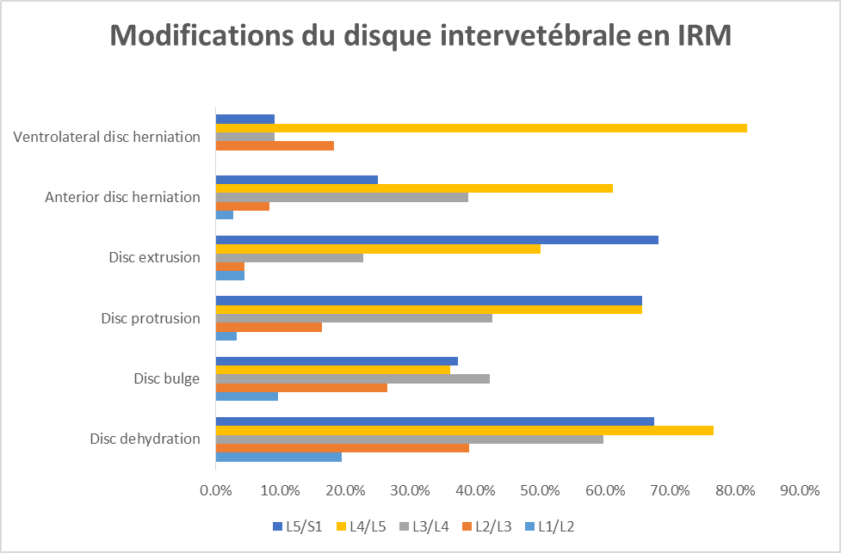
Fig. 1: modifications du disque intervertébral en IRM

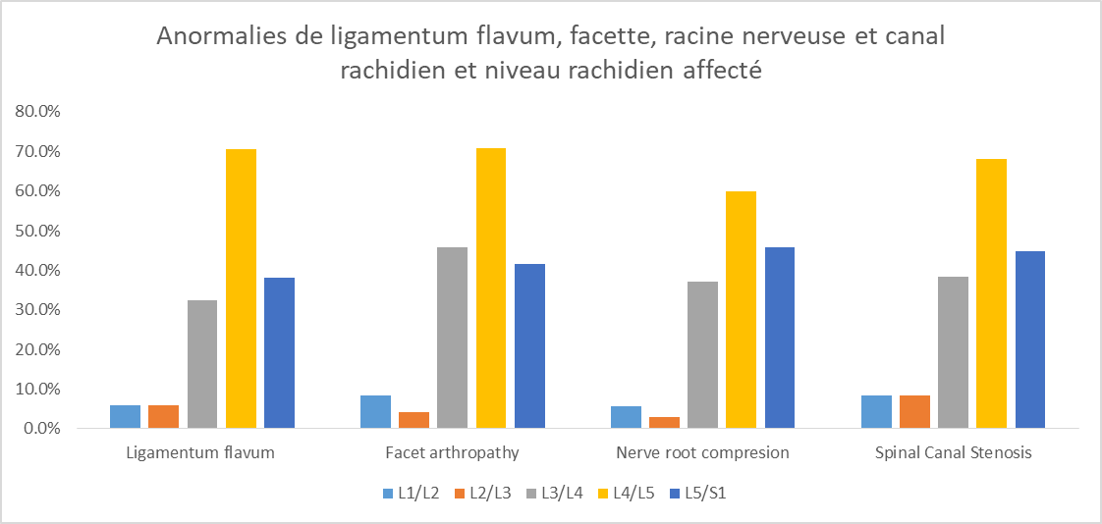
Fig. 2: Anomalies de Ligamentum flavum, facette, racine nerveuse et canal rachidien et niveau rachidien affecté

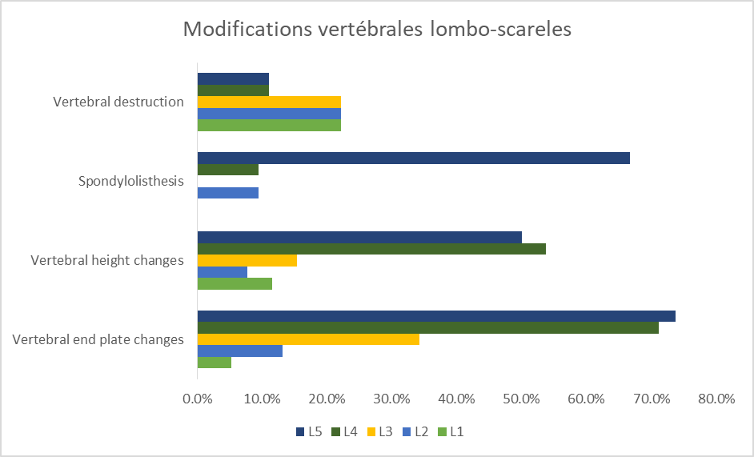
Fig. 3: Anomalies de modifications vertébrales lombo-sacrées et niveau de la colonne vertébrale touchée

Images 1a et b; IRM T2 lombosacrée sagittale et axiale montrant: déshydratation discale multiniveau de L3 / 4 (astérisque bleu) à L5 / et protrusion discale paracentrale droite (flèches bleues) avec sténose du canal rachidien et oblitération foraminale neurale droite à L4 / 5.

