**Case Report**

Management of Intra-orbital Wooden Foreign Bodies at a Resource-limited Setting in Sub-Saharan Africa

### Abstract

**Introduction:** Wooden intra-orbital foreign bodies (IOrbFBs) have a high risk of microbial contamination needing timely diagnosis and treatment. We describe management of three cases of wooden IOrbFB at a resource-limited setting in Liberia. **Materials and Methods:** This is a retrospective case series of three patients with IOrbFB managed at the Liberia Eye Center, Monrovia, Liberia. Demographic details, mode of injury, ocular examination findings, neuroimaging, surgical treatment, and clinical findings on post- operative follow-up visits were noted for each patient. **Results:** All the three patients were young, male, and were involved in traumatic incidents (fall in two cases and road traffic accident in one case). Two patients with visible wooden FB presented within 48 h of injury and one patient with occult FB presented after 2 weeks. All patients underwent orbital imaging followed by surgical exploration for the removal of FB. One patient also had coexisting orbital cellulitis, which was successfully treated medically. One of these patients had best corrected visual acuity of 20/20, and the other two had no perception of light in the affected eyes. **Conclusion:** History of injury with a wooden material should raise a high index of suspicion for an occult IOrbFB. Timely diagnosis and treatment of wooden IOrbFB can be challenging in a resource-limited setting, but with a systematic approach they can be treated satisfactorily.

**Keywords:** *Resource-limited setting, wood on neuroimaging, wooden intra-orbital foreign body*

### Résumé

**Introduction:**

Les corps étrangers intra-orbitaires en bois présentent un risque élevé de contamination microbienne nécessitant un diagnostic et un traitement rapides. Nous décrivons la prise en charge de 3 cas de corps étrangers intra-orbitaires en bois dans un pays aux ressources limitées tel quel le Libéria.

**Matériel et méthodes:**

Cest une étude rétrospective sur 3 cas de Corps étrangers intra orbitaire en bois prise en charge dans le centre oculaire du Libéria situé à Monrovia. Les détails démographiques, le mode de blessure, les résultats de l’examen oculaire, la neuro-imagerie, le traitement chirurgical et les résultats cliniques lors des visites de suivi post-opératoires ont été notés pour chaque patient.

**Résultats:**

Les 3 patients étaient jeunes, de sexe masculin et ont été impliqués dans des incidents traumatiques (chute dans 2 cas, et accident de la voie publique dans un cas). Deux patients avec un corps étranger en bois visible se sont présentés dans les 48 heures suivant la blessure et un patient avec un corps étranger occulte s’est présenté après 2 semaines. Tous les patients ont été soumis à une imagerie orbitaire suivie d’une exploration chirurgicale pour l’élimination du corps étranger. L’un de ces patients avait une acuité visuelle corrigée de 20/20 et les deux autres n’avaient aucune perception de la lumière dans les yeux affectés. **Conclusion:**

La notion de traumatisme par un matériau en bois devrait faire craindre un Corps étranger intra orbitaire occulte. Le diagnostic et le traitement rapides des corps étrangers intra-orbitaire en bois peuvent être difficiles dans un contexte de ressources limitées, mais avec une approche systématique, ils peuvent être traités de manière satisfaisante.

## Niranjan K. Pehere1*, Unity Fahn Dokie1, George Tamba Bornguoi1,

**Kebede Gofer2, Anasua Ganguly Kapoor3, Milind Naik4**

*1Liberia Eye Center, L V Prasad Eye Institute Liberia (Inc.), John F Kennedy Memorial Medical Center, Monrovia, Liberia, 2Department of Radiology, John F Kennedy Memorial Medical Center, Monrovia, Liberia, 3Ophthalmic Plastic Surgery Unit, L V Prasad Eye Institute, Kode Venkatadri Chowdary Campus, Vijayawada, India, 4Ophthalmic Plastic Surgery Unit, L V Prasad Eye Institute, Kallam Anji Reddy Campus, Hyderabad, India*

**Received:** 06-Jun-2021 **Accepted:** 17-Jan-2022 **Published:** 26-Mar-2022

***Address for correspondence:*** *Dr. Niranjan K. Pehere, Liberia Eye Center, L V Prasad Eye Institute Liberia (Inc.), John*

*F. Kennedy Memorial Medical Center, Monrovia, Liberia.*

*E-mail:* [*niranjan@lvpei.org,*](mailto:niranjan@lvpei.org)

# Introduction

An intra-orbital foreign body (IOrbFB) is defined as a foreign body (FB) situated between the bony orbital walls and eyeball.[1] In cases

This is an open access journal, and articles are distributed under the terms of the Creative Commons Attribution-NonCommercial- ShareAlike 4.0 License, which allows others to remix, tweak, and build upon the work non-commercially, as long as appropriate credit is given and the new creations are licensed under the identical terms.

**For reprints contact:** [reprints@medknow.com](mailto:reprints@medknow.com)

with IOrbFB, there is usually a history of violent mode of injury such as gunshot injuries, road traffic accidents, violent assaults, or falls during play or work.[2] The FBs can be classified as metallic and non-metallic. The non-metallic FBs could be organic or non-organic.[2] Wooden

**How to cite this article:** Pehere NK, Dokie UF, Bornguoi GT, Gofer K, Ganguly Kapoor A, Naik M. Management of intra-orbital wooden foreign bodies at a resource-limited setting in Sub-Saharan Africa. J West Afr Coll Surg 2020;10:36-41.

[*nir*](mailto:niranjanp@gmail.com)[*anjanp@gmail.com*](mailto:anjanp@gmail.com)

|  |
| --- |
| **Access this article online** |
| **Website:**  [www.jwacs-jcoac.org](http://www.jwacs-jcoac.org/) |
| **DOI:** 10.4103/jwas.jwas_16_21 |
| **Quick Response Code:** |

36 © 2022 Journal of the West African College of Surgeons | Published by Wolters Kluwer ‑ Medknow

IOrbFBs have a high risk of microbial contamination owing to their porous consistency. Thus they have the potential to cause significant complications because of spread of infection that can endanger vision and life of the patient.[3-6] Hence, timely diagnosis and appropriate management of wooden IOrbFB are of utmost importance. In this report, we describe the clinical presentation and management of three cases of wooden IOrbFBs at a resource-limited setting in Sub-Saharan Africa.

# Materials and Methods

This is a retrospective case series of patients with a diagnosis of IOrbFBs seen over a period of 3 years between September 2017 and August 2020 at the Liberia Eye Center (L V Prasad Eye Institute) located at the John F Kennedy Memorial Medical Center, Monrovia, Liberia. From electronic medical records, patient demographics, mode of injury, injury-to-presentation time and the causes for the same, and ocular and imaging findings were noted. Surgical treatment and its outcomes were also noted.

# Case Reports

Over a period of 3 years, among 360 cases of ocular trauma, 3 patients presented with a wooden IOrbFB. All three of them were young men in the age group of 26–42 years. All of them were involved in traumatic incidents. Details about each case are described subsequently.

### Case 1

A 42-year-old man presented with pain and swelling in the right eye associated with purulent discharge coming from a

wound in the right upper eyelid, following an injury from a stick 2 weeks earlier. He had fallen down at night in a dark environment on a stick which penetrated his right eye. The family members pulled the stick out. There was significant bleeding and pain. He was located 150 km away from the capital city Monrovia, and hence was attended to by a nurse nearby who sutured the wound on the right upper eyelid and prescribed a topical antibiotic. As there was persistent pain and purulent discharge, he reported to our tertiary eye care center in Monrovia. On examination, the patient had swelling of the right upper eyelid with a complete ptosis. There was a sutured lid laceration with purulent discharge from the wound. There was no perception of light in that eye. The eye ball was significantly enophthalmic, and very little portion of cornea could be seen with great difficulty; hence, a detailed examination of the anterior segment and fundus was not possible. Ultrasound B-scan showed intact eyeball, and no FBs could be seen in the orbit. Due to a definite history of injury from a stick, a computed tomography (CT) scan of the orbit was requested to look for any wooden FBs. Due to financial constraints, the CT scan was performed 2 weeks after it was requested. Multiple hypodense “air-like” areas with irregular edges and hyperdense rim were noted in the superior orbit, suggestive of wooden FBs with surrounding inflammatory tissue [Figure 1(c)]. This was associated with fracture involving the whole of the medial wall and floor of the right orbit and subluxation of the eyeball into the maxillary sinus. The FBs were initially reported by the radiologist as “air in the orbit.” However, air introduced at the time of trauma does not usually

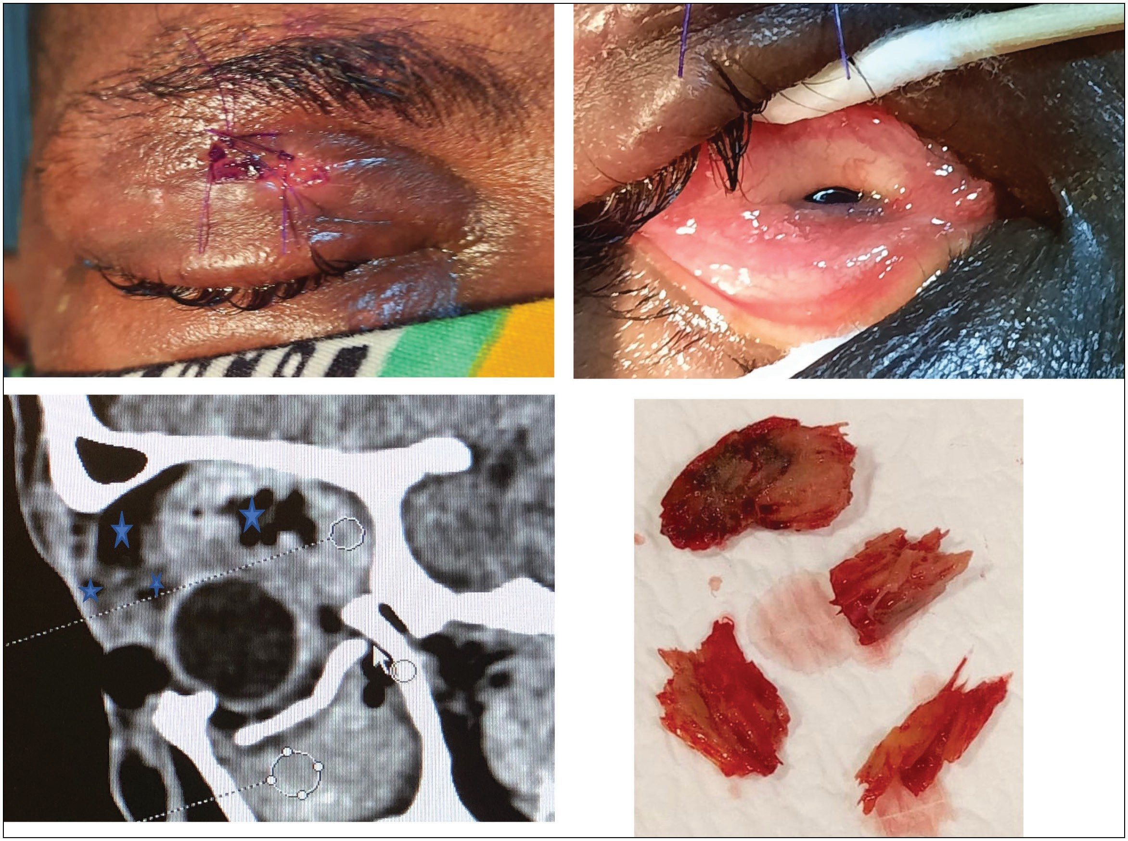

**Figure 1: Clinical and radiological details of case 1. (a) Small entry wound on upper eyelid (white arrow), lid edema, and complete ptosis. (b) Severe chemosis and hypoglobus. (c) CT scan sagittal view showing multiple wooden FBs in superior orbit. (d) Wooden FB after removal (star)**

Journal of the West African College of Surgeons | Volume 10 | Issue 2 | April‑June 2020 37

persist this long, and we could appreciate FB density greater than air at the window width of 1000 HU and window level of 2500 HU. The suggestive history and findings on the CT scan of the orbit helped establish the diagnosis of multiple wooden FBs. The patient was counselled regarding the need to remove the FBs, and surgery was planned to be performed under general anesthesia. At surgery, the previous laceration wound was extended as surgical incision. The FBs were located deep within the orbit, and there were dense adhesions between the FB and surrounding tissues which were carefully dissected. The FBs could be palpated by the surgeon’s index finger. Dastoor’s superior rectus holding forceps was used to remove the FBs. In total, 4 FBs and several splinters were removed. The orbit was thoroughly explored for any residual pieces, and the surgical area was repeatedly irrigated with 5% betadine solution. As there was presence of active infection, fracture repair was deferred. Examination of the eyeball under anesthesia revealed an intact eye ball with optic nerve avulsion. Post-operatively,

intravenous antibiotics (combination of trimethoprim and sulfamethoxazole 1.2 g 8 hourly) and analgesics (intravenous paracetamol 1 g every 6 h) were administered for 3 days followed by oral antibiotics for a week. At 3 months of follow- up, the patient was comfortable with no purulent discharge but the eye was severely enophthalmic.

### Case 2

A 26-year-old man presented to us with complaints of pain, swelling, and loss of vision in the right eye for a day following a road traffic accident. He was riding a motorcycle at a very high speed on the country road when he suddenly lost control and bumped into planks of wood packed by the roadside. Some pieces of the plank got stuck below his right lower eyelid [Figure 2c]. The right eye had no perception of light. There was an axial proptosis and a frozen globe, with both eyelids edematous. The lower eyelid had multiple lacerations with splinters of the wooden plank penetrating it and entering the

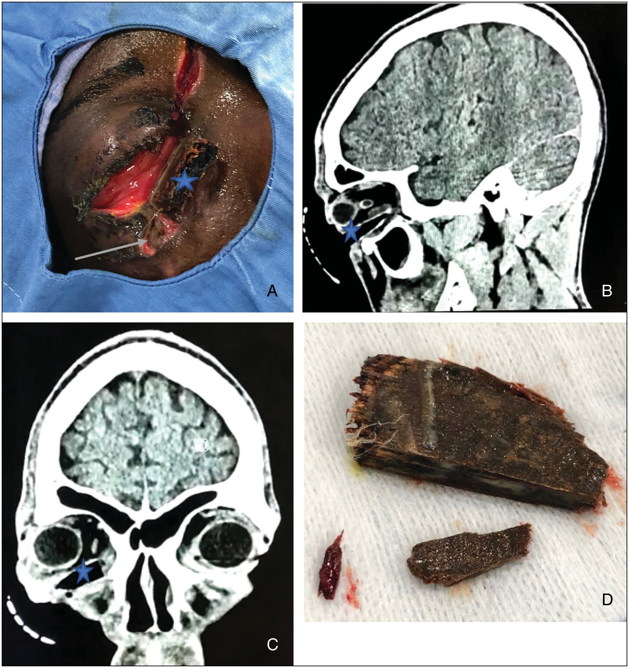

**Figure 2: Clinical and radiological details of case 2. (a) Lower lid laceration (white arrow) and large wooden FB (star) seen. (b) CT scan sagittal view showing large wooden FB (star) in lower orbit reaching far into posterior aspect of orbit. (c) CT scan coronal view showing FB (star) in lower orbit.**

**(d) Wooden FB after removal**

38 Journal of the West African College of Surgeons | Volume 10 | Issue 2 | April‑June 2020

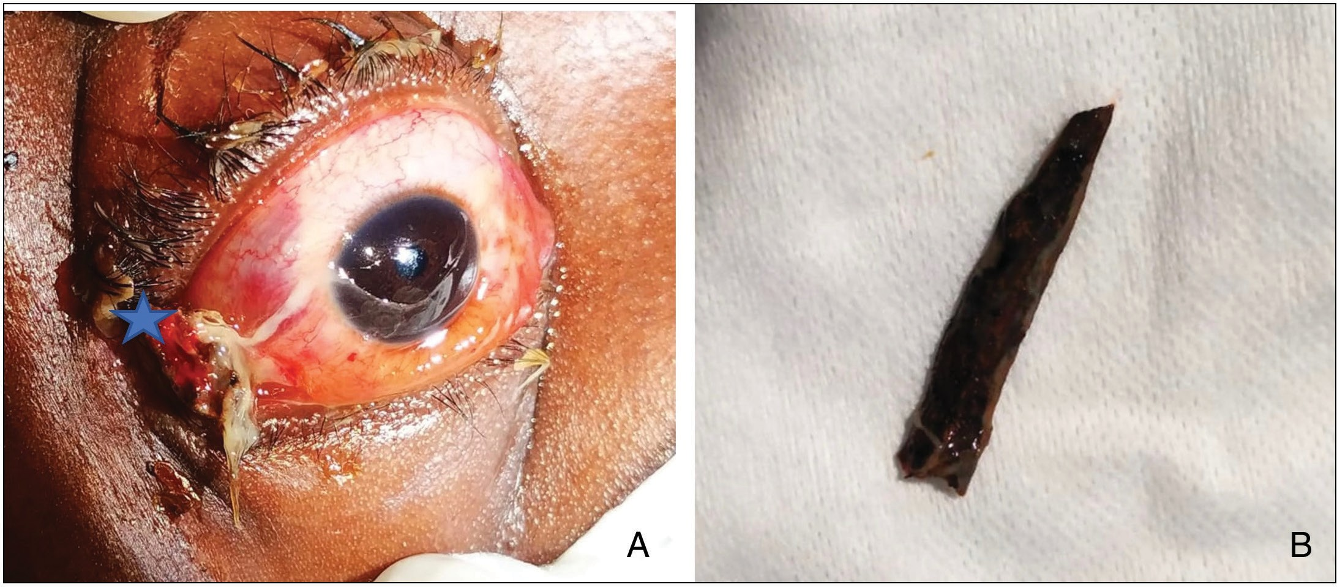

**Figure 3: Clinical and radiological details of case 3. (a) Wooden FB (star) seen impacted in the medial aspect of right orbit. (b) Wooden FB after removal**

orbit. There was hemorrhagic conjunctival chemosis, and the pupil was fixed and dilated with an intact eyeball. Optic nerve avulsion was noted on fundus examination. CT scan of the head and orbit requested to look for the posterior extent of the FB showed the FB in the lower part of the right orbit extending close to the orbital apex [Figure 2b and c]. A diagnosis of wooden FB in the right orbit with orbital cellulitis was made. Two wooden FBs were removed under general anesthesia [Figure 2d], and the lid laceration was primarily repaired pending further reconstruction with skin graft on account of significant tissue loss. The orbital cellulitis was treated with combination of intravenous trimethoprim and sulfamethoxazole 1.2 g 8 hourly and analgesics (intravenous paracetamol 1 g every 6 h). At 1-month follow-up, the orbital cellulitis had resolved.

### Case 3

A 34-year-old man presented with pain in the right eye associated with blurring of vision since the previous day. He had had a fall while walking on a rocky path and a piece of stick penetrated his right eye. His friend removed one piece of stick, but a second one was left behind. On examination, his uncorrected visual acuity (VA) in the right eye was 20/30. There was mild edema in both eyelids along with diffuse congestion and chemosis. A wooden piece was found to be stuck on the lateral aspect of the orbit without causing scleral or corneal perforation [Figure 3a]. Under topical anesthesia, the wooden piece was removed [Figure 3d] and the globe was found to be intact. At 3 months follow-up, the patient had a best corrected VA of 20/20.

All three patients were given intramuscular injection of tetanus toxoid 0.5 mL at the first visit.

# Discussion

It is challenging to diagnose a wooden IOrbFB, especially if the wound of entry is small, and it is difficult to palpate the FB due to its deep location and surrounding tissue edema. In resource-limited areas, these patients may be seen by a paramedical personnel first, who may not suspect a retained orbital FB, as in our case 1.

If the mode of injury suggests possibility of a wooden FB, magnetic resonance imaging (MRI) is the preferred imaging modality.[2-4] But in our setting, MRI is not available and due to resource limitation, patients could not undergo CT scan at presentation. Ultrasonography has been reported to be of limited value in the diagnosis of orbital wooden FB,[7] and the same was our experience too with this patient. X-ray was not done because it has no role in detecting wooden FB as these are not seen on X-ray.[8] Finally, when the CT scan was obtained, the FBs were reported by the radiologist as “air in the orbit.” This was probably because it is a common immediate post- injury finding within the orbit (orbital emphysema), especially if associated with sinus injuries. There are several reports of dry wood mimicking air on CT scan because of its lower electron density and extremely low X-ray attenuation.[7-11] It has been suggested that CT images with lower and wider windows than routine images could distinguish a wooden FB from an air bubble.[8] In our case, we found this technique useful. In addition to the axial cuts, thin coronal and sagittal cuts are needed to look for proximity of the FB to optic nerve and any trans-orbital or intracranial extension.[12] Also, the shape of the FB with the surrounding tissue reaction helped clinch the diagnosis in case 1. Thus in a resource-limited setting if MRI is not available and suspicion for wooden FB is high, CT scan with variable window width, paying attention to the shape of the lesion, is helpful to detect wooden FBs. In cases 2 and 3, there was no difficulty in diagnosis because the FBs were seen directly on examination. CT scans were however performed to determine the proximity of the FBs to the optic nerve.

Diagnosis of IOrbFBs requires a high index of suspicion. Kapoor *et al.*[13] have described a case of retained wooden IOrbFBs presenting as combined anterior and posterior scleritis. Similarly, several cases of missed wooden IOrbFBs have been described in the literature that resembled stye, strabismus, sinusitis, and orbital cellulitis.[14,15] The challenges in these cases causing delayed diagnosis were reported to include unclear history, healing of the conjunctival and cutaneous wounds at the time of presentation, conjunctival chemosis, edema of eyelids, and periorbital skin obscuring the entry

Journal of the West African College of Surgeons | Volume 10 | Issue 2 | April‑June 2020 39

wounds. Thus, retained IOrbFBs should be ruled out in all post- traumatic cases that do not respond well to the conventional treatment.

Once diagnosed, the wooden IOrbFBs need to be removed as soon as possible for several reasons. Due to the pores on their surface and the characteristics of organic matter, they are a great bacterial growth medium and hence may lead to orbital cellulitis, abscess formation, chronic discharging sinus, inferior ophthalmic vein thrombosis, cavernous sinus thrombosis, and even intracranial infection if reaching intracranially.[4-6] Infection rates in IOrbFBs have been reported to be as high as 64% and the cultures of the IOrbFB are often polymicrobial; hence, a broad spectrum antibiotic coverage is necessary, particularly ones with good penetration of blood–brain barrier in view of possibility of intracranial extension of the FBs.[12] Though it seems intuitive to suspect fungal infection due to a wooden FB, the literature does not support fungal infections to be common enough to support empirical use of antifungal medications. Wood is likely to be contaminated with *Clostridium tetani*; hence, injection tetanus toxoid is mandatory[16] and it was given to all three patients described earlier. Other possible sequelae of wooden IOrbFBs include traumatic optic neuropathy, injury to extraocular muscles, granuloma formation, and adhesions of periocular tissues due to chronic inflammatory reaction.[5,6] Cases 1 and 2 had optic nerve avulsion causing complete loss of vision. In case 3, the vision was well preserved both at the time of presentation and after FB removal, because the wooden piece did not penetrate the eyeball and was in the anterior orbit only.

Surgical management of such cases may require a multidisciplinary approach involving an orbital surgeon, neurosurgeon, and faciomaxillary surgeon, depending on the extent of injuries.[17] It has been recommended that the IOrbFB could be explored through the original wound (primary wound approach) for the sake of safety, causing less injury and for a higher chance of retrieval of the FBs. If the wound has closed completely, the surgical approach could be chosen according to the FB size and location.[18] Common approaches into the orbit include anterior transpalpebral approach, anterior transconjunctival approach, and lateral approach. For FBs with intracranial or periorbital sinus extension, one of the neuro- surgical or faciomaxillary approaches may be needed.[1,13]

Being fragile, it is often challenging to remove wooden FBs completely and splinters may be left behind. The surgeon needs to be extra careful to carry out a thorough exploration of the wound for any small pieces. A careful debridement of necrotic tissue and copious irrigation of the wound with antibiotic solution is advised. The FB and purulent material if any should be sent for microbiological culture and sensitivity testing to guide the antibiotic treatment, but it was not available in our setting.[3]

In cases 2 and 3, removal of the FB was relatively easy because they were readily visible and surgically accessible. Also since they presented in just a day after the injury, there were not much adhesions to surrounding tissues. But case 1 was extremely

challenging because the FBs were neither visible nor palpable. There was a gap of 8 weeks between injury and surgery, leading to the formation of adhesions with the orbital tissues which made surgery even more challenging. Due to lack of facilities, the associated orbital factures could not be repaired. But in a resource-limited setting, the priority is pain relief, treating associated infection and prevention of sequel of a retained wooden IOrbFB as described earlier.

In summary, wooden IOrbFBs pose significant challenges for diagnosis and management. A high index of suspicion is needed if there is a definite history of injury with wood. The imaging modality of choice in a resource-limited setting is CT scan orbit (coronal and sagittal cuts) with variable window width. The primary objective in such a setting is to remove the FB to relieve pain, treat infection, and prevent sequelae of a retained IOrbFB. Surgical removal for occult FBs can be challenging, and the surgeon needs to be careful not to leave behind any splinters. Aggressive treatment of associated orbital cellulitis is necessary. There is a great need for public education about how to avoid such eye injuries and also need to educate paramedical health workers in rural areas about when to suspect an orbital FB and refer the patient to a higher center of care.

**Financial support and sponsorship** Hyderabad Eye Research Foundation. **Conflicts of interest**

There are no conflicts of interest.

# References

1. Jabang JN, Dampha L, Sanyang B, Roberts CA, Ceesay B. Management of a large intraorbital wooden foreign body: Case report. Surg Neurol Int 2020;11:158.
2. Fulcher TP, McNab AA, Sullivan TJ. Clinical features and management of intraorbital foreign bodies. Ophthalmology 2002;109:494-500.
3. Reddy SC. Retained wooden foreign body in the orbit. Int J Ophthalmol 2013;6:255-8.
4. Lakshmanan A, Bala S, Belfer KF. Intraorbital organic foreign body—A diagnostic challenge. Orbit 2008;27:131-3.
5. Agarwal PK, Kumar H, Srivastava PK. Unusual orbital foreign bodies. Indian J Ophthalmol 1993;41:125-7.
6. Panda BB, Kim UR. Complications of retained intraorbital wooden foreign body. Oman J Ophthalmol 2014;7:38-9.
7. Bhavsar AR, Fong DS, Kerman B, Yoshizumi MO. Intraorbital air simulating an intraocular foreign body. Am J Ophthalmol 1997;123:835-7.
8. Ho VT, McGuckin JF Jr, Smergel EM. Intraorbital wooden foreign body: CT and MR appearance. AJNR Am J Neuroradiol 1996;17:134-6.
9. Adesanya OO, Dawkins DM. Intraorbital wooden foreign body (IOFB): Mimicking air on CT. Emerg Radiol 2007;14:45-9.
10. Uchino A, Kato A, Takase Y, Kudo S. Intraorbital wooden and bamboo foreign bodies: CT. Neuroradiology 1997;39:213-5.
11. Specht CS, Varga JH, Jalali MM, Edelstein JP. Orbitocranial wooden foreign body diagnosed by magnetic resonance imaging. Dry wood can be isodense with air and orbital fat by computed tomography. Surv Ophthalmol 1992;36:341-4.

40 Journal of the West African College of Surgeons | Volume 10 | Issue 2 | April‑June 2020

1. Shelsta HN, Bilyk JR, Rubin PA, Penne RB, Carrasco JR. Wooden intraorbital foreign body injuries: Clinical characteristics and outcomes of 23 patients. Ophthalmic Plast Reconstr Surg 2010;26:238-44.
2. Kapoor AG, Vijitha VS, Fernandes M. Retained intraorbital wooden foreign body presenting with combined anterior and posterior scleritis. BMJ Case Rep 2020;13:e232237.
3. Liu D. Common denominators in retained orbital wooden foreign body. Ophthalmic Plast Reconstr Surg 2010;26:454-8.
4. Zhou L, Li SY, Cui JP, Zhang ZY, Guan LN. Analysis of missed diagnosis of orbital foreign bodies. Exp Ther Med 2017;13:1275-8.
5. Hansen JE, Gudeman SK, Holgate RC, Saunders RA. Penetrating intracranial wood wounds: Clinical limitations of computerized tomography. J Neurosurg 1988;68:752-6.
6. Shein-Filipowicz A, Kaźmierczak R, Kostkiewicz B, Sempińska- Szewczyk J, Sankowski A. Intraorbital organic foreign body— Radiological methods in diagnosis—Case report. Pol J Radiol 2010;75:55-60.
7. Li J, Zhou LP, Jin J, Yuan HF. Clinical diagnosis and treatment of intraorbital wooden foreign bodies. Chin J Traumatol 2016;19:322-5.



Journal of the West African College of Surgeons | Volume 10 | Issue 2 | April‑June 2020 41