[Downloaded free from http://www.jwacs-jcoac.com on Monday, April 17, 2023, IP: 2.27.163.176]

**Case Report**

**Hydatid Disease of Tibia Reconstructed with Allograft: A Rare Case Report and Literature Review**



**Abstract**

**Background:** Hydatid disease of bone shows a well-defined, multiloculated lytic lesion with the appearance of a bunch of grapes. The presenting symptoms are pain and swelling with or without pathological fracture. The treatment options include surgery followed by a long duration of albendazole. Removal of the involved bone is required to decrease the chances of recurrences. **Case Report:** In our study, we have included a case of 28-year-old woman presented with complaints of pain and difficulty in weight bearing over her right lower limb for 2.5 months. Radiograph suggested an eccentric lytic lesion in midshaft of tibia and biopsy revealed granulosus cyst wall, nucleate germinal layer, the brood capsule, and protoscolices with visible hooklets. Patient was subjected to surgery with the excision of cyst along with extended curettage of bone creating a bone defect around the lesion and with anterolateral platting with coverage of bone defect by allogenic bone grafting. Patient was kept on above knee slab with non-weight-bearing mobilization for 6 weeks. Postoperative chemotherapy with Albendazole was given for 3 months. Patient was followed up every 6 weeks for 3 months and every month thereafter on outpatient basis. Return to work and patient satisfaction were excellent. **Conclusion:** Definitive Surgical management with Preoperative and postoperative chemotherapy seems to be effective to avoid recurrence. The bone defect caused by the disease or surgery can be managed with a bone graft either of autograft or allograft.

**Keywords:** *Allogenic bone graft, echinococcosis, hydatid cyst, skeletal hydatosis, tibia*

**Bishwa Bandhu Niraula,**

**Anil Regmi, Shivam Bansal, Mohit Dhingra,**

**Ravi Hari Phulware1, Saroj Kumar Bhagat**

*Departments of Orthopedics, 1Pathology and Lab Medicine, All India Institute of*

*Medical Sciences, Rishikesh, Uttarakhand, India*

**Introduction**

It is caused by *Echinococcus granulosus* larvae. Dogs are the definitive host whereas cattle are the intermediate hosts. The disease occurs due to accidental infection of humans with eggs of *E. granulosus* followed by the development of larvae.[1,2]

It can develop in any part of the body, with the most common site being liver involving 70% of cases. Bone involvement is as low as 0.5%–2.5% of all human hydatidosis. It remains asymptomatic for a long duration and thus diagnosis is made at later stages and radiology reveals extensive disease. Clinical feature depends on the anatomic location of the boneinvolved.The treatment regime is similar to oncologic therapy rather than the simple surgical excision in the case of visceral hydatidosis.[3,4]

Like in other visceral organs, pericyst formation does not occur in bone. Thus, it

This is an open access journal, and articles are distributed under the terms ofthe Creative CommonsAttribution-NonCommercial-ShareAlike 4.0 License, which allows others to remix, tweak, and build upon the work non-commercially, as long as appropriate credit is given and the new creations are licensed under the identical terms.

**For reprints contact:** reprints@medknow.com

proliferates aggressively along the areas of least resistance likely in bone canals. With time the disease spreads within the bone tissue to reach the cortex and might spreads into surrounding tissues.[5] Hydatid disease of bone shows well-defined, multiloculated lytic lesion with the appearance of a bunch of grapes. The additional features include expansion of bone, thinning of cortex, and spread into the adjacent tissue. The osteoclastic activity is likely due to impairment of blood supply caused due to pressure erosion and local necrosis.[6]

The presenting symptoms are pain and swelling with or without pathological fracture. As it lacks characteristic clinical features it may mimic tuberculosis, chronic osteomyelitis, aneurysmal bone cyst, giant cell tumor, solitary cyst, chondrosarcoma, or fibrocystic disease.[5] The treatment options include surgery followed by a long duration of albendazole. Removal of the involved bone is required to decrease the chances of recurrences. The bone defects

**How to cite this article:** Niraula BB, Regmi A, Bansal S, Dhingra M, Phulware RH, Bhagat SK. Hydatid disease of tibia reconstructed with allograft: A rare case report and literature review. J West Afr Coll Surg 2023;13:122-9.

**Received:** 21-Nov-2022 **Accepted:** 16-Jan-2023 **Published:** 20-Mar-2023

***Address for correspondence:*** *Dr. Mohit Dhingra, Department of Orthopedics, All India Institute of Medical Sciences, Rishikesh 249203, Uttarakhand, India.*

*E-mail: modisbanu77@gmail. com*

**Access this article online**

**Website:**

www.jwacs-jcoac.com

**DOI:** 10.4103/jwas.jwas_286_22

**Quick Response Code:**

122 © 2023 Journal of the West African College of Surgeons | Published by Wolters Kluwer ‑ Medknow

[Downloaded free from http://www.jwacs-jcoac.com on Monday, April 17, 2023, IP: 2.27.163.176]

Niraula, *et al.*: Hydatid cyst of tibia

are covered by either bone graft or bone cement due to its added effect of thermal necrosis.[7,8]

This paper was aimed to present the case of hydatid cyst of midshaft tibia, which was successfully managed with excision of cyst along with extended curettage and allogenic bone grafting and review of literatures available on skeletal hydatosis.

**Case Presentation**

A 28-year-old woman presented with complaints of pain and difficulty in weight bearing over her right lower limb for 2.5 months. visual analog scale score was 8/10. There was a mild swelling over her right leg during the period of 2.5 months. The patient had neither a history of any comorbidities (diabetes, hypertension) nor any significant surgical history. There was no significant history of trauma or tuberculosis contact. The patient did not have any complaints of fever, fatigue, malaise, or weight loss.

On clinical examination, there was localized tenderness present on the anterior aspect of the middle 1/3rd of the leg. There was no local rise in temperature. Both knee and ankle range of motion was within normal limits. The rest of clinical evaluation revealed no other significant findings.

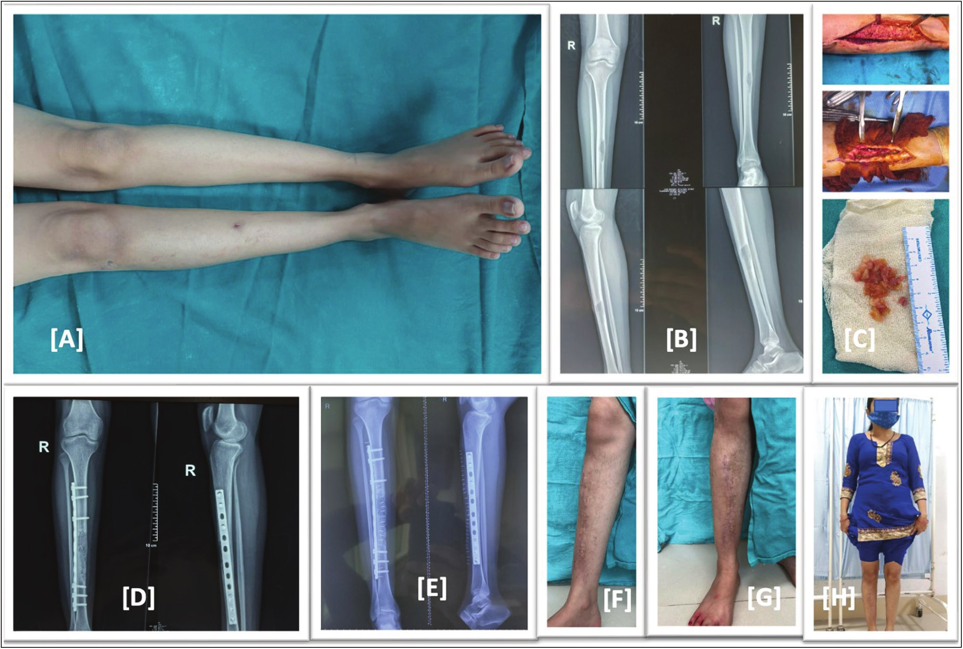

On clinical examination, there was localized tenderness present on the anterior aspect of the middle 1/3rd of the leg. There was no local rise in temperature. Both knee and ankle range of motion was within normal limits. The rest of clinical evaluation revealed no other significant findings. Differential diagnosis includes benign bone tumor (simple bone cyst, fibrous dysplasia, and enchondroma), chronic osteomyelitis, and a brown tumor.

After a routine investigation and following biopsy and radiological findings, a definitive diagnosis of skeletal hydatidosis involving shaft of tibia right side was made, and the patient was subjected to surgery with excision of cyst along with extended curettage of bone creating a bone defect around the lesion and with anterolateral platting with coverage of bone defect by allogenic bone grafting. The patient was then kept on non-weight-bearing mobilization with an above knee slab for 6 weeks. For postoperative chemotherapy, tablet albendazole 400mg once daily for 3 months was given to the patient from Post-operative day-1.

The patient was able to bear weight without pain after 6 weeks as shown in Figure 1. The final histopathological slide of intraoperative specimen was positive for hydatid disease as shown in Figure 2. The patient was followed up

**Figure 1: (A) Preoperative image, right leg with scar mark of biopsy and mild swelling. (B) Preoperative X-ray showing expansile lytic lesion in mid shaft tibia. (C) Intraoperative images, excised hydatid cyst mass. (D) Immediate postoperative X-ray showing in corporation of allograft and fixation by anterolateral tibial plate. (E) Post operative X-ray at 6 month follow up showing well incorporation of allograft. (F–H) Clinical images at 6 month follow up showing healed scar mark no swelling or deformity and full weight bearing of the patient with full return to activity of daily living**

Journal of the West African College of Surgeons | Volume 13 | Issue 2 | April‑June 2023 123

[Downloaded free from http://www.jwacs-jcoac.com on Monday, April 17, 2023, IP: 2.27.163.176]

Niraula, *et al.*: Hydatid cyst of tibia

**Figure 2: Hematoxylin and eosin (H&E ×40) stained section shows *E. Granulosus* cyst wall (A) acellular laminated layer; (B) a nucleate germinal layer; (C) the brood capsule (red arrow), protoscolices (green arrow) with visible hooklets (D)**

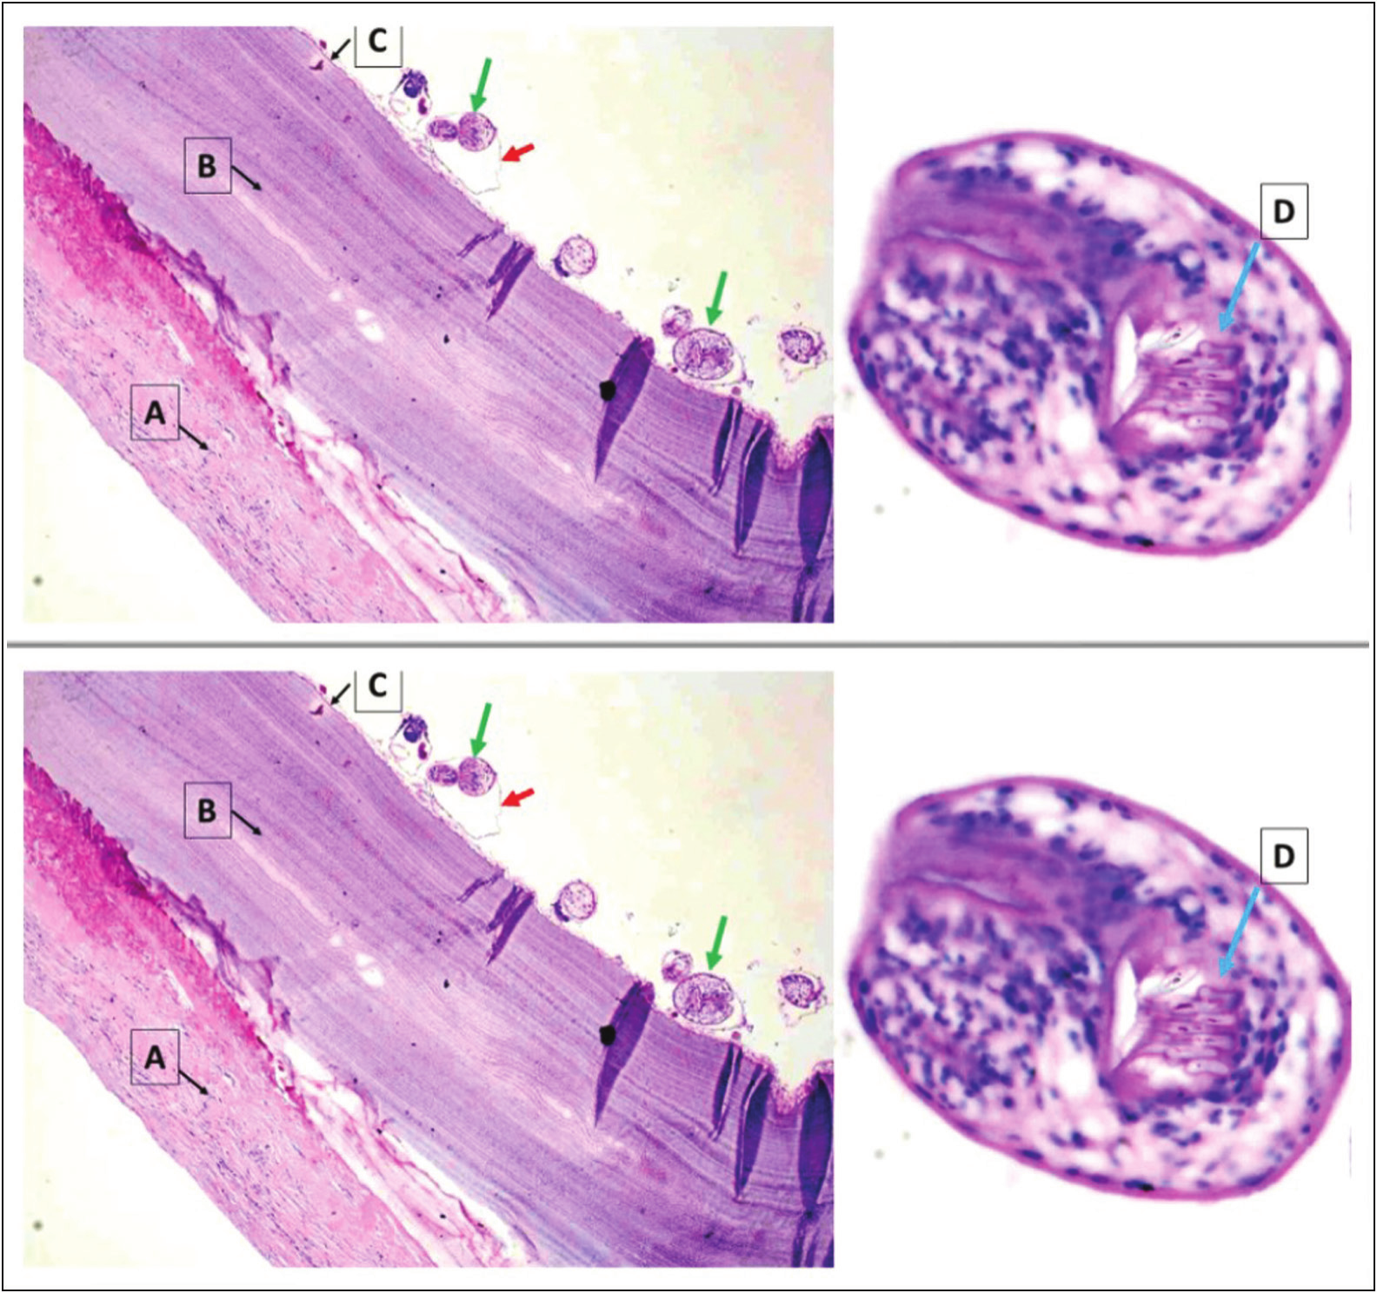

for a period of 6 months at 6 weeks interval. There were no any radiological signs of recurrence over the 6-month period. There was no any complaints of pain or difficulty in weight bearing. Postoperative visual analog scale at 6-month follow-up was 0/10. The knee and ankle ROM was within normal limits and there was no any localized tenderness. The scar mark of surgery has healed with primary intention. Radiologically, there was adequate sign of uptake of allograft. Serology for hydatid disease was also negative for the disease. Return to work and patient satisfaction were excellent.

**Discussion**

Hydatid disease is caused by a tapeworm infection, Echinococcus, namely *E. granulosus* and *Echinococcus multilocularis*, that infects the human species most commonly.[9] Man is the accidental host in this disease. Dogs are the definitive hosts whereas cattle are the intermediate hosts. The definitive hosts, dogs, harvest the adult forms in their gut, where the adult form of tapeworm releases its egg into the feces. These eggs are ingested by the intermediate hosts, namely sheep. After the ingestion of the eggs, the embryo is released in the gut and absorbed into the portal

circulation through the duodenal mucosa. The cyst grows in the highly vascular organs such as muscle bed, liver, and lungs of intermediate host. These cysts are ingested by the definitive hosts where the cysts are absorbed in the intestine and grow into protoscolex, scolex, and into an adult form. Humans are infected due to ingestion of eggs of parasite either through food, water or hands contaminated by eggs. After ingestion of the eggs, the embryo is released in the gut and absorbed into the portal circulation through the duodenal mucosa. In the intestinal mucosa, the parasite grows into an adult form and releases egg which are ingested by the intermediate host. A hydatid cyst has three layers, outer pericyst (formed by host cells, limits growth of parasite in visceral organ), middle soft laminated later, and inner germinal layer. In bone infection, the pericyst is absent.[10-12] In our case the biopsy revealed acellular laminated layer, nucleate germinal layer, protoscolices, and visible hooklets.

The disease mainly involves visceral organ, most commonly the liver (70%). Primary bone hydatidosis is rare and involves 0.5%–2.5%.[3] It might take 10–20 years for hydatid disease of bone to be clinically noted. Thus, the disease is presented in between 4th and 6th decade and women were twice as commonly infected as men. In our case, the

124 Journal of the West African College of Surgeons | Volume 13 | Issue 2 | April‑June 2023

[Downloaded free from http://www.jwacs-jcoac.com on Monday, April 17, 2023, IP: 2.27.163.176]



**Table 1: Review of literature of skeletal hydatosis**

**Author**

**Age/**

**sex**

**Article Presenting**

**complaints**

**Bone**

**involved**

**distant lesion**

**Radiograph** **Other** **Biopsy finding** **Management**

**Chemotherapy Outcome**

**Follow up**

**Complication**

Babitha

*et al.*[9]

52/f

Case

report

Dull

aching

pain

Femur

Fracture with

Lytic lesion,

shaft of femur

Absent Lamellated linear

eosinophilic

anucleated

membranous

structures,

granuloma

formation

and chronic

inflammatory

reaction,

occasional scolices

Interlocking

femur nail for

pathological shaft

of femur fracture

Non union

at fracture site

No recurrence

12 months Non union

Absent

Trilamellar cyst

and scolices of

E. Granulosus

Wide local

excision of cyst

10cm above and

below lesion

Not

mentioned

Osseous tissue

with hyaline

and germinative

membranes,

lymphocytes, and

monocytes

Povidone iodine

by cystectomy

Albendazole

injection followed 10mg/kg/day

for 12 weeks

Arti

42/m Case

report

Pain, mild

swelling

Fibula

Multiple lytic

lesion in mid

shaft fibula

Albendazole

400mg bd for

4 weeks

No

recurrence

seen

12 months –

Kalinova

*et al.*[3]

45/f

Case

report

Pain

Tibia

Oval cystic

lesion with

diameter of

3.5cm on

diaphysis of

tibia, periosteal

reaction on

cortex

Ill defined

lytic lesion

with areas

of patchy

sclerosis,

large solid

cystic mass

of size

10×6.3cm

in right iliac

fossa

No

recurrence

seen, excellent

outcome

24 months None

Jain

31/f

Case

report

Pain

Pelvis

(right

iliac

fossa)

H/O

ovarian

hydatid

cyst

Osseous tissue

with laminated

membrane of

hydatid cyst

mixed with

lymphocytes and

macrophages

Resection of

cystic lesion in

sacroiliac joint,

reconstruction

with allograft

and autograft

(ribs) with

lumbosacroiliac

fixation

Albendazole

for 1 month

No

recurrence

6 months

Niraula, *et al.*: Hydatid cyst of tibia

Journal of the West African College of Surgeons | Volume 13 | Issue 2 | April‑June 2023 125

[Downloaded free from http://www.jwacs-jcoac.com on Monday, April 17, 2023, IP: 2.27.163.176]



Siwach

51/f

Case

report

Pain,

swelling

and

deformity

of thigh

Femur,

and

sacrum

canal left

side,

Segmental

Hemipelvis pathological

fracture left

femur with

with spinal honey comb

appearance

and multiple

osteolytic

lesion, complete

resorption

of femoral

head and

neck, narrow

transition zone

without reactive

bone formation

in whole left

femur

cyst wall and

scolices of E.

Granulosus

absent Trilamellar hydatid Albendazole

10mg/kg/day,

No surgical

intervention was

done

Albendazole

10mg/kg/

day given as

treatment

measures

Died due to

sepsis and

extensive

bedsores

1 month

Died due to

sepsis and

extensive

bedsores

Case 1:

osteolytic

lesion in

diaphysis of

femur

Case 2:

pathological

fracture,

high signal

intensity in

femoral

head,

extensive

soft tissue

compromise

laterally

Case 1: not

multiloculated mentioned

Case 2: not

mentioned

Case 1: not

mentioned

Case 2: Not

mentioned

Case 1: wide

local excision

and

reconstruction

with intercalary

with locked

intramedullary

nail and four

cancellous

screws at distal

osteotomy site

Case 2: wide

local excision

of proximal

femur, proximal

femoral prosthesis

allograft

composite

was used to

reconstruct the

defect, fixation

was done

with dynamic

compression

plates and screw

Case 1: no

preoperative

and

postoperative

allograft, fixation was given

Case 2:

oral

albendazole

15mg/kg/day

for 1 months

and

postoperatively

for 6 months

Case 1:

excellent

outcome

MSTS score

chemotherapy 28/30, no

recurrence at

follow up

Case 2: No

recurrence,

excellent

preoperatively outcome

(MSTS score

29/30)

**Table 1: Continued**

**Author**

**sex**

**Age/ Article Presenting**

**complaints**

**Bone**

**involved**

**Radiograph**

**Other**

**distant lesion**

**Biopsy finding**

**Management**

**Chemotherapy Outcome**

**Follow up**

**Complication**

Musculo

65/f,

33/f

Case

report

(2

cases)

Case 1:not

mentioned

Case 2:

fracture

Case 1:

right

femur

pathological Case 2:

proximal

femur

Case 1:

108 months

Case 2: 60

months

None in both

Niraula, *et al.*: Hydatid cyst of tibia

126 Journal of the West African College of Surgeons | Volume 13 | Issue 2 | April‑June 2023

[Downloaded free from http://www.jwacs-jcoac.com on Monday, April 17, 2023, IP: 2.27.163.176]



Cyst of variable

sizes with smooth

outer membrane,

daughter embryos

seen in inner layer

of cyst

Wide local

curettage to

window on tibia,

thermal effect of

PMMA applied

for 3min and

reconstruction

with femoral

cortical allograft

to cover the

anterior defect,

splenectomy

performed in same

session

Second procedure

was done with

unreamed locked

intramedullary

nail and mixture

of cancellous

allograft

and 30mL

demineralized

bone matrix used

for nonunion

Albendazole

10mg/kg/day

for 1 month

No relapse,

complete

create an anterior preoperatively healing

Complete

union after

second

procedure at

12 months

Wide local

curettage and

defect with

fibular autograft

as well as

allograft

Postoperative

albendazole

reconstruction of 10mg/kg/

day and

Praziquantal

(40mg/kg/

week)

Bitar

26/m Case

report

fracture

following

blunt trauma

after sports

injury

Pathological Tibia

Pathological

fracture of

tibia, well

defined cystic

lesion involving

medullary

cavity and

scalloping of

cortex

None

Foreign body

granuloma and

sheets of

lamellated

membrane

consistent with

hydatid cyst

Curettage of

lesion followed

with bone graft

Albendazole

10mg/kg/day

by reconstruction bd for every 4

weeks out of

6 weeks for 4

months

44 months

mixed lytic

and sclerotic

lesion, bunch

of grapes

appearance,

diffusely

expanded

bone, endosteal

thinning,

no obvious

deformity or

fracture

Multiloculated 5×4cm

cystic

lesion in

spleen

**Table 1: Continued**

**Author**

**Age/**

**sex**

**Article Presenting**

**complaints**

**Bone**

**involved**

**Radiograph**

**Other**

**distant lesion**

**Biopsy finding**

**Management**

**Chemotherapy Outcome**

**Follow up**

**Complication**

Alem-

daroglu

30/m Case

report

Limping,

intermittent

pain,

swelling

Tibia

34 months Non union of

allograft on

first procedure

Schnep-

penheim

54/f

Case

report

Pain and

swelling

Tibia

Multiple

osteolytic lesion

with reactive

sclerosis

None

Trilamellar cystic

wall with scolices

of E Granulosus

Pain free,

asymptomatic

and no

recurrence,

well uptake of

allograft

24 months None

Niraula, *et al.*: Hydatid cyst of tibia

Journal of the West African College of Surgeons | Volume 13 | Issue 2 | April‑June 2023 127

[Downloaded free from http://www.jwacs-jcoac.com on Monday, April 17, 2023, IP: 2.27.163.176]

Niraula, *et al.*: Hydatid cyst of tibia

patient was 28-year-old woman, with the complaints of pain and difficulty in bearing weight in her leg. The lesion initially starts in epiphysis or metaphysis in long bones and spreads onto diaphysis at later stages. X-ray and CT scan can aid onto diagnosis and the imaging shows unilocular, bilocular, or multilocular cyst.[3]



**Table 1: Continued**

**Author**

**Age/**

**sex**

**Article Presenting**

**complaints**

**Bone**

**involved**

**Radiograph**

**Other**

**distant lesion**

**Biopsy finding**

**Management**

**Chemotherapy Outcome**

**Follow up**

**Complication**

Gnana-

sekaran

25/f

Case

report

sinus on and

off

Discharging Femur

Cortical

thickening and

sclerosis with

intervening

lucencies in

diaphysis of

femur, mild

periosteal

reaction with

deformity seen

None

Viable and

necrotic bones

with cyst wall

composed

of acellular

eosinophilic

lamellated

material

surrounded with

fibrosis, scolices

of E Granulosus

with hooklets in

germinal layer

Debridement,

sequestrectomy

followed by

cotrimoxazole,

praziquantel

and albendazole,

second stage

surgery with re

debridement with

hypertonic saline

and hypertonic

saline with

antibiotic cement

spacer for cortical

defect

Postoperative

praziquantel,

and saucerization albendazole

for 6 months

healing,

asymptomatic

and no

evidence of

recurrence

Good wound 12 months Recurrence

after first

debridement

Merkle *et al*.[13] did a review of literature on 45 patients with 51 skeletal involvements and found the following distribution: spine 35%, pelvis 21%, femur 16%, 10% tibia, 6% in ribs, 4% in scapula and skull, 2% in humerus, and 2% in fibula and concluded that 60% of osseous lesions occur in spine, pelvis, and hip joint. 28% in long bones such as femur, tibia, and humerus and 8% in ribs and scapula. It is often misdiagnosed as tumor due to progressive changes and cystic appearance on radiographs.[14] In our case, the diaphysis of midshaft tibia was involved where the lesion was expansile, thin-walled, and cystic.

Plain radiograph is considered the investigation of choice. Honeycomb appearance and ill-defined areas of osteolysis are the radiologic features. Periosteal reaction is not seen. CT scan and magnetic resonance imaging are useful in identifying extension of tumor, radiological measurement, and the extent of spread of tumor into the soft tissue.[15]

The treatment option for hydatid disease of the bone is mainly surgery. But preoperative albendazole followed by surgical removal of cyst followed by postoperative albendazole is considered effective.[16] In about 25%– 30% of cases antihelminthic therapy alone turned out be ineffective.[5] We have given preoperative albendazole followed by surgery by wide local curettage around the lesion to create a bone defect that was filled with allograft.

Xie *et al*.[17] did a retrospective study in 2014 with 40 patients, where 24 patients underwent surgery and 16 patients underwent radiotherapy. Relapse was seen in 14 patients who opted surgery whereas only in three patients postradiotherapy. Pain, bone defects, and limb movement disorder were seen in seven patients with surgery whereas hardening of the irradiated limb was seen in two patients with radiotherapy group. Also, the titers of antibodies of parasites were low among radiotherapy group and patient satisfaction was much better among radiotherapy group.

Gautam *et al*.[18] reported a case with hydatid disease of femur at the site of nonunion subtrochanteric femur fracture presenting with a lytic lesion. Preoperative albendazole followed by curettage and debridement of lesion with exchange nailing, and cement spacer application was done. Following recurrence of the same case 3 months later, the patient was again operated with excision of lesion and cement spacer application, and the patient was kept on chemotherapy for 6 months. The patient was disease-free as shown by X-ray and magnetic resonance imaging, and a femoral shaft allograft was used to reconstruct the bone defect along with the proud nail which was locked proximally

128 Journal of the West African College of Surgeons | Volume 13 | Issue 2 | April‑June 2023

[Downloaded free from http://www.jwacs-jcoac.com on Monday, April 17, 2023, IP: 2.27.163.176]

Niraula, *et al.*: Hydatid cyst of tibia

and distally. At 6-month follow-up, the patient was well, with complete incorporation of allograft and no limb length discrepancy. Another study where femoral allograft was used for the bone defect after wide resection of lesion caused by hydatid disease of bone was done by Muscolo *et al*.[19] Two cases were included in the study where wide local excision of the lesion in the femur followed by femoral allograft and fixation of the allograft with implant was done. In patient-1, where the distal femoral diaphysis was involved allograft was fixed by locked intramedullar nail and four cancellous screws at distal osteotomy site. The outcome was excellent. In this case, the patient had not received any antihelminthic therapy preoperatively or postoperatively. In Patient-2, the patient presented with pathological fracture of proximal femur due to hydatid disease. She was also operated with wide local resection and reconstruction by proximal femoral allograft, followed by fixation with plating. This patient received both preoperative and postoperative chemotherapy treatments, and the outcome was also excellent in this patient. In our case, we did an extended curettage around the cystic lesion in the mid shaft tibia, coverage of defect by allograft, and fixation and stabilization by 12-hole narrow plate. The review of available literature is summarized in Table 1.

**Conclusion**

Skeletal involvement is rare, accounting for less than 3% of hydatid disease. They are often diagnosed late or misdiagnosed as usual hematological and serological tests for hydatid disease are absent. Radiological features are usually suggestive of a lytic lesion of the bone. Biopsy is helpful in diagnosing skeletal hydatid disease. Preoperative chemotherapy followed by a surgery followed by postoperative chemotherapy seems to be effective to avoid recurrence. The bone defect caused by the disease or surgery can be managed with a bone graft either of autograft or allograft.

**Patient’s perspective**

Satisfactory with outcome.

**Informed consent for publication**

Informed consent was obtained from the patient for the publication of this case report. On request, a copy of the written consent is available for review by the Editor-in-Chief of this journal.

**Acknowledgment**

None.

**Financial support and sponsorship**

Nil.

**Conflicts of interest**

There are no conflicts of interest.

**Ethical review committee statement**

Not applicable.

**Author contributions**

B.B.N.—Planning of study, data management, writing, and revising the manuscript.

A.R.—Data management, manuscript preparation. S.B.—Planning of study, revising the manuscript. M.D.—Revising the manuscript.

R.H.P.—Data management.

**References**

1. TorricelliP, MartinelliC, BiaginiR, RuggieriP, De CristofaroR. Radiographic and computed tomographic findings in hydatid disease of bone. Skeletal Radiol 1990;19:435-9.

2. Botezatu C, Mastalier B, Patrascu T. Hepatic hydatid cyst— Diagnose and treatment algorithm. J Med Life 2018;11:203-9.

3. Kalinova K, Proichev V, Stefanova P, Tokmakova K, Poriazova E. Hydatid bone disease: A case report and review of the literature. J Orthop Surg (Hong Kong) 2005;13:323-5.

4. Zlitni M, Ezzaouia K, Lebib H, Karray M, Kooli M, Mestiri M. Hydatid cyst of bone: Diagnosis and treatment. World J Surg 2001;25:75-82.

5. Song XH, Ding LW, Wen H. Bone hydatid disease. Postgrad Med J 2007;83:536-42.

6. Beggs I. The radiology of hydatid disease. Am J Roentgenol 1985;145:639-48.

7. Dathik S, Chopra RK, Talwar J, Pheroz M, Prasad R. Primary hydatidosis of distal femur masquerading malignancy—A rare case. J Clin Orthop Trauma. 2019;10:213-20.

8. ChariPR. Hydatid disease of scapula and upper third of humerus treated by en bloc excision and fibular bone grafting. Indian J Orthop 2007;41:241-3.

9. Babitha F, Priya P, Poothiode U. Hydatid cyst of bone. Indian J Med Microbiol 2015;33:442-4.

10. Lewall DB, McCorkell SJ. Hepatic echinococcal cysts: Sonographic appearance and classification. Radiology 1985;155:773-5.

11. Polat P, Kantarci M, Alper F, Suma S, Koruyucu MB, Okur A. Hydatid disease from head to toe. Radiographics 2003;23:475-94; quiz 536.

12. Reddy IV, Kumar AHA, Samorekar B, Babu BA, Mettu AK. Complicated hydatid cyst of Ulna—A rare case report. J Clin Diagn Res 2017;11:RD01-3.

13. Merkle EM, Schulte M, Vogel J, Tomczak R, Rieber A, Kern P, *et al*. Musculoskeletal involvement in cystic echinococcosis: Report of eight cases and review of the literature. Am J Roentgenol 1997;168:1531-4.

14. Arik HO, Arican M, Cetin NK, Sarp U. Primary intraosseous hydatid cyst of femur. Iran Red Crescent Med J 2015;17:e21070.

15. Loudiye H, Aktaou S, Hassikou H, Bardouni AE, Manouar ME, Fizazi M, *et al*. Hydatid disease of bone. Joint Bone Spine. 2003;70:352-5.

16. Liang Q, Wen H, Yunus A, Tian Z, Jiang F, Song X. Treatment experiences of pelvic bone hydatidosis. Int J Infect Dis 2014;18:57-61.

17. Xie Z, Chen L, Xie Q, Bao Y, Luo X, Yi C, *et al*. Surgery or radiotherapy for the treatment of bone hydatid disease: A retrospective case series. Int J Infect Dis 2015;33:114-9.

18. Gautam D, Malhotra R, Dubey S. Combination drug chemotherapy and massive skeletal allograft in the management of hydatid disease of femur. BMJ Case Rep 2018;2018:bcr2017223332.

19. Muscolo DL, Zaidenberg EE, Farfalli GL, Aponte-Tinao LA, Ayerza MA. Use of massive allografts to manage hydatid bone

disease of the femur. Orthopedics 2015;38:e943-6.

Journal of the West African College of Surgeons | Volume 13 | Issue 2 | April‑June 2023 129