**Original Article**

Hormonal Receptor Expression in Endometrial Carcinoma: A Retrospective Immunohistochemical Study in a Nigerian Tertiary Hospital

## Segun Samson Odetola1, Mustapha Akanji Ajani1,2*, Oluwadamilare Iyapo1,

**Abstract**

**Background:** Endometrial carcinoma is the commonest genital tract malignancy in most developed nations, but it lags behind cervical carcinoma and ovarian cancers in most developing nations including Nigeria. Estrogen has been described as a promoter of endometrial carcinogenesis. **Objectives:** The aim of this study was to demonstrate the frequency of estrogen receptor (ER) and progesterone receptor (PR) expressions of endometrial carcinoma and to correlate it with tumour grade. **Materials and Methods:** Cases of endometrial carcinoma diagnosed in the Department of Pathology over a 10-year period were reviewed retrospectively. The paraffin-embedded blocks were retrieved, and immunohistochemistry for ER and PR was performed on them. Haematoxylin and eosin (H&E) slides were reviewed, and tumours were graded by three independent pathologists. Data were analysed using SPSS version 22. The level of significance was set at *P* ≤ 0.05. **Results:** There were 44 cases of endometrial carcinoma. ER and PR were positive in 29.5% and 18.2% of endometrial carcinoma, respectively. There was no significant association between ER (*P* = 0.361) and PR (*P* = 0.204) expressions and histological grade of the tumour. The most common histological grade was grade 3 with 70% of cases (36 cases), whereas 13 cases (26%) were grade 2 and only 2 cases (4%) were grade 1. **Conclusion:** The positive expressions of ER and PR in endometrial carcinoma suggest that steroid receptor studies may be of potential benefit in the management of some patients with endometrial carcinoma. Future studies employing larger sample size are therefore recommended.

**Keywords:** *Endometrial carcinoma, estrogen receptor, hormone receptors, progesterone receptor*

**Ayodeji A. Salami1,2, Clement Abu Okolo1,2**

*1Department of Pathology, University College Hospital, Ibadan, Oyo State, 2Department of Pathology, College of Medicine, University of Ibadan, Ibadan, Oyo State, Nigeria*

# Introduction

Endometrial carcinoma constitutes a major gynaecological health hazard to humanity as it constitutes the third commonest female malignancy in developing countries and the first in the developed world.[1,2] Low-grade endometrial carcinomas with early stage diagnosis can be managed with surgical intervention, whereas high-grade tumours usually have a poor prognosis.[3] Endometrial carcinomas are either type 1 or type 2 tumours based on histology, i.e., endometrioid endometrial carcinoma and non-endometrioid endometrial carcinoma. Type 2 tumours are *ab initio* high-grade tumours, whereas type 1 tumours can be either low or high grade.[3]

The mean age of diagnosis of endometrial carcinoma is usually between 61 and

63 years.[4] Estrogen is a promoter of endometrial carcinogenesis as it stimulates the rapid proliferation of epithelial cells. Estrogen receptors (ERα and ERβ) are

nuclear transcription factors.[5] Type 1 tumours arise from endometrial hyperplasia, which represents a group of disorders characterized by an increase in the endometrial size, alteration of glandular architecture, and change of gland to stroma ratio.[6] Endometrial hyperplasia has a unique relationship with endometrial carcinoma as studies have shown the malignant potential of proliferative endometrial glandular lesions that may result eventually in endometrial carcinoma.[6] Type 1 endometrial cancers are more associated with microsatellite instability, mutations in PTEN, Beta-catenin, pik3ca, and KRAS, whereas type 2 cancers have been more genetically linked to p53 mutation and Her2/neu overexpression.[7] Type 2 tumours generally occur in women later than type 1 carcinoma, and they usually arise in the setting of endometrial atrophy. Type 2 tumours are by definition poorly differentiated tumours and account for approximately 15% of the cases of endometrial carcinoma.[6]

There is also a relatively higher hormone

**Received:** 02-Jan-2022 **Accepted:** 28-Jan-2022 **Published:** 26-Mar-2022

***Address for correspondence:*** *Dr. Mustapha Akanji Ajani, Department of Pathology,*

*College of Medicine, University of Ibadan and University College Hospital, Ibadan, Oyo State, Nigeria.*

*E-mail: ajanimustapha42@ gmail.com*

receptor positivity noted in well-differentiated

|  |
| --- |
| **Access this article online** |
| **Website:**  [www.jwacs-jcoac.org](http://www.jwacs-jcoac.org/) |
| **DOI:** 10.4103/jwas.jwas_1_22 |
| **Quick Response Code:** |

This is an open access journal, and articles are distributed under the terms of the Creative Commons Attribution-NonCommercial- ShareAlike 4.0 License, which allows others to remix, tweak, and build upon the work non-commercially, as long as appropriate credit is given and the new creations are licensed under the identical terms.

**How to cite this article:** Odetola SS, Ajani MA, Iyapo O, Salami AA, Okolo CA. Hormonal receptor expression in endometrial carcinoma: A retrospective immunohistochemical study in a Nigerian tertiary hospital. J West Afr Coll Surg 2020;10:1-4.

**For reprints contact:** [reprints@medknow.com](mailto:reprints@medknow.com)

© 2022 Journal of the West African College of Surgeons | Published by Wolters Kluwer ‑ Medknow 1

carcinoma than in poorly differentiated carcinoma, thus the higher the expression of ER and progesterone receptor (PR) staining, the better the prognosis and response to treatment.[8,9]

Hormonal therapy for endometrial cancer with its less toxic effect is a better treatment option for endometrial carcinoma.[10] Immunohistochemical expression of ER and PR can be used to prognosticate a patient as well as to predict response to hormonal treatment. This study demonstrates the frequency of expression of steroid hormone receptors in our environment correlating it with tumour grade in patients with endometrial carcinoma.

# Materials and Methods

### Ethical approval

Ethical approval for this study was obtained from the Joint University of Ibadan and University College Hospital, Ibadan Ethical Review Committee with approval number UI/ EC/17/0327.

### Study design

This was a descriptive study of the hormonal receptor expression characteristics of endometrial carcinoma in Nigerian women. Cases of endometrial carcinomas were reviewed retrospectively with ethical clearance from the Institutional Review Board. We studied endometrial cancer cases seen from January 2007 to December 2016 in the Department of Pathology of the Hospital.

### Inclusion criteria

Archival haematoxylin and eosin (H & E)-stained glass slides and the corresponding formalin-fixed paraffin-embedded (FFPE) tissue blocks of all cases with a histological diagnosis of an endometrial carcinoma within the study period were included.

### Exclusion criteria

Cases with missing paraffin blocks or inadequate tissue for immunohistochemistry were excluded from the study. Also, cases of carcinosarcomas were excluded from this study.

### Immunohistochemical staining

Immunohistochemistry for ER and PR status was done using the manufacturers’ protocols.

staining, and 3 denotes strong staining. The proportion of staining is as follows: no nuclear staining is 0, <1% nuclear staining is 1, 1–10% nuclear staining is 2, 11–33% nuclear

staining is 3, 33–66% nuclear staining is 4, and 67–100% nuclear staining is 5. The total score was calculated by adding IS +PS. The maximum score is 8, and scores of 0 and 2 are negative, whereas scores 3, 4, 5, 6, 7, 8, are positive.

### Data analysis

The data obtained were analysed using the SPSS software version 22 (IBM Corporation, SPSS Statistics Inc., USA, 2014). The data were presented as frequency distribution. The χ2 test was used to test for the relationship between hormonal receptor expression and histological grade and type of endometrial carcinoma. The level of significance was set at *P* ≤ 0.05.

# Results

A total of 44 cases of endometrial carcinoma met the inclusion criteria. Out of these cases of endometrial carcinoma, it was found that 13 cases (29.5%) are ER-positive, whereas 8 cases (16%) are PR-positive. The youngest patient with endometrial carcinoma was 40 years old, whereas the oldest was 91 years with a mean age of 63 years. Table 1 shows the distribution of the histological subtypes of endometrial carcinoma with hormonal receptors expression status. The single case of adenosquamous carcinoma, 65% of endometrioid carcinoma cases, and 75% of serous carcinoma cases are negative for ER. There is no significant association between histological subtypes and ER expression (*P* = 0.286). Similarly, the single case of adenosquamous carcinoma (100%), 70% of the endometroid carcinoma cases, and 95% of the serous carcinoma cases are negative for PR. There is no significant association between histological subtypes and PR status (*P* = 0.283). Table 2 shows the distribution of histological grade of endometrial carcinoma and hormone receptor status. None of the grade 1 tumours was positive for ER, 38% of grade 2 tumours were positive for ER, and about 22% of high-grade tumours have positive ER status [Figure 1]. PR expression status had a similar pattern with none of the grade 1 tumours, 31% of grade 2, and 11% of grade 3 tumours being positive for PR [Figure 2].

Positive ER expression status is dispersed evenly across all age groups, and it peaked in the age group of 55–64 years

ER and PR staining reactions were evaluated only in the

glandular epithelium of all cases of endometrial carcinoma. An Allred scoring method that is recommended for scoring ER

### Table 1: Histological subtypes of endometrial carcinomas and hormone receptor status

|  |  |  |  |
| --- | --- | --- | --- |
| and PR expression for breast cancer as adapted for endometrial |  | **Negative** | **Positive** |
| lesions by Łapińska-Szumczyk *et al.*[11] was used in this study. | ER status |  |  |
| The Allred scoring system involves the intensity of staining | Adenosquamous carcinoma | 1 (100%) | 0 |
| (IS) and the proportion of staining (PS) for the nuclear antigen | Endometroid carcinoma | 15 (65.2%) | 8 (34.8%) |
| positivity of the cell. | Serous carcinoma | 15 (75.0%) | 5 (25.0%) |
|  | PR status |  |  |
| **Interpretation of results** | Adenosquamous carcinoma | 1 (100%) | 0 |
| The intensity of staining is graded as 0, 1, 2, and 3. Score 0 | Endometroid carcinoma | 17 (73.9%) | 6 (26.1%) |

means no staining, 1 means weak staining, 2 means moderate

Serous carcinoma 19 (95%) 1 (5%)

2 Journal of the West African College of Surgeons | Volume 10 | Issue 2 | April‑June 2020

constituting 38%. The lowest percentage of expression was seen in the age groups of 35–44 and 75+ years, which was 8%, respectively [Table 3]. There is no significant association between ER status and the age group of the patients at diagnosis (*P* = 0.685).

The age group with the highest incidence of positive PR expression is 65–74 years constituting 43%. No case below 45 years was positive for PR [Table 3]. There is no statistical association between PR expression status and age group at diagnosis (*P* = 0.818).

# Discussion

The status of hormone receptors serves prognostic and predictive functions in endometrial carcinoma.[12,13] There have also been attempts to use hormonal receptor status and ki-67 expression in stratifying endometrial carcinomas into type 1 and type II endometrial carcinomas as against morphological classification alone.[14] High-grade tumours with advanced stage often lack expression of one or both receptors.[12] Most cases in this study were hormone receptors negative, with only 29.5% and 18.2% expressing either ER or PR, respectively. Musfera *et al.*[15] in India demonstrated 60.7% and 64.3% ER and PR positive rates, respectively, for endometrial cancers. A study in Lagos, Nigeria, which reviewed eight cases of endometrial cancer over a 5-year period, reported three out of the eight cases to express both ER and PR, which is about 37.5% positivity

rate.[14] This value is comparable to our finding that showed that most cases of endometrial carcinoma in our environment do not express hormone receptors. This could partly explain the higher stage of presentation of our patients with the attendant poor prognosis.[1,16] A study done in Asia inferred that the better outcomes of Asians with endometrial carcinoma can be attributable to the high prevalence of hormone receptors positive tumours in their population.[17]

Hormone receptors expressions in this study did not show any significant association between histological subtypes of endometrial carcinoma. This finding contrasts sharply with reports from studies done by Goswami *et al.*,[18] who established a significant association between histological subtypes and ER expression. Castagnetta *et al.*[19] in their study also did not find any correlation between hormone receptors and histological grades, although receptor-negative tumours were more likely grade 3 endometrial cancers. This difference in our study from others might be due to the quality of the storage of the paraffin blocks with the associated tumour heterogeneity of expression.[19] It could also be a factor of the relatively small number of tissue blocks that were reviewed in this study.

ER did not show any significant association with the histological grade of endometrial cancer (*P* = 0.361). Creasman[20] in his study also demonstrated that PR expression correlated with histological subtype and grade, whereas ER only correlated with tumour grade. So also Fukuda *et al.*[16] demonstrated

that PR expression correlated better with FIGO stage, grade,

### Table 2: Histological grade of endometrial carcinomas and their hormone receptor status

**Negative Positive**

ER status

Low grade 2 (100%) 0

and myometrial invasion depth. The study by Wik *et al.*[21] demonstrated that the lack of ER-α receptor in endometrial cancer is usually associated with more aggressive tumours with decreased patient survival.

|  |  |  |  |
| --- | --- | --- | --- |
| Intermediate grade | 8 (61.5%) | 5 (38.5%) | Immunohistochemical expression of hormone receptors in |
| High grade PR status | 21 (72.4%) | 8 (27.6%) | endometrial cancer is the most reliable predictor of survival  in endometrial cancer.[16] With the significantly low proportion |
| Low grade | 2 (100%) | 0 | of tumours expressing ER and PR in our environment, it |
| Intermediate grade | 9 (69.2%) | 4 (30.8%) |  |
| High grade | 26 (89.7%) | 3 (10.3%) |  |

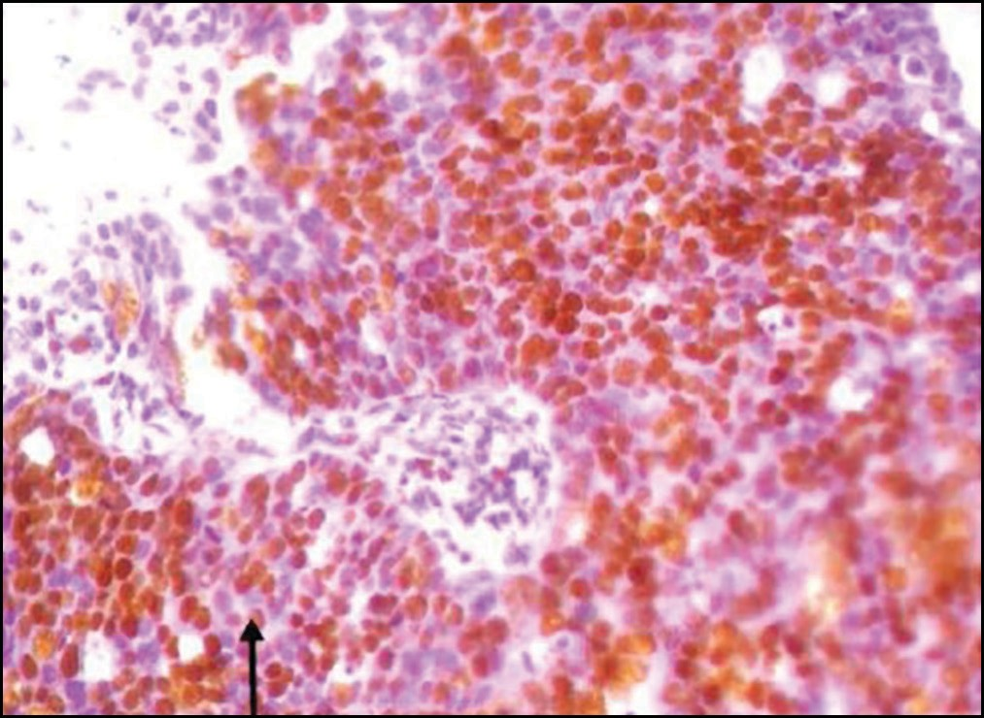

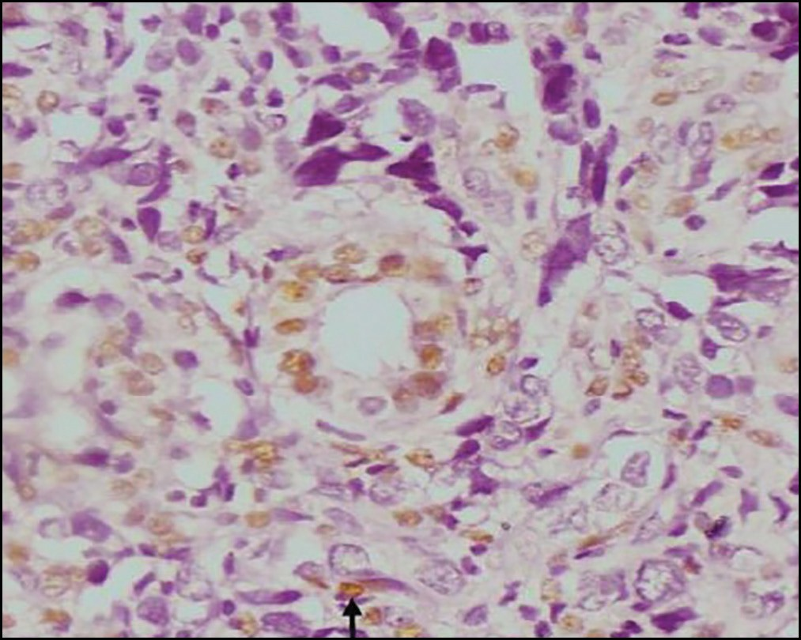**Figure 1: Photomicrograph showing strong estrogen nuclear receptor positivity (immunohistochemical stain, ×100)**

**Figure 2: Photomicrograph showing moderate progesterone nuclear receptor positivity (immunohistochemical stain, ×100)**

Journal of the West African College of Surgeons | Volume 10 | Issue 2 | April‑June 2020 3

### Table 3: Age distribution of hormonal status of endometrial carcinoma

|  |  |  |  |  |  |
| --- | --- | --- | --- | --- | --- |
|  | **35–44 years** | **45–54 years** | **55–64 years** | **65–74 years** | **75+ years** |
| ER status |  |  |  |  |  |
| Negative | 0 | 5 (16.7%) | 8 (26.7%) | 12 (40%) | 5 (16.7%) |
| Positive | 1 (7.6%) | 3 (23.1%) | 5 (38.5%) | 3 (23.1%) | 1 (7.6%) |
| PR status |  |  |  |  |  |
| Negative | 1 (2.7%) | 7 (19.4%) | 11 (30.5%) | 12 (33.3%) | 5 (13.9%) |
| Positive | 0 | 1 (14.3%) | 2 (28.6%) | 3 (42.9%) | 1 (14.3%) |

could be implied that the biology of endometrial cancer in our environment is much more aggressive.

# Conclusion

Hormone receptors expression for endometrial cancer is relatively low in our environment when compared with that in the USA.[13] Despite the fact that the incidence of endometrial carcinoma in our environment is low, it seems to be much more aggressive with a poorer prognosis. Immunohistochemistry for hormone receptors would be very useful in stratifying our patients for appropriate care and prognosis. Future studies employing larger sample size are therefore recommended.

### Limitations

There are few limitations in this study. First, the study was an institutional-based study, and due to the low incidence of endometrial carcinoma in our environment, we could have a relatively low sample size to adequately power the study. Secondly, the storage condition of archival tissues can have some effect on the performance of immunohistochemistry. Despite these limitations, this study provides epidemiological data on the expression of hormone receptors in endometrial carcinoma in our environment.

### Financial support and sponsorship

Nil.

### Conflicts of interest

There are no conflicts of interest.

# References

1. Adekanbi AOA, Jimoh MA, Ajani MA, Fawole AO. Endometrial cancer in Ibadan: Epidemiological and clinico-pathological features—10 year review. N Y Sci J 2016;9:19-23.
2. Ferlay J, Soerjomataram I, Dikshit R, Eser S, Mathers C, Rebelo M, *et al*. Cancer incidence and mortality worldwide: Sources, methods and major patterns in GLOBOCAN 2012. Int J Cancer 2015;136:359-86.
3. Witkiewicz AK, Wright TC, Ferenczy A, Ronnett BM, Kurman RJ. In: Kurman JR, Ellenson LH, Ronnett MB, editors. Blaustein’s Pathology of the Female Genital Tract. 6th ed. New York: Springer; 2011. p. 156-288.
4. Van Weelden WJ, Massuger LFAG. Anti-estrogen treatment in endometrial cancer : A systematic review. Front Oncol 2019;9:1-12.
5. Hua H, Zhang H, Kong Q, Jiang Y. Mechanisms for estrogen receptor expression in human cancer. Exp Hematol Oncol 2018;7:1-11.
6. Kumar V, Abass AK, Aster J. Robbins & Cotran Pathologic Basis of Disease. 8th ed. Philadelphia: Saunders Elsevier; 2010. p. 1007-18.
7. Wei JJ, Paintal A, Keh P. Histologic and immunohistochemical analyses of endometrial carcinomas: Experiences from endometrial biopsies in 358 consultation cases. Arch Pathol Lab Med 2013;137:1574-83.
8. Martin JD, Hähnel R, McCartney AJ, Woodings TL. The effect of estrogen receptor status on survival in patients with endometrial cancer. Am J Obstet Gynecol 1983;147:322-4.
9. Lacey JV Jr, Chia VM, Rush BB, Carreon DJ, Richesson DA, Ioffe OB, *et al*. Incidence rates of endometrial hyperplasia, endometrial cancer and hysterectomy from 1980 to 2003 within a large prepaid health plan. Int J Cancer 2012;131:1921-9.
10. Wang C, Tran DA, Fu MZ, Chen W, Fu SW, Li X. Estrogen receptor, progesterone receptor, and HER2 receptor markers in endometrial cancer. J Cancer 2020;11:1693-701.
11. Łapińska-Szumczyk SM, Supernat AM, Majewska HI, Gulczyński J, Biernat W, Wydra D, *et al*. Immunohistochemical characterisation of molecular subtypes in endometrial cancer. Int J Clin Exp Med 2015;8:21981-90.
12. Di Donato V, Iacobelli V, Schiavi MC, Colagiovanni V, Pecorella I, Palaia ÞI, *et al*. Impact of hormone receptor status and Ki-67 expression on disease-free survival in patients affected by high-risk endometrial cancer. Int J Gynecol Cancer 2018;28:505-13.
13. Backes FJ, Walker CJ, Goodfellow PJ, Hade EM, Agarwal G, Mutch D, *et al*. Estrogen receptor-alpha as a predictive biomarker in endometrioid endometrial cancer. Gynecol Oncol 2016;141:312-7.
14. Dawodu OO, Okunade KS, Daramola A, Banjo AAF. Review of immunohistochemical typing of endometrial carcinoma at the Lagos University Teaching Hospital. Afr Health Sci 2019;19:2468-75.
15. Musfera N, Masjeed A, Gaurish S, Khandeparkar S, Joshi AR. Immunohistochemical study of ER, PR, Ki67 and p53 in endometrial hyperplasias and endometrial carcinomas. J Clin Diagnostic Res 2017;11:EC31-4.
16. Fukuda K, Mori M, Uchiyama M, Iwai K, Iwasaka T, Sugimori H. Prognostic significance of progesterone receptor immunohistochemistry in endometrial carcinoma. Gynecol Oncol 1998;69:220-5.
17. Shen F, Gao Y, Ding J, Chen Q. Is the positivity of estrogen receptor or progesterone receptor different between type 1 and type 2 endometrial cancer? Oncotarget 2017;8:506-11.
18. Goswami S, Sen A, Biswas M. Association of the hormonal receptor status of endometrial carcinomas with the markers of tumor aggression: A comparison with similar studies in developed nations. Med J Dr DY Patil Univ 2017;10:334-8.
19. Castagnetta L, Lo Casto M, Mercadante T, Polito L, Cowan S, Leake RE. Intra-tumoural variation of oestrogen receptor status in endometrial cancer. Br J Cancer 1983;47:261-7.
20. Creasman WT. Prognostic significance of hormone receptors in endometrial cancer. Cancer 1993;71:1467-70.
21. Wik E, Ræder MB, Krakstad C, Trovik J, Birkeland E, Hoivik EA, *et al*. Lack of estrogen receptor-α is associated with epithelial- mesenchymal transition and PI3K alterations in endometrial carcinoma. Clin Cancer Res 2013;19:1094-105.

4 Journal of the West African College of Surgeons | Volume 10 | Issue 2 | April‑June 2020