**Original Article**

**Glomus Tumour of Hand––A Commonly Misdiagnosed Pathology: A Case Series**



**Abstract**

**Introduction:** Glomus tumours are benign neoplasms arising from the glomus body, a network of specialized neuromyoarterial structures containing arteriovenous anastomosis and regulating temperature. It is often misdiagnosed as paronychia, arthritis, traumatic sequelae, and many other conditions including psychiatric misdiagnosis. A typical triad of paroxysmal pain, point tenderness, and cold intolerance characterize it. Surgical excision is the treatment of choice, either by transungual or lateral approaches. **Materials and Methods:** We carried out a retrospective study of cases operated in our department in the last 4 years. Patients are evaluated based on either clinical parameters (Love test, Hildreth test, and cold insensitivity) or radiological parameters (X-ray and magnetic resonance imaging). Parameters such as age, gender, tumour side, presenting complaints, duration of symptoms, diagnostic modality, follow-up duration, recurrence, and postoperative nail deformity were analysed. Visual analogue scale (VAS) score was the primary statistical parameter, and the change in VAS score following surgery was analysed with paired *t* test. **Result:** Mean preoperative VAS was 7.75±0.5; in a total of four patients, and following surgery, VAS was reduced to a mean of 1±1.5. Paired *t* test on the change of VAS score following surgery showed a significant difference in the VAS score (*P* = 0.002838). The average age was 39.25. The male-to-female ratio was 1:3, and the mean follow-up was 16 months (range 2–48 months). The mean duration of symptoms was 5.75 years (range 2–10 years). Two cases were in the right-hand side, and two cases were on the left-hand side; the thumb was most commonly involved with 50% (*n* = 2) incidence. **Conclusion:** Glomus tumours are often misdiagnosed and are intervened with different treatment options before being surgically intervened. With complete surgical excision, recurrence is nil but postoperative nail growth requires nearly 10 months.

**Level of Evidence:** Level IV

**Keywords:** *Cold insensitivity, glomus tumour, Hildreth test, Love’s pin test, nailbed, transungual approach*

**Mohit Dhingra, Bishwa Bandhu Niraula,**

**Anil Regmi, Shivam Bansal, Vivek Singh,**

**Ravi Hari Phulware**

*Department of Orthopedics, All India Institute of Medical Science (AIIMS), Rishikesh, Uttarakhand, India*

**Introduction**

Glomus tumours are benign neoplasms arising from the glomus body, a network of specialized neuromyoarterial structures containing arteriovenous anastomosis and regulating temperature.[1,2] Approximately 2% of hand tumours occur in the distal phalanx in the subungual area due to the abundance of glomus bodies.[3,4]

A typical triad of paroxysmal pain, point tenderness, and cold intolerance characterize it.[5] The long duration of presentation denotes misdiagnosis of the tumour.[6] It has been mistaken for neuroma, gout, arthritis, causalgia, and different treatment manoeuvres, both medical and surgical, have been applied in the past,

This is an open access journal, and articles are distributed under the terms ofthe Creative CommonsAttribution-NonCommercial-ShareAlike 4.0 License, which allows others to remix, tweak, and build upon the work non-commercially, as long as appropriate credit is given and the new creations are licensed under the identical terms.

**For reprints contact:** reprints@medknow.com

including amputation.[7] Complete excision is the treatment of choice, which provides complete relief of pain 2–4 weeks following excision.[8] Transungual and lateral are the two surgical approaches applied.[9] Postoperative nail deformity and recurrence of symptoms can be encountered following surgery due to incomplete excision.[10]

This study aimed to evaluate a series of cases of glomus tumours of nailbed of fingers, often initially being misdiagnosed as well as intervened with various treatment modalities before presenting to us. All of these cases were operated by a transungual approach.

**Materials and Methods**

We carried out a retrospective study of cases operated in our department in the last

**How to cite this article:** Dhingra M, Niraula BB, Regmi A, Bansal S, Singh V, Phulware RH. Glomus tumour of hand––A commonly misdiagnosed pathology: A case series. J West Afr Coll Surg 2022;12:39-45.

**Received:** 15-Aug-2022 **Accepted:** 13-Sep-2022 **Published:** 23-Nov-2022

***Address for correspondence:*** *Dr. Mohit Dhingra, Department of Orthopedics, All India Institute of Medical Science (AIIMS), Rishikesh 249203, Uttarakhand, India. E-mail: modisbanu77@gmail. com*

**Access this article online**

**Website:**

www.jwacs-jcoac.com

**DOI:** 10.4103/jwas.jwas_171_22

**Quick Response Code:**

© 2022 Journal of the West African College of Surgeons | Published by Wolters Kluwer ‑ Medknow 39

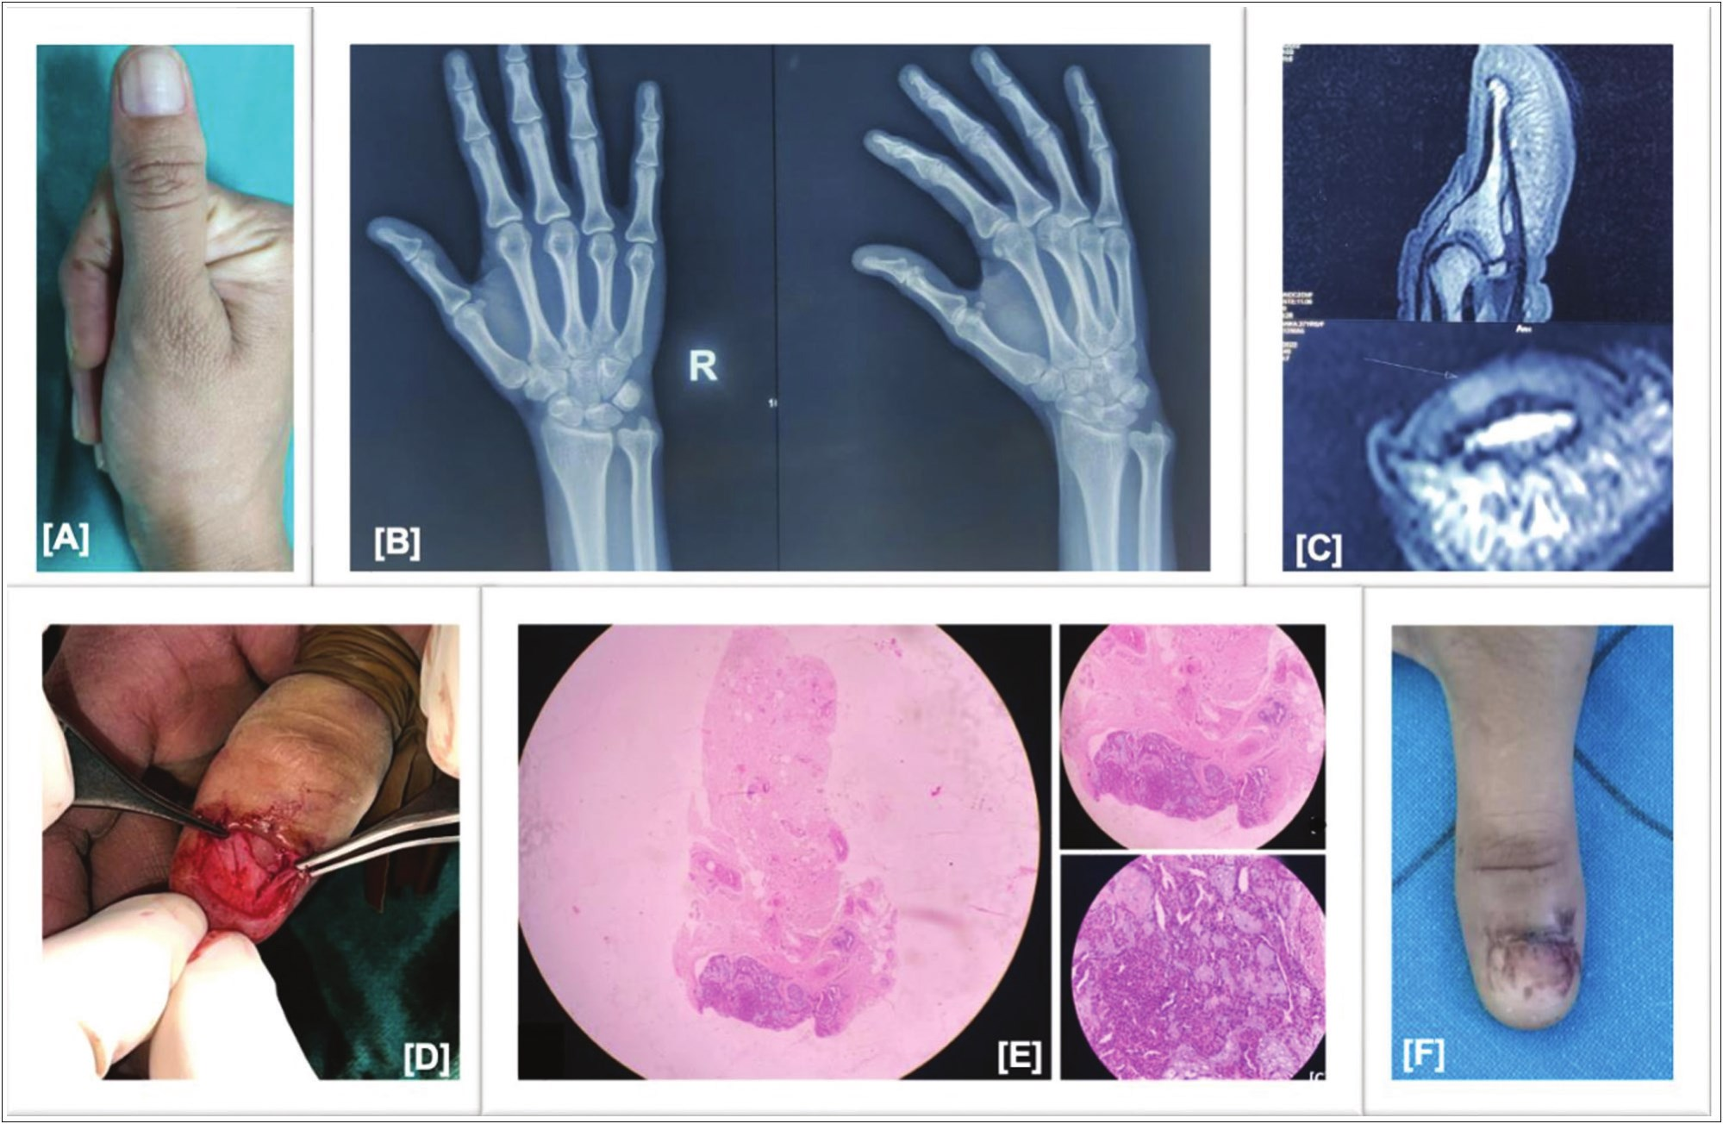

Dhingra, *et al.*: Glomus tumour of hand

2 years. All these cases were clinically assessed with age, gender, location, and duration of symptoms. These cases were assessed both preoperatively and postoperatively by standard clinical test:

1. Love test (pain over the tumour on the application of pressure with the pin head).[11]

2. Hildreth test (pain of Love test will be abolished by applying a tourniquet at the base of the affected finger).[11]

3. Cold insensitivity was done by applying cold water or ice packs over the tumour to check for intolerance to cold or pain insensitivity.

Biopsy-proven cases of glomus tumour along with clinical criteria (paroxysmal pain, point tenderness, and cold insensitivity) or radiological criteria (magnetic resonance imaging [MRI] indicative of glomus tumour, hypointense on T1, and hyperintense on T2) were included.[12] All the patients were operated by an transungual approach where excision of tumour was done and the nail bed was closed. Patients were asked to follow-up in the outpatient department at 6 weeks of interval for clinical assessment.

Change in Love test, Hildreth test, and cold sensitivity before and after surgery was used as a clinical assessment tool.

Visual analogue scale (VAS) scoring, which is used as per our routine analysis, for the patients both pre- and postoperatively was taken and a change in VAS score was assessed statistically by applying paired *t* test.

All the data were entered in MS Excel and analysed.

**Case Presentation Case 1**

A 27-year-old woman presented with pain in her distal thumb right side for 2 years. She was taking treatment for paronychia and arthritis for the same. She had undergone numerous interventions with heat therapy, cryotherapy, antifungal, corticosteroids, and steroids before being diagnosed clinically as a case of glomus tumour. Clinical examination revealed a positive Love pin test and Hildreth test. The VAS score was 7/10 and the cold sensitivity test was negative in this patient. Diagnosis was made on MRI finding, which was suggestive of a mass of size 2mm × 2mm on the right thumb overlying nail matrix [Figure 1].

Surgical excision was carried out through a transungual approach under finger block and tourniquet followed by the closure of nail bed.

**Figure 1: Case 1: (A) Preoperative clinical pics showing a bluish demarcation line in the nail bed suggestive of nail bed glomus tumour. (B) Preoperative X-ray showing no any bony involvement. (C) MRI image showing a mass of size 2mm × 2mm on right thumb overlying nail matrix. (D) Intraoperative image showing transungual approach. (E) Postoperative histopathological images in 10×, 20×, 40× magnification, showing round to ovoid glomus cells with interspersed fibroblast, delicate vasculature and myxoid stroma. No evidence of necrosis, mytosis and atypia seen. (F) 2-month follow-up images showing no nail growth**

40 Journal of the West African College of Surgeons | Volume 12 | Issue 4 | October‑December 2022

Dhingra, *et al.*: Glomus tumour of hand

A follow-up of 2 months showed that all three tests, Love pin test, Hildreth test, and cold insensitivity test, were negative. VAS score was 3/10 postoperatively.

The last follow-up does not show full nail growth as shown in Figure 1.

**Case 2**

A 37-year-old woman presented with throbbing pain in her right distal thumb for 2 years. She was misdiagnosed as a case of paronychia for months. The patient was given various treatment modalities for paronychia. The patient also underwent drainage for paronychia and presented to us with a nail deformity as shown in Figure 2. The patient was diagnosed clinically and radiologically. Clinical examination revealed a positive Love pin test and Hildreth test, whereas the cold sensitivity test was negative. VAS score was 9/10.

Diagnosis was made on MRI finding, which was suggestive of a mass of size 6mm × 4mm on the right thumb posterior to the distal phalanx [Figure 2].

Surgical excision was carried out through a transungual approach under finger block and tourniquet, followed by the closure of nail bed. A follow-up of 4 months showed that all three tests, Love pin test, Hildreth test, and cold insensitivity test, were negative. VAS score was 1/10 at follow-up.

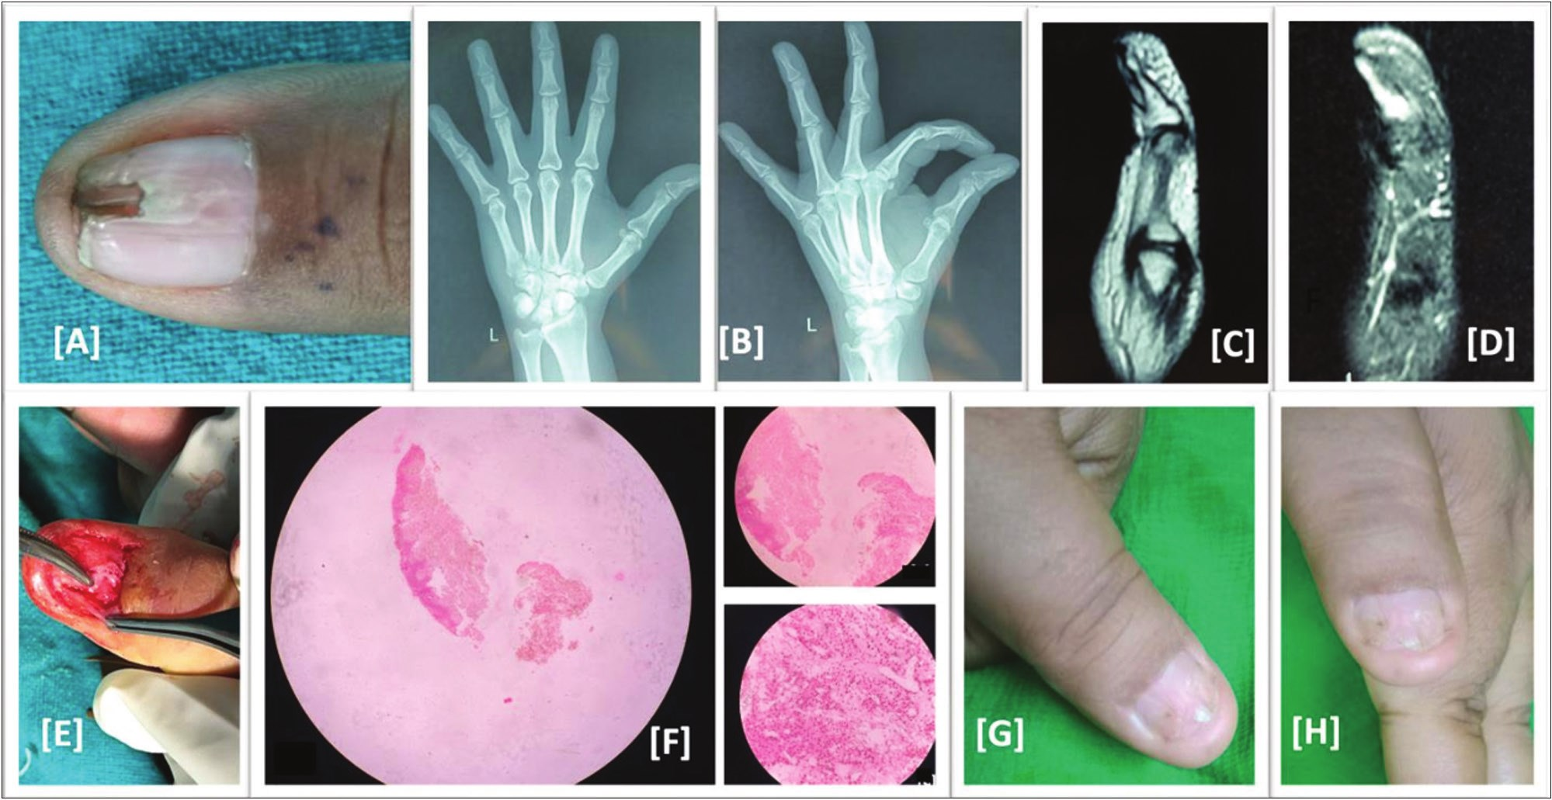

The last follow-up does not show full nail growth as shown in Figure 2.

**Case 3**

A 43-year-old man presented with throbbing pain on his left middle finger for 7–8 years. The pain was mild initially and the patient took conservative treatment options. As the duration of the disease increased, the patient was labeled as arthritis and given nonsteroidal anti-inflammatory drugs (NSAIDs) or steroids. Clinical examination revealed a positive Love pin test and Hildreth test, whereas the cold insensitivity test was negative. VAS score was 7/10.

Diagnosis was made on clinical parameters.

Surgical excision was carried out through a transungual approach under finger block and tourniquet, followed by the closure of the nail bed.

A follow-up of 10 months showed a negative Love pin test, Hildreth test, and cold insensitivity test. VAS Score was 0/10.

The details are shown in Figure 3.

**Case 4**

A 50-year-old woman presented with severe pain on her left ring finger for 10 years. The patient took over-the-counter drugs for years. She was misdiagnosed with chronic pain syndrome, paronychia, arthritis, and soft-tissue neoplasm. She received various treatment regimes including conservative measure like hot and cold compression and medication such as NSAIDs or corticosteroids. The patient was also labeled as having a psychiatric disorder. Patient

**Figure 2: Case 2: (A) Preoperative clinical pics showing nail deformity. (B) Preoperative X-ray showing no any bony involvement. (C and D) Preoperative MRI images of size 6×4mm on the right thumb posterior to the distal phalanx of the thumb. (E) Intraoperative images showing transungual approach. (F) Postoperative Histopathological images shown in 10×, 20×, 40× magnification, showing sheets of uniform round to ovoid glomus cells with interspersed fibroblast, Absent mitosis and atypia. (G and H) 4 months follow-up showing no nail growth**

Journal of the West African College of Surgeons | Volume 12 | Issue 4 | October‑December 2022 41

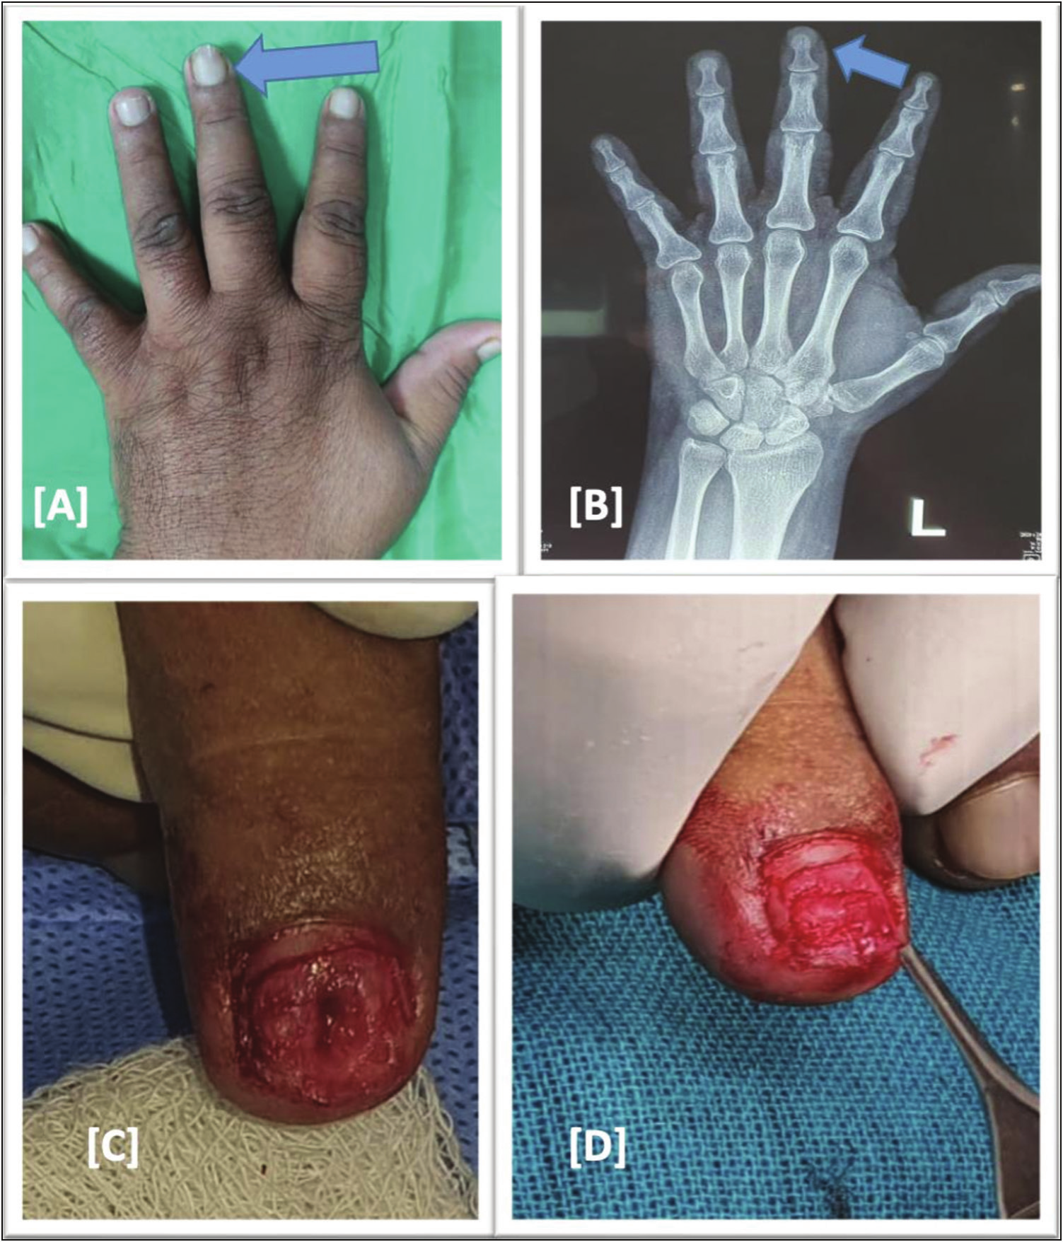

Dhingra, *et al.*: Glomus tumour of hand

**Figure 3: Case 3: (A) Preoperative clinical images showing bluish discoloration of nail bed. (B) Preoperative X-ray showing no bone involvement by tumour. (C and D) Intraoperative images showing transungual approach, removal of nail plate**

was diagnosed clinically. Clinical examination revealed a positive Love pin test,

Hildreth test and cold insensitivity test. VAS score was 8/10. Diagnosis was made on clinical parameters.

Surgical excision was carried out through a transungual approach under finger block and tourniquet, followed by the closure of nail bed.

a follow-up of 48 months showed that all three tests, Love pin test, Hildreth test, and cold insensitivity test, were negative. VAS score was 0/10.

The details are shown in Figure 4.

**Results**

In our series of four patients, the average age was 39.25 (27–50 years). The male:female ratio was 1:3, and the mean

follow-up was 16 months (range 2–48 months). The mean duration of symptoms before the patient was diagnosed was 5.75 years (range 2–10 years, SD = 3.34). Two cases were on the right side and two were on the left side. Thumb was involved in two cases, both on the right side: one of the index finger and one of the middle fingers. The predominant symptom was pain (*n* = 4), with cold insensitivity present in 50% of cases (*n* = 2).

Mean preoperative VAS was 7.75±0.5 and post-surgery VAS was reduced to a mean of 1±1.5. Paired *t* test on change of VAS score after surgery showed a significant difference in the VAS score (*P* = 0.002838).

Examination showed a positive Love test and a Hildreth test in all four cases. Cold sensitivity was present in only two of the cases and absent in those cases where the thumb was involved. Postoperatively all the findings

42 Journal of the West African College of Surgeons | Volume 12 | Issue 4 | October‑December 2022

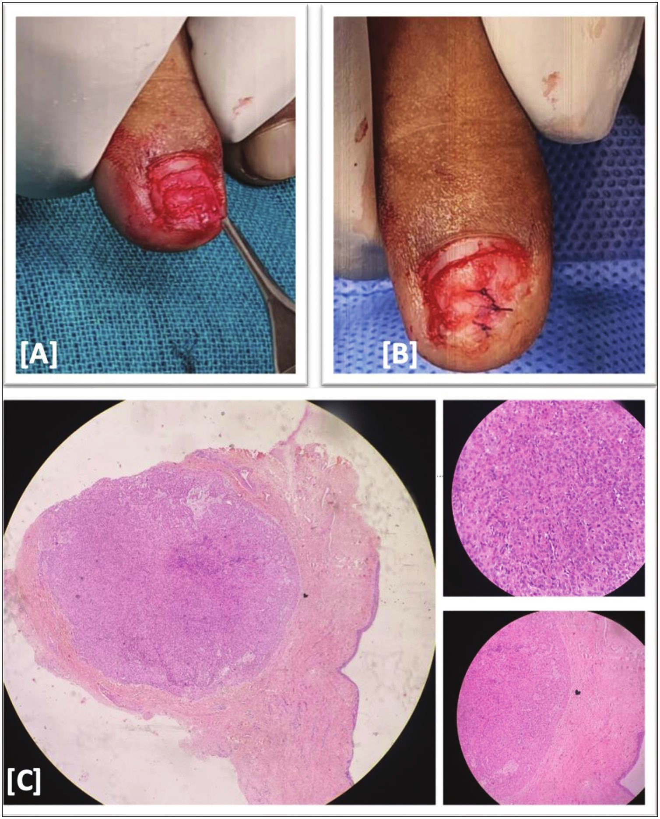

Dhingra, *et al.*: Glomus tumour of hand

**Figure 4: Case 4: (A and B) Intraoperative transungual approach of excision of tumour. (C) Histopathology images of excised tissue shown in 10×, 20× and 40× magnification, showing round to ovoid glomus cells. No evidence of necrosis, mitosis, and atypia**

were absent that showed a good outcome of surgery on these symptoms.

Radiologically all tumours showed no bony involvement or destruction on X-rays and MRI was an investigation of choice as it helped in proper localization of tumour including size and location, hyperintense on T2, and hypointense on T1.

The mean length of hospital stay was 2 days for all the patients (*n* = 4) including the day of the surgery and the patient was discharged on POD-1.

Nail growth was seen in patients with a follow-up of more than 10 months. Two patients who had a follow-up of 2 months and 4 months did not have nail growth and two patients who had follow-up of 10 months and 48 months had complete nail growth.

**Discussion**

The fingertips are most commonly affected by glomus tumours that are benign neoplasms of vascular origin.[13] The majority of subungual glomus tumours occur in middle-aged women; tumours in other anatomical sites are more prevalent in men.[14] Our study also presents the glomus tumour of the subungual region, with a mean age of 39.25 years with a male-to-female ratio of 1:3, which corresponds with the previous studies.[4]

Glomus tumour often remains misdiagnosed. Santoshi *et al.*[15] claim that early diagnosis of glomus tumour is necessary, or they might be labeled as chronic pain, disuse syndrome, or psychiatric misdiagnoses. In our series, patients were either labeled as paronychia, arthritis, soft-

Journal of the West African College of Surgeons | Volume 12 | Issue 4 | October‑December 2022 43

Dhingra, *et al.*: Glomus tumour of hand

tissue tumour, chronic pain syndrome, soft-tissue tumours, or psychiatric disorders. The average duration of symptoms before diagnosis was made was 5.75 years (SD = 3.34) and this shows that patients are often misdiagnosed before getting definitive treatment.

Van Geertruyden *et al.*[16] found that 80% of patients with digital glomus tumours experienced spontaneous pain, 100% reported pain sensitivity, and 63% reported cold hypersensitivity; however, in our study pain was present in 100% of cases and cold hypersensitivity was present in 50% of cases. Tingmao Chou *et al.*[14] found that 33% of patients had nail deformities and 29% had reddish-blue discoloration, whereas 25% cases (*n*= 1) had nail deformity and 50% of cases (*n* = 2) had bluish discoloration of nail. In our study, the most common presenting complaint is pain which was present in all cases, following which cold sensitivity was present in 50% (*n* = 2) cases in our study, which was less compared with previous studies. In addition, patients having a lesion in the thumb had no cold sensitivity, so the cold sensitivity is related to the digit involved. In our case, 25% (*n* = 1) patient had nail deformity, 50% (*n* = 2) had blueish discoloration, and 25% (*n*= 1) had neither nail deformity nor nail discoloration.

The classic triad of symptoms and three main clinical tests, the Love pin test, the Hildreth test, and the cold sensitivity test, can provide high sensitivity and specificity for diagnosis without imaging tests.[11,14] Bhaskaranand *et al.*[17] conducted an experiment on 18 patients and observed that the cold sensitivity test was 78% accurate; the Hildreth test was 78% accurate, and the Love pin test was 78% accurate.[17] In our study, all the patients (100% [*n* = 4]) had a positive Hildreth test and Love pin test, whereas cold insensitivity was present in 50%(*n* = 2) of cases. Thus, showing Hildreth test and Love pin test is 100% accurate in diagnosing glomus tumour.

Approximately 50% of patients with subungual tumours have bone erosion on plain radiographs.[18] MRI makes it possible to detect lesions as small as 2mm in diameter.[19] The sensitivity of MRI in a series of 42 patients was reported to be 90%.[20] In our study, 50% (*n* = 2) cases were diagnosed with MRI and clinical findings, whereas 50% (*n* = 2) cases were diagnosed by clinical findings only.

The curative treatment of choice for glomus tumours is complete surgical excision.[10] Van Geertruyden *et al.*[16] performed a transungual resection in 30 patients, showing a 6.6% recurrence rate and 3.3% postoperative nail bed deformity rate. Malignant glomus tumours are extremely rare, with only limited published case reports.[21,22] The chance of malignant change in glomus tumours is as low as 1%.[14,23] In our study, all cases were operated by surgical excision by a transungual approach. During the period of 2 months to 48 months follow-up, none of the cases had a recurrence of tumour and none had nail deformity. Approximately 50% (*n* = 2) of cases having follow-up for

more than 10 months had complete nail growth. None of the cases in our study had a malignant transformation.

Smilevitch *et al.*’s[24] study showed a massive improvement in VAS score in glomus tumour postoperatively, where VAS average for preoperative pain was 8.7 (range, 5–10), whereas it was 0.8 (range, 0–9) postoperatively.[24] In our study, with follow-up from 2 months to 48 months, VAS was significantly improved from preoperative mean VAS of 7.75±0.5 to postoperative mean VAS of 1±1.5.

Hence, we can conclude that Glomus tumours are often misdiagnosed and labeled as paronychia, arthritis, chronic pain syndrome, or vaguely labeled as soft-tissue neoplasm before a correct diagnosis is reached. Thumb is the most common finger involved and surgical excision is the treatment of choice. Transungual approach is the common surgical approach and postoperative nail growth requires nearly 10 months as per our study.

**Limitations of our study**

Our studies have certain limitations due to the small sample size(*n*= 4), due to the rarity of pathology, and misdiagnosis in most of the cases. Approximately 50% of our cases had a short follow-up duration. However, multicentric large sample size randomized controlled trials with long follow-up are required to strengthen our conclusion.

**Declaration of patient consent**

The authors certify that they have obtained all appropriate patient consent forms. In the form the patient(s) has/have given his/her/their consent for his/her/their images and other clinical information to be reported in the journal. The patients understand that their names and initials will not be published and due efforts will be made to conceal their identity, but anonymity cannot be guaranteed.

**Financial support and sponsorship**

Not applicable.

**Conflicts of interest**

There are no conflicts of interest.

**References**

1. Gombos Z, Zhang PJ. Glomus tumor. Arch Pathol Lab Med 2008;132:1448-52.

2. Honsawek S, Kitidumrongsook P, Luangjarmekorn P, Pataradool K, Thanakit V, Patradul A. Glomus tumors of the fingers: Expression of vascular endothelial growth factor. World J Orthop 2016;7:843-6.

3. Aicha EA, Zakia D, Sara E, Hanane B, Fz M. Glomus tumor is not always digital: Case report. J Med Care Res Rev 2020; 3:331-2.

4. Lee W, Kwon SB, Cho SH, Eo SR, Kwon C. Glomus tumor of the hand. Arch Plast Surg 2015;42:295-301.

5. Jeong HJ, Kim CM, Yoon DM, Yoon KB. Concomitant glomus tumor with CRPS in the hand. Korean J Pain 2013;

26:295-8.

44 Journal of the West African College of Surgeons | Volume 12 | Issue 4 | October‑December 2022

Dhingra, *et al.*: Glomus tumour of hand

6. Mortada H, AlRabah R, Kattan AE. Unusual location of pulp glomus tumor: A case study and literature review. Plast Reconstr Surg Glob Open 2022;10:e4206.

7. Rettig AC, Strickland JW. Glomus tumor of the digits. J Hand

Surg Am 1977;2:261-5.

16. Van Geertruyden J, Lorea P, Goldschmidt D, de Fontaine S, Schuind F, Kinnen L, *et al*. Glomus tumours of the hand: A retrospective study of 51 cases. J Hand Surg Br 1996;21:257-60.

17. Bhaskaranand K, Navadgi BC. Glomus Tumour of the Hand.

J Hand Surg 2002;27:229-31.

8. Saaiq M. Presentation and management outcome of glomus tumors of the hand. Arch Bone Jt Surg 2021;9:312-8.

9. Moon SE, Won JH, Kwon OS, Kim JA. Subungual glomus tumor: Clinical manifestations and outcome of surgical treatment. J Dermatol 2004;31:993-7.

10. Song M, Ko HC, Kwon KS, Kim MB. Surgical treatment of subungual glomus tumor: A unique and simple method. Dermatol Surg 2009;35:786-91.

11. Morey VM, Garg B, Kotwal PP. Glomus tumours of the hand: Review of literature. J Clin Orthop Trauma 2016;7:286-91.

12. Koç O, Kivrak AS, Paksoy Y. Subungual glomus tumour: Magnetic resonance imaging findings. Australas Radiol 2007;51 Spec No.:B107-9.

13. Hufschmidt K, Foissac R, Camuzard O, Cardot-Leccia N, Chignon-Sicard B, Balaguer T. Glomus tumors of the upper limb: Single-center retrospective study of clinical and functional outcomes. Hand Surg Rehabil 2017;36:290-5.

14. Chou T, Pan SC, Shieh SJ, Lee JW, Chiu HY, Ho CL. Glomus tumor: Twenty-year experience and literature review. Ann Plast Surg 2016;76:S35-40.

15. Santoshi JA, Kori VK, Khurana U. Glomus tumor of the fingertips: A frequently missed diagnosis. J Family Med Prim

Care 2019;8:904-8.

18. Chiang YP, Hsu CY, Lien WC, Chang YJ. Ultrasonographic appearance of subungual glomus tumors. J Clin Ultrasound 2014;42:336-40.

19. Ham KW, Yun IS, Tark KC. Glomus tumors: Symptom variations and magnetic resonance imaging for diagnosis. Arch Plast Surg 2013;40:392-6.

20. AL-Qattan MM, AL-Namla A, AL-Thunayan A, AL-Subhi F, EL-Shayeb AF. Magnetic resonance imaging in the diagnosis of glomus tumours of the hand. J Hand Surg 2005;30: 535-40.

21. Mizutani L, Tanaka Y, Kondo Y, Bando H, Hara H. Glomus tumor of a female breast: A case report and review of the literature. J Med Ultrason (2001) 2014;41:385-8.

22. Wesley Wetherington R, Glenn Lyle W, Sangüeza OP. Malignant glomus tumor of the thumb: A case report. J Hand Surg 1997;22:1098-102.

23. Folpe AL, Fanburg-Smith JC, Miettinen M, Weiss SW. Atypical and malignant glomus tumors: Analysis of 52 cases, with a proposal for the reclassification of glomus tumors. Am J Surg Pathol 2001;25:1-12.

24. Faisan Smilevitch D, Chaput B, Grolleau JL, Rongieres M, Mansat P. Improvement in quality of life after surgery for glomus

tumors of the fingers. Chir Main 2014;33:330-5.

Journal of the West African College of Surgeons | Volume 12 | Issue 4 | October‑December 2022 45