**Original Article**

The Burden of Geriatric Trauma at the University College Hospital, Ibadan, Nigeria

**Tolulope Ogunrewo1, Oluwagbenga Temitope Alonge1,2**

**Abstract**

**Background:** Geriatric populations presently account for 9% of the world population and this is expected to increase. Injuries to the elderly accounted for 5.8 million accident and emergency visits in the USA as well as 4% of patients treated for traumatic injuries in Abuja, Nigeria. Traumatic injury is therefore a major cause of morbidity in the elderly as such the need for the study in our environment. **Aims and Objectives:** The aim(s) of this article is to review the incidence and types of traumatic injury among elderly population who presented at the University College Hospital, Ibadan, Nigeria and to determine the causes of traumatic injury involving the geriatric age group in our environment. **Materials and Methods:** A retrospective hospital-based study involving the records of geriatric patients who presented with traumatic injuries between January 2014 and June 2021 at the geriatric center and the accident and emergency department of the hospital. The record was retrieved from the Total Quality Management Unit of the hospital. **Results:** About 7.61% of the traumatic injury that presented at the accident and emergency department within the study period involved geriatric patients with a male-to-female ratio of 1:1.08, whereas 0.3% of the patients for inpatient care at the geriatric center had traumatic injury. Fall was the most common cause of traumatic injury observed and fracture the most common traumatic injury observed. **Conclusion:** Less than 10% of the patients with traumatic injury who presented at the University College Hospital, Ibadan, Nigeria are in the geriatric age group. Most of the traumatic injury involving geriatric patients in our environment is due to low energy falls, and fracture is the most common injury observed, with the femur being the most affected bone. Therefore, interventions directed at reducing the incidence of falls in our environment will hopefully help in reducing the incidence of traumatic injuries in the older population.

**Keywords:** *Fall, fracture, geriatric, motor vehicle road traffic crash, trauma*

*1Department of Orthopedic Surgery and Trauma, University College Hospital, 2Department of Orthopedic Surgery and Trauma, College of Medicine, University of Ibadan, Nigeria*

# Introduction

Patients classified as belonging to the geriatric age group are older persons aged 65 years and over,[1] and they accounted for 9% of the world population in 2019. It is estimated that the number of older persons will exceed 16% of the world population by the year 2050.[2] According to the 2006 census estimate in Nigeria, the geriatric age group accounted for 4% of the total population.[3]

In the USA, injuries in the older persons accounted for more than 5.8 million accident and emergency visits[4] as well as 14% of all injury-related emergency department visits,[4] and they are also the second group with the highest risk of traumatic injuries aside younger adults.[5] In a report from Abuja, Nigeria, elderly patients accounted for 4% of patients treated for trauma-related injuries.[6]

This is an open access journal, and articles are distributed under the terms of the Creative Commons Attribution-NonCommercial- ShareAlike 4.0 License, which allows others to remix, tweak, and build upon the work non-commercially, as long as appropriate credit is given and the new creations are licensed under the identical terms.

**For reprints contact:** [reprints@medknow.com](mailto:reprints@medknow.com)

Trauma is the fifth most common cause of death in the elderly,[4] and it is characterized by low energy falls, delayed diagnosis, and increased mortality.[7] Unfortunately, and despite the relatively low life expectancy in the continent, sub-Saharan Africa bears the greatest regional burden of trauma mortality.[8] In addition, trauma in the elderly patients is associated with the need for special consideration due to their altered anatomy as well as due to decreased ability to tolerate stresses.[9] The types of traumatic injury seen in elderly population include head injury, chest trauma, abdominal injury, spinal and musculoskeletal injury, soft tissue injury, and burns.[10]

The causes of geriatric trauma are falls, pedestrian injury such as being struck by motor vehicles, motor vehicle crash (MVC), motorbike crash, assault, domestic abuse, burns as well as penetrating injuries.[11,12] Fall is defined as the inadvertent coming to rest on the ground, floor, or other lower level

**How to cite this article:** Ogunrewo T, Alonge OT. The burden of geriatric trauma at the University College Hospital, Ibadan, Nigeria. J West Afr Coll Surg 2021;11:13-7.

**Received:** 15-Feb-2022 **Accepted:** 10-Mar-2022 **Published:** 22-Jul-2022

***Address for correspondence:*** *Dr. Tolulope Ogunrewo, Department of Orthopedic Surgery and Trauma, University College Hospital, Ibadan, Nigeria.*

*Email:* [*ogunrew*](mailto:ogunrewotolu@gmail.com)[*otolu@gmail.com*](mailto:otolu@gmail.com)

|  |
| --- |
| **Access this article online** |
| **Website:**  [www.jwacs-jcoac.org](http://www.jwacs-jcoac.org/) |
| **DOI:** 10.4103/jwas.jwas_42_22 |
| **Quick Response Code:** |

© 2022 Journal of the West African College of Surgeons | Published by Wolters Kluwer ‑ Medknow 13

(which excludes intentional change in position to rest in a furniture).[13,14] It is the most common mechanism of injury in the geriatric age group,[9,15,16] and fatality rate following geriatric falls is about 45.3% in males whereas it is about 59.5% in the female gender.[9] MVC was observed in Abuja, Nigeria to be the commonest reason for trauma center visit by the elderly population accounting for 48.4%. Some of the reasons for increase in elderly pedestrian vehicular injuries are decreased mobility, decreased cognitive ability to make decisions about safe road crossing, decreased sensory input, and decreased walking speed across the ground.[17]

Risk factors for traumatic injury in the elderly patient include age, restricted mobility, more frequent use of multiple medications, disturbance of gait, altered plantar reflex, poor vision, presence of anxiety or depression, and impaired cardiovascular response to traumatic events.[18-20] Poor outcome measure in the management of trauma in this special group of patients is attributed to the presence of co-morbidities, frailty, reduced physiological reserves, and the effect of multiple prescribed medications also known as poly-pharmacy.[21]

Aging is the non-reversible, deteriorative changes that ultimately lead to death, which is characterized by progressive loss of functional reserve in many organs.[17] Each 1-year increase in age beyond 65 years, odds of dying after geriatric trauma increase by 6.8%.[22] Increasing number of co-morbid diseases associated with aging increases the risk of worse outcome because the prevalence of preexisting co-morbid conditions has been shown to increase with age.[22] These conditions are found in about 40% of older persons in the sixth decade of life, which increase to about 69% at age 75years.[23] The most significant predictors of dying after geriatric trauma include cancer, renal failure, hepatic disease, heart disease, and pulmonary disease.[24]

With the establishment of the first one-stop-shop Geriatric Center in Nigeria and the West African sub-region at the University College Hospital, Ibadan, Nigeria in 2012, we review the rate of occurrence and types of traumatic injury among elderly population who presented at the University College Hospital, Ibadan as well as the causes of injury involving the geriatric age group over a 7.5-year time frame.

# Materials and Methods

This is a retrospective hospital-based study to determine the rate of occurrence and the pattern of traumatic injury in patients 65 years and above who presented and were managed at the Accident and Emergency Department and at the Geriatric Centre of the University College Hospital between January 2014 and June 2021. The University College Hospital, Ibadan, Nigeria is an 850-bed teaching hospital and it is also a referral center from various hospitals in the country.

Data were obtained using a predesigned format which was compiled from the electronically stored data generated during the admission process of the patients at the Accident

and Emergency Department through the total quality management section as well as the electronic medical record of the geriatric center of the University College Hospital, Ibadan, Nigeria.

Data retrieved included the history of injury and radiological findings where applicable. Other information retrieved through the format included the biodata, the mechanism of injury, distribution of injuries, and when fracture was involved the bone affected was noted. The data were reviewed over a 7.5- year period extending from January 2014 to June 2021. The data were analyzed using Statistical Package for the Social Sciences version 16.

# Results

A total of 6516 patients presented at the Accident and Emergency Department of the University College Hospital, Ibadan, Nigeria, with various forms of traumatic incidents during the period under review. About 496 patients (7.61%) were aged 65 years, of which 238 were males and 258 females. The male-to-female ratio is 1:1.1. About 3784 patients presented at the outpatient unit of the geriatric center of the hospital within the study period but there was no reported case of traumatic injury during the period. However, of the 718 elderly patients who were admitted for inpatient care at the geriatric center, two cases of fracture were recorded accounting for 0.3% of the cases admitted to the center.

Low energy fall was the most common mechanism of traumatic injury in geriatric patients in this study and it accounted for over 48% of the total [Figure 1].Other causes include road traffic crash, assault, burn, and gun shot. Fracture was the most common traumatic injury accounting for 64.3%, whereas head injury accounted for 15.01% [Figure 2]. Other injuries observed include soft tissue injury, chest injury, joint dislocation, and cervical spine injury.

Fractures involving the femur bone was the most common fracture observed [Figure 3] in these patients, and other bones involved in the descending order of involvement are tibia and fibula, radius and ulnar, ankle, and pelvic bone. The neck of the femur was the most affected part of the bone [Figure 4].

During the period of the study, 30 (0.5%) trauma-related deaths were documented, patients were at the accident and emergency department, while the patients discharged against medical advice.

# Discussion

In our study, geriatric trauma accounted for 7.6% of all trauma admissions in the accident and the emergency department of the University College Hospital, Ibadan, Nigeria. A similar study done in Abuja, Nigeria showed that geriatric patients accounted for 4% of trauma-related admissions.[6] The sex distribution in our review reveals equal affectation (M:F; 1:1.1); however, some studies showed greater affectation in males, whereas others showed higher affectation in females.[6,24] Some

14 Journal of the West African College of Surgeons | Volume 11 | Issue 3 | July-September 2021

of the reasons given for increased male affectation include men adventurous nature as well as the bread winning role of men.

The rates of occurrence of low energy falls and road traffic crash in this study were 48.4% and 43.6%, respectively [Figure 1] and they were the most common causes of traumatic injury seen in this study. Low energy falls may be due to impairment in cognitive functions and behavioral functions. The incidence is between 30% and 40% among community dwellers and about 50% in individuals in long-term care settings.[25] Other contributing factors to falls include increasing age, visual impairment, depression, presence of osteoarthritis, previous history of fall, vertigo, and the female gender.[26] Similar studies from Norway, USA, and UAE also showed low energy falls as the most common cause of traumatic injury in the older persons in these climes.[24]

Long bone fractures and head injury were the most common injuries observed in this study [Figure 2]. They accounted for 64.33% and 15.01% of the cases, respectively. The reasons for this may be due to deteriorating bone stock and an increase in the incidence of falls.[27] Similar finding was noted in Norway and UAE where bone fractures were the most common type of injuries observed; however, head injury was observed to be the most common form of injury reported in the study done in Abuja, Nigeria.

Fractures involving the femur, the tibia, and fibula were the most commonly observed in this study [Figure 3]. Fractures involving the femur accounted for 41.64%, whereas fractures involving the tibia and fibula accounted for 19.10%. These are similar to the findings in Norway and UAE, whereas findings in Kazakhstan showed higher involvement of the bones of the upper limb within the age category.[28]

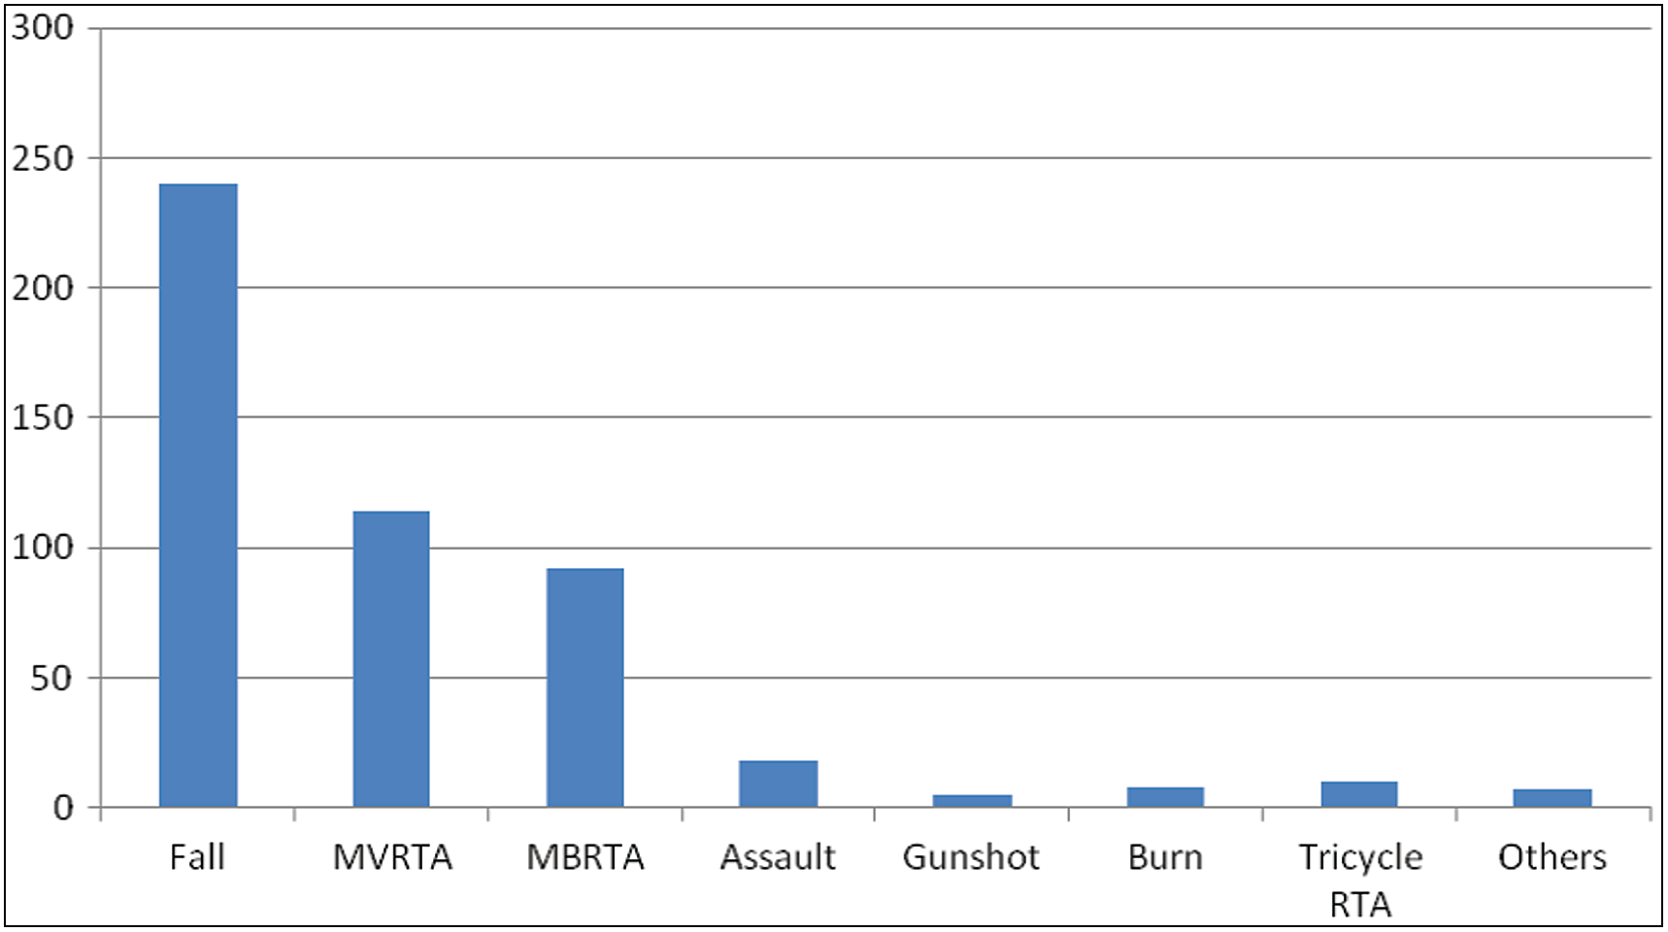

**Figure 1: Mechanism of injury (with the frequency of occurrence)**

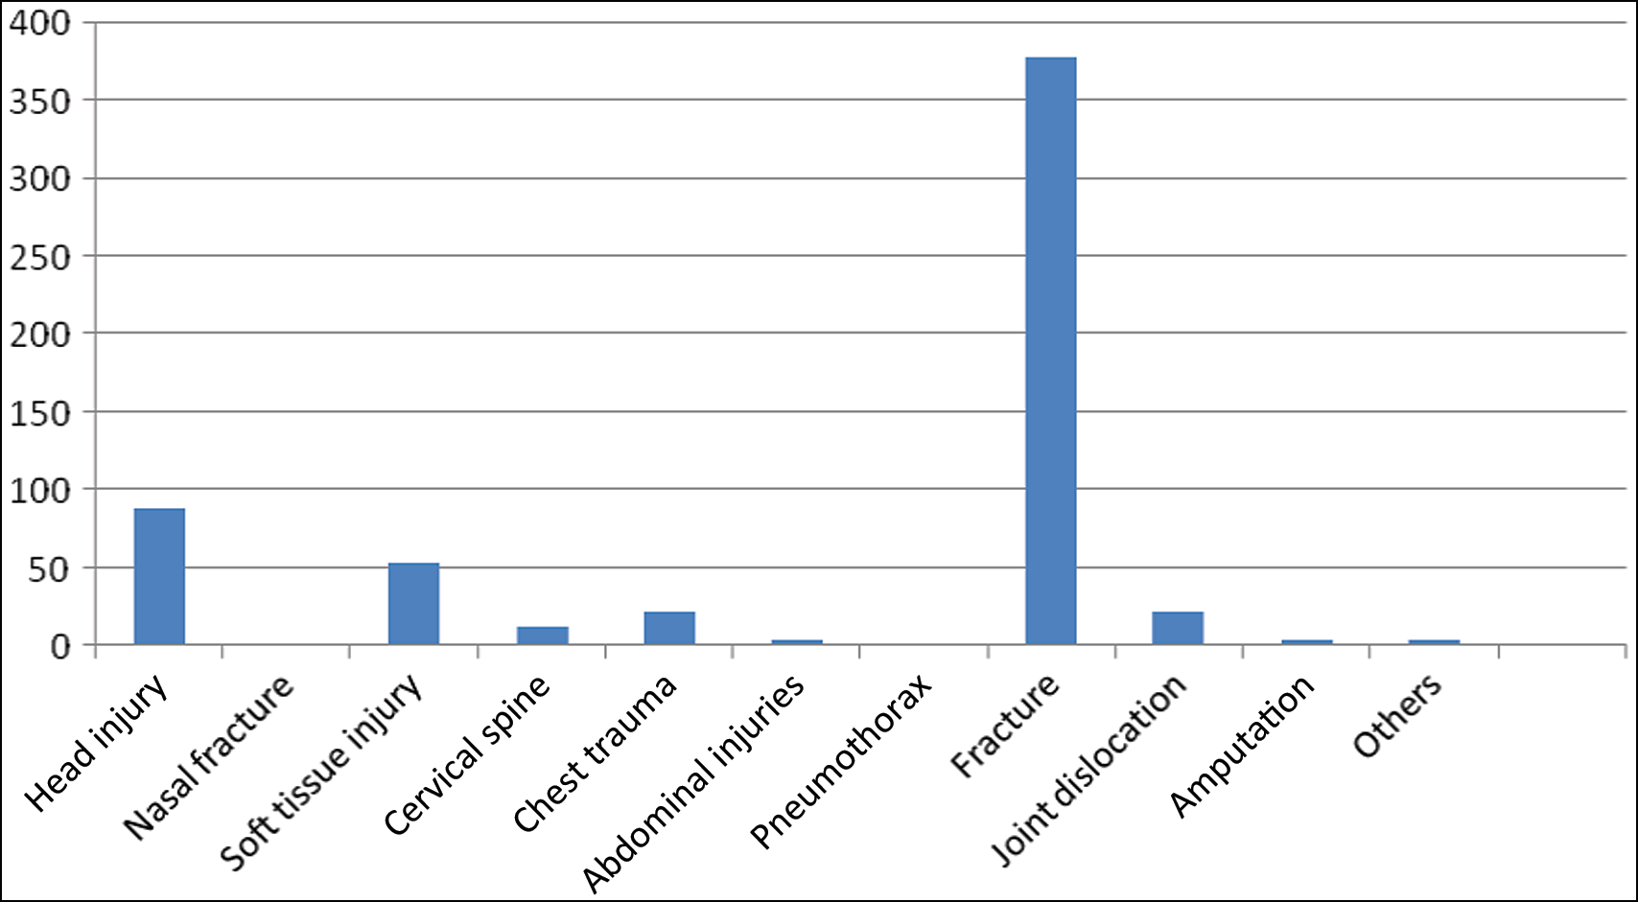

**Figure 2: Distribution of injuries**

Journal of the West African College of Surgeons | Volume 11 | Issue 3 | July-September 2021 15

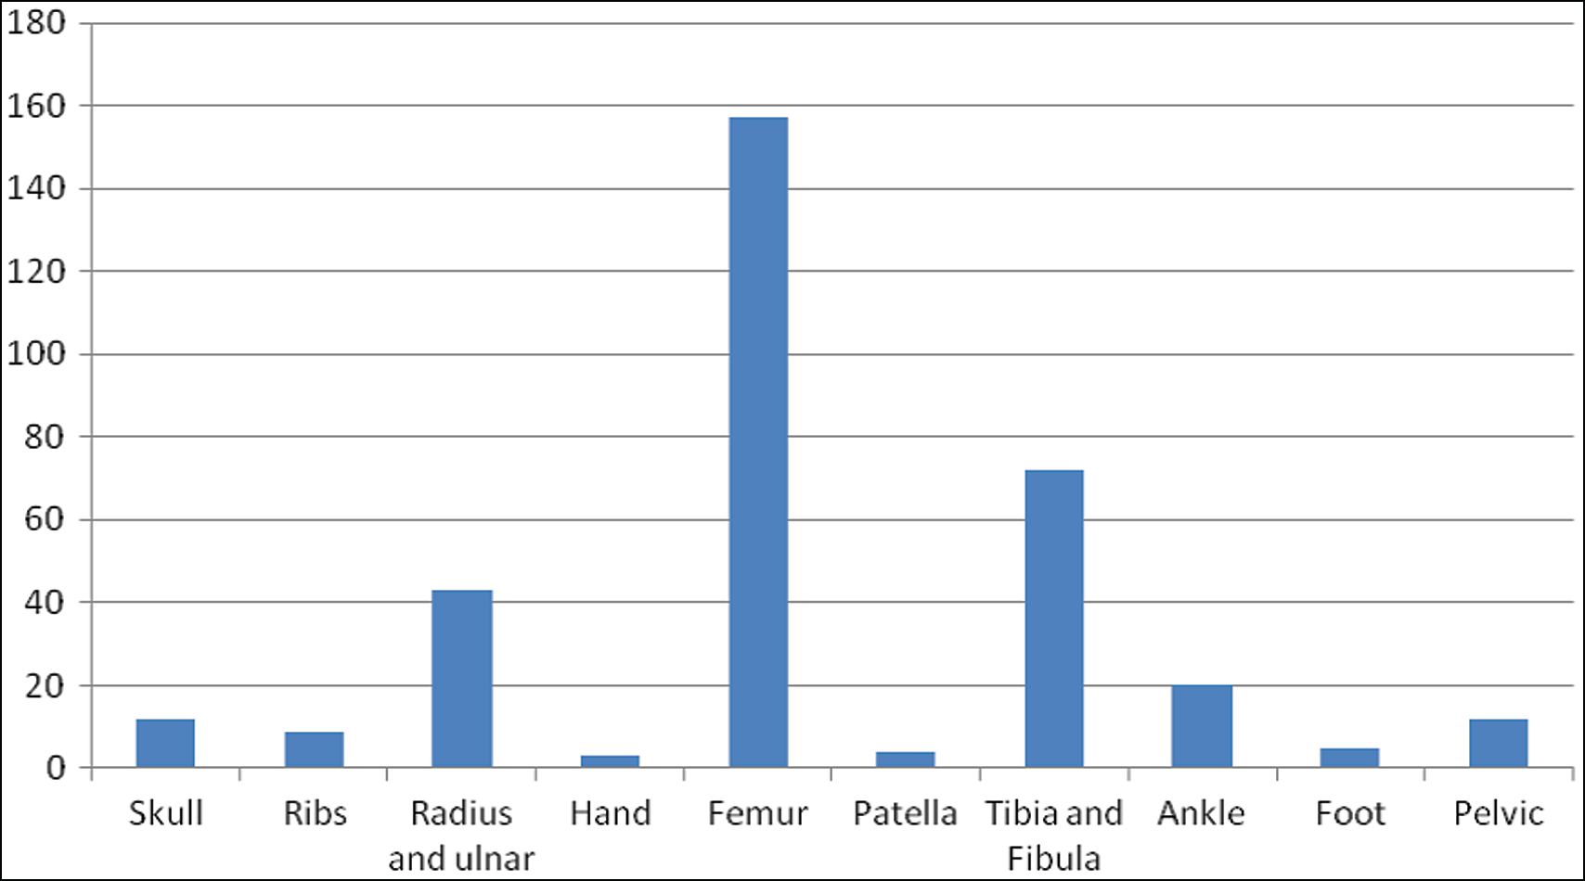

**Figure 3: Fractures (distribution and frequency)**

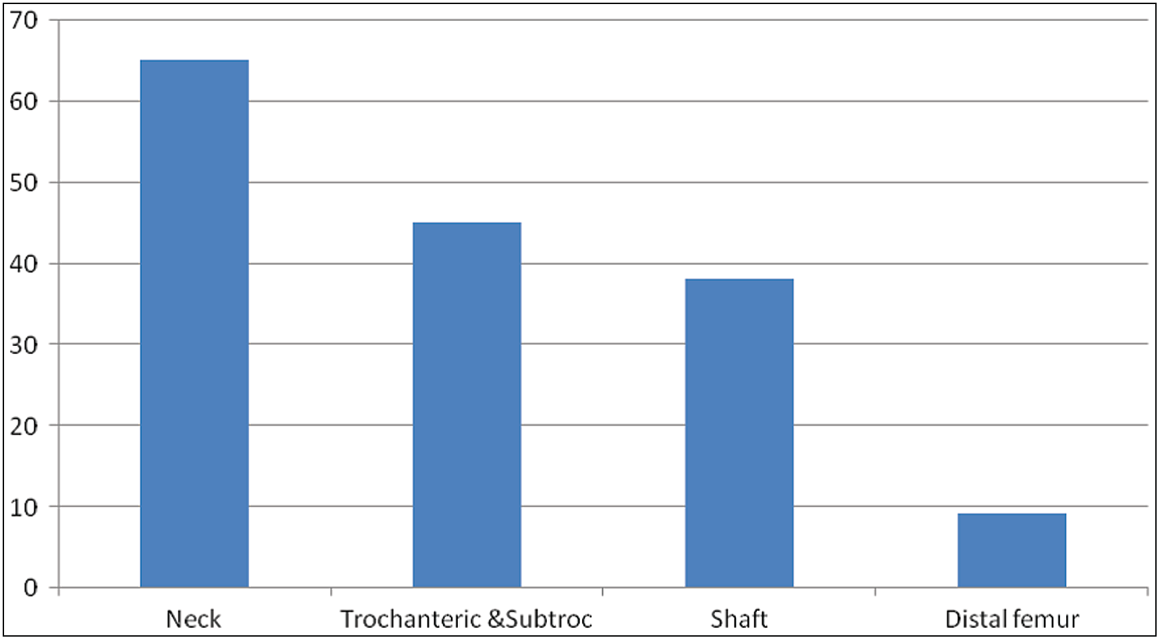

**Figure 4: The distribution of fractures involving the femur (the bone most frequently fractured)**

We observed a mortality of 0.5% in this study. Other studies showed a mortality rate that ranged between 7.6% and 9.0%. The reason for this may be due to the fact that the data reviewed only involved the period these patients spent in the accident and emergency department as they were not followed up during the admission into the specialist wards to further review the outcome.

The risk of inpatient death following trauma has been observed to increase with age, male gender, black race, severity of injury, and the presence of co-morbidity.[29,30]

# Conclusion

Less than 10% of the patients with traumatic injury who presented to the University College Hospital, Ibadan, Nigeria are in the geriatric age group. Most of the traumatic injury involving geriatric patients in our environment is due to low

energy falls, and fracture is the most common injury observed with the femur being the most affected bone. Therefore, interventions directed at reducing the incidence of falls in our environment will hopefully help in reducing the incidence of traumatic injuries in the older persons.

## Financial support and sponsorship

Nil.

## Conflicts of interest

There are no conflicts of interest.

# References

1. Barlow AP, Zarifa Z, Shillito RG, Crumplin MK, Edwards E, McCarthy JM. Surgery in a geriatric population. Ann R Coll Surg Engl 1989;71:110-4.

16 Journal of the West African College of Surgeons | Volume 11 | Issue 3 | July-September 2021

1. United Nations. Department of Economic and Social Affairs, Population Division. World Urbanization Prospects. The 2017 Revision, Highlights (ST/ESA/SER. A/352). 2017.
2. Okhakhu A, Okolugbo N, Onyeaguara N. Pattern of otolaryngological disorders amongst geriatric population in Benin city, Nigeria. Int J Mod Altern Med Res 2013;1:14-9.
3. Luchette FA, Yelon JA, editors. Geriatric Trauma and Critical Care. Cham: Springer; 2017.
4. Frohlich M, Caspers M, Lefering R, Driessen A, Bouillon B, Maegele M, *et al*. Do elderly trauma patients receive the required treatment? Epidemiology and outcome of geriatric trauma patients treated at different levels of trauma care. Eur J Trauma Emerg Surg 2020;46:1463-9.
5. Okoye OG, Olaomi OO, Osi-Ogbu O, Gwaram UA. Pattern of trauma in elderly patients seen at the trauma centre of National Hospital Abuja, Nigeria. Afr J Emerg Med 2021;11:347-51.
6. Coats TJ, Lecky F. “Major trauma”: Now two separate diseases? Emerg Med J 2017;34:494.
7. Gallaher J. Elderly Trauma in Sub-Saharan Africa. 2016. Masters Paper, University of North Carolina.
8. Brooks SE, Peetz AB. Evidence based care of geriatric trauma patients. Surg Clin 2017;97:1157-74.
9. Levy DB, Hanlon DP, Townsend RN. Geriatric trauma. Clin Geriatr Med 1993;9:601-20.
10. Ismail AA, Pye SR, Cockerill WC, Lunt M, Silman AJ, Reeve J, *et al*. Incidence of limb fracture across Europe: Results from the European Prospective Osteoporosis Study (EPOS). Osteoporos Int 2002;13:565-71.
11. Kowe FT, Ademola-Popoola JJ. Geriatric trauma. DOKITA 2016;38.
12. Yoshida-Intern S. A Global Report on Falls Prevention, Epidemiology of Falls. Ageing and Life Course, Family and Community Health. Geneva: WHO. 2007.
13. Berg RL, Cassells JS, editors. Institute of Medicine (US) Division of Health Promotion and Disease Prevention. The Second Fifty Years: Promoting Health and Preventing Disability. Washington, DC: National Academies Press (US); 1992. PMID:25144081.
14. Adams SD, Cotton BA, McGuire MF, Dipasupil E, Podbielski JM, Zaharia A, *et al*. Unique pattern of complications in elderly trauma patients at a level I trauma center. J Trauma Acute Care Surg 2012;72:112-8.
15. Miyoshi Y, Kondo Y, Hirano Y, Ishihara T, Sueyoshi K, Okamoto K, *et al*. Characteristics, injuries, and clinical outcomes of geriatric trauma patients in Japan: An analysis of the Nationwide Trauma Registry Database. Sci Rep 2020;10:19148.
16. McMahon DJ, Schwab CW, Kauder D. Comorbidity and the elderly trauma patient. World J Surg 1996;20:1113-9; discussion 1119-20.
17. Gabell A, Simons MA, Nayak US. Falls in the healthy elderly: Predisposing causes. Ergonomics 1985;28:965-75.
18. Ebrahim S, Kalache A. Epidemiology in Old Age. London: BMJ Publishing Group; 1996. p. 436. ISBN:0727909487.
19. Tinetti ME, Speechley M, Ginter SF. Risk factors for falls among elderly persons living in the community. N Engl J Med 1988;319:1701-7.
20. O’Neill S, Brady RR, Kerssens JJ, Parks RW. Mortality associated with traumatic injuries in the elderly: A population based study. Arch Gerontol Geriatr 2012;54:e426-30.
21. Grossman MD, Miller D, Scaff DW, Arcona S. When is an elder old? Effect of preexisting conditions on mortality in geriatric trauma. J Trauma 2002;52:242-6.
22. Milzman DP, Hinson D, Magnant CM. Overview and outcomes. Crit Care Clin 1993;9:633-56.
23. Adam SH, Eid HO, Barss P, Lunsjo K, Grivna M, Torab FC, *et al*. Epidemiology of geriatric trauma in United Arab Emirates. Arch Gerontol Geriatr 2008;47:377-82.
24. Naharcı Mİ, Doruk H. Approach to fall in elderly population. Türk Sİlahlı Kuvvetlerİ, Koruyucu Hekİmlİk Bültenİ 2009;8:437-44.
25. Joseph A, Kumar D, Bagavandas M. A review of epidemiology of fall among elderly in India. Indian J Community Med 2019;44:166-8.
26. Benedict MOA, Adefuye AO. Profile of geriatric presentations at the emergency department of a rural district hospital in South Africa. Pan Afr Med J 2020;36:245.
27. Tlemissov AS, Dauletyarova MA, Bulegenov TA, Rakhypbekov TK, Grjibovski AM. Epidemiology of geriatric trauma in an urban Kazakhstani setting. Iran J Public Health 2016;45:1411-9.
28. Adebusoye LA, Olowookere OO, Ajayi SA, Akinmoladun VI, Alonge TO. Mortality trends among older patients admitted to the geriatric centre, University College Hospital, Ibadan, Nigeria, 2013- 2017. West Afr J Med 2020;37:209-15.
29. Rzepka SG, Malangoni MA, Rimm AA. Geriatric trauma hospitalization in the United States: A population-based study. J Clin Epidemiol 2001;54:627-33.

Journal of the West African College of Surgeons | Volume 11 | Issue 3 | July-September 2021 17