**Original Article**

Fractures of the Mandible: Epidemiological Study of 519 Nigerian Cases

**Rowland Agbara1, Benjamin Fomete2, Kelvin Uchenna Omeje3**

**Abstract**

**Background:** Epidemiological studies despite their limitations provide information that is useful for the formulation of effective and efficient injury prevention strategies. **Aim:** The aim is to carry out epidemiology study of mandibular fracture in a Nigerian population. **Setting:** Department of Oral and Maxillofacial Surgery, Ahmadu Bello University Teaching Hospital, Shika-Zaria, Nigeria. **Materials and Methods:** A retrospective observational study was carried out at the Ahmadu Bello University Teaching Hospital, Shika-Zaria. Data retrieved from patients’ case notes and operating records were subjected to statistical analysis involving frequencies (count, percent), measures of central tendency (mean), and measures of dispersion (standard deviation) using Statistical Package for Social Sciences (SPSS) version 16 (SPSS Inc., Chicago, IL). Mandibular fracture was classified based on sites, and patients’ socioeconomic status was classified based on United Kingdom National Statistics Socio-economic Classification (NS- SEC, 2010). **Results:** There were 466 (89.9%) males and 53 (10.1%) females. Based on Socio-economic Classification (NS-SEC, 2010), there was a preponderance of analytical class 6 (*n* = 217; 54.9%) and 8 (*n* = 127; 32.2%). Road traffic–related accident (*n* = 385; 74.2%) was the most common aetiological factor, and a total of 215 (41.4%) patients had a record of loss of consciousness. The mandibular body (*n* = 225; 32.0%) followed by the parasymphyseal (*n* = 187; 26.6%) regions were the most fractured sites. Closed-reduction technique was the predominant treatment modality. **Conclusions:** A road traffic accident was the most common aetiological factor for mandibular fracture, and the mandibular body had the highest frequency of fractures. Measures aimed at injury prevention should be continually reviewed and updated to limit the morbidity and economic burden on individuals.

**Keywords:** *Male, mandible, traffic accidents, trauma, treatment*

*1Department of Oral/ Maxillofacial Surgery, Faculty of Dental Sciences, University of Jos, Plateau State, 2Oral and Maxillofacial Surgery Department, Ahmadu Bello University Teaching Hospital,*

*Shika-Zaria, Kaduna State, 3Oral and Maxillofacial Surgery Unit, Dental and Maxillofacial Surgery Department, Aminu Kano Teaching Hospital, Kano State, Nigeria*

# Introduction

The facial skeleton develops from the first branchial arches and contributes significantly to function and aesthetics. In addition, it provides protection to vital structures such as the eyes and brain. The disruption of this skeleton may be associated with functional and aesthetic problems.

For ease of description, the facial skeleton is divided into three parts: upper, middle, and lower thirds.[1] The lower-third is formed by

with geographical location attributable to sociocultural factors, enforcement of safety regulations, amongst other factors.[1,3] Similarly, the fracture pattern of the mandible is influenced by factors such as age, type and direction of force, presence/absence of teeth, and osseous disease process amongst other factors. The clinical presentation of mandibular fractures includes pain, sublingual ecchymosis, step deformity, abnormal mobility, malocclusion, and limited mouth opening. Factors such as age, site of fracture, level of

**Received:** 13-Jan-2022 **Accepted:** 11-Apr-2022 **Published:** 29-Jul-2022

the mandible and consists of a tooth and a

consciousness, and degree of displacement

nontooth bearing portion. Fractures of the mandible have been variously classified based on factors such as basal bone involvement, site, tooth in fracture line, and the complexity of the fracture.[2]

Mandibular fractures may arise from different aetiologies, and these include road traffic crashes, sports, assault, and falls. The predominant aetiological factors vary

This is an open access journal, and articles are distributed under the terms of the Creative Commons Attribution-NonCommercial- ShareAlike 4.0 License, which allows others to remix, tweak, and build upon the work non-commercially, as long as appropriate credit is given and the new creations are licensed under the identical terms.

**For reprints contact:** [reprints@medknow.com](mailto:reprints@medknow.com)

influence these presentations.[1]

Imaging techniques allow for a more detailed analysis of fracture sites and guide in treatment planning. Techniques available include plain radiography (intraoral and extraoral), ultrasonography, computed tomography (CT), and magnetic resonance imaging (MRI).[4] These techniques have different sensitivity in the diagnosis of mandibular fracture, and their use is influenced by cost, age, availability, patients’ cooperation, and site of the fracture.

**How to cite this article:** Agbara R, Fomete B, Omeje KU. Fractures of the mandible: Epidemiological study of 519 Nigerian cases. J West Afr Coll Surg 2021;11:26-32.

***Address for correspondence:*** *Dr. Rowland Agbara, Department of Oral and Maxillofacial Surgery, Faculty of Dental Sciences, University of Jos, Jos, Plateau State, Nigeria. E-mail:* [*row_prof@yahoo.com*](mailto:row_prof@yahoo.com)

|  |
| --- |
| **Access this article online** |
| **Website:**  [www.jwacs-jcoac.org](http://www.jwacs-jcoac.org/) |
| **DOI:** 10.4103/jwas.jwas_10_22 |
| **Quick Response Code:** |

26 © 2022 Journal of the West African College of Surgeons | Published by Wolters Kluwer ‑ Medknow

Both operative and nonoperative techniques are acceptable treatment options for mandibular fracture, and the preferred treatment option may be guided by age, type and site of fractures, comorbid conditions, severity, cost, and skill.[5] The optimum aim of a treatment is to restore patient back to pretrauma aesthetics and function.

Epidemiological studies may be limited in terms of generalisability, but they provide information that is useful for the formulation of effective and efficient injury prevention strategies within the available limited resources. Researchers earlier showed that factors such as car design, speed limit, and substance abuse are important in the event of trauma, and this led to changes in car design, enforcement of speed limit, helmet and seat belt use, and the regulation of alcohol and other substance usage amongst individuals while driving all in a bid to reduce road traffic–related crashes and injuries. Despite the availability of some data on mandibular fractures, studies with relatively large sample size are few especially from northern Nigeria. This study seeks to provide some information necessary for the comparison of epidemiological data by researchers globally, and that will guide policy makers to review and plan evidence-based preventive measures targeted at preventing mandibular fractures within a population.

# Materials and Methods

This is a retrospective observational study of patients presenting with mandibular fractures at the Department of Oral and Maxillofacial Surgery, Ahmadu Bello University Teaching Hospital (ABUTH), Shika-Zaria, from August 1999 to June 2021. This department has been a foremost maxillofacial surgery centre in the country and received referrals from all regions of the country. Patients who were brought into the hospital dead and those who had a treatment for mandibular fracture outside the hospital but presented for follow-up were excluded. There were no previously treated mandibular fractures seen within the study period that were included in the data collected. The study was approved by the institutional research board with approval number ABUTH/HREC/CL/05. Mandibular fracture was classified based on sites according to Dingman and Natvig.[2] The social status of patients was classified based on the United Kingdom National Statistics Socio-economic Classification (NS-SEC, 2010), whereas time interval between trauma and maxillofacial surgery consultation was classified as early (7 days and below) and late (8 days and above). Paediatric and elderly age groups were defined as less than 17 years and 60 and above years, respectively. Information sourced from patients’ case notes and operating records included age, sex, aetiology, presentation, investigation, concomitant injuries, treatment, and complications. This was subjected to statistical analysis involving frequencies (count, percent), measures of central tendency (mean), and measures of dispersion (standard deviation) using Statistical Package for Social Sciences (SPSS) version 16 (SPSS Inc., Chicago, IL). A *P* value < 0.05 was considered significant. Descriptive statistical output was represented in the form of tables and charts.

# Results

A total of 519 patients was presented with mandibular fractures within the period studied. Of these, 77 (14.8%) occurred in the paediatric group, 15 (3.0%) cases in the elderly, whereas the remaining 427 (82.3%) cases occurred in individuals between these two age groups. There were 466 (89.9%) males and 53 (10.1%) females, giving a male to female ratio of 8.8:1. Patients’ ages ranged from 1 to 80 years with a mean age of 29.0 ± 13.0 years. The 20–29 (*n* = 176; 33.9%) and the 30–39

(*n* = 129; 24.9%) year age groups had the highest frequency of mandibular fracture [Figure 1].

Marital status was documented in 442 (57.7%) patients, and of these, 63.4% (*n* = 185) were married, whereas 36.4% (*n* = 107) were single. The analysis of the social status of the 442 adult patients based on the United Kingdom National Statistics Socio-economic Classification (NS-SEC, 2010) showed a preponderance of analytical class 6 (*n* = 217; 54.9%) and 8 (*n* = 127; 32.2%). The family life cycle of the adult single and married patients based on Duvall[6] family development theory could not be effectively classified because of limited information.

Road traffic–related accident (*n* = 385; 74.2%) was the most frequent aetiological factor for mandibular fracture [Figure 2] and consisted of the following: motorcycle (*n* = 196; 50.9%), motor vehicular (*n* = 107; 27.8%), pedestrian (*n* = 40; 10.4%),

bicycle (*n* = 9; 2.3%), and unspecified (*n* = 33; 8.6%). Male gender predominated in all the aetiological factors, and this was statistically significant (*P* = 0.000).

The time interval between trauma and presentation to the hospital in 389 patients ranged from 1 to 8640 hours with a median time of 48.0 hours. About 84.1% (*n* = 327) of the patients presented early. There was no statistical relationship between the type of associated injury and timing of presentation (*P* = 0.54). Comorbid diseases were present in only eight patients (diabetes mellitus = 1, retroviral disease = 2, hypertension = 2, epilepsy = 2, diabetes mellitus/hypertension = 1).

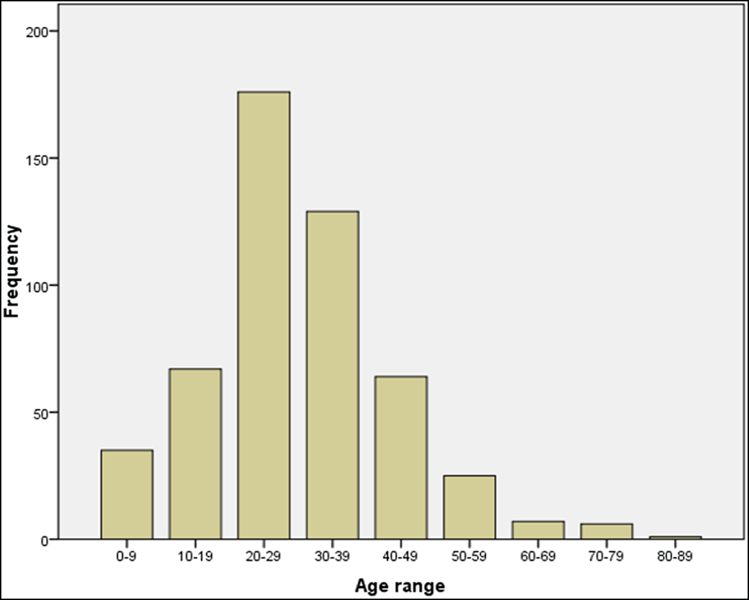

**Figure 1: Age distribution of patients with mandibular fracture**

Journal of the West African College of Surgeons | Volume 11 | Issue 4 | October-December 2021 27

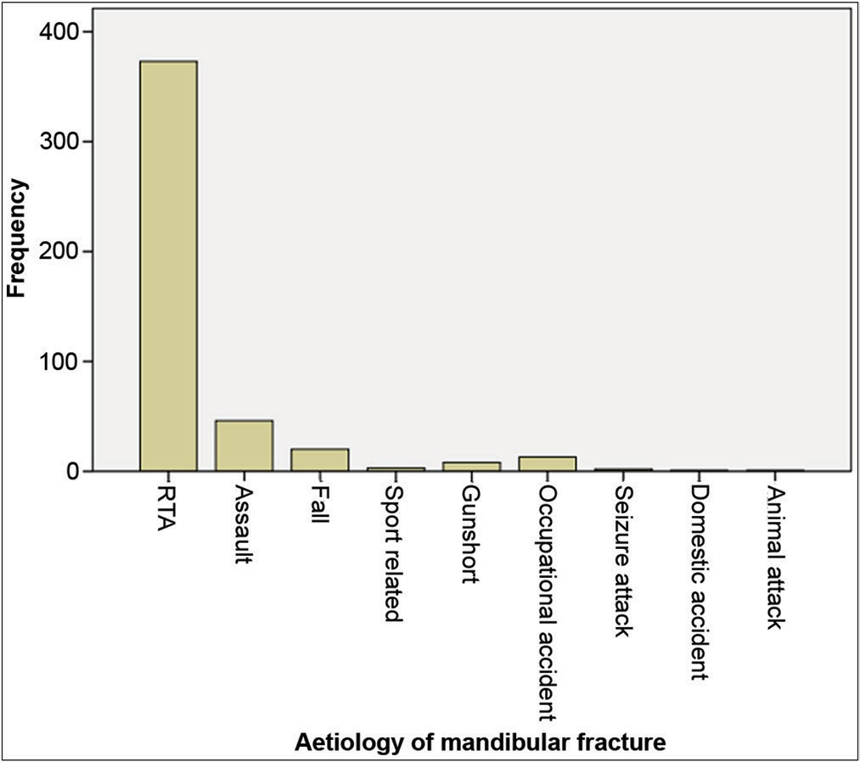

**Figure 2: Aetiology of mandibular fracture. RTA = road traffic accident**

## Table 1: Distribution of mandibular fractures based on sites

**Table 2: Distribution of mandibular fracture based on isolated and combined patterns**

**Mandibular fracture site Frequency**

|  |  |
| --- | --- |
| Para + body | 40 (7.7%) |
| Symp + angle + condyl | 2 (0.4%) |
| Body | 120 (23.1%) |
| Body + condyl | 8 (1.5%) |
| Symp + parasym | 4 (0.8%) |
| Symp | 36 (6.9%) |
| Parasym | 91 (17.5%) |
| Symp + body | 11 (2.1%) |
| Symp + dento | 9 (1.7%) |
| Body + angle | 27 (5.2%) |
| Angle | 18 (3.5%) |
| Parasym + dento | 5 (1.0%) |
| Parasym + condyl | 10 (1.9%) |
| Symp + condyl | 15 (2.9%) |
| Symp + body | 1 (0.2%) |
| Dento | 35 (6.7%) |
| Symp + parasym + dento | 1 (0.2%) |
| Body + dento | 11 (2.1%) |
| Parasym + angle | 21 (4.0%) |
| Angle + dento | 1 (0.2%) |
| Parasym + body + dento | 3 (0.6%) |
| Para + body + ramus | 1 (0.2%) |
| Symp + para + body | 1 (0.2%) |
| Condyl | 6 (1.2%) |
| Symp + condyl + dento | 1 (0.2%) |
| Symp + parasym + angle | 1 (0.2%) |
| Parasym + angle + dento | 1 (0.2%) |
| Symp + angle | 9 (1.7%) |
| Ramus | 1 (0.2%) |
| Parasym + body + condyl | 1 (0.2%) |
| Body + angle + dento | 1 (0.2%) |
| Parasym + body + angle | 1 (0.2%) |
| Parasym + body + coron | 1 (0.2%) |
| Ramus + coron | 1 (0.2%) |
| Angle + ramus | 1 (0.2%) |
| Symp + angle + condyl | 1 (0.2%) |
| Angle + condyl | 1 (0.2%) |
| Unspecified | 21 (4.0%) |
| Total | 519 (100%) |

There were 704 mandibular fractures sustained by 498 patients, and this consisted of 695 (98.7%) noncomminuted and nine (1.3%) comminuted fractures. In the remaining 21 (4.0%), the site was not specified. Malunited fractures accounted for 3.1% (*n* = 29) of cases. The mandibular body (*n* = 225; 32.0%) followed by the parasymphyseal (*n* = 187; 26.6%) regions were the most fractured sites [Table 1]. Body fractures were most often associated with parasymphyseal and angle fractures in 8.0% and 5.4% of cases, respectively, whereas parasymphyseal fractures show frequent association with angle fractures in 4.2% of cases [Table 2]. Symphyseal fracture showed more frequent association with condylar fracture (3.0%), whereas

|  |  |
| --- | --- |
| **Mandibular fracture sites** | **Frequency** |
| Symphyseal | 86 (12.2%) |
| Parasymphyseal—left | 92 (13.1%) |
| Parasymphyseal—right | 81 (11.5%) |
| Bilateral parasymphyseal | 14 (2.0%) |
| Body—left | 84 (12.0%) |
| Body—right | 85 (12.1%) |
| Body—bilateral | 56 (8.0%) |
| Angle—left | 34 (4.8%) |
| Angle—right | 48 (6.8%) |
| Bilateral angle | 3 (0.4%) |
| Ramus—left | 4 (0.6%) |
| Ramus—right | 1 (0.1%) |
| Coronoid—left | 2 (0.3%) |
| Condyle—left | 20 (2.8%) |
| Condyle—right | 13 (1.8%) |
| Bilateral condyle | 12 (1.7%) |
| Dentoalveolar—left | 14 (2.0%) |
| Dentoalveolar—right | 7 (1.0%) |
| Bilateral dentoalveolar | 44 (6.3%) |
| Dentoalveolar (unspecified) | 4 (0.6%) |
| Total | 704 (100%) |

Condyl = condyle, coron = coronoid, dento = dentoalveolar, para = parasym, parasym = parasymphyseal, symp = symphyseal

parasymphyseal fracture was the second most associated fracture with condylar fracture (2.0). Of the 519 patients analysed, unilateral (*n* = 191; 36.8%) fractures were slightly higher than bilateral (*n* = 182; 35.1%) fractures [Table 3]. Male gender dominated in all sites of mandibular fracture, but this was not statistically significant (*P* = 0.008).

Patients sustained 648 associated nonmandibular injuries consisting of hard- (*n* = 549; 84.7%) and soft-tissue (*n* = 99; 15.3%) injuries. Zygomatic complex (*n* = 162; 25.0%) and Le Forte 2 fractures (*n* = 105; 16.2%) were the most frequent hard tissue injuries, whereas the lip (*n* = 17; 2.6%), frontal (*n* = 16; 2.5%), and cheek (*n* = 13; 2.0%) regions accounted for the most soft-tissue injuries [Table 4]. Zygomatic complex

28 Journal of the West African College of Surgeons | Volume 11 | Issue 4 | October-December 2021

## Table 3: Mandibular fracture distribution based on sides

**Mandibular side Frequency**

|  |  |
| --- | --- |
| Left | 94 (18.1%) |
| Right | 97 (18.7%) |
| Bilateral | 182 (35.1%) |
| Midline | 39 (7.5%) |
| Midline/left | 19 (3.7%) |
| Midline/right | 11 (2.1%) |
| Midline/left/right | 12 (2.3%) |
| Unspecified | 65 (12.5%) |
| Total | 519 (100%) |

fracture was most often associated with mandibular body (*n* = 46; 31.5%) and parasymphyseal fractures (*n* = 36; 25.9%).

The anaesthetic techniques used were local anaesthesia (*n* = 32; 7.5%), local anaesthesia plus conscious sedation (*n* = 141; 33.3%), and general anaesthesia (*n* = 193; 45.5%) [Figure 3]. Anaesthetic technique was not documented in the remaining 49 (11.8%). The treatment was administered to 415 (80.0%) patients, whereas 104 (20.0%) patients had no treatment given and the commonest reason was discharged against medical advice. However, the reason was unspecified in 56 (10.8%) patients. Closed-reduction technique was the preferred treatment option [Table 5] by surgeons.

The period of hospital stay ranged from 1 to 94 days with a mean of 18.0 days. Follow-up review notes in these patients were available in only 23 (5.5%) of the 415 patients treated, and the frequent complications noted were malocclusion and delayed fracture healing [Table 6]. Although more males than females presented with complications, this was not statistically significant (*P* = 0.413). Similarly, there was no statistically significant relationship between complication and mandibular fracture pattern (single versus multiple) (*P* = 0.151).

# Discussion

In agreement with earlier studies,[7-10] mandibular fracture occurred more frequently in individuals who are in the third and fourth decades of life. This is typically the active age group with respect to schooling, work, business engagement, and social life. These activities require mobility and thus predispose them to the danger of road traffic–related accidents especially where road traffic rules are poorly enforced, roads are poorly maintained, and inefficient public transport system exists. However, assault was reported as the predominant aetiological factor in these age groups by some previous researchers.[9,11] These differences may be due to cultural and religious factors in this environment that frowns against alcohol consumption. Moreover, most young adults in this environment live with their parents for a considerable period and thus still have some measures of parental control. The increasing rate of cultism, terrorism, and substance abuse may lead to an upsurge in a number of cases from assault in future studies. Similarly, as suggested by Abotaleb *et al.*,[3] other considerations such as health insurance payment policy

## Table 4: Associated injuries occurring with mandibular fractures

**Associated injuries Frequency**

Hard tissue (craniofacial)

|  |  |
| --- | --- |
| Orbital blow-out | 5 (0.8%) |
| Frontal bone fracture | 1 (0.2%) |
| Nasal complex | 29 (4.5%) |
| Isolated nasal fracture | 3 (0.5%) |
| Le Fort I | 44 (6.8%) |
| Le Fort II | 105 (16.2%) |
| Le Fort III | 13 (2.0%) |
| Zygomatic arch fracture | 7 (1.1%) |
| Zygomatic complex fracture | 162 (25%) |
| Maxillary dentoalveolar fracture | 66 (10.2%) |
| Palatal fracture | 61 (9.4%) |
| Temporal bone fracture | 1 (0.2%) |
| Parietal bone fracture | 2 (0.3%) |

Hard tissue (others)

|  |  |
| --- | --- |
| Clavicular fracture | 5 (0.8%) |
| Femoral fracture | 8 (1.2%) |
| Radial bone fracture | 6 (0.9%) |
| Ulnar bone fracture | 5 (0.8%) |
| Ischiopubic fracture | 2 (0.3%) |
| Tibia fracture | 8 (1.2%) |
| Fibular fracture | 4 (0.6%) |
| Humeral fracture | 2 (0.3%) |
| Rib fracture | 4 (0.6%) |
| Metacarpal fracture | 1 (0.2%) |
| Hip dislocation | 1 (0.2%) |
| Phalangeal fracture | 1 (0.2%) |
| Metatarsal fracture | 1 (0.2%) |
| Clavicular dislocation | 1 (0.2%) |
| Lateral malleolar fracture | 1 (0.2%) |

Soft tissue

|  |  |
| --- | --- |
| Nose | 8 (1.2%) |
| Cheek | 13 (2.0%) |
| Mentum | 7 (1.1%) |
| Frontal | 16 (2.5%) |
| Lower lip | 14 (2.2%) |
| Upper lip | 3 (0.5%) |
| Scalp | 11 (1.7%) |
| Submental | 2 (0.3%) |
| Tongue | 1 (0.2%) |

Others

|  |  |
| --- | --- |
| Globe rupture | 6 (0.9%) |
| Facial nerve palsy | 11 (1.7%) |
| Epidural haematoma | 2 (0.3%) |
| Epicranial haematoma | 1 (0.2%) |
| Occulomotor nerve palsy | 1 (0.2%) |
| Pneumothorax | 1 (0.2%) |
| Avulsed Achilles tendon | 1 (0.2%) |
| Traumatic testicular amputation | 1 (0.2%) |
| Total | 648 (100%) |

may influence the documentation of aetiological factors in some environments.

A preponderance of mandibular fractures in the male gender is consistent with previous findings. However, a male to female

Journal of the West African College of Surgeons | Volume 11 | Issue 4 | October-December 2021 29

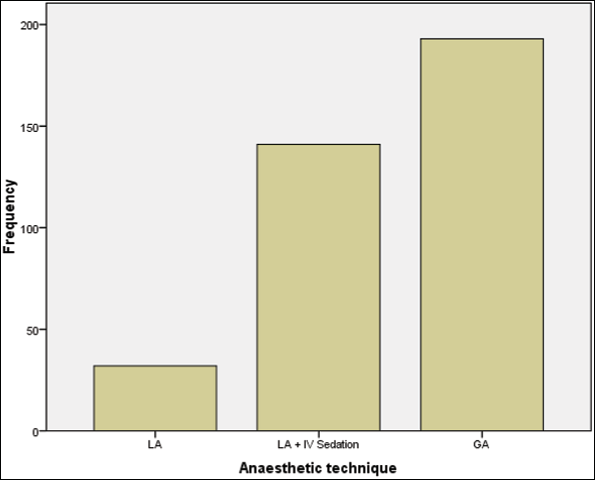

**Figure 3: Anaesthetic technique used in the treatment of mandibular fracture. GA = general anesthesia, LA = local anesthesia, LA + IV sedation**

**= local anesthesia + intravenous sedation**

|  |  |  |
| --- | --- | --- |
|  | **Table 5: Treatment modalities used** |  |
| **Treatment** |  | **Frequency** |
| CRF |  | 356 (85.8%) |
| ORIF wire |  | 32 (7.7%) |
| Conservative |  | 13 (3.1%) |
| ORIF plate |  | 7 (1.7%) |
| Splinting |  | 7 (1.7%) |
| Total |  | 415 (100%) |

CRF = closed reduction and fixation

## Table 6: Complications noted in the treatment of mandibular fractures

|  |  |
| --- | --- |
| **Complication** | **Frequency** |
| Hypertrophic scar | 1 (4.3%) |
| Malocclusion | 6 (26.1%) |
| Marginal mandibular nerve palsy | 1 (4.3%) |
| Infection of incision line | 1 (4.3%) |
| Limited mouth opening | 5 (21.7%) |
| Delayed fracture healing | 6 (26.1%) |
| Limited mouth opening | 1 (4.3%) |
| Infected fracture | 1 (4.3%) |
| Tooth loss | 1 (4.3%) |
| Total | 23 (100%) |

ratio of 8.8:1 recorded is higher than report from previous studies including those with larger sample population.[7,9-11] The female gender is generally restricted to indoor life style in this environment as a result of religious and cultural beliefs. Even when outdoor, they are less likely to use transport means such as motorcycle (which accounted for 52.5% of injuries) because of these beliefs.

The family life cycle stage (which may impose greater financial responsibility) and the socioeconomic status of the individuals can have a significant effect on the treatment affordability

and family comfort. The socioeconomic status of the patients based on the United Kingdom National Statistics Socio- economic Classification (NS-SEC, 2010) revealed mostly a disadvantaged analytical class. The gross national income per capita of Nigeria for 2020 was 2000 United State Dollars (USD).[12] The average cost of fixing a unilateral mandibular fracture using closed-reduction and open-reduction and internal fixation (ORIF) technique under local anaesthesia in a public health institution in this region is about 105.7 and 283 USD (excluding cost of investigations, admission, medications, feeding, etc), respectively. Under general anaesthesia, the cost is about 226.4 and 471.7 USD (based on the current exchange rate of 530 naira to a dollar at the parallel market), respectively. This shows the enormous financial burden they bear in receiving the treatment for their injuries. This may impact not only on their treatment but also on their ability to cater for their basic and family needs. This is further worsened by the low coverage of the national health insurance scheme resulting in out-of-pocket payment.

A loss of consciousness with mandibular fracture could not be analysed because of a paucity of information. A prevalence rate of 17.6% was reported by Hung *et al.*[13] However, a higher prevalence rate has been reported by other studies.[14,15] The difficulty in determining a loss of consciousness in a patient (especially where recovery occurs before arriving at the hospital) may account for variations. The mandibular body and parasymphyseal regions were the most frequently fractured sites when mandibular fracture occurred with a loss of consciousness.[13,14]

A prevalence rate of 15.9% in delayed presentation (8 days and above) was noted in this study, and this is similar to a prevalence rate of 16.6% in delayed facial fracture presentation previously reported.[16] However, a higher delayed presentation rate of 42.5%[17] and 41.2%[18] has been reported. Late presentation following mandibular fracture is influenced by several factors including late or nonrecognition by nonspecialist doctors, the ability of patient to maintain function such as chewing, the presence of associated injuries, financial limitations and distance to the nearest specialist health facility. Early presentation allows for early treatment, which may improve patients’ feeding (and overall nutritional status) and possible use of local anaesthesia in some fractures, which are still mobile (as opposed to general anaesthesia when refracturing is indicated) and reduce the hospital stay and cost of treatment.

The diagnosis of mandibular fracture usually follows clinical and radiological examination. The radiological techniques available include ultrasonography, plain radiography, CT, and MRI. CT scan is the gold standard because of its sensitivity which is about 100%.[4,19] Thus, unsuspected craniofacial fractures can be identified. Moreover, craniocervical CT scan allows for the identification of traumatic brain injury, which has been found to be present in 69% of patients with mandibular fracture (moderate to severe in 14%–34% of cases).[20] The nonidentification of traumatic brain injury may be associated

30 Journal of the West African College of Surgeons | Volume 11 | Issue 4 | October-December 2021

with increased morbidity and mortality. However, because of cost and radiation exposure, the use of the Canadian CT Head Rule, New Orleans Criteria, and S100 protein estimation allows for patient selection for CT imaging.[21] The low use of CT scan in this study may be related to its cost and to its nonavailability prior to 2005 in the study facility.

Similar to previous studies,[22,23] the mandibular body was the most frequently fractured site. Studies have reported different sites of the mandible as the most common fractured site. These include angle,[9,13] parasymphysis,[7,14,20] symphysis,[3,11] and condyle.[8,10] From these and other numerous studies, it can be deduced that the commonest site fractured is influenced by several factors such as age and sex of the study population, aetiology, and imaging technique used. Abotaleb *et al.*[3] reported a significant association between the presence of third molar and angle fracture, whereas van den Bergh *et al.*[22] reported a stronger association between angle fracture and female gender. This present study found no association between gender and fracture site/pattern.

Generally, mandibular fracture may occur in isolation or in combination with other injuries. Zygomatic complex fracture was the most frequently associated craniofacial fracture noted, and this is in agreement with previous studies.[3,7,10] However,a prevalence rate of 25% associated zygomatic complex fracture in this study is lower than 32%, 34%, and 40.6% reported by these studies, respectively.[3,7,10] The finding of the frequent occurrence of zygomatic complex fracture with mandibular body and parasymphyseal fractures should alert the clinician to check these sites during clinical examination.

Local anaesthetic technique alone or in combination with conscious sedation was used considerably in the treatment of mandibular fracture. This technique has been used in the management of fractures involving both the tooth and nontooth bearing portions of the mandible in well-selected patients.[24,25] It reduces the need for the operating theatre space (because it can be done in the clinic), admission space, and the duration of hospital stay. This translates to the reduced treatment cost for the patient. However, monitoring and resuscitative equipment should be available in the clinic especially when treating combined mandibular and certain midfacial fractures under local anaesthesia in which oculocardiac reflex may occur as previously experienced by the first and second authors under a different setting.

In this study, closed reduction was the most frequently used technique. This is contrary to previous studies[3,7,10,22] in which ORIF was the predominant technique used. Although closed-reduction technique with intermaxillary fixation is not recommended in certain individuals such as those with seizure disorder, ventilatory dysfunction, mental diseases,[26] it has been shown to offer similar outcome in occlusion and fewer complications rate when compared with ORIF in a systematic review.[27] The high use of closed-reduction technique in the present study may be due to its lower cost, operating theatre space constraint, and the nonavailability of plate osteosynthesis prior to year 2015 in the study centre.

Malocclusion and delayed fracture healing accounted for most complications noted in this study. Malocclusion and infection were reported as the commonest complications by earlier studies.[3,7] These complications were noted more frequently in smokers and those consuming alcohol, with systemic disease, with multiple mandibular fractures and who had closed-reduction technique.[3] The present study found no significant association between fracture pattern and complication rate.

Being a retrospective study, missing data could have impacted on the results. Similarly, the low use of CT may have impacted on mandibular fracture pattern and concomitant injuries (especially craniocerebral) documented. Finally, complications noted during follow-up review may not be the true picture because only a few numbers of patients presented for follow- up review. However, the large volume of mandibular fracture patients studied is one of the few from northern Nigeria, and this is useful for both researchers and policy makers.

# Conclusion

Road traffic crashes have continually contributed significantly in mandibular fracture aetiology. The body and parasymphyseal regions appear to be the commonest sites affected. Measures aimed at injury prevention should be continually reviewed and updated to limit the morbidity and economic burden on individuals.

## Financial support and sponsorship

Nil.

## Conflicts of interest

There are no conflicts of interest.

# References

1. Bank P, Brown A. Fractures of the Facial Skeleton. 1st ed. Bristol: Wright; 2001. p. 17-34.
2. Passi D, Malkunje L, Atri M, Chahal D, Singh TK, Goyal J. Newer proposed classification of mandibular fractures: A critical review with recent updates. Ann Med Health Sci Res 2017;7: 314-8.
3. Abotaleb BM, Al-Moraissi E, Zhiqiang W, Ping C, Yongjie K, Alkebsi K, *et al*. A detailed analysis of mandibular fractures epidemiology, treatment and outcomes: A 5-year retrospective study, Gansu Province-China. J Oral Maxillofac Surg Med Pathol 2018;30:197-205.
4. Naeem A, Gemal H, Reed D. Imaging in traumatic mandibular fractures. Quant Imaging Med Surg 2017;7:469-79.
5. Smith DM, Bykowski MR, Cray JJ, Naran S, Rottgers SA, Shakir S, *et al*. Mandible fractures in 120 children: Demographics, treatment, outcomes, and early growth data. Plast Reconstr Surg 2013;131:1348-58.
6. Duvall EM. Family development’s first forty years. Family Relations 1988;37:127-34.
7. Eskitaşcıoğlu T, Ozyazgan I, Coruh A, Günay GK, Yontar Y, Altıparmak M. Fractures of the mandible: A 20-year retrospective analysis of 753 patients. Ulus Travma Acil Cerrahi Derg 2013;19:348-56.

Journal of the West African College of Surgeons | Volume 11 | Issue 4 | October-December 2021 31

1. Zix JA, Schaller B, Lieger O, Saulacic N, Thorén H, Iizuka T. Incidence, aetiology and pattern of mandibular fractures in central Switzerland. Swiss Med Wkly 2011;141:13207.
2. Morris C, Bebeau NP, Brockhoff H, Tandon R, Tiwana P. Mandibular fractures: An analysis of the epidemiology and patterns of injury in 4,143 fractures. J Oral Maxillofac Surg 2015;73:951. e1-951.e12.
3. Chrcanovic BR, Abreu MH, Freire-Maia B, Souza LN. 1,454 mandibular fractures: A 3-year study in a hospital in Belo Horizonte, Brazil. J Craniomaxillofac Surg 2012;40:116-23.
4. Afrooz PN, Bykowski MR, James IB, Daniali LN, Clavijo- Alvarez JA. The epidemiology of mandibular fractures in the United States, part 1: A review of 13,142 cases from the US national trauma data bank. J Oral Maxillofac Surg 2015;73:2361-6.
5. World Bank national accounts data, and OECD National Accounts data files. Available from: https://data.worldbank.org/indicator/ NY.GNP.PCAP.CD. [Last accessed on Sep 5, 2021].
6. Hung YC, Montazem A, Costello MA. The correlation between mandible fractures and loss of consciousness. J Oral Maxillofac Surg 2004;62:938-42.
7. Khan M, Ashraf N, Din QU. Loss of consciousness in mandibular fractures an audit of 254 patients. Pak Oral Dent J 2011; 31:33-6.
8. Sobin L, Kopp R, Walsh R, Kellman RM, Harris T. Incidence of concussion in patients with isolated mandible fractures. JAMA Facial Plast Surg 2016;18:15-8.
9. Ugboko VI, Odusanya SA, Fagade OO. Maxillofacial fractures in a semi-urban Nigerian teaching hospital. A review of 442 cases. Int J Oral Maxillofac Surg 1998;27:286-9.
10. Porter M, Lownie M, Cleaton-Jones P. Maxillofacial injury: A retrospective analysis of time lapse between injury and treatment in a South African academic maxillofacial and oral surgery unit. S Afr J Surg 2013;51:138-42.
11. Adesinaa OA, Wemambua JC, Opaleyea TO, Salami AY. Maxillofacial fractures: A three-year survey. J Curr Surg 2019;9:51-6.
12. Wilson IF, Lokeh A, Benjamin CI, Hilger PA, Hamlar DD, Ondrey FG, *et al*. Prospective comparison of panoramic tomography (zonography) and helical computed tomography in the diagnosis and operative management of mandibular fractures. Plast Reconstr Surg 2001;107:1369-75.
13. Czerwinski M, Parker WL, Williams HB. Algorithm for head computed tomography imaging in patients with mandible fractures. J Oral Maxillofac Surg 2008;66:2093-7.
14. Choonthar MM, Raghothaman A, Prasad R, Pradeep S, Pandya K. Head injury—A maxillofacial surgeon’s perspective. J Clin Diagn Res 2016;10:ZE01-6.
15. van den Bergh B, van Es C, Forouzanfar T. Analysis of mandibular fractures. J Craniofac Surg 2011;22:1631-4.
16. Ortakoğlu K, Günaydin Y, Aydintuğ YS, Bayar GR. An analysis of maxillofacial fractures: A 5-year survey of 157 patients. Mil Med 2004;169:723-7.
17. Chellappa N, Meshram V, Kende P, Landge J, Aggarwal N, Tiwari M. A working paradigm for managing mandibular fractures under regional anesthesia. J Korean Assoc Oral Maxillofac Surg 2018;44:275-81.
18. Howlader D, Ram H, Mohammad S, Singh V, Gamit J, John RS. Surgical management of mandibular subcondylar fractures under local anesthesia: A proposed protocol. J Oral Maxillofac Surg 2019;77:1040.e1-9.
19. Cornelius CP, Ehrenfeld M. The use of MMF screws: Surgical technique, indications, contraindications, and common problems in review of the literature. Craniomaxillofac Trauma Reconstr 2010;3:55-80.
20. Andreasen JO, Jensen SS, Kofod T, Schwartz O, Hillerup S. Open or closed repositioning of mandibular fractures: Is there a difference in healing outcome? A systematic review. Dent Traumatol 2008;24:17-21.

32 Journal of the West African College of Surgeons | Volume 11 | Issue 4 | October-December 2021