EXPERIENCE WITH MANAGING COMPLICATED FRACTURES USING ILIZAROV PRINCIPLE IN LAGOS, NIGERIA
EXPÉRIMENTATION DU SOIN DES FRACTURES COMPLIQUÉES À L'AIDE DU PRINCIPE ILIZAROV À LAGOS, AU NIGÉRIA
*Kayode MO, Adewole OA, Shoga MO, Giwa SO
Department of Orthopaedics, Lagos State University Teaching Hospital, Lagos, Nigeria.
E-mail: mikekayodemike@yahoo.com

*Correspondence
Grant support: None
Subvention: Aucun
Conflict of interest: None
Conflit d'intérêts: Aucun

ABSTRACT
Background: Management of complicated bone fractures in our environment is very challenging. The Ilizarov principle has been found to be a viable management option worldwide, but the use of this method in our environment has been sparsely reported.
Aim: To document our use of Ilizarov method to manage patients with complicated long bone fractures and the outcome.
Design of study: Prospective observational study.
Setting: Lagos State University Teaching Hospital, Ikeja, Nigeria.
Methodology: All the patients were treated between June 2009 and December 2012 using the Linear Rail-fixator System (LRS) according to Ilizarov principle. They were followed up for at least two years and data on demography, indications, procedure and outcome were collected and subjected to statistical analysis.
Results: Thirty patients whose procedures had been concluded were recruited. The age range was 4 - 57 years with a mean of 38 years ; 17 were male while 13 were female with a male/female ratio of 1.3:1. Specific indications for treatment included infected non-union, failed implant with limb length discrepancy and mal-union. They all had bone defects ranging from 4cm to 12cm and the pre-operative period of morbidity ranged from 2 months to 8 years. Seventeen patients had acute docking and lengthening, 10 had bone transport while 3 had simple limb lengthening. Using the Association for the Study and Application of the Method of Ilizarov (ASAMI) criteria, bone outcome was excellent in 7 patients, good in 20 and poor in 3. Functional outcome was excellent in 8, good in 19 and poor in 3. Complications included pin site infection (grades I & II) in 14 patients, knee stiffness in 6 and regenerate fracture in 1.
Conclusion: Ilizarov surgery is a good method of limb reconstruction in our environment. Our major complications are the high rate of pin site infection and knee stiffness. Good pin site care and early physiotherapy is essential.
Key words: Complicated fractures, Ilizarov surgery, Infected non-union.

ABSTRAIT
Contexte: Le soin des fractures osseuses compliquées dans notre environnement est très complexe. Le principe Ilizarov s'est avéré être une option de traitement viable dans le monde entier, mais son usage dans notre environnement a été peu rapportée.
Objectif: Pour fournir des informations sur notre utilisation de la méthode d'Ilizarov pour gérer les patients subissant des fractures osseuses compliquées longues et les suites.
Conception de l'étude: Étude observationnelle prospective.
Lieu: Centre hospitalier universitaire, Ikeja, Nigéria
Méthodologie: Tous les patients ont été traités entre juin 2009 et décembre 2012 à l'aide du Linear Rail-fixator System (LRS) conformément au principe Ilizarov. Ils ont été suivis pendant au moins deux ans et des données sur la démographie, les indices, la procédure et les résultats ont été ramassées et soumises à une analyse statistique.
Résultats: Trente patients dont les procédures avaient été résolues ont été recrutés. La tranche d'âge était de 4 à 57 ans avec une moyenne de 38 ans; 17 étaient des hommes et 13 étaient des femmes avec une proportion hommes / femmes de 1,3: 1. Les indices spécifiques au traitement comportaient une pseudarthrose infectée, un implant raté avec une divergence de longueur de membre et un cal vicieux. Ils avaient tous des défauts osseux allant de 4 cm à 12 cm et la période préopératoire du caractère maladif allait de 2 mois à 8 ans. Dix-sept patients avaient un accostage vif et un allongement, 10 avaient un transport osseux et 3 avaient un allongement simple des membres. Grace aux critères de « l'Association pour l'Etude et l'Application de la Méthode d'Ilizarov », (Association for the Study and Application of the Method of Ilizarov (ASAMI) les résultats osseux étaient excellents chez 7 patients, bons chez 20 et moins bon chez 3. Les suites fonctionnels étaient excellentes chez 8, bons chez 19 et moins bon chez 3. Les complexités comprenaient une infection du site de la broche (niveaux I et II) chez 14 patients, une raideur du genou chez 6 patients et une fracture régénérée chez 1 patient.
Conclusion: La chirurgie d'Ilizarov est une bonne méthode pour redresser des membres dans notre milieu. Nos complications principales sont le taux élevé d'infection du site de la broche et la raideur du genou. Un bon soin du site de la broche et une physiothérapie préalable sont essentielles.
Mots clés: Fractures compliquées, Chirurgie d'Ilizarov, Pseudarthrose infectée.

INTRODUCTION
Long bone fractures are almost always due to high energy injuries. This may be from motor vehicular crash, firearms and falls amongst others¹. No age group is immune from this but trauma is generally more prevalent in the young and active. Throughout the world, trauma is a leading cause of death and disability for all age groups except persons older than 60 years and is one of the top three causes of death for persons between 5 and 44 years².
Several factors are responsible for the development of complications, including the trauma itself, open or closed injuries, management option offered and choice of fixation implant. Patient factors such as alcohol consumption and early weight bearing against medical advice are other factors which may cause complications^{3,4}. Infections, which may result from some of the above factors is also a major complication which may affect the management options available⁵.
Management of complicated fractures has always been a challenge to orthopaedic surgeons especially in the resource challenged countries. Where resources are available, orthopaedic surgeons have the options of choosing vascularised bone transfers, bone transport, allogenic bone graft, bone graft substitutes and several other means¹. Ilizarov surgery has gradually gained prominence as more surgeons acquire the skill as the device becomes more readily available and affordable.
Distraction osteogenesis(callotaxis), popularised by Ilizarov, hitherto an infrequently performed procedure has become a regular procedure today⁶.
Under controlled mechanical conditions, an osteotomy that is distracted will produce bone between the distracted ends: this is referred to as osteogenesis. Simultaneous histiogenesis also occurs in the surrounding soft tissues.
Earlier procedures were performed using the Ilizarov frame which is a bulky, heavy device but other less bulky, cheaper devices requiring shorter learning curves such as the Linear Rail System (LRS) are now being used. Apart from correcting limb length discrepancy with lengthening, the procedure has been adapted and used to correct various forms of deformities both congenital and acquired. Such deformities include those from complicated fractures.
Soft tissue loss with multiple sinuses, osteomyelitis, osteopenia, complex deformities with limb length inequality, stiffness of the adjacent joint, polybacterial multi-drug resistant infection and smoking all complicate treatment and recovery^{3,7,8,9}.
Brinker¹⁰ defines non-union as a fracture that, according to the treating physician, has no possibility of healing without further intervention. He further posited that all available definitions of non-union and delayed union including one by the Food and Drug Administration (FDA) of USA and another by Muller, are inconsistent, subjective, ambiguous and arbitrary and therefore do not have any objective criteria. For example, several months of observation should not be required to declare a tibia shaft fracture with 10cm of segmental loss a non-union. According to Struijs et al⁷, infected non-union is defined as a state of failure of union and persistence of infection at the fracture site for 6 to 8 months. Infected non-unions of the long bones present a great challenge to the orthopaedic surgeon in providing optimal treatment of this entity. This is because treatment of infected non-unions, particularly those that have had failed multiple attempts at internal fixation or have significant deformity is complex^{8,9}.
Limb length discrepancy (LLD) is another significant complication of long bone fractures. A difference in the length of the upper and lower limbs is not uncommon in the population. When the difference is obvious, especially in the lower limbs, it affects, not only the gait of the person, it also disturbs the whole lower limb biomechanics. It may also be a cause of lower back pain, hip and knee pain.
Lower limb LLD greater than 3cm requires surgical lengthening of the shorter limb. It should be noted that the treatment of LLD requires months, even years, for completion and requires patience and full co-operation of the patient as well as the family¹⁰.
Since the end of the last century, a large number of surgical techniques for limb lengthening have been proposed but none has successfully solved the complex problems associated with limb segment elongation. However, the Ilizarov method appears to be the most beneficial¹¹.
It is said that living tissues subjected to slow steady traction becomes metabolically activated in both the biosynthetic and proliferative cellular pathways: this is referred to as the law of tension-stress¹⁰. Proper application of this principle combined with surgical techniques that limit trauma to bone and soft tissues can be used to lengthen all the segments of both upper and lower limbs¹¹. Pin tract infection is graded by Paley as: Grade I which is soft tissue inflammation: Grade II which is soft tissue infection and Grade III which is bone infection^{1,12,13}.
Over the years we have used this procedure and this study aims to share our experience in the management of complicated fractures using distraction osteogenesis. The challenges and complications encountered over this period would also be highlighted and discussed.

PATIENTS AND METHODS
This is a prospective study of patients who required lower limb reconstruction following injuries sustained from motor vehicle crashes and gunshots as well as those with post traumatic growth disorders undertaken in our hospital between 2009 and 2012. Approval for the study was sought and obtained from the ethics committee of the hospital. Only the patients treated using the Linear Rail System(LRS) manufactured by S. H. Pitkar Orthotools Pvt Ltd (www.pitkar.com) of Pune, India were included in the study. The LRS functions according to Ilizarov principle and is composed of a rail made of stainless steel painted black, 6.5mm stainless steel tapered pins, end and central clamps and a compression-distraction (CD) unit. The rails come in different lengths (200, 300 and 400mm), and the pins in different lengths of 150mm, 170mm and 200 mm. Paediatric LRS is also available for children. (Fig 1)
Clinical diagnosis of our patients included infected non-union, failed internal fixation with non-union and limb length discrepancy, bone necrosis and gap non-union. Treatment was either simple bone elongation, acute docking and elongation and bone transport. Excluded were patients with pathological fractures, metabolic bone disease and poor bone stock.
The limb deformities were assessed pre-operatively, noting the skin condition including ulcers and sinuses, limb length discrepancies, angular deformities, bone gaps, range of joint motion and evidence of osteomyelitis. Full length plain radiographs and clinical photographs were used for assessment. Pre-operative investigations for fitness for surgery and anaesthesia were carried out as was a pre-operative review by the anaesthetists. Informed consent for surgery was obtained from the patients, who were adequately counselled with regards to the usually very lengthy duration of treatment and the need for proper pin-site and wound care. Pre-operative physiotherapy was carried out to strengthen the muscles, improve joint range of motion and to teach non-weight-bearing crutch walking.
All the procedures were carried out under spinal anaesthesia with the exception of children who had general anaesthesia. The pins were inserted in the safe corridors of the thigh (lateral intermuscular septum) and the leg (subcutaneous antero-medial border). Intra-operative imaging was used to guide pin insertion and osteotomy.
Sub-periosteal low energy osteotomy was performed after pre-drilling the cortex and bone lengthening was carried out by gradual distraction of the osteotomy site at the rate of 1mm (0.25mm four times daily), commenced ten days after osteotomy. For bone transport, a segment of bone was gradually transported within a soft tissue envelope to the other side of the bone gap (docking site).
The patients were discharged two weeks after surgery, having learnt how to use the device for distraction and to care for the pin-sites. They were ambulated non-weight-bearing with axillary crutches and seen at 2-week intervals for the first 3 visits and at monthly intervals thereafter. The follow up period of the patients was between 2 and 3 years At each follow-up visit, the following were observed: distance moved by the Compression-Distraction (CD) unit, active and passive range of motion of adjacent joints, sensation and power of muscle groups, pin site care and general hygiene, checking and tightening of loose bolts to ensure the stability of the device and limb measurements. Radiographs to assess distraction, alignment and quality of regenerate bone were taken monthly. Accurate antero-posterior and lateral views require proper limb positioning, so x-rays were supervised by the authors.
Biographic data, pre-operative diagnosis, indications for surgery, limb deformities, procedures performed, complications and outcome were documented and analysed using Microsoft excel software 2007 and presented in simple tables. Pin tract infection was graded using the Paley classification and outcome was assessed according to the Association for the Study and Application of the Method of Ilizarov (ASAMI) criteria ¹⁴.

RESULTS
Thirty patients whose procedures had been concluded were recruited into the study. The youngest was 4 years old while the oldest was 57years old with a mean age of 38years. Forty percent (40%) of the patients were in the 31-40 years age group (Table 1). There were 17 males and 13 females giving a male: female ratio of 1.3:1 (Fig. 2).
Motor vehicular crash accounted for 80% of the injuries sustained by these patients while 4 patients (13.3%) sustained gun-shot injuries (Fig. 3).
In terms of diagnosis, 10 patients (33.3%) had infected non-union, 7 patients (23.3%) had failed implant with aseptic non-union and associated limb length discrepancy (LLD) Five patients (16.7%) had open comminuted fractures and bone necrosis, five (16.7%) had mal-union with LLD, two (6.7%) had aseptic non-union with LLD in the absence of an implant and one (3.3%) had segmental bone loss at the scene of the crash (Table 2).
The period of morbidity before treatment ranged from 3 weeks to 8 years. All the bones affected were lower limb bones with the tibia accounting for 56.7% (17 patients) and the femur, 43.3% (13 patients). The bony defects ranged between 4cm and 12cm.
The procedures that were performed in these patients included acute docking and elongation (17 patients), bone transport (10 patients) and simple elongation (3 patients). (Figs 3-8) The device remained fixed to the bone for periods between 9 and 20 months.
Outcome assessment using the ASAMI method revealed 7 excellent, 20 good and 3 poor bone outcome and 8 excellent 19 good and 3 poor functional outcome (Fig. 5).
Complications noted were pin site infection Paley grade I in 6 patients and grade II in 8 patients (46.7%), knee stiffness in 6 and regenerate fracture in 1. All the patients who had knee stiffness had surgery on the femur. The patient with the regenerate fracture had surgery on the femur and presented to us following a fall several months after she had started full weight bearing ambulation. She subsequently had a repeat procedure done.

DISCUSSION
More than half of our patients were aged between 21 and 40 years and there were more males than females. This is the common age range for post traumatic injuries seen in other studies and males are more commonly affected than females^{15,16}. A large number (80%) of our patients sustained their injuries in motor vehicle crashes, similar to findings by Chalya et al¹⁵ in Tanzania. Seventeen of the patients presented with non-unions, 10 of which were infected, representing 58.8%. Others have reported fewer cases of infected non-union in their series¹⁷. The high percentage of cases of infected non-union in this study was because the patients sustained open fractures, a risk factor for infected non-union.
The ASAMI criteria used for outcome measurement in this study revealed that most of the patients had good bony and functional outcomes. Other workers had reported higher values for good outcome but this report showed a learning curve^{1, 14,18,19}.
A sizeable number of patients (46.7%) in this study developed pin tract infection, higher than what some other workers had reported^{20,21}. However, all the patients had Paley grades I and II infection which were successfully treated with antibiotics as recommended by other workers^{1,12}. This study showed figures higher than findings by other workers because the patients were discharged rather early. Knee stiffness was observed in 20% of the patients following femoral lengthening procedures. This was observed early in the study and prompted us to perform the subsequent procedures with the knee flexed which reduced the number of patients with this complication. In addition to this, some of the patients who came late presented with knee stiffness being a complication of the treatment received prior to referral. Knee stiffness affected the ASAMI scores of these patients giving a relatively poor outcome.
The main limitations of our study were the relatively small number of patients and the limited period of follow-up of 2 years.

Conclusion: This study has shown that Ilizarov surgery is a good option for limb reconstruction especially in patients with limb length deformities and chronic osteomyelitis.

REFERENCES
- Sahibzada AS, Khan MA, Khan MS. Management of tibial bone defect due to high energy trauma using the locally manufactured external fixator by segmental bone transport. J Ayub Med Coll Abbottabad. 2005;17(3):68-72.
- Hettrich CM, Browner B. High-energy trauma. Best Practice & Research Clinical Rheumatology. 2012 Apr 30;26(2):281-8.
- Nwagbara IC. Osseous union in cases of nonunion in long bones treated by osteosynthesis. Nigerian journal of clinical practice. 2010;13(4).
- Ikpeme IA, Mkpanam NE, Abang IE, Ngim NE, Udosen AM. Long Bone Non-Unions and Malunions: Risk Factors and Treatment Outcomes in Calabar, Southern Nigeria. Open Journal of Orthopedics. 2013 Sep 24;3(06):253.
- Ikem IC, Oginni LM, Bamgboye EA, Ako-Nai AK, Onipede AO. The bacteriology of open fractures in Ile-Ife, Nigeria. Nigerian journal of medicine: journal of the National Association of Resident Doctors of Nigeria. 2004;13(4):359-65.
- Brinker MR, O'connor DP, Crouch CC, Mehlhoff TL, Bennett JB. Ilizarov treatment of infected nonunions of the distal humerus after failure of internal fixation: an outcomes study. Journal of orthopaedic trauma. 2007 Mar 1;21(3):178-84.
- Pugh DM, McKee MD. Advances in the management of humeral nonunion. Journal of the American Academy of Orthopaedic Surgeons. 2003 Jan 1;11(1):48-59.
- Rozbruch SR, Segal K, Ilizarov S, Fragomen AT, Ilizarov G. Does the Taylor Spatial Frame accurately correct tibial deformities?. Clinical Orthopaedics and Related Research®. 2010 May 1;468(5):1352-61.
- Brinker MR. Nonunions: evaluation and treatment. Skeletal trauma: basic science, management, and reconstruction. 2003.
- Sanders R. Operative Principles of Ilizarov. Journal of Orthopaedic Trauma. 1992 Jun 1;6(2):266.
- Ilizarov GA. Lengthening of Upper and Lower Limb Segments. In Transosseous Osteosynthesis 1992 (pp. 287-328). Springer, Berlin, Heidelberg.
- Paley D. Problems, obstacles, and complications of limb lengthening by the Ilizarov technique. Clinical orthopaedics and related research. 1990 Jan 1;250:81-104.
13. Kortor JN, Kpela TM, Poopola SO. Pin-tract infections following external fixation of open fractures. Journal of Medicine in the Tropics. 2011;13(2):105-8.
- .Paley D, Catagni MA, Argnani F, Villa A, Bijnedetti GB, Cattaneo R. Ilizarov treatment of tibial nonunions with bone loss. Clinical orthopaedics and related research. 1989 Apr 1;241:146-65.
- Chalya PL, Mabula JB, Dass RM, Mbelenge N, Ngayomela IH, Chandika AB, Gilyoma JM. Injury characteristics and outcome of road traffic crash victims at Bugando Medical Centre in Northwestern Tanzania. Journal of trauma management & outcomes. 2012 Feb 9;6(1):1.
- Naddumba EK. Musculoskeletal trauma services in Uganda. Clinical orthopaedics and related research. 2008 Oct 1;466(10):2317-22.
- Malik MH, Harwood P, Diggle P, Khan SA. Factors affecting rates of infection and nonunion in intramedullary nailing. Bone & Joint Journal. 2004 May 1;86(4):556-60.
- Abdel-Aal AM. Ilizarov bone transport for massive tibial bone defects. Orthopedics. 2006 Jan 1;29(1).
- Polyzois D, Papachristou G, Kotsiopoulos K, Plessas S. Treatment of tibial and femoral bone loss by distraction osteogenesis: experience in 28 infected and 14 clean cases. Acta Orthopaedica Scandinavica. 1997 Jan 1;68(sup275):84-8.
20. Ferreira N, Marais LC. Pin tract sepsis: incidence with the use of circular fixators in a limb reconstruction unit. SA Orthopaedic Journal. 2012 Jan;11(1):40-7.
21. Parameswaran AD, Roberts CS, Seligson D, Voor M. Pin tract infection with contemporary external fixation: how much of a problem?. Journal of orthopaedic trauma. 2003 Aug 1;17(7):503-7.

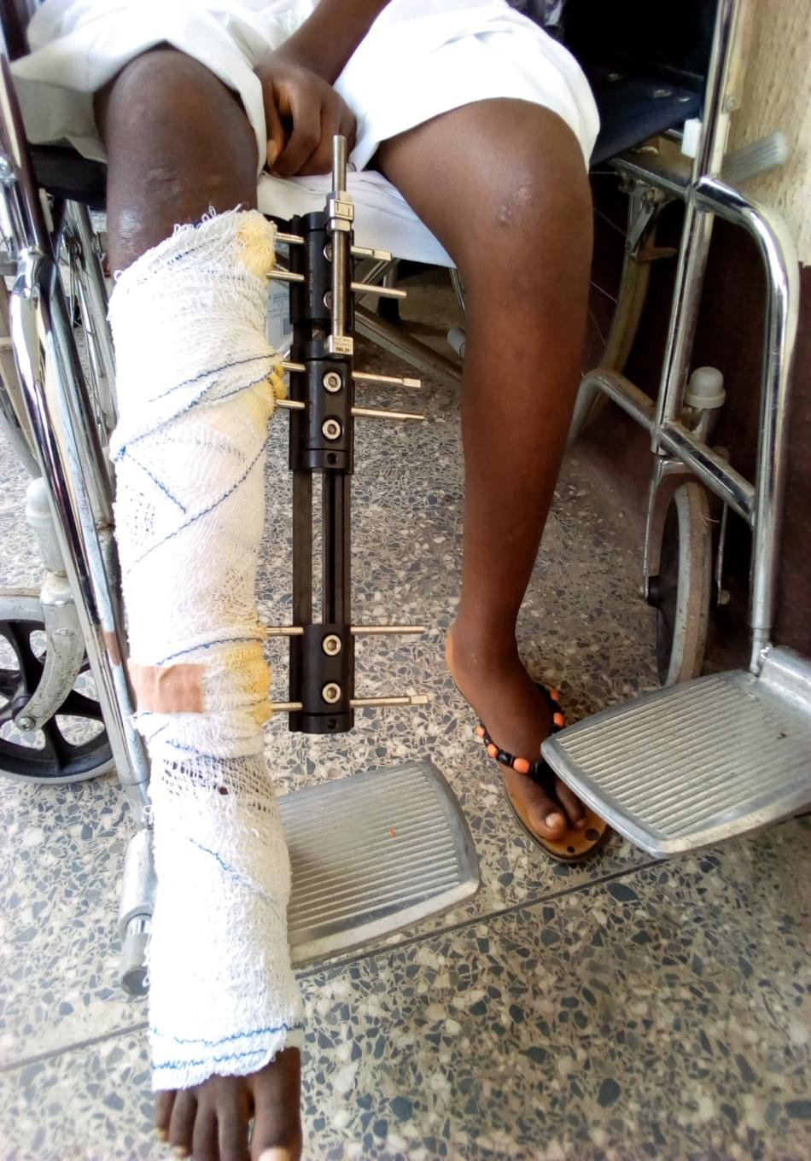
Fig. 1: Linear Rail System (LRS)

TABLE 1 : Age distribution of the patients
AGE (YEARS) | FREQUENCY | PERCENTAGE
0-10  11-20  21-30  31-40  41-50  51-60  TOTAL | 1  1  5  12  9  2  30 | 3.33  3.33  16.67  40  30  6.67  100

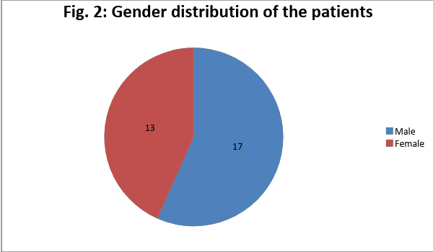

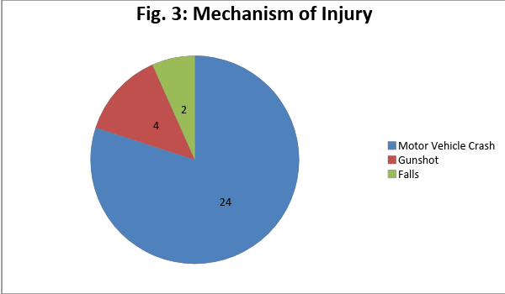

TABLE 2: INDICATIONS FOR SURGERY
DIAGNOSIS | FREQUENCY | PERCENTAGE
INFECTED NON-UNION  FAILED IMPLANT WITH  NON-UNION AND LIMB  LENGTH DISCREPANCY  OPEN COMMUNITED  FRACTURE WITH BONE  NECROSIS  MALUNION WITH LIMB  LENGTH DISCREPANCY  SEGMENTAL BONE LOSS  ASEPTIC NON-UNION  WITH LIMB LENGTH  DISCREPANCY  TOTAL | 10  7  5  5  1  2  30 | 33.3  23.33  16.67  16.67  3.33  6.67  100

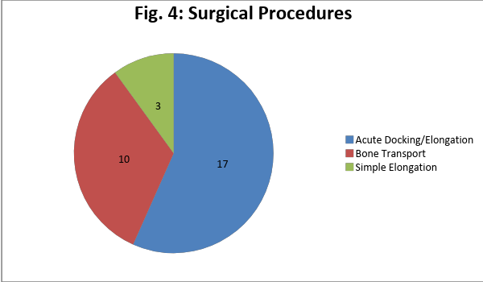

Fig. 5: Outcome of management using ASAMI Classification
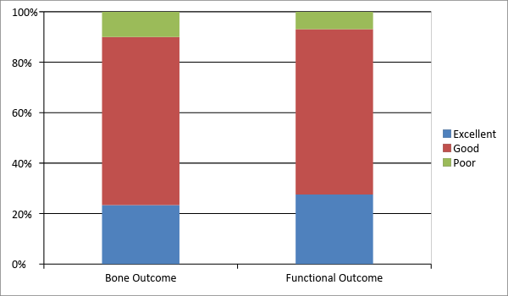

Fig. 6: Failed implant with non-union and limb length discrepancy
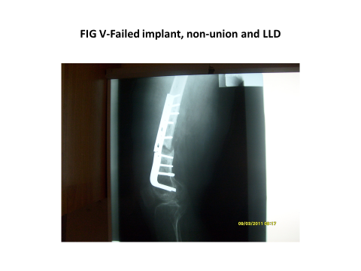

Fig. 7: Acute docking post implant removal and commencement of elongation

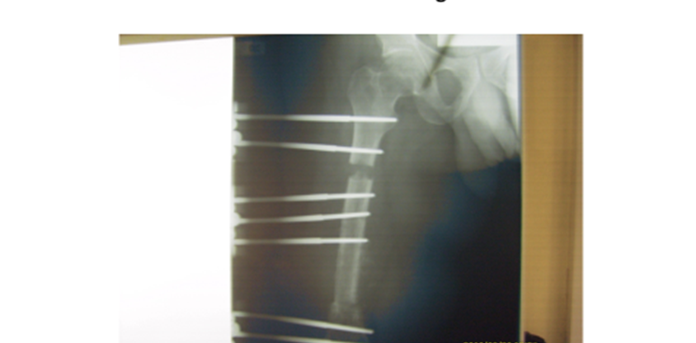

Fig. 8: After removal of LRS
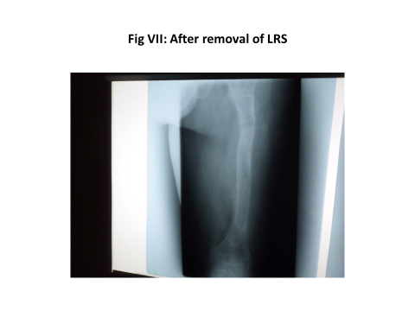

INTRODUCTION
Les fractures des os longs sont presque toujours en raison des blessures à haute énergie. Quelques-unes des raisons peuvent provenir d'un accident d'automobile, d'une arme à feu ou d'une chute¹. Aucun groupe d'âge n'est à l'abri de cela, mais le traumatisme est généralement plus courant chez les jeunes et les actifs. Dans le monde entier, les traumatismes sont une cause principale de décès et d'incapacité pour tous les groupes d'âge, sauf des personnes de plus de 60 ans et c’est l'une des trois sources primordiales de décès chez les gens de 5 à 44 ans².
Plusieurs facteurs sont à l’origine du développement de complications et même le traumatisme, les blessures ouvertes ou fermées, l'option de gestion offerte et le choix de l'implant de fixation. Les facteurs liés au patient, tels que la consommation d'alcool et le port prématuré de poids contre un avis médical, sont d'autres facteurs qui peuvent entraîner des complications^{3,4}. Les infections, qui peuvent provenir de certains des facteurs ci-dessus, sont également une complexité majeure qui peut affecter les options de gestion disponibles⁵.
Le soin des fractures compliquées a toujours été un défi pour les chirurgiens orthopédiques, surtout dans les pays où il manque assez de ressources. Là où les ressources sont disponibles, les chirurgiens orthopédiques sont en mesure de choisir entre les transferts osseux vascularisés, le transport osseux, la greffe osseuse allogénique, les substituts de greffe osseuse et plusieurs autres moyens¹. La chirurgie d'Ilizarov a doucement pris de l’importance comme plus de chirurgiens acquièrent cette compétence au fur et à mesure que l'appareil devient plus facilement disponible et abordable.
L'ostéogenèse de distraction (callotaxis), fait connaître par Ilizarov et ce qui était, jusqu'ici une procédure rarement effectuée est aujourd’hui devenue une procédure régulière⁶.
Dans des conditions mécaniques contrôlées, une ostéotomie distraite produira de l'os entre les limites distraites: c'est ce qu'on appelle l'ostéogenèse. L'histogenèse simultanée se produit également dans les tissus mous alentour.
Des procédures préalables ont été effectuées par le biais du cadre Ilizarov qui est un dispositif volumineux et lourd, mais d'autres dispositifs qui s’avèrent moins coûteux et nécessitant des courbes d'apprentissage plus courtes telles que le système LRS (Linear Rail System) sont maintenant utilisés. En dehors de redresser le divergence de longueur de membre avec l'allongement, la procédure a été adaptée et utilisée pour amender des formes variées de déformations à la fois congénitales et acquises. De telles déformations comprennent celles de fractures compliquées.
Le traitement et la récupération sont embrouillés par la perte de tissus mous avec maints sinus, ostéomyélite, ostéopénie, déformations complexes avec une disparité de longueur de membre, raideur de l'articulation adjacente, infection poly bactérienne multi-résistante aux médicaments et au tabagisme^{3,7,8,9}.
Brinker¹⁰ définit la pseudarthrose comme une fracture qui, d’après le médecin qui traite, n'a aucune possibilité de guérison sans davantage d’intervention. Il a postulé de plus que toutes les définitions disponibles de pseudarthrose et union retardée, notamment celle de la Food and Drug Administration (FDA) des États-Unis et une autre par Muller, manquent de cohérence, sont subjectives, ambiguës et arbitraires et n'ont donc aucun critère objectif.
Pour l’expliquer davantage ; plusieurs mois d'observation ne devraient pas être nécessaires pour déclarer une fracture de la diaphyse du tibia avec une perte segmentaire de 10 cm une pseudarthrose. Selon Struijs et al⁷, une pseudarthrose infectée est définie comme un état d'échec de l'union et de la persistance de l'infection au site de la fracture pour une période de 6 à 8 mois. Les pseudarthroses infectées des os longs représentent un grand défi pour le chirurgien orthopédique dans le soin optimal de cette maladie. Cela vient de l’état complexe du soin des pseudarthroses infectées, surtout celles qui ont échoué à de multiples tentatives de fixation interne ou qui présentent une déformation importante^{8,9}.
Le divergence de longueur des membres est une autre complication significative des fractures des os longs. Une dissimilitude dans la longueur des membres plus hauts et plus bas est fréquente dans la population. Lorsque la dissimilitude est apparente, surtout dans les membres plus bas, elle affecte non seulement la démarche de la personne, mais elle gène aussi l'ensemble de la biomécanique des membres inférieurs. Il peut également être à l’origine de douleur au bas du dos, de la hanche et du genou.
Dans le cas où le membre inférieur LLD est supérieur à 3 cm une chirurgie est nécessaire pour créer un allongement du membre le plus court. Il faut noter que le soin de la LLD nécessite des mois, voire des années, pour l'achèvement et exige de la patience et une pleine coopération du patient ainsi que de la famille¹⁰.
Depuis la fin du siècle dernier, un grand nombre de techniques chirurgicales pour l'allongement des membres ont été proposées, mais aucune n'a réussi à résoudre les problèmes complexes associés à l'allongement du segment des membres. Pourtant, la méthode d'Ilizarov semble être la plus bienfaisante.
On dit que les tissus vivants soumis à une traction lente et régulière deviennent métaboliquement activés dans les voies cellulaires biosynthétiques et prolifératives: c'est ce qu'on appelle la loi de tension-stress¹⁰. Une bonne application de ce principe aussi bien que des techniques chirurgicales qui limitent le traumatisme osseux et les tissus mous peuvent être utilisés pour allonger tous les segments des membres supérieurs et inférieurs¹¹. L'infection du site de goupille est classée par Paley comme: Niveau I qui est une inflammation des tissus mous: Niveau II qui est une infection des tissus mous et Niveau III qui est une infection osseuse^{1,12,13}.
Au fil des années, nous avons utilisé cette procédure et cette étude cherche à répartir notre expérience dans la gestion des fractures complexes en utilisant l'ostéogenèse de distraction. Les défis et les complications rencontrés pendant cette période seraient aussi mis en évidence et discutés.
PATIENTS ET MÉTHODES
C’est une étude prospective sur les patients qui avaient besoin d'une reconstruction des membres plus bas suite à des blessures subies lors d'accidents et de coups de feu ainsi que chez ceux qui souffrent des troubles de croissance post-traumatiques dans notre hôpital entre 2009 et 2012. On a cherché et a obtenu l’approbation de cette étude auprès du comité de l'hôpital et ce ne sont que les patients traités avec le système linéaire (LRS) fabriqué par S.H. Pitkar Orthotools Pvt Ltd (www.pitkar.com) de Pune, en Inde, qui ont été inclus dans l'étude. Le LRS fonctionne conformément au principe d'Ilizarov et se compose d'un rail en acier inoxydable peint en noir, des broches coniques en acier inoxydable de 6,5 mm, des clamps de fond et central et d'une unité de compression-distraction (CD). Les rails ont des longueurs différentes (200, 300 et 400 mm) et les broches de différentes longueurs de 150 mm, 170 mm et 200 mm. Le LRS pédiatrique est aussi disponible pour les enfants. (Fig. 1)
Le diagnostic clinique de nos patients comptait une pseudarthrose infectée, une fixation interne ratée avec une pseudarthrose et un divergence de longueur de membre, une nécrose osseuse et une pseudarthrose. Le soin comprenait un allongement osseux simple, un accostage et une élongation aiguë et un transport d’os. Cela n’inclut pas les patients souffrant des fractures pathologiques, une maladie osseuse métabolique et un pauvre stock d’os.
Les déformations des membres ont été évaluées d’une manière préopératoire, notant la condition de la peau y compris les ulcères et les sinus, les anomalies de longueur des membres, les déformations angulaires, les lacunes osseuses, la gamme de mouvement articulaire et la présence d'ostéomyélite. Des radiographies complètes et des photographies cliniques ont été utilisées pour l'évaluation. Des examens préopératoires pour le penchant à la chirurgie et à l'anesthésie ont été effectués, aussi bien qu'un examen préopératoire par les anesthésistes. Le consentement éclairé pour la chirurgie a été obtenu chez des patients, qui ont été convenablement conseillés à propos de la durée presque toujours très longue du traitement et la nécessité d'un soin approprié des broches et des blessures. La kinésithérapie préopératoire a été réalisée pour renforcer les muscles, améliorer l'amplitude des mouvements articulaires et enseigner la marche à béquille non porteuse.
Toutes les procédures ont été réalisées sous anesthésie rachidienne à l'exception des enfants qui ont eu une anesthésie générale. Les broches ont été insérées dans les parties sécuritaires de la cuisse (septum latéral intermusculaire) et de la jambe (bordure antéro-médiane sous-cutanée). L'imagerie peropératoire a été utilisée pour guider l’entrée des broches et l'ostéotomie.
Une ostéotomie sub-périostée à faible énergie a été achevée après un perçage préliminaire du cortex et un allongement d’os a été achevée par une distraction progressive du site d'ostéotomie au taux de 1mm (0,25mm quatre fois par jour), commencée dix jours après l’ostéotomie. Pour le transport osseux, un segment d'os a été progressivement transporté dans une enveloppe de tissu mou de l'autre côté de l'espace osseux (site d'accostage).
Les patients étaient laissés sortir deux semaines après la chirurgie, ayant appris comment utiliser l'appareil pour se distraire et prendre soin des sites d'épingles. Ils ont un traitement ambulatoire non porteurs de poids avec des béquilles axillaires et ont été vus à des intervalles de 2 semaines pour les 3 premières visites et tous les mois par la suite. La période de suivi des patients était de 2 à 3 ans et à chaque visite de suivi, les observations suivantes ont été faites: distance parcourue par l'unité Compression-Distraction (CD), une portée active et passive des articulations adjacentes, une sensation et puissance des groupes musculaires, du soin du site de la goupille et de l'hygiène générale, la vérification et le resserrement des boulons desserrés pour assurer la stabilité du dispositif et des mesures des membres. Des radiographies pour évaluer la distraction, l'alignement et la qualité de l'os régénéré ont été prises chaque mois. Les vues antéro-postérieures et latérales précises exigent un bon positionnement des membres, de sorte que les rayons X ont été supervisés par les auteurs.
Les données biographiques, le diagnostic préopératoire, les indications chirurgicales, les déformations des membres, les interventions effectuées, les complications et les résultats ont été documentés et analysés grâce au logiciel Microsoft Excel 2007 et présentés dans des tableaux simples. L'infection des broches a été évaluée grâce à la classification de Paley et les résultats ont été évalués selon les critères de l'Association pour l'étude et l'application de la méthode d'Ilizarov (ASAMI)¹⁴.
RÉSULTATS
Trente patients dont les procédures avaient été conclues ont été résolus dans l'étude. Le plus jeune avait 4 ans tandis que le plus âgé avait 57 ans avec un moyen âge de 38 ans. Quarante pour cent (40%) des patients étaient âgés de 31 à 40 ans (tableau 1). Il y avait 17 mâles et 13 femelles donnant une proportion mâle / femelle de 1,3: 1 (Graphique 2)
Les accidents routiers ont exprimé 80% des blessures subies par ces patients, tandis que 4 patients (13,3%) ont subi des blessures par coup de feu. (Graphique 3)
En termes de diagnostic, 10 patients (33,3%) avaient une pseudarthrose infectée, 7 patients (23,3%) avaient eu une implantation ratée avec un pseudarthrose aseptique et divergence de longueur de membre associé (LLD). Cinq patients (16,7%) avaient des fractures comminutives ouvertes et de la nécrose osseuse, cinq (16,7%) avaient une cal vicieux avec LLD, deux (6,7%) avaient une pseudarthrose aseptique avec LLD au cas d’un manque d'implant et une (3,3%) avaient une perte d’os segmentaire sur les lieux de l'accident. (Tableau 2)
La période de morbidité avant le soin allait de 3 semaines à 8 ans. Tous les os affectés étaient des os des membres plus bas avec le tibia représentant 56,7% (17 patients) et le fémur, 43,3% (13 patients). Les malformations osseuses fluctuaient entre 4 cm et 12 cm.
Les procédures qui ont été faites chez ces patients incluaient l'accostage et l'allongement aigus (17 patients), le transport osseux (10 patients) et l'allongement simple (3 patients). (Graphique 3-8) Le dispositif est resté fixé à l'os entre 9 et 20 mois.
L'évaluation des résultats à l'aide de la méthode ASAMI a démontré 7 excellents, 20 bons et 3 faibles résultats osseux et 8 excellents, 19 bons et 3 faibles résultats fonctionnels. (Graphique 5)
Les complications notées étaient celles d’infection du site de la goupille Paley niveau I chez 6 patients et niveau II chez 8 patients (46,7%), une raideur du genou chez 6 et une régénération chez 1 patient. Tous les patients subissant d’une raideur au genou ont eu une chirurgie du fémur. Le patient ayant de la fracture régénérée a subi une opération sur le fémur et nous a été présentée à la suite d'une chute plusieurs mois après qu'elle ait commencé à avoir un port ambulatoire complet. Elle a ensuite eu une procédure répétée.
DISCUSSION
Plus de la moitié de nos patients avaient entre 21 et 40 ans et il y avait plus d'hommes que de femmes. C'est la tranche d'âge fréquente pour les blessures post-traumatiques remarquées dans d'autres études et les hommes sont plus souvent affectés que les femmes^{15,16}. Un grand nombre (80%) de nos patients ont été blessés dans des accidents routiers, ce qui est semblable aux résultats de Chalya et al¹⁵ en Tanzanie. Dix-sept des patients présentaient des pseudarthroses, dont 10 qui étaient infectées, représentaient 58,8%. D'autres ont rapporté moins de cas de pseudarthrose infectée dans leur série¹⁷. Le pourcentage élevé de cas de pseudarthrose infectée dans cette étude était en raison des fractures ouvertes que les patients subissaient, un facteur de risque de pseudarthrose infectée.
Les critères ASAMI qui ont été utilisés pour mesurer des résultats de cette étude ont révélé que la plupart des patients avaient de bons résultats osseux et fonctionnels. D'autres travailleurs ont rapporté des valeurs plus élevées pour de bons résultats, mais ce rapport a montré une courbe d'apprentissage^{1,14,18,19}.
Un nombre assez grand de patients (46,7%) dans cette étude ont développé une infection des broches, plus élevée que ce qui a été rapportée par d'autres travailleurs^{20,21}. Pourtant, tous les patients avaient une infection de de Paley niveau I et II qui ont été traités avec succès, grâce à des antibiotiques, comme conseillé par d'autres travailleurs^{1,12}. Cette étude a montré des chiffres plus hauts que les conclusions des autres travailleurs parce que les patients ont été libérés plutôt tôt. Une raideur du genou a été observée chez 20% des patients à la suite d'une procédure d’allongement fémoral. Cela a été observé au début de l'étude et cela nous a incités à faire les procédures suivantes avec le genou fléchi, ce qui a réduit le nombre de patients ayant cette complication. En outre de cela, certains des patients qui sont arrivés en retard présentaient une raideur au genou étant une complication suite au traitement reçu avant le renvoi. La raideur du genou a affecté les scores ASAMI de ces patients et a donné un résultat relativement faible.
Les principales limites de notre étude étaient le nombre relativement faible de patients et la période limitée de suivi de 2 ans.
Conclusion: Cette étude a montré que la chirurgie d'Ilizarov est une bonne option pour la reconstruction des membres surtout chez les patients subissant des déformations de longueur de membre et une ostéomyélite chronique.
LES RÉFÉRENCES
1. Sahibzada AS, Khan MA, Khan MS. Prise en charge de la malformation d’os tibial dû à un traumatisme à haute énergie par le biais du fixateur externe fabriqué localement par un transport osseux segmentaire. J Ayub Med Coll Abbottabad. 2005; 17 (3).
2. Hettrich CM, Browner B. Trauma de haute énergie. Meilleure pratique et recherche de Rhumatologie clinique. 2012 30 avril; 26 (2): 281-8.
3. Nwagbara IC. Union osseuse dans des cas de pseudarthrose des os longs traités par ostéosynthèse. Journal nigérian de pratique clinique. 2010; 13 (4).
4. Ikpeme IA, Mkpanam NE, Abang IE, Ngim NE, Udosen AM. Pseudarthrose à long os et Cal vicieux: Facteurs de risque et résultats du traitement à Calabar, Nigéria du Sud. Journal ouvert d'orthopédie. 2013 24 septembre ; 3 (06): 253.
5. Ikem IC, Oginni LM, EA Bamgboye, Ako-Nai AK, Onipede AO. La bactériologie des fractures ouvertes à Ile-Ife, Nigeria. Journal nigérian de médecine: journal de l'Association nationale des médecins résidents du Nigeria. 2004; 13 (4): 359-65.
6. Brinker MR, O'connor DP, Crouch CC, Mehlhoff TL, Bennett JB. Traitement Ilizarov des Pseudarthroses infectés de l'humérus distal après un échec de la fixation interne: une étude des résultats. Journal de traumatisme orthopédique. 2007 1er mars ; 21 (3): 178-84.
7. Pugh DM, McKee MD. Progrès dans la prise en charge de la pseudarthrose humérale. Journal de l'Académie américaine des chirurgiens orthopédiques. 2003 1er janvier; 11 (1): 48-59.
8. Rozbruch SR, Segal K, Ilizarov S, Fragomen AT, Ilizarov G. Le Cadre Spatial de Taylor corrige-t-il scrupuleusement les déformations tibiales? Orthopédie clinique et recherche connexe. 2010 1er mai; 468 (5): 1352-61.
9. Brinker MR. Pseudarthroses: évaluation et traitement. Traumatisme squelettique: science, soin et reconstruction de base. 2003.
10. Sanders R. Principes opératifs d'Ilizarov. Journal de Traumatisme Orthopédique. 1992 1er juin; 6 (2): 266.
11. Ilizarov GA. Allongement des segments des membres supérieurs et inférieurs. Dans l’Osteosynthesis Transossous 1992 (pages 287-328). Springer, Berlin, Heidelberg.
12. Paley D. Problèmes, obstacles et complications de l'allongement des membres par la technique d'Ilizarov. Orthopédie clinique et recherche apparentée. 1990 1er janvier; 250: 81-104.
13. Kortor JN, Kpela TM, Poopola SO. Infections des broches suite à la fixation externe de fractures ouvertes. Journal de la médecine sous les tropiques. 2011; 13 (2): 105-8.
14 .Paley D, Catagni MA, F Argnani, Villa A, Bijnedetti GB, Cattaneo R. Traitement d’Ilizarov des pseudarthroses tibiales avec perte osseuse. Orthopédie clinique et recherche apparentée. 1989 1er avril; 241: 146-65.
15. PL Chalya, Mabula JB, Dass RM, N Mbelenge, Ngayomela IH, Chandika AB, Gilyoma JM. Caractéristiques des blessures et résultats des victimes d'accidents routiers au Centre médical de Bugando, dans le nord-ouest de la Tanzanie. Journal de la gestion du traumatisme et des résultats. 2012 9 février; 6 (1): 1.
16. Naddumba EK. Services de traumatisme musculosquelettique en Ouganda. Orthopédie clinique et recherche liée. 2008 1er octobre; 466 (10): 2317-22.
17. Malik MH, P Harwood, Diggle P, Khan SA. Facteurs touchant les taux d'infection et de pseudarthrose dans le clou intramédullaire. Bone & Joint Journal. 2004 1er mai; 86 (4): 556-60.
18. Abdel-Aal AM. Transport d'os d'Ilizarov pour des malformations osseuses tibiales massives. Orthopédie. 2006 1er janvier; 29 (1).
19. Polyzois D, Papachristou G, Kotsiopoulos K, Plessas S. Soin de la perte osseuse tibiale et fémorale par ostéogenèse de distraction: expérimentation dans 28 cas infectés et 14 cas propres. Acta Orthopaedica Scandinavica. 1997 1er janvier; 68 (sup275): 84-8.
20. Ferreira N, Marais LC. Septicité des broches: incidence de l'utilisation de fixateurs circulaires dans une unité de reconstruction de membre. SA Journal orthopédique. 2012 jan; 11 (1): 40-7.
21. Parameswaran AD, Roberts CS, Seligson D, Voor M. Infections des broches avec la fixation externe contemporaine: combien d'un problème ?. Journal de traumatisme orthopédique. 2003 1er août; 17 (7): 503-7.
Fig. 1: Système de rail linéaire

TABLEAU 1 : Répartition d’âge des patients
ÂGE (ANS) | FRÉQUENCE | POURCENTAGE
0-10  11-20  21-30  31-40  41-50  51-60  TOTAL | 1  1  5  12  9  2  30 | 3.33  3.33  16.67  40  30  6.67  100

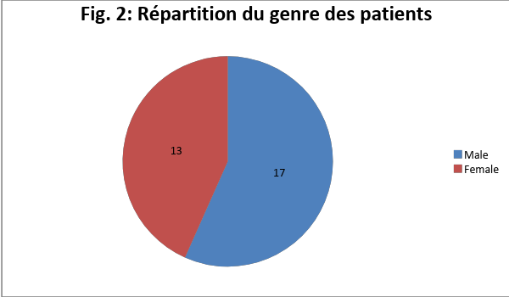

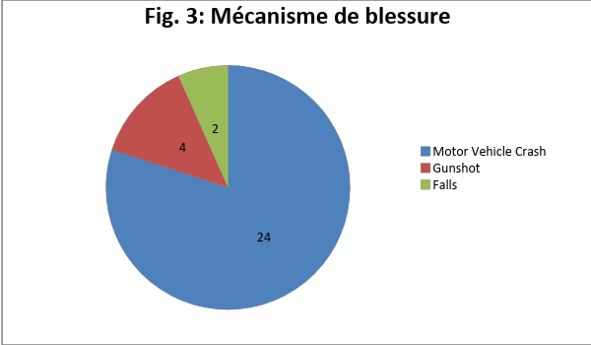
- Accident automobile
- Coup de feu
- Chutes

TABLEAU 2: INDICATIONS POUR LA CHIRURGIE
DIAGNOSTIC | FRÉQUENCE | POURCENTAGE
PSEUDARTHROSE INFECTÉ  IMPLANT RATÉ DE PSEUDARTHROSE  ET DIVERGENCE DE L’ALLONGEMENT  DE MEMBRE  FRACTURE OUVERTE DE / AVEC  UNE NÉCROSE OSSEUSE  CAL VICIEUX DE / AVEC DIVERGENCE DE L’ALLONGEMENT DE MEMBRE  PERTE OSSEUSE SEGMENTAIRE  PSEUDARTHROSE ASEPTIQUE  DE / AVEC DIVERGENCE DE  L’ALLONGEMENT DE MEMBRE  TOTAL | 10  7  5  5  1  2  30 | 33.3  23.33  16.67  16.67  3.33  6.67  100

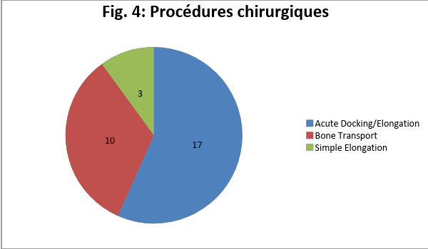

Fig. 5: Résultat de prise en charge grâce à la classification d’ASAMI
- Accostage aigu / allongement
- Transport osseux
- Allongement simple

Fig. 6: Implant raté de / avec pseudarthrose et divergence de l’allongement de membre
- Faible / moins bon
- Bon
- Excellent

Fig. 7: Enlèvement de post implant d’accostage aigu et le début d’allongement

Fig. 8: Apres l’enlèvement de LRS

