EXPERIENCE WITH MANAGING PENETRATING ANTERIOR NECK INJURIES IN LAGOS, NIGERIA
EXPERIENCE AVEC LA GESTION DE BLESSURES DU COU ANTÉRIEUR PÉNÉTRANT A LAGOS, NIGERIA

*Nwawolo CC, Asoegwu CN
Otorhinolaryngology unit,
Department of Surgery,
Lagos University Teaching Hospital,
Lagos, Nigeria. E-mail: clementnwawolo@yahoo.com

*Correspondence

Grant support: None
Subvention: Aucun
Conflict of interest: None
Conflit d'intérêts: Aucun

ABSTRACT

Background: Penetrating anterior neck injuries are potentially life threatening and the causes vary across countries of the world. Studies in Nigeria have been mainly isolated case reports and few retrospective studies.
Aim: The aim of this study was to assess the causes, severity and management outcome of patients treated in our centre.
Methodology: This is a retrospective study of penetrating anterior neck injuries treated at the Lagos University Teaching Hospital over a 25-year period. The case records were retrieved and demographic data as well as the causes, site, extent of injuries and treatment outcome were analyzed.
Results: The mean age of the 39 patients in this study was 30.5yrs ± 7.9 SD with a male: female ratio of 6.8:1. Inflicted cut throat injuries accounted for 46% followed by vehicular accidents in 21%. Zone II site of the neck was the commonest site of injury 61.6% of the patients; while 71.8% of the patients presented within 24hrs of the injury, 46% of them had immediate blood transfusion. Tracheostomy was the main method of securing the airway. Primary soft tissue repair was performed on all the patients. Laryngopharyngeal repair was done in 61.5%. Peri-operative mortality was 7.7% and 83.3% had prolonged hospital admission with wound infection in 27.8% and laryngotracheal stenosis in 22.2% as the commonest complications.
Conclusion: This study has shown that penetrating anterior neck injuries is not uncommon in Nigeria and commonly due to cut throat and vehicular accidents. Proper documentation and following established management protocols will improve outcome.
Key words: Anterior neck injuries, Cut throat, Vehicular accidents, Tracheostomy.

ABSTRAIT

Contexte : Les blessures pénétrante du cou antérieur pose une situation potentiellement mortel et les causes varient selon les pays du monde. Les études du Nigéria a été principalement isolé des cas de repport et peu des études rétrospective.
But: Le but de cette étude c’est d’evaluer les causes , la sévérité et gestion de résultats des patients traités dans notre centre.
Méthodologie: C’est une étude rétrospective de lésions antérieur pénétrante du cou traité à l’hôpital d’enseignement de l’université de Lagos dans une période de 25 ans . Les dossiers étaient retiré et des données démographique ainsi que les causes, site, niveau de lésions et résultat du traitement étaient analysé .
Résultats: Le moyen âge 39 patients dans cette étude était 30.5ans ± 7.9 SD avec un mâle : femme ratio de 6.8:1 des lésions acharnée est responsable pour 46% suivi par l’accident de vehicule dans 21% Zone II site du cou était le plus commun site de blessure 61.6% des patients; alors que 71.8% des patients présenté dans 24h de blessure , 46% d’eux ont eu la transfusion sanguine immédiat . La trachéotomie était la méthode majeure de sécuriser la voie aérienne . La réparation du tissu primaire mouiller était fait sur tout les patients. La réparation laryngopharyngeal était fait dans 61.5%. La mortalité peri-operative était 7.7% et 83.3% ont prolongé l'admission à l’hôpital avec l’infection de blessure dans 27.8%etsténoses laryngotracheal dans 22.2% étant le plus commune complications.
Conclusion: Cette étude a montré que les blessures pénétrante d ’ antérieur du cou n’est pas rare au Nigéria et se produit normalement en raison d ’ acharnée et des accidents de véhicule . La propre documentation et la suivi de protocol de gestion établi va améliorer le résultat .
Mots clés: Blessure intérieur du cou , Couper la gorge , Accidents de vehicule,Trachéotomie.

INTRODUCTION
Penetrating neck injuries are associated with a breach in the skin and underlying platysma muscle of the neck and are significantly prone to causing mortality or severe morbidity depending on the cause, site and severity of the injury^{1, 2}. They pose a great challenge to the attending surgeons because of the important structures in the neck that could be affected³.The causes of penetrating anterior neck injuries include gunshot injuries, stab wound injuries, neck laceration from vehicular accidents and inflicted cut throat injuries which could be homicidal or suicidal ³. Some authors have classified these injuries as accidental, homicidal and suicidal ² ⁻ ⁵. This classification appears simple but in cases of stab injuries to the neck during a fight or a stray bullet injury from a gunshot, it is debatable if these are homicidal or accidental. The anatomic site of injury in the anterior neck is important as this helps to determine the structures that may be affected. The severity of the injury also depends on the structures in the neck that are affected. It is in this regard that the Roon and Christensen’s classification⁶ of the zones of the neck is useful for ease of assessment. The classification identifies three major zones in the neck. Zone -1extends from the level of the sternal notch to the cricoid cartilage. Zone-2 extends from cricoid cartilage to the angle of mandible and Zone-3 extends from the angle of mandible to the base of the skull.

Penetrating neck injuries have been reported to account for 5 – 10% of trauma cases in some studies⁷ ⁻ ⁹. In Nigeria and most sub-Saharan African countries, it is difficult to estimate the incidence or prevalence of penetrating neck injuries as comprehensive trauma registries are few. Studies on penetrating neck injuries in Nigeria have mainly consisted of case reports and they have noted that these cases may be under reported¹⁰ ⁻ ¹³. This study is aimed at appraising the pattern of penetrating anterior neck injuries managed at the Lagos University Teaching Hospital, Lagos, Nigeria over a 25-year period in order to assess the causes, types of injury, and management outcome.

METHODOLOGY

This is a 25-year retrospective study of penetrating anterior neck injuries that were managed by the Otorhinolaryngology unit in collaboration with other surgical units and the anaesthesia department of the Lagos University Teaching Hospital, Lagos, Nigeria from January 1992 to December 2016. The records of 58 patients managed for penetrating anterior neck injuries were initially obtained from the operating theatre register. The records of 8 patients treated for anterior neck injuries between January 1992 and December 1995 was obtained from the collated data used for a previously published study ¹⁴. The discharge summaries of 7 patients treated between January 1996 and December 2004 and the case files of 24 patients treated between 2005 and 2016 were retrieved from the medical records department of the hospital. Patients that were not managed by in collaboration with the Otorhinolaryngology unit in the hospital were excluded.

The data extracted for each patient included the demographic profile, cause of injury, type of injury, extent of injury, treatments and outcome. The causes were classified as gunshot injuries, stab injuries, vehicular accident injuries and inflicted cut throat injuries. The Roon and Christensen’s classification⁶ of the anatomic zones of the neck was used to assess the site of injury from the documented clinical findings. Treatment was classified as resuscitative measures, airway maintenance technique and repair of wounds. The extent of injuries was identified through the documented operative findings and classified as involvement of the skin, muscles & small blood vessels, involvement of the larynx, pharynx, oesophagus, vascular involvement and neural involvement. Outcome of management was noted as recovery, complications, duration of hospitalization and mortality.
The data collected were documented in a study form and entered into a Microsoft excel worksheet. The data were grouped and analyzed using Microsoft excel statistical package of windows 10. The tables and charts were constructed using Microsoft word software with the results displayed in text, tables and figures. Specimen pictures of some patients were included as figures to highlight the types of injuries.

RESULTS
A total of 58 patients were recorded in the operating theatre register but the data of 39 patients were retrieved for inclusion into the study. The age range of the patients was 6yrs to 65yrs with a mean of 30.5 ± 7.9SD. There were 34 males and 5 females with a male: female ratio of 6.8: 1.

Age-group distribution of the patients
Table 1 shows the age group distribution of the patients in relation to the cause of penetrating anterior neck injury. The peak age group affected was the 4th decade (38.5%) while 66.7% were in their 3rd and 4th decades of life.

Causes of injuries
The causes of injuries were as illustrated in Fig. 1. Inflicted cut throat injuries accounted for 46% of the cases, followed by vehicular accidents (21%).

Sites of injury
The zones of the neck that were involved in the injuries are summarized in Table 2.

Tissues involved in injury
The skin, muscles and small blood vessels were affected in all the patients and the laryngopharynx was affected in 61.5% of the patients as illustrated in Fig. 2.

Figures 3 – 13 are pictures of some of the patients

Clinical presentation and resuscitative measures
Table 3 shows the profile of clinical presentation and resuscitative measures that were recorded.

Surgical treatment
All the patients had surgical treatment with neck wound exploration and primary soft tissue repair. Specific organ repair procedures were done as necessitated such as laryngopharyngeal repair in 61.5%, hemi-thyroidectomy in 10.3%, oesophageal repair in 10.3% and fixation of mandibular fractures in 12.8% of the patients; vascular or neural repairs were not recorded.

Morbidity and mortality profile
Table 4 shows the mortality and morbidity profile of the patients.

DISCUSSION

Penetrating anterior neck injuries varied from minor lacerations or puncture wounds involving the skin, muscles and small blood vessels in the neck to severe injuries that involved the laryngeal framework, pharynx and deeper structures in the neck. The male gender preponderance and the peak age in the 3rd and 4th decades of life seen in the results of this study were highlighted in other published studies^{2, 10 - 13}. Adoga et al in their report of three cases of suicidal cut throat injuries noted that all were males with two in the 3rd and 4th decades of life while Adebola et al reported the case a 24 year old man with inflicted cut throat injury^{12, 13}. Onotai et al in a retrospective study, reported on 24 cases of cut throat injuries seen in Port Harcourt over a ten year period and all the patients were males between the ages of 26 and 45 years¹⁵.

In our study there were a few females (12.8%). In reports from other developing countries, Panchappa et al reported a m:f ratio of 6.3:1 in a retrospective study of cut throat injuries in India while Gilyoma et al reported a m:f ratio of 2.4:1 in a retrospective / prospective study in Tanzania^{2, 16}. This was attributed to the tendency of young adult males to be more involved in civil strife actions, substance abuse and interpersonal violence. Other reasons adduced were mental illness and frustration from unemployment. Adoga et al noted the link between unemployment and suicide tendency as reported in the study by Shah and Bhandarkar^{12, 17}. The study by Iseh and Obembe also noted that a significant proportion of emergency cases of anterior neck cut throat injuries (52.6%) were from suicidal attempts by people with a background history of psychiatric illness¹⁸. The 3rd and 4th decades of life also constitute a relatively high proportion (30.2 %) of the Nigerian population ¹⁹.

Some studies estimated that 50 - 95% of penetrating neck injuries result from gunshots and stab wounds and attributed a low incidence of penetrating neck injuries to vehicular accidents ^{5, 7, 9, 20}. However, the result from this study showed that vehicular accident was a common cause of penetrating neck injury (21%). This may be due to the high rate of road traffic accidents in Nigeria particularly from commercial motorcycle accidents ²¹. On the contrary, the vehicular accident victims in Nigeria may be surviving longer after the injuries than those with gunshot injuries to be able to access hospital care. Gunshot injuries to the neck in this study were few despite the fact that gunshot injuries are common in Nigeria. The relatively few numbers may be due to the fact that high velocity gunshot injuries to the neck are more likely to be lethal. Stab wounds in this study were from assault during interpersonal fights and superficial as they might not be with the intent to kill. Another reason for the relatively few cases of stab wound injuries in this study may be that, deep stab wounds were probably fatal and the patients did not reach the hospital for treatment; forensic studies have shown the fatality of stab injuries to the neck ⁴.

Miller et al (1991) reported that 60-75% of penetrating neck injuries involve zone II ²² similar to the finding in this study as zone II alone injuries accounted for 61.6% of cases while zone II both alone and in conjunction with other zones was involved in 83.2% of the patients. Zone II is anatomically the most accessible part of the neck to injuries as Zones I and III are protected by bones and thus less accessible to trauma. Penetrating injury to zone I is likely to be fatal as the main anatomic structures in this zone are the great vessels (subclavian blood vessels, common carotid arteries, aortic arch, brachiocephalic blood vessels and jugular veins), lung apices, trachea and oesophagus and the recurrent laryngeal nerves ¹. Zone III is in the superior aspect of the neck and the mandible is usually protective. Most patients with zone III injuries (17.9%) were from low velocity gunshot and vehicular accident injuries. Mandibular bone fractures were recorded in 12.8% of patients in this study.

Most (71.8%) of the patients presented within 24 hours of the injury and the peak duration before presentation was 12 – 24 hours. This may be due to the perceived seriousness of penetrating anterior neck injuries among the populace because open neck wounds cause apprehension and panic in individuals leading to early presentation for hospital care ²³.

Blood transfusion was administered to 46% of the patients as part of resuscitative measures in their initial management while 42% had blood transfusion intra-operatively. This implies that these patients had significant blood loss from the injuries. 12% of the patients were haemodynamically stable on presentation as they had superficial injuries as documented. Tracheostomy was the main route of airway maintenance in this study. A longitudinal study on tracheostomy in Lagos highlighted the use of tracheostomy in the management of upper airway obstruction (UAO) due to external laryngeal trauma in 13% of 177 of patients with UAO¹⁴. Ezeanolue documented the importance of tracheostomy in the airway management of severe penetrating neck injuries¹¹. This has also been documented in case reports from Nigeria on penetrating anterior neck injuries^{10, 12, 13}. Tracheostomy has been reported to be a good method of securing the airway pre-operatively in severe penetrating neck injuries as endotracheal intubation of open neck wounds could cause more damage to the injury ^{16, 18, 20, 23}.

The mortality rate in this study was low (7.6%); due to the relatively early presentation of the patients and the policy of early primary wound exploration and repair of affected tissues that was performed in all the patients. The morbidity profile of patients in this study showed that 83.3% of patients had prolonged hospital admission of more than 4 weeks post operatively - a reflection of the severity of the injuries. Tracheostomy decannulation was unsuccessful in 22.2% of the patients that survived. These patients had laryngotracheal stenosis. Wound infection rate was 27.8% despite prophylactic pre-operative parenteral antibiotic administration on all the patients. Fistula formation was noted in 11% of the patients which all healed with conservative management.

CONCLUSION: This study has shown that penetrating anterior neck injuries is not uncommon in Nigeria and is commonly due to cut throat and vehicular accidents. Proper documentation and following established management protocols will improve outcome.

ACKNOWLEDGEMENT
We would like to acknowledge Drs. Najomoh AA, Johnson KJ and Ogunbiyi AA who are resident otorhinolaryngologists in our unit for collating the theatre records and case sorting. We thank Ms Elizabeth Olimah for data input.

REFERENCES

- Fagan JJ, Nicol AJ. (2008) Neck Trauma. In: Gleeson, M., Ed., Scott-Brown’s Otorhinolaryngology, Head and Neck Surgery, 7th Edition, Great Britain, Hodder Arnold, 1768.

- Panchappa SA, Natarajan D, Karuppasamy T, Jeyabalan A, Ramamoorthy RK, Thirani S, et al. Cut Throat Injuries—A Retrospective study at a tertiary referral hospital. International Journal of Otolaryngology and Head & Neck Surgery. 2014; 3: 323-329

- Tisherman SA, Bokhari F, Collier B, Cumming J, Ebert J, Holevar M, et al. Clinical practice guideline: penetrating zone II neck trauma. J Trauma. 2008; 64(5): 1392- 1405.

- Prajapati Pranav, Sheikh MI. A study of homicidal deaths by mechanical injuries in Surat, Gujarat. J Indian Acad Forensic Med 2010; 32(2): 134 – 138.

- Stiernberg CM, Jahrsdoerfer RA, Gillenwater A. Gunshot wounds to the head and neck. Arch Otolaryngol Head Neck Surg. 1992; 118: 592– 597.

- Roon AJ, Christensen N. Evaluation and treatment of penetrating cervical injuries. J Trauma. 1979; 19(6): 391- 397.

- Harris R, Olding C, Lacey C, Bentley R, Schulte KM, Lewis D, et al. Changing incidence and management of penetrating neck injuries in the South East London trauma centre. Ann R Coll Surg Engl. 2012; 94(4): 240 -244

- Siau RT, Moore A, Ahmed T, Lee MS, Tostevin P. Management of penetrating neck injuries at a London trauma centre. Eur Arch Otorhinolaryngol. 2013; 270(7): 2123 - 2128.

- Nason RW, Assuras GN, Gray PR, Lipschitz J, Burns CM. Penetrating neck injuries: analysis of experience from a Canadian trauma centre. Can J Surg. 2001; 44(2): 122 - 126.

- Amadasun JEO. Decision making in self-inflicted life threatening neck injuries: report of two cases. J Otorhinolaryngol Head Neck Surg. 1999; 2: 21–23.

- Ezeanolue BC. Management of the upper airway in severe cut throat injuries. Afr J Med Med Sci 2001; 30: 233–235.

- Adoga AA, Ma’an ND, Embu HY, Obindo TJ. Management of suicidal cut throat injuries in a developing nation: three case reports. Cases J. 2010; 3: 65 - 68.

- Adebola SO, Ologe FE, Ogunkeyede SA, Adedayo GA, Ogundoyin OA. Penetrating anterior neck injury: A multidisciplinary approach. IOSR J Dent Med Sci. 2014; 13: 20 -24.

- Nwawolo CC, Oyewole EA, Okeowo PA. Tracheostomy: a longitudinal study. Niger J Surg. 1997; 4(2): 53 - 57.

- Onotai LO, Ibekwe U. The pattern of cut throat injuries in the university of Port Harcourt Teaching Hospital. Port Harcourt. Niger J Med. 2010; 19: 264 – 266.

- Gilyoma JM, Hauli KA, Chalya PL. Cut throat injuries at a university teaching hospital in northwestern Tanzania: a review of 98 cases. BMC Emerg Med. 2014; 14(14): 1 - 7.

- Shah A, Bhandarkar R. Cross-national study of the correlation of general population suicide rates with unemployment rates. Psychol Rep. 2008;103(3): 793 – 796

- Iseh KR, Obembe A. Anterior neck injuries presenting as cut throat emergencies in a tertiary health institution in north western Nigeria. Niger J Med. 2011; 20(4): 475 – 478.

- Nigeria Population Census – 2006. Nigeria data portal. Population distribution by age. (updated 31 May 2016) http://nigeria.opendataforafrica.org/xlomyad/population-distribution-by-age-2006

- Grewal H , Rao PM , Mukerji S , Ivatury RR. Management of penetrating laryngotracheal injuries. Head Neck. 1995: 17(6): 494-502.

- Solagberu BA., Ofoegbu CKP, Nasir AA, Ogundipe OK, Adekanye AO, and Abdur-Rahman LO. Motorcycle injuries in a developing country and the vulnerability of riders, passengers, and pedestrians. Injury Prevention. 2006; 12(4): 266-268.

- Miller RH, Duplechain JK. Penetrating wound of the neck. Otolaryngol Clin North Am. 1991; 24: 15–29.

- Akhtar S, Awan S. Laryngotracheal trauma: its management and sequelae. J Pak Med Assoc. 2008; 58(5): 241- 243.

Table 1: Age group distribution of the study patients in relation to cause of injury

Age Groups Yrs. | Gunshot Injury | Stab Wound Injury | Vehicular Accident Injury | Inflicted Cut throat Injury | TOTAL | (%)
< 10 | 0 | 0 | 2 | 0 | 2 | 5.1%
10 – 19 | 0 | 0 | 2 | 2 | 4 | 10.3%
20 – 29 | 2 | 2 | 1 | 6 | 11 | 28.2%
30 – 39 | 2 | 4 | 1 | 8 | 15 | 38.5%
40 – 49 | 1 | 0 | 2 | 0 | 3 | 7.7%
50 – 59 | 1 | 0 | 0 | 1 | 2 | 5.1%
≥ 60 | 1 | 0 | 0 | 1 | 2 | 5.1%
TOTAL | 7 | 6 | 8 | 18 | 39 | 100%

Table 2: Distribution of the anatomic zones of the neck involved in relation to the cause of injury

Zones of Neck Affected | Gunshot Injury | Stab Wound Injury | Vehicular Accident Injury | Inflicted Cut throat Injury | TOTAL
Zone I alone | 0 | 0 | 0 | 0 | 0 |  | 0%
Zone II alone | 2 | 4 | 0 | 18 | 24 |  | 61.6%
Zone III alone | 5 | 0 | 0 | 0 | 5 |  | 12.8%
Zones I & II | 0 | 0 | 2 | 0 | 2 |  | 5.1%
Zones II & III | 0 | 2 | 4 | 0 | 6 |  | 15.4%
Zones I, II & III | 0 | 0 | 2 | 0 | 2 |  | 5.1%
TOTAL | 7 | 6 | 8 | 18 | 39 |  | 100%

Table 3: Clinical presentation and resuscitative measures applied

Clinical Presentation & Resuscitation Measures | Number of Patients (%). n = 39
Duration before presentation  < 12 hrs.  12 – 24 hrs.  >24 hrs. | 8 (20.5%)  20 (51.3%)  11 (28.2%)
Pre-operative Blood transfusion  Not given  Given | 21 (53.8%)  18 (46.2%)
Airway maintenance  Nil  Endotracheal Intubation  Tracheostomy  Cricothyroidotomy | 6 (15.4%)  0  33 (84.6%)  0

Table 4: Morbidity and mortality profile of the patients

Mortality & Morbidity Profile | Number of Patients.  n = 39 (%)
Treatment outcome  Recovery  Mortality at Surgery  Mortality after Surgery | 36 (92.3%)  2 (5.1%)  1 (2.6%)
Duration of Hospital Admission  < 1 wk.  1 – 4 wks.  >4 wks. | Number of Patients (%). n = 36  4 (11.1%)  2 (5.6%)  30 (83.3%)
Tracheostomy decannulation  Successful  Unsuccessful | 28 (77.8%)  8 (22.2%)
Complications noted  Wound infection  Fistula formation  Laryngotracheal stenosis | 10 (27.8%)  4 (11.1%)  8 (22.2%)

Fig. 1: Causes of penetrating anterior neck Injuries

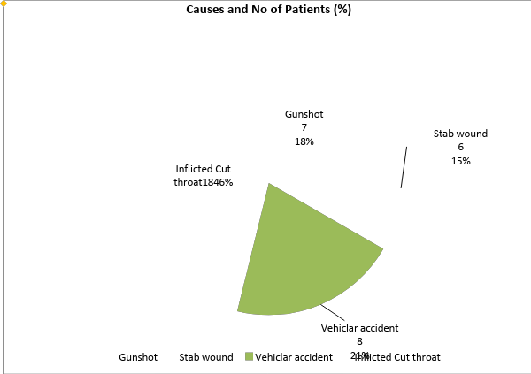

Fig. 2: Distribution of the structures involved in the injuries

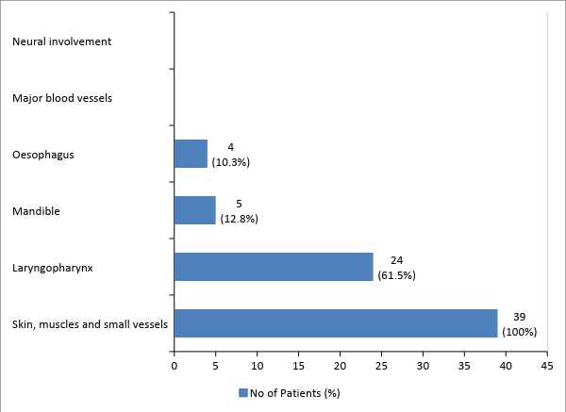

Fig. 3: A 42 year old road transport official with stab wound injury to the anterior neck during an interpersonal violence

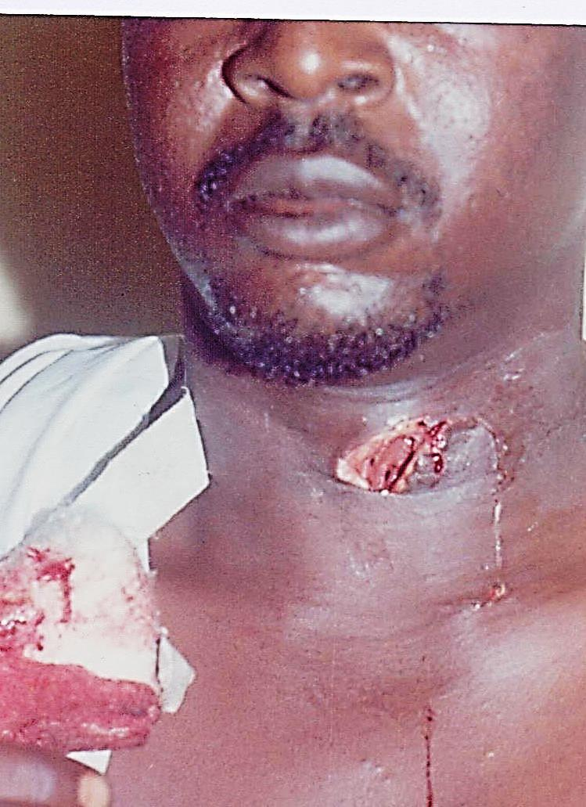

Fig. 4: The patient after treatment

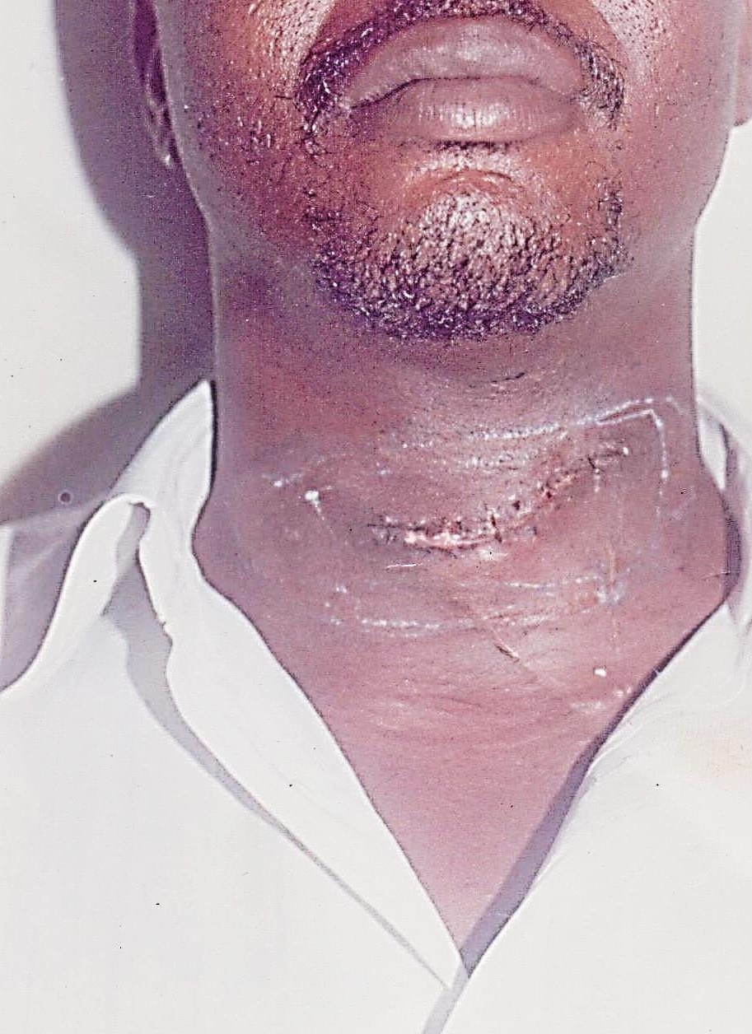

Fig. 5: 16 year old student with self-inflicted cut throat injury
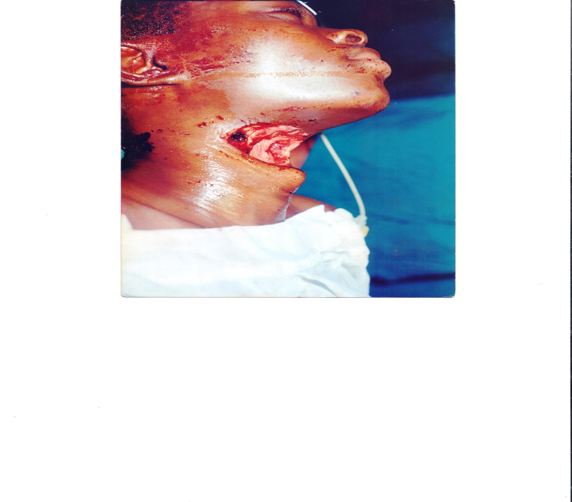

Fig. 6: Injury assessment in the theatre before wound cleaning and tracheostomy

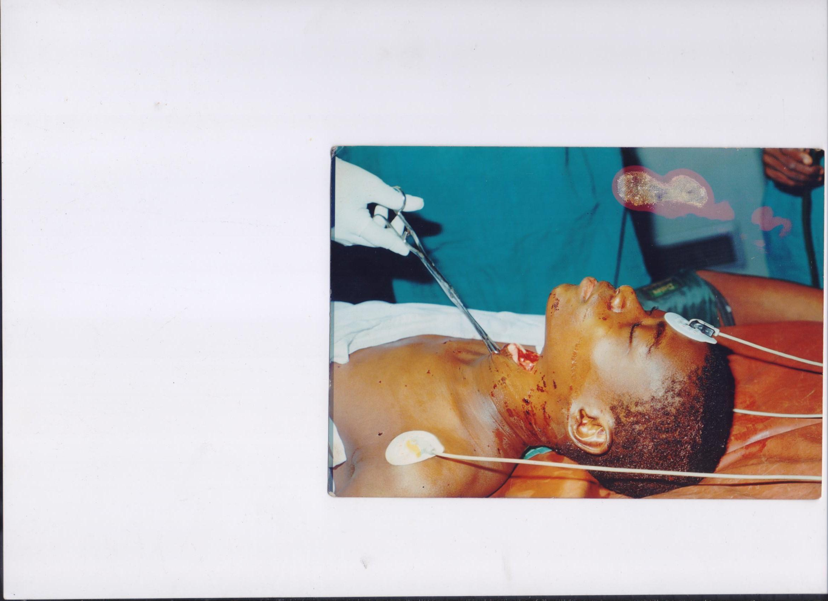

Fig 7: Repair of the cut throat structures in layers

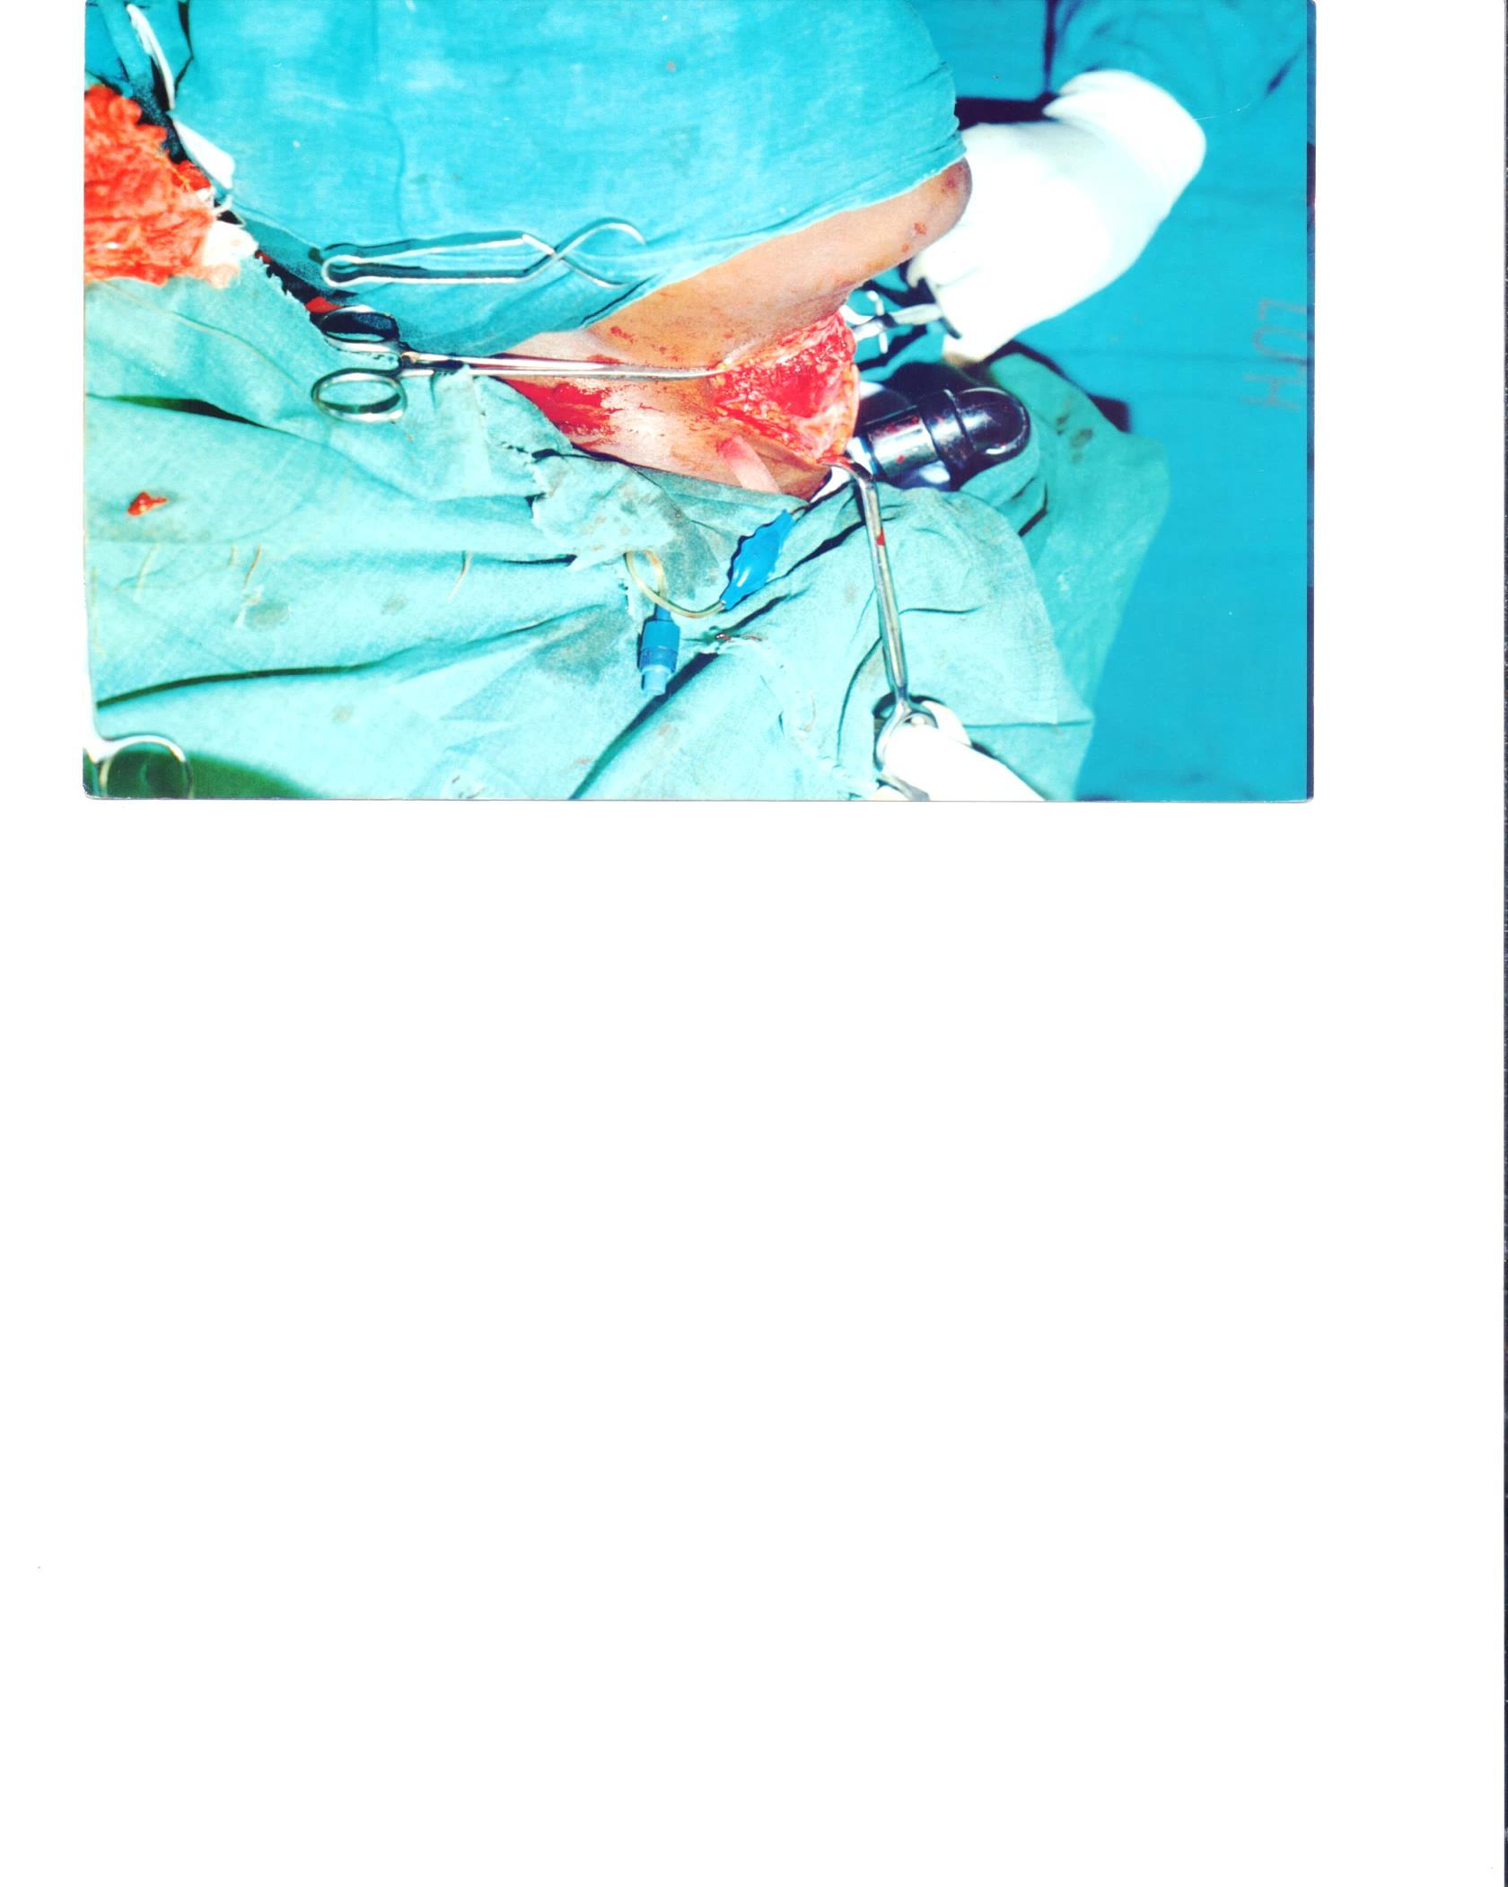

Fig. 8: Skin closure

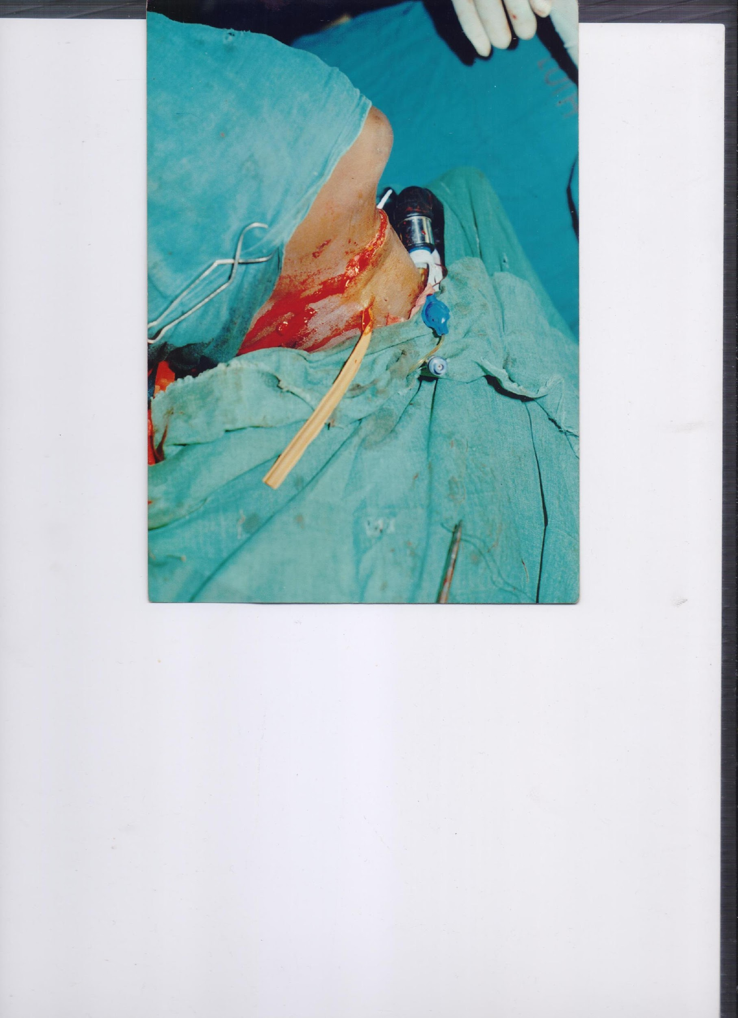

Fig. 9: Healed cut throat wound awaiting decannulation

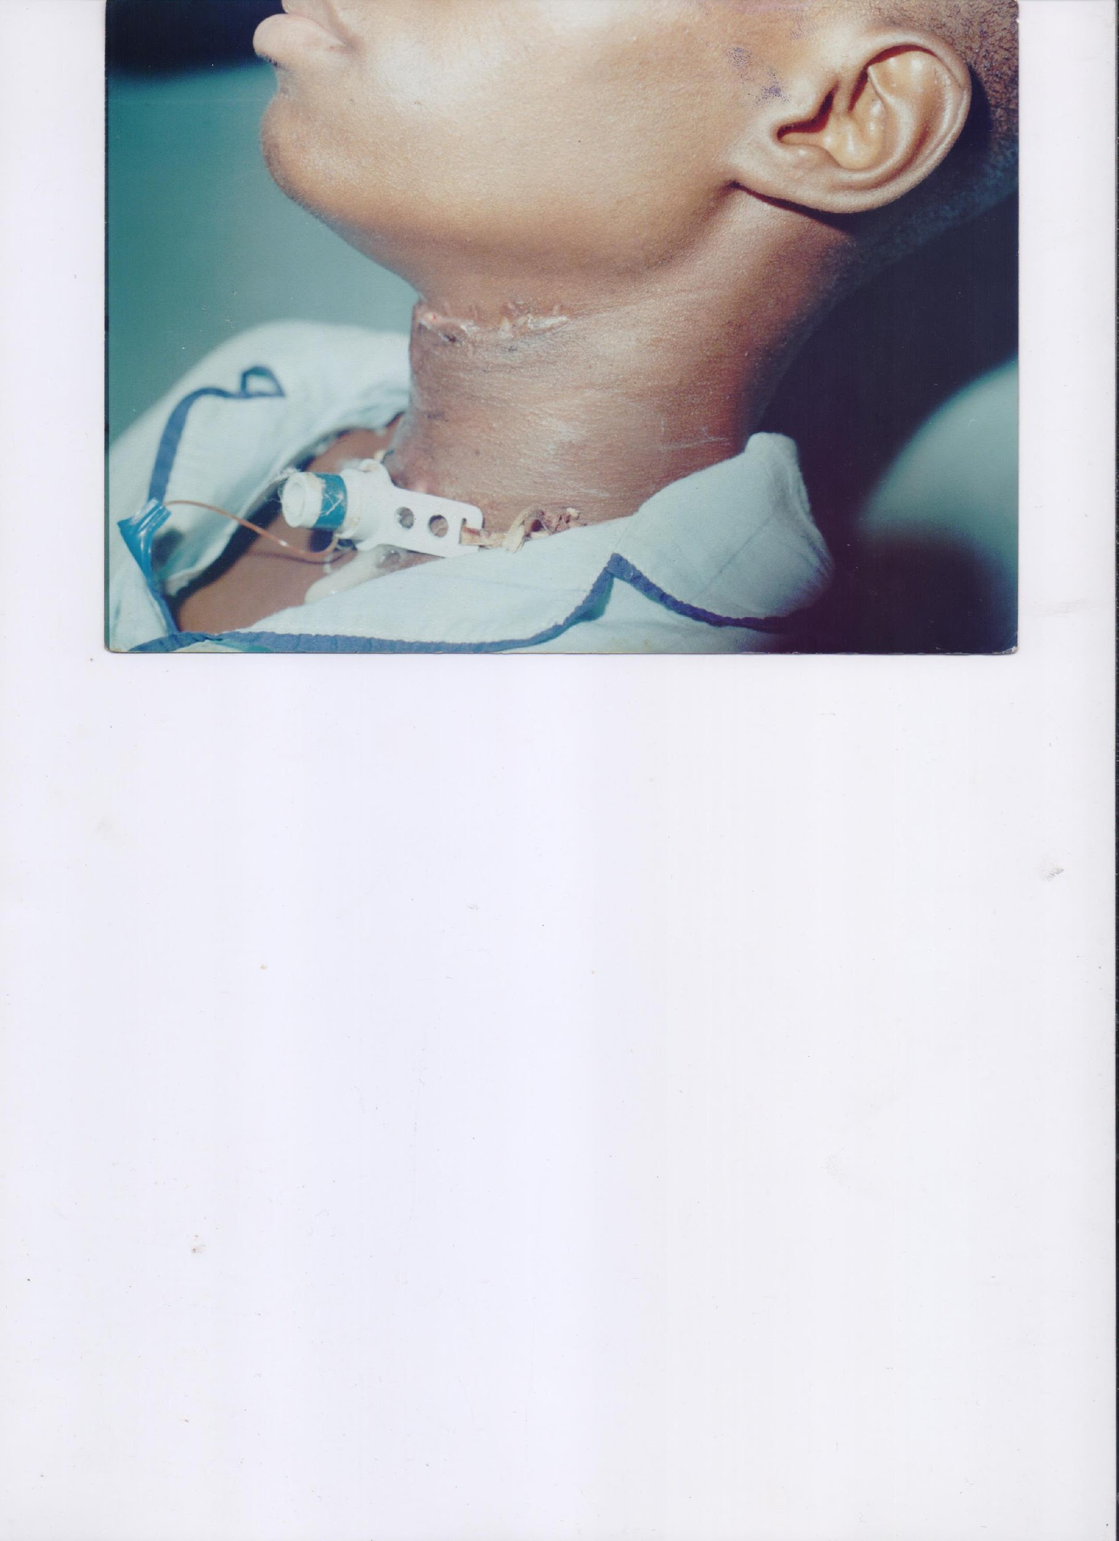

Fig. 10: Successful decannulation

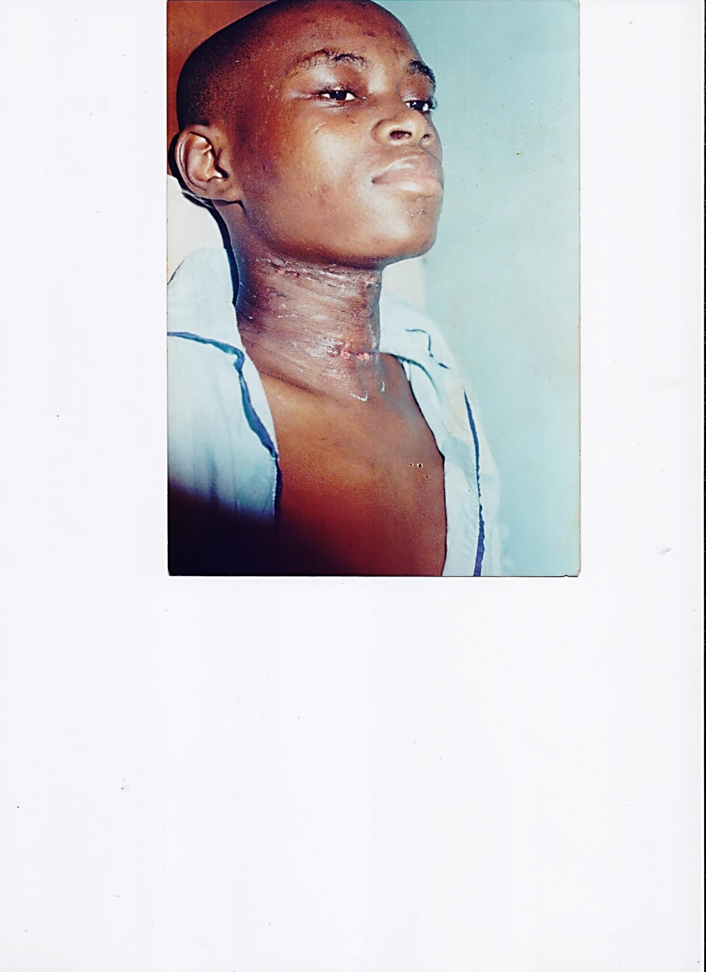

INTRODUCTION
Les blessures du cou pénétrant sont associé avec une violation dans la peau et la muscle platysma sous jacinthe du cou et ils sont significativement sensible à la cause de mortalité ou la morbidité sévère selon la cause , site et sévérité de la blessure ^{1, 2}. Ils constituent un grand défi aux chirurgiens traitant par la raison des structures important dans le cou qui peut être affecté ³.Les blessures pénétrant d ’ antérieur du cou incluent les blessures par balle , blessures à l'arme blanche , lacération du cou ,des accidents de vehicule et les blessures de couper de gorge qui peut être homicide ou suicidaire ³. Des auteurs ont classifié ces blessures comme accidentel, homicide et suicide ² ⁻ ⁵. Cette classification semble être simple mais dans les cas de blessures à l'arme blanche au cou lors de combat ou la blessure de balle perdu , il est discutable s’il s'agit de homicide ou accidentel. Le site anatomique de blessure dans le cou antérieur est important car il aide à déterminer les structures qui peut être affecté . La sévérité de blessure dépend aussi sur les structures dans le cou qui sont affecté . C’est dans cet égard que la classification de Roon et Christense ⁶ des zones du cou est utile pour l'évaluation aisance . La classification identifie trois zones majeurs dans le cou . Zone -1 est prolongé du niveau de forchette sternale à la cartilage cricoide . Zone-2 est prolongé de cartilage cricoide jusqu'à’
l’ angle de mandibule et la zone-3 est prolongé de l’ angle mandibule à la crâne.

Des blessures pénétrant du cou ont été rapportés d’être responsable de 5 – 10% de cas de traumatisme dans quelques études ⁷ ⁻ ⁹ au Nigéria et dans la plupart du pays sous - saharien Afrique , il est difficile d’estimer l’incidence ou la prévalence de blessures pénétrante du cou comme les registres du traumatisme compréhensive sont petit .Les études sur les blessures pénétrante du cou au Nigéria ont consisté principalement des cas de rapports et il est noté que ces cas peuvent être sous rapporté ¹⁰ ⁻ ¹³. Le but de cette étude c’est d’evaluer la conception de blessure pénétrante antérieure du cou géré à l’hôpital d’enseignement de l’université de Lagos, Lagos, Nigéria pendant une période de 25-ans à fin d’evaluer les causes, les types de blessures , et le résultat de gestion .

METHODOLOGIE

C’est une étude rétrospective de 25-ans de blessure pénétrante antérieure du cou géré par la section Otorhinolaryngologie en collaboration avec d’autre section chirurgicale et le département anesthésie de l’hôpital d’enseignement de l’université de Lagos , Lagos, Nigéria du Janvier 1992 au Décembre 2016. Les dossiers de 58 patients géré pour la blessure pénétrante antérieure étaient initialement obtenu du registre de théâtre d'opération . Les dossiers de 8 patients traité pour la blessure de cou entre Janvier 1992 et Decembre 1995 était obtenu à partir des données assemblé utilisé pour l’étude précédente publié ¹⁴. Le résumé de 7 patients libéré et traité entre Janvier 1996 et Décembre 2004 et les dossiers de 24 patients traité entre 2005 et 2016 étaient retiré du département de dossier médical de l’hôpital . Les patients qui n’etaient pas géré en collaboration avec la section Otorhinolaryngologie à l’hôpital étaient exclus.

Les données retiré pour chaque patient inclut la profile démographique , la cause de blessure , type de blessure, niveau de blessure, traitement et la finalité . Les causes étaient classifié comme des blessures par balle , blessures à l'arme blanche, des blessures accidents de vehicule et acharnée infligé. La classification de Roon et Christensen ⁶ de zones anatomique du cou était utilisé pour évaluer le site de blessure à partir de résultats clinical documenté . Le traitement était classifié comme des mesures réanimation,technique de maintenance de voie aérienne et la réparation des blessures. Le niveau de blessures était identifié à travers les résultats operative documenté et classifié comme impliquant de la peau , muscles & des petit vaisseaux sanguin , qui inclus le larynx, le pharynx, l’oesophage, implication vasculaire et implication neurale . Les résultats de gestion étaient noté comme la récupération, les complications, la durée d’ hospitalisation et mortalité.
Les données collectées étaient documenté dans une fiche d’étude et remplit dans le logiciel de feuille calcul . Les données était groupé et analysé utilisant le paquet statistique de Microsoft excel fenêtre10. Les tableaux et graphiques étaient construit utilisant le logiciel Microsoft word avec des résultats démontré en texte ,les tableaux et figures . Les images de spécimens de quelques patients était inclus comme figures pour énumérer les points forts de types de blessures.

RESULTAT
Un total de 58 patients étaient enregistré dans le registre théâtre d’ opération mais les données de 39 patients étaient prise pour inclusion dans cette étude .
La gamme d’âge de ces patients était 6ans à 65ans avec un moyen de 30.5 ± 7.9SD. Il y avaient 34 mâles et 5 femmes avec un mâle: femme ratio de 6.8: 1.

Distribution de tranche d'âge des patients
Tableau 1 montre la distribution de tranche d’âge des patients en relation à la cause de blessure antérieure pénétrante du cou . Le maximum tranche d’âge affecté était le 4eme décennie(38.5%) alors que 66.7% étaient dans leurs 3eme et 4eme décennie de la vie.

Causes des blessures
Les causes des blessures étaitent comme illustré dans Fig. 1 . L’acharnée infligé était responsable pour 46% des cas , suivi par l’accident de vehicule (21%).

Sites de blessure
Les zones du cou qui étaient impliqué dans les blessure sont résumées au tableau 2.

Les Tissus impliqué dans la blessure
La peau , muscles et des petits vaisseaux sanguins étaient affecté dans tous les patients et le laryngopharynx était affecté en 61.5% du patients comme illustré dans la Fig. 2.

Figures 3 – 10 sont les images de quelques patients

Présentation Clinicale et mesure de récupération
Tableau 3 montre le profil de présentation clinicale et mesure de récupération qui était enregistré .

Traitement Chirurgicale
Tout les patients ont eu un traitement chirurgical avec l ’ exploration de blessure du cou et la réparation de tissu mouille primaire .Les procédures de réparation d ’ organe spécifique étaient fait comme nécessaire ainsi que la réparation laryngopharyngeal dans 61.5%, hemi-thyroidectomie dans 10.3%, réparation oesophagedans 10.3% et la fixation de fractures mandibulaire dans 12.8% des patients; la réparation vasculaire ou neurale n’étaient pas enregistré .

Morbidité et profile de mortalité
Tableau 4 montre la profile de mortalité et morbidité des patients.

DISCUSSION

Les blessures pénétrante antérieure varient de lacération mineure ou blessures par piqure impliquant la peau , les muscles et des petits vaisseaux sanguin dans le cou aux blessures sévères qui impliquent le cadre larynx, pharynx et les structures approfondie du cou. La prépondérance de genre mâle et le maximum âge de 3eme et 4eme décennies de la vie selon les résultats de cette étude était souligné dans d’autre études publié ^{2, 10 - 13}. Adoga et al dans leur rapport de trois cas de suicide des blessures acharnée ont noté qu’ils sont tout des mâles avec deux dans le 3eme et 4eme décennies de la vie alors que Adebola et al ont rapporté le cas d’un homme de 24 ans avec la blessure de couper de gorge infligé ^{12, 13}. Onotai et al dans une étude rétrospective , ont rapporté 24 cas de blessure acharnée à Port Harcourt pendant une période de dix ans et tout les patients étaient mâles entre l’âge de 26 et 45 ans¹⁵.

Dans notre étude, il y a peu de femmes (12.8%). Selon le rapport des autre pays en voie du développement , Panchappa et al ont rapporté m:f ratio de 6.3:1 dans une étude rétrospective de blessure de couper de gorge à l’Inde alors que Gilyoma et al ont rapporté un m:f ratio de 2.4:1 dans une étude rétrospective / étude prospective en Tanzanie^{2, 16}. Cela était attribué à la tendance de jeune adulte mâles qui sont plus impliqué dans les actions des conflits civils, abus de substance toxique et violence interpersonelle .D’autres raison avancé étaient des maladies mentales et la frustration de chômage . Adoga et al ont noté le lien entre le chômage et la tendance de suicide comme rapporté dans l’etude de Shah et Bhandarkar^{12, 17}. L’étude par Iseh et Obembe ont noté aussi une proportion significative des cas urgences des blessures antérieure d ’acharnée (52.6%) viennent de tentative de sucide par les gens avec une histoire de maladie psychiatrique ¹⁸. Le 3eme et 4eme décennies de la vie constituent aussi une proportion relativement élevé (30.2 %) de la population Nigériane ¹⁹.

Quelques études ont estimé que 50 - 95% de blessure pénétrante du cou qui s’est produit de blessure par balle et blessure à l'arme blanche et attribué à l’incidence bas de blessure pénétrante du cou par les accidents de vehicule/. ^{5, 7, 9, 20}. Néanmoins , le résultat de cette étude a montré que l’accident de vehicule était une commune cause de blessure pénétrante du cou (21%). Cela peut être en raison du taux élevé d’accident routier au Nigéria particulièrement les moto bicyclettes commerciale ²¹. Au contraire , les victimes d’accident vehiculaire au Nigéria peuvent survivre plus long qu’ après les blessures que ceux qui ont eu les blessures par balle d’être capable d'accéder au soin à l’ hôpital . Les blessures du cou dans cette étude était peu malgré le fait que les blessures par balle sont commune au Nigéria. Les nombres relativement peu peut être en raison de vélocité élevé de blessures par balle au cou sont plus probable mortel . Les blessures à l'arme blanche dans cette étude étaient de l’agression lors de combat interpersonnelle et superficiel comme il n’est pas prévu à la mort . Une autre raison pour les cas relativement peu de blessures à l'arme blanche dans cette étude peut être que les blessures approfondie à l’arme blanche était probablement fatal et les patients n’ont pas visité l’hopital pour le traitement; car des études légales ont montré la fatalité de blessures à l'arme blanche au cou ⁴.

Miller et al (1991) ont rapporté que 60-75% des blessures pénétrante du cou impliquent la zone II ²² similaire au résultat de cette étude comme zone II seulement les blessures sont responsable de 61.6% des cas alors que le zone II seulement et en collaboration avec d’autres étaient impliqué dans 83.2% des patients. Zone II est anatomiquement la partie le plus accessible aux blessures du cou commes les Zones I et III sont protégés par des os et sont moins accessible au traumatisme . La blessure pénétrante à la zone I est probablement fatal car les structures anatomique majeures dans cette zone sont des grand vaisseau(vaisseau sanguin sous-claviers, carotide commune , -- arteres, arch aortique ,vaisseau sanguin brachiocephalic et veines jugulaires), apex poumonaire, trachée et oesophage et le nerf larynge récurrent ¹. Zone III est dans l’aspect supérieur du cou et la mandibule est normalement protective.La majorité des patients avec des blessures zone III (17.9%) étaient de vélocité bas de coup de feu et blessures d’accident vehiculaire . Les fractures de l’os mandibulaire étaient enregistré dans 12.8% des patients dans cette étude .

La majorité (71.8%) des patients présenté dans 24 h de blessure et la durée maximum avant la présentation était 12 – 24 h. Cela peut être par la raison de gravité conçu des blessures pénétrante antérieure du cou parmi la populace l parce que les blessures ouverte causent l’appréhension et panique chez les individus ce qui mène à la présentation précoce au soin à l’hôpital²³.

La transfusion du sanguine a été administré aux 46% patients comme une partie de mesure de récupération dans leur gestion initiale alors que 42% ont eu la transfusion sanguine intra-operativement. Cela impliue que ces patients ont eu la perte du sang significative de blessures. 12% des patients étaient hémodynamiquement stable lors de présentation comme ils ont des blessures superficielle comme documenté . La trachéotomie était la route majeur de maintenance de voie aérienne dans cette étude . Une étude longitudinale sur la trachéotomie à Lagos à souligné l’utile de trachéotomie dans la gestion de l’ obstruction de voie aérienne supérieure (UAO) en raison de traumatisme de larynge externe dans 13% de 177 des patients avec UAO¹⁴. Ezeanolue a documenté l’ importance de trachéotomie dans la gestion de voie aérienne de blessure pénétrante du cou sévère¹¹. Cela aussi a été documenté dans les cas rapport du Nigéria sur les blessures antérieure pénétrante du cou ^{10, 12, 13}. La trachéotomie été rapporté d’être une bonne méthode de sécuriser la voie aérienne pre-operativement dans les blessures pénétrante du cou comme l ’intubation endotracheale du cou ouvert de blessure peut causer plus d'endommager à la blessure^{16, 18, 20, 23}.

Le taux de mortalité dans cette étude était bas (7.6%); en raison de présentation relativement précoce des patients et la politique d ’ exploration de blessure primaire précoce et la réparation de tissu affecté qui est fait dans tout les patients. La profile de morbidité des patients dans cette étude a montré que 83.3% des patients ont prolongé l'admission à l’hôpital de plus de 4 semaines
post operativement - une réflection de sévérité des blessures . La decannulation de trachéotomie était un échec dans 22.2% des patients qui ont survit. Ces patients ont eu la sténose laryngotracheal . Le taux d’infection des blessures était 27.8% malgré la prophylactique pre-operative parentéral antibiotiques administré sur tout les patients.Formation de fistule était noté dans 11% des patients qui se sont tous guérits avec la gestion conservative .

CONCLUSION: Cette étude a montré que les blessures antérieure pénétrante du cou est commun au Nigéria et normalement en raison de couper la gorge et accident de véhicule . Propre documentation et adhérence aux protocols de gestion établi va améliorer le résultat .

RECONNAISANCE
Nous voudrions remercier les Drs. Najomoh AA, Johnson KJ et Ogunbiyi AA qui sont résidents oto-rhinolaryngologistes dans notre section pour l'assemblage des dossiers du théâtre et le tri de cas. Nous remercions Mlle Elizabeth Olimah pour l'entrée de données .
.
REFERENCES

- Fagan JJ, Nicol AJ. (2008) Traumatisme du cou . In: Gleeson, M., Ed., Scott-Brown’s Otorhinolaryngologie, La chirurgie de tête et le cou, 7th Edition, Great Britain, Hodder Arnold, 1768.

- Panchappa SA, Natarajan D, Karuppasamy T, Jeyabalan A, Ramamoorthy RK, Thirani S, et al. Blessures de couper de gorge —Une étude rétrospective à l’hôpital tertiaire référence .Journal International d’otolaryngologie et la chirurgie de tête et le cou . 2014; 3: 323-329

- Tisherman SA, Bokhari F, Collier B, Cumming J, Ebert J, Holevar M, et al. Le guide pratique clinicale : pénétrant la zone II traumatisme . J Trauma. 2008; 64(5): 1392- 1405.

- Prajapati Pranav, Sheikh MI. Une étude des morts homicide par les blessures mécanique en Surat, Gujarat. J Indian Acad Forensic Med 2010; 32(2): 134 – 138.

- Stiernberg CM, Jahrsdoerfer RA, Gillenwater A. Blessure de par balle à la tête et le cou. Arch Otolaryngol Chirurgie de tête et cou . 1992; 118: 592– 597.

- Roon AJ, Christensen N. Evaluation et le traitement de blessure cervicale pénétrante. J Trauma. 1979; 19(6): 391- 397.

- Harris R, Olding C, Lacey C, Bentley R, Schulte KM, Lewis D, et al. Changement de l’incidence et gestion des blessures du cou pénétrante au sud -est de Londres centre traumatisme . Ann R Coll Surg Engl. 2012; 94(4): 240 -244

- Siau RT, Moore A, Ahmed T, Lee MS, Tostevin P. Gestion de blessures pénétrante du cou au centre traumatisme Londres. Eur Arch Otorhinolaryngologie. 2013; 270(7): 2123 - 2128.

- Nason RW, Assuras GN, Gray PR, Lipschitz J, Burns CM. Blessure pénétrante du cou : analyse d'expérience du centre traumatisme Canadien . Can J Surg. 2001; 44(2): 122 - 126.

- Amadasun JEO. La prise de décision dans la situation pontiellement mortel infligé par soi de blessure du cou ; report de cas . J Chirugie Otorhinolaryngologie la tête et le cou . 1999; 2: 21–23.

- Ezeanolue BC. Gestion de voie aériennes supérieure dans une blessure sévère de couper de gorge .Afr J Med Med Sci 2001; 30: 233–235.

- Adoga AA, Ma’an ND, Embu HY, Obindo TJ. Gestion de blessures de couper de gorge suicidaire dans les pays en voie de développement : trois cas de rapports. Cases J. 2010; 3: 65 - 68.

- Adebola SO, Ologe FE, Ogunkeyede SA, Adedayo GA, Ogundoyin OA. Les blessures anterieure pénétrante du cou : Une approche multidisciplinaire . IOSR J Dent Med Sci. 2014; 13: 20 -24.

- Nwawolo CC, Oyewole EA, Okeowo PA. Trachéotomie: une étude longitudinale . Niger J Surg. 1997; 4(2): 53 - 57.

- Onotai LO, Ibekwe U. Le modèle de blessure de couper la gorge à l’ université de l’hôpital de l’enseignement. Port Harcourt. Niger J Med. 2010; 19: 264 – 266.

- Gilyoma JM, Hauli KA, Chalya PL. Les blessures de couper de gorge à l’hôpital d’enseignement du nord-ouest Tanzanie: une revue de 98 cases. BMC Emerg Med. 2014; 14(14): 1 - 7.

- Shah A, Bhandarkar R.étude Transnationale de corrélation de taux de sucide de population générale avec le taux de chômage . Psychol Rep. 2008;103(3): 793 – 796

- Iseh KR, Obembe A. Blessures antérieure du cou présentant en tant que la couper de gorge urgences dans l ’ établissement de santé tertiaire au nord-ouest du Nigéria. Niger J Med. 2011; 20(4): 475 – 478.

- Nigeria Population Census – 2006. Les donnée Nigeria distribution de population par age. (updated 31 May 2016) http://nigeria.opendataforafrica.org/xlomyad/population-distribution-by-age-2006

- Grewal H , Rao PM , Mukerji S , Ivatury RR. Gestion de blessures pénétrante de laryngotracheal . Tête et Cou 1995: 17(6): 494-502.

- Solagberu BA., Ofoegbu CKP, Nasir AA, Ogundipe OK, Adekanye AO, et Abdur-Rahman LO. Blessures de motor bicyclette dans les pays en voie de développement et la vulnérabilité des cyclistes , passagers, et les piétons prevention de blessures . 2006; 12(4): 266-268.

- Miller RH, Duplechain JK. Blessure pénétrante du cou . Otolaryngol Clin North Am. 1991; 24: 15–29.

- Akhtar S, Awan S. Traumatisme Laryngotracheal : sa gestion et sequelle. J Pak Med Assoc. 2008; 58(5): 241- 243.

Tableau 1: La distribution de tranche d’âge des patients étudié en relation à la cause de blessure .

Tranche  d’âge . | Blessure par balle | Blessures à l'arme blanche | Blessure d’Accident de Vehicule | Couper de gorge infligé | TOTAL | (%)
< 10 | 0 | 0 | 2 | 0 | 2 | 5.1%
10 – 19 | 0 | 0 | 2 | 2 | 4 | 10.3%
20 – 29 | 2 | 2 | 1 | 6 | 11 | 28.2%
30 – 39 | 2 | 4 | 1 | 8 | 15 | 38.5%
40 – 49 | 1 | 0 | 2 | 0 | 3 | 7.7%
50 – 59 | 1 | 0 | 0 | 1 | 2 | 5.1%
≥ 60 | 1 | 0 | 0 | 1 | 2 | 5.1%
TOTAL | 7 | 6 | 8 | 18 | 39 | 100%

Tableau 2: Distribution des zones anatomique du cou impliqué par rapport à la cause de blessure .

Zones du cou Affecté | Blessure par balle | Blessure à l'arme blanche | Blessure d’Accident deVéhicule | Blessure de couper de gorge infligé | TOTAL
Zone I seule | 0 | 0 | 0 | 0 | 0 |  | 0%
Zone II seule | 2 | 4 | 0 | 18 | 24 |  | 61.6%
Zone III seule | 5 | 0 | 0 | 0 | 5 |  | 12.8%
Zones I & II | 0 | 0 | 2 | 0 | 2 |  | 5.1%
Zones II & III | 0 | 2 | 4 | 0 | 6 |  | 15.4%
Zones I, II & III | 0 | 0 | 2 | 0 | 2 |  | 5.1%
TOTAL | 7 | 6 | 8 | 18 | 39 |  | 100%

Table 3: Présentation Clinicale et mesures de réanimationion appliqué

Présentation Clinicale & Mesures Réanimation | Nombre de Patients (%). n = 39
Durée avant la présentation  < 12 h.  12 – 24 h.  >24 h. | 8 (20.5%)  20 (51.3%)  11 (28.2%)
.Pre-operative transfusion sanguine  Non donné  Donné | 21 (53.8%)  18 (46.2%)
Maintenance de voie de aérienne  Nil  L’intubation Endotracheale  Tracheostomie  Cricothyroidotomie | 6 (15.4%)  0  33 (84.6%)  0

Tableau 4: Profile morbidité et mortalité des patients

Mortalité & Profile Morbidité | Nombre de Patients.  n = 39 (%)
Résultat du Traitement  Récupération  Mortalité lors de Chirurgie  Mortalité après la Chirurgie | 36 (92.3%)  2 (5.1%)  1 (2.6%)
Durée de l’admission  < 1 semaine.  1 – 4 semaines.  >4 semaines. | Nombre de Patients (%). n = 36  4 (11.1%)  2 (5.6%)  30 (83.3%)
Decannulation Trachéotomie  Réussite  Echec | 28 (77.8%)  8 (22.2%)
Des Complications noté  L’Infection de blessure  La formation de fistule  La Sténoses Laryngotracheal | 10 (27.8%)  4 (11.1%)  8 (22.2%)

Fig. 1: Causes de blessures antérieure pénétrante du cou

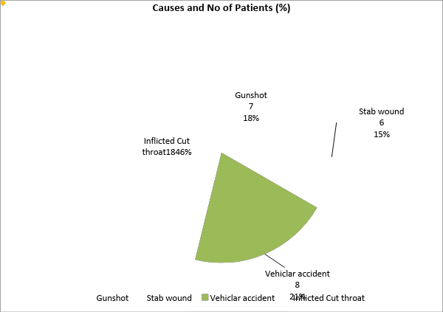
Causes et nombre de patients
Gunshot : coup de feu
Stab wound : Blessure à l'arme blanche
Vehicular Accident : Accident de véhicule
Inflicted cut throat: couper de gorge Infligé

Fig. 2: Distribution des structures impliqué dans les blessures

Number of patients : Nombre de Patients
Neural involvement : Implication neurale
Major blood vessels : vaisseaux sanguins majeurs
Oesophagus: Oesophage
Mandible : Mandibule
Laryngopharynge :Laryngopharyngeal
Skin, muscles and small blood vessels : la Peau, le muscles et des petits vaisseaux sanguins

Fig. 3: Un mâle de 42 ans officier du transport routier avec blessure à l’arme blanche à l'intérieure du cou lors de violence interpersonnel

Fig. 4: Le patient après le traitement

Fig. 5: Un étudiant de 16ans avec la couper de gorge infligé par soi

Fig. 6: Evaluation de blessure dans le théâtre avant la nettoyage de la plaie et trachéotomie

Fig 7: Réparation de structure de couper de la gorge en couches

Fig. 8: Fermeture de la peau .

Fig. 9: Guérison de blessure acharnée attendant la decannulation

Fig. 10: La réussite de decannulation

