EXPERIENCE WITH MANAGING CHILDHOOD URETHROCUTANEOUS FISTULA AT IBADAN
EXPERIENCE AVEC LA GESTION DE FISTULE URETERO-CUTANEE DE L’ENFANCE A IBADAN

*Takure AO, Adebayo SA, Sotunmbi PT, Olapade-Olaopa EO, Okeke LI, Shittu OB.
Department of Surgery, University College Hospital, Ibadan, Nigeria. E-mail: aotakure@yahoo.com
*Correspondence
Grant support: None
Subvention: Aucun
Conflict of interest: None
Conflit d'intérêts: Aucun

Abstract
Background: Urethrocutaneous fistula could be a distressing condition to the child and parents alike. Its management could be challenging and requires adequate expertise.
Aim: To review the characteristics and aetiology of urethrocutaneous fistula managed in our division over a ten-year period.
Methodology: All children with urethrocutaneous fistulae from July 2006 to June 2015 were subject of this review. The demography, aetiology, type of fistula, operation performed and the outcome were retrieved from the division operation book and case notes of the patients. The data was analyzed using SPSS Inc. version 20 and odd ratio.
Results: Thirty-five children were managed over a period of ten tears. The age ranged from 6 months to 13 years with a mean of 4±1.9years. Seventy one percent of urethrocutaneous fistulae resulted from complication of childhood male circumcision procedures performed in private hospitals and by nurses. One child (3%) had isolated perineal urethrocutaneous fistula while 26% complicated hypospadias repair at these locations: glandular in 1% case, subcoronal in 3% cases, penile in 2% cases, and penoscrotal in 3% cases. Ten (29%) children with abnormal haemoglobin AC was noted in 3 (9%) patients and haemoglobin AS in 7 (20%) patients. The odd ratio between abnormal haemoglobin and normal haemoglobin was 3.8. The surgical repair of post-circumcision urethrocutaneous fistulae and post-hypospadias had a recurrent fistulae in 4 (16%) and 3 (33%) respectively. Majority of the fistulae were repaired by simple closure in 80% post-circumcision and in 44% post-hypospadias repair. in the more difficult cases, penile degloving with urethral mobilization was done in 16% post-circumcision fistula and 22% post-hypospadias fistula with no recurrence.
Conclusion: in this study, post-circumcision urethrocutaneous fistula was the commonest cause of childhood urethrocutaneous fistula, the severe ones could require penile degloving to achieve repair without tension; recurrence was a major complication.
Key words: Childhood urethrocutaneous fistulae, Circumcision, Hypospadias repair, Recurrence.

Abstrait
Contexte : Fistule uretero- cutanée peut être une condition pénible à l’enfant et ses parents ensemble. Son gestion peut consistituer un défi et qui requiert l’expertise appropriée.
But: Pour revoir les caractéristiques et étiologie de fistule uretero- cutanée géré dans notre section pendant une période de 10 ans .
Méthodologie: Tout les enfants avec fistule uretero- cutanées du Juillet 2006 au Juin 2015 étaient sujets de cette revue . La démographie ,l’ étiologie, type de fistulae, opération faite et les résultats étaient retiré du cahier d’operation de la section et les case de notes des patients. Les données étaient analysé utilisant SPSS Inc. version 20 et rapport de cotes.
Résultats: Trente cinq enfants étaient géré pendant une période de dix ans . La gamme d’âge étaient 6 mois à 13 ans avec un moyen de 4±1.9ans. Soixante et un pourcentage d’uretero- cutanée est le résultat de complication de procédure de circoncision de l’enfance des garcons fait aux hôpitaux privé par les infirmières . Un enfant (3%) a eu le fistule uretero-cutanée périnéale isolé alors que 26% ont eu la réparation hypospadias compliqué dans ces lieux : glandulaire dans le cas 1% , sous-coronaire dans 3% cas , dans les cas du pénis en 2% cas, et pénoscrotal dans 3% cas. Dix(29%) enfants avec l’hémoglobine anormale AC étaient noté dans 3 (9%) patients et l’hémoglobine AS dans 7 (20%) patients. Le rapport de cotes entre hémoglobine anormale et hémoglobine normale était 3.8. La réparation chirurgicale du post-circoncision fistule uretero- cutanées et le post-hypospadias ont eu la fistule récurrent en 4 (16%) et 3 (33%) respectivement. La majorité des fistules étaient réparé par la fermeture simple dans 80% post-circoncisions et dans 44% la réparation post-hypospadias dans les cas difficiles, la déglutition du pénis avec la mobilisation uretral étaient fait en16% de fistule post-circoncision et 22% post-hypospadias fistule avec aucune récurrence.
Conclusion: dans cette étude , la fistule uretero- cutanée post-circoncision était le plus commun cause de fistule uretero -cutanée de l’enfance , ceux qui sont sévère peut exiger la déglutition du pénis pour achever les réparations sans tension; la récurrence était une complication majeure
Mots clés : La fistule uretero- cutanée de l’enfance, Circoncision, Réparation de Hypospadias, Récurrence.

Introduction
The incidence of urethrocutaneous fistula after hypospadias repair is varied across the world. Figures varied from 7% in the western world, 21.4% in Asia, 9.8% in Nigeria and 16.5% in Egypt ^{1,2,3,4,5}. The occurrence of these post hypospadias repair urethrocutnaneous fistulae is related to the size of fistula, the location of the fistula, the type of sutures material, the technique of repair and the use of operating loops ^{2,6}.
The repair of post hypospadias urethrocutaneous fistula is challenging because it has unacceptable recurrent rate despite numerous techniques employed in its repair which include simple closure of fistula ⁶, use of dartos flip flap ⁷ and tunneled tunica vaginalis flap ⁸, preserve the tract and turn it inside out (PATIO) ⁹, and waterproofing technique ¹⁰.
Urethrocutaneous fistula following male childhood circumcision is said to be uncommon in developed world ¹¹ but the incidence is 2.1% in Nigeria ¹²; in most cases they are amenable to simple fistula closure.
We report our finding of childhood urethrocutaneous fistula including the outcome of various surgical techniques over a ten-year period at Ibadan.

Material and Methods
This was a retrospective study of all the consecutive children with urethrocutaneous fistulae over a period of ten-years at Ibadan. The patients were categorized based on the aetiology of the fistula as post-circumcision, post-hypospadias repair and congenital urethrocutaneous fistulae. We collected data on the demographics, the size of the fistula (whether less or greater than 5 mm), the location of the fistula (glandular, subcoronal/coronal, penile, penoscrotal and perineal), the haemoglobin genotype, the type and strength of sutures were analyzed using International Business Machines Corporation Statistical Package for Social Sciences (IBM SPSS) Version 20.
All the children had inhalational general anaesthesia with endotracheal intubation. The fistula size that were less than 5mm were repaired by simple circumferential excision of fistula while those fistulae greater than 5mm (Fig.1) were repaired by penile degloving (Fig. 2) with mobilization of urethra proximal and distal to the fistula, and closure of the urethrocutaneous fistula (Fig. 3). In all the methods of repair, overlapping sutures line were avoided. All the patients were followed up for 6 months (Fig. 4 and 5).
Methods of fistula repair in this study:
- Simple closure: With the child in the supine position and general anaesthesia administered. The penile skin around the fistula opening was infiltrated with saline solution. A circumferential incision was made around the fistula and the fistula tract was dissected. The fistula edge was closed with inverting, 5/0 polyglactin sutures for children < 2 years of age or 4/0 polyglactin for those above 2 years. Local dartos flap was raised as second layer over the closed fistula. Then the penile skin closure was effected with interrupted 4/0 polyglactin.
- Circumferential incision around the fistula, then dissection of the fistulous tract with slight proximal and distal urethral mobilization. The urethral plate was incised and tubularised. This was followed by non-overlapping local flap and penile skin closure. This was performed for fistula with thinned out and fibrotic skin edges.
- In the patients with post circumcision urethrocutaneous fistula located in the glans penis, a circumferential fistula incision was made with dissection and excision of fistulous tract followed by incision on the glans, advancement of the meatus and reconstruction of the glans penis.
- Penile degloving and fistula closure: this method was used when appropriate and when the fistula was equal or greater than 10mm. The penile tissue just proximal to the corona was infiltrated with 1:200,000 adrenaline saline solutions. The penile skin was then degloved proximally and extended ventrally inferior to the skin edge of the fistula (Fig.2). The bulbospongiosus was mobilized both proximal and distal to the fistula. The edge of the fistula was excised, closed with interrupted 5/0 polyglactin (Fig.3) and the dartos flap of tissue around fistula raised as second layer over the repaired urethra. The degloved penile skin was returned to the coronal region and closed with interrupted 4/0 polyglactin suture. The data obtained were analysed SPSS version 20 and odd ratio (OR).

Results
This study was carried out between July 2006 and June 2015. A total of 35 children were managed during the study period. Their age ranged from 6 months to 13 years with a mean of 4±1.9years.
Table 1 shows the characteristics of urethrocutaneous fistula in these children. Twenty-five (71%) of the urethrocutaneous fistulae occurred as complications of male circumcision. Twenty (80%) of the post circumcision urethrocutaneous fistulae were in the sub-coronal part of the urethra, while the remaining 4(16%) and 1(4%) were located in the distal and glandular part of the urethra respectively. Post hypospadias repair urethrocutaneous fistulae were seen in 9 children (265) located at different parts of the urethra namely one in the glans, three in the corona/sub-coronal, two in the penile, and three in the penoscrotal. One child had congenital perineal urethrocutaneous fistula.
Most of the fistulae were less than 5mm in size in 20 (80%) and 6 (67%) in those after circumcision and hypospadias repair respectively.
The odd ratio (OR) between fistula size, fistula recurrence and the aetiology for post circumcision fistula was 0.35 and 0.75 for post hypospadias fistula. There was no statistical significance between fistula size and recurrence of fistula.
Table 2 shows the haemoglobin genotype distributions in the children were AA, in 25 (71%) patients, AS, in 7(20%) and AC, in 3(9%) patients. Eight (23%) children with post circumcision fistula had abnormal haemoglobin genotypes (AC and AS). The odd ratio (OR) of 3.8 between abnormal and normal haemoglobin genotypes for post circumcision urethrocutaneous fistula and post hypospadias repair urethrocutaneous fistula was statistically significant. The odd ratio of 0.5 for the relationship between type of fistulae and suture strength was not statistically significant.
In Table 2, twenty (80%) and 4 (44%) of children with post circumcision and post hypospadias repair had simple closure of their fistulae. Modification of incision of the dorsal urethral plate was incorporated into the repair of fistula in 2 children, one each with post circumcision and post hypospadias repair respectively. Meatal advancement with closure of fistula was performed for 2 (22%) of the post hypospadias repair fistulae.
Six of the seven children with recurrent fistula irrespective of the aetiology, size of fistulae and the congenital urethrocutaneous fistula all had circumferential penile skin degloving and non overlapping dartos flap and penile skin closure with no subsequent recurrence.
The first and second recurrence rate for post circumcision fistulae were 8% and 50% while that for post hypospadias repair fistulae were 25% and 100% respectively. The overall urethrocutaneous fistula recurrence rate was 20%.

Discussion
Urethrocutaneous fistula as a complication of male childhood circumcision is uncommon in the United Kingdom though with low circumcision rate of 5-6%. However, the complication is not uncommon in the United States (80-90%) or Nigeria (87%) where the rate of circumcision is quite high^{13,14}. The post circumcision urethrocutaneous fistula commonly followed those procedures performed outside the secondary or tertiary hospitals as reported by Osifo in Benin-City as was shown in this study ¹². Post circumcision urethrocutaneous fistula accounted for 74% of fistulae seen in this study which was much higher than 21.1% reported in Benin-City, Nigeria¹². This may be related to the population of Ibadan being a cosmopolitan city with a higher population of 3,565,108 compared to 1,125,058 0f Benin-City ¹⁵. Like previous report in Nigeria, majority of the post circumcision urethrocutaneous fistulae were located in the coronal/sbucoronal and distal penile regions ¹⁶. This was not surprising because the frenula artery is found at this location and often is damaged during circumcision by the untrained personnel or by application of the plastibell device ¹⁵. Along with the poor vascular blood supply at the corona^{5,12}, which is in tanderm with the location of most of such fistulae.
The incidence of haemoglobin AC of 9% in this study is much higher than in a population study in Ibadan of 0.2%. However, the incidences of haemoglobin geneotypes AS and AA in this study are like that reported by Umoh et al ¹⁷.
In this study, the size of fistula, aetiology of fistula, strength and type of suture material used for repair were not significant factors in those children with recurrent urethrocutaneous fistulae. This is similar to report by Chung et al, in Korea ². Although Holland et al, reported a relationship between suture strength and recurrence of urethrocutaneous fistula ¹. Post hypospadias repair fistulae tend to occur more in the corona and perineal aspect of the urethra ^{1,6} as we found in this study, where over 60% were in the corona and penoscrotal region.
The simple closure of urethrocutaneous fistula is usually the first technique of choice for closure, but it is often complicated with recurrence particularly for large fistulae. Hence the recommendation that only small size fistula should be closed by this simple method ⁶. In our study majority of the fistulae irrespective of aetiology and size were closed by the simple method and the recurrence rates were 16% and 33% for fistula after circumcision and after hypospadias repair respectively. The high recurrence rate of fistula after hypospadias repair may be related to the small number of patients in this study. The limitation of this study was that the total number of hypospadias repair done within the study period was not examined.
Various techniques have been described to reduce recurrence of childhood urethrocutaneous fistula. These included the use of dartos-based flip flap ⁷, tunneled tunica vaginalis flap ⁸, to preserve the tract and turn it inside out (PATIO) ⁹, and waterproofing technique ¹⁰. In this study, large fistula and recurrent fistulae were treated by penile degloving, inversion of fistula edge, dartos flap layer approximation and return of the degloved penile skin. This technique combined the PATIO repair described by Malone with the dartos based flap described by Tamera et al. All these patients healed without recurrence.
The congenital childhood urethrocutaneous fistula is very rare and only a total of 24 cases have been reported in English literature as at the year 2012 ^{18,19}. We successfully treated a case with congenital fistula of 10mm by penile degolving and closure of fistula tract.
In conclusion, post-circumcision urethrocutaneous fistula was the commonest cause of childhood urethrocutaneous fistula, the severe ones could require penile degloving to achieve repair without tension with no recurrence. Abnormal haemoglobin genotype may play a role in the development of urethrocutaneous fistula.

References
- Holland AJA, Abbacker M, Smith GHH, Cass DT. Management of urethrocutaneous fistula following hypospadias repair. Pediatr Surg Int. 2008;24(9):1047-1051.
- Chung JW, Choi sh, Kim BS, Chung SK. Risk factors for the development of urethrocutaneous fistula after hypospadias repair: A retrospective study. Korean J Urol. 2012;53:711-715.
- Yassin T, Bahaaeldin KH, Husein A , Minawi HE. Assessment and management of urethrocutaneous fistula developing after hypospadias repair. Ann Pediatr Surg. 2011;7(2):88-93.
- Sowande AO, Olajide AO, Salako AA, Olajide FO, Adejuyigbe O, Talabi AO. Experience with transverse prepucial island flap for repair of hypospadias in Ile-Ife, Nigeria. Afr J Paediatr Surg. 2009;6:40-43.
- Elbaky A. Management of urethrocutaneous fistula after hypospdias repair: 10 years experience. BJU Int. 2001;88(6):590-595.
- Mohammed S, Mohammed N, Esmael T, Khaled SH. A simple procedure for the management of urethrocutaneous fistulas; post-hypospadias repair. Afr J Paediatr Surg. 2010;7(2):124-128.
- Soni A, Sheoran S. Repair of large urethrocutaneous fistula with dartos-based flip flap: A study of 23 cases. India J Plast Surg. 2007;40(1):34-38.
- Routh JC, Wolpert JJ, Reinberg Y. Tunneled Tunica Vaginalis Flap for recurrent urethrocutaneous fistulae. Adv Urol [Internet]. 2008[cited 2008 Aug 11]:1-3 Available from: http://www.hindawi.com/journals/au/2008/615928/

- Malone PR. Urethrocutaneous fistula: preserve the tract and turn it inside out: the PATIO repair. BJU Int. 2009; 104(4):550-554.
- Srivastava RK, Tandale MS, Panse N, Gupta A, Sahane P. Management of urethrocutaneous fistula after hypospadias surgery- An experience of thirty-five cases. India J Plast Surg. 2011;44(1):98-103.
- Sancaktutar AA, Pembeul N, Bozhurt Y, Kolcu B, Tepeler A. Multiple circumferential urethrocutaneous fistulae as a rare complication of circumcision and review of literature. Urology. 2011;77(3):728-729.
- Osifo IA. Circumcision mishaps in Nigeria children. Ann Afr Med. 2009;8:266-270.
- Williams N, Kapila L. The circumcision reference library. BJS. 1993;80:1231-1236.
- Okeke L, Asinobi AA, Ikuerowo OS. Epidemiology of complications of male circumcision in Ibadan, Nigeria. BMC Urol. 2006;6:21
- Population of Cities in Nigeria (2018) [cited 2018 Jan 15]. Available from: http://worldpopulationreview.com/countries/nigeria-population/cities/
- Ikuerowo SO, Bioku MJ, Omisanjo OA, Esho JO. Urethrocutaneous fistula complicating circumcision in children. Niger J Clin Pract. 2014;17(2):145-148.
- Umoh AV, Abah GM, Ekanem TI, Essien EM. Haemoglobin genotype: a prevalence study and implications for reproductive health in Uyo, Nigeria. Niger J Med. 2010;19(1):36-41.
- Shukla RM, Mukhopadhyay B, Mandal KC, Barman SS. Congenital penile urethrocutaneous fistula: A rare anomaly and review of literature. Urol Ann. 2011;3(30):161-163.
- Bhatnagar A, Upadhayaya VD, Kumar B. Congenital urethrocutaneous fistula: Case report with review of literature. Indian J Plast Surg. 2012;46(3):563-565

Table 1: Characteristics of urethrocutaneous fistula in children in Ibadan
______________________________________________________________________________
Aetiology number, (%)
Post circumcision 25(71)
Post hypospadias 9(26)
Congenital 1(3)

Location of fistula post circumcision post hypospadias congenital
Glandular 1(4%) 1
Subcoronal 20(80%) 3
Distal penile 4(16%) none
Proximal penile none 2
Penoscrotal none 3
Perineal none none 1

Fistula size/recurrence post circumcision post hypospadias congenital % Total *OR
Fistula <5mm 0.35
Recurrence 3 2
No recurrence 17 4

Fistula > 5mm 0.5
Recurrence 1 1
No recurrence 4 2 Actual recurrence 4(16%) 3(33%) 7/35(20%)
Actual non recurrence 21(84%) 6(67%) 1(3%)

______________________________________________________________________________
*OR – odd ratio

Table 2: Factors affecting childhood urethrocutaneous fistula recurrence and surgical techniques used in Ibadan

Hemoglobin Genotype *OR
Post circumcision post hypospadias congenital % Total 3.8
AC 3 none none 3(9%)
AS 5 1 1 7(20%)
AA 17 8 none 25(71%)

Suture type versus recurrence
4/0 Polyglactin 0.15
Recurrence 3 4
No recurrence 5 1 1
5/0 Polyglactin
No recurrence 17 4

Surgical technique post circumcision post hypospadias congenital
#1 20(80%) 4(44%) not applicable
#2 1(4%) 1(11%) not applicable
#3 none 2(22%) not applicable
#4 4(16%) 2(22%) 1(100%)
____________________________________________________________________________
#1 – simple fistula closure; #2 – incision of urethra plate with fistula closure; #3 – advancement of urethra meatus with fistula closure; #4 – penile degloving, urethral mobilization, fistula closure, fascial and skin closure.

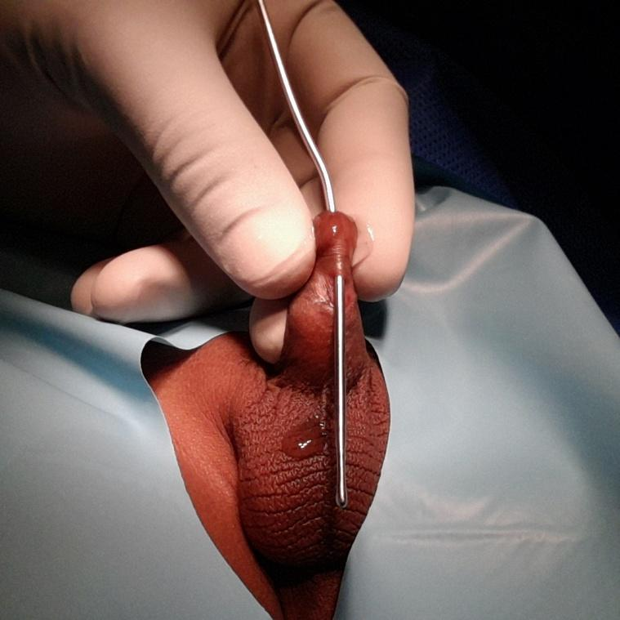
Fig. 1: probe demonstrating recurrent subcoronal urethrocutaneous fistula.

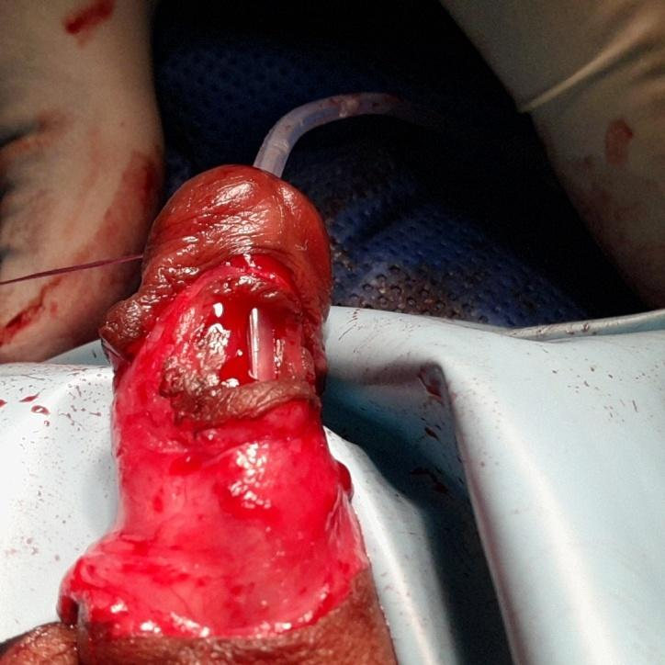

Fig. 2: shows large urethrocutaneous fistula after penis was degloved.

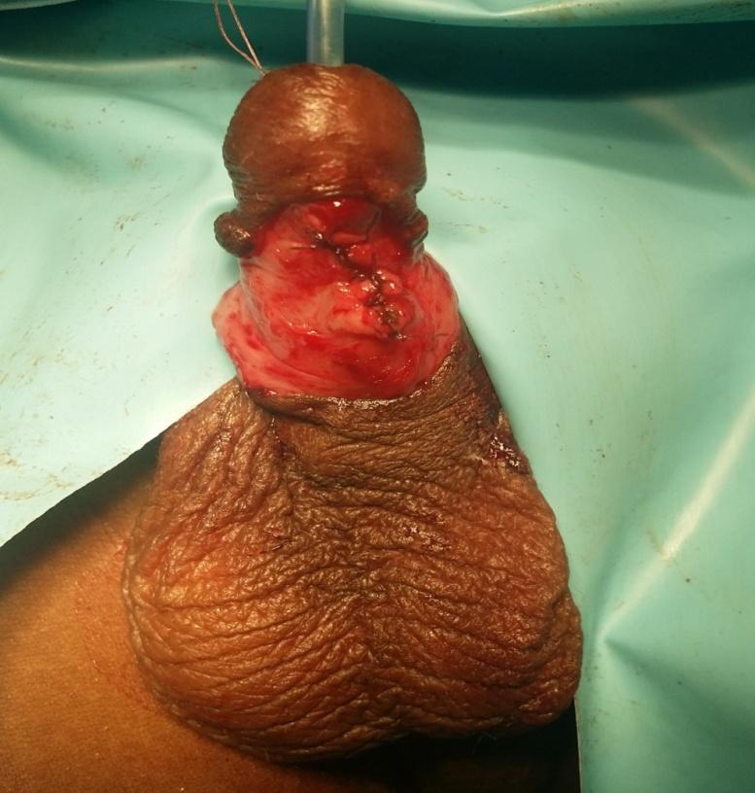
Fig. 3: degloved penis with closed urethrocutaneous fistula.

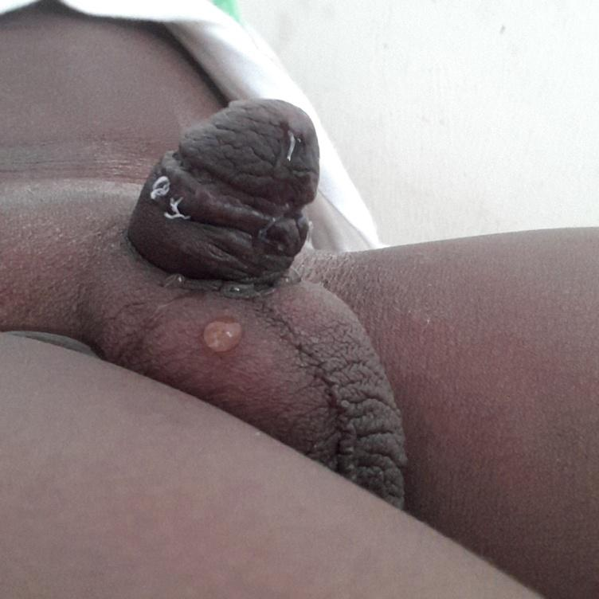
Fig. 4: four weeks after closure of recurrent post circumcision urethrocutaneous fistula.

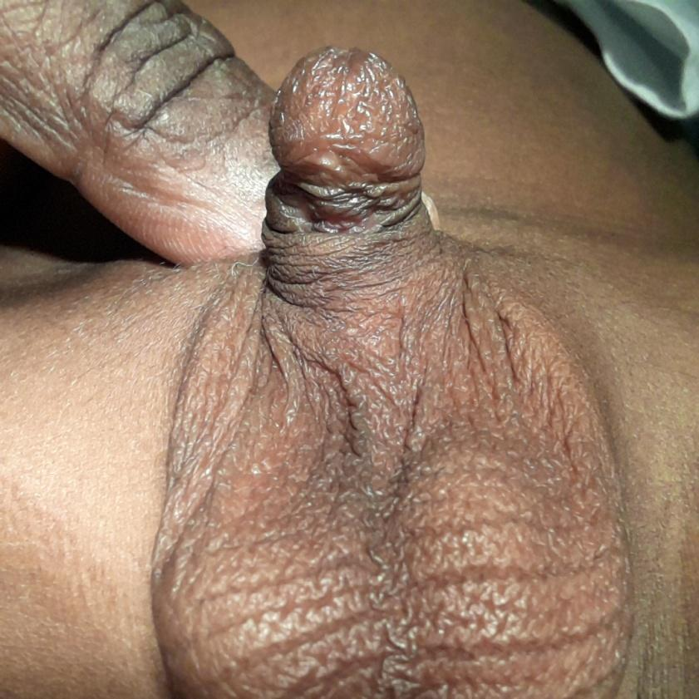
Fig. 5: 6 months after closure of urethrocutaneous fistula

Introduction
L’ incidence de fistule uretero -cutanée après la réparation hypospadias est variée mondialement. Les figures varié de 7% dans le monde occidental, 21.4% en Asie, 9.8% au Nigéria et 16.5% en Égypte^{1,2,3,4,5}. L’ occurrence de ces réparations post hypospadias de fistule uretero- cutanée est lié à la taille de fistule, la location de fistule, le type de matériel de sutures,la technique de réparation et l’usage de boucle opératoire^{2,6}.
La réparation de fistule uretero- cutanée hypospadias est un défi car il a du taux récurrent malgré des techniques nombreux appliquer sa réparation qui inclut la simple fermeture de fistule⁶, l’usage de dartos revirement⁷ et tunique tunnalise vaginalis rabat⁸, préserve le tract et la tourne à l’envers (PATIO)⁹, et la technique hydrofugee ¹⁰.
La fistule uretero- cutanée suite de la circoncisson de garcon dans l’enfance est commun dans les pays en voie de développement¹¹ mais le taux d’ incidence est 2.1% au Nigéria¹²; dans la plupart des cas ils sont accomodable à la simple fermeture de fistule.
Nous rapportons notre résultat de fistule uretero- cutanée de l’enfance comprenant le résultat des techniques chirurgical varier pendant une période de dix ans à Ibadan.

Matériel et Méthodes
C’est une étude rétrospective de tout les enfants consécutive avec la fistule uretero- cutanée pendant une periode de dix ans à Ibadan. Les patients étaient catégorise basé sur l'étiologie de fistule comme post-circoncision,la réparation de post-hypospadias et la fistule uretero- cutanée congénital . Nouc avons ramassé des données démographique, la taille de fistulae (si c’est moins ou plus que 5 mm), la location de fistulae (glandulaire, sous-coronaire/coronaire , pénis, penoscrotale et périnéale), la genotype hémoglobine, type et pouvoir de sutures étaient analysé utilisant le paquet statistique de International Business Machines Corporation pour les sciences sociales (IBM SPSS) Version 20.
Tout les enfants ont l'anesthésie général par inhalation avec intubation endotracheale . La taille qui était moins de 5m était réparé avec l'excision simple de fistule excision circonferentielle alors que ces fistules étaient plus grand que 5mm (Fig.1) étaient réparé par la déglutition du pénis (Fig. 2) avec une mobilisation d’uretral proximal et distal a la fistule,et la fermeture de fistule uretero- cutanée (Fig. 3). Dans toutes les méthodes de repère , les lignes de sutures rabat étaient évité . Tout les patients étaient suivi pendant 6 moid (Fig. 4 et 5).
Méthode de repère fistulae dans cette étude .
- Simple fermeture: Avec l’enfant dans une position allongée et l'anesthésie général administré. La peau du pénis autour de l'ouverture de fistulae était infiltré avec la solution saline . Une incision circonferentielle était fait autour de la fistulae et la tract fistule était disséqué .Le bord de la fistule était fermée avec l ’ inverser, 5/0 polyglactin sutures pour les enfants < 2 ans d’âge ou 4/0 polyglactine pour ceux qui sont au dessus de 2 ans. Le dartos rabat local était élevé comme la deuxième couche sur la fistule fermée . Donc la fermeture de la peau du pénis était affecté avec polyglactin 4/0 interrompu.
- L’incision circonferentielle dans la fistule , et puis la piqure anatomique de tract fistule avec la proximale légère et mobilisation de l’uretral distal . La plaque uretrale était incise et tubularise . Ceci était suivi par le non-chevauchantesver de lambeau local et la fermeture de la peau du pénis. Ceci était fait pour la fistule avec la réduite et le bord de la peau fibrostique .
- Dans les patients avec la fistule de post circoncision uretero -cutanée localisé dans le gland pénis, une incision fistule circonferentielle à été fait avec piqure anatomique et l'excision de tract fistule suivi par l’incision sur le gland ,l’ avancement du méat et la reconstruction du gland pénis.
- La déglutition du pénis et fermeture fistule: cette méthode à été utilisé quand il est appropriat et quand la fistule est égale ou plus que 10mm. Le tissu du pénis est juste proximale à la coronaire était infiltré avec 1:200,000 les solutions de saline adrénaline . La peau de pénis était degantage proximalement et prolongé ventralement inférieur au bord de la peau de fistule (Fig.2). Le bulbospongieux était mobilisé par les proximales et le distal à la fistulae . Le bord de la fistulae était excisé, fermé avec la polyglatine interrompu 5/0 (Fig.3) et le tissus dartos rabat autour de fistule élevé comme deuxième couche sur l’uretral réparé . La peau du pénis degantage était retourné à la région coronaire et fermé avec la suture polyglactine interrompu 4/0 . Les données obtenues étaient analysé avec SPSS version 20 et rapport de case ratio (OR).

Résultats
Cette étude a été fait entre le Juillet 2006 et Juin 2015.Un total de 35 enfants étaient géré pendant cette période . Leur âge étaient de 6 mois à 13 ans avec un moyen de 4±1.9anss.
Tableau 1 montre les caractéristiques de fistule uretero- cutanée dans ces enfants . Vingt cinq (71%) de fistule uretero-cutanée se produit comme des complications de circoncision de mâle . Vingt (80%) de circoncision de fistule uretero -cutanée étaient dans la partie sous-coronaire d’uretral, alors que le reste 4(16%) et 1(4%) étaient localisé dans le distal et la partie glandulaire d’uretral respectivement. La réparation de post hypospadias de fistule uretero- cutanée étaient vue en 9 enfants(265) localisé dans les parties différentes d’uretral à savoir dans les glans, trois dans la coronaire/sous -coronaire, deux dans le pénis, et trois dans le pénoscrotal. Un enfant à eu la fistule uretero-cutanée de périnéale congénital.
La plupart de fistulae est moins de 5mm en taille dans 20 (80%) et 6 (67%) dans quelques uns après la circoncision et réparation de hypospadias respectivement.
Le rapport de cotes (OR) entre la taille fistule, la récurrence de fistulae et l'étiologie pour le post circoncision fistule était 0.35 et 0.75 pour le post hypospadias fistule. Il n y a aucune significative statistiquement entre la taille fistule et la récurrence fistule.
Tableau 2 montre que la distribution de genotype hémoglobine chez les enfants AA, dans 25 (71%) patients, AS, dans 7(20%) et AC, dans 3(9%) patients. Huit (23%) enfants avec le post circoncisson fistule ont l’hémoglobine anormale (AC et AS). Le rapport de cotes (OR) de 3.8 les genotypes hémoglobine normale et anormale pour la post circoncision de la fistule uretero- cutanée et la réparation de hypospadias fistule uretero -cutanée était statistiquement significative . Le rapport de cotes de 0.5 pour la relation entre le type de fistule et son pouvoir suture n’était pas statistiquement significative.
Au tableau 2, vingt (80%) et 4 (44%) des enfants avec le post circoncision et la réparation du post hypospadias ont eu une simple fermeture de leur fistulae. La modification de l’ incision de la plaque d’uretral dorsal était incorporé dans la réparation de fistule dans 2 enfants,chaque un avec le post circoncision et la réparation du post hypospadias respectivement. L’avancement méat avec fermeture de fistule était fait pour 2 (22%) de réparation fistule post hypospadias.
Six parmi les sept enfants avec la fistule récurrent quelque soit l'étiologie,taille de fistule et la fistule uretero - cutanée congénital ont tous circonferentiel et le pénis déglutition de peau et dartos rabat et de la fermeture de peau pénis sans récurrence subséquent.
La première et second taux de récurrence pour le post circoncisson fistule étaient8% et 50% alors que pour la réparation du post hypospadias fistulae étaient 25% et 100% respectivement. L’ entière taux de récurrence de fistule uretero- cutanées était 20%.
Discussion
La fistule uretero-cutanée est une complication de circoncision de l’enfant mâle est rare au royaume uni même que le taux bas de circoncision de 5-6%. Néanmoins, la complication est commune aux états unis (80-90%) ou au Nigéria (87%) la où le taux de circoncision est élevé^{13,14}. La fistule post cironcision uretero-cutanée est normalement accompagné par les procédures effectué en dehors d'école secondaire ou les hôpitaux tertiaires comme rapporté par Osifo à Benin-City comme il est montré dans cette étude¹². La fistule uretero-cutanée post circoncision est responsable de 74% fistule vue dans cette étude qui était plus élevé que 21.1% rapporté à Benin-City, Nigéria ¹². Cela peut être lié à la population d’ Ibadan étant la ville cosmopolite avec une population élevé de 3,565,108 comparé à 1,125,058 de Benin-City ¹⁵. Comme le rapport précédent au Nigéria, la majorité de fistule uretero- cutanée post circoncision était localisé dans coronaire/sous-coronaire et région de distal du pénis¹⁶. Cela n'était pas surprenant parce que l'artère frenulum est trouvé dans cette location et il est souvent endommagé pendant la circoncision par des personnels incompétents ou par le dipositif de plastibell ¹⁵. Avec la pauvre approvisionnement vasculaire en sang à la coronaire^{5,12}, ce qui en revanche en tandem avec la location de la plupart de ce genre de fistule.
L’ incidence d’ hémoglobine AC de 9% dans cette étude est plus élevé que dans une étude de population d’ Ibadan de 0.2%. Néanmoins , les incidences des genotypes hémoglobine AS et AA dans cette étude sont celui qui est rapporté par Umoh et al¹⁷.
Dans cette étude, la taille de fistule, étiologie de fistule, pouvoir et le type de matériel suture utilisé pour la réparation n’était pas de facteurs significative dans les enfants avec le la fistule uretero-cutanée récurrent . Ceci est similaire au rapport de Chung et al, en Corée². Même que Holland et al, ont rapporté une relation entre le pouvoir de suture et la récurrence de fistule uretero-cutanée¹. Le réparation de fistule post hypospadias se produit souvent dans la coronaire et l'aspect périnéale aspect de l’ uretral^{1,6} comme trouvé dans cette étude , ou plus de 60% était la coronaire et région pénoscrotal.
La simple fermeture de simple fistule uretero-cutanée est normalement la première technique de choix pour la fermeture , mais il est souvent compliqué avec la récurrence particulièrement pour le large fistule. Donc la recommendation que seul les petits taille de fistule doit être fermé par une simple méthode⁶. Dans notre étude ,la majorité des fistules quelque soit l’étiologie et taille étaient fermé par une simple méthode et les taux de récurrence étaient 16% et 33% pour la fistule après la circoncision et après la réparation hypospadias respectivement. La haute récurrence de taux de fistule après la réparation hypospadias peut être lié aux petits nombres de patients dans cette étude. La limitation de cette étude était que le nombre total de réparation hypospadias a été fait dans la période où l’étude n’était pas examiné.
Des techniques varier ont été décrit pour réduire la récurrence de fistule uretero-cutanée de l’enfance. Ils inclurent l’usage de dartos rabat⁷, tunique tunnalise vaginalis rabat⁸, pour préserver le tract et le tourne à l'inverse (PATIO)⁹, et la technique de déglutition¹⁰. Dans cette étude, le large fistule et fistule récurrent étaient traité par la deglutition du pénis, l'inverse de bord de fistule, dartos rabat couche approximation et le retour de la peau de déglutition de pénis. Cette technique a combiné le reparation PATIO décrit par Malone avec le dartos rabat décrit par Tamera et al. Tout ces patients se sont guérit sans la récurrence.
La fistule congénitale de uretero-cutanée de l’enfance est très rare et seulement un total de 24 cas à été rapporté dans la biographie anglaise en 2012^{18,19}. Nous avons traité avec succès un cas avec la fistule congénital de 10mm par la déglutition du pénis et la fermeture de tract fistule.
En conclusion, la fistule uretero-cutanée du post circoncision était la cause le plus commun de fistule uretero-cutanée , ceux qui sont sévère peut require la déglutition du pénis pour achever la réparation sans tension avec aucune récurrence. La genotype hémoglobine anormale peut jouer un rôle dans le développement de fistule uretero-cutanée.

Références
- Holland AJA, Abbacker M, Smith GHH, Cass DT. Gestion de fistule uretero-cutanée suite de la reparation de hypospadias . Pediatr Surg Int. 2008;24(9):1047-1051.
- Chung JW, Choi sh, Kim BS, Chung SK. Risques facteurs du développement de la fistule uretero-cutanée après la réparation de hypospadias : Une étude rétrospectives. Korean J Urol. 2012;53:711-715.
- Yassin T, Bahaaeldin KH, Husein A , Minawi HE. Evaluation et gestion de fistule uretero-cutanée en voie développement après la réparation d’hypospadias . Ann Pediatr Surg. 2011;7(2):88-93.
- Sowande AO, Olajide AO, Salako AA, Olajide FO, Adejuyigbe O, Talabi AO. Expérience avec l’ile transverse prepuce rabat pour la reparation d’hypospadias à Ile-Ife, Nigéria. Afr J Paediatr Surg. 2009;6:40-43.
- Elbaky A. La gestion de fistule uretero-cutanée après la réparation d’ hypospdias : expérience de 10 ans. BJU Int. 2001;88(6):590-595.
- Mohammed S, Mohammed N, Esmael T, Khaled SH. Une simple procédure pour la gestion de fistule uretero-cutanée; la réparation post-hypospadias . Afr J Paediatr Surg. 2010;7(2):124-128.
- Soni A, Sheoran S. La réparation de large fistule uretero-cutanée avec dartos rabat: Une étude de 23 cas. Inde J Plast Surg. 2007;40(1):34-38.
- Routh JC, Wolpert JJ, Reinberg Y.Tunique tunnelise vaginalis rabat pour la fistule uretero-cutanée récurrent. Adv Urol [Internet]. 2008[cited 2008 Aug 11]:1-3 Disponible à: http://www.hindawi.com/journals/au/2008/615928/

- Malone PR uretero-cutanée : préserve le tract et le tourne à l’inverse : la réparation PATIO . BJU Int. 2009; 104(4):550-554.
- Srivastava RK, Tandale MS, Panse N, Gupta A, Sahane P. Gestio d’uretero-cutanée après la chirurgie hypospadias - Une expérience de trente cinq cas . Inde J Plast Surg. 2011;44(1):98-103.
- Sancaktutar AA, Pembeul N, Bozhurt Y, Kolcu B, Tepeler A.Circonferentiel multiple de fistule uretero-cutanée en tant que complication rare de circoncision et revue de biographie de littérature . Urologie 2011;77(3):728-729.
- Osifo IA. Circumcision mishaps chez les enfants Nigérian . Ann Afr Med. 2009;8:266-270.
- Williams N, Kapila L. Bibliothèque de référence de circoncision . BJS. 1993;80:1231-1236.
- Okeke L, Asinobi AA, Ikuerowo OS. Épidémiologie de complications de circoncision de mâle à Ibadan, Nigéria. BMC Urol. 2006;6:21.
- La population des cités au Nigéria (2018) [cited 2018 Jan 15]. Disponible à : http://worldpopulationreview.com/countries/nigeria-population/cities/
- Ikuerowo SO, Bioku MJ, Omisanjo OA, Esho JO. Fistule uretero-cutanée compliquer la circoncision ches enfants . Niger J Clin Pract. 2014;17(2):145-148.
- Umoh AV, Abah GM, Ekanem TI, Essien EM. Genotype Hémoglobine : une étude de prévalence et implications de la santé reproductive à Uyo, Nigéria. Niger J Med. 2010;19(1):36-41.
- Shukla RM, Mukhopadhyay B, Mandal KC, Barman SS . Congenital pénis fistule uretero-cutanée : Une anomalie rare et revue de littérature. Urol Ann. 2011;3(30):161-163.
- Bhatnagar A, Upadhayaya VD, Kumar B. Fistule uretero Congénitale: Cas de repport avec la revue de littérature. Inde J Plast Surg. 2012;46(3):563-565.

Tableau 1: caractéristiques de fistule uretero-cutanée chez les enfants à Ibadan
______________________________________________________________________________
Étiologie nombre, (%)
Post cironcision 25(71)
Post hypospadias 9(26)
Congénital 1(3)

Location de fistule post circoncision post hypospadias congénital
Glandulaire 1(4%) 1
Sous-coronaire 20(80%) 3
Pénis Distal 4(16%) Aucune
Pénis.Proximal Aucune 2
Pénoscrotal Aucune 3
Périnéale Aucune Aucune 1

Taille de Fistule /récurrence post circoncision post hypospadias congénital % Total *OU
Fistule <5mm 0.35
Récurrence 3 2 A Aucune récurrence 17 4

Fistule > 5mm 0.5
Récurrence 1 1
Aucune récurrence 4 2 Récurrence actuel 4(16%) 3(33%) 7/35(20%)
Aucune recurrence actuel 21(84%) 6(67%) 1(3%)

______________________________________________________________________________
*OU – rapport de case

Tableau 2: Les facteurs qui affectent la fistule uretero-cutanée récurrence et techniques chirurgicale utilisé à Ibadan
______________________________________________________________________________
Genotype Hémoglobine *OU
Post cironcision post hypospadias congénital % Total 3.8
AC 3 aucune aucune 3(9%)
AS 5 1 1 7(20%)
AA 17 8 aucune 25(71%)

Suture type versus récurrence
4/0 Polyglactin 0.15
Récurrence 3 4
Aucune récurrence 5 1 1
5/0 Polyglactine
Aucune récurrence 17 4

Technique Chirurgicale post cironcision post hypospadias congénital
#1 20(80%) 4(44%) non applicable
#2 1(4%) 1(11%) non applicable
#3 aucunee 2(22%) non applicable
#4 4(16%) 2(22%) 1(100%)
____________________________________________________________________________
#1 – simple fermeture de fistule ; #2 – incision de plaque uretrale avec la fermeture de fistule ; #3 – avancement d’uretral de méat avec la fermeture de fistule; #4 – la déglutition du pénis , mobilisation uretral ,fermeture fistule , fermeture faciale et la peau

Fig. 1: Sonde démontrer la récurrente sous-coronaire fistule uretero-cutanée

Fig. 2: Montrant le large fistule uretero-cutanée après la déglutition du pénis

Fig. 3: La déglutition du pénis avec la fistule uretero- cutanée fermé

Fig. 4: Quatre semaines après la fermeture de post cironcision de fistule uretero-cutanée récurrent

Fig. 5: 6 mois après la fermeture de fistule uretero-cutanée

