**Original Article**

Effects of Covid-19 Pandemic on The Surgical Training of Final Year Medical Students in South-Eastern Nigeria

## Abstract

**Background:** The COVID-19 pandemic has drastically impacted surgical training and education of medical students in various institutions. The South-eastern Nigeria situation was evaluated with respect to surgical training, with a view to identify gaps and proffer solutions. **Objectives:** To determine the impact of covid-19 pandemic on surgical training of undergraduate medical students, their experiences and alternatives being implemented to continue their education. **Materials and Methods:** Design: Cross-sectional survey amongst 181 final year medical students in South-eastern Nigeria was conducted.

A structured questionnaire designed using the free software Google® Forms was utilized for the study. The questionnaire was electronically distributed randomly using online platforms. The data obtained was analyzed by Statistical Package for the Social Sciences (SPSS®). Ethical approval was obtained from the appropriate ethics and research unit prior to commencement of the study. **Results:** In all, 181 final year medical students completed and submitted the questionnaire. Majority of the respondents (55.8%) denoted that their exposure to surgical cases in general were markedly decreased; 61.9% and 56.9% of respondents reported a slight decrease in physical examination and clerkship opportunities respectively. 51.1% indicated that a hybrid of virtual and physical classes was used with cost of data subscription being a major challenge to active online participation according to 58.3% of the respondents. Departmental conferences and case discussions reduced according to 47.8% of respondents while 56.9% attested to a reduction in opportunities to acquire basic surgical skills since the pandemic. Majority of respondents said their personal study time remained the same and 56.9% said their overall undergraduate surgery training has been slightly worse than before the pandemic.

There was no statistically significant relationship associating gender with clerkship opportunities, physical examination opportunities or exposure to surgery cases in the Covid-19 pandemic era using a p-value of <0.05 as significant **(Chi-square 1.395, p-value 0.85); Chi-square-2.985, p-value- 0.40, Chi-square-3.325, p-value-0.51 respectively). Conclusion:** The COVID-19 pandemic has significantly affected the clinical and teaching components of undergraduate surgical training in South-Eastern Nigeria. It has, however, led to increased adoption of digital technology which should be further explored in the face of current realities.

We recommend that there should be a flexible re-adjustment of the syllables and pattern of surgical training of medical students to accommodate unavoidable events that can disrupt the training such as the covid-19 pandemic in a bid to prevent future disruptions in training.

**Keywords:** *Covid-19 pandemic, final year, medical education, medical students, Nigeria, South-East, surgical training*

**Kelechi U. Imediegwu1, Paschaline C. Onwuka2, Angelica C. Uwaezuoke2, Jude C. Abor2, Ajibola Oladiran3,4**

*1Department of Orthopaedic Surgery, National Orthopaedic Hospital, Enugu, 2College of Medicine, University of Nigeria, Enugu, 3Department of Surgery, College of Medicine, University of Ibadan, 4Orthopaedic and Trauma Surgery Department, University College Hospital, Ibadan, Nigeria*

**Received:** 30-May-2022 **Accepted:** 27-Jul-2022 **Published:** 06-Oct-2022

***Address for correspondence:***

*Dr. Ajibola Babatunde Oladiran, Department of Surgery,*

# Introduction

In late December 2019, the coronavirus disease-2019 (COVID-19), caused by a novel severe acute respiratory syndrome coronavirus 2 (SARS-CoV-2), emerged in Wuhan, China.[1] By 30th January 2020, when the World Health Organization (WHO) announced COVID-19 as the sixth Public Health Emergency of International

Concern, it had spread to over 20 countries worldwide (including the United States of America).[2] The WHO declared the disease a pandemic on 11 March 2020, having affected over 100 countries, with more than 100,000 recorded infections.[3,4] To date, over 23 million cases and more than 800,000 deaths have been reported in 215 countries worldwide.[5] All African countries are affected, with a total case count of over

*College of Medicine, University of Ibadan, Orthopaedic and Trauma Surgery Department, University College Hospital, Ibadan.*

*E-mail:* [*aboladir*](mailto:aboladiran@com.ui.edu)[*an@com.ui.edu.*](mailto:an@com.ui.edu) *ng,* [*ajibola.oladiran@yahoo.com*](mailto:ajibola.oladiran@yahoo.com)

1 million and more than 27,000 deaths,

|  |
| --- |
| **Access this article online** |
| **Website:**  [www.jwacs-jcoac.com](http://www.jwacs-jcoac.com/) |
| **DOI:** 10.4103/jwas.jwas_129_22 |
| **Quick Response Code:** |

This is an open access journal, and articles are distributed under the terms of the Creative Commons Attribution-NonCommercial- ShareAlike 4.0 License, which allows others to remix, tweak, and build upon the work non-commercially, as long as appropriate credit is given and the new creations are licensed under the identical terms.

**How to cite this article:** Imediegwu KU, Onwuka PC, Uwaezuoke AC, Abor JC, Oladiran A. Effects of COVID-19 pandemic on the surgical training of final year medical students in South-Eastern Nigeria. J West Afr Coll Surg 2022;12:64-70.

**For reprints contact:** [reprints@medknow.com](mailto:reprints@medknow.com)

64 © 2022 Journal of the West African College of Surgeons | Published by Wolters Kluwer ‑ Medknow

Imediegwu, *et al.*: Effects of covid-19 pandemic on the surgical training of final year medical students in south-eastern nigeria

representing 5% of all cases reported globally.[5] Since the first case of COVID-19 in sub-Saharan Africa was reported in Nigeria on 27 February 2020, the country has recorded 53,477 cases and 1011 deaths in all her 36 states, including the Federal Capital Territory (FCT), as at 28 August 2020.[6,7] Over 850 Nigerian health workers have been infected with the virus.[8] More than 300 of these are resident doctors, sadly, 14 have died from the infection.[8] The foregoing gives a peek into the public health impact of the COVID-19 pandemic.

In line with international measures, the Nigerian government declared a total lockdown on 30th March 2020.[9] Although the total lockdown was eased on 27 April 2020 to allow for minimal essential activities, containment measures such as curfews, restricted patient care, especially so with the suspension of outpatient clinics and postponement of elective operations across most surgical specialties.[10] Patients were also generally reluctant to visit hospitals due to fear of contracting the virus.[11,12] Studies evaluating the implications of these on patient outcomes during the pandemic have shown a significant rise in mortality and morbidity.[13,14]

Clinical education is uniquely different from education in other disciplines at undergraduate levels because of the fundamental relationship between clinical work and clinical science education, in which education takes place in the workplace and both are complimentary. Therefore, the strategies used in nonclinical disciplines cannot be realistic in the clinical sciences, especially in surgery. In the past centuries, surgeons have been taught through the Halstedian model of training that entails learning the techniques of surgery through apprenticeship. This method was quite successful in providing a skilled surgical workforce in the past.[15]

The pandemic and its containment measures have important ramifications on the training of medical doctors.[16] The surgical specialties, being largely dependent on patient flow for hands-on experience, stand the greatest risk of being negatively affected. The impact of the coronavirus pandemic on student’s surgery education in the south-eastern part of Nigeria is being evaluated in this study.

The Coronavirus disease 2019 (COVID-19) pandemic has altered how surgery education is delivered worldwide. Didactic sessions have transitioned to electronic/online platforms and clinical teaching opportunities are limited. These changes will affect how surgery is taught to clinical students. In the clinical learning environment, medical students primarily shadow surgeons and surgical residents and attend surgical resident teaching sessions. These formats of surgery education, which have been the tenets of the specialty, pose significant challenges during the pandemic. This article reviews how undergraduate surgery education is affected by COVID-19 and explores solutions

for teaching and learning based on e-learning and blended learning theory.

Following the pandemic, surgery students have had to deal with various inconsistencies in learning surgical skills. This research helps bring to the attention of the education board on how to restructure the learning curriculum for the students for optimal learning while providing them with necessary protective apparels.

While the pandemic restrictions are being largely relaxed in many countries, it is important to develop readiness for further similar occurrences so that when the next big pandemic occurs, there will be less widespread disruptions in the healthcare system, especially in medical and surgical training and education.

# Materials and Methods

## Study area

This study was conducted among the various tertiary institutions in south-eastern Nigeria which includes: University of Nigeria, Nsukka (UNN), Nnamdi Azikiwe University (NAU), Enugu state University of Technology (ESUT), Imo State University (IMSU), Chukwuemeka Odumegwu Ojukwu University (COOU), Ebonyi State University (EBSU).

South-Eastern Nigeria is the indigenous homeland of Igbo people. It is a cultural and common linguistic region in southern Nigeria. Politically, there are five major states in the south east which includes: Enugu, Anambra, Abia, Ebonyi, Imo.

## Study type

This is a descriptive cross-sectional online survey conducted among the undergraduate final year medical students in a developing African nation such as Nigeria, to determine the perception of medical students regarding how the COVID-19 pandemic affected their surgery postings and surgical training, and the difficulties encountered and alternatives preferred in a bid to maintain or re-establish the educational process.

## Study population

The study population included final year undergraduate medical students in various tertiary universities in Southeastern Nigeria who consented to participate in this study. Survey responses were collected anonymously.

## Sampling method

The stratified sampling method was adopted, where each of the above listed south eastern universities would be regarded as a stratum out of which each individual final year student would be randomly selected. Using this method of sampling, all strata have a proportionate representation in the sample as every unit in the strata has an equal chance of being selected.

## Study design

A predesigned online-based questionnaire was developed by the principal investigator. The content accuracy and internal validity of the survey items were finalized with multidisciplinary input from the study investigators. The questionnaire is made up of two sections. The data collected includes: Social Demographics and Assessment of the effects of COVID-19 on surgical education, and experience and attitude toward having a virtual centered education. The type of questions used included: Yes/No questions, four response questions in a form of strongly agree, agree, disagree, and strongly disagree (modified Likert scale) as well as other open questions. The questionnaire was sent to the students and preceded by a brief informed consent stated in the opening of the electronic questionnaire.

## Sample size

A total of 181 respondents were gotten from the online Google form questionnaire.

## Data analysis

Data was entered and analyzed using the Statistical Package for the Social Sciences (SPSS).

## Ethical consideration

Permission was obtained from the Institutional Review Board of the University of Nigeria Teaching Hospital, Ituku-Ozalla. The number assigned to the ethical clearance certificate issued is: NHREC/05/01/2008B-FWA0000245 8-1RB00002323. Permission was obtained prior to commencement of the study. Participants were told the purpose of the study and who the researchers are. They were also be provided with information on risks, benefits, privacy and anonymity in the language they could understand so that they could make an informed decision as to whether or not to participate. Participants who agreed to participate were asked to sign a consent form containing the above information.

# Results

## Social demographic characteristics of respondents

At the end of the study, 181 final year medical students from 6 tertiary institutions (state and federal universities) in south-eastern Nigeria submitted the questionnaire. Of the 181 respondents, 56.7% were from University of Nigeria, Nsukka (UNN), 12.9% were from Nnamdi Azikiwe University (NAU), 11.8% were from Enugu State University of Technology (ESUT), 9.6% were from Ebonyi State University (EBSU), 6.2% were from Chukwuemeka Odumegwu Ojukwu University (COOU) and the remaining respondents were from Imo State University (IMSU). Of all the respondents, 76.4% were between the ages of 21– 25 years while 22.5% were between the ages of 26–30 years, the remaining 2% were above 31 years. There was an equal number of male (50%) and female (50%) respondents.

93.8% of respondents were single while 6.2% were married. 96.1% of the respondents have no children while 3.9% have children. 97% of the respondents were Christians while the remaining 3% were either Muslim or Atheists. 93.2% of the respondents were Igbo, 3% were Yoruba, the remaining 3.8% were either, Hausa, Efik, Bini, Idoma, Ijaw, Igala or Urhobo.

## Assessment of the effect of covid-19 pandemic on training

Majority of the respondents (55.8%) denoted that their exposure to surgical cases in general were slightly reduced, 21.5% reported that their exposure to surgical cases remained the same, 19.3% reported that their exposure was markedly reduced. Regarding their clerkship opportunities, 56.9% of respondents agreed that it was slightly reduced, 22.1% agreed that it remained the same as it was prior to the pandemic, 17.1% of respondents reported that their clerkship opportunity was markedly reduced; the remaining 3.9% respondents reported that clerkship opportunity slightly increased. Regarding their physical examination opportunities, 61.9% agreed that it was slightly reduced, 19.3% agreed that it was markedly reduced, 16.6% agreed that it remained the same prior to the pandemic while the remaining 3.2% agreed that it has slightly increased. Pertaining to the lecture platforms employed in teaching surgery topics as seen in [Figure 1] below, 51% said that a hybrid of virtual and physical classes were used, 39% reported that lectures were continued virtually, 7% said that lectures were stopped during the pandemic period, the remaining 3% reported that their lectures were continued physically.

A greater number of the respondents (58.3%) reported that the physical tutorial sessions with consultants and residents were slightly reduced, 21.1% said that it was markedly reduced, 18.9% said that it remained the same while the remaining 1.7% said that it was slightly increased. Regarding the virtual tutorial sessions, 53.3% said that it

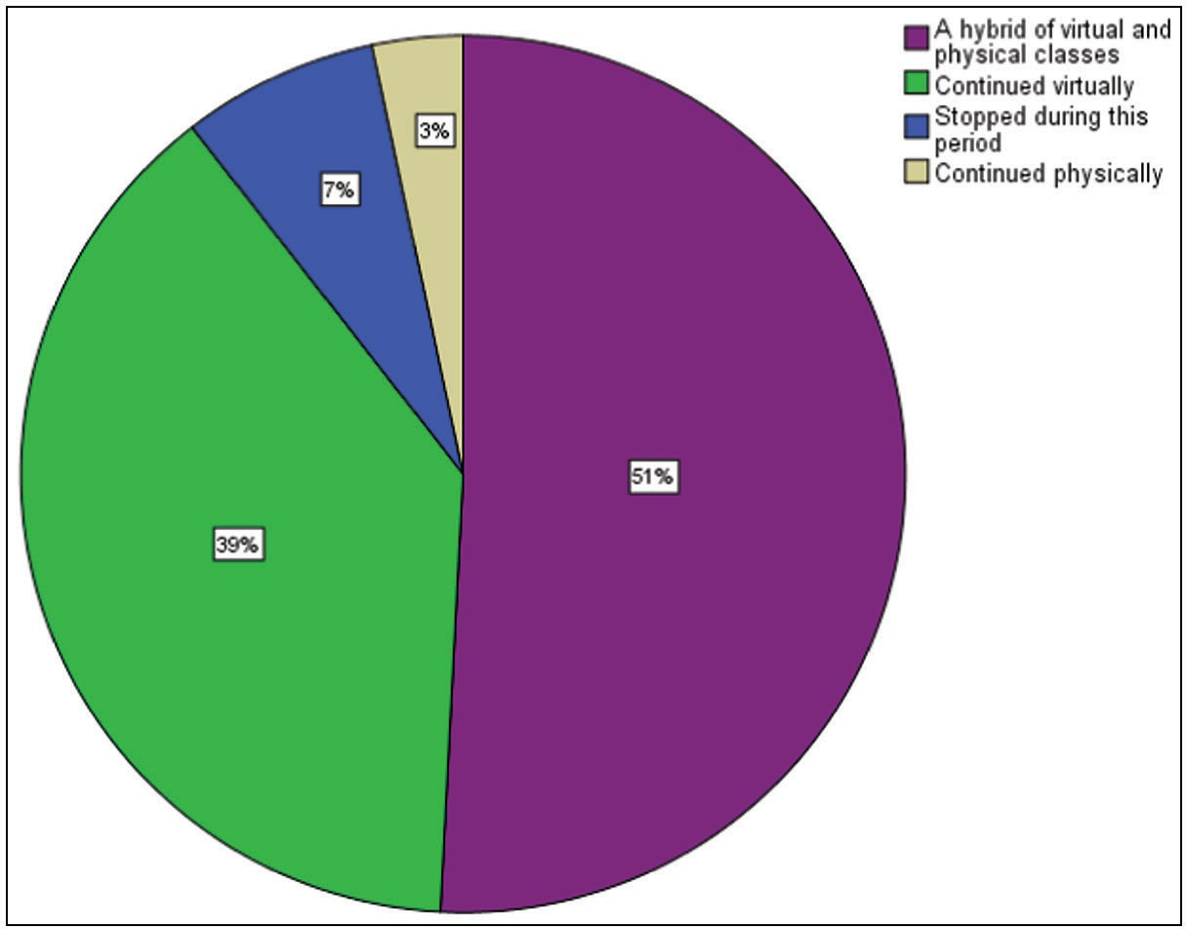

**Figure 1: Teaching of surgery following the onset of the pandemic**

was slightly increased, 16.7% said that it was markedly increased, 14.4% said that it was slightly reduced. 8.3% said that it remained the same and 7.2% said that it was markedly reduced. For their operative teaching exposure (pre, intra and post-operative), 57.8% said that it has slightly reduced, 22.8% said that it has remained the same prior to the pandemic, 15.6% said that it has markedly reduced, the remaining 3.8% said that it has slightly increased. Regarding the effect of the pandemic on the personal study hours spent on surgery topics, 48.1% said that it has remained the same, 27.6% said that it has slightly increased, 18.8% of respondents said that it has slightly reduced, 2.5% said that it has markedly increased and 3% said that it has markedly reduced. 47.8% of respondents said that there was a slight reduction in the conferences and case discussions directed by the surgery department, 33.3% said that it has remained the same, 14.4% said that it has markedly reduced while the remaining 4.5% said that it has slightly increased.

Regarding the student’s opportunities for basic surgical skill acquisition training, 56.9% said that it has slightly reduced, 20.4% said that it has remained the same, 17.7% said that it has markedly reduced while 5% said that it has slightly increased. 58.3% of respondents agreed that participation in virtual classes was affected by cost of data, 21.1% strongly

agreed, 8.9% were not sure, 6.7% disagreed and 5% strongly disagreed. [Figures 2 and 3] below shows a general overview of the aforementioned responds.

As seen in [Figure 4] below, 86% of participants said that personal protective equipment (PPEs) were not provided for the students while PPEs were provided for the remaining 14%. 59.4% of respondents agreed that the lack of PPEs affected their participation in surgical procedures.

With regards to the impact of the covid-19 pandemic on the overall undergraduate surgical training of the final year students as seen in [Figure 5] below, 57% said that it has been slightly worse than before the pandemic, 20% said that it has been much worse than before the pandemic, 17% said that it has remained the same, 6% said that it has been slightly better than before the pandemic and the remaining 1% said that it has been much better than before the pandemic.

As seen in [Table 1] above, There was no statistically significant relationship associating gender with clerkship opportunities, physical examination opportunities or exposure to surgery cases in the Covid-19 pandemic era using a p-value of <0.05 as significant **(Chi-square 1.395, p-value 0.85); Chi-square-2.985, p-value- 0.40, Chi-square-3.325, p-value-0.51 respectively).**

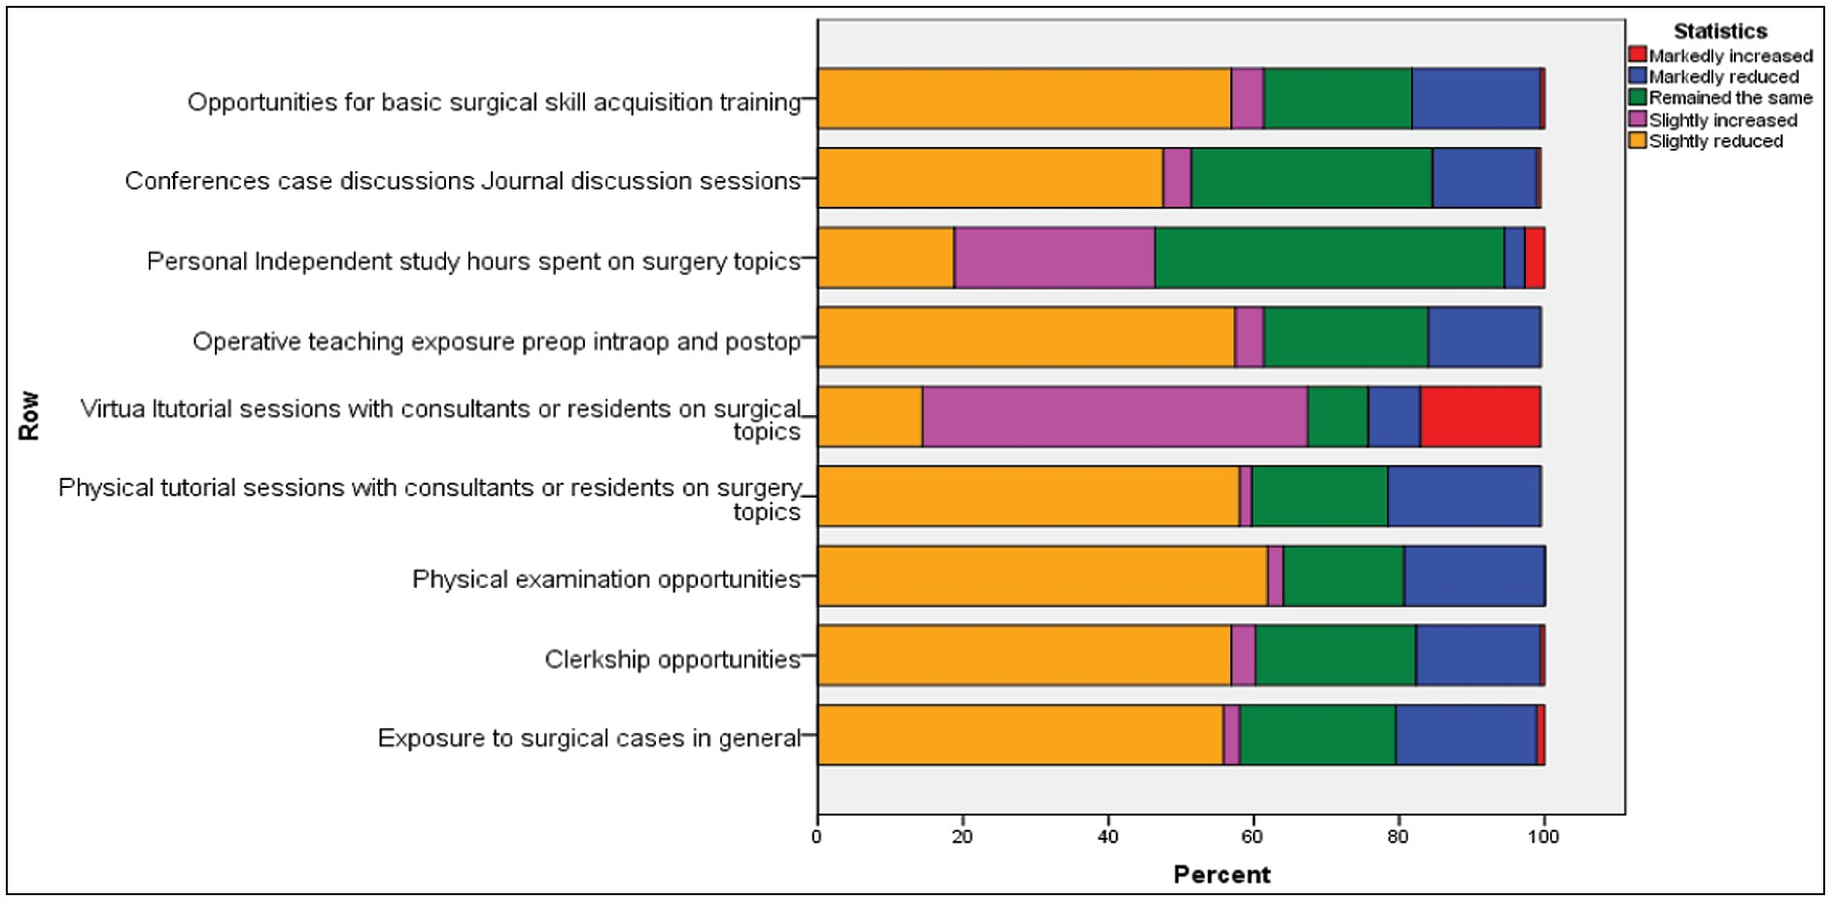

**Figure 2: Perception of students of the impact of COVID-19 on surgery education**

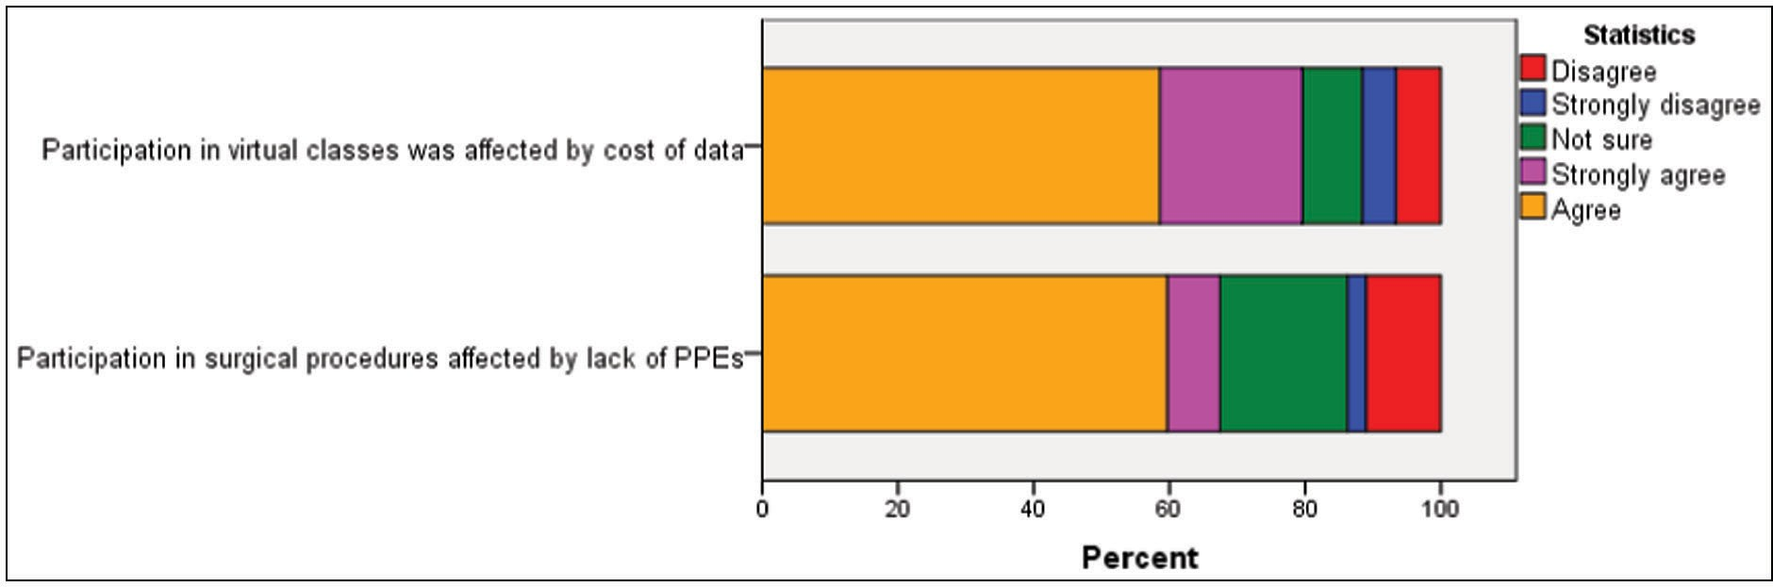

**Figure 3: Factors affecting surgery learning during the pandemic**

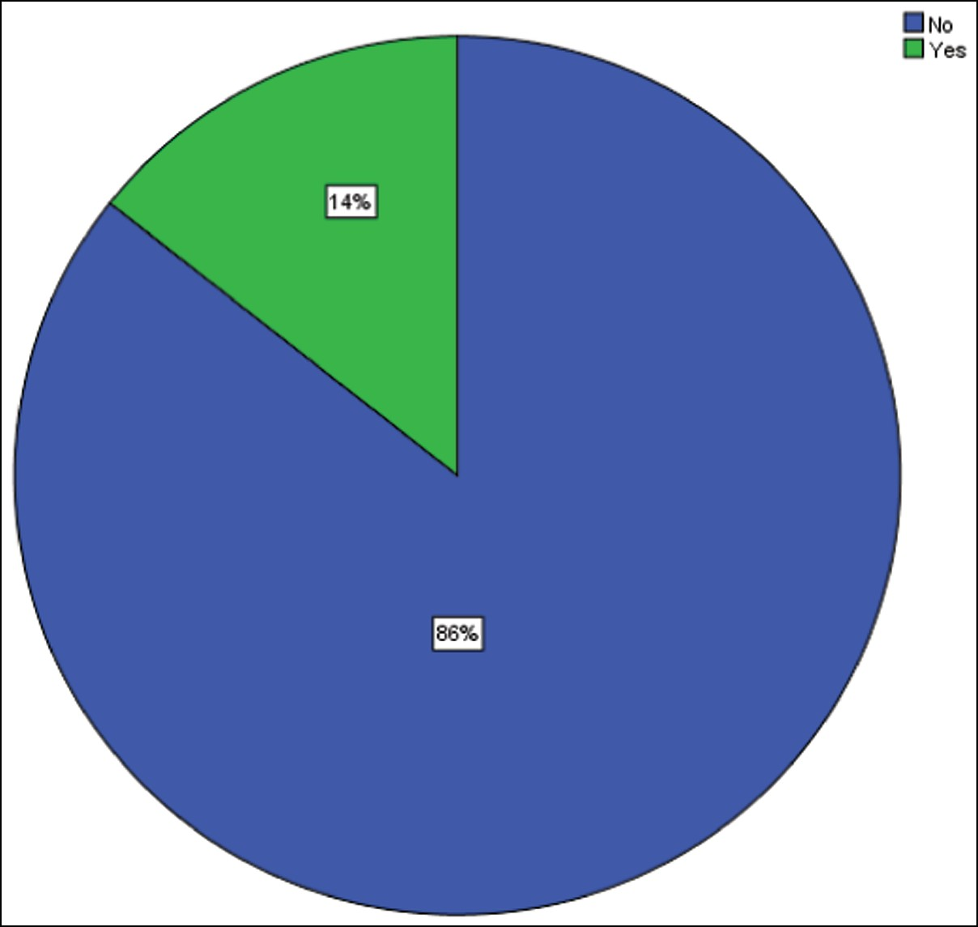

**Figure 4: Provision of personal protective equipment to students for surgical procedures**

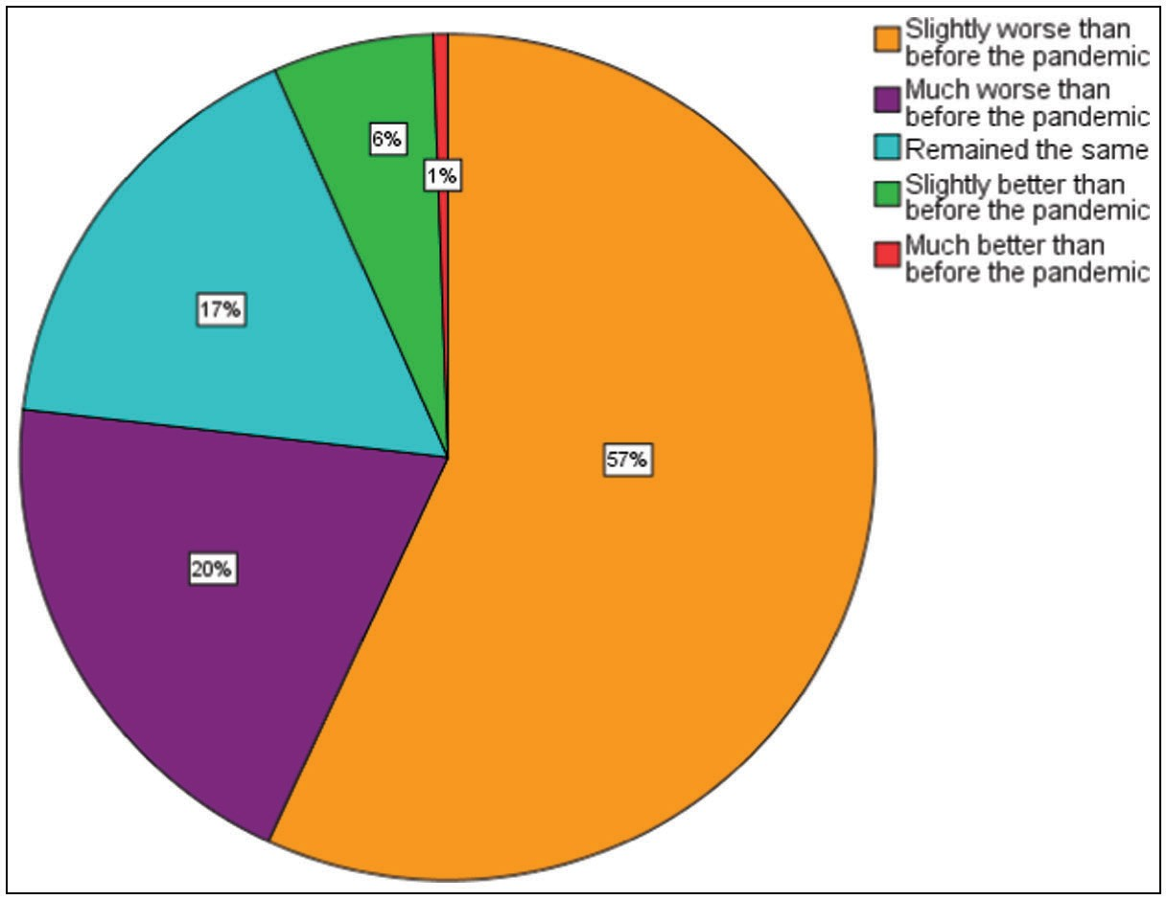

**Figure 5: General perception of impact of the pandemic on medical education**

# Discussion

This study has shown that almost all aspects of surgical training were affected by the pandemic with increasing delays in the training periods and inadequate surgical teaching and exposure. Disease containment measures like lockdowns and social distancing necessitated the postponement/cancellation of outpatient clinics and elective operations during the peak of the pandemic and this led to a major set-back in the undergraduate surgical training of medical students.[10] Limiting elective clinical activities protected patients from in-hospital viral transmission, preserved Personal Protective Equipment (PPE) to be prioritized for the care of patients with COVID-19, and

made ward and critical care beds available for upsurges in the numbers of COVID-19 cases.[16] The American College of Surgeons and the Royal College of Surgeons of England both recommended that non-emergency procedures be postponed or delayed, except cancer-related operations during the peak of the pandemic.[17,18] Local and regional bodies such as the Society of Gynaecology and Obstetrics of Nigeria (SOGON) also recommended telephone consultations for non-emergency cases, and reorganization of duty rosters to prevent patients visiting the hospital unnecessarily and to limit hospital contact of medical personnel.[19] Expectedly therefore, the majority of respondents in our study reported a reduction or cancellation of physical lectures and tutorials in their institutions. Most of them also reported seeing fewer patients in the outpatient clinics (reduced clerkship opportunities), as well as a reduction in the number of and attendance at emergency and elective operations. These findings are similar to the findings of other authors.[15,20-23] These findings have potential significant negative impact on surgical training and education and acquisition of surgical skills and expertise, which are greatly dependent on hands- on experience. Most (85.6%) of the respondents said that PPEs were not provided for the students, making it difficult for them to participate in the few available cases. Though the Nigerian government has recently ramped up efforts in increasing the supply of PPE to public hospitals across the country, these are still grossly inadequate.[10] [Figure 3] above shows a diagrammatic representation of the factors affecting surgical training of the final year medical students as gotten from their responses. From the data gotten, about 60% of them agreed that the cost of data and lack of PPEs affected their surgical training.

A noteworthy finding is that most of the respondents reported that their personal study time on surgery topics remained the same prior to the pandemic. This is unexpected because following the down-scaling of clinical and surgical activities, a greater amount of time should have been channeled to reading but that did not seem to be the case. In a similar study conducted by Omolabake *et al.*[24] on residents rather than students in north central Nigeria, there was an improvement in personal study time of their respondents. This begs the question of the level of seriousness towards academics of medical students when compared to the surgical residents. Understandably, the level of maturity and the stakes also vary widely and these are likely contributors to the degree of commitment and effort put into study. Also, most of the respondents (47.8%) reported that there was a slight reduction in conference and case discussions organized by the surgery department which is also a good avenue for students to learn. Majority of the respondents (51.1%), also reported that training/academic programs in their institutions were currently being conducted using a hybrid of virtual platforms and physical sessions. Simulations or

## Table 1: Factors affecting surgical training during the pandemic

|  |  |  |  |  |  |  |
| --- | --- | --- | --- | --- | --- | --- |
|  | |  | **Sex** |  | **Chi-square** | **p-value** |
| **Female** |  | **Male** |  |  |
| **Clerkship opportunities** | **Markedly increased** | 0 |  | 1 | 1.395 | 0.85 |
|  |  | 0.0% |  | 1.1% |  |  |
|  | **Markedly reduced** | 14 |  | 17 |  |  |
|  |  | 15.6% |  | 18.7% |  |  |
|  | **Remained the same** | 21 |  | 19 |  |  |
|  |  | 23.3% |  | 20.9% |  |  |
|  | **Slightly increased** | 3 |  | 3 |  |  |
|  |  | 3.3% |  | 3.3% |  |  |
|  | **Slightly reduced** | 52 |  | 51 |  |  |
|  |  | 57.8% |  | 56.0% |  |  |
| **Physical examination opportunities** | **Markedly reduced** | 13 |  | 22 | 2.985 | 0.40 |
|  |  | 14.4% |  | 24.2% |  |  |
|  | **Remained the same** | 17 |  | 13 |  |  |
|  |  | 18.9% |  | 14.3% |  |  |
|  | **Slightly increased** | 2 |  | 2 |  |  |
|  |  | 2.2% |  | 2.2% |  |  |
|  | **Slightly reduced** | 58 |  | 54 |  |  |
|  |  | 64.4% |  | 59.3% |  |  |
| **Opportunities for basic surgical skill acquisition training** | **Markedly increased** | 1 |  | 0 | 3.325 | 0.51 |
|  |  | 1.1% |  | 0.0% |  |  |
|  | **Markedly reduced** | 16 |  | 16 |  |  |
|  |  | 17.8% |  | 17.6% |  |  |
|  | **Remained the same** | 17 |  | 20 |  |  |
|  |  | 18.9% |  | 22.0% |  |  |
|  | **Slightly increased** | 6 |  | 2 |  |  |
|  |  | 6.7% |  | 2.2% |  |  |
|  | **Slightly reduced** | 50 |  | 53 |  |  |
|  |  | 55.6% |  | 58.2% |  |  |

hands-on technical skills training are difficult to conduct virtually though,[25] and while they are a good addition to the teaching processes, they cannot replace the direct transfer of hands-on skills that only possible through physical interaction with patients under the guidance and tutelage of consultants and residents. Another drawback to the virtual sessions is the generally poor mobile network and internet connectivity, as well as expensive data subscriptions in Nigeria. This impairs the quality of interactions during virtual sessions and detracts from the quality of the teaching and learning experiences of all participants. Some respondents on the other hand, reported little or no change in their surgical training during the pandemic. This could probably be due to their perception of what is usually the normal based on their personal experiences or their approach to learning.

The limitations of this study include the use of an online google questionnaire which made it difficult to ensure that most respondents who received the form actually filled them and the small sample size.

# Conclusion

The COVID-19 pandemic has significantly affected the clinical and teaching components of undergraduate surgical

training in South-Eastern Nigeria. It has, however, led to increased adoption of digital technology which should be further explored in the face of current realities.

We recommend that there should be a flexible re-adjustment of the syllables and pattern of surgical training of medical students to accommodate unavoidable events that can disrupt the training such as the covid-19 pandemic in a bid to prevent future disruptions in training.

## Acknowledgements

All final year medical and dental students at University of Nigeria Teaching Hospital, Ituku-Ozalla, Enugu, Nigeria.

## Financial support and sponsorship

This research received no specific grant from any funding agency in the public, commercial or not-for-profit sectors.

## Conflict of interest

Nil.

## Author’s contribution

Dr. Kelechi U. Imediegwu was the Lead author, He conceived the idea of the work, designed the questionnaire and analysis, was involved in the collation of the work,

wrote the paper and did the editing and initial review of the manuscript.

The other authors (*Paschaline C. Onwuka, Angelica*

*C. Uwaezuoke, Jude C. Abor*) also assisted with the collection of data, analysis of the work and the editing of the final write-up.

The corresponding author was Dr. Ajibola B. Oladiran who helped with reviewing the questionnaire, final manuscript and correspondence.

## Ethics approval and consent to participate

Ethical clearance was obtained from the Health Research and Ethics Committee, University of Nigeria Teaching Hospital, Ituku-Ozalla, Enugu state before commencement of the study. The number assigned to the ethical clearance certificate issued is: NHREC/05/01/2008B-FWA0000245 8-1RB00002323.

## Consent for publication

Participation was voluntary, and the purpose of the research was explained to each respondent. Informed consent was obtained before inclusion into the study. However, anonymity of participants was ensured, and no personal information was collected during the survey.

## Availability of data and material

Additional data from the research project could be made available by the author on request.

# References

1. Xu Z, Shi L, Wang Y, Ying L. Pathological findings of COVID-19 associated with acute respiratory distress syndrome. 2020. https:// [www.bmj.com/content/368/bmj.m606.](http://www.bmj.com/content/368/bmj.m606) [Last accessed on 2022 Apr 4].
2. Lai CC, Shih TP. Severe acute respiratory syndrome coronavirus 2 (SARS-CoV-2) and coronavirus disease2019 (COVID-19): The epidemic and the challenges. 2020. https://pubmed.ncbi.nlm.nih. gov/32081636/. [Last accessed on 2022 Mar 6].
3. Jebril N. World health organisation declared a pandemic public health menace: A systematic review of the coronavirus disease 2019 COVID-19. 2020. https://papers.ssrn.com/sol3/papers. cfm?abstract_id=3566298. [Last accessed on 2022 Apr 9].
4. Callaway E. Coronavirus vaccines: Five key questions as trials begin. Nature 2020;579:481.
5. Africa centre for disease control. Outbreak brief 32 COVID-19 Pandemic. [www.africacdc.org.](http://www.africacdc.org/) 2020. [Last accessed on 2022 Jul 8].
6. Adepoju P. Nigeria responds to COVID-19; first case detected in sub-saharan africa. Nat Med 2020;26:444-8.
7. Nigeria centre for disease control. COVID-19 Nigeria. [www.](http://www/) covid19.ncdc.gov.ng. 2020. [Last accessed on 2022 May 11].
8. Punch healthwise. COVID-19: 319 doctors infected, 14 dead as 33 states owe N 5,000 monthly hazard allowances. https:// healthwise.punchng.com 2020. [Last accessed on 2022 Apr 10].
9. Kalu B. COVID-19 in Nigeria: A disease of hunger. Lancet Respir Med 2020;8:556-7.
10. Ijarotimi OA, Ubom AE, Olofinbiyi BA, Kuye-Kuku T, Orji EO, Ikimalo JI. COVID-19 and obstetric practice: A critical review of the nigerian situation. Int J Gynaecol Obstet 2020;151:17-22.
11. Premium times. COVID-19: Nigeria’s third phase of eased lockdown to last four weeks-Official. [https://www](http://www/). premiumtimesng.com/news/headlines6/412306-covid19nigerias- third-phase-of-eased-lockdown-to-last-four-weeksofficial.html. 2020. [Last accessed on 2022 May 4].
12. Patel S, Lorenzi N, Smith T, Carlson BR, SternbergJr P. Critical insights from patients during the COVID-19 pandemic. NEJM Catal Innov Care Deliv 2020;1:35-9.
13. Egol KA, Konda SR, Bird ML, Dedhia N, Landes EK, Ranson RA, *et al*.; NYU COVID Hip Fracture Research Group. Increased mortality and major complications in hip fracture care during the COVID-19 pandemic: A new york city perspective. J Orthop Trauma 2020;34:395-402. https://doi.org/10.1097/ BOT.0000000000001845
14. Adam S, Zahra SA, Chor CYT, Khare Y, Harky A. COVID-19 pandemic and its impact on service provision: A cardiology prospect. Acta Cardiol 2021;76:830-7.
15. Pertile D, Gallo G, Barra F, Pasculli A, Batistotti P, Sparavigna M, *et al*.; SPIGC Working Group. The impact of COVID-19 pandemic on surgical residency programmes in Italy: A nationwide analysis on behalf of the italian polyspecialistic young surgeons society (SPIGC). Updates Surg 2020;72:269-80.
16. COVIDSurg Collaborative. Elective surgery cancellations due to the COVID-19 pandemic: Global predictive modelling to inform surgical recovery plans. Br J Surg 2020;107:1440-9.
17. American College of Surgeons. Guidelines for triage of nonemergent surgical procedures. 2020. Available at: https:// [www.facs.org/covid-19/clinical-guidance/triage.](http://www.facs.org/covid-19/clinical-guidance/triage) [Last accessed on 2022 Mar 17].
18. Russell TR. The surgical workforce: Averting a patient access crisis. Surg Clin North Am 2007;87:797-809, v.
19. Notrica MR, Evans FM, Knowlton LM, Kelly McQueen KA. Rwandan surgical and anesthesia infrastructure: A survey of district hospitals. World J Surg 2011;35:1770-80.
20. Society of Gynaecology and Obstetrics of Nigeria (SOGON). SOGON advice on SARS-COV-19 (COVID-19) infection practice guidance for members. 2020. https://sogon.org/coronavirus- covid-19-infection-in-pregnancy-rcog/. [Last accessed on 2022 Apr 12].
21. Amparore D, Checcucci E, Piazzolla P, Porpiglia F. AUTHOR REPLY. Urology 2022;164:e316.
22. Potts JR 3rd. Residency and fellowship program accreditation: Effects of the novel coronavirus (COVID-19) pandemic. J Am Coll Surg 2020;230:1094-7.
23. Fuller S, Vaporciyan A, Dearani JA, Stulak JM, Romano JC. COVID-19 disruption in cardiothoracic surgical training: An opportunity to enhance education. Ann Thorac Surg 2020;110:1443-6.
24. Omolabeke B, Ugwu B, Abiodun A, Ago C. Overview of the effect of Vivid-19 pandemic on residency training in surgery and related specialties in North-Central Nigeria. Journal of Advances in Medicine and Medical Research, 2020;32:126-1. [https://www](http://www.researchgate.net/publication/346971824_Overview_).resear[chgate.net/publication/346971824_Overview_](http://www.researchgate.net/publication/346971824_Overview_) of_the_Effects_COVID_19_Pandemic_on_Residency_Training_ in_Surgery_and_Related_Specialties_in_North-Central_Nigeria
25. Daodu O, Panda N, Lopushinsky S, Varghese TK Jr, Brindle M. COVID-19 - considerations and implications for surgical learners. Ann Surg 2020;272:e22-3.