**Original Article**

Dorsal Corporoplasty Techniques in the Management of Chordee Associated with Severe Hypospadias at a Teaching Hospital in Yaoundé, Cameroon: A Retrospective Study

# Introduction

**Abstract**

**Introduction:** The prevalence of hypospadias is 1 in 300 male births, of whom one in four will have some form of chordee. Correction of the chordee is imperative but presents a challenge with complications, including residual chordee, penile nodulations, and shortening. This study aimed at reporting the outcomes and at sharing our experience with the surgical correction of chordee associated with hypospadias at the Yaounde Gyneco-Obstetric and Pediatric Hospital (YGOPH). **Patients and Methods:** We carried out a retrospective cross-sectional study covering an eight-year period from 1 January 2010 to December 2017 at the Pediatric Surgery Service of the YGOPH. The study included all files of patients with severe hypospadias who underwent chordee correction using dorsal corporoplasty techniques and were reviewed for outcome evaluation. **Results:** A total of 40 patients met the inclusion criteria, of whom 22 (55%) had chordee corrected by the Nesbit corporoplasty technique, 13 (32.5%) by the Tunica Albuginia Plication (TAP) corporoplasty technique, and five (12.5%) by the Yachia corporoplasty technique. The median age at surgery was six (five to seven) years. The median follow-up period for the patients was five (three to six) years. Penile nodules were not observed in our series. Penile shortening was identified in four patients (18.2%) after Nesbit corporoplasty. Four patients had a residual chordee that was significant enough, requiring another correction. **Conclusion:** Irrespective of the technique of dorsal corporoplasty used in the correction of chordee associated with severe hypospadias, penile nodulation and shortening are not of concern, and residual chordee, if present, is usually mild and does not require any correction.

**Keywords:** *Chordee, corporoplasty, hypospadias, Nesbit, outcome, tunica albuginea plication, Yachia*

Severe hypospadias are always accompanied by an abnormal ventral curvature of the penis called chordee. Although there is no clear definition in the literature of severe hypospadias, most experts in hypospadias repair would agree that those with proximal division of the corpus spongiosum and severe chordee fall into this category.[1,2]

Hypospadias comprise the most common malformation of the penis[1,3]; their prevalence is approximately 1 in 300 male births, of which one in four will have some degree of chordee.[4] The incidence of chordee varies in different types of hypospadias: 23.5% in distal, 29.4% in mid-shaft, and 68.3% in proximal forms.[5] Many surgical techniques have been used to correct chordee. Low- grade (minor) curvatures (<30°) and some high-grade chordees can be easily corrected by using simple techniques such

This is an open access journal, and articles are distributed under the terms of the Creative Commons Attribution-NonCommercial- ShareAlike 4.0 License, which allows others to remix, tweak, and build upon the work non-commercially, as long as appropriate credit is given and the new creations are licensed under the identical terms.

**For reprints contact:** [reprints@medknow.com](mailto:reprints@medknow.com)

as penile degloving[6]; however, severe (high-grade or major) cases (>30°) often require more complex surgical procedures called corporoplasty. Orthoplasty, which includes corporoplasty in the case of severe chordee, is the first step in surgery for severe hypospadias and it aims at obtaining a straight and functional penis.

Chordees present a challenge to classification, particularly for correction.[7] Correction of chordee is imperative, and the search for new and better solutions remains challenging.[8] Correction of the chordee, regardless of whether associated with hypospadias, involves either lengthening the shorter side of the corpora cavernosa or shortening the longer side.[4] Several techniques and modifications of previously described techniques have been described to improve complication rates. The most important structural complication of chordee repair is persistent penile curvature.[9] In patients with

**How to cite this article:** Ngwa TE, Mbouche LO, Dadje KL, Mouafo TF, Angwafor FF. Dorsal corporoplasty techniques in the management of chordee associated with severe hypospadias at a teaching hospital in Yaoundé, Cameroon: A retrospective study. J West Afr Coll Surg 2020;10:23-9.

## Tagang Ebogo Titus Ngwa1,

**Landry Oriole Mbouche2,3, Kamkui Laure Dadje2,3, Tambo Faustin Mouafo2,3,**

**Fru Forbuzshi Angwafor2**

*1Department of Clinical Sciences, Faculty of Health Science,*

*The University of Bamenda, Bamenda, 2Department of Surgery and Sub-specialties, Faculty of Medicine and Biomedical Sciences, University of Yaounde, 3Department of Pediatric Surgery, Yaounde Gynaeco-Obstetric and Paediatric Hospital, Yaoundé, Cameroon*

**Received:** 25-Dec-2021 **Accepted:** 18-Feb-2022 **Published:** 26-Mar-2022

***Address for correspondence:***

*Dr. Tagang Ebogo Titus Ngwa,*

*P.O. Box 39 Bambili, Department of Clinical Sciences, Faculty of Health Sciences, The University of Bamenda, North West Region, Bamenda, Cameroon.*

*E-mail:* [*ngwa.ebog*](mailto:ngwa.ebogo@uniba.cm)[*o@uniba.cm*](mailto:o@uniba.cm)

|  |
| --- |
| **Access this article online** |
| **Website:**  [www.jwacs-jcoac.org](http://www.jwacs-jcoac.org/) |
| **DOI:** 10.4103/jwas.jwas_64_21 |
| **Quick Response Code:** |

© 2022 Journal of the West African College of Surgeons | Published by Wolters Kluwer ‑ Medknow 23

low-grade curvatures, recurrence of penile curvature after dorsal corporoplasty is approximately 7%, and approximately 21.4% of patients are initially managed by dorsal plication for high-grade curvatures.[10] Other structural complications of corporoplasty include penile nodulation and shortening. This study aimed at reporting the outcome of chordee correction and at sharing our experience with the surgical correction of congenital penile curvature associated with hypospadias at the YGOPH.

# Patients and Methods

### Study setting and patients

We carried out a retrospective cross-sectional study covering an eight-year period from 1 January 2010 to December 2017, at the Pediatric Surgery Service of the YGOPH. The study included all patients with severe hypospadias who underwent chordee correction by using dorsal corporoplasty techniques and were reviewed for outcome evaluation. Patients in whom chordee was corrected by dorsal corporoplasty techniques, reviewed for outcome but did not consent for inclusion in the study; those who were not reviewed for outcome evaluation; cases of chordee corrected by penile degloving; cases of chordee without hypospadias corrected by dorsal corporoplasty; and cases of chordee associated with disorder of sex development (DSD) who underwent transgendered genitoplasty were excluded from the study.

### Study procedure

Ethical clearance was obtained from the Institutional Review Board (IRB) of the YGOPH [Comite Institutionnel d’Ethique de la Recherche pour la Sante Humaine (CIERSH), Reference Number 930/CIERSH/DM/2019]. For data collection, theater records and hospital registers were used to identify the files of patients with severe hypospadias and significant chordees. The files of the selected patients were studied to evaluate whether they met the inclusion criteria, and basic data were collected from the files and entered into a preconceived data entry sheet. The selected patients were then invited through a telephone call, and their parents were advised to come along with pictures that showed the penis of their children in erection. On arrival, consent for inclusion in the study and to analyze pictures of the erect penis of their children was obtained. The outcome of the surgical repair was also reviewed clinically, palpating for penile nodulations, evaluating for shortening by measuring the stretched penile length, and matching it to the reference range as per the stretched penile length in prepubertal boys in Egypt.[11] The penis was considered short, if the measured stretched penile length based on the patients age was smaller than the corresponding reference range as per the stretched penile length of prepubertal boys in Egypt. Pictures of the penis in erection were also analyzed and matched with the corresponding erection grade as on the fourth item of the Hypospadias Objective Scoring Evaluation (HOSE) score. In cases where there were no available pictures, the parents were shown the standard erection sample as on the fourth item of the HOSE score, to indicate which level of erection closely fits that of their children.

### Operational description of techniques

Dorsal corporoplasty was achieved by making incisions on the dorsal aspects of the corpus cavernosum and closing the incisions in several ways so as to straighten the penis. Three techniques of dorsal corporoplasty that were commonly used at the YGOPH are: the Nesbit Ellipse excisional corporoplasty technique, the Tunica Albuginia Plication (TAP) corporoplasty technique, and the Yachia longitudinal incisions and the Heineke-Miculicz closure corporoplasty technique.

The first step in dorsal corporoplasty is degloving of the penis, then incising the Buck fascia laterally at the 4 and 8 o’clock position, and mobilizing the neurovascular bundle by carefully dissecting the Buck fascia from the dorsal tunica albuginea [Figure 1]. A vessel loop can then be passed under the neurovascular bundle to assist in elevation and dissection of the neurovascular bundle.

In Nesbit corporoplasty [Figures 2 and 3], the tunica albuginea can be grasped with an Allis clamp at the point of maximal curvature and the tunica is then excised sharply. After the horizontal ellipse is removed, it is closed with interrupted 5-0 monofilament absorbable sutures such as polydioxanone suture

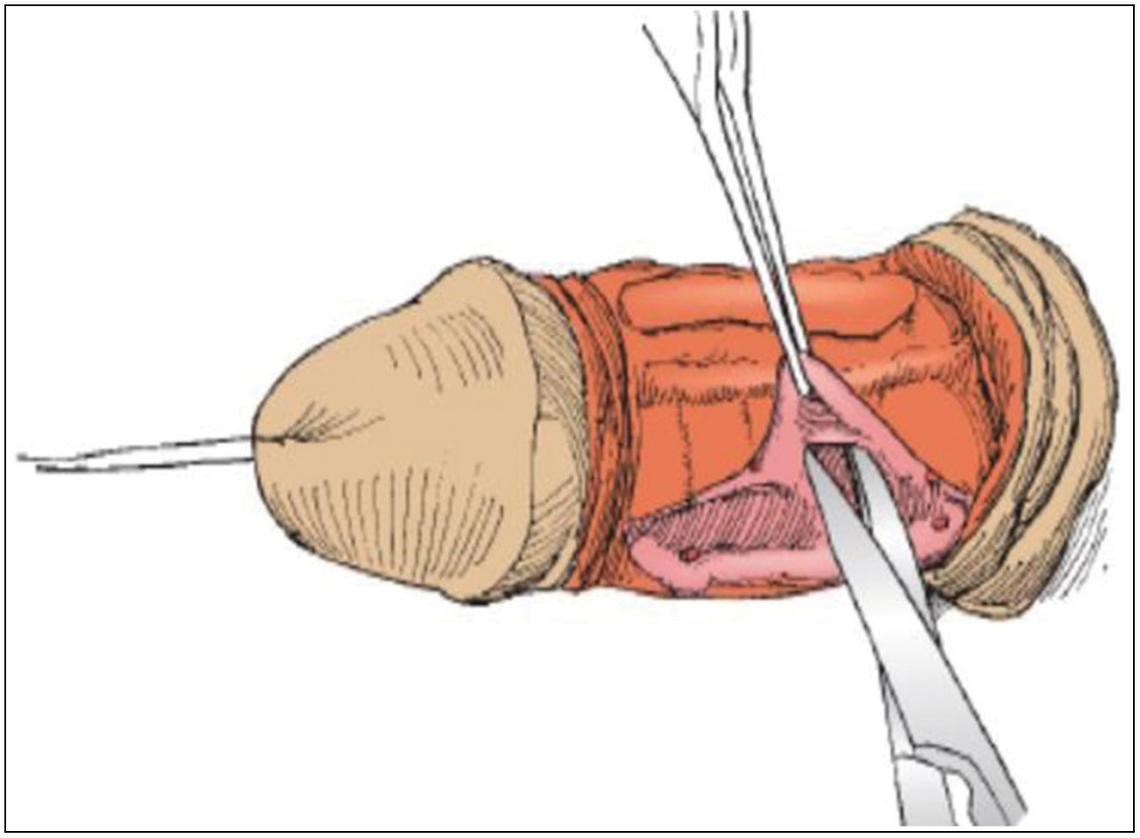

**Figure 1: Elevation and dissection of the neurovascular bundle. [From Mingin G, Baskin LS. Management of chordee in children and young adults. Urologic Clinics of North America 2002;29(2):277-84.]**

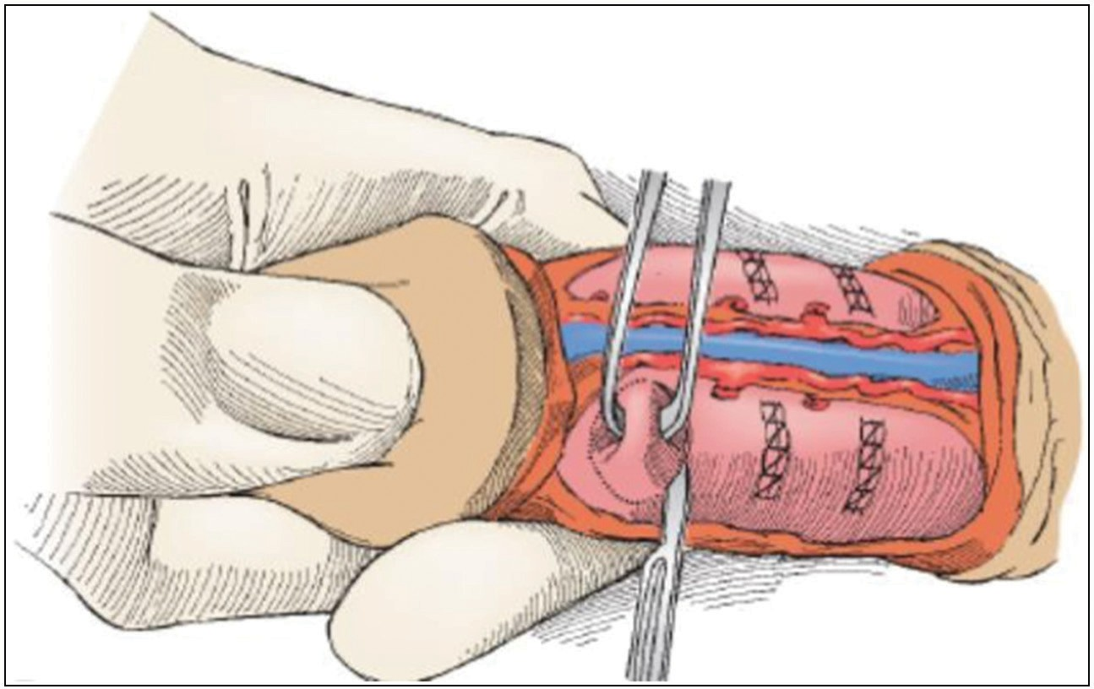

**Figure 2: Nesbit excision corporoplasty [From Mingin G, Baskin LS. Management of chordee in children and young adults. Urologic Clinics of North America 2002;29(2):277-84.]**

24 Journal of the West African College of Surgeons | Volume 10 | Issue 2 | April‑June 2020

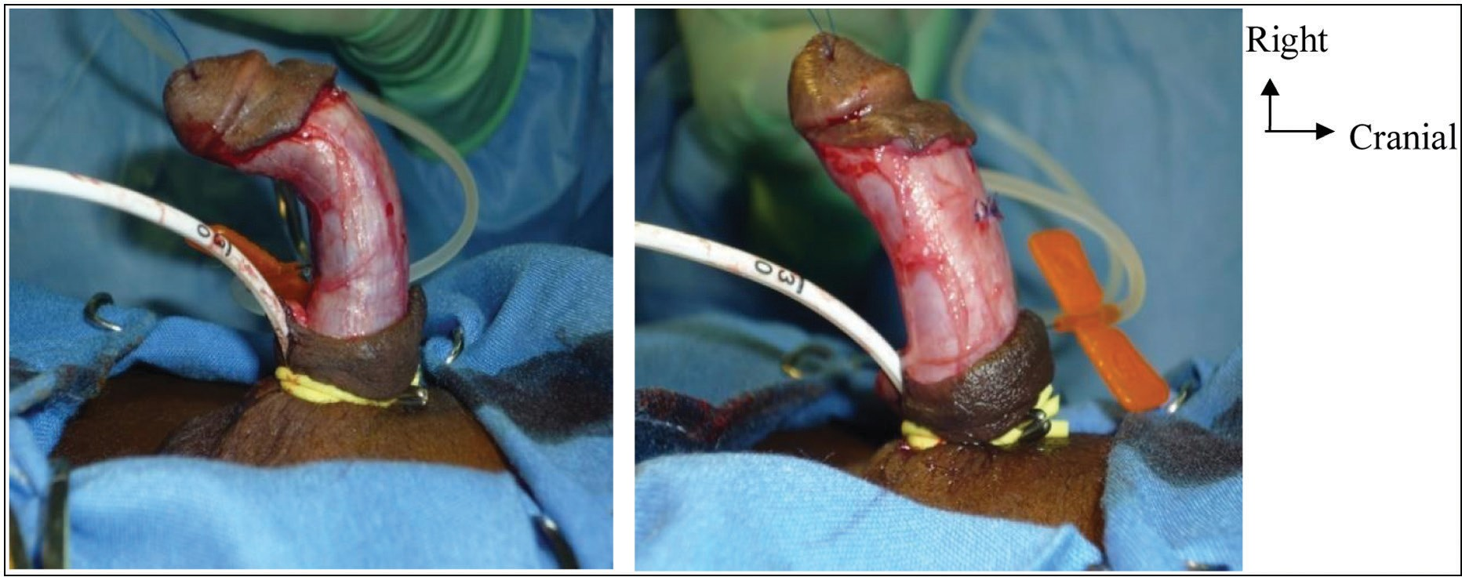

**Figure 3: (A) Demonstration of chordee before corporoplasty. (B) Artificial erection test after corporoplasty (YGOPH Paediatric Surgery Service Collection)**

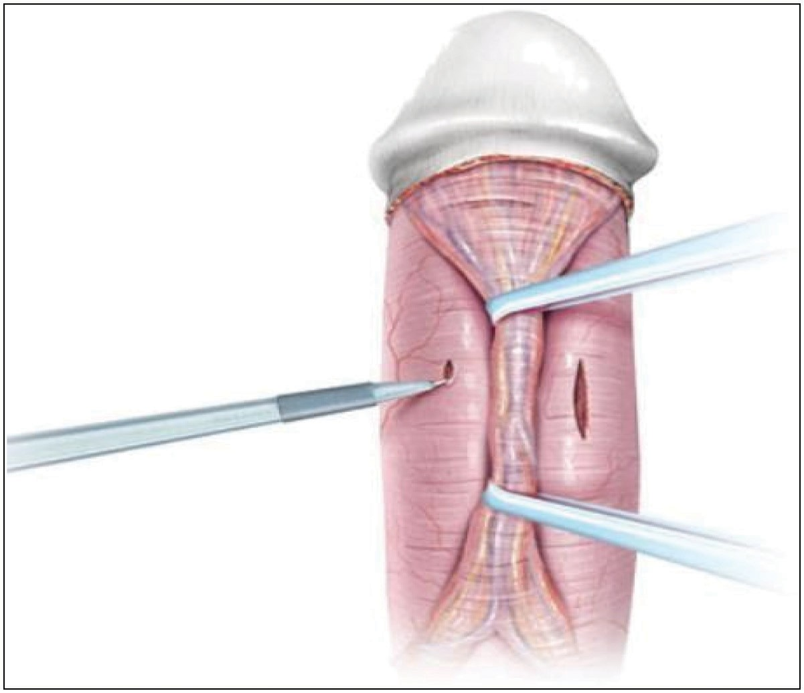

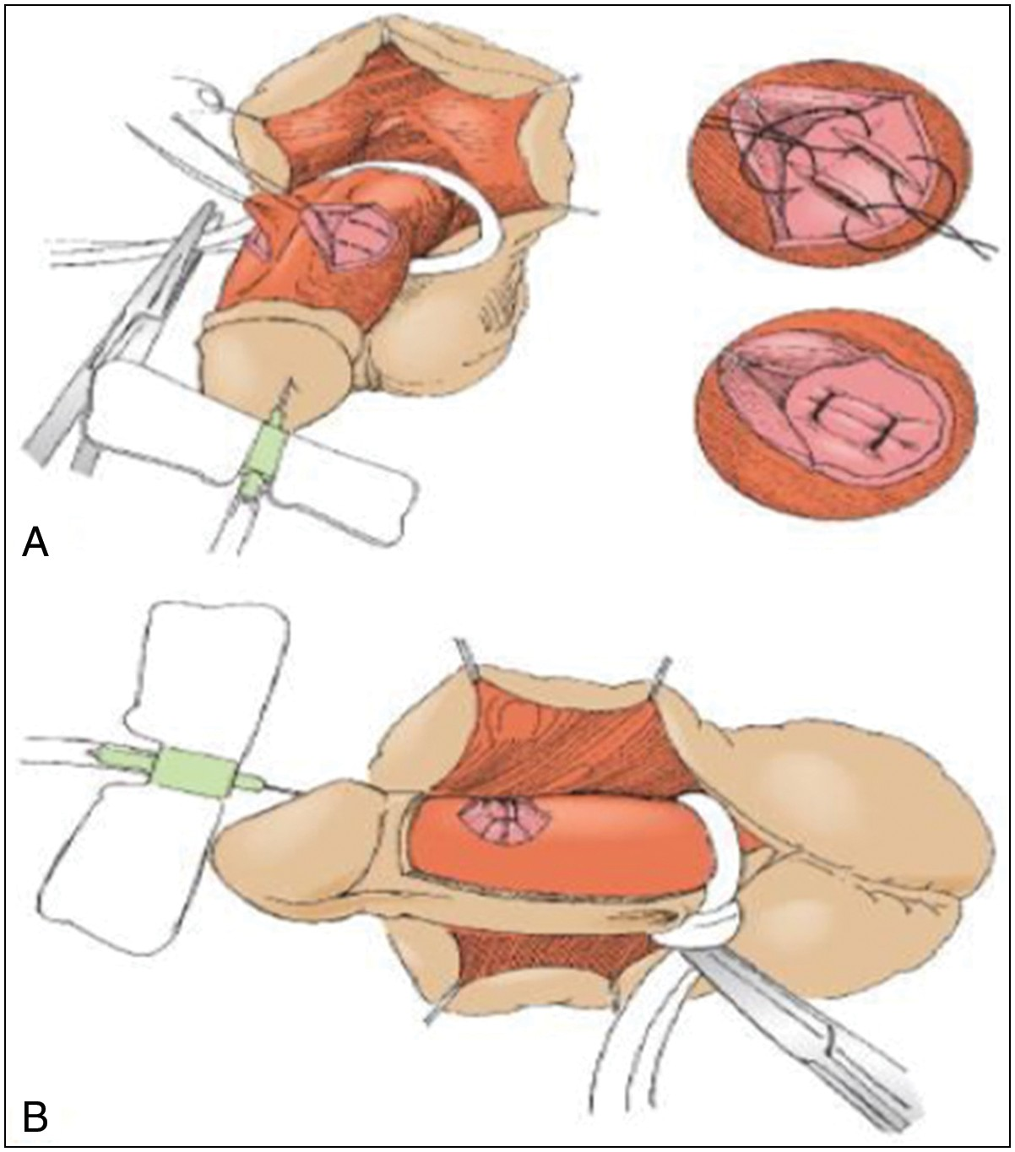**Figure 4: (A and B): Tunica albuginea plication [From Mingin G, Baskin LS. Management of chordee in children and young adults. Urologic Clinics of North America 2002;29(2):277-84.]**

(PDS) or Maxon suture with the knots buried. They are excised in a corresponding location on the right and left corporal bodies. Multiple excisions can be needed in severe cordee.

In the TAP corporoplasty [Figure 4], rather than excise the corporal tissue, two parallel incisions approximately 4 to 6 mm apart and 8 mm long are made through the tunica albuginea at the point of maximum curvature. Without excision of the intervening tunica, the outer edges of the incisions are approximated with interrupted monofilament absorbable sutures. This shortens the corporal body and reverses the curvature. More than one plication may be necessary in severe cases.

The Yachia plication technique [Figure 5] involves making longitudinal incisions on the tunica albuginea, stretching the

**Figure 5: Yachia incision corporoplasty [From Mingin G, Baskin LS. Management of chordee in children and young adults. Urologic Clinics of North America 2002;29(2):277-84.]**

incisions transversely by using hook retractors and closing the margins transversely as per the Heineke-Mikulicz principle with monofilament absorbable sutures (4-0 or 5-0 Maxon or PDS sutures) using inside-out and outside-in sutures so that the knots are buried. These repairs were done by multiple surgeons with varied experiences and differences in their choices of surgical techniques.

### Variables

Sociodemographic and clinical variables included date of birth, age at time of surgery, town and region of origin, history of circumcision and previous hypospadias repair, clinical presentation, diagnosis and associated anomalies, management techniques, including type of hypospadias repair and type of corporoplasty, and clinical findings during follow- up appointments.

The selected patients were then invited to obtain informed consent for inclusion to the study, and the main outcomes of the corporoplasty measures were obtained by clinical examination of the penis and by using photographs of the penis in erection

Journal of the West African College of Surgeons | Volume 10 | Issue 2 | April‑June 2020 25

provided by the parents if available, comparing it with the standards as per the fourth item (the erectile component) of the HOSE score, which scores erection or chordee on 4: straight (4), mild angulation <10° (3), moderate angulation >10° but

<45° (2), and severe angulation >45° (1).

### Statistics

Data were collected with the aid of a data entry form, displayed in an Excel spreadsheet, and entered into STATA 2016 statistical software for analysis.

The outcome variables were penile shortening as per the reference for normal stretched penile length in Egyptian prepubertal boys,[11] the presence or absence of penile nodules, and residual chordee as per the erectile component of the HOSE score; the predictor variables were age at surgery, previous hypospadias repair, circumcision, location of urethral meatus before surgery, and the method used in correcting chordee.

Categorical variables are presented as frequencies and their proportions, whereas continuous variables are presented as means (and standard deviation) or median (and interquartile range) where appropriate, or as frequencies and percentages

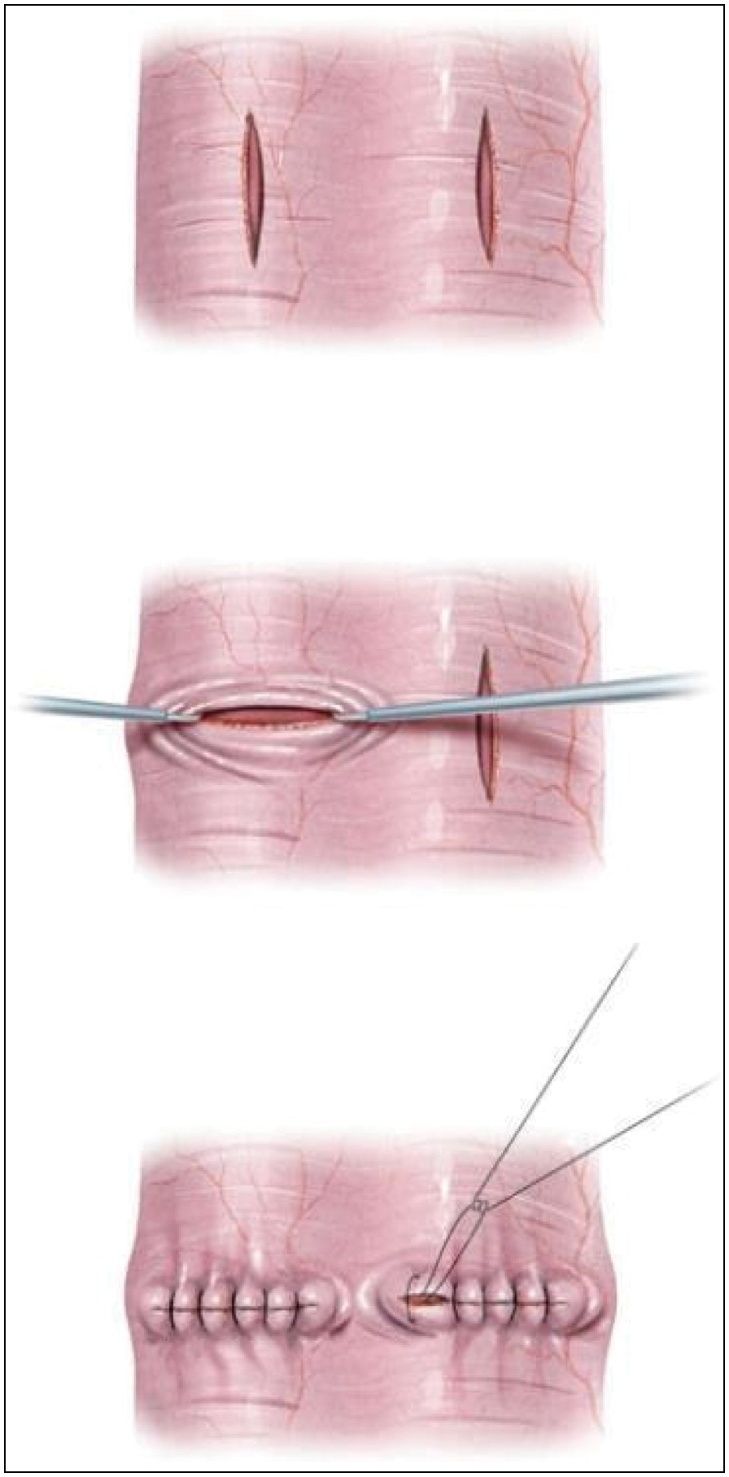

**Figure 6: Yachia closing [From Mingin G, Baskin LS. Management of chordee in children and young adults. Urologic Clinics of North America 2002;29(2):277-84.]**

after categorization by using predefined cutoffs or the median. The Kruskal–Wallis test was used to assess differences in continuous variables of interest among the various techniques. The results are presented in tables to ease organization and comprehension.

# Results

A total of 40 patients met the inclusion criteria. Of the 40 patients recruited in the study, 22 (55%) had chordees corrected by the Nesbit Ellipse excisional corporoplasty technique, 13 (32.5%) were corrected by using the TAP corporoplasty technique, and five (12.5%) by Yachia longitudinal incisions and the Heineke-Miculicz closure corporoplasty technique based on the preference and experience of the surgeon.

The distribution of age at surgery was bimodal and positively skewed, with a median age of six (five to seven) years and age extremes of 3 and 11 years. The median follow-up period for patients included in the study was five (three to six) years.

All included patients had proximal hypospadias: 42.5% were perineal, 37.5% penoscrotal, 2.5% scrotal, and 17.5% posterior penile [Table 1]. Thirty-five (87.5%) patients presented with severe chordee, whereas five (12.5%) had moderate chordee. Eleven patients (27.5%) had severe hypospadias, with chordee associated with cryptorchidism; among them, three (7.5%) had bilateral cryptorchidism. However, in six patients (12%), hypospadias and chordee were associated with bifid scrotum.

### Table 1: Sociodemographic and clinical characteristics

**Variable Frequency**

Median age (years) 6

IQR (years) 5–7

Age extremes 3–11

Median follow-up period (years) 5

IQR (years) 3–6

Type of proximal hypospadias (%)

Perineal 42.3

Scrotal 2.5

Penoscrotal 37.5

Posterior penile 17.5

Type of chordee (%)

Severe 35 (87.5)

Moderate 5 (12.5)

|  |  |
| --- | --- |
| Associated abnormalities (%) |  |
| Cryptorchidism | 11(27.5) |
| Bifid scrotum | 6 (12%) |
| Previous surgery (%) |  |
| Circumcision alone | 3 (7.5) |
| Failed previous hypospadias repair | 13 (32.5) |
| Technique of hypospadias repair (%) |  |
| Bracka technique | 16 |
| Koyanagi-Hayashi | 20 |
| One-stage onlay flap technique | 4 |
| Corporoplasty technique (%) |  |
| Nesbit | 22 |
| TAP | 13 |
| Yachia | 5 |

26 Journal of the West African College of Surgeons | Volume 10 | Issue 2 | April‑June 2020

### Table 2: Association between the type of corporoplasty and penile shortening

|  |  |  |  |  |  |
| --- | --- | --- | --- | --- | --- |
| **Variable** | **Nesbit (*n* = 22)** | **TAP (*n* = 13)** | | **Yachia (*n* = 5)** | ***P* Value** |
| No shortening | 18 (81.8) | 13 (100%) | | 5 (100%) | 0.620¥ |
| Shortening | 4 (18.2%) | 0 (0%) | | 0 (0%) |  |
| ¥ Kruskal–Wallis test (α = 0.05) |  |  | |  |  |
| **Table 3: Association between the type of corporoplasty and residual chordee** | | | | | |
| **Erection component of HOSE Score** | | **Nesbit (*n* = 22)** | **TAP (*n* = 13)** | **Yachia (*n* = 5)** | ***P* Value** |
| Straight penis (4) | | 17 (77.3%) | 08 (61.5%) | 1(20%) | 0.550± |
| Mild angulation < 10 (3) | | 04 (18.2%) | 05 (38.5%) | 1(20%) |  |
| Moderate angulation >10 <45 (2) | | 01 (04.5%) | 00 (0%) | 3(60%) |  |
| Severe angulation >45 (1) | | 00 | 00 |  |  |
| ± Kruskal–Wallis test (α = 0.05) | |  |  |  |  |

Sixteen (40%) patients had a history of previous penile surgery, including circumcision alone in three (7.5%) patients and a history of failed previous hypospadias repair, including circumcision in 13 (32.5%) patients. All the circumcised patients (16 patients, 40%) who had previously failed hypospadias repair underwent the two-stage Bracka technique, whereas the non-circumcised patients underwent either the one-stage Koyanagi-Hayashi technique (20 patients, 50%) or the one-stage onlay technique (four patients, 10%) [Table 1].

None of the 40 patients included in our study complained of penile nodules, and no penile nodules were palpated on clinical examination.

On penile shortening, four patients (18.2%) had some penile shortening, all of whom had chordee corrected by Nesbit corporoplasty, and the shortened length was estimated to be less than 1 cm. It was also observed that all four patients with penile shortening after Nesbit dorsal corporoplasty had a history of failed hypospadias surgery. However, there was no statistically significant association between the Nesbit, TAP, or Yachia corporoplasty techniques and penile shortening [Table 2].

After Nesbit corporoplasty, four (18.2%) patients had mild residual chordees and one (04.5%) patient had moderate chordee. Five (38.5%) patients had mild residual chordee after TAP corporoplasty, whereas three (60%) patients had moderate and one (20%) had mild residual chordee after Yachia dorsal corporoplasty. However, these differences were not statistically significant between the three techniques [Table 3]. Also, four (10%) patients in our series had moderate residual chordee requiring a secondary intervention, all of whom had a history of failed hypospadias repair.

After corporoplasty, five (12.5%) patients who preoperatively had moderate chordee developed residual curvatures, and nine patients (22.5%) who had severe chordee developed residual chordee [Table 4]. Of the 14 patients with residual chordee, four had residual chordee that was significant and needed a review of corporoplasty.

# Discussion

One in four hypospadias will have some degree of chordee.[4] The incidence of chordee varies in different types of hypospadias:

### Table 4: Association between preoperatory degree of chordee and residual chordee

**Type of preoperatory chordee Residual chordee (%)**

Mild 0 Moderate 5 (12.5%)

Severe 9 (22.5%)

23.5% in distal, 29.4% in mid-shaft, and 68.3% in proximal forms.[5] Many theories have been proposed to explain the etiology of chordee, including skin tethering, fibrotic dartos, Buck fascia,[12] abnormal development of the urethral plate, fibrotic mesenchymal tissue at the urethral meatus, and dorso- ventral corporal disproportion.[13,14] During the 16th week of the fetal period, the penis has a physiological ventral curvature, which resolves between the 20th and 25th weeks.[13] Arrest of embryonic development at some point during this process maintains this curvature.[12] In addition, urethral defects are always associated with thinning and hypodevelopment of the corpus spongiosum and other ventral structures that ultimately lead to penile disproportion and curvature.[12] Several classification systems for chordees have been proposed, and the most commonly used is that proposed by Braga *et al.*,[15] who classified chordees as major or severe (>60), moderate (40–60), and minor or mild (<40). Corporoplasty is the correction of chordee, and the goal is to reconstruct and obtain a functional penis that is adequate for sexual intercourse.[9]

Although many factors can influence the timing of surgical correction of penile malformation, such as the environment in which the patient is managed, the anesthetic risk, penile dimensions, and the psychological effect of genital surgery,[9] the patients in our series underwent surgery significantly later than the recommended time. The American Academy of Pediatrics suggests that the optimal time for elective male genital surgery is 6–12 months.[16] After the age of six months, the risk of anesthesia is no greater than when older,[17] and there is reduced patient anxiety when hypospadias repair is performed before 18 months of age.[18] Some pediatric urologists prefer to operate on a significantly larger penis, and as such, delay the procedure. The small number of surgeons specializing in the reconstruction of penile malformations, especially hypospadias in Cameroon, may have played a role in this delay.

Journal of the West African College of Surgeons | Volume 10 | Issue 2 | April‑June 2020 27

Although circumcision can influence the choice of surgical technique for hypospadias correction, it does not influence the choice of corporoplasty technique and has no effect on the outcome (residual chordee, penile length, and penile nodules).

The location of the urethral meatus in the uncorrected hypospadias penis (perineal, scrotal, penoscrotal, penile) and the associated anomalies (cryptorchidism, penoscrotal transposition, bifid scrotum) may play a role in the classification of hypospadias and in selecting the technique of hypospadias surgery, but it has no effect on the technique of chordee correction, which is based on the experience and preference of the surgeon; it did not have any effect on the outcome of corporoplasty.

Residual chordee is a documented complication after Nesbit corporoplasty and is the most disturbing cosmetic problem after chordee correction in patients with severe hypospadias. The degree of chordee or its classification does not determine the type or outcome of corporoplasty. In our series, five patients (12.5%) who preoperatively had moderate chordee developed residual chordee, and nine patients (22.5%) who had high-grade curvatures developed residual curvatures. Four patients (40%) had moderate residual curvatures that were significant and required corporoplasty review. These results are similar to those of Bar Yosef *et al.*,[10] who found a 7% recurrence of penile curvature after dorsal corporoplasty in patients with low-grade curvatures and 21.4% ventral curvature recurrence in patients initially managed by dorsal plication for high-grade curvatures (>30°–40°).

In this study, the Nesbit technique was the least associated with residual chordee (22.7%) compared with 38.5% and 80% after the TAP and Yachia dorsal corporoplasty techniques, respectively. However, these differences were not significant (*P* = 0.550, α=0.05). The success rate of penile straightening after Nesbit corporoplasty was 77.3%, which is similar to that reported by Daitch *et al.*,[19] who reported that the success rate of penile straightening for Nesbit corporoplasty ranges from 57% to 100% in patients with congenital curvature. The success rate of TAP in the correction of chordee in congenital penile curvatures is 85%–100%,[20] Cormio *et al.*[21] reported their experience in 40 patients who underwent TAP to correct congenital penile curvature and obtained full subjective and objective straight penises in 92.5% of patients. This result is different from the one we report here, in which we report a 61.5% residual curvature. The small number of patients analyzed (*n* = 13) may have contributed to this result.

There are conflicting reports on the results of Yachia corporoplasty, with some authors reporting excellent residual chordee outcomes and some troubling outcomes. Although much of the literature on the use of Yachia corporoplasty is in the correction of PD and other acquired penile curvatures, it has been widely used to correct congenital penile curvatures, mostly in those involving hypospadias. Daitch *et al.*[19] reported 89% excellent penile straightening and 7% residual chordee less than 20°after incising the tunica albuginea longitudinally and closing it transversely. In patients who presented with a history of failed hypospadias repair, the previous surgery

affected the type of hypospadias repair but had no influence on the technique of corporoplasty and may have influenced the occurrence of residual chordee. In our series, four patients had moderate residual chordee and required redo corporoplasty, all of whom had a history of previous failed hypospadias repair. This may further imply that chordees with a history of failed hypospadias repair may be a risk factor for residual chordee.

Penile nodulation after corporoplasty, irrespective of the technique used, is not currently a problem. Nesbit corporoplasty has been the mainstay of dorsal corporoplasty, and most of the newer techniques are modifications of the Nesbit technique. Although penile nodules and suture-related complications (such as suture granuloma and knots nodules) have been described, and the complication is said to occur in one-third of patients after Nesbit corporoplasty,[4] none of the patients in our case reported penile nodules. This may be related to the use of absorbable suture materials in our setting for Nesbit CP. This was demonstrated by Basiri *et al.*,[22] who compared the results of corporal plication using vicryl versus nylon sutures for the treatment of congenital penile curvatures, and they reported a significantly lower complication rate in the vicryl group than in the nylon group (6% to 39%, respectively, *P* = 0.04). Chertin *et al.*[23] reported no penile nodulations in a 12-year experience with 83 patients whose congenital penile curvatures were corrected by using the TAP technique and long-term follow-up.[23] Although we had very few patients to draw reasonable scientific conclusions from Yachia corporoplasty, no penile nodulations were recorded, which is similar to the results described in the literature.[22] These results are similar to ours. This is partly due to the improved suturing technique that involves burring of the knots with inverted stitches carefully placed and the Buck fascia meticulously closed. In addition, monofilament absorbable sutures have been tested and used with the same success rate as non-absorbable sutures, with the added advantage of no residual nodules and limited fibrosis.

Irrespective of the corporoplasty technique used, loss of penile length is still a concern for dorsal corporoplasty procedures. This is in accordance with the principle of dorsal corporoplasty to correct chordee, which denotes shortening of the longer side (dorsal), as opposed to ventral corporoplasty (with the use of grafts and flaps), which involves lengthening the shorter side. There is a consensus that in chordees >60°, dorsal corporoplasty should not be used because it results in a significant loss of penile length. In this study, loss of penile length, though judged not significant (<1 cm), was only found in the Nesbit corporoplasty, and it was not recorded in the TAP and Yachia corporoplasty techniques. These differences were not statistically significant (*P* = 0.1135; α=0.05). In addition, the four cases of penile shortening observed using the Nesbit technique were all patients with a history of failed hypospadias surgery. This raises another question: Could a history of failed hypospadias repair be a risk factor for penile shortening after corporoplasty? Penile shortening in the literature after the Nesbit technique has been reported as 17.4–100% and 41–90% for, respectively, excision and plication corporoplasties in patients with congenital penile curvatures.[24] Although objective evaluation of the loss of

28 Journal of the West African College of Surgeons | Volume 10 | Issue 2 | April‑June 2020

penile length in Nesbit corporoplasty is difficult, theoretically, it is inevitable[4]; however, this rarely affects coital function.[21] In our study, loss of penile length was seen in four patients who underwent Nesbit corporoplasty, but the degree of penile shortening was judged to be insignificant. Chertin *et al.*[23] also reported no penile shortening in a 12-year experience with 83 patients whose congenital penile curvatures were corrected using the TAP technique and long-term follow-up. These results are similar to ours. For Yachia corporoplasty techniques, measures such as limiting the corpora incision to 1 cm have been used, and loss of penile length is still a major problem in Yachia corporoplasty. Complete mobilization of the penile shaft during hypospadias repair and corporoplasty may account for the absence of loss of penile length. The variable results in our series may also be a function of the multiple surgeons who performed the surgeries and their varied experiences. This also explains the absence of a clear-cut indication for corporoplasty, which seems to have stemmed from the preference of the surgeon.

# Conclusion

The type of dorsal corporoplasty used to correct chordees associated with severe hypospadias depends on the surgeon’s preference, not on the age at the time of surgery, location of the urethral meatus, technique of hypospadias repair, or other external factors. A history of previous failed hypospadias repair affects the technique of hypospadias repair, but it has no influence on the technique of dorsal corporoplasty. Irrespective of the dorsal corporoplasty technique used in the correction of chordee associated with severe hypospadias, the use of absorbable monofilament sutures with inverted knots solves the issue of penile nodulation. Penile shortening is usually less than a centimeter, and it has no effect on erectile function. Residual chordee, if present, is usually mild and does not require correction. This may not be the case for patients with a history of failed hypospadias repair.

### Acknowledgement

The authors acknowledge the Yaounde Gynaecologic and Pediatric Hospital for authorizing them to use their databases and medical records for the purpose of this project, and all the patients who consented to be included in this study. Special thanks are due to Professor Laurence Baskin, professor of Pediatric surgery, for granting the authors the authorization to use illustrations from his publications *Management of chordee in children and young adults. Urologic Clinics of North America 2002;29 (2):277–84.*

### Financial support and sponsorship

This study was funded by the authors and had no external funding.

### Conflicts of interest

There are no conflicts of interest.

# References

1. Bu ̈yu ̈ku ̈nal C. Evolution of hypospadias surgery: Historical perspective. In: Hadidi AT, Azmy AF, editors. Evolution of Hypospadias Surgery. AF Heidelberg: Springer; 2004. p. 1-17.
2. Mingin G, Baskin LS. Management of chordee in children and young adults. Urol Clin North Am 2002;29:277-84, v.
3. Springer A, Krois W, Horcher E. Trends in hypospadias surgery: Results of a worldwide survey. Eur Urol 2011;60:1184-9.
4. Baskin LS, Duckett JW. Dorsal tunica albuginea plication for hypospadias curvature. J Urol 1994;151:1668-71.
5. Mureau MA, Slijper FM, Slob AK, Verhulst FC, Nijman RJ. Satisfaction with penile appearance after hypospadias surgery: The patient and surgeon view. J Urol 1996;155:703-6.
6. Weber BA, Braga LH, Patel P, Pippi Salle JL, Bägli DJ, Khoury AE, *et al*. Impact of penile degloving and proximal ventral dissection on curvature correction in children with proximal hypospadias. Can Urol Assoc J 2014;8:424-7.
7. Nissen KB, Udesen A, Garne E. Hypospadias: Prevalence, birthweight and associated major congenital anomalies. Congenit Anom (Kyoto) 2015;55:37-41.
8. Perović S, Đorđević M, Đaković N. A new approach to the treatment of penile curvature. J Urol 1998;160:1123-7.
9. Hayashi Y, Kojima Y. Current concepts in hypospadias surgery. Int J Urol 2008;15:651-64.
10. Bar Yosef Y, Binyamini J, Matzkin H, Ben-Chaim J. Midline dorsal plication technique for penile curvature repair. J Urol 2004;172: 1368-9.
11. El-Ammawi TE, Abdel-Aziz RTA, Mohamed WM, Nasif GA, Abdel-Rahman SGM. Measurement of stretched penile length in prepubertal boys in Egypt. J Pediatr Urol 2018;14:553.e1-.e5.
12. Moscardi PRM, Gosalbez R, Castellan MA. Management of high- grade penile curvature associated with hypospadias in children. Front Pediatr 2017;5:189.
13. Baskin LS, Duckett JW, Lue TF. Penile curvature. Urology 1996;48:347-56.
14. Kaplan GW, Lamm DL. Embryogenesis of chordee. J Urol 1975;114:769-72.
15. Braga LH, Lorenzo AJ, Bagli DJ, Dave S, Erg K, Farhat WA *et al*. Central penile versus dorsal plication for severe ventral curvature in children with proximal hypospadias. Urol 2008;180:17.
16. American Academy of Paediatrics. Timing of elective surgery on the genitalia of male children with particular reference to the risks, benefits, and psychological effects of surgery and anaesthesia. Paediatrics 1996;97:590-4.
17. Betts EK. Anesthesia in the neonate and young infant. Dial Pediatr Urol 1981;4:3.
18. Manley CB, Epstein ES. Early hypospadias repair. J Urol 1981;125:698-700.
19. Daitch JA, Angermeir KW, Montague DK. Modified corporoplasty for penile curvature: Long-term results and patient satisfaction. J Urol 1999;162:2006-9.
20. Hsieh JT, Huang HE, Chen J, Chang HC, Liu SP. Modified plication of the tunica albuginea in treating congenital penile curvature. Bju Int 2001;88:236-40.
21. Cormio L, Zizzi V, Bettocchi C, Berardi B, Sblendorio D, Traficante A, *et al*. Tunica albuginea plication for the correction of penile curvature. Scand J Urol Nephrol 2002;36:307-10.
22. Basiri A, Sarhangnejad R, Ghahestani SM, Radfar MH. Comparing absorbable and nonabsorbable sutures in corporeal plication for treatment of congenital penile curvature. Urol J 2011;8:302-6.
23. Chertin B, Koulikov D, Fridmans A, Farkas A. Dorsal tunica albuginea plication to correct congenital and acquired penile curvature: A long-term follow-up. Bju Int 2004;93:379-81.
24. Baskin LS, Lue TF. The correction of congenital penile curvature in young men. Br J Urol 1998;81:895-9.

Journal of the West African College of Surgeons | Volume 10 | Issue 2 | April‑June 2020 29