**Original Article**

**Difference in Muscle Strength and Functional Outcome in Direct Lateral Approach versus Posterior Approach in Total Hip Arthroplasty: A Prospective Cohort Study**



**Abstract**

**Background and Purpose:** The choice between posterior approach (PA) and direct lateral approach (DLA) for total hip arthroplasty (THA) remains a contentious issue regarding clinical outcome optimization and restoring patient function. Previous studies have evaluated the postsurgical outcomes mostly in the form of Harris hip score (HHS), and the data to objectively measure the postoperative muscle power is scarce. We intend to objectively compare the hip abduction and extension strengths and other functional outcomes with a very simple tool in PA and DLA in the Indian population as most patients do not undergo as intensive rehabilitation in the postoperative period as in the western world. **Materials and Methods:** A total of 158 patients underwent THA during the study period, of which 48 met inclusion criteria and only 42 completed 6 months follow-up. Patients were evaluated preoperatively, postoperatively at 2 weeks, 6 weeks, 3 months, and 6 months follow-up. At each visit, muscle strength was tested using a customized sling device mounted on a pulling apparatus fitted on the wall, as well as a pain score (VAS), Harris hip score (HHS), and Short Form Survey (SF-36). **Results:** The study showed statistically significant better hip muscle strength at 2 weeks postoperative for leg press test and 2 weeks as well as 6 weeks postoperative for hip abduction strength in the PA. However, no differences were noted during the 3 or 6 months follow-up period among the DLA and PA. The surgical approach used has no effect on VAS, HHS, or SF-36 scorings. **Conclusion:** The weak abductor mechanism at 2 and 6 weeks and extension mechanism at 2 weeks in a cohort of DLA in contrast to the PA are seen in the early postoperative period and hence are short-lived muscle weakness. However, there is no effect on VAS, HSS, and SF-36 scores. Therefore, the surgical approach is to be chosen according to the surgeon’s expertise.

**Keywords:** *Direct lateral approach, muscle strength, posterior approach, total hip arthroplasty*

**Sajid Ansari,**

**Sanny Kumar Singh, Anil Regmi,**

**Tarun Goyal1, Roop Bhushan Kalia,**

**Raj Kumar Yadav2, Aditya Koduvally Suresh Gowda**

*Department of Orthopaedics, All India Institute of Medical Sciences, Rishikesh, Uttarakhand, 1Department of Orthopaedics, All India*

*Institute of Medical Sciences, 2Department of Physical Medicine and Rehabilitation, All India Institute of Medical Sciences, Rishikesh, India*

**Introduction**

Posterior approach (PA) and lateral approach (LA) to hips are the principal methods of approaching total hip arthroplasty (THA) worldwide.[1] While PA is known for a higher dislocation rate, the direct lateral approach (DLA) has been criticized for decreasing the abductor strength.[2] However, some studies have shown a meticulous repair of the posterior capsule and external rotators to reduce the dislocation rate in the PA approach.[3,4] Wang *et al.* reported significant degeneration in hip abductor muscle after THA via PA and comparable abductor strength while comparing DLA and PA. This brings us to the question of whether abductors can also heal well after partial detachment from greater trochanter in DLA. Although multiple studies have

This is an open access journal, and articles are distributed under the terms ofthe Creative CommonsAttribution-NonCommercial-ShareAlike 4.0 License, which allows others to remix, tweak, and build upon the work non-commercially, as long as appropriate credit is given and the new creations are licensed under the identical terms.

**For reprints contact:** reprints@medknow.com

compared the functional and radiological outcomes between these two approaches to elicit comparable results, the difference in abduction and extension strength has only been explored in a handful of studies.[2,5,6]

Unlike the western population, most Indian lifestyle involves activities requiring ground-level squatting and sitting crossed-legged, which may be highly influenced by hip extensor and abductor strengths.[7] Also, most patients do not undergo as intensive rehabilitation in the postoperative period as in the western world.[8] Considering the cultural and ethnic differences between Indians and westerners, this study aims to examine the effect of direct lateral and posterior hip arthroplasty on extensor and abductor strength as a primary outcome and the postoperative pain (VAS), Harris hip score (HHS), general condition of the

**How to cite this article:**Ansari S, Singh SK, Regmi A, Goyal T, Kalia RB, Yadav RK, *et al.* Difference in muscle strength and functional outcome in direct lateral approach versus posterior approach in total hip arthroplasty: A prospective cohort study. J West Afr Coll Surg 2023;13:6-14.

**Received:** 27-Oct-2022 **Accepted:** 20-Nov-2022 **Published:** 18-Jan-2023

***Address for correspondence:*** *Dr. Roop Bhusan Kalia, Department of Orthopaedics, All India Institute of Medical Sciences, Rishikesh 249202, Uttarakhand, India.*

*E-mail: roopkalia2003@yahoo. com*

**Access this article online**

**Website:**

www.jwacs-jcoac.com

**DOI:** 10.4103/jwas.jwas_258_22

**Quick Response Code:**

6 © 2023 Journal of the West African College of Surgeons | Published by Wolters Kluwer ‑ Medknow

Ansari, *et al.*: Direct lateral approach versus posterior approach in total hip arthroplasty

patient (SF-36), Trendelenburg gait, and hip dislocation as secondary outcomes. The current study hypothesizes that there are no differences in these outcome parameters among DLA and PA.

**Materials and Methods**

A prospective cohort study was conducted at a tertiary level teaching institute after obtaining ethical clearance from the institutional ethical committee. We included patients with unilateral primary osteoarthritis, secondary osteoarthritis, and avascular necrosis of the femoral head while excluding patients undergoing revision hip surgery, contralateral hip involvement or surgery, unilateral or bilateral knee anomalies, and patients with inflammatory, infectious, and neurological conditions. All patients undergoing total hip replacement during the study period (December 2019 to June 2021) were enrolled in the study, fulfilling the inclusion criteria.

Two orthopaedic surgeons having the same level of experience performed the procedure. Patients underwent surgery according to the surgeon’s preference so that patients can get the best from each surgeon.

**Surgical details**

The patients were induced with appropriate anaesthesia according to their medical conditions. Under all aseptic precautions, the affected hip to be operated on was prepared and draped. The incision line was marked with a sterile skin marker.

**Direct lateral approach**

Using skin incision as described by McFarland and Osborne[9] and modified by Hardinge,[10] the sheath of tensor fasciae latae was split proximally along the direction of the anterior fibres of the gluteus maximus and subperiosteally dissected the combined muscle mass of the anterior third of the vastus lateralis and the gluteus medius from greater trochanter. The joint capsule was identified, a T-shaped incision was made, and the femoral head was dislocated. The femoral neck was excised, and implant placement was done. During the closure, the abductor muscle and the combined muscle mass were reinserted into the greater trochanter using trans-osseous nonabsorbable sutures. The rest of the wound was closed in layers.

**Posterior approach**

Following the curved skin incision as described by Kocher and Langenbeck[11] and later modified by Gibson (1950),[12] the gluteus maximus muscle was identified and dissected along its fibres. The short external rotators of the hip along with piriformis muscles were identified and were elevated from their femoral insertion site along with the capsule in a single layer and tagged with a suture. During the closure, the capsule, along with tagged short external rotators, was stitched back with trans-osseous

nonabsorbable sutures. The rest of the wound was closed in layers. In all patients, ceramic-on-polyethylene implant (Depuy Synthes, warehouse, USA) combination and hybrid fixation technique were used.

**Outcome measures**

All outcomes were measured by a single qualified person from the Department of Physical Medicine and Rehabilitation (PMR) not involved in the surgery. He was blinded about the side and the approach used in that patient by hiding the scar of the surgery. Strength tests were done after the patient was pain-free with or without analgesia. All patients underwent strength tests, which are expressed as one repetition maximum (1RM) in a standardized one-week preoperatively. The 1RM strength test is considered a valid test to evaluate muscular strength in the lower extremities.[13,14] This 1RM strength test was done after brief instruction from the examiner without preconditioning the patient as resistance training experience, a number of familiarization sessions, part of the body assessed, exercise selection, and age or sex of participants do not affect the measurement.[14] In strength tests, the initial weight load was 1kg for the abduction strength test and 5kg for the extension strength test.

*1RM* ***l****eg press test*

It was performed using a customized sling device mounted on a pulling apparatus fitted to a wall with the patient in the supine position, using both lower limbs alternately in the same sitting. First, the nonoperated lower limb and then the operated lower limb were tested. The patient’s arms were kept by the side of the body and not holding the table. The extension strength test was approved when the patient was able to perform the movement from a flexed position with a hip joint angle of 45° and a knee joint angle of 45° to full extension and brought back to flexed position again [Figure 1]. At each repetition, the weight was increased by 100g for extension strength tests, and the test was halted when the patient could no longer manage to perform the test.

*1RM abduction strength test*

This was also performed using a customized sling device mounted on a pulling apparatus fitted to a wall with the patient in the supine position, using both lower limbs alternately in the same sitting. First, the non-operated lower limb and then the operated lower limb was tested. The abduction strength test was approved when the patient was able to perform the movement from a neutral position to maximum possible abduction and back to a neutral position again. The patient’s arms were kept by the sides of the body and not holding the table to extend the tested lower limb with toes placed vertically upwards and to move the lower limb in horizontal abduction [Figure 2]. At each repetition, the weight load was increased by 100g, and the test was halted when the patient could no longer perform

Journal of the West African College of Surgeons | Volume 13 | Issue 1 | January‑March 2023 7

[Downloaded free from http://www.jwacs-jcoac.com on Tuesday, February 7, 2023, IP: 2.28.143.76]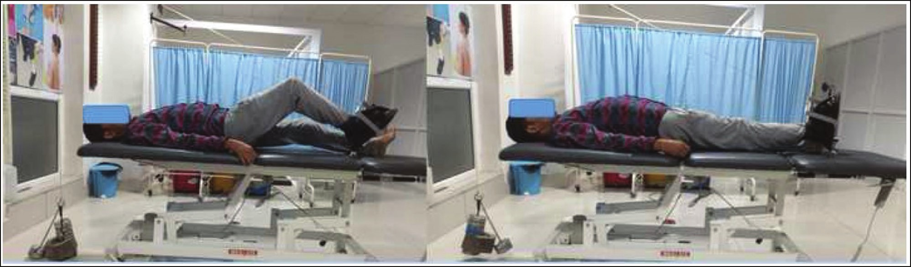

Ansari, *et al.*: Direct lateral approach versus posterior approach in total hip arthroplasty

**Figure 1: One repetition maximum (1RM) leg prone test**

**Figure 2: One repetition maximum (1RM) hip abduction test**

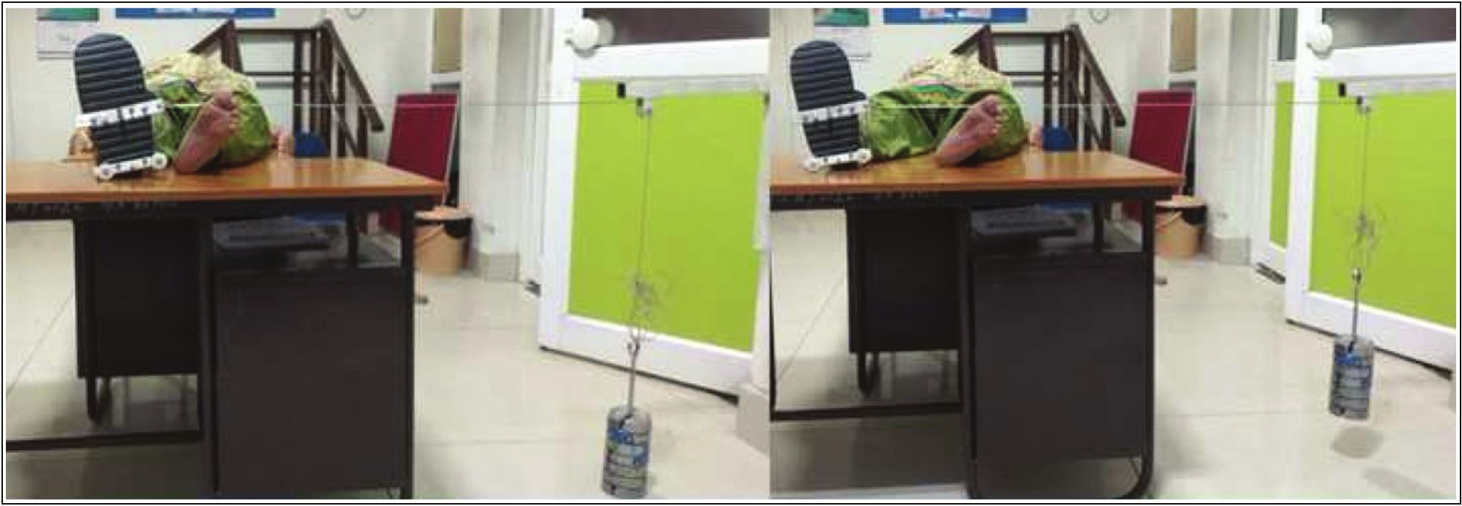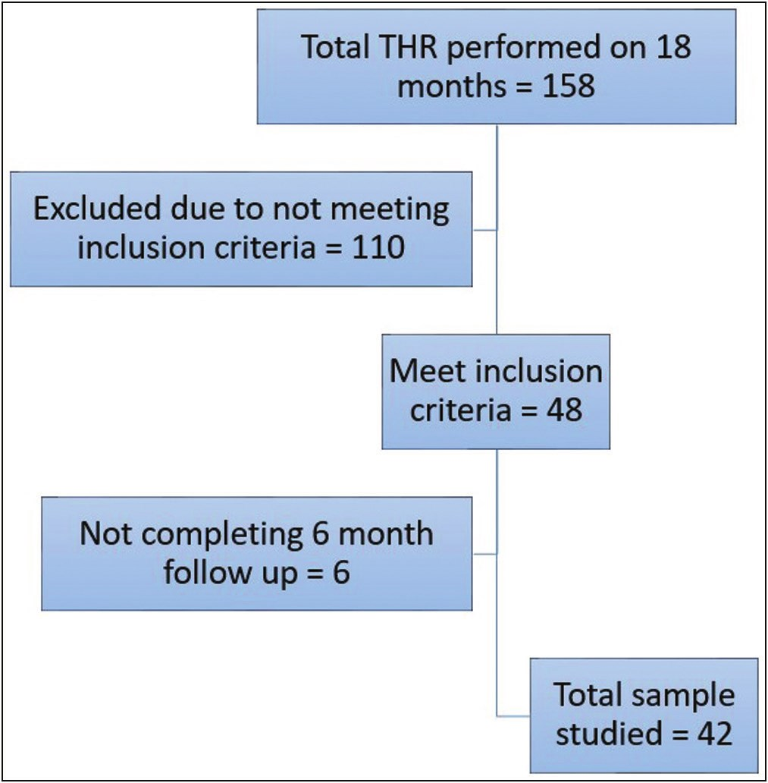

the test. Pain score (VAS), HHS, and Short Form Survey (SF-36) were also evaluated by an evaluator from the PMR department at each visit of the patient. Statistical Tests: All outcome variables were tested for normality (Kolmogorov-Smirnoff). Normally distributed data were reported as means ± standard deviation (SD), and non-normally distributed data were reported as medians. All outcome variables preoperative and postoperative parameters within the same group were compared using the paired *t*-test and Wilcoxon signed-rank test and between groups using the Student’s *T*-test and Mann-Whitney *U* test. All statistical tests were two-sided with a level of significance of 5%. Results were considered significant when the value of *P* was less than 0.05. Test results were analyzed using IBM SPSS Statistics version 24.

**Result**

A total of 158 patients underwent THA during the study period, out of which 48 met inclusion criteria and only 42 completed 6 months follow-up [Figure 3]. The baseline data of the patients were comparable between both groups [Table 1], and there was no significant difference between the two groups in age, sex, BMI, leg press test, and hip abduction test during the preoperative period. Various hip pathologies in this study were avascular necrosis of

**Figure 3: Algorithm showing study characteristics**

the femoral head (total = 28; in PA, 13 and DLA, 15), secondary osteoarthritis of the hip (total = 8; in PA, 6 and DLA, 4), dysplasia of femoral head (total = 3; in PA, 2

8 Journal of the West African College of Surgeons | Volume 13 | Issue 1 | January‑March 2023

Ansari, *et al.*: Direct lateral approach versus posterior approach in total hip arthroplasty

**Table 1: Preoperative patient’s baseline characteristics of patients**

**Mean (SD)** Age (Years) 45.09 (12.71)

**PA**

**Mean with 95% CI** 45.09±5.31(39.8–50.4)

**Mean (SD)** 44.75 (15.44)

**DLA**

**Mean with 95% CI** 44.75±6.77 (38–51.5)

***P*-Value**

0.94

Sex (M/F) BMI

Leg press test (kg) Abduction test (kg)

24.03 (1.61) 7.61 (0.90) 2.31 (0.54)

10/12

24.03±0.67(23.4–4.7) 7.61±0.37 (7.23–7.99) 2.31±0.22 (2.08–2.54)

24.09 (0.99) 7.65 (0.94) 2.14 (0.54)

9/11 0.95 24.09±0.434 (23.7–24.5) 0.54

7.65±0.41 (7.24–8.08) 0.9 2.14±0.237 (1.9–2.38) 0.32

PA: posterior approach, DLA: direct lateral approach, SD: standard deviation, BMI: body mass index. Preoperative patient’s baseline characteristics in PA and DLA

and DLA, 1) and giant cell tumour of the femoral head (total = 1; in PA, 1and DLA, 0).

**1RM leg press test**

Patients in the DLA group (mean, 8.46kg) had a significantly larger reduction in muscular strength than the patients in the PA group (mean, 9.22kg) at 2 weeks postoperative period (mean difference = 0.76kg, *P* = 0.012). At subsequent follow-up (6-week, 3-month, and 6-month) postoperatively, there was less mean difference in mean muscle strength change (0.074, -0.079, and -0.306, respectively) compared with preoperative values in both study groups.

The Wilcoxon signed-rank test showed statistically significant improvement in leg press tests between preoperative scores and 6 months of postoperative follow-up in both approaches (in PA, mean rank = 11.50; in DLA, mean rank = 10.50). However, the change in strength following the leg press test in both groups (PA and DLA) was not statistically significant (in PA, mean rank = 20.16; in DLA, mean rank = 22.98; *U* = 249.5; *P*-value = 0.46). Similarly, when the leg press test of the operated side at 6-month post-op was compared with that of the normal side at 6 months then, the Mann-Whitney *U* test showed a statistically significant difference between the two sides in both approaches [Table 2].

**1RM abduction test**

Unpaired *t*-test at 2 weeks and 6 weeks postoperatively indicates that abduction power in the PA (mean = 3.6kg and 4.3kg; SD = 0.35 and 0.49, respectively) patients is significantly more than in patients with DLA (mean=3.3kg and 4.1kg; SD = 0.26 and 0.29, respectively). At subsequent follow-up (3 and 6 months) postoperatively, there was no statistically significant difference, and both study groups were comparable.

The paired*t*-test (PA) and Wilcoxon signed-rank test (DLA) showed statistically significant improvement in abduction strength between preoperative scores and postoperative at 6 months follow-up in both approaches (*P*-value < 0.0001 in each). However, the change in strength following the abduction test in both groups (PA and DLA) was not statistically significant (in PA, mean rank = 22.64; in DLA, mean rank = 20.25; *U* = 195; *P*-value = 0.53). Similarly, when the abduction test of the operated side at

6-months post-op was compared with that of the normal side at 6-months, the Mann-Whitney *U* test showed a statistically significant difference between the two sides in both approaches [Table 3].

**Pain scoring**

The Mann-Whitney *U* test showed no statistically significant difference between both groups in the median of preoperative and postoperative VAS. Wilcoxon signed-rank test shows the statistically significant difference between the median of preoperative scores and postoperative VAS scores at every follow-up in both approaches [Table 4].

**Harris hip score**

Mann-Whitney *U* test showed no statistically significant difference in median preoperative HHS and 6-week and 6-month postoperative HHS between both groups. Wilcoxon signed-rank test showed a statistically significant difference between the median of preoperative and 6-month postoperative HHS in each group [Table 5].

**SF-36 score**

The Wilcoxon signed-rank test (PA) and paired *t*-test (LA) showed a statistically significant difference between preoperative and 6-month postoperative SF-36 scores in the posterior and lateral groups, respectively [Table 6].

**Adverse effect**

*Trendelenburg gait*

Only one patient had Trendelenburg gait during the entire postoperative follow-up in the LA group, while there was no incidence of Trendelenburg gait in the PA group.

*Hip dislocation*

There was no incidence of hip dislocation between the groups.

**Discussion**

This study intends to assess the effect of the surgical approach on hip muscle strength in the Indian population as most of the patients undergoing THA do not undergo intensive rehabilitation in the postoperative period as in the western world.[7,8] In our study, the short-term differences in muscular strength between the groups point toward different

Journal of the West African College of Surgeons | Volume 13 | Issue 1 | January‑March 2023 9

[Downloaded free from http://www.jwacs-jcoac.com on Tuesday, February 7, 2023, IP: 2.28.143.76]

Ansari, *et al.*: Direct lateral approach versus posterior approach in total hip arthroplasty

**Table 2: Leg press test—comparison between groups Mann-Whitney U test (between groups) – leg press test**

**Approach** ***N***

Pre- op PA 22 DLA 20

**Mean** **Sum of rank rank**

21.1 464.5 21.9 438.5

**U** **Z**

211.5 -0.22

**P-value**

0.83

**Unpaired T-Test (between groups) – leg press test**

Normal

2 weeks post-op

6 weeks post-op

3 months post-op

6 months post-op

**Approach** ***N***

PA 22 DLA 20 PA 22 DLA 20 PA 22 DLA 20 PA 22 DLA 20 PA 22 DLA 20

**Mean** **Mean difference**

14.01 -0.1464 14.16

9.223 0.7627 8.46

10.114 0.0736 10.04

11.336 -0.0786 11.415

12.409 -0.3059 12.715

**SD** **P-Value**

1.33 0.72 1.3

1.12 0.01 0.69

1.26 0.83 0.97

1.27 0.83 1.1

1.3 0.43 1.2

**Wilcoxon Signed-rank test (leg press test)**

**Comparing change in strength = 6 month – pre-op**

**Approach** ***N***

PA 22 DLA 20



**Mean** **U** **P rank**

20.16 249.5 0.46 22.98

**Wilcoxon Signed-rank test (leg press test)**

**Approach**

PA

DLA

***N*** **Side tested at** **Mean** **U** **P 6-month post-up rank**

22 Operated 15.7 391.5 0 Normal 29.3

20 Operated 14.73 315.5 0.002 Normal 26.28

PA: posterior approach, DLA: direct lateral approach

muscles traumatized in each surgical approach chosen for the procedure. Similar to the study done by Downing *et al.*[15] and Holm *et al.*,[16] the muscles affected in DLA are mainly the muscles that help a normal person to stand upright from a sitting position the gluteus maximus which is the hip extensor, the vastus lateralis is the knee extensor, and the gluteus medius, apart from being the main hip abductor, it also supports the pelvis during gait along with gluteus minimus and tensor fascia lata.[17] The muscles affected in the PA are mainly the hip abductors, the gluteus maximus (upper fibres), the short hip external rotator, the piriformis muscle, and gemelli muscles.[17] Muscles used during leg press tests are quadriceps, hamstrings, and gluteal muscles. During DLA, the vastus lateralis muscle is injured because the incision is extended toward it, so leg press strength is therefore reduced; this may be the reason for inferior leg press strength in patients in the DLA group. The leg press test has superior outcomes in PA than in DLA as the incision over the gluteus maximus is slightly posterior than in DLA.[18] This might be the reason for less reduction in leg press muscular strength in PA than in DLA. The gluteus

medius and minimus are the main hip abductors, but small contributions from the piriformis muscle, the tensor fascia latae, and the upper fibres of the gluteus maximus are also involved. The gluteus medius and minimus are injured in DLA, so anticipating inferior abductor muscle strength in this group of patients is obvious. The above data also suggest that the traumatization of the gluteus maximus in the DLA group during the surgical procedure has a more vital effect on leg press and muscular abduction strength than in PA.[18] As anticipated, improvement in muscular strength was noted in each group in post-op follow-up, but the amount of improvement differed between the groups. Owing to the traumatization of quadriceps (vastus lateralis) and gluteus medius, the inferior result of the leg press test and hip abduction test in DLA may be anticipated. Patients in DLA groups have a statistically significant reduction in hip abduction muscular strength than the PA group from preoperatively until 2 and 6 weeks and in leg press muscle strength at 2 weeks but insignificant at 6 weeks postoperatively following THA surgery. At 3 and 6-month follow-up, muscular strength in DLA patients was slightly

10 Journal of the West African College of Surgeons | Volume 13 | Issue 1 | January‑March 2023

Ansari, *et al.*: Direct lateral approach versus posterior approach in total hip arthroplasty

**Table 3: Abduction test—comparison between groups Unpaired *T*-test (between groups)—abduction test**

**Approach** ***N*** **Mean** **Mean** **SD** **95% CI** ***P*-Value difference**

Normal PA 22 DLA 20

Pre-op PA 22 DLA 20

2 weeks post-op PA 22 DLA 20

6 weeks post-op PA 22 DLA 20

3 months post-op PA 22 DLA 20

6 months post-op PA 22 DLA 20

6.764 0.1636 6.6

2.309 0.1691 2.14

3.6 0.31 3.29

4.318 0.2632 4.055

5.177 0.0973 5.08

6.059 0.2691 5.79

**Lower** **Upper**

0.5844 -0.1828 0.5101 0.345 0.5201

0.5362 -0.1676 0.5057 0.316 0.5423

0.345 0.1191 0.5009 0.002 0.2553

0.4837 0.0107 0.5157 0.041 0.2929

0.5863 -0.2605 0.455 0.586 0.5578

0.4382 -0.0233 0.5615 0.07 0.4994

**Comparing change in strength =**

6 month – pre-op

**Approach**

PA DLA

**Wilcoxon signed-rank test (abduction test)**

***N*** **Mean rank** ***U***

22 22.64 195 20 20.25

**Wilcoxon Signed-rank test (abduction test)**

***P*-Value**

0.53

**Approach**

PA



***N*** **Side tested at**

**6-month post-up**

22 Operated Normal

**Mean rank**

15.7 29.3

***U*** ***P*-Value**

391.5 0

PA: posterior approach, DLA: direct lateral approach

**Table 4: Pain scoring: VAS**

**Mann-Whitney *U* test (between groups)—VAS**

Pre-op

2 weeks post-op

6 weeks post-op

3 months post-op

6 months post-op

**Approach** PA

DLA PA DLA PA DLA PA DLA PA

DLA

***N*** **Mean rank** 22 21.27 20 21.75 22 20.89 20 22.18 22 21.86 20 21.1

22 21.95 20 21

22 21.5

20 21.5

**Sum of rank** 468

435 459.5 443.5 481 422 483 420 473

430

***U*** ***Z*** 215 ‒0.139

206.5 ‒0.381

212 ‒0.359

210 ‒0.953

220 0

***P*-Value** 0.89

0.7

0.72

0.34

1

**Wilcoxon signed-rank test—VAS**

**Approach**

PA

DLA

**Comparison**

6 months post-op and pre-op

***N*** **Mean rank**

22 11.5

20 10.5

**Sum of rank** ***Z***

253 ‒4.2 210 ‒4

***P*-Value**

0

0

PA: posterior approach, DLA: direct lateral approach

lower than that of PA patients, but it was not statistically significant. As mentioned above, there was a statistically significant improvement in abduction strength between preoperative scores and postoperative at every follow-up in both approaches. The abductor muscle strength of the operated side at 6-month post-op compared with that of

the normal side showed a statistically significant difference between the two sides in both approaches. The above data also suggest that the traumatization of the gluteus maximus in the DLA group during the surgical procedure has a more vital effect on leg press and muscular abduction strength than in PA. As anticipated, improvement in muscular

Journal of the West African College of Surgeons | Volume 13 | Issue 1 | January‑March 2023 11

Ansari, *et al.*: Direct lateral approach versus posterior approach in total hip arthroplasty

**Table 5: Harris hip score**

**Mann-Whitney *U* test (between groups)—HHS**

Pre-op

6 weeks post-op

6 months post-op

**Approach** PA

DLA PA DLA PA

DLA

***N*** **Mean rank** 22 21.11 20 21.93 22 22.36 20 20.55 22 19.48

20 23.73

**Sum of rank** ***U*** 464.5 211.5 438.5

492 201 411

428.5 175.5

474.5

***Z*** ***P*-Value** ‒0.214 0.83

‒0.489 0.63

‒1.162 0.25

**Wilcoxon signed-rank test—HHS**

**Approach**

PA

DLA

**Comparison** ***N***

6 months post-op and pre-op 22

20

**Mean rank**

11.5

10.5

**Sum of rank** ***Z***

253 ‒4.11 210 ‒3.92

***P*-Value**

0

0

HHS: Harris hip score, PA: posterior approach, DLA: direct lateral approach

**Table 6: SF-36 score Wilcoxon signed-rank test**

**Approach** Posterior

**Comparison** ***N*** 6-month post-op and pre-op 22

**Mean rank** 11.5

**Sum of rank** ***Z*** 253 ‒4.11

***P*-Value** 0

**Paired samples test**

**Approach** **Comparison** ***N*** **Mean** **SD** **Paired differences** ***P*-Value Mean SD 95% CI**



Lateral 6-month post-op and pre-op 20 38

20 71.3

3.23 33.3

3.98

**Lower** **Upper**

4.85 ‒31.03 30.73 0

SF-36: Short Form Survey, SD: standard deviation, CI: confidence interval

strength was noted in each group in post-op follow-up, but the amount of improvement differed between the groups. Patients in DLA groups have a statistically significant reduction in hip abduction muscular strength than the PA group from preoperatively until 2 and 6 weeks and in leg press muscle strength at 2 weeks but insignificant at 6 weeks postoperatively following THA surgery. At 3 and 6-month follow-up, muscular strength in DLA patients was slightly lower than that of PA patients, but it was not statistically significant. As mentioned above, there was a statistically significant improvement in abduction strength between preoperative scores and postoperative at every follow-up in both approaches. The abductor muscle strength of the operated side at 6-month post-op was compared with that of the normal side, which showed a statistically significant difference between the two sides in both approaches. These results correlate with the hip abductor strength measurements, as the Trendelenburg test became negative as the abductor strength improved. The above data obtained have similarities with the findings of Downing*etal.*,[15] Winther*etal.*,[17] and Kiyama*etal.*,[19] who also stated that there is no statistically significant difference in leg press test and hip abductor strength test between their PA and DLA groups postoperative follow-up. Barber *et al.*[20] also did not find any statistically significant muscle testing between DLA and PA. However, Gore *et al.*[21]

noted inferior hip abductor strength test in DLA than PA group. Similarly, Witzleb *et al.*,[22] Jolles *et al.*,[2] Masonis *et al.*,[23] and Lorio R *et al.*[24] reported increased abductor insufficiency in DLA than PA.

**Pain scoring**

Patients in both groups benefited from THA. In the preoperative period, patients in both groups had higher pain scores. During each postoperative follow-up, patient pain scores were on the lower sides as compared with preoperative pain scores. Pain scores at 3 months and 6 months in each group were zero. The visual analogue scale mainly assesses the quantitative aspects of pain, leaving the sensory component untouched. Patients in their preoperative period described the pain as constant or intermittent aching pain or an intermittent sharp severe pain in the groin, and some patients also had referred pain in the knee, buttock, or greater trochanter. In early postoperative periods, most patients described the pain of an aching nature, which subsided with time. It was evident that the joint replacement decreased the severity of pain perceived by the patient, but it does not affect the sensory qualities of the pain as the aching nature of the preoperative pain persists in most patients in the postoperative period. Our study showed no statistically significant difference in VAS between PA and DLA. However, there is a statistically

12 Journal of the West African College of Surgeons | Volume 13 | Issue 1 | January‑March 2023

[Downloaded free from http://www.jwacs-jcoac.com on Tuesday, February 7, 2023, IP: 2.28.143.76]

Ansari, *et al.*: Direct lateral approach versus posterior approach in total hip arthroplasty

significant improvement from preoperative to postoperative VAS at each follow-up in both study groups. A meta-analysis conducted by Putananon *et al.*[25] found no statistically significant difference in VAS scores between DLA and PA.

**Harris hip score**

HHS assesses the effect of hip surgery, and it mainly evaluates hip disabilities as the pain domain in HHS dominates other domains like the functional and deformity domain. The study by Edmund *et al.*on the effect of surgical approach for a total hip replacement on hip function using HHSs and Trendelenburg’s found a statistically significant difference in HHS, with greater improvement in the PA group.[26] A study by Pongcharoen *et al.* comparing anterior, lateral, and posterior approaches showed no significant differences in the HHS.[27] A study done by Petis *et al.* also found no statistically significant difference between the two approaches.[28] Our study also reflected no statistically significant difference in HHS between PA and DLA. However, there was a statistically significant difference in scoring between preoperation and postoperation at every follow-up in both groups.

**SF-36 scoring**

In this study, there is no statistically significant difference seen between the PA and DLA groups in postoperative follow-up. However, there was a statistically significant improvement from preoperative to postoperative health status in each group. A study done by Petis *et al.* showed no statistically significant difference in SF-36 scoring between the DLA and PA approaches.[28] The randomized control trial (RCT) conducted by Witzleb *et al.*[22] on short-term outcomes after posterior versus lateral surgical approach for THA also reflected no statistically significant difference in SF-36 scoring between the DLA and PA approach.

Our study had a few limitations such as being a nonrandomized study, small sample size, shorter duration of follow-up, lack of consideration of vertical and horizontal offset, use of the nonstandardized tool to measure muscle strength, and the possibility of bias during measurement of preoperative and postoperative functional outcome scores.

**Conclusion**

To conclude, the weak abductor mechanism (at 2 and 6 weeks) and extension mechanism (at 2 weeks) in a cohort of DLA in contrast to the PAare seen in the early postoperative period and hence is a short-lived muscle weakness. The type of surgical approach used has no effect on VAS, HHS, and SF-36 scorings. So, the surgical approach is to be chosen according to the surgeon’s expertise. However, there is a need for a strategically planned multicentric randomized study with a long-term follow-up and a large sample size.

**Financial support and sponsorship**

Nil.

**Conflicts of interest**

There are no conflicts of interest.

**Declaration of patient consent**

The authors certify that they have obtained all appropriate patient consent forms. In the form the patient(s) has/have given his/her/their consent for his/her/their images and other clinical information to be reported in the journal. The patients understand that their names and initials will not be published and due efforts will be made to conceal their identity, but anonymity cannot be guaranteed.

**Institutional review or ethical clearance**

The institutional review board approved the study.

**References**

1. Brooks PJ. Dislocation following total hip replacement: Causes and cures. Bone Joint J 2013;95-B:67-9.

2. Jolles BM, Bogoch ER. Posterior versus lateral surgical approach for total hip arthroplasty in adults with osteoarthritis. Cochrane Database Syst Rev 2006;3:CD003828.

3. Hernandez NM, Steele JR, Wu CJ, Cunningham DJ, Aggrey GK, Bolognesi MP, *et al*. A specific capsular repair technique lowered early dislocations in primary total hip arthroplasty through a posterior approach. Arthroplast Today 2020;6:813-8.

4. Swanson TV, Kukreja MM, Ballard JC, Calleja HGM, Brown JM. The “capsular noose”: A new capsular repair technique to diminish dislocation risk after the posterior approach total hip arthroplasty. International Journal of Surgery Open 2019;17:8-14.

5. Berstock JR, Blom AW, Beswick AD. A systematic review and meta-analysis of complications following the posterior and lateral surgical approaches to total hip arthroplasty. Ann R Coll Surg Engl 2015;97:11-6.

6. Miller LE, Gondusky JS, Bhattacharyya S, Kamath AF, Boettner F, Wright J. Does surgical approach affect outcomes in total hip arthroplasty through 90 days of follow-up? A systematic review with meta-analysis. J Arthroplasty 2018;33:1296-302.

7. Mulholland SJ, Wyss UP. Activities of daily living in non-western cultures: Range of motion requirements for hip and knee joint implants. Int J Rehabil Res 2001;24:191-8.

8. Kumar P, Sen RK, Aggarwal S, Jindal K. Common hip conditions requiring primary total hip arthroplasty and comparison of their post-operative functional outcomes. J Clin Orthop Trauma 2020;11:192-5.

9. Osborne G. The history of surgical access for hip replacement. Current Orthopaedics 1986;1:61-6.

10. Hardinge K. The direct lateral approach to the hip. J Bone Joint Surg Br 1982;64:17-9.

11. Mehlman CT, Meiss L, DiPasquale TG. Hyphenated-history: The Kocher-Langenbeck surgical approach. J Orthop Trauma 2000;14:60-4.

12. Gibson A. Posterior exposure of the hip joint. J Bone Joint Surg Br 1950;32-B:183-6.

13. VerdijkLB, van LoonL, MeijerK, SavelbergHH. One-repetition maximum strength test represents a valid means to assess leg

strength in vivo in humans. J Sports Sci 2009;27:59-68.

Journal of the West African College of Surgeons | Volume 13 | Issue 1 | January‑March 2023 13

Ansari, *et al.*: Direct lateral approach versus posterior approach in total hip arthroplasty

14. Grgic J, Lazinica B, Schoenfeld BJ, Pedisic Z. Test-retest reliability of the one-repetition maximum (1rm) strength assessment: A systematic review. Sports Med Open 2020;6:31.

15. Downing ND, Clark DI, Hutchinson JW, Colclough K, Howard PW. Hip abductor strength following total hip arthroplasty: A prospective comparison of the posterior and lateral approach in 100 patients. Acta Orthop Scand 2001;72:215-20.

16. Holm B, Thorborg K, Husted H, Kehlet H, Bandholm T. Surgery-induced changes and early recovery of hip-muscle strength, leg-press power, and functional performance after fast-track total hip arthroplasty: A prospective cohort study. PloS One 2013;8:e62109.

17. Winther SB, Husby VS, Foss OA, Wik TS, Svenningsen S, Engdal M, *et al*. Muscular strength after total hip arthroplasty: A prospective comparison of 3 surgical approaches. Acta Orthop 2016;87:22-8.

18. Agten CA, Sutter R, Dora C, Pfirrmann CW. MR imaging of soft tissue alterations after total hip arthroplasty: Comparison of classic surgical approaches. Eur Radiol 2017;27:1312-21.

19. Kiyama T, Naito M, Shinoda T, Maeyama A. Hip abductor strengths after total hip arthroplasty via the lateral and posterolateral approaches. J Arthroplasty 2010;25:76-80.

20. Barber TC, Roger DJ, Goodman SB, Schurman DJ. Early outcome of total hip arthroplasty using the direct lateral vs the posterior surgical approach. Orthopedics 1996;19:873-5.

21. Gore DR, Murray MP, Sepic SB, Gardner GM. Anterolateral

compared to posterior approach in total hip arthroplasty:

Differences in component positioning, hip strength, and hip motion. Clin Orthop Relat Res 1982;165:180-7.

22. Witzleb WC, Stephan L, Krummenauer F, Neuke A, Günther KP. Short-term outcome after posterior versus lateral surgical approach for total hip arthroplasty: A randomized clinical trial. Eur J Med Res 2009;14:256-63.

23. Masonis JL, Bourne RB. Surgical approach, abductor function, and total hip arthroplasty dislocation. Clinical Orthopaedics and Related Research® 2002;405:46-53.

24. IorioR, HealyWL, WarrenPD, ApplebyD. Lateral trochanteric pain following primary total hip arthroplasty. J Arthroplasty 2006;21:233-6.

25. Pongcharoen B, Chaichubut K. Limping following primary total hip replacement: Comparison of 3 surgical approaches. JB JS Open Access 2019;4:e0043.

26. Edmunds CT, Boscainos PJ. Effect of surgical approach for total hip replacement on hip function using Harris hip scores and Trendelenburg’s test: A retrospective analysis. Surgeon 2011;9:124-9.

27. Putananon C, Tuchinda H, Arirachakaran A, Wongsak S, Narinsorasak T, Kongtharvonskul J. Comparison of direct anterior, lateral, posterior and posterior-2 approaches in total hip arthroplasty: Network meta-analysis. Eur J Orthop Surg Traumatol 2018;28:255-67.

28. Petis S, Howard JL, Lanting BL, Vasarhelyi EM. Surgical approach in primary total hip arthroplasty: Anatomy, technique

and clinical outcomes. Can J Surg 2015;58:128-39.

14 Journal of the West African College of Surgeons | Volume 13 | Issue 1 | January‑March 2023