**Original Article**

**The Correlation of Sonographic and Histopathologic Findings in the Diagnosis of Palpable Breast Masses in Zaria**

**Abstract**

**Introduction:** Presently, histology is the gold standard in definite diagnosis of breast masses. Ultrasound is a relatively cheap, non-invasive, and non-ionizing imaging modality which is widely available in most hospitals. An assessment of its accuracy in diagnosing breast masses is necessary to minimize unwarranted biopsies. **Aim and Objectives:** This study aims to correlate the ultrasonographic and histopathologic findings in the diagnosis of patients with palpable breast masses. **Materials and Methods:** This was a cross-sectional hospital-based study, which involved 100 consecutive patients who presented with palpable breast masses in Zaria. This was carried out for a period of 7 months (November 2016–June 2017). They had a clinical breast examination to identify the mass, which was then imaged and biopsied via ultrasound-guided fine needle aspiration cytology. **Results:** The generated data were analysed using SPSS version 23.0 (Chicago, IL, USA). There were more benign masses (63%) than malignant masses (29%). On correlating the final diagnosis of ultrasound to that of histology, it was found to have a sensitivity of 89%; specificity of 94%; positive predictive value of 89%; negative predictive value of 94%; and accuracy of 92%. **Conclusion:** This study shows that there was a correlation between ultrasound and histology findings in differentiating between benign and malignant masses. This proves that ultrasound has a significant role to play in evaluating and diagnosing clinically palpable breast masses.

**Keyword:** *Histopathology, palpable breast masses, ultrasonography*

**Nafisa Bello, Sefiya Adebanke**

**Olarinoye-Akorede, Halima Mono Mohammed, Ibrahim Aliyu,**

**Mubarak Zubair Abdullahi, Muhammad Zaria Ibrahim, Sulieman Lawal,**

**Muhammad Haruna Rasheed**

*Department of Radiology, Ahmadu Bello University Teaching Hospital, Zaria, Nigeria*

**Introduction**

Breast cancer is the most common cancer in women worldwide.[1] Prompt diagnosis and treatment is achieved by doing a thorough clinical breast examination (CBE), imaging, and tissue sampling for a definite diagnosis.[2]

Ultrasonography (USS) has a well-established ability to diagnose the nature and the extension of breast pathologies.[2-5] Histology is presently the gold standard investigation for the diagnosis of breast masses.[6]

The correlation of sonographic and histopathologic findings will help determine the utility and sensitivity of ultrasonography as a first-line imaging modality in the diagnosis of palpable breast masses.

**Aims**

The aim of this study was to correlate the sonographic features and histopathologic findings in the diagnosis of patients with palpable breast masses in Zaria.

This is an open access journal, and articles are distributed under the terms ofthe Creative CommonsAttribution-NonCommercial-ShareAlike 4.0 License, which allows others to remix, tweak, and build upon the work non-commercially, as long as appropriate credit is given and the new creations are licensed under the identical terms.

**For reprints contact:** reprints@medknow.com

**Materials and Methods**

Prior to the commencement of this study, approval by the Ethical and Research Committee of the hospital was obtained.

**Study design**

This cross-sectional hospital-based study was carried out in the Department of Radiology, in a tertiary health institution located in north western Nigeria. The convenient sampling method was used. This study was carried out over a period of 7 months, from November 2016 to June 2017 after approval was granted by the Ethical Committee.

The study group was made up of 100 consenting consecutive Nigerian adults aged 18 years and above with a palpable breast mass.

On consenting to the study, procedure was explained and consent form was signed by the patient. A physical examination of the breast was done to identify the palpable mass.

**How to cite this article:** Bello N, Olarinoye-Akorede SA, Mohammed HM, Aliyu I, Abdullahi MZ, Ibrahim MZ, *et al.* The correlation of sonographic and histopathologic findings in the diagnosis of palpable breast masses in Zaria. J West Afr Coll Surg 2023;13:74-8.

**Received:** 29-Sep-2022 **Accepted:** 25-Oct-2022 **Published:** 18-Jan-2023

***Address for correspondence:*** *Dr. Nafisa Bello, Department of Radiology, Ahmadu Bello University Teaching Hospital, Zaria, Nigeria.*

*E-mail: nafbells@gmail.com*

**Access this article online**

**Website:**

www.jwacs-jcoac.com

**DOI:** 10.4103/jwas.jwas_218_22

**Quick Response Code:**

74 © 2023 Journal of the West African College of Surgeons | Published by Wolters Kluwer ‑ Medkno

Bello, *et al.*: Diagnosis of palpable breast masses in Zaria

Both breasts were scanned using a sonography system (Mindray, DC-8 series, China). The patient was placed in a supine position and arm on the side to be examined was raised and the hand placed under the neck to keep the breast firm on to the chest wall.

Sonographic gel was applied over the skin of the entire breast including the axilla. A high frequency (10 MHz) linear array transducer was then gently applied over the breast, and both sagittal and transverse scans were done radially.

When a mass was found, the shape, margins, orientation, echo pattern, and posterior acoustic features were recorded. Based on these BI-RADS descriptors for ultrasound, a final assessment category was assigned as follows:

• Category 2: Benign findings;

• Category 3: Probably benign findings; • Category 4: Suspicious abnormality;

• Category 5: Highly suggestive of malignancy.

**Table 1: Age distribution of subjects with palpable breast masses in Zaria**

**Age group** **Frequency** **Percent** 18–27 39 39 28–37 23 23 38–47 20 20 48–57 7 7 58–67 10 10 68–77 1 1 Total 100 100



Category 1 (negative findings) and 6 (biopsy-proven malignancy) were not included in this study.

The confirmation of the ultrasound diagnosis was made by fine needle aspiration cytology (FNAC), which was done by a pathologist in the hospital.

**Data analysis**

The results and data generated from patients with palpable breast masses were compiled in an Excel data sheet before being analysed using Statistical Package for Social Sciences (SPSS) version 23.0 (Chicago, IL, USA). Results obtained from the sonographic features of palpable breast masses and their correlating histological findings were statistically analysed and represented in the form of tables. This was then used to find the following values: true positive (TP), false positive (FP), true negative (TN), false negative (FN), sensitivity, specificity, positive predictive value (PPV), negative predictive value (NPV), and accuracy.

**Discussion**

All participants were females. The mean age of the patients in this study was 34.66±13.99 (range 18–69) years, which is similar to a study done in Zaria by Yusufu *et al.*[7] which had a mean age of 36.4 (range 13–80) years after a 14-year study of breast masses in the same environment.

The age distribution of subjects presenting with palpable breast masses as shown in Table 1 noted that the age group 18–27 had the highest incidence of breast lump with 39 (39%) subjects followed by the 28–37 age group that had 23 subjects. This is similar to a study by Singh *et al.*, which

**Table 2: Ultrasound descriptor vs. sonographic BI-RADS category**

**Ultrasound** **BI-RADS** **Total**

**Descriptor**

Shape of mass

Orientation

Margin

Mass boundary

Echogenicity

Posterior Acoustic Features

Oval Round Irregular Parallel

Non-parallel Circumscribed Non-circumscribed Abrupt

Halo Hypoechoic Hyperechoic Complex Isoechoic Enhancement Shadow Mixed

None

**2 (%) 3 (%) 4 (%)** 18 (25) 40 (56) 9 (13) 0 (0) 7 (88) 0 (0)

0 (0) 0 (0) 2 (10) 9 (20) 30 (66) 4 (9) 9 (16) 17 (31) 7 (13)

18 (25) 47 (65) 4 (6) 0 (0) 0 (0) 7 (25)

18 (19) 47 (51) 7 (8) 0 (0) 0 (0) 4 (50)

16 (23) 34 (48) 5 (7) 2 (67) 0 (0) 0 (0) 0 (0) 9 (41) 6 (27) 0 (0) 4 (100) 0 (0)

15 (20) 43 (57) 5 (6) 3 (60) 0 (0) 2 (40) 0 (0) 1 (100) 0 (0) 0 (0) 3 (17) 4 (22)

**5 (%)**

4 (6) 71 1 (12) 8

19 (90) 21 2 (5) 45 22 (40) 55 3 (4) 72 21 (75) 28 20 (22) 92

4 (50) 8 16 (23) 71 1 (33) 3 7 (32) 22 0 (0) 4

13 (17) 76 0 (0) 5 0 (0) 1

11 (61) 18

*BI-RADS 2 indicates benign findings; BI-RADS 3, probably benign; BI-RADS 4, suspicious abnormality; BI-RADS 5, highly suspicious of malignancy

*Number in parentheses indicates percentage of total

Journal of the West African College of Surgeons | Volume 13 | Issue 1 | January‑March 2023 7

Bello, *et al.*: Diagnosis of palpable breast masses in Zaria

**Table 3: Ultrasound descriptors vs. histologic (FNAC) findings**

**Ultrasound Descriptor**

Shape of mass

Orientation

Margin Mass Boundary

Echogenicity

Posterior Acoustic Features

Oval Round Irregular Parallel

Non-parallel Circumscribed Non-circumscribed Abrupt

Halo Hypoechoic Hyperechoic Complex Isoechoic Enhancement Shadow Mixed

None

**C2 (%)** **C3 (%)** 54 (76) 0 (0)

5 (63) 2 (25) 4 (19) 0 (0)

39 (87) 0 (0) 24 (44) 2 (3) 59 (82) 2 (3) 4 (14) 0 (0) 61 (66) 2 (2) 2 (25) 0 (0) 52 (73) 2 (3) 2 (67) 0 (0) 5 (23) 0 (0) 4 (100) 0 (0) 52 (68) 2 (3) 3 (60) 0 (0) 1 (100) 0 (0) 7 (39) 0 (0)

**Histology**

**C4 (%)** 4 (6) 0 (0) 2 (10) 0 (0) 6 (11) 4 (5) 2 (7) 6 (7) 0 (0) 2 (3) 0 (0) 4 (18) 0 (0) 6 (8) 0 (0) 0 (0) 0 (0)

**Total C5 (%)**

13 (18) 71 1 (12) 8 15 (71) 21 6 (13) 45 23 (42) 55 7 (10) 72 22 (79) 28 23 (25) 92 6 (75) 8 15 (21) 71 1 (33) 3 13 (59) 22 0 (0) 4 16 (21) 76 2 (40) 5 0 (0) 1 11 (61) 18

†C2 indicates benign findings; C3, probably benign; C4, suspected malignancy; C5, malignant carcinoma; number in parentheses indicate percentage of total;

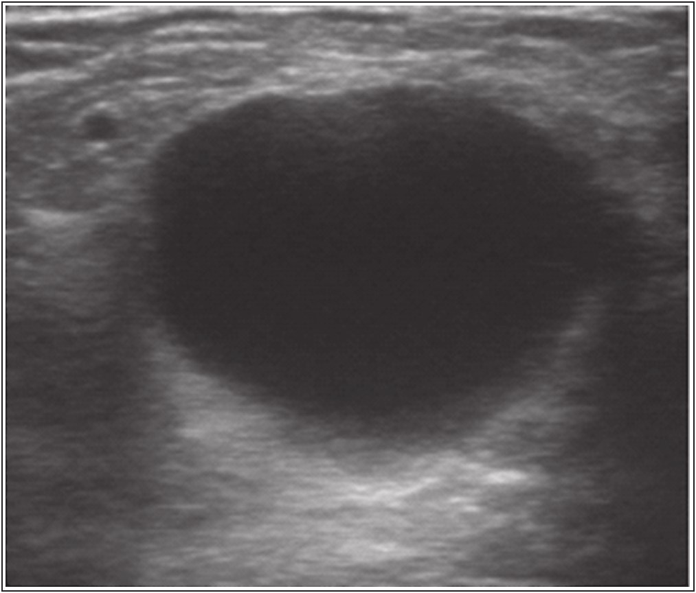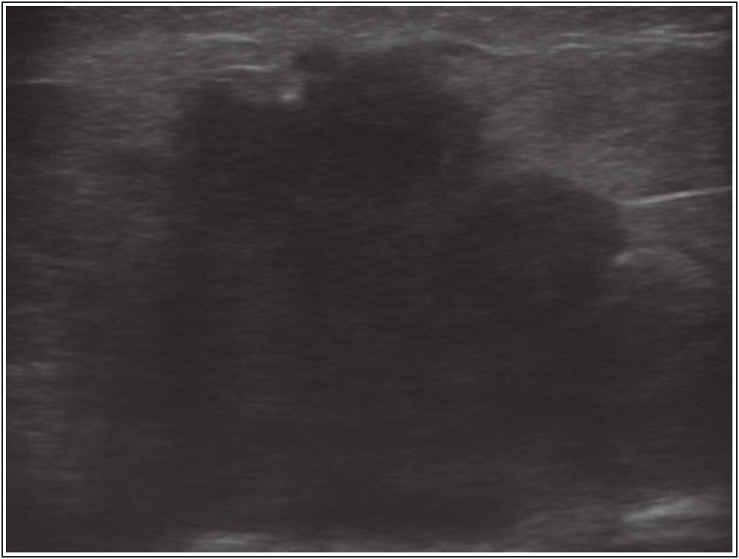

**Figure 1: A longitudinal ultrasound scan showing a hypoechoic round mass with posterior acoustic enhancement which was assigned a BI-RADS 2 category. On FNAC, it was found to be a simple cyst**

had the highest incidence of breast lumps in the age group of 20–29 years (44%).[8]

Tables 2 and3 show ultrasound descriptors versus their BI-RADS class and histology findings, respectively. Ultrasound features which favoured benign diagnoses were oval (76%) and round (87%) shapes, with a well-circumscribed margin (82%) and an abrupt boundary (66%), which is similar to what was also noted in other studies [Figure 1].[3,6,9-11]

Ultrasound features predictive of malignancy in this study as shown in Table 3 were irregular shape (71%) with a non-circumscribed margin (79%) and a halo (75%) surrounding

**Figure 2: A longitudinal ultrasound scan showing an irregular hypoechoic mass with angulated and speculated margins. This was assigned BI-RADS 5 category and on FNAC it revealed to be breast carcinoma**

the mass [Figure 2].This is similar to what was recorded in other studies.[3,9-11]

The correlation of BI-RADS grades to histology findings in this study as shown in Table 4 is similar to that reported by Lehman *et al.*,[12] whereby BI-RADS 2 and 3 were 99.7% and 100% for benignity, respectively, whereas this study had a 100% and 87.3% correlation for benignity for BI-RADS 2 and 3, respectively. In the case of BI-RADS 5, Costantini *et al.*[13] and Lehman *et al.*[12] noted 87.3% and 90% of their masses to be malignant, which is higher than that recorded in this study with 83.3% correlation for malignancy. In BI-RADS 4, an 81.1% correlation for malignancy was recorded, whereas Costantini *et al.*[13] and Lehman *et al.*[12] noted 46.7%

76 Journal of the West African College of Surgeons | Volume 13 | Issue 1 | January‑March 2023

Bello, *et al.*: Diagnosis of palpable breast masses in Zaria

**Table 4: Correlation of BI-RADS grading to their histology findings**

**BI-RADS**

2 (%) 3 (%) 4 (%) 5 (%) Total

**2**

18 (100) 41 (87.2) 2 (18.2) 2 (8.3) 63

**Histology**

**3** **4** 0 (0) 0 (0)

2 (4.3) 4 (8.5) 0 (0.0) 0 (0.0) 0 (0.0) 2 (8.3) 2 6

**Total 5**

0 (0) 18 0 (0.0) 47 9 (81.8) 11

20 (83.3) 24 29 100

**Table 5: *P*-values of the correlation between the BI-RADS class and histology**

**BI-RADS** **Histology** **Significance 2 3 4 5**

2 0.0001 Significant 3 0.129 Not

significant 4 0.438 Not

significant 5 0.0001 Significant

**Table 6: A 2×2 table showing findings on ultrasound vs. histology, taking histology as the gold standard**

**Test results** **Histology** **Total D+ (disease** **D- (disease**



**positive)** **negative)**

**T+ (test positive)** 31 (TP) 4 (FP) 35 **T- (test negative)** 4 (FN) 61 (TN) 65 **Total** 35 65 100

‡D+, indicates disease positive on histology (C4 and C5); D**-**, indicates disease negative on histology (C2 and C3); T+, test positive (lesions assigned to BI-RADS 4 and 5); T**-**, test negative (lesions assigned to BI-RADS 2 and 3); TP, true positive; FP, false positive; FN, false negative; FP, false positive

and 8.6% correlation for malignancy, respectively. The low correlation for malignancy under the BI-RADS 4 category in the study done by Lehman *et al.* may be due to the fact that their study was restricted to those of age 30–39 years only, whereas this study had a wider range of 18–69 years.

Table 4 also shows that there were more benign masses than malignant ones proven on histology. About 63% of the masses were found to be benign in this study and is similar to the study done by Nuhu *et al.*,[14] which had 63% benign masses in a study done in Maiduguri. Yusufu *et al.*[7] noted 71% benign masses in their study in Zaria, which is higher than what was determined in this study.

Statistical test of independence was done as shown in Table 5, and the BI-RADS grading was found to be statistically significant (*P* = 0.0001) in its correlation with histology in BI-RADS 2 and 5 categories. This is similar to what was noted in a study by Hong *et al.*[11] BI-RADS 3 and 4, in contrast, were not statically significant with values of 0.129 and 0.487, respectively, in correlation with histology.

**Table 7: Sensitivity, specificity, PPV, NPV, and accuracy of the study using values from Table 6**

**Parameter** **Formula** ***n*** **%** **Value** Sensitivity TP/(TP+FN) 31/(31+4) 89 0.886 Specificity TN/(TN+FP) 61/(61+4) 94 0.938 PPV TP/(TP+FP) 31/(31+4) 89 0.886 NPV TN/(TN+FN) 61/(61+4) 94 0.938 Accuracy (TP+TN)/Total (31+61)/100 92 0.920

The predictive value of ultrasound in diagnosing breast masses was calculated using a 2×2 table [Table 6] and then used in Table 7, to calculate the sensitivity, specificity, NPV, PPV, and the accuracy. This study confirms the high sensitivity (identification of malignant lesions in patients with breast cancer; 89%) and the high NPV (identification of true negative findings in disease-free patients; 94%) of the sonographic BI-RADS classification. The BI-RADS also had a high specificity (94%) because of the low number of false-positive findings (four cases) in this study.

The accuracy of this study (92%) in differentiating between benign and malignant masses was similar to that of Irurhe *et al.*[15] and Pande *et al.*,[10] which recorded 97% and 94%, respectively, and higher than 71% recorded by Costantini *et al.*[13]

**Conclusion**

The high sensitivity, specificity, NPV, and accuracy seen in this study confirm the usefulness of ultrasound in diagnosing and differentiating between benign and malignant masses. The study also notes benign masses to be more common than malignant breast masses.

This shows that ultrasound use should be considered in patients with clinically palpable breast masses as an initial investigation and follow-up as it is more accessible and relatively cheaper in developing countries such as Nigeria. In many communities, mammography is expensive, plagued by frequent breakdowns, and found only in few areas; therefore, sonography can be used early in evaluating any breast mass and follow-up ultrasound scans are done as advised by American College of Radiology to avoid frequent biopsies which are more expensive.

**Recommendation**

Further studies with longer durations are needed to prove the usefulness of ultrasound in showing the stability of

Journal of the West African College of Surgeons | Volume 13 | Issue 1 | January‑March 2023 77

Bello, *et al.*: Diagnosis of palpable breast masses in Zaria

the grey scale features of BI-RADS 3 masses leading to a reduction in the amount of biopsies done.

Studies should also be done to include non-palpable masses because ultrasound accuracy has been shown to vary according to palpability of the lesion.

**Acknowledgement**

5. Lehman CD, Lee AY, Lee CI. Imaging management of palpable breast abnormalities. Am J Roentgenol 2014;203:1142-53.

6. Gonzaga MA. How accurate is ultrasound in evaluating palpable breast masses? Pan Afr Med J 2010;7:1.

7. Yusufu LM, Odigie V, Mohammed A. Breast masses in Zaria, Nigeria. Ann Afr Med 2003;2:13-6.

8. Singh K, Azad T, Gupta GD. The accuracy of ultrasound in

diagnosis of palpable breast lumps. JK Sci 2008;10:186-8.

The authors would like to thank all those who contributed in the making of this article.

**Financial support and sponsorship**

This was a self-sponsored study. **Conflicts of interest**

There are no conflicts of interest.

**References**

1. Breast Cancer Statistics. World Cancer Research Fund International [Internet]. Available from: http://www.wcrf.org/int/ cancer-facts-figures/data-specific-cancers/breast-cancer-statistics. [Last accessed on Feb 2, 2016].

2. Klein S. Evaluation of palpable breast masses. Am Fam Physician

2005;71:1731-8.

9. Rahbar G, Sie AC, Hansen GC, Prince JS, Melany ML, Reynolds HE, *et al*. Benign versus malignant solid breast masses: US differentiation. Radiology 1999;213:889-94.

10. Pande A, Lohani B, Sayami P, Pradhan S. Predictive value of ultrasonography in the dignosis of palpable breast lump. Kathmandu Univ Med J 2003;1:78-84.

11. Hong AS, Rosen EL, Soo MS, Baker JA. BI-RADS for sonography: Positive and negative predictive values of sonographic features. Am J Roentgenol 2005;184:1260-5.

12. Lehman CD, Lee CI, Loving VA, Portillo MS, Peacock S, Demartini WB, *et al*. Accuracy and value of breast ultrasound for primary imaging women 30–39 years of age. Am J Roentgenol 2012;199:1169-77.

13. Costantini M, Belli P, Lombardi R, Franceschini G, Mulè A, Bonomo L. Characterization of solid breast masses: Use of the sonographic breast imaging reporting and data system lexicon.

J Ultrasound Med 2006;25:649–59; quiz 661.

3. Sah R, Jha A. Accuracy of USG in stratifying palpable breast lesions: Correlative study using fine needle aspiration for cytology. Innoriginal Int J Sci 2015;2:9-15.

4. Colan-georges A. Atlas of Full Breast Ultrasonography. 1st ed. Switzerland: Springer International Publishing AG Switzerland;

2016.

14. Nuhu A, Musa AB, Aliyu S. Management of breast lumps in Maiduguri, Nigeria. Sahel Med J 2014;17:50.

15. Irurhe NK, Adekola OO, Awosanya GO, Adeyomoye AO, Olowoyeye OA, Awolola NA, *et al*. The accuracy of ultrasonography in the diagnosis of breast pathology in

symptomatic women. Niger Q J Hosp Med 2012;22:236-9.

78 Journal of the West African College of Surgeons | Volume 13 | Issue 1 | January‑March 2023