Conservative Management of Congenital Unilateral Eyelid Ectropion in a 3-day-old Neonate in Jos North-Central Nigeria

## Tenmang Panshak,

**Abstract**

**Background:** Congenital ectropion is a rare congenital eyelid eversion with chemosis. It is twice more common in males. We report a case of congenital unilateral eversion of the upper eyelid with severe chemosis that was successfully managed conservatively. **Aim:** The case is being reported for its rarity, demonstrating effectiveness of conservative management with 3% hypertonic saline. Also to create awareness of the diseases and ease of management amongst health workers. **Case Presentation:** The patient was a 4 day old female child with a congenital unilateral eversion of the right upper eyelid and severe chemosis following uneventful delivery. Patient was also noticed to be febrile, but no other physical or systemic anomaly. A conservative treatment approach was used which consisted of the application of antibiotics eye drop and ointment and padding of the eye with 3% hypertonic saline soaked gauze. The eyelid reverted spontaneously after 3 days and the condition was completely resolved without complications. **Conclusion:** Congenital eyelid eversion is a benign condition that excellently responds to conservative treatment. Creating awareness of its existence and treatment approach amongst health workers is essential.

**Keywords:** *Congenital, conservative, ectropion, eyelid disease, unilateral*

**Alice V. Ramyil, Nievel Buetnaan Maigida, Pamela Onyinye Anyika,**

**Patricia Wade**

*Department of Ophthalmology, Jos University Teaching Hospital, Jos, Plateau, Nigeria*

# Introduction

Congenital eyelid eversion is a rare condition typically bilateral, which is characterized by the outward turning of the lids, prolapse of the conjunctiva and chemosis. This condition is mostly seen to be present at birth, however late presentation has been reported.[1,2]

Most cases reported have no ocular or generalized systemic associations, the exact etiology for the condition remains unknown, though several possible mechanisms have been proposed such as vertical shortening of the anterior lamellar or vertical elongation of the posterior lamellar of the eyelids and failure of the orbital septum to fuse with the levator aponeurosis.[3] It is commonly seen in black infants, children with Downs syndrome and collodion skin disease.[1,4] This condition is twice as common in males and in premature babies.[4]

If not treated early, it could lead to complications like epidermization of the conjunctiva and secondary infection. Even though corneal complications are said to be rare because of the protective effect of the chemosis on the cornea,

This is an open access journal, and articles are distributed under the terms of the Creative Commons Attribution-NonCommercial- ShareAlike 4.0 License, which allows others to remix, tweak, and build upon the work non-commercially, as long as appropriate credit is given and the new creations are licensed under the identical terms.

**For reprints contact:** [reprints@medknow.com](mailto:reprints@medknow.com)

corneal perforation has been reported.[5] Most cases are treated conservatively (medically), while surgical intervention is reserved for late presentation, and those not responding to medical treatment or with complications.[2]

We present a rare case of unilateral congenital eversion of the upper lid that was managed effectively conservatively with complete and spontaneous inversion of the eyelids. There’s a need for proper education to all health workers that this is amendable to conservative care hence referral should be prompt.

# Case Presentation

A 2 day old female baby, who was delivered via spontaneous vaginal delivery at a private hospital in Jos Plateau State was referred with unilateral right upper eyelid eversion. She was the 6th of 6 children born to a 40 year old house wife in a non-consanguineous marriage at 40 weeks of gestation. Pregnancy was said to be booked and regularly followed up no history of vaginal infection during pregnancy, labour and delivery were uneventful and no instrumentation during delivery. Her birth weight was 2.3kg. There was marked eversion of the right upper lids with much swelling.

**How to cite this article:** Panshak T, V Ramyil A, Maigida NB, Anyika PO, Wade P. Conservative management of congenital unilateral eyelid ectropion in a 3-day-old neonate in Jos North-Central Nigeria. J West Afr Coll Surg 2022;12:104-6.

**Received:** 23-Mar-2022 **Accepted:** 28-Apr-2022 **Published:** 23-Aug-2022

***Address for correspondence:*** *Dr. Tenmang Panshak Elisha, Department of , Ophthalmology,*

*Jos University Teaching Hospital, P.MB 2076, Jos, Plateau, Nigeria. E-mail: panshak_tenmang@ yahoo.com*

|  |
| --- |
| **Access this article online** |
| **Website:**  [www.jwacs-jcoac.com](http://www.jwacs-jcoac.com/) |
| **DOI:** 10.4103/jwas.jwas_67_22 |
| **Quick Response Code:** |

104 © 2022 Journal of the West African College of Surgeons | Published by Wolters Kluwer ‑ Medknow

Examination revealed ectropion (eversion) of the right upper eyelid with severe conjunctival chemosis and discharge [Figure 1]. After instillation of topical anesthetic agent, with the use of Desmarres retractors, the eyelids were separated gently and the cornea appeared normal and healthy with brisk pupillary reaction.

Baby was noticed to be febrile with a temperature of 38.6°, and with a poor cord hygiene.

The baby was admitted and reviewed by the pediatricians, and no morphological anomaly was found on examination. An investigation for neonatal sepsis was done and full blood count showed granulocytosis with normal total white blood cell count, urine and cerebrospinal fluid cultures were all normal. Child was treated for neonatal sepsis with intravenous ceftriaxone and gentamicin for 7 days and the fever subsided after 3 days. The eye was cleaned daily to keep the external eye clear of any discharge. The ectropion was managed with the application of topical 3% hypertonic saline soaked gauze pad daily to the right eye. The 3% hypertonic saline was formulated at the pharmacy unit of Jos University Teaching Hospital. An eye drop moxifloxacin was instilled 8 hourly along with chloramphenicol ointment given 2 hourly. Though the swelling reduced significantly on the second day, treatment was continued and on the third day, the chemosis was fully resolved and the lid reverted back to normal position [Figure 2] The eye was no longer padded after the third day, the 3% hypertonic

saline, topical antibiotic were instilled 8 hourly 5 minutes apart, and the antibiotic ointment was then used twice daily.

The child was discharged on the 7th day post presentation without any surgical intervention. He was seen after 2 weeks, and lids were found to be normal with a healthy looking globe.

# Discussion

Complete eversion of the eyelid is a rare condition,[1] although a few cases have been seen to be reported worldwide and in Nigeria.[6-9] This is the first unilateral eyelid eversion to be reported from Plateau state and North Central Nigeria, and to the best of our knowledge the last reported case was over 3 decades ago with a bilateral eyelid eversion.[10] The condition is mostly bilateral, a few unilateral cases have been reported to occur similar to our index patient.[6] The presentation of eyelid eversion is usually alarming to both the parents and healthcare professional, especially if seen for the first time.[2] Several factors have been postulated in the pathogenesis including orbicularis oculi hypotony, birth trauma, vertical shortening of the anterior lamellar or vertical elongation of the posterior lamella of the eyelid with failure of the orbital septum to fuse with the levator aponeurosis, absence of an effective lateral canthal ligament and lateral elongation of the eyelid.[5] However, in this our index case, delivery was via spontaneous vaginal delivery with no history of birth trauma or instrumentation during delivery. Labour was neither prolonged, nor difficult and there was no evidence of maternal genital infection, however this could have been as a result of an unknown intrauterine inflammation.[6] This However, is been suggested from a other studies that prolonged labour is a predisposing factor for the occurrence of the eyelid eversion in some cases, it has also been reported in children delivered via caesarean section[2,11]

It has been suggested that careful history when evaluating such patients should be ensured; including getting detailed information on pregnancy and labour, looking out for signs and symptoms of infection during pregnancy.[6] A detailed Paediatric review is important to ascertain the health of the patient and to rule out other congenital anomalies, like Down’s syndrome and collodion skin.[1] This patient was found to be febrile, but responded well to treatment with antibiotics within 5 days. This is similar to other reports that found neonatal sepsis in some of their cases.[2,6] The mother is a grand multiparous woman, this may relate to the cause of the condition, the role of parity on the occurrence of this condition has been questioned by earlier work in Nigeria.[8,10]

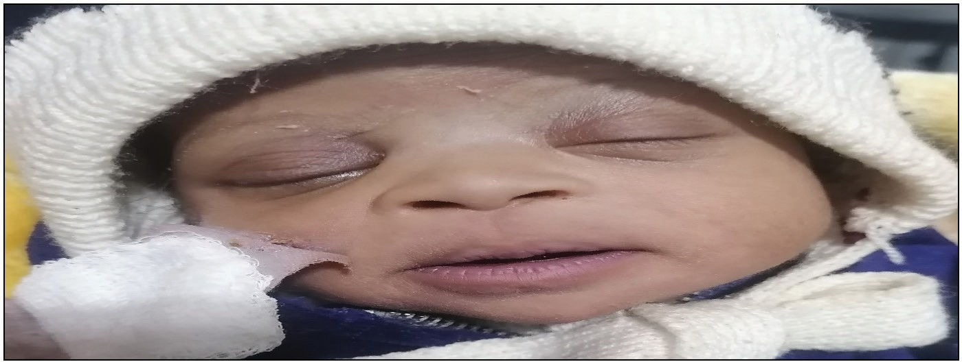

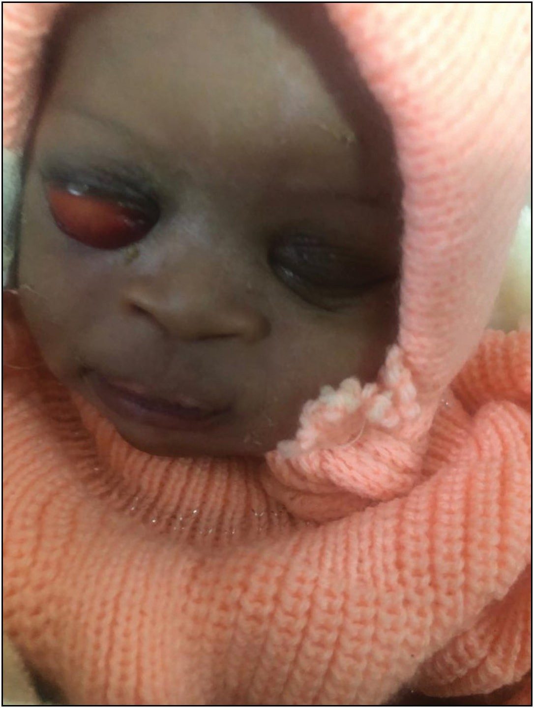**Figure 1: Child with right congenital ectropion at presentation Figure 2: Child on day 3 after using 3% hypertonic saline**

Journal of the West African College of Surgeons | Volume 12 | Issue 1 | January‑March 2022 105

The patient had mucoid discharge which was believed to have originated from the oedematous lid tissues, as such daily eye cleaning was performed to keep the external eye clear of any discharge.[6] The mechanism by which the 3% hypertonic saline-soaked guaze dressing worked is by the hypertonicity of the saline which allow for osmotic movement of fluid from the oedematous tissue through a semipermeable conjunctival membrane. This might have helped with the resolution of the oedema and subsequent lid reversion,[6] others have reported similar successes with conservative management as well even though they used higher concentrations of hypertonic saline, 5%.[2,6,9] Surgical interventions was the main stay of treatment reserved for cases with late presentation, complications or cases not responding to medical management.[2] The surgical intervention included temporary tarsoraphy with excision of redundant conjunctiva, fornix sutures, full thickness skin graft of the upper eyelid, and subconjunctival injection of hyaluronic acid.[6,10,11] The only case reported from Plateau State over 3 decades was a bilateral ectropion that was managed surgically.[10] The current case was managed conservatively with a complete resolution of upper eyelid ectropion.

# Conclusion

Unilateral congenital ectropion of the upper lid is a rare clinical entity in ophthalmic practice. Complete and excellent resolution can be achieved with the use of topical 3% hypertonic saline, topical lubricants and antibiotics. Its benign course, however, as shown in this case, justifies a conservative approach in anticipation of an excellent result. Health professionals in obstetric, neonatal care and community health workers need to be aware of the existence of this anomaly, and in addition, they should be aware that with conservative management complete resolution can be achieved. Early presentation and institution of such management is key in preventing complications.

### Acknowledgement

The authors would like to thank the parents of this child for consenting to the writing of this case for publication.

### Declaration of patient consent

The authors certify that they have obtained all appropriate patient consent forms. In the form the patient(s) has/have

given his/her/their consent for his/her/their images and other clinical information to be reported in the journal. The patients understand that their names and initials will not be published and due efforts will be made to conceal their identity, but anonymity cannot be guaranteed.

### Financial support and sponsorship

Nil.

### Conflict of interest

The authors declare that there is no conflict of interest regarding the publication of this paper.

# References

1. Sellar PW, Bryars JH, Archer DB. Late presentation of congenital ectropion of the eyelids in a child with down syndrome: A case report and review of the literature. J Pediatr Ophthalmol Strabismus 1992;29:64-7.
2. Dohvoma VA, Nchifor A, Ngwanou AN, Attha E, Ngounou F, Bella AL, *et al*. Conservative management in congenital bilateral upper eyelid eversion. Case Rep Ophthalmol Med 2015;2015:389289.
3. Blechman B, Isenberg S. An anatomical etiology of congenital eyelid eversion. Ophthalmic Surg 1984;15:111-3.
4. Chakraborti C, Tripathi P, Bandopadhyay G, Mazumder DB. Congenital bilateral ectropion in lamellar ichthyosis. Oman J Ophthalmol 2011;4:35-6.
5. Al-Hussain H, Al-Rajhi AA, Al-Qahtani S, Meyer D. Congenital upper eyelid eversion complicated by corneal perforation. Br J Ophthalmol 2005;89:771.
6. Adeoti CO, Ashaye AO, Isawumi MA, Raji RA. Non-surgicsl management of congenital eversion of the eyelids. J Ophthalmic Vis Res 2010;5:3:188-92.
7. Awoyesuku EA, Pedro-Egbe CN, Sibeudu OA. Congenital upper lid eversion and severe chemosis in a new bor. Nig J Clin Pract 2014:17:2:248-50.
8. Dawodu OA. Total eversion of the upper eyelids in a newborn. Niger Postgrad Med J 2001;8:145-7.
9. Fasina O. Management of bilateral congenital upper eyelid eversion with severe chemosis. J Ophthalmic Vis Res 2013;8:175-8.
10. Ibechukwu BI, Iya CK. Early surgical management of two cases of bilateral congenital prolapse of the superior conjunctival fornices with lid eversion. West Afr J Med 1991;10:433-8.
11. Onua AA, Akahara OC. Congenital ectropion and moderate chemosis of upper eyelids in an hour old baby in a rural Niger-Delta community, Nigeria. J Global Biosci 2020;9:4:6938-42.

106 Journal of the West African College of Surgeons | Volume 12 | Issue 1 | January‑March 2022