**CASE REPORTS / CAS CLINIQUES**

**CERVICAL LIPOSARCOMA IN A 22 YEAR OLD MAN– AN UNCOMMON PRESENTATION**

**\*Njem JM, Ugwu BT, Akims SM, Adewale GA**

*Corresponding Author:

Dr. J.M. Njem

Cardiothoracic Surgery Unit, Department of Surgery, Jos University Teaching Hospital, Jos,

Nigeria

Email- njemjoe@gmail.com

Conflict of interests: None

**ABSTRACT**

Liposarcomas are uncommon malignant growths, most of which occur in the retroperitoneum and lower extremities. Liposarcoma arising in the head and neck is an uncommon and a potentially life threatening malignancy. We present a 22 year-old male with a dedifferentiated cervical liposarcoma, who had local excision, with no recurrence at twenty months of follow-up. This patient has drawn our attention to the fact that although liposarcomas are rare in the neck and commonly occur in patients between 40 and 60 years, any neck swelling in the young with atypical features should raise suspicion as to the possibility of malignancy.

**Key words:** Liposarcoma, cervical region, Asymptomatic

**INTRODUCTION**

Liposarcomas are uncommon messenchymal tumours that usually arise in the lower extremities or retroperitoneum[1]-6,8-14. Their occurrence in the head and neck is uncommon and potentially life threatening because of the risk of air way compromise[2], 5,8. They represent approximately 1% of head and neck sarcomas2, [3],[4].Liposarcoma commonly affects adults between the ages of 40 and 60 years, with a mean of 50 years, and a slight male preponderance[5],7,8,10 .It is classified into 5 sub-types: well differentiated, myxoid, dedifferentiated, pleomorphic and mixed[6],[7],11. Liposarcoma could present with features similar to those oflipoma, the tendency in such cases is to proceed to surgery after minimal investigations because of the benign presentation. This becomes even more appealing in the young in whom such a malignancy is rare. A high index of suspicion is, however, required especially in cases with atypical presentation in which histological diagnosis should be obtained before proceeding to surgery.The prognosis of liposarcoma of the neck appears to be better than liposarcoma occurring elsewhere3,8.

Liposarcomaof the neck in children and young people is uncommon, hence the need to report this case.

**CASE REPORT**

We present a 22-year old male who was referred to Jos University teaching hospital on account of a painless right sided neck swelling which had progressively increased in size for about one year, with no swelling in any other part of the body. Patient had no cough, dyspnoea or dysphagia. There was no history suggestive of tuberculosis or thyroid disease. On examination, there was a large mass involving the anterior and posterior triangles as well as the supraclavicular region of the right side of the neck measuring 14 x 8cm (Fig 1). The mass was firm with well-defined edges. X-ray of the neck showed a large soft tissue swelling on the right side. A contrast-enhanced CT scan of the neck showed a well circumscribed mass surrounding the right common carotid artery and displacing the internal jugular vein. The mass had a lipomatous attenuation (Fig. 2). A diagnosis of lipoma was made and the patient was prepared and had resection through a cervical approach. Intra-operatively the mass was found to be adherent to the surrounding tissues, which were excised with the mass. The right common carotid artery, internal jugular vein as well as the right vagus nerve were dissected from the mass and preserved. The mass weighed approximately 900g and measured 10 x 8 x4 cm. Grossly the mass had yellow-brown gelatinous cut surface (Fig. 3). Histopathology revealed dedifferentiated liposarcoma (Figs 4 & 5). Patient was counselled for adjuvant radiotherapy but he declined it. Post operatively he did well and has remained free of tumour recurrence in a follow-up period of twenty months.



Figure 1: The neck mass (white arrow)

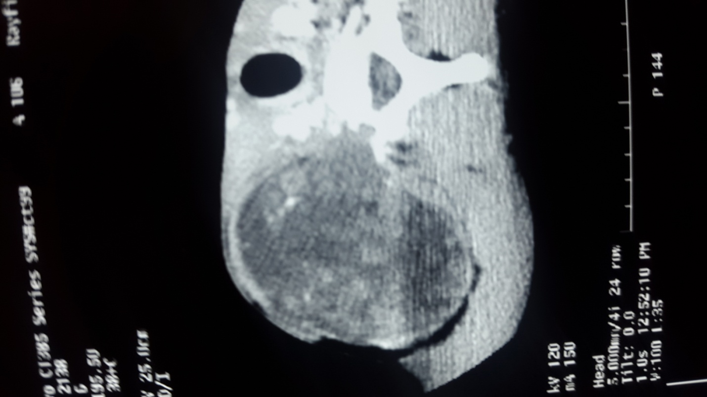

Figure 2: Contrast CT scan showing mass (arrow)

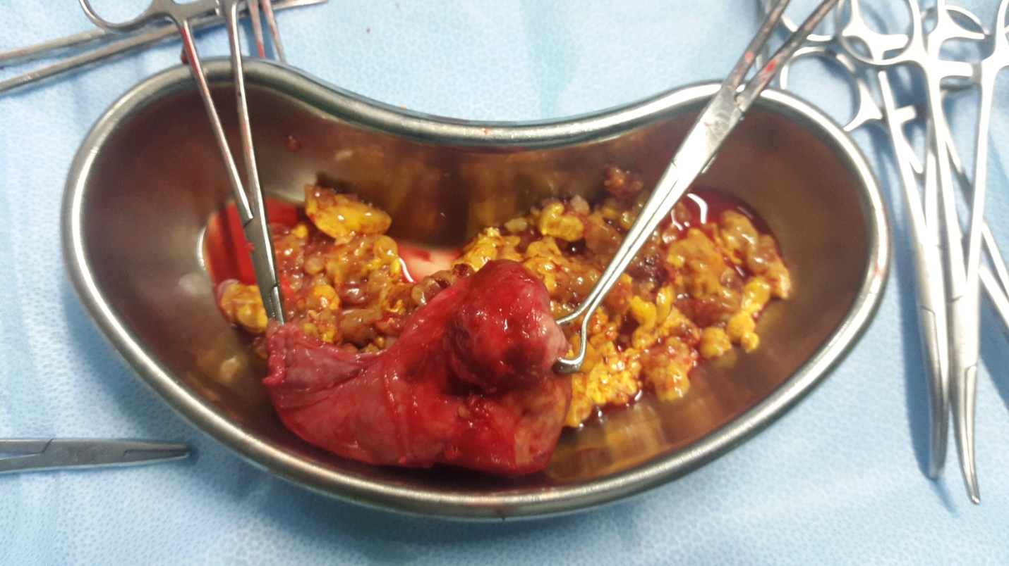

Figure 3: Mass with yellow-brown cut surface

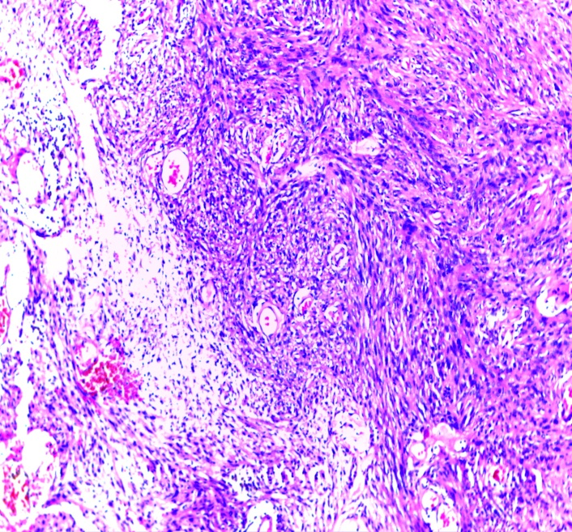

Figure 4: Shows sheets of malignant adipocytes abutting fascicles of malignant spindle cells in a storiform pattern. H&E x10

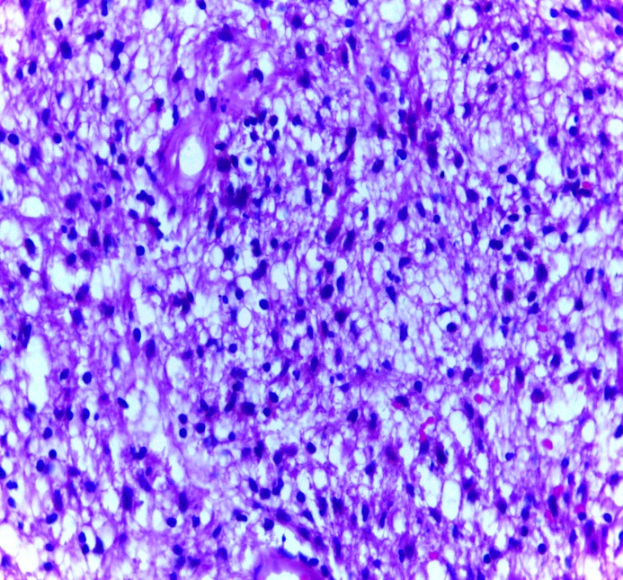

Figure 5 Shows predominant liposarcoma component of tumour with sheets of malignant lipoblasts, typically consisting of large pleomorphic polygonal cells with central nucleus indented by numerous clear intracytoplasmic vacoules

**DISCUSSION**

Liposarcoma primarily affects adults between the ages of 40 to 60 years, the mean age of occurrence being 50 years, with a slight male preponderance [8],9, 12.Dedifferentiated liposarcomas occur most frequently in patients in their seventh decade of life, with no sex predilection[9], 11. They arise from deep connective tissue spaces and are mesenchymal tumours of lipogenic origin that develop de novo[10], 14. These tumours are uncommon in the head and neck. The patient was a young man with a large neck mass. Liposarcomas are similar to lipomas in terms of their indolent course and initial clinical presentation. Patients generally present with a painless mass that would only draw attention when it became significant in size or when pressure symptoms arose. The patient presented because of the cosmetic appearance of the large neck mass.

The clinical behaviour of dedifferentiated liposarcoma, which reflects the high-grade histologic characteristics of most of these lesions, is more aggressive than well-differentiated liposarcomas. This might explain the rapid growth of the tumour in this patient to the size at presentation one year from the initial appearance of the mass. Surgery remains key to the management of dedifferentiated liposarcoma, radiotherapy and chemotherapy being adjuncts for local and systemic control respectively. The patient had wide local excision with tumour free margins and has remained free of tumour recurrence for a follow up period of twenty months.

This case underlines the importance of accurate preoperative evaluation in young patients presenting with neck masses but without symptoms suggestive of malignancy. The patient was a young man, with no symptom other than the cosmetic effect of the large neck mass. A fine needle aspiration was not done because of the benign presentation of the lesion and the patient’s young age. A preoperative diagnosis of dedifferentiated liposarcoma could have prepared the patient better to accept adjuvant therapy. This is because the patient felt his problem which was the mass had been taken off and he did not see the reason for another session of treatment with its attendant complications and cost implication despite adequate counselling regarding the need for it.

**CONCLUSION**

Dedifferentiated liposarcoma, although uncommon in the neck or in young people, should be included in the differential diagnosis of neck masses in this age group.

**REFERENCES**

1. Galli A, Giordano L, Muriana P, Bandiera A, Negri G, Zannini P et al; Multidisciplinary Management of a Giant Cervico-Mediastinal Liposarcoma: A Case Report and Literature Review. ENT J. 2017; 96: E10-E13.

2. Ohita N, Watanabe T, Abe Y, Ishida A, Aoyagi M, Nasus A, et al. Dedifferentiated posterior Cervical Liposarcoma with Carcinoid : Report of a Case. Larynx. 2011; 38: 421-5.

3. Golledge J, Fisher C, Rhys-Evans PH. Cancer. 1995; 6:1051-8.

4. Reno O, Davoli F, Rancon A, Papalia E, Casadi C. Giant Cervico-Mediastinal Well-Differentiated Liposarcoma. Heart-Lung Circ. 2015; 24: e112-4.

5. Wangi Y, Shi H. Dedifferentiated Liposarcoma of the Neck. American J Neuroradiology. 2012;33: E4-E6.

6. Belletews F, Juan JS, Jose MG, Moragas M, Gaspa A, Bernal-Sprekelsen M. Bulky Cervical Liposarcoma Associated with Sleep Apnoea Syndrome. Journal of Oto-Rhino-Laryngology 2009; 126: 209-13.

7. Kindblom LG, Angervail L, Jarlstedt J. Liposarcoma of the Head and Neck ; A Clinico-Pathological Study of Four Cases. Cancer 1978 ; 42; 774-80.

8. Gritlis S, Khamasi K, Lachkhem A, Touati C, Chlorfa A, Ben MT et al. Head and Neck Liposarcoma: A 32 Year Experience; Auris Nasus Larynx 2010; 37: 347-51

9. Fredric MS, Garfield D. Liposarcoma of the Neck; Arch Otolaryngol 1968; 88:419-22

10. Henricks WH, Chu YC, Goldblum JR. Dedifferentiated Liposarcoma with osteosarcoma; A Clinicopathological Analysis of 155 Cases with a Proposal for an Expanded Definition of Dedifferentiation. Am J Surg Pathol 1997;21:271-81.

11. Yamamoto T, Matsushima T, Marui T. Dedifferentiated Liposarcoma with Chondroblasticosteosarcomatous Dedifferentiation; Pathol Int 2000; 50:558-61

12. Yu L, Jung S, Hojnowski L. Dedifferentiated Liposarcoma of soft tissue with high-grade osteosarcomatous Dedifferentiation; Radiographics ;2005;25:1082-86

13. Toshiyasu T, Ehara S, Yamaguchi T. Dedifferentiated Liposarcoma of the Retroperitoneum with osteosarcomatous component: Report of two Cases. Clin Imaging 2009; 33:70-74.

1.
2.
3.
4.
5.
6.
7.
8.
9.
10.