**Case Report**

Central Mini-tenotomy and Environmental Modifications to Correct “Macular Diplopia” due to Sickle Cell Retinopathy in a Resource-limited Setting

**Niranjan Pehere, George Bornguoi, Unity Fahn**

**Abstract**

Epiretinal membrane causing binocular diplopia, also denoted “macular diplopia,” is a well-established entity, which is often difficult to treat. Mini-tenotomy is a surgical procedure to treat diplopia due to small- angle deviations. In this case report, we describe the successful management of a patient with “macular diplopia” secondary to sickle cell retinopathy using a central mini-tenotomy of the left superior rectus muscle and environmental adaptations to diminish peripheral retinal fusion.

**Keywords:** *Epiretinal membrane, macular diplopia, sickle cell retinopathy*

**Abstrait**

La membrane épirétinienne causant une diplopie binoculaire, également appelée “diplopie maculaire”, est une entité bien établie, qui est souvent difficile à traiter. La mini ténotomie est une procédure chirurgicale permettant de traiter la diplopie due aux déviations des petits angles. Dans ce rapport de cas, nous décrivons la prise en charge réussie d’un patient présentant une “diplopie maculaire” secondaire à une rétinopathie drépanocytaire, au moyen d’une mini-ténotomie centrale du muscle droit supérieur gauche et d’adaptations environnementales visant à diminuer la fusion rétinienne périphérique.

*Liberia Eye Centre, L.V. Prasad Eye Institute, John F. Kennedy Memorial Medical Centre, Monrovia, Liberia*

# Introduction

Epiretinal membrane causing binocular diplopia, also called as “macular diplopia,” is often difficult to treat.[1] In a resource-limited setting where treatment modalities like Fresnel prisms or Bangerter’s filters are unavailable, it becomes even more challenging.

# Case Report

A 48-year-old man presented to us in September 2018 with binocular vertical diplopia of a year’s duration. He was known to have sickle cell disease (genotype SC) and sickle cell retinopathy in both eyes for which he had undergone pan-retinal photocoagulation (PRP) in both eyes. In his left eye, he had developed fibrovascular proliferation with traction at the macula, for which he had undergone pars plana vitrectomy and membrane peeling a year earlier. His diplopia largely remained unchanged after the surgery.

His visual acuity for distance in each eye was 20/40 not improving with any refractive correction, and N8 for near with a +2.0

|  |
| --- |
| **Access this article online** |
| **Website:**  [www.jwacs-jcoac.org](http://www.jwacs-jcoac.org/) |
| **DOI:** 10.4103/jwas.jwas_17_21 |
| **Quick Response Code:** |

diopter sphere correction. He had normal head posture and facial symmetry. On cover test for distance and near, he had a positive angle kappa in the left eye, with left hypertropia (LHT) of 4 prism diopters (PD) in primary gaze, increasing to 6PD in both up and down gaze, associated with 2PD esotropia (ET) in downgaze. On head tilt to right, there was LHT of 4PD, increasing to 8PD on head tilt to left. On double Maddox rod (DMR) testing, there was a 10° excyclotorsion of the left eye. There was no underaction or overaction of any extraocular muscles [Figure 1].

On keeping 2PD base up prism in front of the right eye and a 2PD base down in front of the left eye, the patient initially perceived a single image, but soon the image in the left eye was described as moving up and down. There were PRP laser marks and few persistent retinal neovascular fronds in both eyes, with fine wrinkling of the macula in the left eye. Due to resource limitation, fundus photographs could not be taken.

In view of the retinal findings, a diagnosis

**Received:** 07-Jul-2021 **Accepted:** 04-Jan-2022 **Published:** 05-Mar-2022

***Address for correspondence:***

*Dr. Niranjan Pehere,*

*Liberia Eye Centre, L.V. Prasad Eye Institute, John F. Kennedy Memorial Medical Centre, 22nd St. & Tubman Blvd. Sinkor, Monrovia Montserrado County Republic of, Tubman Blvd, Monrovia, Liberia.*

*E-mail:* [*nir*](mailto:niranjanp@gmail.com)[*anjanp@gmail.com*](mailto:anjanp@gmail.com)

of “macular diplopia” due to the epiretinal

This is an open access journal, and articles are distributed under the terms of the Creative Commons Attribution-NonCommercial- ShareAlike 4.0 License, which allows others to remix, tweak, and build upon the work non-commercially, as long as appropriate credit is given and the new creations are licensed under the identical terms.

**For reprints contact:** [reprints@medknow.com](mailto:reprints@medknow.com)

membrane (ERM) in the left eye was made. To

**How to cite this article:** Pehere N, Bornguoi G, Fahn U. Central mini-tenotomy and environmental modifications to correct “macular diplopia” due to sickle cell retinopathy in a resource-limited setting. J West Afr Coll Surg 2020;10:39-41.

© 2022 Journal of the West African College of Surgeons | Published by Wolters Kluwer ‑ Medknow 39

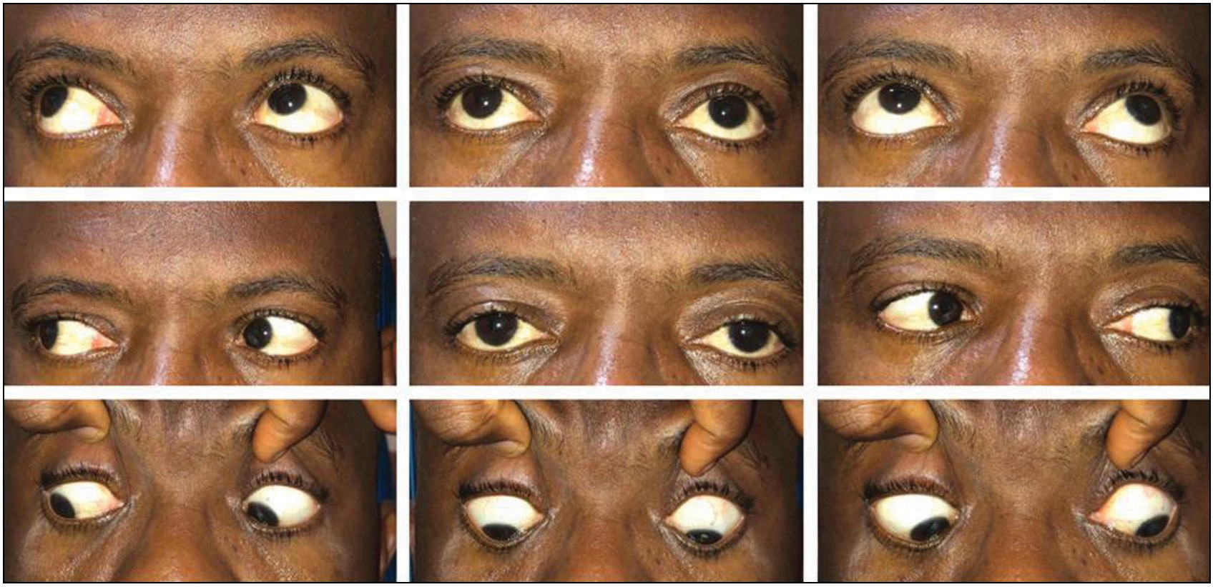

**Figure 1: Preoperative ocular alignment and ocular motility**

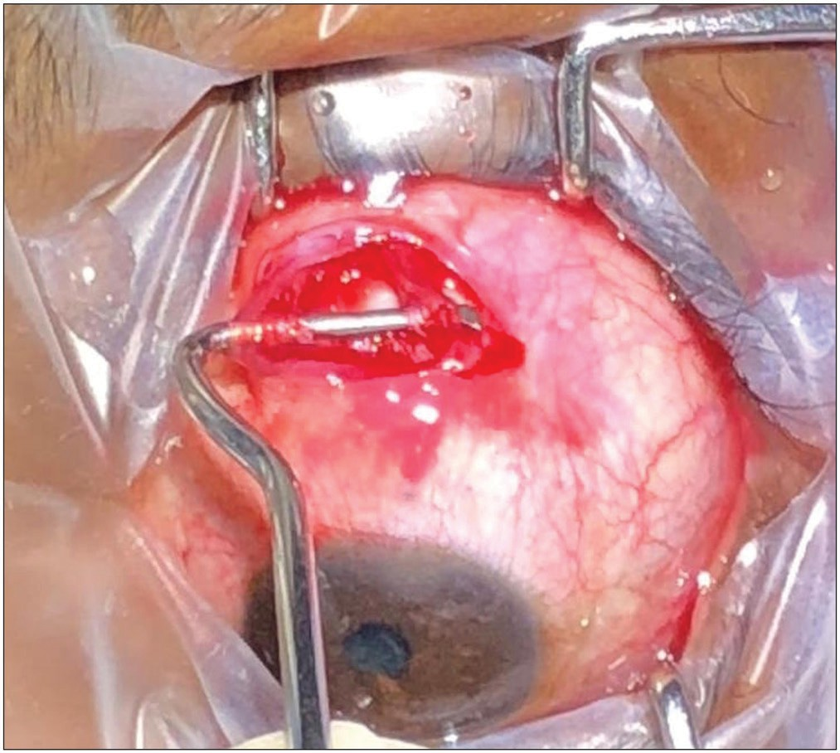

**Figure 2: Central mini-tenotomy for left superior rectus muscle**

confirm this diagnosis, the “lights on-off test” was performed and was positive.[1] The patient was advised to use a small patch in the center of his glasses in the left eye to relieve the diplopia, but he found it inconvenient. As other treatment modalities like Bangerter’s filters or Fresnel prisms were unavailable, we planned to carry out a central minitenotomy of the left superior rectus muscle under topical anesthesia. After instilling proparacaine 0.5% eye drops, the full extent of the superior rectus tendon was exposed using fornix incision. After cauterizing prominent blood vessels, the central tendon was excised using Vannas scissors, in an isosceles triangle shape measuring 4 mm at its insertion base [Figure 2].

Postoperatively from day 1, the patient noticed a significant improvement in diplopia. He was orthophoric in all positions of gazes, except 3PD LHT with 2PD ET in downgaze. He was advised to follow a few strategies, based on the principle of reducing stimulation of peripheral retinal fusion and promoting

central fusion. He was also advised to use photogray glasses, large computer screen, and software to reduce illumination level and increase the font size. At 1-year follow-up visit, he was diplopia free in most of his routine activities. He had LHT of 2PD in primary position and downgaze and was orthophoric for near fixation.

# Discussion

Our patient had multiple factors contributing to his intractable binocular diplopia like ERM with foveal displacement causing central-peripheral fusional rivalry, strabismus, aniseikonia, and metamorphopsia. Central minitenotomy seems to have diminished the strabismic element, approximating the images, thus helping with fusion. Yet owing to the persistence of other factors, fusion tended to break intermittently and the patient experienced transient diplopia.

Disturbance in the balance of peripheral motor fusion to central sensory fusion is proposed as the basis of “macular diplopia.”[2] Maculopathy alters the photoreceptor orientation resulting in an alteration of central sensory alignment. When the central sensory fusion mechanism holds the misaligned foveal points together, this results in a secondary misalignment of the peripheral points. The patient’s peripheral fusion tries to help align the anatomically misaligned central macular points preventing central fusion, and diplopia results.[2] Typically these patients have good visual acuity but with metamorphopsia, and small-angle comitant or incomitant hyperdeviation without any cyclovertical muscle dysfunction.[1] ERM peeling has been shown to help in resolution of diplopia in some patients,[3] but in our patient it did not work. This could be due to permanent minute macular displacement, persisting even after surgical relief of the forces causing macular traction.[1]

Management of “macular diplopia” is frustrating as there is no complete and permanent cure available. It is important that the patient understands his condition well. Patients can be trained to actively ignore the blurred image in the affected eye and many

40 Journal of the West African College of Surgeons | Volume 10 | Issue 1 | January‑March 2020

actually succeed in doing that over time.[3] Our patient did try the same for more than a year, but it did not help. He also attempted partial occlusion of one eye, but could not adjust to it as his profession involved significant public interaction and working with computers for long hours. Successful use of Fresnel prisms and Bangerter’s filters[3] has been described but cost and limited availability is an issue, especially in a resource-limited setting like sub-Saharan Africa. Extraocular muscle surgery can bring images closer, facilitating fusion. Among all surgical options to treat small-angle deviations, central mini-tenotomy seems to be an effective one.[4] In our patient, this option was desirable in view of his sickle cell disease to reduce the risk of anterior segment ischemia. We modified it slightly by performing it after incising the conjunctiva and tenon’s capsule, to make it more predictable. As the patient reported a significant reduction in diplopia from day one after surgery, it suggests that the surgery helped him fuse better. In addition to surgery, environmental adaptations to reduce stimulation of peripheral fusion also seem to have helped to make the patient comfortable in daily activities.

## Acknowledgement

We are thankful the Hyderabad Eye Research Foundation for assistance in conducting this study. We also thank to Prof Gordon N Dutton, FRCS, Emeritus Professor of Visual Science, Department of Vision Science, Glasgow Caledonian University, Glasgow, G4 0BA, United Kingdom, for his help to edit the manuscript.

## Financial support and sponsorship

Nil.

## Conflicts of interest

There are no conflicts of interest.

## Declaration of patient consent

The authors certify that they have obtained all appropriate patient consent forms. In the form the patient(s) has/have given his/her/their consent for his/her/their images and other clinical information to be reported in the journal. The patients understand that their names and initials will not be published and due efforts will be made to conceal their identity, but anonymity cannot be guaranteed.

# References

1. De Pool ME, Campbell JP, Broome SO, Guyton DL. The dragged- fovea diplopia syndrome: Clinical characteristics, diagnosis, and treatment. Ophthalmology 2005;112:1455-62.
2. Veverka KK, Hatt SR, Leske DA, Brown WL, Iezzi R Jr, Holmes JM. Causes of diplopia in patients with epiretinal membranes. Am J Ophthalmol 2017;179:39-45.
3. Hatt SR, Leske DA, Klaehn LD, Kramer AM, Iezzi R Jr, Holmes JM. Treatment for central-peripheral rivalry-type diplopia (“dragged-fovea diplopia syndrome”). Am J Ophthalmol 2019;208:41-6.
4. Wright KW. Mini-tenotomy procedure to correct diplopia associated with small-angle strabismus. Trans Am Ophthalmol Soc 2009;107:97-102.

Journal of the West African College of Surgeons | Volume 10 | Issue 1 | January‑March 2020 41