**Case Report**

**Biliary Atresia Splenic Malformation: A Case Report from A Tertiary Centre in West Africa and the Lessons Learnt**

**Abstract**

Biliary atresia (BA) is a rare disease characterised by biliary obstruction of unknown origin that presents in the neonatal period. It is classified into syndromic with various congenital anomalies and non-syndromic (isolated anomaly). We present a case of syndromic BA associated with polysplenia and intestinal malrotation, discovered incidentally during the Kasai procedure. The small intestine was found to be non-rotated with the duodenojejunal junction to the right of the vertebral column. The presence of accessory spleens was noted. Kasai portoenterostomy and Ladd’s procedure were performed. The patient had an uneventful postoperative course with the passage of cholic stool from the third postoperative day. At the seventh-month follow-up, the stool remained cholic. A multidisciplinary approach in the care of babies with BA and long-term follow-up is crucial for a successful outcome.

**Keywords:** *BASM, biliary atresia, Cholestatic jaundice, intestinal malrotation, polysplenia*

**Introduction** **Case Presentation**

Biliary atresia (BA) is a neonatal We present a 2-month-old 5.9kg female cholangiopathy characterized by infant who came to our facility with a progressive fibroinflammatory obliteration 5-week history of prolonged jaundice, pale-of both extra- and intra-hepatic bile ducts, coloured stools and dark yellow urine. There generally leading to cholestasis, portal was no history of fever and no abdominal fibrosis, and, ultimately, biliary cirrhosis.[1] swelling. She was the only child of her It is believed to be the most common parents. The mother was 31 years old and surgical cause of cholestatic jaundice in had a relatively uneventful antenatal course. infancy with an incidence possibly varying There was however a positive history of from 5 in 100,000 to 32 in 100,000 live Hepatitis B viral infection during the first births.[2] The highest incidence appears to trimester. Maternal screens for infections on be in Asia and the lowest in Europe and presentation at our facility were negative. North America.[3] The incidence in West There was no history of chronic illness or Africa is not known because of lack of drug intake nor radiation exposure to the adequate birth registries. mother or unborn child. The baby was born full-term via normal spontaneous

Most patients with BA (70%–95%) are

described to have “isolated” lesions with vaginal delivery, with a birth weight of no other extrahepatic anomalies.[4] Others the parents. Abdomen examination showed most common being polysplenia which is hepatomegaly and umbilical hernia. She also known as the biliary atresia splenic

3kg. There was no consanguinity among

may have one or more anomalies with the

was haemodynamically stable, with no

abnormal facies.

malformation (BASM). It is reported in

approximately 10% of cases of biliary Laboratory investigations, complete blood atresia.[5] count (CBC), serum electrolytes, urea and creatinine were all within the normal

We are unaware of any other case of the

syndromic form of BA reported from a West (0.1–2.4mg/dL) iwith a direct bilirubin of 6.6mg/dL (0.1–0.4mg/dL) suggestive of

range. Total b lirubin was 12.6 mg/dL

African centre.

**Olumide A. Elebute, Manuella Talla Timo1,**

**Felix M. Alakaloko, Justina O.**

**Seyi-Olajide, Christopher O. Bode,**

**Adesoji O. Ademuyiwa**

*Paediatric Surgery Unit, Department of Surgery, Lagos University Teaching Hospital, Idi-Araba, Lagos, Nigeria, 1Paediatric Surgery Unit, Mother and Child Department, Felix Houphouet Boigny University, Abidjan, Cote D’Ivoire*

**Received:** 15-Sep-2022 **Accepted:** 23-Oct-2022 **Published:** 18-Jan-2023

***Address for correspondence:*** *Dr. Manuella Talla Timo, Paediatric Surgery Department, Felix Houphouet Boigny University, Abidjan, Cote D’Ivoire.*

*E-mail: manuellatimo@gmail. com*

**Access this article online**

**Website:**

www.jwacs-jcoac.com

**DOI:** 10.4103/jwas.jwas_195_22

This is an open access journal, and articles are distributed under the terms ofthe Creative CommonsAttribution-NonCommercial-ShareAlike 4.0 License, which allows others to remix, tweak, and build upon the work non-commercially, as long as appropriate credit is given and the new creations are licensed under the identical terms.

**For reprints contact:** reprints@medknow.com

**Quick Response Code:**

**How to cite this article:** Elebute OA, Timo MT, Alakaloko FM, Seyi-Olajide JO, Bode CO, Ademuyiwa AO. Biliary atresia splenic malformation:A case report from a tertiary centre in West Africa and the lessons learnt. J West Afr Coll Surg 2023;13:106-10.

106 © 2023 Journal of the West African College of Surgeons | Published by Wolters Kluwer ‑ Medknow

Elebute, *et al.*: Biliary atresia splenic malformation

obstructive jaundice. The liver enzymes were all deranged and reported as:-

Alkaline phosphatase: 515 µmol/L (40–120 µmol/L)

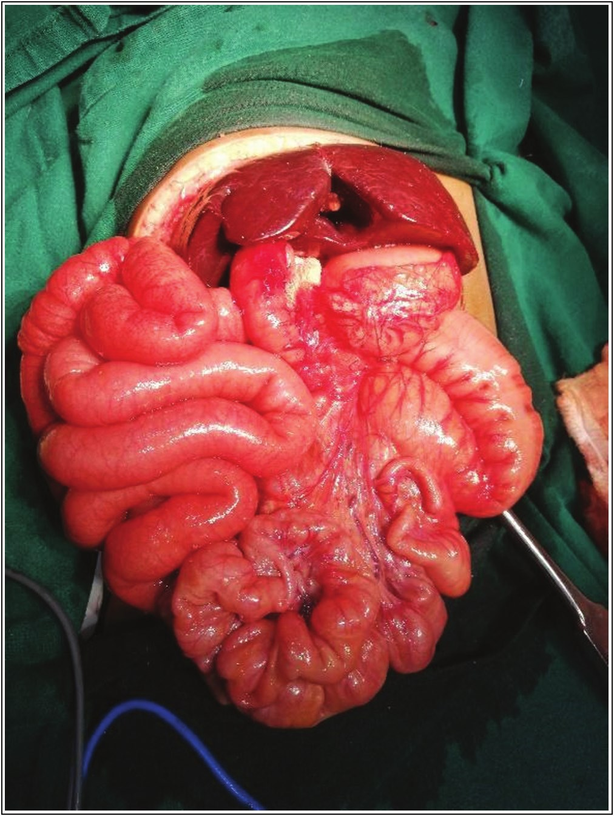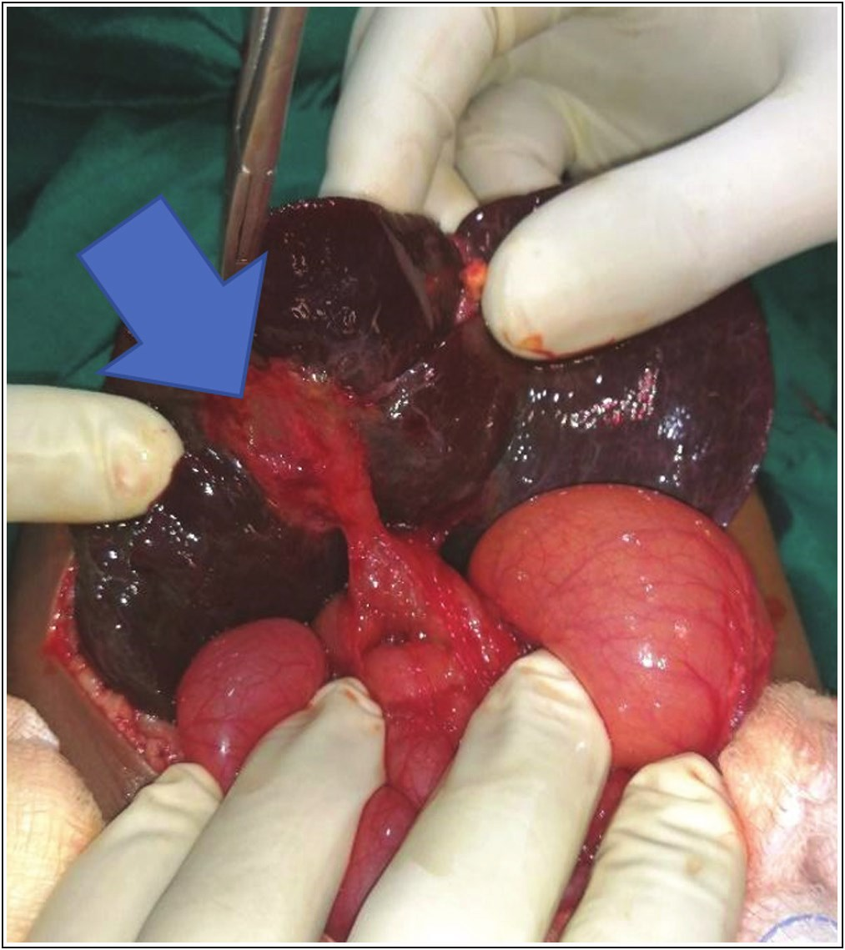

Alanine transaminase: 366 µmol/L (10–40 µmol/L)

Aspartate transaminase: 530 µmol/L (10–42 µmol/L)

Gamma Glutamyl transferase: 305 µmol/L (5–43 µmol/L)

Total serum protein was at the borderline of normal. The clotting profile was normal. Infectious and metabolic screens including, urine culture, and hepatitis B and C screen were negative. TORCH (toxoplasmosis, rubella, cytomegalovirus, and herpes) titres, serum alpha-1 antitrypsin and thyroid function test were not performed.

The gall bladder could not be visualized by ultrasonography. An MRI of the abdomen showed a non-visualization of the gall bladder and atretic extra-hepatic biliary duct with normal intrahepatic radicles on T2-weighted images. No other anomaly was detected. A diagnosis of BA based on the above finding and a Kasai portoenterostomy was offered for the patient.

The operation was performed 2 weeks after admission under general anaesthesia. We lack facilities for an intraoperative cholangiogram which would have enabled better delineation of the anatomy of the extrabiliary tree. The peritoneal cavity was gained via a subcostal incision. The duodenojejunal (DJ) junction was found on the right side and the large bowel sited on the left in a position of complete non-rotation [Figure 1]. Other intraoperative findings were a non-cirrhotic liver and an atretic extrahepatic biliary tract which included the gallbladder, common hepatic duct, the right and left hepatic ducts [Figure 2]. Polysplenia consisting of four accessory spleens was noted in the left hypochondrium [Figure 3]. These were left unperturbed.

A Kasai’s portoenterostomy and Ladd’s procedure were performed at the same sitting. For the latter, the entire extrahepatic biliary tree was mobilized right up to the porta hepatitis, with the proximal end of the tree culminating as a triangular fibrotic cone and excised flush to the liver substance [Figure 4]. The portion of the jejunum incorporated into the roux-en-Y was prepared with the end of the afferent limb being 10cm from the DJ junction. Bowel continuity was established via an end-to-side anastomosis to the efferent limb, 40cm from the DJ junction. The efferent limb was channelled directly to the porta hepatis without routing it through the transverse mesocolon and behind the transverse colon. The free end of the efferent limb was closed and the portoenterostomy was fashioned using the antimesenteric border of the bowel instead. The incision into the bowel lumen was made about a centimetre away from the closed end and the bowel opening was wide enough to incorporate the entire portal plate. Bile drainage was restored by sewing this portion of the roux-en-Y loop to the plate with interrupted 5/0 vicryl sutures [Figure 5].

**Figure 1: Intraoperative finding showing intestinal non-rotation, with the large bowel- the descending colon, appendix on the left, and small bowel on the right side**

**Figure 2: Intraoperative finding showing an atretic gallbladder (blue arrow)**

Journal of the West African College of Surgeons | Volume 13 | Issue 1 | January‑March 2023 10

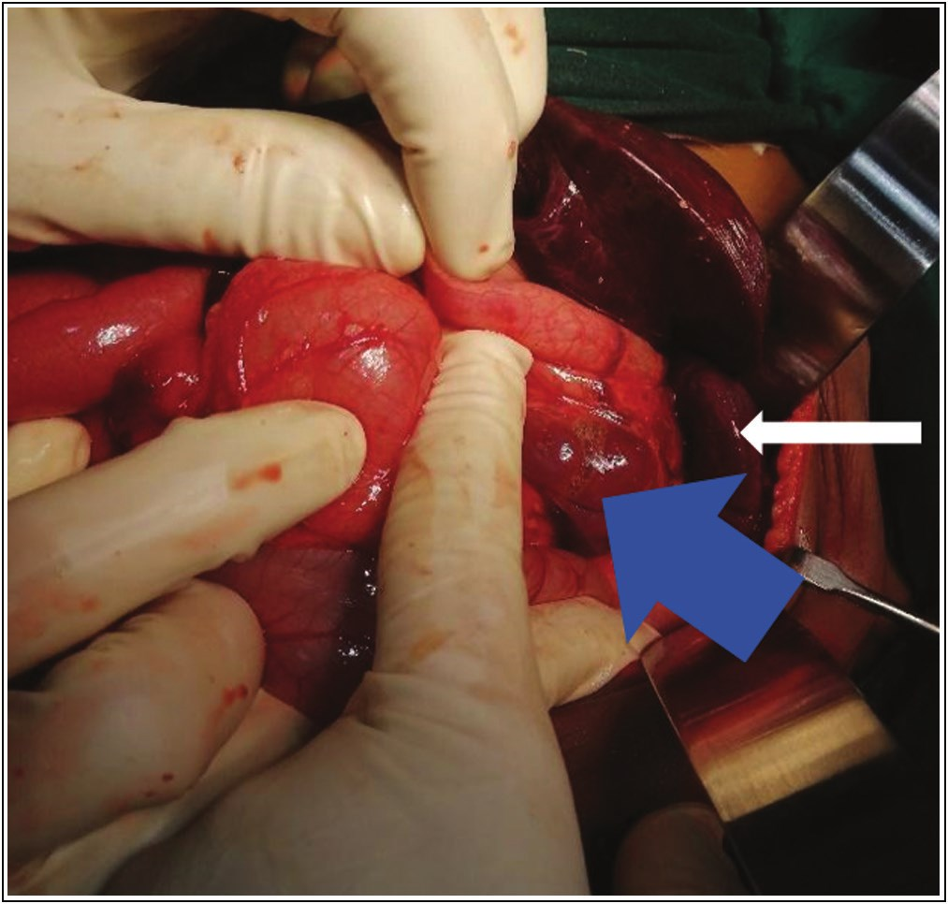

Elebute, *et al.*: Biliary atresia splenic malformation

**Figure 3: Intraoperative photographs showing accessory spleens (blue arrow) and spleen (white arrow)**

**Figure 4: Intraoperative photograph after dissection of the porta hepatis, showing the right and left portal veins (blue arrow), and the fibrous cone transected at porta hepatis (white arrow)**

The Ladd’s procedure was carried out by widening the base of the small bowel mesentery. The entire small bowel was left on the right side of the abdomen and the colon was on the left. A formal appendectomy was equally performed.

The postoperative course was uneventful. She passed out cholic stools from postoperative day three. commenced oral intake on day four and was well tolerated. She was administered trimethoprim/sulfamethoxazole (TMP/SMZ), ursodeoxycholic acid and fat soluble vitamins. The patient was discharged on the sixth postoperative day. At the

seventh-month follow-up, the stool remained cholic and there was a progressive decrease in liver enzymes.

**Discussion**

BA can be classified into three broad clinicopathologic groups: Isolated BA (70%–80%); Syndromic BA with laterality defects, also known as BASM; and cystic BA where there is a cystic change in an otherwise obliterated biliary tract.[6]

BASM could include an array of splenic malformations (usually polysplenia, but also asplenia and double spleen), disorders of visceral symmetry (e.g., situs inversus and malrotation), malformations of the intraabdominal veins (e.g., absent inferior vena cava, preduodenal portal vein).[6]

Although BASM has been widely reported in several single and multicentre studies in Asia, Europe and North America, we did not come across any reported case from Africa during our literature search and this may probably be the first reported case.

Furthermore, Kakembo *et al*.[7] in Uganda explained that the seemingly low incidence of BA could be attributed to the fact that many cases are undiagnosed and labelled as medical jaundice and end up being wrongly managed. Anecdotal reports from other centres in Nigeria lend support to Kakembo’s assumption.

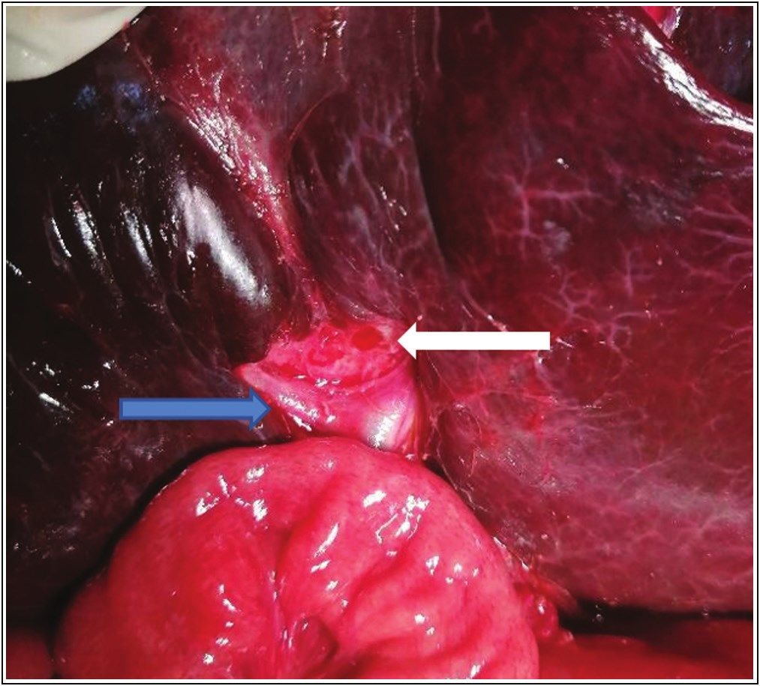

Mabogunje[8] and Mshelbwala *et al*.[9] in Zaria, North-Central Nigeria in separate reviews of BA cases reported no case of BASM from a total of 50 pooled cases spanning a combined period of 26 years. Okoro*etal*.[10] in the Southern part of Nigeria, had no single record of BASM in their five-year multicentre review.

Similarly, in one of the largest series, we found from Africa, Kerkeni *et al*.[11] in Tunisia reported 74 confirmed cases of BA over a period of 25 years and in their study no single case of BASM was mentioned.

Most reported cases of BASM involved BA with polysplenia, and occasionally with variable degrees of gut anomaly.[12] Furthermore, patients with polysplenia usually have a higher incidence of congenital heart disease and, if not diagnosed early could lead to the late onset of serious cardiac manifestations.[13]

Female infants are usually affected and, there seems to be a link between BA and the presence of an abnormal intrauterine environment (e.g., maternal diabetes, autoimmune disease).[13,14] In BA associated with congenital anomalies, genetic abnormalities may play a significant role. Several genes have been found to be associated with laterality defects such as CFC1, FOXH1, NODAL, and ZIC3, but few variants have been found in patients who also have BA.[15] Genetic mutations found in patients with laterality defects and BA include CFC1 ZIC3 and PKD1-L1, although these findings are rare. In most patients,

108 Journal of the West African College of Surgeons | Volume 13 | Issue 1 | January‑March 2023

[Downloaded free from http://www.jwacs-jcoac.com on Tuesday, February 7, 2023, IP: 2.28.143.76]

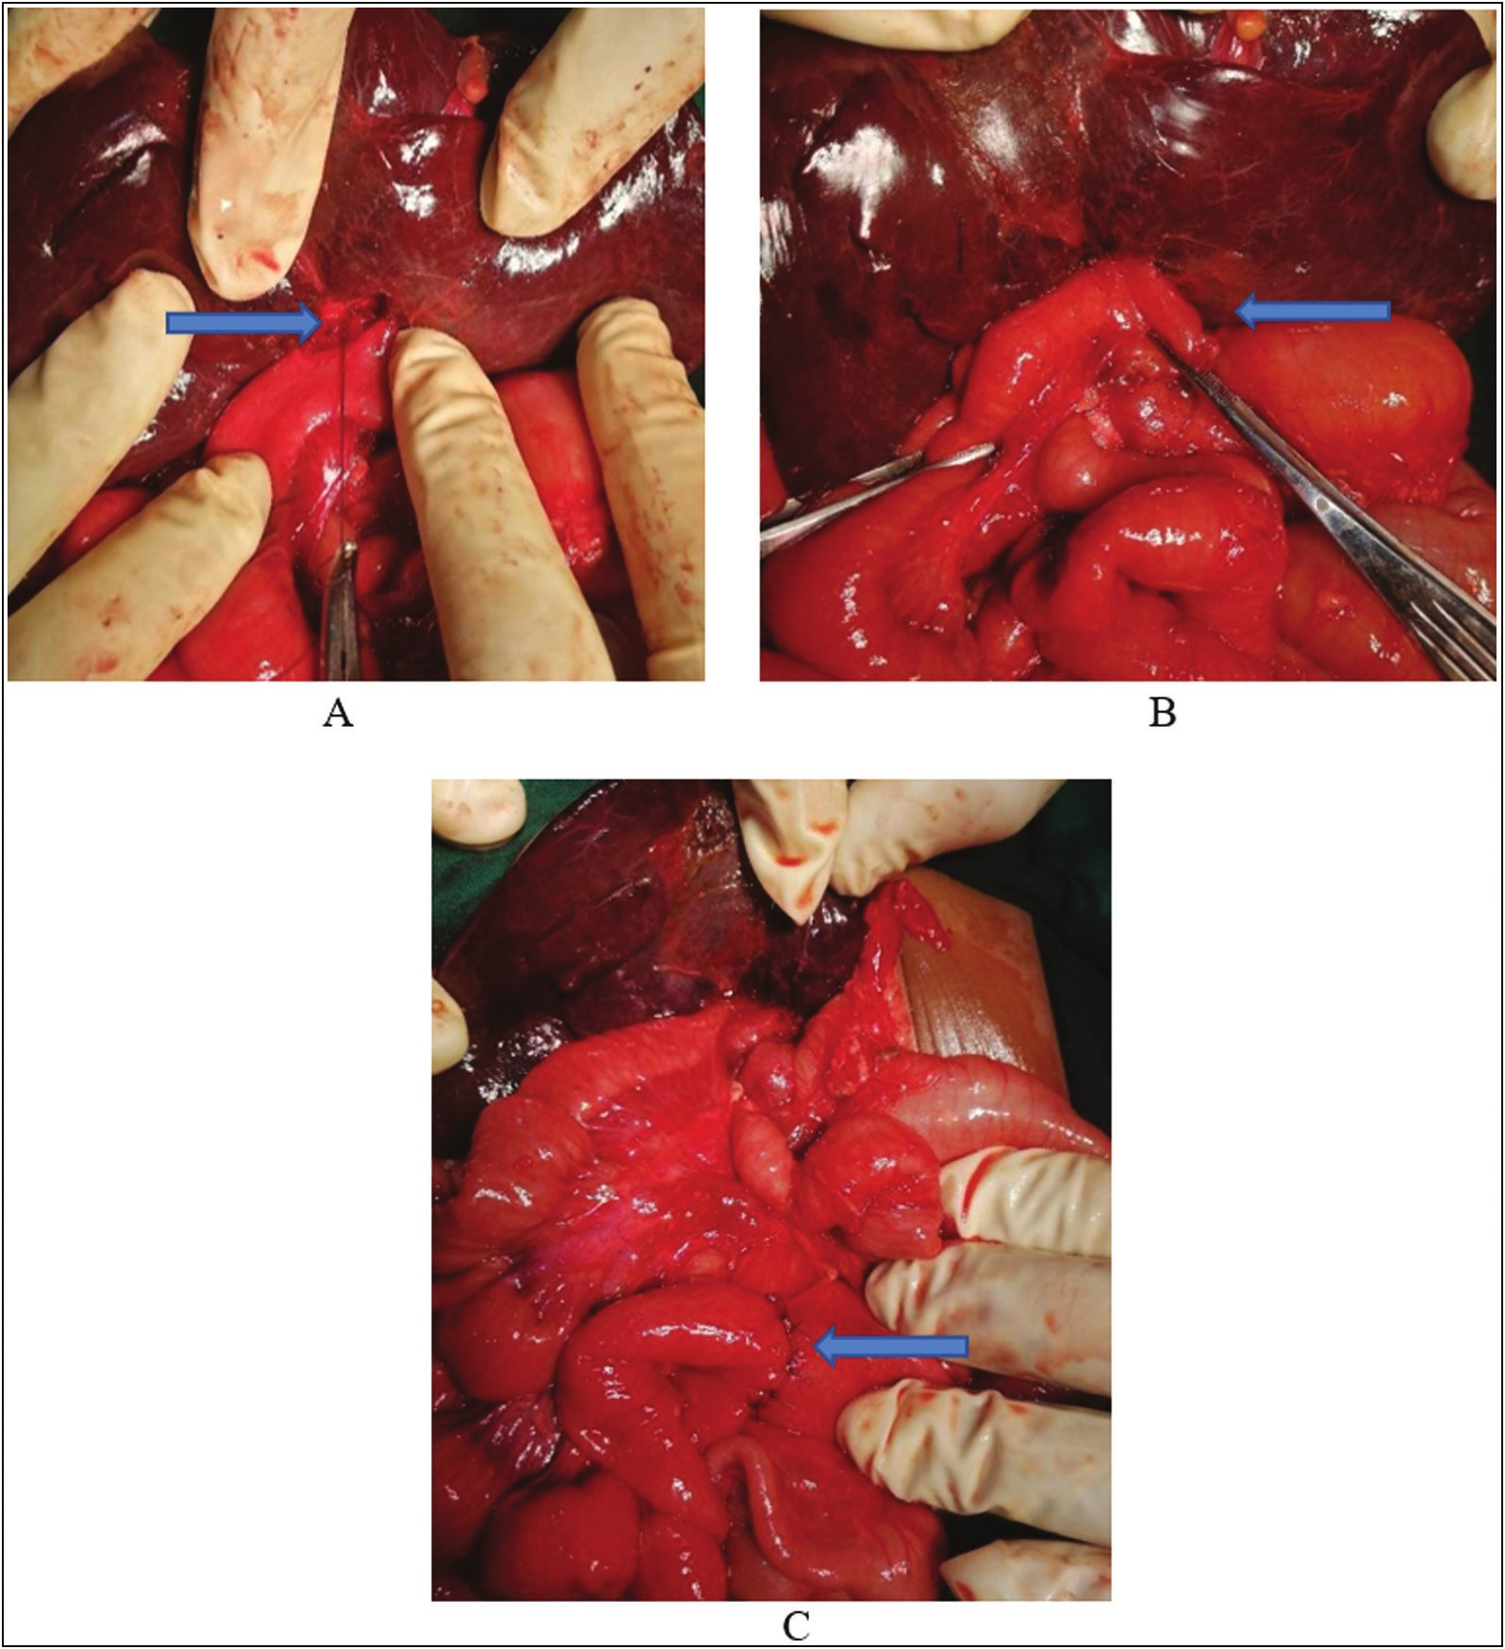

Elebute, *et al.*: Biliary atresia splenic malformation

**Figure 5: Intraoperative photograph showing portoenterostomy: (A) placement of posterior wall sutures of the Roux-en-Y jejunal loop, (B) after completion of end-to-side portojejunostomy, and (C) after completion of end-to-side jejuno-jejunostomy**

genetic susceptibility, compounded by several factors, but most importantly infectious, have been implicated in the pathogenesis.[15]

In the index patient, we lack the resources to investigate these genetic possibilities. However, there was a history of maternal Hepatitis B viral infection during the first trimester. Whether this had a causal effect in our patient is unknown. There were no clinical or biochemical indicators of maternal diabetes or thyrotoxicosis.

In our patient, a diagnosis of BASM was only made intraoperatively, sonography and magnetic resonance cholangiopancreatography (MRCP) failed to detect polysplenia and abnormal gut rotation. Our experience appears to be similar to that of several other researchers where a diagnosis of BASM was made only on the operating table.[16] And as with most other reports, our patient did not

have any gastrointestinal symptoms that may have aroused the suspicion of malrotation.[16]

Although BASM is rare, our experience has shown the need for a thorough preoperative evaluation for other congenital malformations in every diagnosed case of BA, which is important for effective planning of surgery. Such a thorough search for additional anomalies was obviously missing in our index patient. The importance of a multidisciplinary approach in the management of BA cannot, therefore, be overemphasized.[17] The ideal team should consist of gastroenterologists, radiologists, cardiologists, radio nuclear physicists, clinical pathologists, histopathologists and surgeons. Our lack of such a team in our institution may have contributed to the gap we had in the diagnosis of BASM. Furthermore, the input of other specialists in the team such as cardiologists could easily be sought when needed and networking between relevant disciplines would

Journal of the West African College of Surgeons | Volume 13 | Issue 1 | January‑March 2023 109

[Downloaded free from http://www.jwacs-jcoac.com on Tuesday, February 7, 2023, IP: 2.28.143.76]

Elebute, *et al.*: Biliary atresia splenic malformation

ensure a more effective long-term follow-up after surgical treatment.

The abdominal heterotaxy in a case of BA has few surgical implications. These problems are related to the orientation of the Roux-en-Y loop. In a typical portoenterostomy, the Roux-en-Y loop is passed through an opening made in the mesentery of the transverse colon. However, in the case of intestinal malrotation of the gut, this may not be achievable due to the orientation of the bowel loops which precludes this. In our case, we had to manoeuvre the Roux-en-Y loop directly to the portal plate for hepaticojejunostomy, without channelling it through the transverse mesocolon.

4. Gupta L, Bhatnagar V. A study of associated congenital anomalies with biliary atresia. J Indian Assoc Pediatr Surg 2016;21:10-3.

5. Davenport M, Savage M, Mowat AP, Howard ER. Biliary atresia splenic malformation syndrome: An etiologic and prognostic subgroup. Surgery 1993;113:662-8.

6. Asai A, Miethke A, Bezerra JA. Pathogenesis of biliary atresia: Defining biology to understand clinical phenotypes. Nat Rev Gastroenterol Hepatol 2015;12:342-52.

7. Kakembo N, Muzira A, Kisa P, Sekabira J. Biliary atresia: An easily missed cause of jaundice amongst children in Uganda. East Cent Afr J Surg 2016;21:3.

8. Mabogunje OA. Biliary atresia in Zaria, Nigeria: A review. Ann

Trop Paediatr 1987;7:200-4.

There are conflicting reports on the clinical outcome of patients with BASM after hepatoportoenterostomy. Some researcher reported a bad outcome, probably due to associated cardiac abnormalities, whereas others did not observe a worseningin the hepatobiliarydisease.[18] Although we did not detect any cardiac anomaly in our patient, we are of the opinion that there is still a need for long-term follow-up as indicated in all post-portoentetostomy patients. As immediate restoration of bile flow is not a good reflection of overall long term outcome and the progressive fibrosis characteristic of the condition is not halted by Kasai’s operation.[19]

**Conclusion**

BASM is a rare occurrence. The surgeon must be aware of the surgical implications of coexisting anomalies such as associated malrotation.

Despite the good early outcome, the patients with this condition should have a prolonged follow-up which is best overseen through a multidisciplinary approach.

**Financial support and sponsorship**

Not applicable.

**Conflicts of interest**

There are no conflicts of interest.

**References**

1. Vij M, Rela M. Biliary atresia: Pathology, etiology and pathogenesis. Future Sci OA 2020;6:FSO466.

2. Chardot C. Biliary atresia. Orphanet J Rare Dis 2006;1:28.

9. Mshelbwala PM, Sabiu L, Lukong CS, Ameh EA. Management of biliary atresia in Nigeria: The ongoing challenge. Ann Trop Paediatr 2007;27:69-73.

10. Okoro PE, Igwe P, Opara PI. Pattern and survival of biliary atresia patients; experience in Southern Nigeria. Niger J Surg 2013;19:4-6.

11. Kerkeni Y, Ksiaa A, Belghith M, Sahnoun L, Maazoun K, Krichene I, *et al*. Biliary atresia: Experience of a nord African center. Tunis Med 2015;93:683-6.

12. Mirza B, Iqbal S, Sheikh A. Biliary atresia associated with polysplenia syndrome, situs inversus abdominus, and reverse rotation of intestine. APSP J Case Rep 2012;3:14.

13. Schwarz KB, Haber BH, Rosenthal P, Mack CL, Moore J, Bove K, *et al*.; Childhood Liver Disease Research and Education Network. Extrahepatic anomalies in infants with biliary atresia: Results of a large prospective North American Multicenter Study. Hepatology 2013;58:1724-31.

14. Davenport M, Tizzard SA, Underhill J, Mieli-Vergani G, Portmann B, HadzićN. The biliary atresia splenic malformation syndrome: A 28-year single-center retrospective study. J Pediatr 2006;149:393-400.

15. Berauer JP, Mezina AI, Okou DT, Sabo A, Muzny DM, Gibbs RA, *et al*.; Childhood Liver Disease Research Network (ChiLDReN). Identification of polycystic kidney disease 1 like 1 gene variants in children with biliary atresia splenic malformation syndrome. Hepatology 2019;70:899-910.

16. Ozden O, Kılıc SS, Alkan M, Tumgor G, Tuncer R. Biliary atresia splenic malformation syndrome: A single center experience. Acta Medica 2019;50:36-41.

17. Moreira RK, Cabral R, Cowles RA, Lobritto SJ. Biliary atresia: A multidisciplinary approach to diagnosis and management. Arch Pathol Lab Med 2012;136:746-60.

18. Xu X, Dou R, Zhao S, Zhao J, Qingyun G, Wang Li, *et al*. Outcomes of biliary atresia splenic malformation (BASM) syndrome following Kasai operation: A systematic review and

meta-analysis. World J Pediatr Surg 2022;5:e000346.

3. Davenport M, Muntean A, Hadzic N. Biliary atresia: Clinical phenotypes and aetiological heterogeneity. J Clin Med 2021;10:5675.

19. Wang KS; Section on Surgery; Committee on Fetus and Newborn; Childhood Liver Disease Research Network. Newborn screening for biliary atresia. Pediatrics 2015;136:e1663-9.

110 Journal of the West African College of Surgeons | Volume 13 | Issue 1 | January‑March 2023