**Case Report**

**Look Beyond the Cataract: A Case Report on Alport Syndrome**

**Abstract**

Alport syndrome is an inherited disease with a trio of hearing loss, ocular abnormalities, and progressive renal failure. The most severe form is commonest in males due to the X-linked mutations. We present a 25-year-old male who presented with deterioration of vision over 5 years, further questioning revealed use of hearing aid. Although he had no renal-related complaints, investigation revealed proteinuria. There is a need for proper examination of developmental cataract to avoid missing out on Alport syndrome.

**Keywords:** *Alport syndrome, cataract, hearing loss*

**Introduction** had no renal complaints. The second case

was a 24-year-old male with similar story

Alportlsyndrome is a rare disorder affecting and was hospitalized for difficulty in seeing kidneys. It was described by A. Cecil Alport revealing signs of kidney disease. Both X-linked in 85%, autosomal recessive in patients were commenced on [ angiotensin-10%, or autosomal dominant in 5%. This

multip e body organs: the eyes, ears, and

and hearing with further investigation

in 1927.

[1]

Inheritance is predominantly

converting enzyme inhibitors.

5]

occurs as a result of genetic type IV collagen The case being reported here is that of a male defect.[2] This collagen is a major component patient who presented with worsening visual of the human basal membrane. symptoms. He developed hearing symptoms at age 10 and later he was investigated for



disorder.

Ocular findings of Alport syndrome

include posterior polymorphous corneal

dystrophy, spherophakia, lenticonus,

renal problems. Chronologically, visual symptoms are the most recent. There was no

anterior polar, posterior polar cataract, positive family history of ocular or systemic irregular astigmatism, fundal lesions such

as drusens, flecked retinopathy, and retinal **Case Report**

neovascularization.[3] A 25-year-old student who presented to the Other systemic features include nephritis eye clinic with bilateral gradual deterioration with haematuria due to glomeruli basement of vision. The patient has previously membrane damage.[4] This commonly affects presented 5 years earlier to the same eye males but can affect both sexes. There is centre; a diagnosis of cataract was made associated progressive sensorineural hearing but the patient declined cataract surgery. loss (SNHL) from childhood, but still have He was given a pair of lens with unknown some hear capacity in adult life.[4] power. No prior history of ocular trauma,

surgery, or use of traditional medication. No eye pain, itching, or redness. No history

Wexler described two cases in which eye

anomalies aided in the detection of Alport

syndrome.[5] The first case was a 19-year- of flank pain, changes in urine colour, blood old male with a 5-year history of difficulty

in urine, or body swelling.

in seeing and hearing, and ocular exam His previous medical history revealed that revealed bilateral anterior and posterior he had bilateral hearing loss for which he lenticonus. Further investigation revealed wore hearing aids from the age of 10. Two proteinuria and haematuria, although he years prior to this current presentation, he

took ill with abdominal discomfort and was seen in a primary health care where he

This is an open access journal, and articles are distributed under the terms ofthe Creative CommonsAttribution-NonCommercial-ShareAlike 4.0 License, which allows others to remix, tweak, and build upon the work non-commercially, as long as appropriate

**How to cite this article:** Oyediji FJ, Abdullahi AU,

was told to get an abdominal ultrasound

creditcis given .and the new creations are licensed under the Shirama YB. Look beyond the cataract: A case

identi al terms

report on Alport syndrome. J West Afr Coll Surg **For reprints contact:** reprints@medknow.com 2022;12:126-9.

**Funmilayo Jane Oyediji, Abubakar Usman Abdullahi, Yakubu Bababa Shirama1**

*Departments of Ophthalmology, 1Radiology, Abubakar Tafawa Balewa University Teaching Hospital/Abubakar Tafawa Balewa University, Bauchi, Nigeria*

**Received:** 09-Sep-2022 **Accepted:** 13-Oct-2022 **Published:** 23-Nov-2022

***Address for correspondence:*** *Dr. Funmilayo Jane Oyediji, Department of Ophthalmology, Abubakar Tafawa Balewa University Teaching Hospital, Bauchi, Nigeria.*

*E-mail: funmiola5@yahoo.com*

**Access this article online**

**Website:**

www.jwacs-jcoac.com

**DOI:** 10.4103/jwas.jwas_188_22

**Quick Response Code:**

126 © 2022 Journal of the West African College of Surgeons | Published by Wolters Kluwer ‑ Medknow

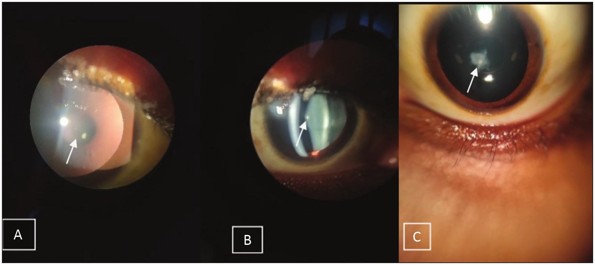

Oyediji, *et al.*: A case report on Alport syndrome

scan for a suspected renal problem but never got the confirmatory results. He is not diabetic nor hypertensive.

He does not have a family history of ocular or systemic conditions.

He is an undergraduate student in one of the tertiary institutions in Bauchi State.

His general examination revealed a healthy young man, not in obvious distress, not pale, anicteric, acyanosed, afebrile, no pedal oedema, no peripheral lymphadenopathy.

His blood pressure was 110/70 mmHg. Ocular examination was as shown in Table 1.

Slit-lamp examination revealed right oil droplet reflex [Figure 1(a)], with lenticonus in Figure 1(b) and left anterior capsule opacity in Figure 1(c). These led to further detailed questioning on other systemic symptoms as reported in the history mentioned earlier. He had his hearing aids, and audiology results in Figure 2 showed moderate-to-severe SNHL. To assess the patient’s renal status, he had urinalysis which revealed proteinuria but urea, electrolytes and creatinine were within normal limits. Abdominal

ultrasound scan and intravenous urology were normal and showed complete excretion. A referral was made to a nephrologist for follow-up on renal status. These ocular signs in conjunction with his hearing and renal findings were in keeping with the diagnosis of Alport’s syndrome. Findings were explained to the patient and the need to have cataract extraction as lenticonus can worsen and there is a possibility of spontaneous rupture. But the patient still declined surgery and preferred to continue with spectacle correction.

**Comment**

Alport syndrome is also known as hereditary nephritis or collagen IV-related nephropathies, which is often associated with SNHL and ocular problems. Alport syndrome results from mutations in COL4A3, COL4A4, and COL4A5 gene with three inheritance patterns. The first and most common is X-linked Alport syndrome, which is associated with COL4A5 gene on Xq22.3 with more severity in males than in females. Second is the autosomal recessive Alport syndrome in which males and females have equal disease severity. The last and the rarest type is the autosomal

Visual acuity-unaided Lid and lashes Conjunctiva



Cornea

Anterior chamber

6/24 Normal White Transparent

Deep and quiet

**Table 1: Ocular findings Right eye**

**Left eye** 6/24

Normal White Transparent

Deep and quiet

Pupil Lens

Dilated fundus

Intraocular pressure Refraction Corrected visual acuity

Round, regular, reactive Anterior lenticonus

Pink disc, CDR 0.2, normal vessels, flat healthy retina, no flecks

17 mmHg

+2.00DS/-1.50DCx 180o 6/18

Round, regular, reactive Anterior capsule opacity

Pink disc, CDR 0.2, normal vessels, flat healthy retina, no flecks

18 mmHg

+2.50DS/-2.00DCx180o 6/9

**Figure 1: Anterior segment slit-lamp findings. (a) Right anterior oil droplet reflex. (b) Right anterior lenticonus. (c) Left anterior capsular opacity**

Journal of the West African College of Surgeons | Volume 12 | Issue 4 | October‑December 2022 127

Oyediji, *et al.*: A case report on Alport syndrome

**Figure 2: Audiology report**

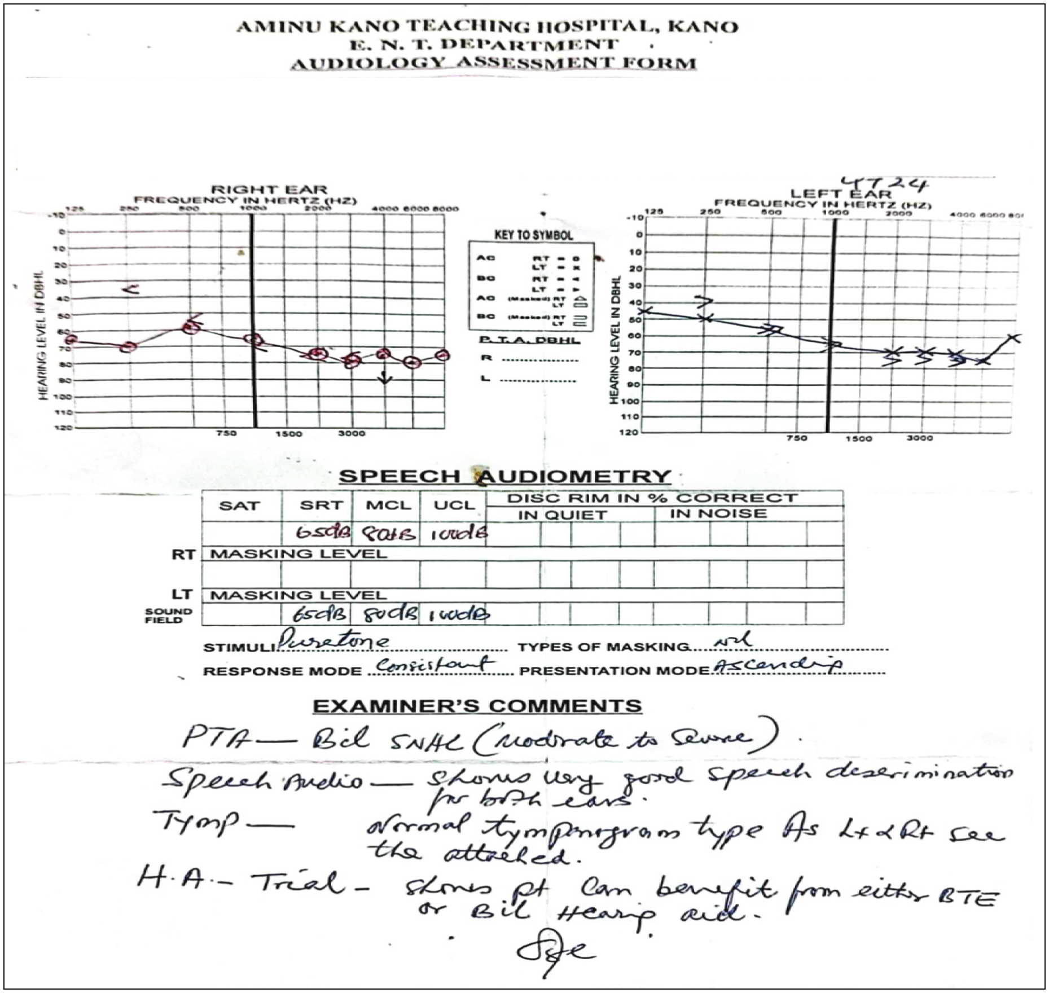

dominant Alport syndrome; males and females have equal disease severity. This gene provides coding instructions for type IV collagen in a protein present in the kidney, inner ear structures, and the eyes.[4,6,7]

Lenticonus is abnormal central lens curvature in which the lens capsule appears conical.[8] It could be anterior or posterior. Anterior lenticonus associated with familial haemorrhagic nephritis is associated with Alport’s syndrome, whereas posterior lenticonus is associated with Lowe’s oculosyndrome.[8,9] Anterior lens capsule involvement results in bilateral anterior lenticonus in 25% of the cases.[4,10] The degree of visual impairment depends on the extent of lens involvement, which may be progressive.[4,11,12] Ocular symptoms can manifest as myopia or irregular astigmatism. Lenticonus ceases to progress on cataract formation.[12] Severity of lenticonus is a valuable marker of disease severity.[4] Worsening of the lens defect with visual defect led to our patient returning for a review. The oil droplet sign on slit-lamp examination clinched the diagnosis, and refraction revealed the presence of myopic astigmatism which could be responsible for difficulty in focusing.[1,4,12]

Other ocular symptoms include posterior polymorphous corneal dystrophy, posterior subcapsular opacities, and recurrent corneal erosions due to basement membrane defect which could be incapacitating. Bruch’s membrane defect possibly leads to retinal pigment epithelial changes, which manifest as flecked retina or fundus albipunctatus. With recent advances, optical coherence tomography findings reveal internal limiting membrane and internal limiting membrane anomalies which manifest as dot-and-fleck retinopathy mostly on the macular of the eye.[4]

Disease of the glomerular basement membrane manifests as nephritis with haematuria, which is most life-threatening.[4] Renal condition is commoner in males with earlier onset. Our patient has proteinuria, a pointer to a possible renal insufficiency which is being further investigated for. SNHL starts with high frequencies and precedes renal disease. Due to clinical and genetic heterogeneity of Alport syndrome, not all patients have complete syndrome of nephritis, hearing loss, and ocular symptoms.

Considering the varied presentation and the extent, the goal of managing patients with Alport syndrome is to improve the quality of life by decreasing symptoms. To improve

128 Journal of the West African College of Surgeons | Volume 12 | Issue 4 | October‑December 2022

Oyediji, *et al.*: A case report on Alport syndrome

quality of life, our patient currently has hearing aids and corrective spectacles. If visual symptoms worsen and the patient is ready, then he would have cataract surgery with intraocular lens replacement. But all precautions would be put in place because of the risk of complications; the central protruded capsule is fragile and hence there is a need to meticulously create capsulorhexis. Also, our patient is also being followed up by the nephrologist for proteinuria that was detected, although he is currently asymptomatic. Risk factors for renal failure need to be controlled throughout life time. Over time, glomeruli damage may worsen with loss of kidney function leading to fluid retention, which can progress to end-stage renal disease. Such were the case reports of a 40-year-old woman and 35-year-old man with severe renal damage who had kidney transplant. The 40-year-old lady had sequential bilateral clear lens extraction and intraocular lens implant under general anaesthesia. At 1-year review, her vision was 6/6.[13,14] Ototoxic medications and exposure to high noise should be avoided.

**Conclusion**

Alport syndrome is a rare condition. There is a need for high index of suspicion in young persons with cataract who have co-existing systemic conditions. All males with anterior lenticonus should be evaluated for Alport syndrome. A good and comprehensive knowledge on this condition is required among all physicians because it requires a multidisciplinary approach to speed up diagnosis and improve medical care.

**Financial support and sponsorship**

Nil.

**Conflicts of interest**

There are no conflicts of interest.

**References**

surgery for severe obstructive sleep apnea hypopnea syndrome]. Lin Chung Er Bi Yan Hou Tou Jing Wai Ke Za Zhi 2018;32: 1727-30.

3. Savige J, Colville D, Rheault M, Gear S, Lennon R, Lagas S, *et al*. Alport syndrome in women and girls. Clin J Am Soc Nephrol 2016;11:1713-20.

4. Hereditary ocular disease [Internet]. Available from: https:// disorders.eyes.arizona.edu/category/keywords/anterior-lenticonus. [Last accessed on Aug 14, 2022].

5. Wexler M. Eye abnormalities detectable in exam may help to diagnose Alport syndrome, study says [Internet]. p. 2019. Available from: https://alportsyndromenews.com/2019/09/30/ eye-abnormalities-detected-in-exam-may-help-diagnose-alport-study-says/#. [Last accessed on Aug 13, 2022].

6. Latif W, Zieve D, Conaway B. What is Alport syndrome? [Internet]. 2021. Available from: https://www.pennmedicine.org/ for-patients-and-visitors/patient-information/conditions-treated-a-to-z/alport-syndrome. [Last accessed on Aug 12, 2022].

7. Fields D. Alport syndrome genetics and inheritance [Internet]. 2019. Available from: https://www.news-medical.net/health/ Alport-Syndrome-Genetics-and-Inheritance.aspx. [Last accessed on Aug 14, 2022].

8. Yanoff MM. Lenticonus—An overview | ScienceDirect Topics [Internet]. 2019. Available from: https://www.sciencedirect.com/ topics/medicine-and-dentistry/lenticonus. [Last accessed on Oct 4, 2022].

9. Halawani LM, Abdulaal MF, Alotaibi HA, Alsaati AF, Bin Dakhil TA. Development of posterior lenticonus following the diagnosis of isolated anterior lenticonus in Alport syndrome. Cureus 2021;13:e12970.

10. Al-Mahmood AM, Al-Swailem SA, Al-Khalaf A, Al-Binali GY. Progressive posterior lenticonus in a patient with Alport syndrome. Middle East Afr J Ophthalmol 2010;17:379-81.

11. Alport syndrome [Internet]. Medscape. 2021. Available from: https://emedicine.medscape.com/article/238260-overview. [Last accessed on Oct 3, 2022].

12. Savige J, Sheth S, Leys A, Nicholson A, Mack HG, Colville D. Ocular features in Alport syndrome: Pathogenesis and clinical significance. Clin J Am Soc Nephrol 2015;10:703-9.

13. Mavrikakis I, Zeilmaker C, Wearne MJ. Surgical management of

anterior lenticonus in Alpot’s syndrome. Eye 2002;16:798-800.

1. Osuna V, Al Othman B, Marcet MM. Alport syndrome [Internet]. 2022. Available from: https://eyewiki.aao.org/Alport_Syndrome. [Last accessed on Aug 13, 2022].

2. Zhang X, Liu YH, Wu J, Gao CB, Zhao Y, Wang Y, *et al*.

[Application of modified cricothyrotomy in the multiplane

14. Deshpande S. Ophthalmic examination for diagnosis of Alport syndrome. Med J Dr DY Patil Univ [Internet] 2015;8:682-3. Available from: https://www.researchgate. net/publication/299404790_Ophthalmic_examination_for_ diagnosis_of_Alport_syndrome.

Journal of the West African College of Surgeons | Volume 12 | Issue 4 | October‑December 2022 129