Awareness of Hazard Risks and Prevention Among Orthopaedic Surgery Residents in South East Nigeria

## Abstract

**Background:** Orthopaedic surgery is a specialty that deals with a lot of complex and delicate procedures which involve the use of power tools as well as handling of sharp tools and bony spicules, which, among other things, expose trainees to day-to-day hazards which can predispose them to an array of health challenges and burden the health sector. Knowledge of different measures in minimizing some of these risks can go a long way to saving lives and resources. **Objectives:** This study aims to determine the level of awareness among orthopaedic surgical residents about various hazards and risks and to ascertain their views on the prevention thereof to guide certain decision- making concerning surgical hazard risk reduction. **Materials and Methods:** A cross-sectional survey of orthopaedic surgery residents in South East Nigeria was conducted using a structured questionnaire designed using the free software Google® Form and was electronically distributed randomly to orthopaedic surgery residents in southern Nigeria using platforms including WhatsApp and Telegram. The data obtained were analysed using Statistical Package for the Social Sciences (SPSS) statistical software version 26. Consent was obtained from all respondents by outlining a clear statement of consent at the beginning of the form. **Results:** At the end of the study period, 49 surgical residents completed and submitted the questionnaire. There was a significant level of awareness of surgical hazard risks among the surgical residents, with over 90% agreeing to radiation exposure, needlestick injury, and inhalation of smoke being the major surgical hazard risks encountered in orthopaedic surgery practice. Over 95.9% of the respondents agreed that the use of sharp collection devices can help reduce needlestick injuries. All respondents agreed that the provision of adequate personal protective equipment (PPE) can help reduce surgical hazards. It was noted that the majority of the respondents (65.3%) had their preliminary knowledge about exposure to surgical hazard risks and appropriate safety measures during their undergraduate education. About 30.6% were aware of a surgery hazard risk safety guideline in their training centres, whereas only 65.3% of those people have studied the guidelines. There was no statistically significant associations between the level of training and marital status and those who had studied the surgical hazard risk guidelines available in their centres (*P* = 0.086, *χ*2= 2.942; *P* = 0.715, *χ*2=0.133, respectively). All of the residents know that immunization can help reduce the impact of disease risk among the surgery staff, but only 73.5% have completed a hepatitis B immunization and 55.1% have completed the tetanus immunization. **Conclusion:** Surgical hazards risks are important issues that need to be addressed and measures regularly reviewed appropriately to ensure and maintain the safety and health of the orthopaedic surgical and all other health personnel. There is a significant level of awareness of surgical hazard risks and prevention measures among orthopaedic residents, but the level of compliance to safety guidelines is not yet optimal. **Recommendation:** PPEs and sharp collection boxes should always be available in theatres and measures should be taken to encourage residents’ adherence to studying and practicing established surgical safety guidelines in their hospitals and also completing their immunization schedules.

**Keywords:** *Hazards, knowledge, orthopaedic surgery, southern Nigeria, surgical residents*

**Kelechi U. Imediegwu1, Francis C. Ezeh2, Mariam Yakubu2, Ozioma P. Igwe2, Ajibola Babatunde Oladiran3**

*1Department of Orthopaedic Surgery, National Orthopaedic Hospital, Enugu, 2University of Nigeria (UNN), Nsukka,*

*Enugu, 3Department of Surgery, College of Medicine, University of Ibadan, Oyo State, Nigeria*

**Received:** 31-Mar-2022 **Accepted:** 28-Apr-2022 **Published:** 23-Aug-2022

***Address for correspondence:***

*Dr. Ajibola Babatunde Oladiran, Department of Surgery, College of Medicine, University of*

# Introduction

Healthcare workers are constantly exposed to various occupational hazards at work. Surgical specialties are in no way any less of a high-risk area. Orthopaedic surgery

training, like most other surgical specialties, requires a safe practice guideline to ensure good outcomes for patients and staff. Hazard is an intrinsic quality of material, agent, source of energy, or circumstance that has the potential to have unpleasant

*Ibadan, Oyo State, Nigeria.*

*E-mail: ajibola.oladiran@yahoo. com*

outcomes or cause morbidity, whereas the

|  |
| --- |
| **Access this article online** |
| **Website:**  [www.jwacs-jcoac.com](http://www.jwacs-jcoac.com/) |
| **DOI:** 10.4103/jwas.jwas_85_22 |
| **Quick Response Code:** |

This is an open access journal, and articles are distributed under the terms of the Creative Commons Attribution-NonCommercial- ShareAlike 4.0 License, which allows others to remix, tweak, and build upon the work non-commercially, as long as appropriate credit is given and the new creations are licensed under the identical terms.

**How to cite this article:** Imediegwu KU, Ezeh FC, Yakubu M, Igwe OP, Oladiran AB. Awareness of hazard risks and prevention among orthopaedic surgery residents in South East Nigeria. J West Afr Coll Surg 2022;12:11-6.

**For reprints contact:** [reprints@medknow.com](mailto:reprints@medknow.com)

© 2022 Journal of the West African College of Surgeons | Published by Wolters Kluwer ‑ Medknow 11

risk in this context is the likelihood that damage to health may occur from a hazard. Surgical risks are activities related to the day-to-day job of surgical professionals that have the potential to cause or enhance the risk of harm or illness. To attain an acceptable risk level in the workplace, safety control measures must be implemented, whereas workplace safety typically refers to the process of safeguarding the health and safety of employees while on the job, regardless of occupation.[1] It is therefore imperative for orthopaedic surgery trainees to have proper access to different hazard risk reduction protocols to conserve manpower and other resources and also to be aware of not just the possible risks they may confront in the operating room, but also of the safety measures required to protect them.

Anderson *et al.*[2] found that hand hygiene, isolation of infection, vital signs, and medication delivery were some of the points at which some occupational hazards can be encountered in surgical wards. The respiratory tract can be exposed to gas (volatile anaesthetics) and aerosols (smoking gas via coagulation) in the operation room, which can pose possible health risks if precautions are not taken and these can predispose to potential gravidity and fertility disruptions, neurotoxicity, and cancer development.[3] Other hazards include radiation, noise, and pathogenic agents. Ergonomics is another factor that can pose some hazards to surgical residents and has been understudied among healthcare workers in general. Pain and incapacity caused by poor ergonomics are common across surgical specialties, and surgeons seldom get appropriate ergonomic training in the context of surgery.[4] In terms of more ergonomically safe postures and motions, healthcare institutions should guarantee that operating rooms are surgeon-friendly and some improvements may include employing body support, taking stretch breaks, using a microscope rather than surgical loops (for a more neutral neck posture), and inserting lengthy screws with power tools.[5]

Some occupational safety measures for burden reduction include the construction of effective air extraction systems, efforts to decrease exposure to radiation and noise, and the use of safer tools to prevent needlestick accidents.[6] Consistent implementation and adherence to these safety measures can help with risk reduction while also contributing to health maintenance. Individual occupational safety precautions, such as the usage of personal protective equipment (PPE) (e.g., radiation protective clothes and orthopedic reinforced gloves), should also be adhered to.[6] It was observed that surgeons are exposed to many risks that most are unaware of owing to the negligence of the surgeon and lack of available facilities.[7] This study aims to identify the knowledge of orthopaedic surgery residents about these hazard risks they face during their day-to-day activities and available preventive measures.

## Objectives of the study

1. To determine the knowledge level of surgery residents about surgical hazards;
2. To determine the level of knowledge about preventing and minimizing surgery hazards;
3. To identify the various views of residents towards hazard risk reduction.

# Materials and Methods

A cross-sectional study was conducted among orthopaedic surgical residents in south-eastern Nigeria. Nigeria’s southeast is one of the country’s six geopolitical zones. There are five states in the region which consist of Enugu, Anambra, Abia, Imo, and Ebonyi. The sampling procedure used was mainly convenience sampling since persons who voluntarily consented to participate were readily available via the various social media platforms. Data were collected using a semi-structured online-based questionnaire

## Table 1: Have you studied the safety guideline provided by your institution

|  |  |  |  |  |
| --- | --- | --- | --- | --- |
| **Factors** | **Outcome**  **Yes** | **Outcome**  **No** | ***χ*2** | ***P-*value** |
| Marital status |  |  |  |  |
| Married | 11 | 19 | 0.133 | 0.715 |
| Single | 6 | 13 |  |  |
| Do you have children? |  |  |  |  |
| Yes | 12 | 17 | 1.402 | 0.236 |
| No | 5 | 15 |  |  |
| Level of training |  |  |  |  |
| Senior Registrar 2 | 9 | 9 | 2.942 | 0.086 |
| Senior registrar 1 | 8 | 23 |  |  |
| Institute of training |  |  |  |  |
| National College | 1 | 5 | 1.186 | 0.553 |
| West African College | 6 | 12 |  |  |
| Both | 10 | 15 |  |  |

No statistically significant *χ*2 was found

12 Journal of the West African College of Surgeons | Volume 12 | Issue 1 | January‑March 2022

## Table 2: Have you completed hepatitis B vaccination?

|  |  |  |  |  |
| --- | --- | --- | --- | --- |
| **Factors** | **Outcome**  **Yes** | **Outcome**  **No** | *χ***2** | ***P-*value** |
| Marital status |  |  |  |  |
| Married | 21 | 9 | 0.478 | 0.489 |
| Single | 15 | 4 |  |  |
| Do you have children? |  |  |  |  |
| Yes | 21 | 8 | 0.041 | 0.840 |
| No | 15 | 5 |  |  |
| Level of training |  |  |  |  |
| Senior Registrar 2 | 13 | 5 | 0.023 | 0.880 |
| Senior registrar 1 | 23 | 8 |  |  |
| Institute of training |  |  |  |  |
| National College | 3 | 3 | 2.257 | 0.324 |
| West African College | 13 | 5 |  |  |
| Both | 20 | 5 |  |  |
| Have you studied the safety guideline? |  |  | 2.865 | 0.091 |
| Yes | 10 | 7 |  |  |
| No | 26 | 6 |  |  |
| Training on surgical hazards |  |  |  |  |
| Undergraduate | 21 | 11 | 2.912 | 0.088 |
| Post-graduate | 15 | 2 |  |  |

No statistically significant *χ*2 was found

## Table 3: Have you completed tetanus immunization?

|  |  |  |  |  |
| --- | --- | --- | --- | --- |
| **Factors** | **Outcome**  **Yes** | **Outcome**  **No** | *χ***2** | ***P-*value** |
| Marital status |  |  |  |  |
| Married | 15 | 15 | 0.814 | 0.367 |
| Single | 12 | 7 |  |  |
| Do you have children? |  |  |  |  |
| Yes | 15 | 14 | 0.328 | 0.567 |
| No | 14 | 8 |  |  |
| Level of training |  |  |  |  |
| Senior Registrar 2 | 10 | 8 | 0.002 | 0.961 |
| Senior Registrar 1 | 17 | 14 |  |  |
| Institute of training |  |  |  |  |
| National College | 1 | 5 | 4.384 | 0.112 |
| West African College | 10 | 8 |  |  |
| Both | 16 | 9 |  |  |
| Have you studied the safety guideline? |  |  |  |  |
| Yes | 10 | 7 | 2.865 | 0.091 |
| No | 26 | 6 |  |  |
| Training on surgical hazards |  |  |  |  |
| Undergraduate | 17 | 15 | 0.146 | 0.703 |
| Post-graduate | 10 | 7 |  |  |

No statistically significant χ2 was found

created on Google Forms. To ensure anonymity and confidentiality, the questionnaires were self-administered. The questionnaires had three sections: Section 1 assessed sociodemographic characteristics of the respondents such as age, sex, marital status, and number of years in the residency training program; Section 2 assessed knowledge of some common surgical hazards; and Section 3 assessed knowledge of preventive measures to reduce the hazard

risks in surgery. A total of 49 responses were collected and analysed using IBM-Statistical Package for Social Sciences version 26 (IBM-SPSS version 26).

Univariate analyses of frequencies and proportions and mean and standard deviations were performed. Bivariate analyses were also performed to explore relationships between the independent and dependent variables.

Journal of the West African College of Surgeons | Volume 12 | Issue 1 | January‑March 2022 13

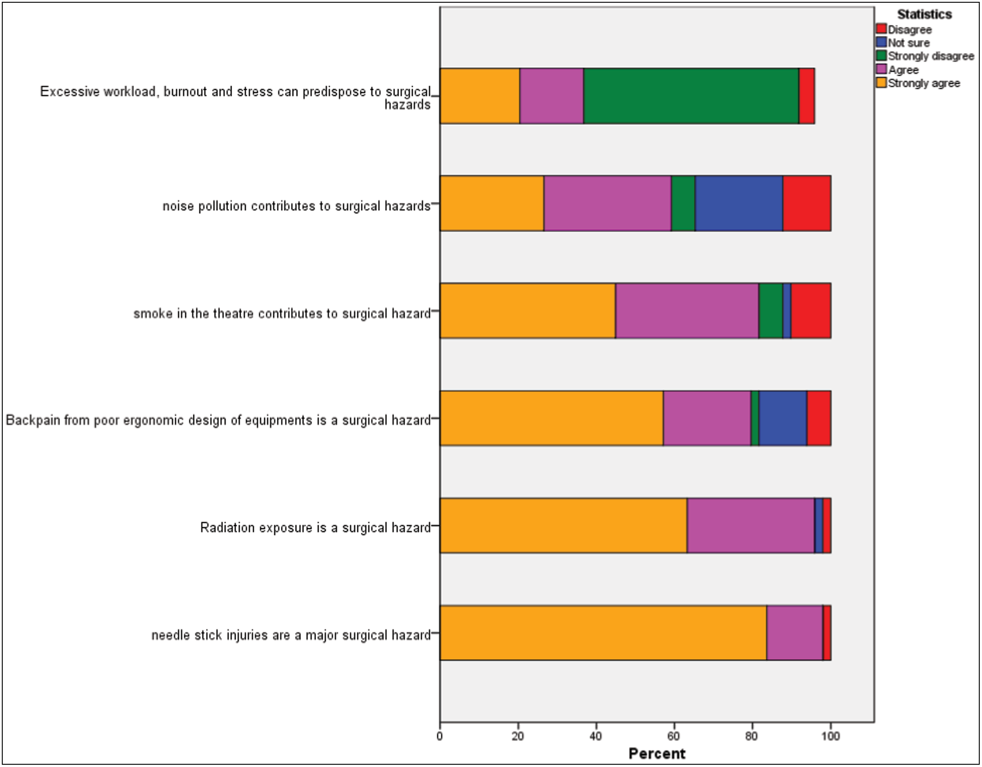**Figure 1: Perception of causes of surgical hazards**

# Results

The number of respondents from the West African College of Surgeons was 25 (51%), 6 (12.2%) were from the National Postgraduate College of Surgeons, and 18 (36.7%) were members of both institutes. Forty (81.6%) of the respondents were males, whereas females were 9 (18.4%). About 63.3% of the respondents were senior residents, whereas 36.7% were registrars. About 61% are married, 38.8% are single, and 40.8% have children.

Up to 65.3% of individuals got their knowledge of occupational hazards during their undergraduate medical education, while 34.7% were exposed to it during their postgraduate level. Almost all respondents, over 95.9%, knew that chemical hazards occur during surgical practice. With all knowing that surgical hazards can occur due to equipment malfunction or failure, 98% of the respondents think that needlestick injury constitutes a surgical hazard. Over 96% also agree that radiation exposure is a surgical hazard with detrimental health impacts. Over 79.5% of the respondents said that back pain is an occupational hazard concern among surgeons, 12.2% are unsure, and 8.1%

disagree. The majority of the residents (81.6%) answered that smoke is a surgical hazard, and over 16.3% disagreed [Figure 1]. Concerning noise pollution, 59.2% agreed that it is a surgical hazard, 22.4% were unsure, and the rest disagreed. Over 59.2% of the respondents believed that excessive workload does not predispose residents to hazards, whereas 36.7% agree that it does contribute to risks.

The measures suggested by the residents to aid the prevention of surgical hazards include [Figure 2] providing proper training of staff on different hazards risks and prevention, provision and maintenance of adequate surgical instruments, theatre designs and appropriate protective equipment, better ergonomics, restructuring work schedules to include off days after calls and prevent burnouts, proper description of staff roles to avoid overstepping of duties during work, good working environment, and a better hospital welfare policy with regular checks to detect and solve some hospital issues that arise.

About 30.6% of the residents said that there is a surgical heath safety guideline in their training centres, 26.5% answered no, and 42.9% are not sure. Although 65.3% of the respondents

14 Journal of the West African College of Surgeons | Volume 12 | Issue 1 | January‑March 2022

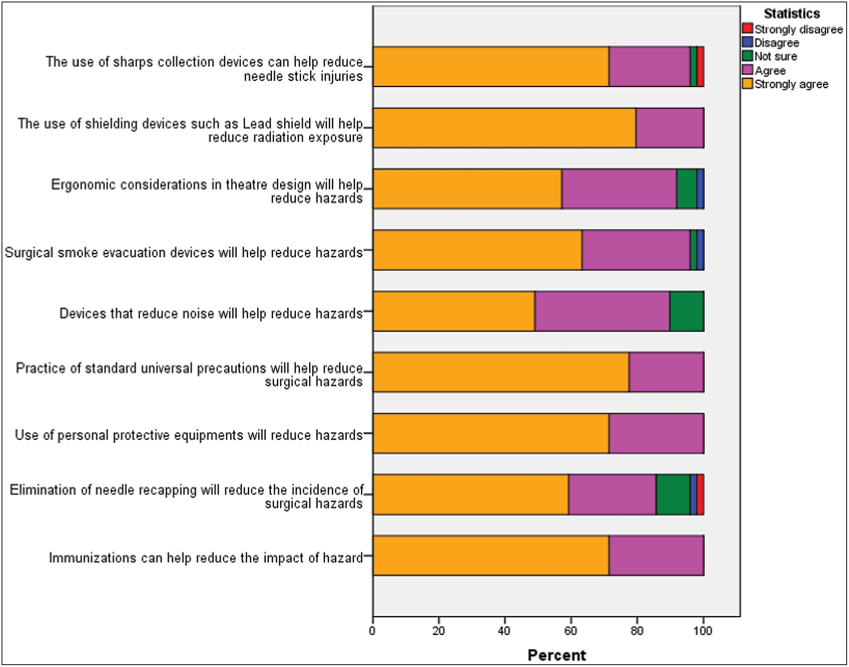

**Figure 2: Recommendations to reduce surgical hazards**

said that they have studied the guidelines, 34.7% said that they have not studied it [Table 1]. Over 95.9% of the respondents said that the use of sharp collection devices can help reduce needlestick injuries. All respondents agree that the provision of adequate PPE, e.g., protective gears and practice of standard universal precautions, can help reduce surgical hazards. Over 91.8% of the respondents are of the opinion that the application of ergonomics would help in reducing the incidence of back pain among residents. About 89.9% of the residents say that provision of devices to reduce noise is helpful in the reduction of hazards from noise pollution, whereas 10.2% are unsure. According to 96% of the residents, surgical smoke evacuation devices help reduce the incidence of hazards from surgical smoke. All of the residents know that immunization can help reduce the impact of disease risk among the surgery staff, but only 73.5% have completed a hepatitis B immunization [Table 2] and 55.1% have completed the tetanus immunization [Table 3].

## Outcomes measured and correlated

Have you studied the health safety guideline provided for your institution?

Have you completed your hepatitis B vaccination? Have you completed tetanus vaccination?

# Discussion

To our knowledge, our study is unique; after a comprehensive search in the English literature, we were unable to find a study that compared both objective and subjective correlation data of musculoskeletal (MSK) symptoms and intra-operative ergonomic hazards across multiple surgical subspecialties. The MSK pain and injury suffered by surgeons are a frequent occurrence, particularly in the context of prolonged procedures which require the surgeon to operate in a static posture for an extended period. This discomfort and the impact of poorly adapted ergonomics in surgical practice were validated in our paper using both objective and subjective assessments.

Others include sharp injuries, blood-borne pathogens, latex allergy, laser plumes, hazardous chemicals, anaesthetic gases, equipment hazards, static postures, and job-related stressors. These hazards make it essential that all surgical professionals follow any established guidelines to reduce the

Journal of the West African College of Surgeons | Volume 12 | Issue 1 | January‑March 2022 15

risk of exposure and infection. Future studies should further validate the measure of hazardous attitudes among surgeons and determine if they are associated with preventable adverse events, while the study provides important baseline information concerning this important issue.

# Conclusion

Proactive risk assessments were used to systematically identify and prioritize hazards in surgical wards and allowed interventions to be recommended. These are practical tools that can determine where patient safety efforts should be targeted in clinical healthcare environments.

## Financial support and sponsorship

Nil.

## Conflicts of interest

There are no conflicts of interest.

## Ethics approval and consent to participate

Ethical clearance from a hospital was not obtained before the research was conducted because it was a simple questionnaire survey with no treatment offered nor patients involved.

## Consent for publication

Participation was voluntary, and the purpose of the research was explained to each respondent. Informed consent was obtained before inclusion into the study. However, anonymity of participants was ensured, and no personal information was collected during the survey.

## Availability of data and material

Additional data from the research project could be made available by the author on request.

## Authors’ contribution

Dr. KUI was the lead author. He conceived the idea of the work, designed the questionnaire and analysis, was involved in the collation of the work and the writing of the paper, and did the editing and initial review of the manuscript. The other authors (FCE, MY, OPI) also assisted with the collection of data and in the analysis of the work. The corresponding author was Dr. AO, who was involved with reviewing the questionnaire, the writing, editing, and review of the final manuscript, and did the correspondence.

# References

1. Aluko OO, Adebayo AE, Adebisi TF, Ewegbemi MK, Abidoye AT, Popoola BF. Knowledge, attitudes and perceptions of occupational hazards and safety practices in Nigerian healthcare workers. BMC Res Notes 2016;9:71.
2. Anderson O, Brodie A, Vincent CA, Hanna GB. A systematic proactive risk assessment of hazards in surgical wards: A quantitative study. Ann Surg 2012;255:1086–92.
3. Boeckelmann I, Sammito S, Meyer F. [Work strain by anaesthetic gas and surgical smoke due to tissue coagulation as well as safety measures in surgical operating rooms—What the surgeon needs to know]. Zentralbl Chir 2013;138:94–103.
4. Aaron KA, Vaughan J, Gupta R, Ali NE, Beth AH, Moore JM, *et al*. The risk of ergonomic injury across surgical specialties. PLoS One 2021;16:e0244868.
5. AlQahtani SM, Alzahrani MM, Harvey EJ. Prevalence of musculoskeletal disorders among orthopedic trauma surgeons: An OTA survey. Can J Surg 2016;59:42–7.
6. Darius S, Meyer F, Böckelmann I. [Hazard assessment and occupational safety measures in surgery: Relevant knowledge on occupational medicine]. Chirurg 2016;87: 948–55.
7. Salahuddin O, Qadir A, Aslam M. Occupational hazards for surgeons. Ann King Edward Med Coll 2005;11:568. Doi:10.21649/akemu.v11i4.1115.

16 Journal of the West African College of Surgeons | Volume 12 | Issue 1 | January‑March 2022