**Original Article**

**Auditing the Findings of Computed Tomographic Angiographic Examinations Using 160-Slice Scanner: Analysis of 5-Year Experiences from Northwestern Nigeria**



**Abstract**

**Background:** Computed tomographic angiography (CTA) is a promising tool for the rapid characterisation of the anatomy and structural lesions of the vascular system. **Aim/Objectives:** The aims/objectives of the study were to determine the frequency and pattern of vascular lesions in northern Nigeria. We also set to determine the agreement between clinical and CTA diagnosis of vascular lesions. **Materials and Methods:** We study patients that had CTA studies over a 5-year period. In total, 361 patients were referred for CTA, but only the records of 339 of them were retrieved and analysed. The information about patients’ characteristics, clinical diagnosis, and the findings on CTA was also retrieved and analysed. The categorical data results were expressed as proportions and percentages. The Cohen’s kappa coefficient (κ statistic) was used to determine the agreement between the clinical and CTA findings. A *P* value of <0.05 was considered statistically significant. **Results:** The mean (standard deviation) age of the subjects was 49.3 (17.9) years with a range of 1–88 years, consisting of 138 (40.7%) females. Up to 223 patients had various abnormalities on CTA. There were 27 (8.0%) cases of aneurysms, eight (2.4%) cases of arteriovenous malformations, and 99 (29.2%) cases of stenotic atherosclerotic disease. There was a significant agreement between the clinical diagnosis and corresponding findings on CTA showed for intracranial aneurysms (*k*= 15.0%; *P*< 0.001), for pulmonary thromboembolism (*k*= 4.3%; *P*< 0.001), and for coronary artery disease (*k* = 34.5%; *P* < 0.001). **Conclusions:** The study found that close to 70% of the patients referred for CTA have abnormal findings, out of which stenotic atherosclerosis and aneurysm are the common findings. Our findings highlighted the diagnostic value of CTA variety of clinical conditions and underscored the prevalence of many vascular lesions in our environment, which hitherto were regarded as uncommon.

**Keywords:** *Aneurysm, angiography, artery, computed tomography, thrombosis*

**Anas Ismail, Yusuf Lawal, Adamu Abba Adamu1,**

**Isa Hassan Muhammad1, Tahir Sani1, Saadatu Hassan Jaafar1,**

**Zainab Hayatu1, Mohammed Kabir Saleh**

*Radiology Department, Bayero University, 1Radiology Department, Aminu Kano Teaching Hospital, Kano, Nigeria*

**Introduction**

Computed tomographic angiography (CTA) is a radiologic examination of the blood vessels using computed tomography and intravenous (IV) injection of iodinated contrast medium.[1] The technology of CTA is becoming increasingly popular because of fewer complications and shorter examination times when compared with conventional angiography.[2] Over the last two decades, the CTA represents one of the most important technical developments in computed tomography (CT) imaging, and it is competing with invasive angiography in the diagnostic evaluation of cardiovascular abnormalities and postoperative assessment of patients with vascular diseases.[2,3] Furthermore, CTA and magnetic resonance

This is an open access journal, and articles are distributed under the terms ofthe Creative CommonsAttribution-NonCommercial-ShareAlike 4.0 License, which allows others to remix, tweak, and build upon the work non-commercially, as long as appropriate credit is given and the new creations are licensed under the identical terms.

**For reprints contact:** reprints@medknow.com

angiography are gradually replacing diagnostic catheter angiography for the treatment planning of patients with atherosclerosis disease as they are both less invasive, faster, and capable of providing an adequate map of the disease process, which is critical to treatment planning.[4] Other advantages of CTA include shorter acquisition times, retrospective creation of thinner sections from source data, and improved volume rendering with minimal artifacts. It can also provide a very high temporal resolution and visualisation of the related adjacent bony structures, which may be important in surgical planning.[5,6]

Clinical conditions such as intracranial haemorrhage caused by the rupture of an aneurysm or arteriovenous (AV)

**How to cite this article:** Ismail A, Lawal Y, Adamu AA, Muhammad IH, Sani T, Jaafar SH, *et al.* Auditing the findings of computed tomographic angiographic examinations using 160-slice scanner: Analysis of 5-year experiences from Northwestern Nigeria.J West Afr Coll Surg 2023;13:66-72.

**Received:** 18-Sep-2022 **Accepted:** 21-Dec-2022 **Published:** 20-Mar-2023

***Address for correspondence:*** *Dr. Anas Ismail,*

*Radiology Department, Bayero University, Kano, Nigeria.*

*E-mail: aismail.rad@buk.edu.ng*

**Access this article online**

**Website:**

www.jwacs-jcoac.com

**DOI:** 10.4103/jwas.jwas_199_22

**Quick Response Code:**

66 © 2023 Journal of the West African College of Surgeons | Published by Wolters Kluwer ‑ Medknow

[Downloaded free from http://www.jwacs-jcoac.com on Monday, April 17, 2023, IP: 2.27.163.176]

Ismail, *et al.*: CT angiography: Experiences from northern Nigeria

malformation, ischemic brain strokes, pulmonary thromboembolism and dissection of the thoracic or abdominal aorta, coronary arterial stenosis, visceral vascular stenosis, and peripheral vascular diseases can be diagnosed using CTA.[7] Previous studies have shown that most CTA studies were predominantly requested for the evaluation of cranial lesions.[8,9] Adekanmi and Osobu[10] had reported that most patients had cranial/ cerebral CTA, followed by pulmonary artery CTA, and then lower limb CTA. The least requested CTA examinations were hepatic and cardiac CTAs. The most common vascular abnormalities on CTA were cases of an aneurysm, whereas the least type of abnormalities on CTA was vasculitis.[10]

The availability of a 160-slice CT scanner in Aminu Kano Teaching Hospital (AKTH) Kano, Nigeria, a high-volume tertiary referral centre in the northwestern part of the country, and the reported usefulness of CTA in the diagnosis and management of vascular lesions prompted the need for the audit of all CTA examinations done over the last 5 years in order to document the prevalence and distribution pattern of vascular disease conditions over the study period among the patients attending AKTH using a 160-slice CT scanner. We also have also assessed the relationship between the clinical diagnostic indications and CTA findings over a 5-year period of the study. This study will determine the prevalence and pattern of vascular lesions based on CTA in our environment and will also guide and improve our practices as well as effective communication to managing clinicians.

**Materials and Methods**

This cross-sectional descriptive study was carried out on patients that underwent all various forms of CTA from January 2017 to January 2022 at the CT scan unit of our hospital using the 160-slice CT scanner.

The study population included all the patients that had any form of CTA scans over the previous 5-year period. All subjects were referred to the CT scan unit for CTA examination for various vascular conditions during the study period. We have excluded patients with incomplete records and those with images of poor diagnostic quality. Ethical clearance was obtained from the institutional review board on November 22, 2021.

The data were retrieved from the radiology departmental records. These included age, sex, clinical diagnosis, and other relevant clinical information filled on the request forms by the referring physician for the indicated CTA study or any important documentation in the patient hospital folder.

All CTA images were acquired by a Helical Multidetector Computed Tomography machine—160-slice CT scanner (Aquillion prime Model TSX-303A, Toshiba Medical Systems Corporation, 1385, Shimoshigami, Otawara-Shi, Japan, 2014). All subjects had fasted for about 4–6h prior

to the study. An appropriate peripheral wide-bore IV cannulation of the appropriate upper limb was used for the dynamic injection of low osmolar iodinated contrast medium after obtaining informed consent.

Patients were positioned in line with the requested CTA, and an appropriate CTA protocol was selected. IV contrast medium dose and rate were calculated based on the patient’s weight. The flow rate of dynamic injection of contrast medium was based on the calculated dose and IV cannular size. In all cases, a low osmolar iodinated contrast medium of 300mg/50mL was used. The volume ranged from 1 to 2mL/kg, depending on the patient’s body mass at the rate of 3.0–4.5mL/s. An appropriate artery (commonly abdominal or thoracic aorta) was selected following the positioning of the body part, and a CTA examination was carried out. The guiding Hounsfield unit value was set according to the type of angiography examination, the region of interest was kept on the desired artery, and the images were acquired. The additional protocol was applied in some CTA exams such as coronary CTA where images were acquired using prospective electro cardiography gating, and the scan was done in suspended respiration.

After the completion of the scan, the maximum intensity projection and multiplanar reconstructed images were generated from the acquired original axial images with the inbuilt Vitrea-vital vessel software dedicated imaging workstation, version 6.6.3. All native and reconstructed images were saved on the departmental server for archiving.

The CTA reports and scan images of the subjects were retrieved and analysed. In cases where the CTA images and/or patient records were inadequate as outlined in the exclusion criteria, they were not included. The confidentiality of subjects was preserved by assigning numbers to each eligible subject in place of real names or hospital numbers, and the data were kept strictly confidential and safe.

The data collected were analysed using IBM statistical package for the social sciences (IBM-SPSS) software package (Version 23) for windows 10. Data were presented in tables and charts where indicated. The categorical data results were expressed as proportions and percentages. Continuous data were assessed for normality. Those that are normally distributed were summarised using means and standard deviation (SD), whereas those that are skewed were summarised using the median and interquartile ranges.

Chi-square test was used for categorical data, and for the analysis of continuous variables, student *t*-test or analysis of variance as applicable was used to compare means of normally distributed data (parametric), whereas Mann– Whitney U test was used to assess the median difference for those without normal distribution (nonparametric). The κ statistic was used to determine the agreement between the clinical and CTA findings. In all tests of associations, a confidence interval of 95% was used, and a *P* value of <0.05 was considered statistically significant.

Journal of the West African College of Surgeons | Volume 13 | Issue 2 | April‑June 2023 67

[Downloaded free from http://www.jwacs-jcoac.com on Monday, April 17, 2023, IP: 2.27.163.176]

Ismail, *et al.*: CT angiography: Experiences from northern Nigeria

**Results**

Out of 361 patients who presented for CTA in the department during the period under review, only the records and images of 339 were reviewed. The remaining 22 patients were excluded on the basis of incomplete records or poor image quality. Their mean (SD) age was 49.3 (17.9) years with a range of 1–88 years. There were 208 (59.3%) males and 138 (40.7%) females, as shown in Table 1.

Among the nine frequently requested CTA examinations, cranial/cerebral CTA (23.3%) and pulmonary artery CTA (23.0%) are the most commonly requested examinations, closely followed by lower limb CTA (19.2%) and cardiac/ coronary CTA (18.6%), respectively. Among the least requested CTA examinations were upper limb CTAs (1.8%) and very rarely splanchnic CTA (0.3%) as shown in Figure 1.

The clinical diagnostic indications for various CTA examinations vary according to the anatomical regions of the CTA procedures, as shown in Table 2. In total, the clinical diagnoses in most of the studies were suspected

**Table 1: Sex distribution among the study population Sex** **Frequency** **Percent** Male 201 59.3 Female 138 40.7 Total 339 100.0

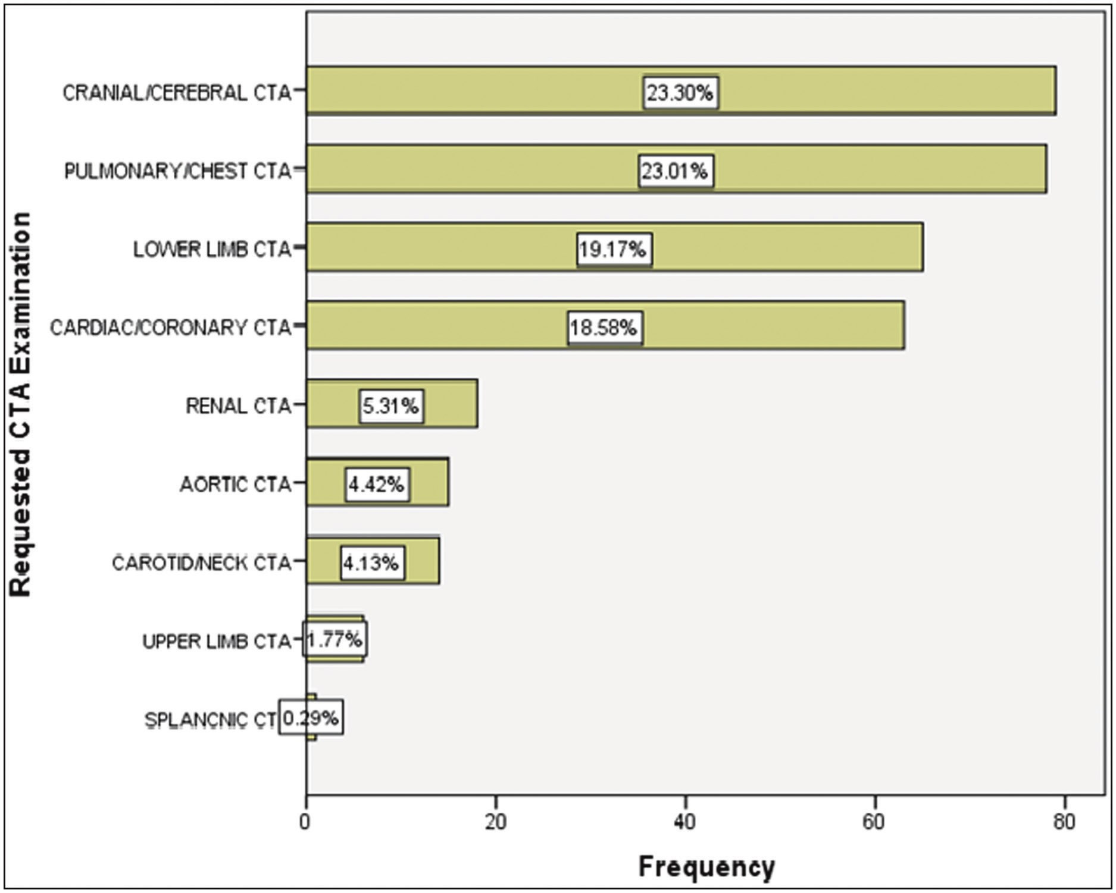

extracranial vascular lesions in 258/339 subjects (76.1%). Intracranial vascular lesions were suspected in 81/339 (23.9%) cases. Out of these 81 cases, suspected cerebral infarction, subarachnoid haemorrhage, and suspected intracranial space-occupying lesions were the reasons for cranial CTA in 18, 15, and 14 subjects, respectively. Among other CTA examinations, pulmonary thromboembolism was the most common diagnosis in 61 patients. This is followed by suspected coronary artery diseases in 57 subjects and peripheral vascular diseases in 55 subjects. In addition, traumatic vascular lesions in 11 subjects and congenital vascular anomalies in three subjects were also recorded.

**CTA findings among the study population**

This study shows that a majority of the subjects, 223 (65.8%), had various abnormalities on CTA, whereas no vascular abnormality was documented in 119 (34.2%). As shown in Table 3, out of the 223 patients with vascular abnormalities, 27 (8.0%) were confirmed to be cases of aneurysms on CTA [Figure 2]. As exemplified in Figure 3, AV malformations were diagnosed on CTA imaging in eight (2.4%) cases, and 99 (29.2%) cases had the atherosclerotic stenotic disease [Figure 4]. The least type of abnormal CTA result among the subjects on CTA was haemangioma, which was seen in one (0.3%) case, six (1.8%) cases of AV fistula, and seven (2.1%) cases of arterial transection. Furthermore, 46 (13.6%) of the subjects had other vascular abnormalities, which include: intracerebral bleed, haemangioma of the

**Figure 1: CTA studies were requested in the study population**

68 Journal of the West African College of Surgeons | Volume 13 | Issue 2 | April‑June 2023

[Downloaded free from http://www.jwacs-jcoac.com on Monday, April 17, 2023, IP: 2.27.163.176]

Ismail, *et al.*: CT angiography: Experiences from northern Nigeria

**Table 2: Clinical diagnostic indications among the study population**

**CTA examination** Cranial/cerebral CTA

Carotid/neck CTA

Cardiac/coronary CTA

Pulmonary/chest CTA Upper limb CTA

Lower limb CTA

Aortic/renal + lower limb CTA

Upper limb/chest CTA

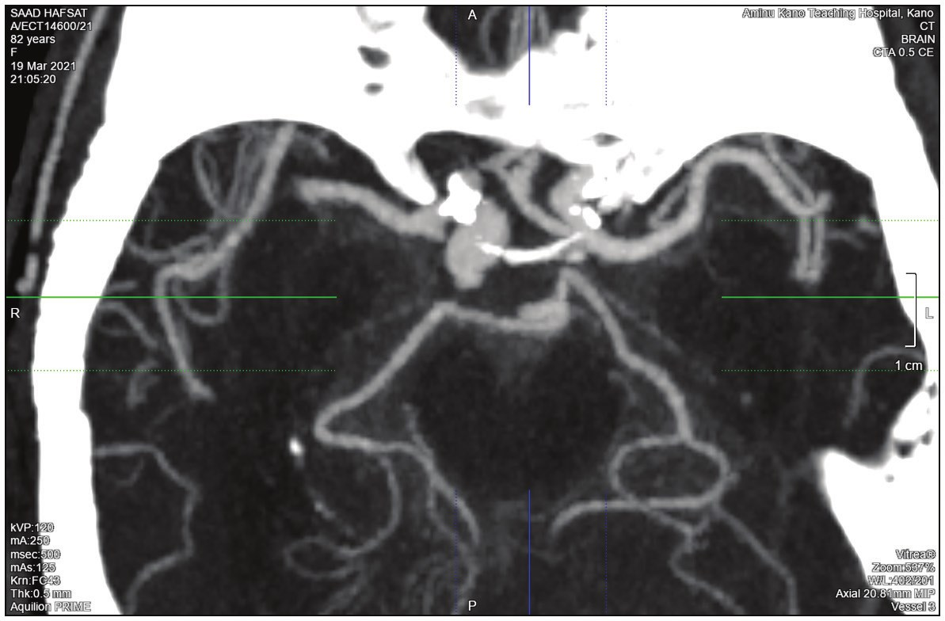

**Indication**

Recurrent intracranial bleed SAH

Suspected aneurysm Suspected AVM Suspected ICSOL

Suspected carotico-cavernous fistula Cerebral infarction

Chronic headache Head injury Craniofacial tumours Neck tumours

Suspected coronary artery disease Heart diseases

Suspected pulmonary thromboembolism Chest tumours

Upper limb tumours Gluteal/groin tumours Lower limb tumours Peripheral vascular disease Intra-abdominal tumours

Suspected renal artery stenosis Allograft donor

Traumatic vascular lesions Congenital anomalies

**Frequency** 8

15 11 6 14 1 18 4 4 6 6 57 21 61 6 3 1 7 55 4 10 7 11 3

**Percent** 2.4 4.4 3.2 1.8 4.1 0.3 5.3 1.2 1.2 1.8 1.8 16.8 6.2 18.0 1.8 9 0.3 2.1 16.2 1.2 2.9 2.1 3.2 9

ICSOL = intracranial space occupying lesion, SAH = Sub arachnoid haemorrhage

**Table 3: CTA findings of vascular lesions**

**CTA findings** Aneurysm

Vaso-occlusive disease/ atherosclerotic disease AV malformation

AV fistula Haemangioma Pulmonary embolism Encased vessels Arterial transection

Other vascular abnormalities Normal findings

Total

**Frequency** 27 99

8 6 1 24 5 7 46

116 339

**Percent** 8.0

29.2

2.4 1.8 .3 7.1 1.5 2.1 13.6 34.2 100.0

lower lip, caroticocavenous fistula, and double inferior vena cava.

Among the study subjects with aneurysms, 16 (59.3%) were intracranial aneurysms, out of which 2/16 had multiple aneurysms. The vessel-specific frequencies are as follows: posterior cerebral artery (PCA) (one), internal carotid artery (ICA) (two), anterior cerebral artery (ACA) and posterior communicating artery (PCOM) (three each), and middle cerebral artery (MCA) (five), as shown in Table 4. The extracranial aneurysms were observed at the left common carotid artery (one), right subclavian artery (one) and two cases each at the abdominal aorta, thoracic aorta, axillary artery, right iliofemoral artery, and superficial femoral artery.

**Figure 2: Axial view of maximum intensity projection of the cerebral CTA, showing bulbous dilation of the terminal right ICA. The apex of the aneurysm shows marginal irregularities, suggestive of a recent rupture**

Others are one case each of superior vena cava and internal jugular vein aneurysms. AV malformation and fistula were seen in eight and six subjects, respectively [Figure 5]. Vaso-occlusive/atherosclerotic diseases were also documented in 99 subjects [Figure 2]. The majority, 43 (43.4%), involved the coronary arteries followed by the femoropopliteal arteries in 35 subjects (35.4%). Other CT findings in the study population were pulmonary thromboembolism, most of which involved the right main pulmonary artery, eight cases were seen involving the pulmonary trunk, whereas the left main pulmonary artery was least affected with five cases

Journal of the West African College of Surgeons | Volume 13 | Issue 2 | April‑June 2023 69

[Downloaded free from http://www.jwacs-jcoac.com on Monday, April 17, 2023, IP: 2.27.163.176]

Ismail, *et al.*: CT angiography: Experiences from northern Nigeria

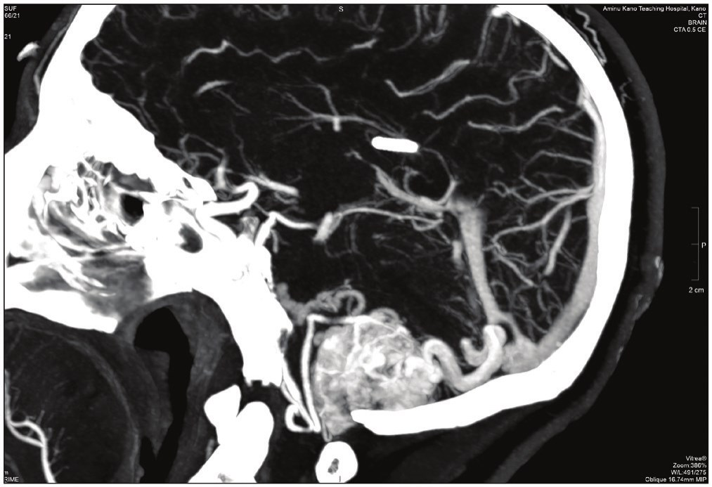**Table 4: Distribution of vascular disease among three selected CTA exams**

**Intracranial aneurysm**

**Coronary artery disease**

**Pulmonary thromboembolism**

**Vessels** **Frequency Vessels** **Frequency Vessels** **Frequency**

ICA MCA ACA PCA PCOM Multiple

2 LM 5 LAD 3 CX

1 RCA

3 Multiple 2

3 PT 8 23 RMPA 9 1 LMPA 5 8 Multiple 2

8

**Figure 3: Sagittal reconstructed CTA of the posterior fossa, showing hypervascular mass with a feeding artery from the posterior–inferior cerebellar artery. Note the early venous opacification, suggestive of an AV malformation**

**Figure 4: A frontal view of 3D/volume-rendered CTA of the terminal abdominal aorta and both lower limbs, showing abrupt termination of the flow of contrast medium in the right popliteal and proximal left femoral artery**

[Table4]. Vascular encasement was also observed among five subjects in this study with two cases involving the external carotid artery and three cases of the right iliofemoral artery encasement.

As shown in Table 5, the test of agreement between the clinical indications and the computed tomographic findings showed that clinical diagnostic indication for intracranial aneurysm is statistically significant and is in agreement with the CTA findings (*k*= 15.0%; *P*< 0.001). Furthermore, the clinical diagnosis of pulmonary thromboembolism showed a statistically significant slight agreement with CTA results

CX = circumflex, LAD = left anterior descending, LM = left main, LMPA = left main pulmonary artery, PT= pulmonary trunk, RCA = right coronary artery, RMPA = right main pulmonary artery

for pulmonary thrombo embolism (*k* = 4.3%; *P* < 0.001). As shown in Figure 5, a statistically significant fair level of agreement between clinical diagnosis for coronary artery disease and CTA findings of coronary artery disease was observed (*k* = 34.5%; *P* < 0.001).

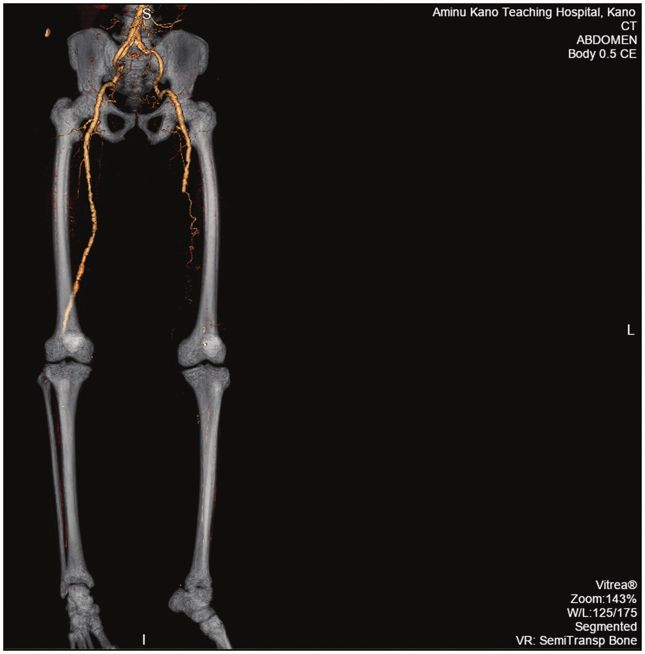

**Discussion**

The present study using a 160-slice CT scanner highlighted many qualities of CTA with great potential to replace conventional angiography. CTA is now becoming increasingly popular and represents the most important technological evolution in CT imaging over the last decades, using only IV contrast material thereby gaining acceptance as a quicker and safer alternative, less expensive, and noninvasive compared with conventional angiography.[2,3,7,10]

In this report from northwestern Nigeria, a total of 339 subjects were evaluated. The mean age of 49 years among the participants was consistent with 46 years reported by Adekanmi and Osobu[10] in a similar study in 2020 in Ibadan, which spanned over 8 years on CTA evaluation of vascular pathology in a Nigerian tertiary hospital. It is however lower than the 56–57 years reported by Ikpeme *et al*.[11] in a previous study in 2014 on CT findings of cerebrovascular disease in adults in Calabar, southern Nigeria.

Findings from this audit also showed a male preponderance with a male:female ratio of 1.5:1. This is consistent with earlier reports by Anas and Muhammad[8] in 2012 in Kano northern Nigeria, Adekanmi and Osobu[10] in 2020, and Ogbole *et al.*[9] in 2010 both in Ibadan, south-western Nigeria, which also showed a male preponderance of 1.3, 1.3, and 1.6, respectively. This is, however, different from the study by Man *et al.*[12] in Hong Kong in 2010, which reported a ratio of about 1:1. Albeit, their study mainly focused on the audit of CTA for pulmonary embolism in a regional hospital.

The most frequently requested examinations in the study population were for cranial/cerebral CTA, accounting for 23.3% of all requests. This finding is partly due to the high

70 Journal of the West African College of Surgeons | Volume 13 | Issue 2 | April‑June 2023

[Downloaded free from http://www.jwacs-jcoac.com on Monday, April 17, 2023, IP: 2.27.163.176]

Ismail, *et al.*: CT angiography: Experiences from northern Nigeria

**Table 5: Agreement between three selected clinical diagnostic indications compared with CTA findings**

**Clinical diagnostic indication** Intracranial aneurysms Coronary artery disease Pulmonary thromboembolism

**Sensitivity (%)** 31.3 71.9 36.1

**CTA findings**

**Specificity (%)** **PPV (%)** 84.3 31.3 66.7 85.4 75 91.7

**NPV (%)** **DOR** **Kappa** 84.3 2.4 0.15 46.7 5.1 0.34 13.3 1.6 0.04

DOR = diagnostic odds ratio, NPV = negative predictive value, PPV = positive predictive value

**Figure 5: Distribution of most frequent CTA findings**

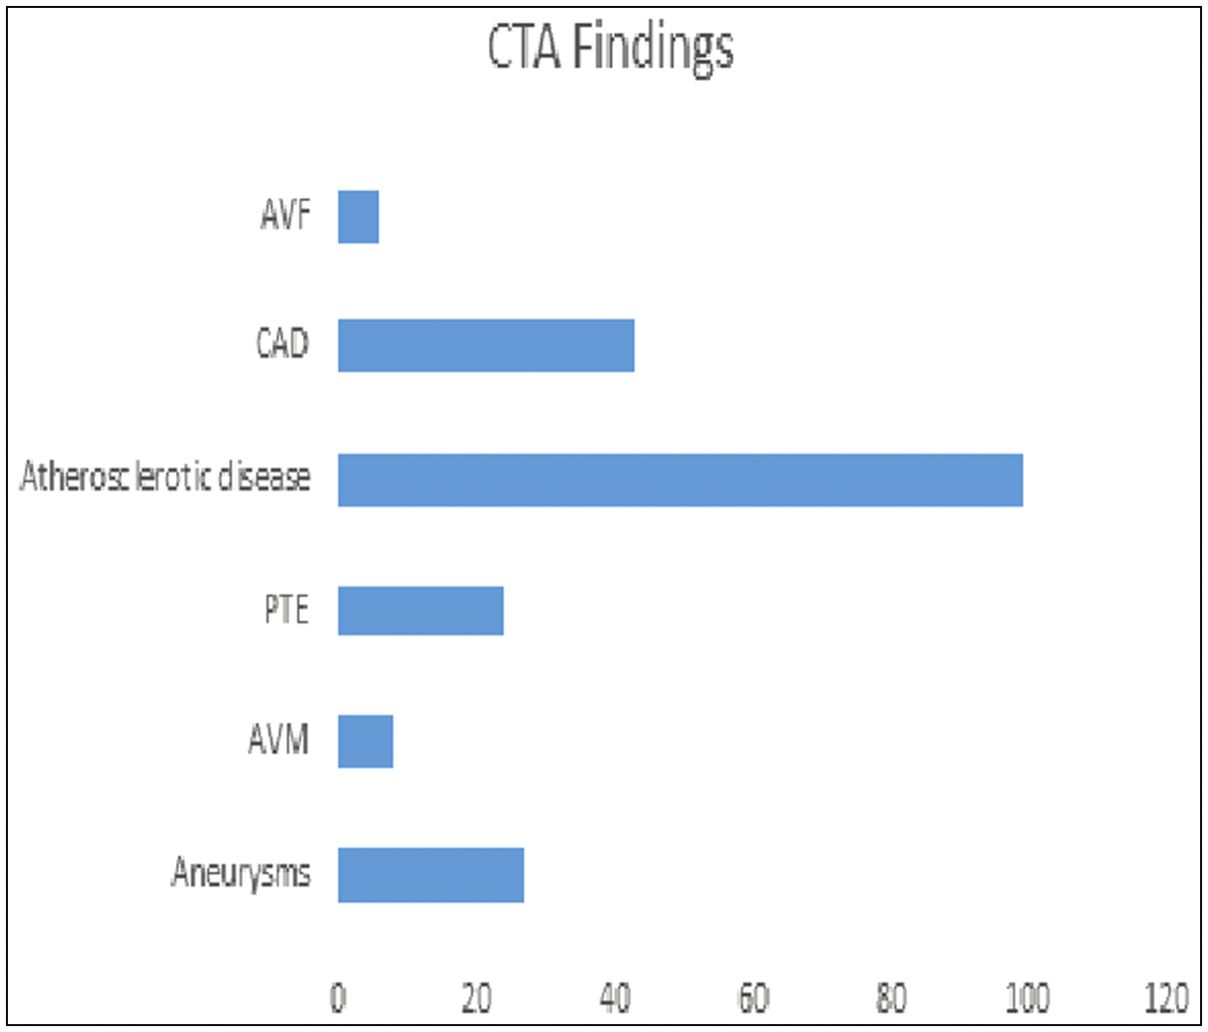

prevalence of intracranial haemorrhage, which in also in agreement with other studies showing that most CTA studies were predominantly requests for the evaluation of cranial lesions as highlighted by Adekanmi and Osobu,[10] Anas and Muhammad,[8] and Ogbole *et al.*[9] with frequencies of 46%, 48.5%, and 45% of the cases, respectively.

The CTA findings in this study revealed no detected abnormality (normal study) in 34.2% of all cases. This is somewhat similar to higher values of normal findings as reported by Anas and Muhammad[8] (30%) and Ogbole *et al.*[9] (43.5%). Albeit, Adekanmi and Osobu[10] reported a much lower value of normal findings (15.4%). This is likely due to differences in the sample size, duration of the study, and the targeted study population.

As expected, vascular anomalies predominate in the CTA findings of the current audit. The leading vascular abnormalities identified included the cases of vaso-occlusive/atherosclerotic disease, aneurysms, pulmonary embolism, and arterio venous malformation (AVMs) accounting for 29.2%, 8.0%, 7.1%, and 2.4%, respectively. Similar findings of leading vascular anomalies were also documented by Ogbole *et al.*[9] and Adekanmi and Osobu.[10] The intracranial CTA exam showed a higher prevalence of aneurysms, and AVMs cases were intracranial (59.3%), out of which the intracranial aneurysms were three times more common than AVMs. This finding agrees with what Adekanmi and Osobu[10] reported of the intracranial

aneurysm being three times more common than AVMs, but is in contrast with the work of Ogbole *et al.*,[9] which documented more intracranial AVMs than aneurysms with a ratio of 1:2. This is likely due to differences in sample size and duration of the study employed by different researchers.

Among the subjects with intracranial aneurysms in this study, 12.5% had multiple aneurysms. This finding is lower than the figures reported by Adekanmi and Osobu[10] and in the ISAT trial in 2015 in the United Kingdom by Molyneux *et al.*[13] in which 30.8% and 21.3% of intracranial aneurysm cases showed multiple aneurysms, respectively. The present audit revealed only 2.4% of AVMs. This is much lower than 9.7% and 13.7% reported by Ogbole *et al.*[9] and Adekanmi and Osobu.[10] The sample size and environmental factors may be responsible for the above-noted differences.

Furthermore, this audit showed an average annual hospital incidence of about seven intracranial vascular anomalies/ year in Kano. This is somewhat closer to the findings in a previous study by Adekanmi and Osobu[10] who reported an average annual hospital incidence of about six intracranial vascular anomalies/year in Ibadan. However, Ogbole *et al.*[9] reported a lower annual hospital incidence of about two/ year, also in Ibadan. These differences might be due to the sample size being larger in this current study compared with the previous studies and probably the increased awareness among the medical community in the hospital of the availability of advanced imaging techniques of CTA used in the current study.

Vaso-occlusive/atherosclerotic disease was found in up to 29.2% of cases in this audit. This is higher than the values of 16% and 15.8% quoted in the previous studies by Ogbole *et al.*[9] and Adekanmi and Osobu.[10] Furthermore, findings from this audit among the subjects with peripheral occlusive disease revealed the coronary arteries as the commonest sites (43.3%) followed by the femoropopliteal arteries (35.4%), which are at variance with the study of Adekanmi and Osobu[10] who identified with the tibial arteries being the commonest site of atherosclerotic occlusive lesions, and the study by Kumar *et al.*[4] reported the femoropopliteal pathway as the commonest site of atherosclerotic occlusive lesions in the abdominal aorta and in bilateral lower limb vessels. This variable observation can be attributed to the differences in study design employed by the individual researchers. In this audit, up to 18.6% of subjects with

Journal of the West African College of Surgeons | Volume 13 | Issue 2 | April‑June 2023 71

[Downloaded free from http://www.jwacs-jcoac.com on Monday, April 17, 2023, IP: 2.27.163.176]

Ismail, *et al.*: CT angiography: Experiences from northern Nigeria

coronary artery disease had multiple sites of involvement, which is in agreement with various findings from previous studies in subjects with the steno-occlusive disease as reported by Adekanmi and Osobu,[10] Nguyen-Huynh *et al.*,[14] and Rotzinger *et al.*,[15] which documented a large individual variation of multiple occlusion sites on CTA.

The current audit also identified pulmonary thromboembolism in 7.1% of the study subjects, which is slightly lower than the 10.3% reported by Adekanmi and Osobu.[10] Out of 78 requested pulmonary/chest CTAs, about 30% had positive pulmonary embolism, which is higher than 23% recorded by Molyneux *et al.*[13] This observation may be due to differences in sample size, study design, lifestyle, and geographical factors among the study subjects.

This study also identified five cases of vascular encasement by tumours. However, previous researchers from available studies did not demonstrate vascular encasement but reported many tumours with varying degrees of vascular displacement.[9,10]

When clinical diagnostic indications were compared with CTA findings, there was a statistically significant slight agreement of suspected intracranial aneurysms and pulmonary thromboembolism with imaging diagnosis on CTA. There was also a statistically significant fair level of agreement between clinical diagnosis of coronary artery diseases and CTA findings of coronary artery disease. A similar observation of the test of the agreement was also reported by Adekanmi and Osobu,[10] which emphasised the importance of CTA as a crucial tool in clinical evaluation and care of patients.

**Conclusions**

Though this study is retrospective, and we did not collect data to determine the association between the cardiovascular risk factors and some of the findings on CTA, the findings of this study highlighted the diagnostic value of CTA variety of clinical conditions and underscore the prevalence of many vascular lesions, which hitherto regarded as rather uncommon in our settings. Specifically, the study found that close to 70% of the patients referred for CTA have abnormal findings, out of which stenotic atherosclerosis and aneurysm are the common findings. Further large-scale longitudinal studies to determine the relationship between the risk factors and the development of vascular lesions will add value to the existing knowledge and help in planning future interventions to reduce morbidity and mortality from vascular disease.

**References**

1. Liguori C, Frauenfelder G, Massaroni C, Saccomandi P, Giurazza F, Pitocco F, *et al*. Emerging clinical applications of computed tomography. Med Devices (Auckl) 2015;8:265-78.

2. Addis KA, Hopper KD, Iyriboz TA, Liu Y, Wise SW, Kasales CJ, *et al*. CT angiography: In vitro comparison of five reconstruction methods. AJR 2001;177:1171-6.

3. Sun Z, Al-Moudi M, Cao Y. CT-angiography in the diagnosis of cardiovascular disease: A transformation in cardiovascular CT practice. Quant Imaging Med Surg 2014;4:376-96.

4. Kumar UK, Bhandari SG, Kumar SJ, Bansal S, Prasad J, Thukra BB. Evaluation of peripheral arterial occlusive disease by computed tomography angiography. Int J Res Med Sci 2016;4:4675-82.

5. Ismail A, Suwaid MA, Hikima MS. Computed tomographic angiography: An alternative to catheter-angiography in the evaluation of a scalp arterio-venous malformation. Sahel Med J 2014;17:164-6.

6. Prashant GS, Jhaveri KS. Neurovascular applications of CT angiography. Ind J Radiol Imag 2000;10:123-41.

7. Duddalwar VA. Multislice CT angiography: A practical guide to CT angiography in vascular imaging and intervention. Br J Radiol 2004;77:S2727-S38.

8. Anas I, Muhammad SA. Audit of pediatric computed tomography at Aminu Kano Teaching Hospital, Kano, Nigeria. West Afr J Radiol 2012;19:11-3.

9. Ogbole G, Ogunseyinde AO, Obajimi MO, Adeyinka OA. Experience with three-dimensional computed tomographic angiography in Ibadan, Nigeria. Niger J Clin Pract 2010;13:187-94.

10. Adekanmi AJ, Osobu B. Computed tomography angiographic evaluation of vascular pathology in a Nigerian tertiary hospital. Afr J Med Health Sci 2020;19:46-54.

11. Ikpeme AA, Bassey DE, Oku AO, Ephraim PE. Computerized tomography findings of cerebrovascular disease in adults in Calabar, Nigeria. West Afr J Radiol 2014;21:12.

12. Man EMW, Luk LY, Cheng CS. Audit of computed tomographic angiograms for pulmonary embolism in a regional hospital in Hong Kong. J Hong Kong Col Radiol 2010;13:68-72.

13. Molyneux AJ, Birks J, Clarke A, Sneade M, Kerr RSC. The durability of endovascular coiling versus neurosurgical clipping of ruptured cerebral aneurysms: 18-year follow-up of the UK cohort of the International Subarachnoid Aneurysm Trial (ISAT). Lancet 2015;385:691-7.

14. Nguyen-Huynh MN, Wintermark M, English J, Lam J, Vittinghoff E, Smith WS, *et al*. How accurate is CT angiography in evaluating intracranial atherosclerotic disease? Stroke 2008;39:1184-8.

15. Rotzinger DC, Mosimann PJ, Meuli RA, Meaeder P, Michel P. Site and rate of occlusive disease in cervicocerebral arteries: ACT angiography study of 2209 patients with acute ischemic stroke.

Am J Neuroradiol 2017;38:868-74.

72 Journal of the West African College of Surgeons | Volume 13 | Issue 2 | April‑June 2023