**Original Article**

**A Modified Rectal Mucosal Biopsy for the Diagnosis of Hirschsprung’s Disease: Zaria Experience**



**Abstract**

**Background:** Full-thickness rectal biopsy is often used for the diagnosis of Hirschsprung’s disease (where a suction biopsy kit is not available). This is associated with some challenges such as limited theatre space and the need for general anaesthesia. We aim to highlight the usefulness and sensitivity of a modification of the rectal mucosal biopsy without general anaesthesia in the diagnosis of Hirschsprung’s disease. **Materials and Methods:** This is a retrospective analysis of children with Hirschsprung’s disease who had rectal mucosal biopsy over a 16-year period (January 2004– December 2019). Research was approved with institutional number ABUTHZ/HREC/H22/2022. The patients had the biopsy with small, curved artery forceps, surgical blade, and dissecting scissors. Histological analyses of tissue were done. Clinical data and results were recorded on a structured *pro forma*, and the data were analysed. **Results:** There were 263 boys and 97 girls with a median age of 10.5 months. Only 37 (10.3%) of the rectal biopsies were done by consultants. Hirschsprung’s disease was confirmed in 279 (75.5%) of the partial-thickness biopsies, whereas 52 (14.4%) biopsies were inadequate specimens. Resident doctors were responsible for 92.2% (47) of inadequate biopsies (*P* = 0.63), although they did 89.7% of all biopsies. In one (0.3%) patient, the procedure ended as a full-thickness biopsy leading to a significant haemorrhage that required blood transfusion. **Conclusions:** The modified rectal mucosal biopsy is a simple, safe, and effective method for making the diagnosis of Hirschsprung’s disease. This is performed without general anaesthesia and is useful where a suction biopsy kit is unavailable.

**Keywords:** *Grasp biopsy, Hirschsprung’s disease, modified rectal mucosal biopsy*

**Tunde Talib Sholadoye, Halima Oziohu Aliyu1,**

**Philip Mari Mshelbwala2**

*Division of Paediatric Surgery, 1Department of Pathology, Ahmadu Bello University Teaching Hospital, Zaria, 2Division of Paediatric Surgery, Department of Surgery, University of Abuja, Abuja, Nigeria*

**Introduction**

Full-thickness rectal biopsy (FRB) is often used for the diagnosis of Hirschsprung’s disease (HD), where a suction biopsy kit is not available. This was first advocated by Swenson and Bill in 1948, though it has some attendant constraints such as limited theatre space and the need for general anaesthesia. Noblett devised the rectal suction biopsy (RSB) tube for diagnosis[1]; however, facilities for suction biopsy are not readily available in most resource-limited settings. We, therefore, decided to highlight the usefulness and sensitivity of a modification of the rectal mucosal biopsy without anaesthesia in the diagnosis of HD.

**Materials and Methods**

This is a retrospective review of children with HD, who had modified rectal mucosal biopsy over 16 years (January 2004 – December 2019) in the Division of Paediatric

This is an open access journal, and articles are distributed under the terms ofthe Creative CommonsAttribution-NonCommercial-ShareAlike 4.0 License, which allows others to remix, tweak, and build upon the work non-commercially, as long as appropriate credit is given and the new creations are licensed under the identical terms.

**For reprints contact:** reprints@medknow.com

Surgery, Ahmadu Bello University Teaching Hospital, Zaria, Nigeria. Research was approved with institutional number ABUTHZ/HREC/H22/2022. Clinical data and results were recorded on a structured *pro forma*, and the data were analysed using SPSS version 22.0.

Instruments required for the procedure include small, curved artery forceps, surgical blades, and dissecting scissors. Other materials are surgical gloves, lubrication jelly (K-Y jelly), and a piece of gauze [Figure 1].

No special bowel preparation is necessary.

**Inclusion criteria**

All patients admitted to the paediatric surgery division with a suspected clinical diagnosis of HD requiring rectal biopsy were included in the study.

**Exclusion criteria**

All patients with features of enterocolitis were excluded.

**How to cite this article:** Sholadoye TT, Aliyu HO, Mshelbwala PM. A modified rectal mucosal biopsy for the diagnosis of Hirschsprung’s disease: Zaria experience. J West Afr Coll Surg 2023;13:36-9.

**Received:** 16-Oct-2022 **Accepted:** 11-Nov-2022 **Published:** 18-Jan-2023

***Address for correspondence:*** *Dr. Tunde Talib Sholadoye, Division of Paediatric Surgery, Ahmadu Bello University Teaching Hospital, Zaria, Nigeria.*

*E-mail: hamedtalib2000@ yahoo.co.uk*

**Access this article online**

**Website:**

www.jwacs-jcoac.com

**DOI:** 10.4103/jwas.jwas_241_22

**Quick Response Code:**

36 © 2023 Journal of the West African College of Surgeons | Published by Wolters Kluwer ‑ Medknow

[Downloaded free from http://www.jwacs-jcoac.com on Tuesday, February 7, 2023, IP: 2.28.143.76]

Sholadoye, *et al*.: Modified rectal biopsy in Hirschsprung’s disease

**Consent**

Informed consent and/or assent is obtained.

**Procedure**

With the patient in the dorsal or lateral position, via the transanal route, the rectal mucosa is held with a curved artery forceps 1cm above the dentate line (usually about 3cm above the anal opening). The instrument is guided by the index finger of the nondominant hand into the rectum. Gently the

**Figure 1: Materials required for the procedure**

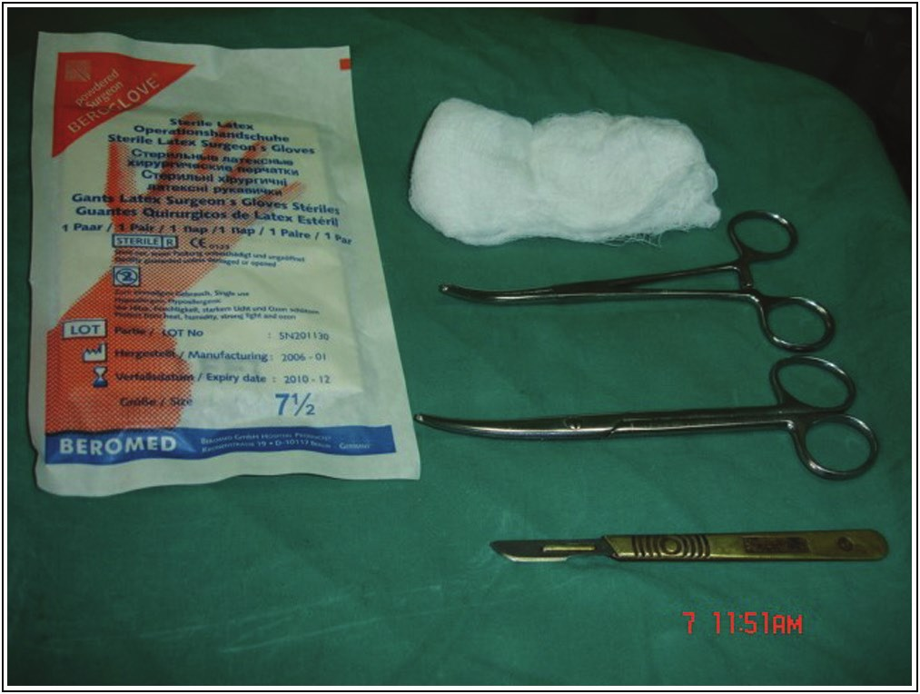

rectal mucosa and submucosa are grasped and withdrawn through the anus without releasing the hold on the tissues. Difficulties in dragging the tissue through the anus indicate that the tissue grasped is too thick (including the muscular layer). The grasped tissue is then excised with a surgical blade or scissors beyond the tissue. The tissue obtained is immediately put in a formalin-containing specimen bottle and sent for histological analysis. The rectum is packed with gauze for 10–15min. The patient on colonic washout had suspension of procedure for 2–3 days to allow for healing.

**Results**

There were 360 patients, 263 boys and 97 girls, with an age range of 3 days to 17 years (median = 10.5 months). The majority, 194 (53.9%), of the procedures were performed by senior registrars, whereas 108 (30.0%), 37 (10.3%), and 21 (5.8%) of the procedures were done by second-year registrars, consultants, and first-year registrars, respectively.

Initial partial-thickness biopsy was used to confirm the diagnosis of HD in 279 (77.5%) patients with suspected HD. In 52 (14.4%) of the patients, the biopsies were inadequate to make the diagnosis at the initial histological review. Twenty-nine (8.1%) of the patients suspected clinically to have HD had normal enteric ganglia. Resident doctors were responsible for 92.2% of inadequate biopsies (*P*= 0.63), although they did the majority (89.7%, 323) of all biopsies [Table 1]. Percentages of the inadequate biopsy were 10.8, 10.8, 17.6, and 38.1 with the

**Table 1: Histological findings and doctor cadre that performed the procedure**

**Findings** **Procedure by (percentage vertical)** **Total**

Ganglion seen (not HD) HD

Inadequate specimen Total

**Consultant**

1 (2.7) 32 (86.5)

4 (10.8) 37 (100)

**Senior registrar**

15 (7.7) 158 (81.4)

21 (10.8) 194 (100)

**Old registrar (>1 year)**

13 (12.0) 76 (70.4)

19 (17.6) 108 (100)

**New registrar (<1 year)**

0 (0)

13 (61.9)

8 (38.1) 21 (100)

29 (8.1) 279 (77.5)

51 (14.2) 360 (100)

Adequacy for pathologic diagnosis

Yes No Total

*P* value is 0.01

Experienced (C & senior registrar)

206 25 231

Inexperienced (registrars) Total

102 308 27 52 129 360

**Table 2: Repeat biopsy by cadre that performed the procedure**

**Need for repeat biopsy** **Cadre of doctor who performed biopsy** **Total**

**Consultant (C)** Yes 4 (10.8)

No 33 (89.2) Total 37 (100)

**Senior registrar (SR)** 22 (11.3)

172 (88.7) 194

**Old registrar (>1 year)** 15 (13.9)

93 (86.1) 108

**New registrar (<1 year)** 7 (33.3)

14 (66.7) 21

48 (13.3) 312 (86.7) 360

Yes No Total

*P* value is 0.12

Experienced (C & SR) 26

205 231

Inexperienced (registrars) Total 22 48 107 312 129 360

Journal of the West African College of Surgeons | Volume 13 | Issue 1 | January‑March 2023 37

[Downloaded free from http://www.jwacs-jcoac.com on Tuesday, February 7, 2023, IP: 2.28.143.76]

Sholadoye, *et al*.: Modified rectal biopsy in Hirschsprung’s disease

consultant, senior registrar, second-year registrar, and first-year registrar, respectively. Consultants and senior registrars were considered to be experienced, whereas registrars were considered to be inexperienced. Biopsies done by experienced doctors were adequate for histological diagnosis, which was statistically significant (*P* = 0.01, Table 1).

There was a need for repeat biopsy in 48 (*n* = 360, 13.3%) patients: 42 (11.7%) who had a true inadequate specimen and four patients with an initial report of bowel with parasympathetic ganglia but still having persistent constipation had repeated biopsy of the rectal mucosal and were confirmed to have HD. Two patients had inadequate histology but due to parental request, repeat biopsies were not done because of temporary resolution of symptoms after decompression by colonic wash out. The repeat biopsy represented 0%, 8.3%, 8.3%, and 16.7% in 6, 12, 18, and 24 months old patients, respectively (<6 months to older patients, *P* = 0.06; <1 year compared with older patients, *P*= 0.15). The need for repeat biopsy was highest in first-year resident doctors performing the procedure under supervision [see Table 2]. With consultants and senior registrars were considered to be experienced, whereas first- and second-year registrars were considered to be inexperienced, no statistical significance was noted but when second-year residents who have had longer surgical exposure and skills were considered experienced, there was a significant statistical difference in inadequacy rate by the first-year residents (*P* = 0.005).

Boys were more likely to have a repeat biopsy done (*n*= 42/6; *P* = 0.02). In one (0.3%) of our patients, the procedure ended as a full-thickness biopsy leading to a significant haemorrhage that required blood transfusion after which the patient was discharged the following day without adverse sequelae. Amongst the 360 patients, 93 (25.8%) have had a definitive pull-through procedure. The overall sensitivity and specificity of this biopsy method are 98.8% and 100%, respectively.

**Discussion**

The diagnosis of clinically suspected HD in patients requires a histological diagnosis. A representative posterior rectal wall biopsy is usually taken 2cm above the dentate line to demonstrate the absence of parasympathetic ganglia in submucosal and myenteric plexus with hypertrophied nerve trunks remain the gold standard to confirm the diagnosis.[1,2]

The diagnosis of HD in this study showed some delay with a median age of 10.5 months compared to other high-income settings where most diagnoses are made in the neonatal period.[2-4]

**Procedure**

Several methods[2,5] have been used to obtain a representative specimen for pathological diagnosis of HD, which included full-thickness biopsy under general anaesthesia, RSB,[1] endoscopic biopsy, and instrument biopsy either using

instrument alone or laryngeal biopsy forceps with biopsy tube.[5] In this study, we use curved artery forceps to obtain the rectal biopsy. Studies observed that suction biopsy may not be effective in obtaining representative rectal biopsy for accurate diagnosis of HD in older children >6 months[2] or 1 year.[6] This was attributed to recurrent inflammation with associated mucosal oedema and increasing fibrosis making suction biopsy less effective in obtaining representative specimens with age,[2] but this had no statistical significance in this study. A recent study recommended suction biopsy in infants but full-thickness biopsy in older children and multiple biopsies at 1.5cm above the dentate line where suction biopsy is used.[6] In our setting where suction biopsy kits are not readily available and anaesthesia for full-thickness biopsy may be challenging, instrument biopsy is a handy and very useful tool for the diagnosis of HD. This has been shown to be effective by an earlier study.[5]

**Skill levels of doctor**

The skill level of the biopsy taker matters, being a blind biopsy. It was shown in some studies that trainees are more likely to take an insufficient biopsy compared with the consultants because of developing skills in RSB[2] or FRB.[3] This is more important as in this study, experience significantly affects the adequacy of specimens taken, and 83.9% (302) of the procedures were performed by a senior registrar or second-year registrar. And though the first-year registrar did only 5.8% (21) biopsies, 38.1% of these biopsies were inadequate with only 13% inadequacy rate in more experienced hands. This was statistically significant when compared with the other categories after correction for procedure frequency. Thus, there is an overall need for training and practice to ensure adequate biopsies are obtained for diagnoses.

**Diagnosis**

Over the years, there has been a shift from performing a FRB to RSB because of increasing evidence that the difference between FRB and RSB does not significantly reduce the diagnostic value of the rectal biopsy in patients with clinical suspicion of HD.[7-9] Instrument biopsy using a biopsy tube and laryngeal biopsy forceps has been shown to yield adequate samples including lamina propria mucosa, muscularis mucosa, and submucosal tissue in 88.9% of their patients.[5]

Our modified partial-thickness biopsy had a sensitivity of 98.8%, with four false-negative results, and a specificity of 100%, with no false-positive findings; this is much higher than findings in an earlier study using RSB where the sensitivity of RSB to be 81%, with 12 false-negative results, and specificity of 97%, with four false-positive findings.[7] Though we commonly take a single sample for histological evaluation, studies have shown that multiple samples increase the diagnostic yield.[10]

38 Journal of the West African College of Surgeons | Volume 13 | Issue 1 | January‑March 2023

[Downloaded free from http://www.jwacs-jcoac.com on Tuesday, February 7, 2023, IP: 2.28.143.76]

Sholadoye, *et al*.: Modified rectal biopsy in Hirschsprung’s disease

Although a combination of biopsy with acetylcholinesterase enzyme histochemical staining method has been reported to have a diagnostic accuracy rate of 95.59% and a positive predictive value of 100%,[11] we rely on biopsy alone because of the nonavailability of enzyme assay in our hospital’s pathology department.

**Repeated biopsy**

Where the sample obtained is inadequate for histological diagnosis, a repeat biopsy is advocated.7] About 13% of our patients had repeated partial-thickness biopsy due to nonrepresentative samples from the biopsy, which is not uncommon in other studies, 8%–26%.2,8,9] The inadequacy rates in RSB and FRB were simila [2,10,12] with some studies having as high as 20%.3,8] Multiple sampling reduced the rate of inadequate samples in these studies,3,10] though, this is not our practice.

[

[

r

[

[

A repeated biopsy is more likely in biopsies performed by trainees[3] as we observed more so in first-year resident doctors. Their proficiency increased as they performed more biopsies as observed amongst senior resident doctors and consultants. This was observed in other studies.[13] Conversely, our study did not show a statistically significant need for repeated biopsy based on the experience of the doctor. Several studies observed the need for repeat biopsy in patients above 6 months to 1 year of age.[8,13] In this study, no patient below 6 months required a repeat biopsy, and this advantage is fairly retained up to 18 months of life, although this was not statistically significant. It is contrary to the 3 years observed by Croffie *et al.* where grasp biopsy was compared to RSB.[14]

**Complications**

Complications are uncommon following partial-thickness rectal biopsy, and when it occurs, it is usually mild.[10] Complications tend to occur more in FRB compared to partial-thickness biopsy (grasp biopsy or RSB). Bleeding following biopsy is uncommon as observed in these studies.[3,13] Some authors reported prolonged bleeding in 5.6%[3,10] and bowel perforation[10,13] following full-thickness biopsy. In some cases,[3,10] bleeding resulted in marked anaemia and needing a blood transfusion. Contrarily, a more recent international survey observed a high complication rate following RSB of up to 48.6%, most of which were self-limiting rectal bleeding but unacceptable high persistent rectal bleeding in 12.2% and rectal perforation in 9.5%.[9] Therefore, adequate precaution and monitoring are required following the procedure to limit the occurrence of complications.

**Conclusions**

The modified rectal mucosal biopsy is a simple, safe, and effective method for confirming the diagnosis of HD. This is performed without general anaesthesia and is useful where suction biopsy kits are unavailable. Proper training of the biopsy taker in the procedure limits inadequacy rate, and judicious technique along with adequate monitoring following the procedure is necessary to limit complications.

**Acknowledgements**

We acknowledge the contributions of all specialists and doctors that participated in the actual biopsies and the care of our patients.

**Financial support and sponsorship**

Nil.

**Conflicts of interest**

There are no conflicts of interest.

**References**

1. Noblett HR. A rectal suction biopsy tube for use in the diagnosis of Hirschsprung’s disease. J Pediatr Surg 1969;4:406-9.

2. Muise ED, Cowles RA. Rectal biopsy for Hirschsprung’s disease: A review of techniques, pathology, and complications. World J Pediatr 2016;12:135-41.

3. Bamigbola KT, Nasir AA, Abdur-Rahman LO, Oyinloye AO, Abdulraheem NT, Adeniran JO. Experience with full-thickness rectal biopsy in the evaluation of patients with suspected Hirschsprung’s disease. Ann Pediatric Surg 2014;10: 42-5.

4. Brady AC, Saito JM, Lukas K, Guthrie T, Utterson EC, White FV, *et al*. Suction rectal biopsy yields adequate tissue in children. J Pediatr Surg 2016;51:966-9.

5. Hirose R, Hirata Y, Yamada T, Kawana T, Taguchi T, Suita S. The simple technique of rectal mucosal biopsy for the diagnosis of Hirschsprung’s disease. J Pediatr Surg 1993;28:942-4.

6. Veras LV, Arnold M, Avansino JR, Bove K, Cowles RA, Durham MM, *et al*.; American Pediatric Surgical Association Hirschsprung Disease Interest Group. Guidelines for synoptic reporting of surgery and pathology in Hirschsprung disease. J Pediatr Surg 2019;54:2017-23.

7. Keyzer-Dekker CM, Sloots CE, Schokker-van Linschoten IK, Biermann K, Meeussen C, Doukas M. Effectiveness of rectal suction biopsy in diagnosing Hirschsprung disease. Eur J Pediatr Surg 2016;26:100-5.

8. Muise ED, Hardee S, Morotti RA, Cowles RA. A comparison of suction and full-thickness rectal biopsy in children. J Surg Res 2016;201:149-55.

9. Friedmacher F, Puri P. Current practice patterns of rectal suction biopsy in the diagnostic work-up of Hirschsprung’s disease: Results from an international survey. Pediatr Surg Int 2016;32:717-22.

10. Friedmacher F, Puri P. Rectal suction biopsy for the diagnosis of Hirschsprung’s disease: A systematic review of diagnostic accuracy and complications. Pediatr Surg Int 2015;31:821-30.

11. Gugelmin ES, Torres LFB. The accuracy of acetylcholinesterase reaction in rectal suction biopsy in the diagnosis of Hirschsprung’s disease. J Bras Patol Med Lab 2005;41:431-6.

12. Ax SÖ, Arnbjörnsson E, Gisselsson-Nord D. A comparison of rectal suction and full wall biopsy in Hirschsprung’s disease. Surg Sci 2014;5:15-9.

13. Alizai NK, Batcup G, Dixon MF, Stringer MD. Rectal biopsy for Hirschsprung’s disease: What is the optimum method? Pediatr Surg Int 1998;13:121-4.

14. Croffie JM, Davis MM, Faught PR, Corkins MR, Gupta SK, Pfefferkorn MD, *et al*. At what age is a suction rectal biopsy less likely to provide adequate tissue for identification of ganglion cells? J Pediatr Gastroenterol Nutr 2007;44:

198-202.

Journal of the West African College of Surgeons | Volume 13 | Issue 1 | January‑March 2023 39