Prevalence of Revision Adenoidectomy in a Tertiary Otorhinolaryngology Centre in Nigeria

**Original Article**

**Jamila Lawal1, Hassan Iliya Dadi2,**

**Abstract**

**Introduction:** Remnants or the regrowth of adenoid tissue after adenoidectomy may present with clinical symptoms that could warrant a revision surgery. **Aim and Objectives:** This study aims to determine the prevalence and risk factors of revision adenoidectomy in our centre. **Materials and Methods:** This is a retrospective case–control study conducted in a tertiary otorhinolaryngology centre over a 10-year period. Cases of revision adenoidectomies were identified and matched with controlled cases of single-stage adenoidectomies within the same period. All information was entered into the Statistical Package for the Social Sciences (SPSS) version 25 and analysed using descriptive and cross-tabulation analysis. **Results:** A total of 1249 adenoidectomies were performed during the period of review with 26 being revision cases. The prevalence of revision adenoidectomy was found to be 2.1% with the mean interval between surgeries being 2.1 years. Age ≤ 2 years (odds ratio (OR) = 95.25, *P* < 0.0001), allergy (OR = 0.09, *P* < 0.0001), recurrent tonsillitis (OR = 0.79, *P* = 0.006), recurrent/chronic middle ear infections (OR = 7.5, *P* < 0.0001), and the primary surgeon being a junior registrar (OR = 11.5, *P* < 0.0001) were significantly associated with revision adenoidectomy. The performance of adenoidectomy without tonsillectomy also carries a significant odd (*P* = 0.04). **Conclusion:** Revision adenoidectomy is low in our setting. Young age at primary surgery, the presence of allergy, surgeon’s designation, the extent of surgery, and recurrent middle ear and tonsil infections are factors associated with revision adenoidectomy. These should be considered in risk stratification and surgery planning.

**Keywords:** *Adenoid, adenoid regrowth, revision adenoidectomy, risk factors*

**Key Message:** *Some risk factors predispose to having revision adenoidectomy. Appropriate surgical risk stratification and planning may reduce the need for revision adenoidectomy.*

**Rasheedat Sanni2, Nurudeen Adebola Shofoluwe3**

*1Consultant*

*Otorhinolaryngologist/ Lecture Ear, Nose and Throat Unit, Department of Surgery Barau Dikko Teaching Hospital and Kaduna State University, 2Department of Clinical Services, National Ear Care Centre, Kaduna, 3Department of Surgery, Ear, Nose and Throat Division, Ahmadu Bello University Teaching Hospital Zaria, Nigeria*

# Introduction

Adenoidectomy is the surgical removal of the adenoids and is one of the most commonly performed procedures in otorhinolaryngological practice.[1-3] It is often performed in conjunction with other procedures such as tonsillectomy and myringotomy.[4,5] Although there have been many indications for adenoidectomy, sleep- disordered breathing (SDB), ear disease, and paediatric chronic rhinosinusitis (CRS) remain the major indications for the procedure.[2,6-8] More than half a million adenoidectomies are performed annually in the United States of America alone at a rate of 176 per 100,000 children,[4,7] whereas the incidence in Nigeria is 26% and 74.4% for adenoidectomy alone and adenotonsillar surgeries, respectively.[9]

It is not uncommon to find small clinically asymptomatic adenoid remnants or the

This is an open access journal, and articles are distributed under the terms of the Creative Commons Attribution-NonCommercial- ShareAlike 4.0 License, which allows others to remix, tweak, and build upon the work non-commercially, as long as appropriate credit is given and the new creations are licensed under the identical terms.

**For reprints contact:** [reprints@medknow.com](mailto:reprints@medknow.com)

regrowth following adenoidectomy, with rates as high as 19%.[6,10,11] However, cases of significant adenoid regrowth after the first adenoidectomy, warranting the need for a repeat surgery, have been reported, with prevalence rates ranging from 0.55% to 3%.[10- 14] Factors associated with postsurgery adenoid regrowth include incomplete resection,[6,14] adenoidectomy without tonsillectomy,[13] allergy, acid reflux,[8,11,13] age < 5 years at the first surgery,[8,11] tubal tonsil hyperplasia, and male gender.[5,15]

This study aims to determine the prevalence and risk factors of revision adenoidectomy.

# Materials and Methods

This is a retrospective case–control study conducted in the National Ear Care Centre, Kaduna, a tertiary centre for the research and treatment of otorhinolaryngological and head and neck conditions in Nigeria. Ethical approval for the study was obtained from the

**How to cite this article:** Lawal J, Dadi HI, Sanni R, Shofoluwe NA. Prevalence of revision adenoidectomy in a tertiary otorhinolaryngology centre in Nigeria. J West Afr Coll Surg 2021;11:23-8.

**Received:** 21-Mar-2022 **Accepted:** 24-Apr-2022 **Published:** 22-Jun-2022

***Address for correspondence:*** *Dr. Hassan Iliya Dadi, Department of Clinical Services,*

*National Ear Care Centre, 3 Golf Course Road, Kaduna, Kaduna State, Nigeria.*

*E-mail:* [*dadimiken@gmail.com*](mailto:dadimiken@gmail.com)

|  |
| --- |
| **Access this article online** |
| **Website:**  [www.jwacs-jcoac.org](http://www.jwacs-jcoac.org/) |
| **DOI:** 10.4103/jwas.jwas_61_22 |
| **Quick Response Code:** |

Ethics Committee of the hospital (NECC/ADM/214/V/84).

## Table 1: Characteristics of the cohort

Medical records of all the patients who had adenoidectomy with or without tonsillectomy in the centre between 2010

**Variables First surgery (*n* = 26)**

**Second surgery**

**Control (*n* = 130)**

|  |  |  |  |  |
| --- | --- | --- | --- | --- |
| and 2019 were searched and retrieved, and patients who |  |  | **(*n* = 26)** |  |
| had revision adenoidectomies were identified. A repeated  adenoidectomy was defined as two or more adenoidectomies | Gender  Male | 17 (65%) | 17 (65%) | 55 (42%) |
| performed on a patient with the same name and identification  code in the same hospital within the study period. | Female  Age (years) | 9 (35%) | 9 (35%) | 75 (58%) |

Patients who had an initial adenoidectomy at a different health

|  |  |  |  |
| --- | --- | --- | --- |
| 0 to 2 | 18 (69%) | 3 (12%) | 3 (2%) |
| >2 to ≤4 | 5 (19%) | 8 (31%) | 67 (52%) |

|  |  |  |  |  |
| --- | --- | --- | --- | --- |
| facility were excluded from the study because of the lack of | >4 to ≤6 | 3 (12%) | 11 (42%) | 58 (45%) |
| clinical and operative reports of the primary surgery. Adult | >6 to ≤8 |  | 4 (15%) | 2 (2%) |
| patients (≥18 years) were excluded from the study. From the  retrieved clinical records, information such as the indication for | Mean age | 1.97  (23.5 months) | 5.8  (69.6 months) | 5.0  (60 months) |
| surgery, the age at the time of primary and subsequent surgeries, | Median age | 1.5 | 5 | 5 |
| intersurgery interval, surgical technique, the extent of surgery, | Modal age | 1.5 | 3 | 4 |
| surgeon’s designation, and associated comorbidities was assessed | SD | 1.2 | 3.4 | 1.04 |
| and analysed. Adenoid grade was not categorised because of its |  | | | |
| unavailability in patients’ records. The tonsil size was graded from |
| 0 to IV based on Brodsky grading system.[16] Tonsils graded II |
| and below were considered small tonsils, whereas those graded |
| III and IV were considered big tonsils. Ten percent of the total |
| adenoidectomies performed within the study period were selected |
| as control. For each case of revision adenoidectomy, five cases |
| of single-stage adenoidectomy performed within the same |
| year of the primary surgery were randomly selected as control |
| using Microsoft Excel. Similar information as for the cases was |
| retrieved from the medical records of the control group. |
| All the information was entered into SPSS version 25.0 (IBM, |

Chicago) and analysed using descriptive statistics and cross- tabulations analysis, and a *P* value of <0.05 was considered statistically significant.

# Results

A total of 1249 adenoidectomies were performed within the study period. Thirty-three cases were identified as having had revision adenoidectomy, but only 26 had complete data for analysis and formed the cases for this study. Of the 26, one case had revision twice. 130 controls (~10% of the total adenoidectomies within the study period) were selected. The entire cohort had adenoidectomy by curettage with indirect vision using a mirror. The prevalence of revision adenoidectomy was found to be 2.1%.

A majority of the cases were males constituting 65%, whereas for the control 58% were females [Table 1]. Sixty-nine percent of the cases had their primary surgeries within the first 2 years of life. The mean age at primary surgery was 1.97 years (standard deviation, SD = ±1.2) and 5.8 years at revision surgery. For the control group, 125 (97%) had their surgery between ages of 3 and 6 years, with a mean age at 5 years. The average interval between primary and secondary adenoidectomies was found to be 2.5 years (SD = ±0.6) [Table 1].

Eighty-five percent of the subjects had revision surgery before the age of 6 years [Table 1], with 42% having it within

**Figure 1: Approximate intervals between primary and revision surgeries**

1–2 years of primary surgery [Figure 1]. Although 25 (96.2%) of the cases had one revision adenoidectomy each, a single case (of Down’s syndrome) had two revision adenoidectomies.

The commonest indication for the primary surgeries among the cases was SDB. The distribution of the indications was similar among the control [Figure 2]. During the revision surgery, additional surgical procedures were indicated with eight cases (31%) requiring ventilation tube insertion [Figure 3].

Ten (38.5%) of the caregivers reported symptoms at the second presentation as being worse than symptoms at the first presentation, whereas 14 (53.8%) reported symptoms as the same in severity as the initial presentation.

Cross-tabulation (using Pearson’s chi-square) revealed higher odds of having revision adenoidectomy with a decrease in age. The risk is highest with age ≤ 2 years at primary surgery (odds ratio, OR = 95.25, *P* < 0.0001). From here the risk begins to decrease with an increase in age up until age >6 years when the odds become statistically insignificant. Allergy (OR = 22.9, *P* < 0.0001), recurrent and chronic middle ear infections (*P* < 0.0001), recurrent tonsillitis (*P* = 0.006), adenoidectomy without tonsillectomy, and primary surgeon being a junior registrar (*P* < 0.0001) also carried significant odds for revision adenoidectomy [Table 2].

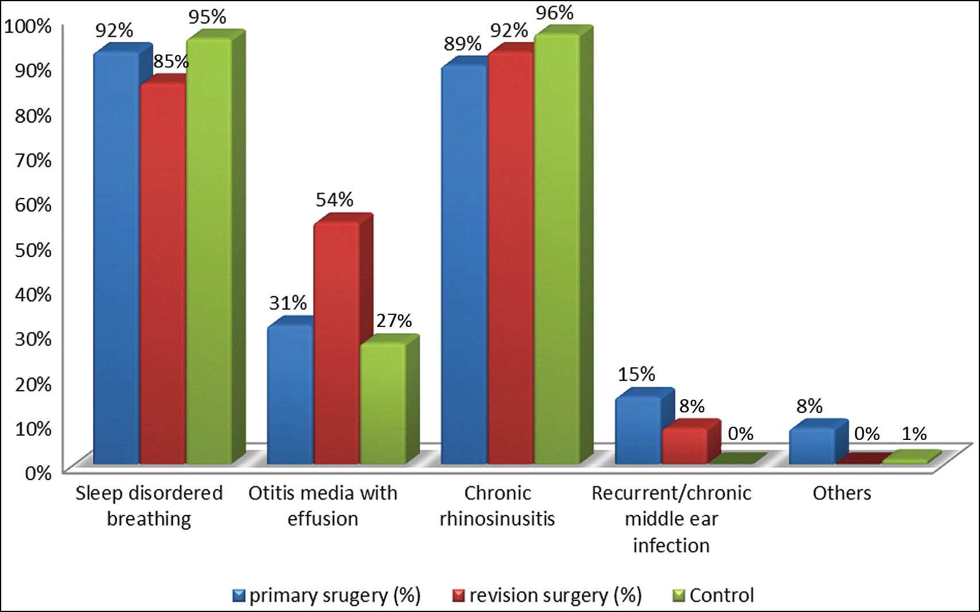

**Figure 2: Indication for surgery among the cohort**

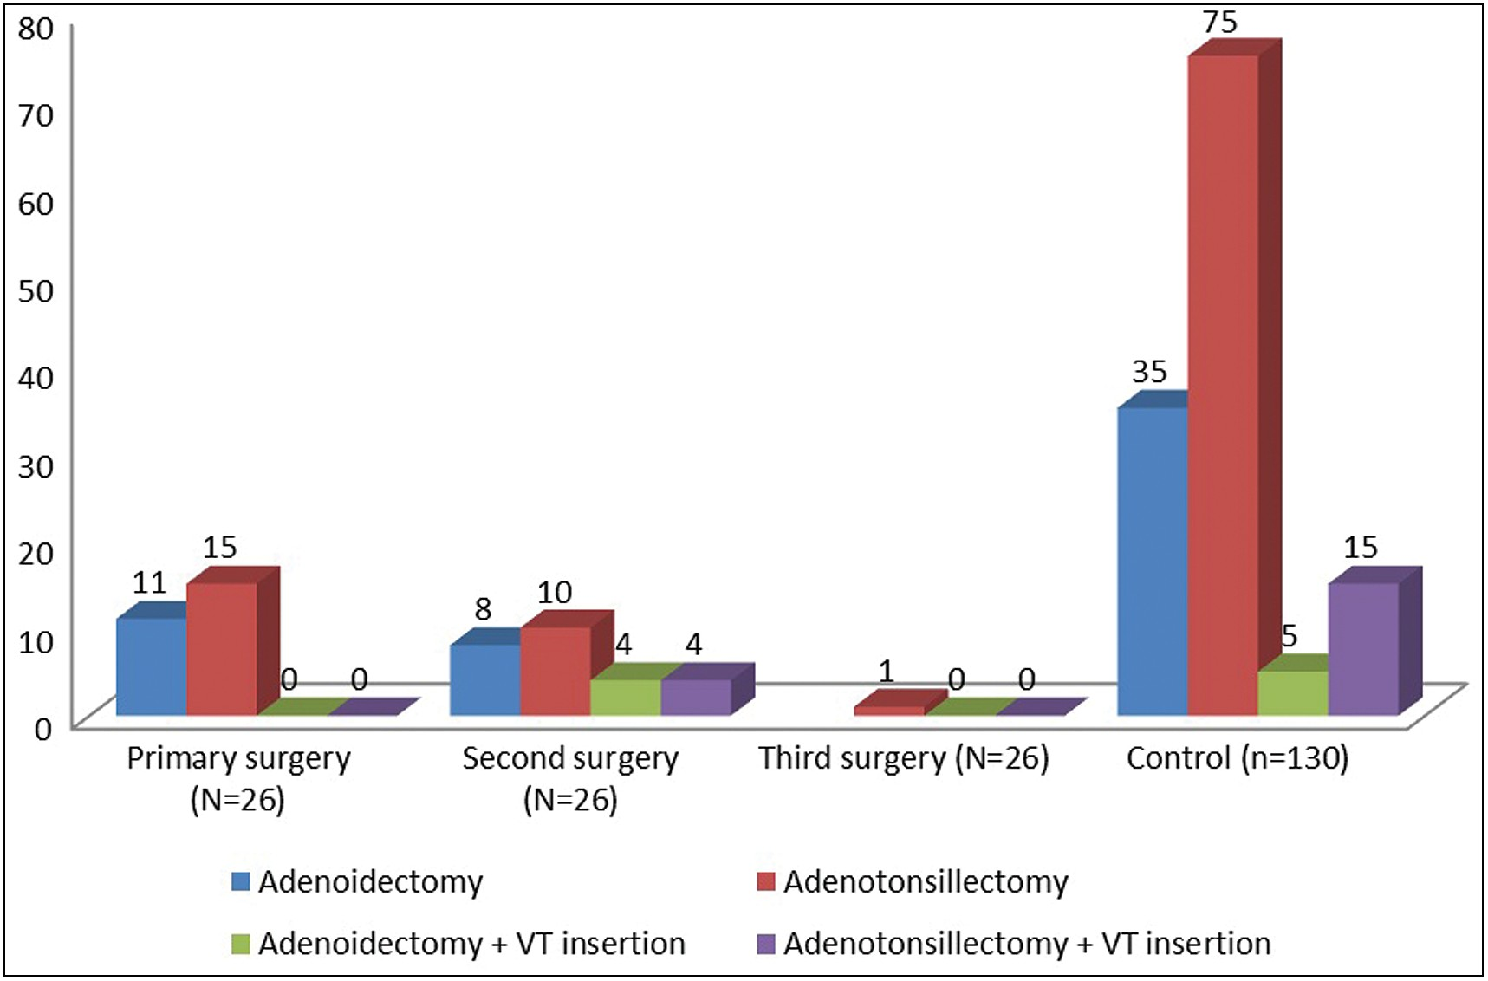

**Figure 3: Comparison of the extent of procedure between the cases (primary and secondary surgeries) and the control**

# Discussion

The rate of revision adenoidectomy in our study was found to be 2.1%, which is within the range (0.55% to 3%) that is frequently reported for hospital-based studies.[8,11-14,16] Population-based prevalence is however reported to range from 2.6% to 9.8%.[5,17] A recent meta-analysis of revision adenoidectomy that included both hospital- and population- based studies has put the overall prevalence at 1%–2%,[18] which is in keeping with our findings.

The mean age at primary surgery was 1.97 ± 1.2 years (23.5 months), which is 2.5 times lower than the mean age for the control [5 ± 1.4 years (60 months)]. Other studies found a higher mean age.[8,13,18,19] Age < 2 years at primary surgery has been reported to increase the likelihood of a revision adenoidectomy.[20] Because of the high prevalence of recurrent upper respiratory tract infections (URTI) in children

<2 years, which in turn has been found to stimulate adenoid growth,[21,22] it then means that removing the adenoids at such an early age could pose a risk for adenoid regrowth, which may

## Table 2: Risk estimates for revision adenoidectomy

|  |  |  |  |  |
| --- | --- | --- | --- | --- |
| **Variable** | **χ2** | **OR** | **95% CI** | ***P* value** |
| Age (years) |  |  |  |  |
| 0–2 | 83.3 | 95.25 | 23.12–392 | <0.0001 |
| 2–4 | 9.1 | 0.22 | 0.08–0.63 | 0.003 |
| 4–6 | 10.0 | 0.16 | 0.05–0.57 | 0.002 |
| >6 | 0.41 | 1.01 | 0.99–1.04 | 0.524 |
| Sex | 4.6 | 2.58 | 1.07–6.21 | 0.052 |
| Male | 2.57 | | 1.10–6.2 | |
| Female | 0.39 | | 0.16–0.94 | |
| Indication for adenoidectomy |  |  |  |  |
| SDB | 1.06 | 2.18 | 0.48–9.97 | 0.30 |
| CRS | 0.00 | 1.00 | 0.27–3.74 | 1.00 |
| OME | 1.54 | 0.49 | 0.16–1.53 | 0.22 |
| R/C MEE | 31.2 | 7.5 | 4.99–11.28 <0.0001 | |
| Comorbidity |  |  |  | |
| Allergy | 22.9 | 0.09 | 0.03–0.29 <0.0001 | |
| Recurrent tonsillitis | 7.43 | 0.79 | 0.73–0.87 | 0.006 |
| Extent of adenoidectomy | 4.14 | 2.44 | 1.01–5.9 | 0.042 |
| Without tonsillectomy |  | 1.83 | 1.06–3.17 |  |
| With tonsillectomy |  | 0.75 | 0.53–1.06 |  |
| Tonsil size |  |  |  |  |
| Small tonsils | 1.20 | 1.60 | 0.69–3.73 | 0.27 |
| Big tonsils | 1.20 | 0.93 | 0.27–1.46 | 0.27 |
| Surgeon’s designation Junior registrar | 31.1 | 11.47 | 4.34–30.36 | <0.0001 |
| Senior registrar | 5.24 | 0.38 | 0.16–0.89 | 0.2 |
| Consultant | 0.59 | 0.55 | 0.12–2.56 | 0.44 |

χ2 = chi-square; CI = confidence interval; OME = otitis media with effusion; R/C MEE = recurrent/chronic middle ear infections

be significant enough to cause symptoms that will necessitate a revision surgery. Possible reasons for the younger age at primary surgery include none-improvement or worsening of symptoms with medical treatment and concerns of being lost to follow-up with prolonged conservative treatment. The mean age at the second surgery (5.8 ± 3.4 years) is similar to the mean age reported for a single-staged adenoidectomy.[18] This age coincides with the age at which adenoid growth reaches a peak and then begins to regress.[4,21] Although 18 (69%) of the cases had primary surgery within the first 2 years of life, 97% of the control had their adenoidectomies between 3 and 6 years of life. This explains the high revision rate among those of the lower age categories. We also found the average interval between surgeries to be 2.5 ± 0.6 years, which is similar to findings by Brietzke *et al.*[20] and Sapthavee *et al.*[23] This could be long enough time for adenoid to regrow and cause symptoms especially in the presence of repeated adenoidal inflammatory reactions from either recurrent URTI or allergy.

Males were 1.9 times the number of females in the cases, whereas in the control, females outnumber males by 1.4. Although we could not find a definite explanation for the higher rate of revision surgery in males, it is likely that our small sample size might have contributed to this discrepancy. There have been conflicting reports on the sex distribution of

revision adenoidectomy, with some studies reporting higher rates in males,[5,18] and others higher rate in females.[19]

The commonest indications for surgery in both the cases and control were SDB, CRS, and otitis media with effusion (OME), similar to what has been earlier reported.[2,7,8] However although all the cases had either adenoidectomy alone (42%) or adenoidectomy with tonsillectomy (58%) during the primary surgery, the number of surgical procedure increases during the revision surgeries, with eight patients (31%) requiring ventilation tube insertion. This increase in the types of surgical procedure during the revision adenoidectomy could have both financial and health implications. Revision surgery does not only imply added morbidity for the patient, it may also portend economic burden, psychological stress, and more surgical risk to the patient.[24]

The increase in the severity of symptoms in those presenting for revision surgery may be related to delay in representation. The average intersurgery interval (of 2.5 ± 0.6 years) is sufficient enough for adenoid to regrow and obstruct the choanae causing worsening of symptoms. Caregivers may have been unaware of a possibility of adenoid regrowth after the primary surgery, which may have contributed to a delay in re-presentation. Careful counselling and follow-up, of especially those at risk, can be helpful in preventing such a scenario.

Analysis for the risks for revision adenoidectomy revealed that performing adenoidectomy on patients aged 0–2 years carries a high odd (OR = 95) of having a subsequent revision surgery (*P* < 0.0001). The risk, as we found, decreases with age and becomes statistically insignificant beyond age 6 years (*P* = 0.52). This is possibly because the stimulation of adenoid growth by either immune reactions or recurrent URTI is maximal during the first 5 years of life and then regresses thereafter. Additionally, the nasopharynx of young children is small and may contribute to incomplete adenoid removal during surgery. The residual adenoid lymphoid tissue may then become hypertrophied or hyperplastic and subsequently cause symptoms.[4,8,21] Although male gender carried 2.5 odds for revision adenoidectomy, this was not found to be statistically significant.

We also found a strong association between the presence of allergy and odds of having revision adenoidectomy (*P* < 0.0001). The adenoid tissues in children with allergic rhinitis have been found to be rich in Ig-E coated mast cells, plasma cells, and histamine. This is associated with increased immune reactions and lymphoid hyperplasia of the adenoid.[25] Because it is difficult to completely remove the adenoid tissues during adenoidectomy in small children because of their relatively smaller nasopharynx, adenoid remnant containing immune mediators may continue to increase in size even after surgery. In the setting of allergic rhinitis with impaired mucous drainage, bacteria and viruses can also colonise the nasal and nasopharyngeal mucosa (including remnants of adenoid tissues) after adenoidectomy, leading to repeated inflammatory adenoiditis and adenoid regrowth. Our findings are similar

to earlier studies who also reported an association between allergy and increased risk of revision adenoidectomy.[11,19,26,27]

In our study, we also found that children presenting with clinical features of recurrent tonsillitis carried a higher odd of having revision adenoidectomy (*P* = 0.006). This is similar to findings by Alsharif *et al.*[28] This may be due to the effects of factors such as allergy, infection, and acid reflux on the pharyngeal mucosa.[8] Studies have demonstrated a high incidence of gastric acid reflux among children undergoing adenoidectomy, and this is found to be associated with mucosal edema and inflammation in the pharynx, leading to adenoid and tonsil hyperplasia/hypertrophy, and hence a risk for recurrent tonsillitis and revision adenoidectomy.[8,28,29] However, as we could not ascertain the presence or absence of acid reflux in the cohort, it is thus difficult to establish a causal relationship.

Furthermore, we found that adenoidectomy performed by a junior registrar carries 11.5 odds of resulting in a revision surgery (*P* < 0.0001). The junior registrar, who is in the early years of his/her training, may be less experienced with less dexterity and hence likely to be more conservative or less confident while curetting the adenoids. Dearking *et al*.[8] found that early years residents were 50% more likely to have performed the primary surgery for a revision adenoidectomy, whereas Le *et al*.[30] on the other hand did not find any association between surgeon level of training and revision adenoidectomy. The retrospective nature of our study, coupled with the small sample size as well as the majority of the procedures being performed by senior registrars, might have been major confounders to our findings. A long-term blinded prospective study based on surgeon’s cadre may be more appropriate in determining the exact association between revision surgery and surgeon’s designation.

Adenoidectomy without tonsillectomy was also significantly associated with revision surgery. Compensatory reactions in the tonsils or other components of the Waldeyer’s ring may possibly stimulate the hypertrophy of the remnant of adenoid lymphoid tissue. Similar hospital-based studies have reported that children who underwent adenoidectomy without tonsillectomy are at a risk of having a revision adenoidectomy.[14,26,28]

The significant association of middle ear infections with revision adenoidectomy may be connected to persistent tubal dysfunction possibly from allergic inflammation or mechanical obstruction from enlarged adenoids. It may also result from repeated colonisation of the middle ear by pathogenic organisms following rhinosinusitis or recurrent adenoiditis. We could not find a significant association between tonsil grade, CRS, SDB, or OME and revision adenoidectomy. This is because these variables were uniformly distributed in both the case and control groups.

## Limitations

We could not correlate the adenoid size with a risk of having a revision adenoidectomy as the size of adenoid using standard parameters was not recorded in the patients’

clinical files. Patients requiring revision adenoidectomy may present in other hospitals than ours, thus affecting the true prevalence rate. Because of the retrospective nature of the study, we could not objectively ascertain the presence or absence of allergies or evaluate other comorbidities such as acid reflux.

# Conclusion

The prevalence of revision adenoidectomy is low but may come with additional burden. Adenoidectomy at a younger age, allergy, recurrent tonsillitis, recurrent/chronic middle ear infections, adenoidectomy without tonsillectomy, and (surgeon’s) lower level of training were found to be significant risk factors for revision adenoidectomy. These could serve as important parameters in the stratification and prediction of disease recurrence and revision surgery for patients at risk. Prospective studies to elucidate factors associated with early presentation and disease severity may be helpful in reducing the need for revision surgeries.

## Financial support and sponsorship

Nil.

## Conflicts of interest

There are no conflicts of interest.

## Ethical clearance

The research was carried out at National Ear Care Centre, No. 3, Golf Course Road, Kaduna, Kaduna State, Nigeria (NECC/ ADM/214/V/84).

# References

1. van den Aardweg MTA, Schilder AGM, Herkert E, Boonacker CWB, Rovers MM. Adenoidectomy for recurrent or chronic nasal symptoms in children. Cochrane Database of Syst Rev 2010;2010:CD008282.
2. Ingram DG, Friedman NR. Toward adenotonsillectomy in children: A review for the general pediatrician. JAMA Pediatr 2015;169: 1155-61.
3. Babakurban TS, Aydın E. Adenoidectomy: Current approaches and review of the literature. Kulak Burun Bogaz Ihtis Derg 2016;26: 181-90.
4. Ramos SD, Mukerji S, Pine HS. Tonsillectomy and adenoidectomy. Pediatr Clin North Am 2013;60:793-807.
5. Lee CH, Chang WH, Ko JY, Yeh TH, Hsu WC, Kang KT. Revision adenoidectomy in children: A population-based cohort study in Taiwan. Eur Arch Otorhinolaryngol 2017;274:3627-35.
6. Yildirim YS, Senturk E, Eren SB, Dogan R, Tugrul S, Ozturan O. Efficacy of nasal corticosteroid in preventing regrowth after adenoidectomy. Auris Nasus Larynx 2016;43:637-40.
7. Schupper AJ, Nation J, Pransky S. Adenoidectomy in children: What is the evidence and what is its role? Curr Otorhinolaryngol Rep 2018;6:64-73.
8. Dearking AC, Lahr BD, Kuchena A, Orvidas LJ. Factors associated with revision adenoidectomy. Otolaryngol Head Neck Surg 2012;146:984-90.
9. Samdi MT, Emmanuel M, Kirfi AM. Adenotonsillar surgeries in Kaduna, Nigeria. Ann Indian Acad Otorhinolaryngol Head Neck Surg 2017;1:6-8.
10. Lesinskas E, Drigotas M. The incidence of adenoidal regrowth after adenoidectomy and its effect on persistent nasal symptoms. Eur Arch Otorhinolaryngol 2009;266:469-73.
11. Joshua B, Bahar G, Sulkes J, Shpitzer T, Raveh E. Adenoidectomy: Long-term follow-up. Otolaryngol Head Neck Surg 2006;135: 576-80.
12. Liapi A, Dhanasekar G, Turner NO. Role of revision adenoidectomy in paediatric otolaryngological practice. J Laryngol Otol 2006;120:219-21.
13. Monroy A, Behar P, Brodsky L. Revision adenoidectomy—A retrospective study. Int J Pediatr Otorhinolaryngol 2008;72:565-70.
14. Duval M, Chung JC, Vaccani JP. A case-control study of repeated adenoidectomy in children. JAMA Otolaryngol Head Neck Surg 2013;139:32-6.
15. Emerick KS, Cunningham MJ. Tubal tonsil hypertrophy: A cause of recurrent symptoms after adenoidectomy. Arch Otolaryngol Head Neck Surg 2006;132:153-6.
16. Brodsky L. Modern assessment of tonsils and adenoids. Pediatr Clin North Am 1989;36:1551-69.
17. Thomas K, Boeger D, Buentzel J, Esser D, Hoffmann K, Jecker P, *et al*. Pediatric adenoidectomy: A population-based regional study on epidemiology and outcome. Int J Pediatr Otorhinolaryngol 2013;77:1716-20.
18. Lee CH, Hsu WC, Ko JY, Yeh TH, Lin MT, Kang KT. Revision adenoidectomy in children: A meta-analysis. Rhinology 2019;57: 411-9.
19. Johnston J, Mahadevan M, Douglas RG. Incidence and factors associated with revision adenoidectomy: A retrospective study. Int J Pediatr Otorhinolaryngol 2017;103:125-8.
20. Brietzke SE, Kenna M, Katz ES, Mitchell E, Roberson D. Pediatric adenoidectomy: What is the effect of obstructive symptoms on the likelihood of future surgery? Int J Pediatr Otorhinolaryngol 2006;70:1467-72.
21. Geiger Z, Gupta N. Adenoid hypertrophy. In: StatPearls. Treasure Island, FL: StatPearls Publishing; 2021. Available from: [https://www.ncbi.nlm.](http://www.ncbi.nlm/) nih.gov/books/NBK536984/. [Last accessed on 2020 Oct 15].
22. Tsagarakis NJ, Sideri A, Makridis P, Triantafyllou A, Stamoulakatou A, Papadogeorgaki E. Age-related prevalence of common upper respiratory pathogens, based on the application of the FilmArray respiratory panel in a tertiary hospital in Greece. Medicine (Baltimore) 2018;97:e10903.
23. Sapthavee A, Bhushan B, Penn E, Billings KR. A comparison of revision adenoidectomy rates based on techniques. Otolaryngol Head Neck Surg 2013;148:841-6.
24. Grindle CR, Murray RC, Chennupati SK, Barth PC, Reilly JS. Incidence of revision adenoidectomy in children. Laryngoscope 2011;121:2128-30.
25. Marseglia GL, Poddighe D, Caimmi D, Marseglia A, Caimmi S, Ciprandi G, *et al*. Role of adenoids and adenoiditis in children with allergy and otitis media. Curr Allergy Asthma Rep 2009;9:460-4.
26. Alkhatib T, Khashoggi K, Bukhari AF, Malaikah RH, Ageely G, Khalifa WM, *et al*. An eight-year case control study identifying predictors of adenoid recurrence. Inter J Otorhinolaryngology 2017;4:4.
27. Huo Z, Shi J, Shu Y, Xiang M, Lu J, Wu H. The relationship between allergic status and adenotonsillar regrowth: A retrospective research on children after adenotonsillectomy. Sci Rep 2017;7:46615.
28. Alsharif S, Alessa S, Alshiqayhi S, AlAmoudi E, Alobiri F, Amro S, *et al*. Incidence and characteristics of revision adenoidectomy among pediatric patients at King Abdulaziz University Hospital in Saudi Arabia. Cureus 2020;12:e7945.
29. Carr MM, Poje CP, Ehrig D, Brodsky LS. Incidence of reflux in young children undergoing adenoidectomy. Laryngoscope 2001;111: 2170-2.
30. Le J, Soumya S, Woods CM, Ooi EH. Factors associated with paediatric revision adenoidectomy: The Flinders experience. Aust J Otolaryngol 2020;3:1-8.